Toward A Design Methodology for Configuring Assistive Wearables

Introduction

Wearable devices (or "wearables") are engineered devices that are worn on the body to perform one or more functions, such as monitoring the wearer's health or activities, assisting the wearer, or communicating with external systems. That is, wearables include sensor, computing, and/or communications technology so that they are considered as "smart" devices. In the engineering research field, they can be classified under cyber-physical-human systems (CPHS) (Rosen and Choi, 2023). To date, wearables have been demonstrated in a broad range of applications from health, fitness, gaming and entertainment to construction and the military. A variety of wearable devices is shown in Figure 1 with a proposed classification.

In this paper, we focus on assistive wearables, that is, wearables that aid users in their daily life activities. More specifically, assistive wearables are technological solutions that enhance the independence, safety, and overall well-being of individuals with specific challenges that may include physical, cognitive, or sensory limitations. The monitoring, assisting, and communicating functions mentioned earlier apply specifically to help overcome the wearer's challenges. Types of assistive wearables include mobility aids, prosthetics and exoskeletons, hearing aids, smart glasses for visual impairment, health monitors, and cognitive support devices, among others.

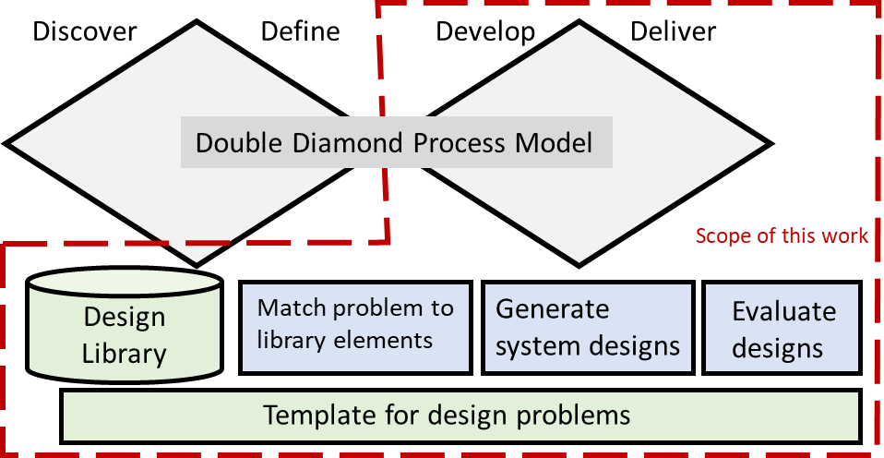

1. Scope and emphasis of the paper - left: variety of wearable devices; right: proposed conceptual design methodology

Wearables share some characteristics and common types of requirements. Potentially, the field of wearables could benefit from a design methodology that guides their development so that design groups do not have to reinvent their problem formulations or product development processes. Also, common software design tools could be developed for the field. In this paper, we propose a starting point for a design methodology focused on the physical configuration design of wearables. More specifically, we propose a configuration design method for wearables and describe its elements. For this paper, we assume that a design problem statement and design requirements have been developed and a design concept identified. Physical principles and components/modules/subassemblies need to be selected and system solutions configured. These solutions should then be evaluated against the requirements. Particularly for assistive wearables, special considerations for acceptability and usability are paramount. In fact, we propose that a template be developed for describing design problems and for representing typical components used in wearables. We adopt the double-diamond design process model (The Design Council, 2023) and focus our research efforts on the second diamond that addresses solution development and evaluation. We assume that the activities related to the first diamond on problem formulation have been completed. Further, given our focus on configuration design, we assume that virtual device models will be available for analysis, but not physical prototypes. A schematic of the proposed design methodology framework is given in Figure 2.

In support of our objective of proposing an initial configuration design methodology, the paper is structured as follows. We review literature of wearable design methods in Section 2. Section 3 describes the proposed conceptual design methodology. An example of applying the design methodology is presented in Section 4, then summary statements are made in Section 5. As described, the methodology is not meant to be comprehensive at this time; rather, it is intended to generate physical configurations, not complete designs. Open research issues are identified to encourage researchers to assist with design methodology development.

1. Design of wearables literature

The body of literature on wearables has grown tremendously over the past two decades. Early work focused on wearable computers (Gemperle et al., 1998); despite the limited application, this work has had significant impact on the field through their proposed 13 design principles for wearables. However, only recently have researchers revisited the ideas of design principles and methodology for wearables. In many cases, this research focused on applying user-centred, inclusive, or universal design perspectives (Clarkson et al., 2003). Many of these papers reviewed the design perspective and described its implications for designing wearables but did not propose a specific method. Some design frameworks have been proposed for gaming and play (Buruk et al., 2019), health and med-tech (Bause et al., 2020), and everyday use (Salisbury et al., 2023). This last paper, based on concepts from user-centred and inclusive design, proposed a "double-diamond" approach to wearable design (see the "Double Diamond Process Model" part of Figure 1 (right)) with four phases: exploring the research environment, defining wants and needs, dreaming (concept generation), and delivering, monitoring and responding. The framework was explored in the context of materials, fabrics, and energy harvesting technologies, but has important implications for a more general wearables design framework and significantly informed our proposed methodology. See Section 3.1 for our usage of the "double-diamond" approach.

Some research has proposed design methods for wearables in specific applications such as neuroprostheses and exoskeletons (Contreras-Vidal et al., 2015) and health monitoring systems (Schauss et al., 2022). Other research focused on developing common design requirements for wearables (Tombert and Kelle, 2016) and surveying technologies for wearables (Frances-Morcillo et al, 2020). The latter paper identified key aspects of smart wearables that can inform the development of design requirements. Taking a human factors viewpoint, they identified three categories of design requirements and enumerated subcategories: physical - comfort, safety, durability; cognitive - usability, reliability; and emotional - engagement (privacy, subtlety), aesthetics.

Many papers have focused on assistive and rehabilitation wearables, emphasizing two or more of the mentioned three categories of design requirements. For example, Shore et al. (2022) investigated technology acceptance and perceptions of robotic devices by older adults. Five themes emerged from the study that influenced the development of a design tool that considers usability and technology acceptance based on user perception, experience, and perceived impact. Meyer et al. (2019) evaluated attachment systems between the wearer and device using existing usability instruments such as the system usability scale (SUS) to assess comfort and performance by paraplegic users. Others have developed novel rehabilitation devices, such as an exoskeleton for hands (Kow et al., 2022), and evaluated their usability, effectiveness, and emotional response with stroke patients.

To summarize the state-of-the-art in wearables design literature, overall principles and frameworks have been developed and some specific design methods have been demonstrated in specific application areas. Much research has concentrated on analyses and evaluations of wearables. But no general design method that has been presented that offers a concrete procedure for smart wearables. In (partial) response to the need for an operationalized design method, we report on an initial configuration design methodology for assistive wearables that builds on the design framework of Salisbury et al. (2023) and the design requirements categories.

1. Proposed configuration design methodology

Each of the main elements in Figure 1 (right) will be described. Additionally, a configuration design method will be proposed that utilizes those elements.

* 1. Configuration design method

The configuration design method is proposed as shown in Figure 2 for constructing a device solution. The method expands upon Figure 1 (right) in organizing the identified elements and activities into a procedure. The method consists of two nested loops, the outer loop for generating subsets of design requirements and the inner loop for identifying components and modules that can meet one or more design requirements. The method assumes the existence of a design library of components and modules that are often found in smart and assistive products. With this library, the design method can match requirements to elements of the design library to identify candidate components and modules from which complete device configurations can be developed. Note that some requirements address problem aspects that do not facilitate matching with physical components, such as requirements on usability, acceptability, manufacturability, etc. These requirements are ignored during configuration design. Steps are numbered for easy reference.

In Step 1, a subset of design requirements that refers to functional or structural aspects of the problem is chosen for further consideration. Some design library components may correspond to more than one design requirement; hence, we consider groups of one or more requirements. The outer loop computes partitions of all relevant design requirements into a set of subsets. Then, the inner loop considers each subset (Step 2) and searches for design library elements that satisfy all requirements in that subset (Step 3). The inner loop ends when all requirement subsets have been considered.

After the inner loop ends, a candidate device is configured from the selected library elements (Step 4), then is evaluated against all design requirements (Step 5). This evaluation can involve detailed technical analyses but will likely be limited to assessments of virtual device models for usability and acceptance requirements. If the evaluation is promising, the designer can choose to keep it for further consideration (Step 6); otherwise, the solution is discarded. The designer can then choose to continue generating solutions by invoking the outer loop again in an iterative manner.

1. Proposed configuration design method
   1. Design library

Most engineered products consist of standard components that are readily available in catalogues as well as components designed specifically for that product. Standard components can include motors, fasteners, bearings, controllers, and many others. Standard components are often part of standard configurations of modules, such as a revolute joint consisting of a shaft supported by bearings, or an actuated joint consisting of a servo motor, controller, and shaft. They are often defined by a set of parameters with which the designer can develop the design with the appropriate performance capabilities. Even product-specific components may have standard elements and parameters that guide their design.

For wearables, a set of standard components can be identified based on typical requirements. For example, wearables need to be fastened or attached to the body; fasteners such as buckles, snaps, buttons, and zippers are common. The technologies incorporated into wearables involve sensors, actuators, and communications capabilities that require electronic circuits and controllers. Many product-specific components fall into readily recognized categories, such as links in an exoskeleton, fabrics that provide the body of a wearable, frames of a head-mounted display, etc. In this work, we assume that both standard and unique components can be classified into categories that are represented in the design library.

We have begun developing a design library for wearables consisting of the types of components described above. To facilitate different types of searches, we include information about the component's classification in a type-of hierarchy, function or purpose, internal behavior, and physical principle(s) under which it operates, in addition to the expected information about parameters and properties. More specifically, the information representation and two examples are given in Table 1.

1. Design library representation and examples

|  |  |  |
| --- | --- | --- |
| Information | Example: Elastic fabric | Example: Servomotor |
| Class of component | fabric | actuator |
| Function | Compress body part | Provide rotary power |
| Behavior/motion/action | Circumferential tension provides compression | Electrical energy converted to rotational motion |
| Physical principles | Solid mechanics | Electrical energy conversion |
| Shape/geometry | flat sheet | cylindrical |
| Material | polymer thread weave | metals |
| Mechanical properties | stiffness | power, etc. |
| Physical properties | density, color | power required, torque-speed relationship, efficiency |
| Connection features | - | electrical ports, shaft, mounting features |

* 1. Wearable design problem template

The intent of the proposed design problem template is to provide the vocabulary with which design problems and design library elements can be described and to ensure that they are consistent. In this manner, designers can formulate problems ensuring that all relevant types of requirements are included. Further, requirements referring to functional, behavioural, or structural aspects can be matched to elements of the library.

An initial design problem template outline is presented in Table 2. Typical types of design requirements for assistive wearables form the major elements of the template and include: usability, acceptance, customization and personalization, comfort, durability, safety, functionality, manufacturability, and affordability. Additional requirements on privacy, security, regulatory compliance, etc. are also important but outside the scope of our considerations in this paper. Functionality should include aspects of sensing, computing, and communications in addition to the specific purpose of the wearable; the language provided by the functional basis should be used as much as possible for functions and behaviours (Hirtz et al., 2002). Subtypes identified in Table 2 provide subcategories of the major "requirement categories" that are likely to be important in a smart product design problem. The third column includes some comments about sources of information for completing the design requirements and some examples to provide guidance.

* 1. Identification of design library elements

After specifying the problem, solutions should be configured. A starting point is to select components and modules that should be part of candidate solutions. In the proposed method, the design library is the source of many of these components and modules. To recognize which are appropriate and guide the designer, candidate library elements can be matched to problem requirements that relate to functions and forms or structures. Matching is indicated by the inner loop involving steps 2 and 3 in the flowchart in Figure 2. Given a subset of requirements, step 3 attempts to find one or more library elements that can fulfil those requirements. To facilitate this matching process, the same terms should be used in requirements and in the library element representations.

As an example, consider the design of a stroke rehabilitation exoskeleton for exercising a patient's hand (bottom right device in Figure 1(left)). Each finger should be bent individually under force control, initiated by a muscle signal. These requirements could be expressed formally as: Bend finger under force control, and Initiate motion from a signal from a specific muscle. The first requirement can be achieved by a linkage driven by a servomotor, where a force sensor provides feedback at the interface of the linkage and finger. Alternatively, a compliant mechanism driven by shape memory actuators (with embedded heaters) could be matched. Attachment of the device to each finger could be accomplished using an elastic band or Velcro straps. Sensing motion intention can be performed using surface electromyography (sEMG) sensors.

1. Design problem template structure, main requirement types

|  |  |  |
| --- | --- | --- |
| Requirement Categories | Subtypes | Sources, Examples |
| Functional | Sensing |  |
|  | Computing |  |
|  | Communications |  |
|  |  | use functional basis for specific purpose |
| Behavior |  | motions, dynamics, functional basis |
| Structural | Shape, geometry |  |
|  | Product architecture |  |
|  | Components, modules |  |
| Physical | Comfort |  |
|  | Safety |  |
|  | Durability |  |
| Cognitive | Usability |  |
|  | Reliability |  |
| Emotional | Engagement (privacy, subtlety) |  |
|  | Aesthetics |  |
|  | Acceptance |  |
| Customization needed |  | none, choose from range of models, customize per patient |
| Manufacturability |  |  |
| Cost |  |  |
| etc. |  |  |

* 1. Configuration of wearable devices

Device configuration entails selecting one matched library element for each requirement, tailoring each element to the corresponding body part (adjust size and shape to fit) by specifying values for all component parameters, then assembling all selected elements into a candidate system solution. A spatial layout should be proposed and interfaces and connections between components should be specified. Of course, multiple device configurations can be generated from the same set of library elements. This step is easy to describe but can be difficult to perform in practice.

* 1. Evaluation of wearable designs

The objective of configuration design is to generate promising concepts and layouts that are worth further development. A designer should evaluate each generated configuration to determine which are worth further consideration. As the designs are not fully fleshed out, they must be reviewed using a heuristic, qualitative or other assessment to identify the ones with a good probability of satisfying each requirement in a reasonable way.

1. Exosuit design

For this example, the following problem statement is considered. A device is desired that aids mobility limited people in maintaining their stability while walking. The device should passively (without actuators) provide restoring forces and moments to the torso if the wearer starts tipping sideways, forward or backward. If the person does fall, a fall sensor should trigger an alert to a caregiver. Additionally, the device should be easy to put on and take off and should require at most one simple user action to initiate its operation. Since the device is intended to replace conventional exoskeletons that could provide similar functionality, the device will be referred to as a (passive) exosuit.

Design requirements are listed in Table 3, along with some candidate designs.

1. Exosuit design requirements and solution principles

|  |  |  |
| --- | --- | --- |
| Requirements | Solution Principle 1 | Solution Principle 2 |
| Provide restoring forces and moments |  |  |
| Sideways disturbances | Inflatable compression, rigid struts | Rigid plates in elastomer |
| Front/back disturbances | Inflatable compression | Rigid plates in elastomer |
| Attach/fasten to body | Velcro straps | Zippers |
| Operation | Straps: manual  Inflation: force sensor, CO2 cartridge | Manual |
| Detect fall | Accelerometer | Gyroscope |
| Send message | Bluetooth | Bluetooth |
| Power device | Wireless rechargeable battery | Wireless rechargeable battery |
| Recharge power source | Wireless recharger in fixture for storing garment | Wireless recharger for removable battery pack |

* 1. Solution principle 1

Two classes of solution principles will be generated. The first is based on the physical principle of an inflated garment that compresses on the wearer's body. The concept is that such compression aids stability by preventing torso rotation. If the wearer bends forward, the garment resists the motion by both resisting stretching in the back (exerts compressive forces on the body) and resisting compression in the front (exerts forces in tensile direction). Similar resistive forces are exerted under sideways rotations.

Specific components can be matched to each requirement. In this case, only single requirements will be considered for this example. As mentioned, an inflatable garment matches against the requirement to provide restoring forces and moments. Additionally, rigid struts also match. In this case, the struts will be combined with inflation for sideways rotations, but not forward and backwards to enable the wearer greater movement ranges. Velcro straps will be used to tighten the garment onto the wearer's torso. Two alternative configurations were developed, as shown in Figure 3. The configuration shown at top is limited to only the torso, while the bottom configuration fits the torso down to the upper thighs. Different layouts of the various components are explored in these configurations.

Regarding operations, we envision that a fixture can be designed on which to hang the garment when not being worn. A CO2 cartridge will be embedded in the garment to inflate it. When in the fixture, the CO2 cartridge needs to be snapped into a device that recharges the cartridge. A force sensor will be added to the garment under a Velcro strap such that, when the strap is pressed, the CO2 cartridge is triggered automatically to inflate the garment.

An accelerometer is selected as the fall detection sensor, similar to sensors embedded in cell phones. To send messages to the caregiver, Bluetooth technology is chosen since it is ubiquitous. A small rechargeable battery can be used to power the sensor, communication system, and CO2 cartridge trigger. Embedded in the fixture will be a wireless recharger that is positioned to correspond to the battery's location in the garment.

1. Design solution principle 1: two alternative inflatable garments
   1. Design configuration 2

The second potential solution is based on a compression garment that relies on passive solid mechanics as its governing physical principle. The bio-inspired solution is shown in Figure 4. It consists of a series of rigid plates (black hexagons) embedded in an elastomer (yellow). Upon zipping up the suit, the compressive pressure acts to stabilize the wearer much like in configuration 1. Additionally, the rigid plates provide extra resistance to compression caused by the wearer tilting in any direction. The specific arrangement of plates in most of the suit was inspired by the plates in a turtle shell, while the plates in the knee area resemble those on an armadillo.

To detect falls, a gyroscope was selected as a rotation sensor, as an alternative to an accelerometer. Similarly to configuration 1, a Bluetooth transmitter was chosen for communication with a smartphone and power for the sensor and communications was achieved using a rechargeable battery. For convenience, the battery should be capable of wireless recharging.

A version of the exosuit could be designed that extends only to the top of the knees to stabilize only the torso. This would be easier to put on and take off and should be more comfortable than the version shown in Figure 4.

The exosuit can be fabricated using a large additive manufacturing machine. A multi-material extrusion system can be used for fabrication using two deposition heads, one for each material type (elastomer and rigid polymer). Alternatively, material jetting could be used to deposit the two materials. Zippers could be inserted into the additive manufacturing machine so that they become embedded during fabrication or could be assembled after fabrication.

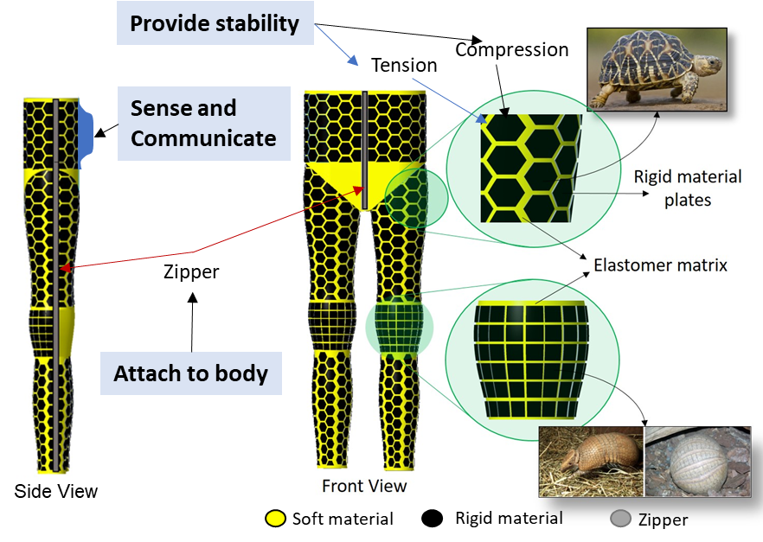

1. Solution principle 2
2. Discussion

Since wearable devices share characteristics, a common design methodology appears to be desirable. The design methodology should guide designers in taking a systematic approach to satisfy technical requirements and meet user expectations on usability and acceptability. In this paper, we sketched a proposed configuration design method for configuring the physical elements of wearables intended. The method was presented in the context of assistive technologies for persons with physical, cognitive, or sensory limitations. Elements of the proposed configuration design capability include a design library of components, a template with which to express wearable design problems, methods to identify design library components that match elements of the problem description, methods to configure wearable devices, and a framework for evaluating wearable designs. The design method was illustrated using an example of a wearable to enhance stability during walking.

The elements of the design method appear to be feasible to develop. The design template and design library are straightforward, although will require significant efforts to develop. However, the steps of matching problem requirements to elements of the design library and generating system designs are less certain. The matching step is straightforward, but it is not clear that this will be sufficient to identify all components and modules of relevance to the wearable. Similarly, the step of generating system designs is a difficult task for designers and, thus far, the method offers little in the way of guidance or direction. Based on the example presented here, the overall method for configuring designs seems workable. Significant additional research is needed for further development and evaluation, however.

The focus on physical configuration design is arguably a simpler aspect of designing wearables than other tasks. Problem formulation involves developing a deep understanding of challenges faced by persons and is typically approached using a co-design strategy with extensive discussions with individuals and their caregivers. Developing design concepts and devising user interfaces are difficult challenges. A more comprehensive approach will be needed to make progress on a useful design methodology for wearables. The authors hope that this introduction to the topic inspires other researchers to contribute to such a methodology.

Acknowledgement

DR and AS gratefully acknowledge support from DR's start-up fund from the Agency for Science, Technology and Research (A*STAR), Singapore.

References

Bause, M.F., Forbes, H., Nickpour, F., and Schaefer, D. (2020), "Towards a health 4.0 framework for the design of wearables: Leveraging human-centered and robust design," Procedia CIRP, 91, pp. 639-645. https://doi.org/10.1016/j.procir.2020.02.222

Buruk, O.O., Isbister, K. and Tanenbaum, T.J. (2019), "A design framework for playful wearables," Proceedings of the 14th International Conference on the Foundations of Digital Games, pp. 1-12. https://doi.org/10.1145/3337722.3337733

Clarkson, J., Coleman, R., Keates, S., and Lebbon, C., 2003, Inclusive Design: Design for the Whole Population, 1st ed., Springer, London. DOI: 10.1007/978-1-4471-0001-0

Contreras-Vidal, J.L., Kilicarslan, A., Huang, H.H., and Grossman, R.G. (2015), "Human-Centered Design of Wearable Neuroprostheses and Exoskeletons," AI Magazine, Vol. 36, pp. 12–22. https://doi.org/10.1609/aimag.v36i4.2613

Francés-Morcillo, L., Morer-Camo, P., Rodríguez-Ferradas, M.I., and Cazón-Martín, A. (2020), "Wearable design requirements identification and evaluation," Sensors, 20(9), pp. 2599. https://doi.org/10.3390/s20092599

Gemperle, F., Kasabach, C., Stivoric, J., Bauer, M., and Martin, R. (1998), "Design for wearability," 2nd IEEE international symposium on wearable computers (cat. No. 98EX215), pp. 116-122.

Hirtz, J., Stone, R.B., McAdams, D.A., Szykman, S., and Wood, K.L. (2002), "A functional basis for engineering design: reconciling and evolving previous efforts," Research in Engineering Design, Vol. 13, pp. 65-82. https://doi.org/10.1007/s00163-001-0008-3

Kow, F.C.S.F., Sinha, A.K., Ming, Z.J., Songyu, B., Kang, J.T.J., et al. (2022), "MIDAS: Multi-sensorial Immersive Dynamic Autonomous System Improves Motivation of Stroke Affected Patients for Hand Rehabilitation," arXiv preprint. https://doi.org/10.48550/arXiv.2203.10536

Lee, H., Ferguson, P.W., and Rosen, J. (2020), "Lower limb exoskeleton systems—overview," Wearable Robotics, pp. 207-229. <https://doi.org/10.1016/B978-0-12-814659-0.00011-4>

Rosen, D.W. and Choi, C. (2023), "Research Issues in the Generative Design of Cyber-Physical-Human Systems,” Journal of Computing and Information Science in Engineering," Vol. 23, paper 060810. https://doi.org/10.1115/1.4062598

Salisbury, L.J., McGinley, C., and Yenigun, E.O. (2023), "Applying people-centred design methods to enhance the development of wearable technology for everyday use," Smart Clothes and Wearable Technology, p. 447-483. Woodhead Publishing. https://doi.org/10.1016/B978-0-12-819526-0.00018-7

Schauss, G., Arquilla, K. and Anderson, A. (2022), "ARGONAUT: An inclusive design process for wearable health monitoring systems," Proceedings of the 2022 CHI Conference on Human Factors in Computing Systems, pp. 1-12. https://doi.org/10.1145/3491102.3517590

The Design Council (2023). The Design Process. Available at: https://www.designcouncil.org.uk/our-resources/the-double-diamond/ (Accessed 13 Nov 2023).

Tomberg, V., Schulz, T., and Kelle, S. (2015), "Applying universal design principles to themes for wearables," International Conference on Universal Access in Human-Computer Interaction, UAHCI 2015, Los Angeles, CA, USA, August 2-7, 2015, pp. 550-560. DOI: 10.1007/978-3-319-20681-3_52

Tomberg, V., and Kelle, S. (2016), "Towards universal design criteria for design of wearables," Proceedings AHFE 2016 International Conference on Design for Inclusion, pp. 439-449. DOI 10.1007/978-3-319-41962-6_39

Turmo Vidal, L., Zhu, H., Waern, A. and Márquez Segura, E. (2021), "The design space of wearables for sports and fitness practices," Proceedings of the 2021 CHI Conference on Human Factors in Computing Systems (pp. 1-14). https://doi.org/10.1145/3411764.3445700