Document

Brett Ashley Kaplan, Interview with Rachel Garfield. 4 January 2019, Swiss Hotel Chicago

In 2018 I invited Rachel Garfield and David Brauner to be part of a panel at the Modern Language Association Annual Conference—to be held in the early part of 2019 in Chicago. The panel was entitled: “Blackness in Convergence/Tension with Jewishness in Contemporary Art and Literature.” I had been very interested in Rachel Garfield’s work for some time (and would like to thank Nadia Valman for encouraging me to explore Rachel’s work for a project on Jewishness and Blackness). After the panel we spent some time discussing the trajectories of her fascinating projects at the Swiss Hotel. This is a revised version of the transcript of that conversation.

Can you tell me a bit about your background and how you came to do the work that you do?

I grew up in a Modern Orthodox family and went to a Jewish Comprehensive school which was very mixed in terms of religiosity, class, and geographic derivation. At 14 I became a punk and led a rather schizophrenic life: religious over the weekend and going to gigs evenings and weekends. At 15 I gave up pretending, gave up trying to reconcile my teenage need to move forward with my familial duty and ran off to my friend Sally’s house. My parents came and got me back on the condition that I didn’t have to partake in the religious life but should not embarrass them or transgress rules that would affect them (i.e. not bring treyf into the house). Sally was a woman whose father was a communist candidate for Hackney, in London called Monty Goldman. He was quite famous in left wing circles in London. It was the clash of my Zionist background and her Communist background that changed us both. We forged our friendship on disputation!

My environment at home was an antiracist household although we did not use that lexicon. It was more to do with treating everyone as an equal. The 1970s was quite a tough time in London and I remember my sister and I were terrorized by kids who lived in our neighborhood for being Jewish. This happened while we were waiting for the coach to take us to our Jewish school. The bullying stopped when it was discovered after the coach drew up while we were still in the throes of a physical fight. Between the ages of 11-14 I went to a non-Jewish school. It was a state school in Ilford, a working-class suburban neighborhood. I remember the playground was divided into the black and Asian (i.e. Indian, Bangladeshi and Pakistani) kids and the white racists – there were regular fights in the playground that politicized me – of course I gravitated towards the Black and Asian kids as friends and was hauled into the headmaster’s office a couple of times for getting into fights with the racist kids. I also remember becoming so angry at a Jewish boy in the school (there were 4 of us in the whole school), who shouted a racist epithet at some kids out of a car window as we were getting a lift home. I couldn’t believe a Jewish person could say or even think that kind of thing – and told him so. My anger at a Jew being racist was massively amplified beyond what I would feel at a white racist and I really lost my temper at him. However, he wasn’t so different from my aunt who considered herself white. She lived in that same area – in the Eastern end of the East End. She was racist herself in a ‘this area isn’t what it used to be’ kind of way, which caused quite a rift particularly when my son was born, as I didn’t want him growing up around those kinds of ideas. No matter how I tried to convince her that Jewish people are immigrants and were not considered white when her grandparents came to the UK, she would not countenance herself as being anything other than English and white.

The Jewish community is very much divided between those who feel that their diasporic heritage and their history of oppression makes them sensitive towards racism and immigration and those who consider themselves white in relation to post-colonial diasporic communities from the global majority. Or those who believed in the assimilation project for Jews and those who identified as not quite white and so aligned themselves with other immigrants. Of course, this mainly relates to the Ashkenazi community: the Mizrachi community cannot ‘pass’. In fact, I don’t pass either as I’m often asked, ‘where am I from?’. ‘You’re not English, are you? Where are you from?’ is a common refrain and I made a piece of work about the indeterminacy of the Jew, where I am either too white or not white enough. It was called “What Am I To You” (1999).

In the 1990s I lived in a part of London with large African-Caribbean, Turkish, Kurdish and Jewish communities. I was figured as Turkish in Stoke Newington. Often, I was thought to be Turkish and was often asked “Where are you from?” I have been assumed to be Indian, Iranian, Portuguese, Italian, Spanish. Other people I knew assumed I was white until told otherwise, some made assumptions about Jewishness. This effect of being different things depending on who I was speaking to seems to be an effect of Jewishness in contemporary Britain, and one of fragmentation.

I don’t like flags or nationhood as a concept but if I had to identify with the country of my birth, I would feel more comfortable identifying with Britishness which seems to incorporate the global majority and acknowledge post-colonialism, whereas Englishness is a singular ethnicity, to which immigrant communities are excluded.

Can you tell me a bit about the media you use in your art?

I was a painter for many years, trying to find my language. I had visited Egypt in 1987. I was so moved by the depth of difference that Islam seems to have made to the culture that I understood how profoundly Protestant Christian the UK is and how that in/forms everything. That took me to living in Madrid in 1989, thinking about the intersections of different religious influences on culture. On my return I started painting using motifs from Jewish/Christian and Muslim iconography but slowly moving towards using just Jewish iconography. These were abstract and emblematic paintings (figure1).

In 1996 I was in an exhibition called Rubies and Rebels: Jewish Female Identity in Contemporary British Art curated by Monica Bohm Duchen and Vera Grodzinski. It was a survey show of Jewish women artists that toured the UK. There was a conference, a catalogue and a journal published in through the show. A key moment for me however was the conference organized by Bryan Cheyette and Laura Marks in the mid-1990s called Modernity, Culture and the Jew that established the notion of a critical Jewish identity politics within the cultural sphere. I had around that time been going to conferences on identity politics in the arts that were focused on people of colour, with no Jewish reference and vice versa, which frustrated me as I saw the issues of antisemitism and racism as being very much intertwined.

Insert figure 1
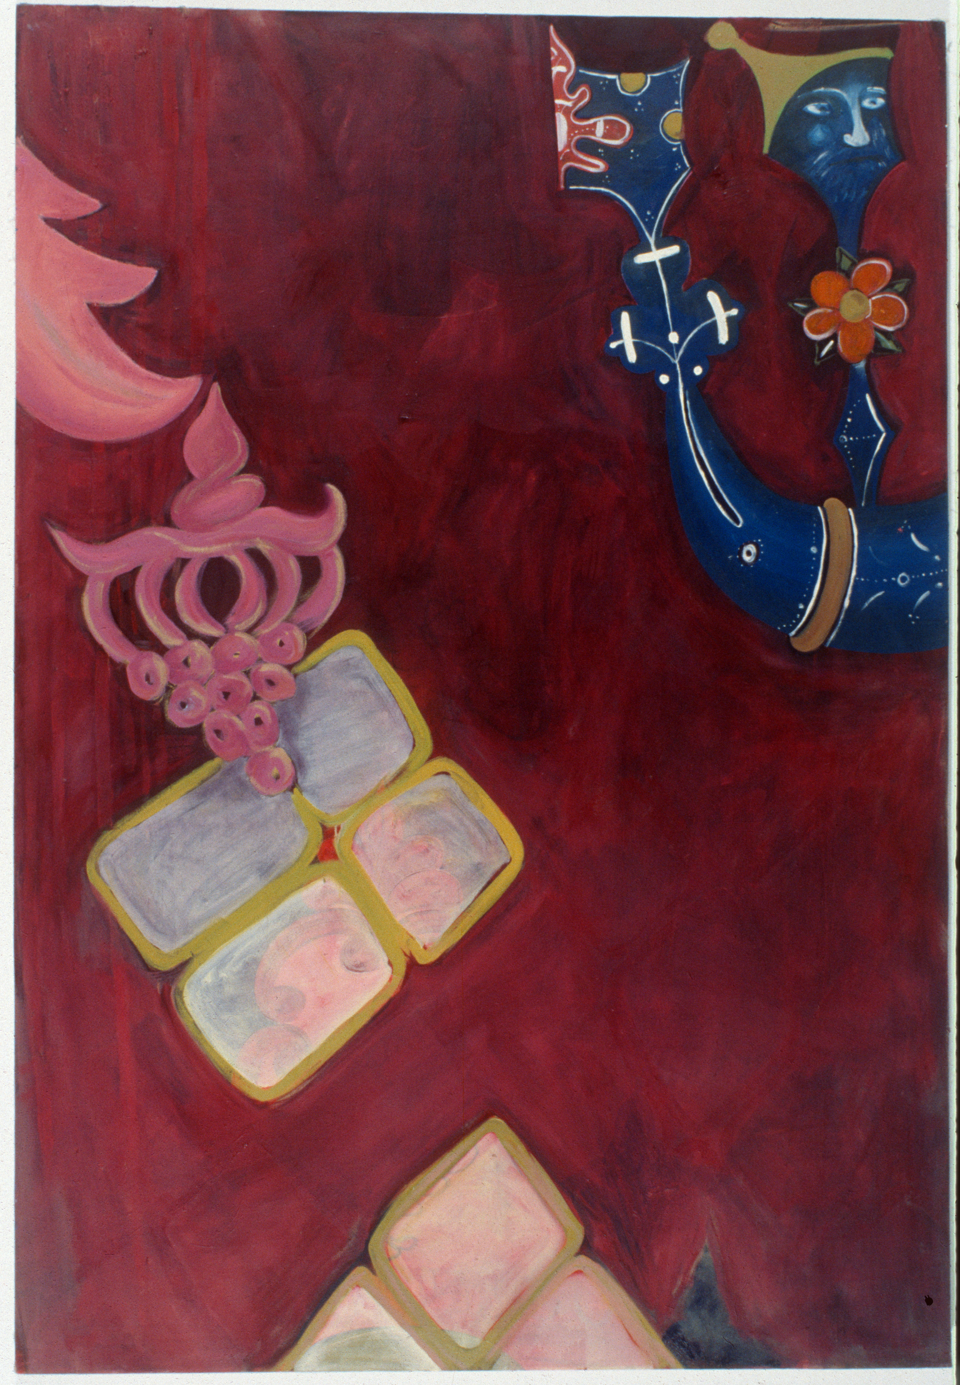
Garfield Rachel, Plenty, Oil on Canvas, 1.52 x 1.06m, 1994, courtesy of the artist
(NB This is what I put in the previous word doc as you asked)

The last paintings I made was in 1996-98 titled Assimilations. These paintings were explicitly about antisemitism, racism, the deep roots of racisms in Enlightenment thinking and how that impacts on racism in today’s UK. They were diptychs of different size, one painting would be 4ft x 6ft and the other 4ft x 2ft. They were text-based paintings that on the larger panel had historical texts from thinkers like Kant, Voltaire etc., picking out racist thinking in their work. I painted these over an abstract backdrop that references Abstract Expressionist language in paint because of the debates around Jewishness and American abstraction. This was juxtaposed with the other part of each dyptich which was a direct painted copy on bare canvas of then recent neo-Nazi leaflets. This constituted a whole series of paintings and was to be the beginning of a politicized turn in my artwork and led to What Am I To You?, which was an image text work that I started on my PhD. This work brought together narratives of racism directed against me, with snapshots of me, taken from my own archive of photographs. For this work I was thinking about the ways in which Jewish people are assigned different roles depending upon context, either of hate or of love, sometimes ‘seen’ and sometimes ‘invisible’.

I began to look more closely and deeply at the Identity Politics debates that instructed the art world understanding of diasporic art practices through doing a PhD (1999-2003). It was a practice-based PhD, which was quite a new qualification then. At the time I was reading many people, such as Kobena Mercer, Franz Fanon, Edward Said, Gayatri Spivak, Homi Babha – the classics. I was very excited and felt an affinity with much of what they wrote, and was particularly interested in the references that Fanon and Said made to Jews (as this was probably the first time I had come across any literature that regarding Jews has having any relevance at all to the ‘black debates’). At the same time I was frustrated by the way, they both acknowledged the history of Jewish suffering but then set up a hierarchy whereby Jews were lesser victims, for example in Black Skins White Masks, Fanon states the Holocaust was ‘little family quarrels’ (1973:115), and that Jews, while victims of racism are relatively protected as they are ‘white apart from some rather debatable characteristics, he can sometimes go unnoticed’ whereas the African ‘is overdetermined from without’ and so ‘a slave to my appearance (1973:115-6). I also critiqued Stuart Hall discussing the representation of black males as racist in there constituting them through the media as muggers, in Policing the Crises: Mugging the State and Law and Order (1978), while not looking at the ways in which the media created the same persona for the Irish and the Jews before them. So that instead of acknowledging the continuum of racist discourse that becomes attached to any group (as could be seen in the racism towards the Polish immigrants in the UK in the noughties) it became an exceptionalist discourse around colour of skin alone.

I countered this in my art and writing by reflecting on issues such as indeterminacy, visibility and invisibility as well as critiquing hierarchies of victimhood. This was a way to try to find a less reductive way of thinking about Identity Politics. So, the text Ali G: Who Does He Think He Is? (published in Jewish Quarterly and Third Text, 2000), who had then just caused a sensation on TV and my film So You Think You Can Tell (2000) and You’re Joking (2005) all dealt with breaking down the assumptions of a black and white binary that was finite, with blacks on one side and Jews on the other. I was thinking of intersectionality and solidarity rather than divisions and hierarchies. Paul Gilroy was very important to me at the time – The Black Atlantic (1993) – this was a revelation to me. Juliet Steyn’s book The Jew; Assumptions of Identity (2000), Jon Stratton’s Coming Out Jewish (2000) and Bryan Cheyette’s chapter on the bifurcation of the Jew (1997).

In the UK there is a lot of low-grade antisemitism (this has dramatically increased since Oct 7 2023). There was a report by the Runnymede Trust in the 1990s that fueled my work about antisemitism in the UK and it was titled “ Very Light Sleeper”
which I think is a good way to think about antisemitism. It is always present but in different guises, sometimes more virulent, sometimes benign but never far away.

Let me talk for a minute about formal composition of my works. My works have always been composed of disparate entities: fragmented or multi-screen. They are multi-vocal through these strategies. Heterogeneity is important to me as the structure of difference. Incommensurability is also important: there are no easy answers to the lived relations of difference. Many have written about this in relation to marginalized identities, but it took me a PhD to connect the dots. The multiple viewpoint is also to do with my own lived experience of being Jewish – What Am I To You (1999) is a photo text piece that encapsulates the indeterminacy that I was grappling with theoretically.

In my PhD enquiry I was partly looking to work out how to make Jewish artwork that wasn’t nostalgic, overly celebratory nor picking over the holocaust. I was a long-standing admirer of many black artists such as Keith Piper, Sonia Boyce, Sunil Gupta, Chila Burman in the UK and Adrian Piper (my particular hero, and who I was told I looked like on several occasions), Glenn Ligon, Coco Fusco and others. Most of the work I saw that was by Jewish artists thinking about their Jewishness in the UK was either looking at the Holocaust, coming to terms with its inherited traumas, which, while important, at the time I saw as reinscribing a retrospective victimhood that no longer was relevant to contemporary European, at least not to the same scale as to other minority groups. I went to JFS (Jewish Free School) comprehensive. The Jewish community was steeped in the trauma of the Shoah. In the 1970s it didn’t feel that far away, but this was at the time when the journalist John Pilger had blown the lid on the Cambodian Genocide of Poll Potts. Me and my friend asked on several occasions, but what about this genocide? It is happening again? Why aren’t you talking about that? Within that context, my question really was - why Jewish art? What is urgent or what are the politics of Jewish identity today? And how to make art in a way that dealt with the urgencies of multicultural Britain, the racisms, etc. through a Jewish perspective.

Obviously, I have an identification that is to do with my upbringing and what makes sense to me on an unconscious level, so my sense both of being an outsider and of that constituting a requirement to treat everyone as an equal is what defines me. Growing up within an orthodox community meant that we didn’t mix with non-Jews and didn’t partake in Christmas, couldn’t eat Easter eggs, because it always fell on Pesach. I didn’t realize to what extent I was an outsider until I was well into adulthood. It wasn’t just that I didn’t understand the Christian references nor the Greek mythological references in much painting or poetry so I didn’t engage with premodern culture. On a personal note, that it was that I was too loud; too aggressive and argumentative (I thought those were good things!); too gauche in my tastes. It took me many years to modify my directness to acceptable levels of polite British society! In the UK, it is expected that you will avoid difficult conversations, one might allude to things but never to take someone on as it is considered rude. What is often seen as argumentative or aggressive is what I would consider to be merely communicating.

What struck me as really interesting about the black artists that I knew and knew of, is that they were political, and saw their work as making a difference to the representation of black subjects, questioning stereotypes and claiming their place as British. The big question for me was to do with that old fashioned concept of solidarity. I saw racism and antisemitism as the same issue, albeit with different manifestations, histories and processes. I thought, and still do that the only way to effect equality and to erase racism is through making alliances with each other as humans rather than fracturing or collapsing into an ethnic insiderist essentialism. Ethnic Insiderism is something I have reflected on a lot and is characterized by Werner Sollors (1986:13) who characterized much interaction around ethnicity at the time as “You will never understand me, don’t you understand?” In other words, a common thread in much identity politics debates at the time (and it has come back as a assumption recently) sets up a hierarchy where each community is so attuned to its own unique histories and processes of victimhood on the one hand and the specific rituals or cultural signs that makes them different that it you cannot hope to form any bridge across communities to form solidarity. I saw this so often, for example in the conferences I attended that had parallel debates of uniqueness. Of course, Anti Semitism has different narratives around it than anti-black racism, to do with different histories. There is also the further complication of Ashkenazi Jews being a minority ‘within Europe’ so we are outsiders, inside. But there is also widespread elision of the Jews from North Africa, Asia and Spain, who are also minorities within the countries of their birth as well as being Jews of Colour in the Anglophone world. There are similar elisions with regards to racism and the post-colonial debates in relation to the Irish or Romany Diasporas.

Through all this reading and thinking about art, discourse, and racisms that I realized that I was most interested in art terms, in the narratives of people’s lives. What is portraiture but a vision of the other? I was and continue to be fascinated in the story of people’s lives and how they negotiated difficulty and contradiction. What makes us, us? As I was feeling my way towards this, a friend of mine, Anne phoned me up. She was an African-American friend who was (sadly she is no longer alive) from what she described as a black-Jewish neighborhood in Chicago. Anne spoke to this woman on the phone: are you Jewish, she asked of this woman? The woman answered “most people think I’m black but yes I’m Jewish. How do you know?” Anne said to me, “You’ve got to meet her and interview her”. This woman had grown up within a Lubavitcher community but had married a Nigerian and became immersed in the African community of her husband and ‘read’ as black. Anne offered in response that she had been around a lot of Jewish people so picked up the inflection. That interview was juxtaposed by another interviewee from the synagogue where I sometimes went who was black, from a Caribbean background. This woman was having an Orthodox Jewish conversion – that was the first place, she claimed where she felt at home. The film “So you think you can Tell” (2000) came out of those conversations (figure 2). The core question in the work was how porous is a community? If Blackness is over determined, and Jewishness not, how so? What happens when people ‘switch’ communities? Is there a definitive border that cannot be crossed? My proposition in the film was that borders can always be crossed.

Insert figure 2

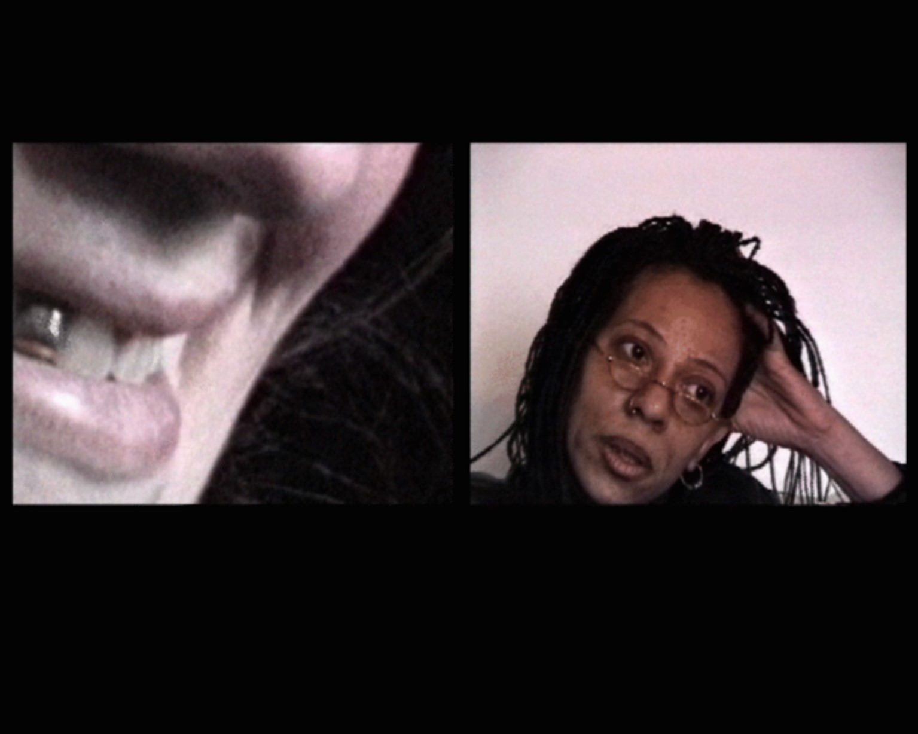
Garfield Rachel, So You Think You Can Tell, 26 mins, Hi8, 2001, courtesy of the artist

However, there was a lot of fear I recall even in the 1990s in terms of these two communities. One example was Walter Mosley who has dual heritage. I saw him talk as part of a Jewish book festival where he talked with great warmth about his Jewish grandparents and the benefits of his dual heritage. Conversely at a black community bookshop in Hackney (Centerprise), with a predominantly black male audience, he only spoke about his black heritage and didn’t mention his dual heritage at all. My friend Wayne, who was with me at Centerprise asked him about his Jewishness. It was a moment of discomfort for him.

In the end I used Judith Butler, particularly Excitable Speech: The Politics of the Performative (1997). to get out of the difficulties of Identity in the Identity politics debates. I was also reading a lot of Jonathan and Daniel Boyarin also engaged with these questions of the relationship to Jewishness, postcolonialism and critical theory. Through them, I started to conceptualize identity as a reiterative practice going through generations rather than being horizontal, carrying down of tradition and set of identifications for how we choose to be or as Paul Gilroy says ‘routes rather than roots’ (1993: 335). Two films came out of this thinking directly. Unmade Up (2003) and You’re Joking (2005, figure 3).

Insert figure 3

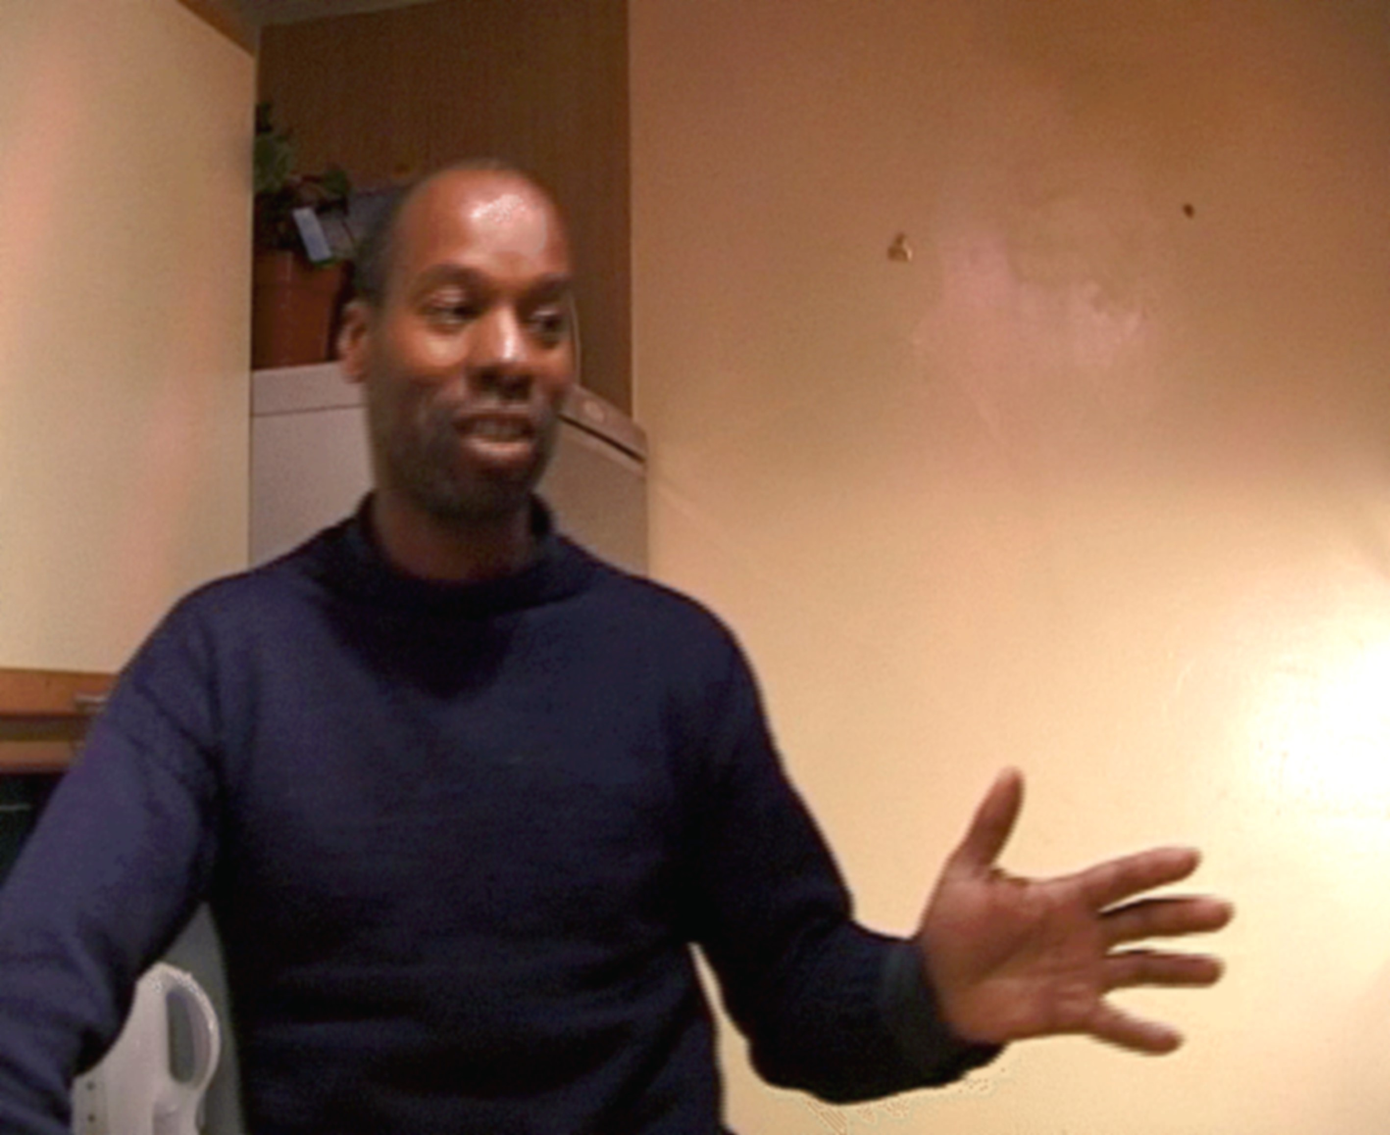
Garfield Rachel, Your Joking!, 8 mins, MiniDV, 2005, courtesy of the artist

Much of my work at this time came out of conversations that I was having with friends and my milieu. A friend Isaac, who went to the same synagogue and lived in a flat upstairs (in the same block), was from a Baghdadi Indian community. It became clear to me on talking to him about funding for young Black and Asian men in Hackney - as he looked at me blankly – his only identification was as a Jew. The other conversation, and one that led directly into Unmade Up (2003) was him talking with a friend of his, also Sephardi, in my kitchen, about how they would ‘never go out with a Jewish woman as they were only after your money’. My interest was piqued because I had heard this said to me on several occasions by men of Caribbean heritage. And so I started to interview him and others (Jewish male and female) about what they thought of dating Jews. I didn’t show their faces but used my own image for the visuals so that the interviewees could speak without fear of being identified. As a result, they spoke freely and it was a funny film with many stereotypical epithets such as ‘as soon as a ring goes on her finger she turns into the exorcist’, ‘all he cares about is the trophy wife’. I had Stephen Dwoskin film me, for his approach to portraiture in film. He filmed me as both flirting with the camera and as a spy listening in to the narrative. It was an awkward film and there is a listening-in-at-the-keyhole quality to it that I wanted to give a sense of an internal community conversation that is claustrophically kept within its own confines. Formally the use of jump cuts and fragmentation, clashing phrases that each contradicted the other and that also didn’t match with my own self presentation on film enhanced the claustrophobia and vertiginous quality of alienation or double consciousness that any ‘minority’ group inhabits. Unmade Up ultimately conveys a sense of confusion over the self, as a subjectivity caught between a myriad of expectations within a small community with specific expectations that turns in on itself, through the need to ‘marry in’. And it was to set the terms for my work into the future.

The next film also dealing with the iterative self was called You’re joking (2005). It came into being by Wayne and I talking about our day-to-day experiences of racism, which seemed to happen quite often. Sometimes even when we were together, as I got dirty looks from Turkish men who assumed that Wayne, a black man, was taking me away from their community (assuming I was Turkish),or being shouted at “Jungle Fever” by some young black kids. Usually what is now called ‘micro-aggression’ but we didn’t really have that language 25 years ago. As we spoke about these micro aggressions that we encountered separately when going about our business I decided that I wanted to work with these encounters into a film or series of vignettes for an installation.

In talking to my friend, the film maker Stephen Dwoskin about what I was trying to do, he recommended I see Portrait of Jason (1967) by Shirley Clark. Clark a Jewish woman, who interviewed Jason Holliday in her flat. It was a groundbreaking film that legendary. In those days, no one had seen this film since the 1960s when it came out and it took me over a year to track it down via her daughter Wendy Clarke in LA who sent me a VHS copy through the post. By the time I got to see it I had almost finished my own film but I was struck by how close Clarke’s film was to what I was doing. You’re Joking (2005) references Portrait of Jason (1967) in its form, and I’ve written about how and why. In my film, we decided that Wayne should act the moments of racism that he’d experienced rather than be interviewed. We decided to work with four narratives, and I asked him to tell them in different ways in a different room in my flat, each with different coloured walls. Thus, each of the four narratives would be edited into a composite of different tellings. Again, I used jump cuts to make the slippage between tellings obvious because the point was that we constitute different selves each time we tell our story. These were truthful incidences. It was important that he acted them as I was moving far away from the notion of authenticity. I don’t believe that a documentary interview captures the authentic moment of truth. This was also a film that commented on hierarchies of racism as each incident had a different inflection – in the first he was called the “n” word by a child, in the second he was told that the problems in Africa are the fault of the Jews, in the third one a Caribbean woman was telling an east European beggar to ‘go back home’ and the fourth one, he was differentiated from an African man (as a British born man of Caribbean heritage) with the epithet ‘jungle-jim up there’ by his white manager. Each vignette is two minutes and is shown as a four-screen installation, each screen a different colour that reads as a series of moving portraits against a wall and makes use of the direct address – a device used to implicate us all.

Probably the last film that was overtly to do with black and Jewish relations was Deep England (2007, figure 4) which has been beautifully written about by Juliet Steyn (2013:97-122). It was made while living in Wolverhampton. It is a film about Diaspora and the contradictions between desire for roots and the inability to know where you are from as heritage and belonging are so much more complex than they are usually presented, so this desire is always ultimately thwarted. I referenced the Black British photographer Ingrid Pollard who made important work in the 1980s reflecting on the black woman in the British landscape, and Jonas Mekas’ film Lost Lost Lost (1976) both working with tropes of displacement, using them to reflect on my mini displacement from East London to Wolverhampton where I had no roots and there were few Jews, to the relationship between the urban and the rural and who belongs in these different locations, triangulating that finally with my own sense of dislocation as a mother trying to find a different visual language that I could work with as a mother, away from the milieu I was used to and outside of the UK centre of the artworld in London. The film embraces the contradictions of belonging and unbelonging: the longing for roots and the impossibility of really knowing your roots.

Insert figure 4

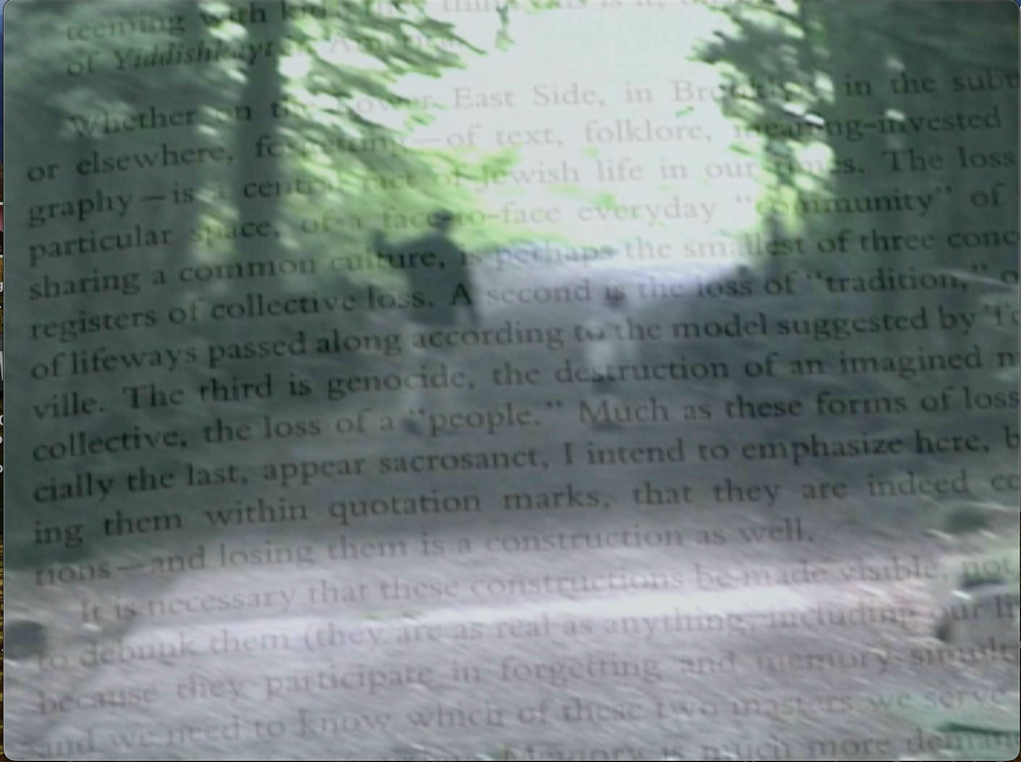
Garfield Rachel, Deep England, 8mins, MiniDV, 2008, courtesy of the artist

My work has evolved from working directly with my own specific identity to thinking more broadly about the ways in which we all, as subjects negotiate contradiction and conflict in our lives; how we navigate the intricacies of community as individuals and where the tensions lay. I have explored these themes in relation to queer communities, the military communities in the UK, sex workers, and I’m now also working on films that involve Jewishness again, but this time through collaborations with other artists and involving the relationships between Jews and other global majority communities. The preoccupations of one’s life keep evolving but circling around the same themes and hopefully continuing to find ways, with more visual depth and nuance that bring the complexities of life into view with generosity and humanity.

Bibliography

Judith Butler, Excitable Speech: The Politics of the Performative (London: Routledge, 1997)

Bryan Cheyette, ‘White Skin, Black Masks: Jews and Jewishness in the writings of George Eliot and Frantz Fanon’, Cultural Readings of Imperialism: Edward Said and the gravity of history, (eds.) Ansell, Pearson, Keith, Parry, Benita, Squires, Judy, Lawrence and Wishart (London, Lawrence Wishart,1997), 106-126

Monica Bohm Duchen and Vera Grodzinski, Rubies and Rebels: Jewish Female Identity In Contemporary British Art (London: Lund Humphries, 1996)

Frantz Fanon, Black Skin, White Masks, (London: Pluto Press, 1986)

Rachel Garfield, ‘Ali G: Just Who Does He Think He Is’ (Third Text, vol. 54, Spring 2001), 63-70

Paul Gilroy, The Black Atlantic: Modernity and Double Consciousness, (London: Verso 1993)

Stuart Hall, Critcher, Chas, Jefferson, Tony, Clarke, John, Roberts, Brian, Policing the
Crises: Mugging, The State, And Law And Order, (London: Macmillan, 1978)

The Runnymede Trust, A Very Light Sleeper: The Persistance and Dangers of Anti Semitism, 1994 (https://www.runnymedetrust.org/publications/very-light-sleeper)

Juliet Steyn, The Jew: Assumptions of Identity, (London: Cassell, 1999)

--- “In the Hinterlands: Identity, Migration & Memory”, Breaching Borders. Cross-cultural Identities: Art, Migrants and the Metaphor of Waste, Steyn, Juliet, Stamselberg, Nadja (eds.) (London: I.B.Tauris, 2013), 97-122

Jon Stratton, Coming Out Jewish, (London: Routledge, 2000)

Email corresponding author: bakaplan@illinois.edu
https://jwa.org/encyclopedia/article/artists-contemporary-anglo
The catalogue was published by Lund Humphries
Accessed 6 January 2024 https://www.runnymedetrust.org/publications/very-light-sleeper

