Bio-revolutions: radical change, design cultures and non-humans

Abstract | This paper explores the interface between culture, design and biology. It draws on methodologies and existing literature on Anthropology and Science and Technology Studies to argue that despite predictions of biotechnologies bringing about revolutionary change in design disciplines, there is a risk of bio-design becoming a ‘failed’ revolution, similar to that of personal computers. To counter this, we introduce the biomaterial probe, a methodology that enables designers to find potential opportunities, challenges and limitations of introducing living systems in the practice of design.

Keywords | BIODESIGN, BIOART, DIYBIO, synthetic biology, biotechnical, biotechnologies

1. Introduction
In July 2017, Stella McCartney issued a press release showcasing their collaboration with Bolt Threads, a biotechnology company specialised in textile materials derived from naturally-occurring fibres. Prototypes followed a year later of a Falabella bag using Mylo, a biomaterial derived from mycellium, the filamentous, branching structure generated by fungi and bacterial colonies. A scaffold of corn starch is used to provide sustenance to mycelium, and once the filamentous structures have grown and depleted the starch, it is put in an oven resulting in a compact, dense fibre. Mycelium-derived materials have become a standard bearer of the biotechnical revolution in design, with designers and technologists developing commercial applications of the biomaterial, ranging from packaging to furniture to textiles.
The cultural semantics of the Mycellium Falabella is worth exploring. The Falabella was introduced in Stella McCartney’s 2010 winter collection, modified and updated regularly since gaining a fashion item status among actresses, socialites and so-called ‘it-girls’. Mycellium-derived materials gained popularity with the inclusion of Mycotecture in the 2014 MoMa exhibition ‘Design and Violence’ curated by Paola Antonelli. The piece, developed by artist and teacher Phillip Ross, is an arch assembled of bricks produced by mixing sawdust with Ganoderma lucidum, a fungus species that metabolises and transforms the wood into a fibrous material (Antonelli et al. 2015). The Mycelium Falabella was also produced to feature in an exhibition, this time organised by the Victoria and Albert Museum in 2018: Fashioned from Nature (Ehrman and Watson 2018).
Four years apart, the use of the material in both pieces signals an evolution in its cultural status: from a promising material to desirable product inscribed in a wider narrative of environmentalism and ethical consumption, signalling an innovation cycle that heralds a long-awaited revolution triggered by a design-led ‘bio-economy’. Here we argue that although mycellium and others offer clear technological improvement over traditional technologies, there is a risk that the long-heralded bio-economy and bio-design results in a failed revolution. We draw a historical parallel to the development and evolution of personal computers to suggest that the potential of biotechnologies for radical change depends on the capacity of designers to give them meaning: to construct frameworks of reference and present their artefacts in culturally meaningful ways. Doing so requires slowing down and detaching from explorations that begin with a logic of substitution, in which living systems are scoped as the ‘green’ alternatives to ‘dirty’ technologies. We present biomaterial, provisional strategies and tactics that enables designers to explore the potential opportunities of the design of living matter. We explain the use of biomaterial probes in an open-ended exploration, revealing the way different actors and non-humans, ranging from institutions to microorganisms, align to facilitate or block design.

2. Living matter and design of the living
Development of mycelium and other similar materials is inscribed in a wider discourse of biotechnical design (Ednie-Brown 2013). The last decade has seen a growing body of theoretical and creative work, a biotechnical discourse, which operates on the premise of using living systems as part of the design and fabrication of artefacts. The biotechnical discourse is prefigured by existing traditions — there is, for example, a long-standing tradition of biological analogy in architecture that stretches from Ancient Antiquity to the Renaissance, to Modernism (Steadman 2008). Caroline Van Eck (1994) suggests there is a continuous theme of imitation of nature that, she proposes, can be described as an alchemist’s quest: a desire to transmute the products of technology — dead matter — into living beings. The alchemist quest can be traced throughout history, from Classical antiquity and the Renaissance’s use of living systems as source of eternal principles of beauty and order; to the way that On Growth and Form influenced the work of Mies Van Der Rohe, Alvar Aalto and Frank Lloyd Wright. The biotechnical discourse however stands apart in its aspiration to use biological systems directly, as a form of living matter (Catts & Zurr, 2014; Ednie-Brown, 2013; Telhan, 2016a).
To understand biotechnical design, it is important to review the evolving narrative of biotechnologies themselves. Contemporary discourses in biotechnologies, led by synthetic biology, aspire to reduce the complexity and randomness of living systems (Breithaupt 2006). Broadly speaking, there is an idea of reducibility connected to notions of parts, systems, and wholes, that are related to the modification of existing organisms and the creation of entirely new ones (Schyfter 2011). In parallel, citizen and enthusiast movements have engaged with the tools and methods of biotechnologies, infusing them with an ethos of democratization. Movements like DIY-Bio have made working with living systems widely available to non-experts (Seyfried, Pei, and Schmidt 2014; Meyer 2014). The combination of approaches and traditions around biotechnologies has motivated the emergence of a biotechnical discourse in design. The development of biotechnical design has created the conditions to trigger substantial opportunities for innovation and for a nascent bio-economy sector in design. Design-led efforts are underway to produce zero-emission bricks through bacterial fermentation (Dosier 2011); bacterially-augmented concrete that repairs itself (Jonkers 2007; Jonkers et al. 2010); alternative industrial methods to produce dye through bacteria (Chieza 2018); and faux-leather synthesised through bacterial metabolism (Bain 2017). These initiatives join a much-hailed ‘biological’ revolution that is often compared to the ‘garage movement’ of personal computing in the 1970s (Landrain et al. 2013; Peccoud 2016).

2.1 Technocentrism and substitution
Biotechnologies make possible new materials, often integrating living and semi-living matter, which offer considerable advantages over existing technologies. These new technical possibilities, however, are also a good opportunity to reflect on whether talk of an upcoming revolution is warranted, and to what extent the current cultures and practices of design support radical change. If we accept the proposition that living matter represents a fundamental change from any form of material or technology ever used in design, then there is a risk of understanding the new using the framing of the old.
A relevant analogy here is horseless carriage, the name given to cars when they had been first released to the consumer market. As a radically new form of technology, users would often refer to cars in reference to horse-drawn carriages, a form of technology they were familiar with. Cars were similar in that they fulfilled the same function, acting as a form of transport to get users from point A to point B. Used as an analogy, the phrase describes the ‘shifting perception of a practice as it transforms in relationship to a new technology’ (Chastain et al. 2002, p.239)

2.2 Bio- revolutions
The risk of framing the new using the terms of the old is illustrated by the development of personal computers in the 1980s and 1990s. Bryan Pfaffenberg (1988) suggests that innovators are often constrained by social processes. Following a social constructivist understanding of technology, he rejects the notion that technological innovation is driven by market demand and, instead, suggests that for technologies to ‘succeed’ in the market and be adopted by large numbers of people, innovators need to construct meaning-frameworks: a narrative that present their innovation as responding to a need that didn’t exist before. Pfaffenberg draws on the notion of the heterogeneous engineer to suggest that innovators do not only manipulate technology, but also change the social world in which the innovation is meant to be inscribed. In doing so, they create new frameworks of social roles, meanings and values.
Pfaffenberg analyses how the success of the personal computer in the 1980s was influenced by the meaning-framework of its creators. Early innovators hoped personal computers would ‘equalize opportunity for all races, creeds, minority groups, social classes — even help save endangered species’ (Bunnel quoted in Pfaffenberg 1988, 41), influenced by disparate movements such as phone phreaking and the hacker ethic. Phone phreakers emerged in the late 1960s as a subculture influenced by the counterculture movement whose members counted technically minded people sharing an aesthetic interest in the complexity of phone networks. One of the most visible members of the movement, Captain Crunch, famously epitomised the movement when he managed to break into the international phone network to connect a call, made from a phone booth in the California Livermore Valley, and that passed through numerous exchange centres including Tokyo, South Africa and Brazil before reaching the phone booth next to him. The motives of Captain Crunch coincided with those of another subculture emerging in parallel to the phone-phreakers, the hacker movement. The Captain wasn’t so much interested, according to his own account, by the ecstasy of gaining control of a technical system; his motives were driven by a desire to learn about a system. Breaking into the system, however, was a transgressive act. He wanted to point out to ‘Ma Bell’, the colloquial name for the Bell Telephone Company, the many issues and weak points of their telephone network. He didn’t want to ‘screw Ma’, he wanted to ‘show Ma Bell how good I am. I don’t want to screw her, I want to work for her’
The motivations of Captain Crunch — a wish for recognition and approval mixed with an aesthetic pull to technology — would be reformulated in Computer Lib, the 1974 publication that came to epitomise the hacker ethics. The author, Ted Nelson, makes an argument to demystify computers and promote a form of computer literacy, enabling laypeople to familiarise themselves with the principles of hardware and software operation. For Nelson, the way that computers developed and were understood by the public had a highly political dimension, insisting on the need to decentralise computers, a technology that had been centralised by big corporations such as IBM. Phone phreaking and the hacker ethics were highly influential in the development of early personal computers. Steve Jobs and Steve Wozniak, co-founders of Apple, famously assembled and sold ‘blue-boxes’ from their dorm: electronic devices that enabled their owners to break into the telephone system in the same way that Captain Crunch had done a few years before.
The meaning framework of phreaking and hacking cultures enabled early innovators to frame the personal computers in terms of a democratization of technology; they would make accessible to ‘the people’ tools that had so far been used for commercial gain and military purposes. Despite the hopes that the new form of technology would promote creativity and autonomy, market pressures and corporate interests meant that personal computers would end up targeting white-collar workers, professionals, and technical specialists, sectors which had already been benefited by older forms of computers. Later innovations, such as networking technologies, would consolidate this trend by making ‘personal’ computers less so, connecting them to larger (and often corporate) mainframes and servers. More contemporary advances, such as the much hailed ‘cloud computing’, would seem anathema to Nelson’s cry to move away from centralisation and to hand control back to the people.

2.3 The living and radical change
Historical parallels are always imperfect — there is a danger to try and see forwards in the same way that we narrate in retrospect. It is, however, possible to argue that biotechnologies risks following the same path that personal computers. On a superficial level, both technologies involve innovations that are not fundamentally radical, but that instead repackage and make more efficient existing techniques and tools. There is a deeper connection between biotechnologies and personal computing, operating at the level of their design cultures.

The genealogy of biotechnology, and especially of synthetic biology, is often contested but practitioners in the field often locate the development of the personal computer and digital technologies in the 1980s and 1990s as a foundational point, inheriting their ideology and meaning-framework (Cameron et al. 2014). A good example is the name of the discipline itself. Drew Endy, Rob Carlson and Roger Brent, often identified as the ‘founders’ of synthetic biology, often referred to their initial efforts as an ‘open-source biology’, describing it as effort to establish a culture of sharing among developers. The design principles of synthetic biology — abstraction, standardisation and modularity — are often explained by drawing analogies to the way computer engineering isolates hardware (the substrate that enables computation) from software (the set of instructions that describe calculations, and how these should be interpreted). The aim is to generate design approaches that require no expert knowledge, in the same way that the personal computer made it possible for some people to develop software without specialised knowledge of computational logic at board level.
The slippages in drawing analogies to personal computers generate also a fluid exchange of meaning-frameworks and conditions innovation and action of biotechnologies. A good example is the arsenic biodetector project developed initially by the 2006 University of Edinburgh iGEM team, a student-led competition that has become an unofficial conference for Synthetic Biology. The project aims at producing a low-cost, easy to use detector for areas known to be prone to groundwater well pollution in Bangladesh. It involves an arsenate-responsive promoter which, when inserted in bacteria, enables expression of genes that change the pH of growth media, providing a colour-coded signalling of arsenic presence. In a close parallel to the phone-phreaking and hacker culture, the narrative of the project is suffused with references to a ‘democratisation’ of technology and a commitment with marginalised communities.
Despite good intentions, the arsenic biodetector is a good example of the risk that biotechnologies run of using counterculture as little more than a punchy slogan. Cristina Agapakis reminds us how the problem of arsenic contamination stems from humanitarian response efforts in the 1970s to provide water for Bangladesh. The design of the tube-wells, combined with political and social issues, ended up generating a public health catastrophe. Although the low-cost bio-detector would be, at first glimpse, a welcomed tool and a potential step towards solving the problem of arsenic contamination, it is also problematic in the way that it is framed and the ideology that animates it. Agapakis writes:
inexpensive diagnosis of arsenic contamination will not be able to address the underlying problems of water infrastructure and management in Bangladesh (…) this history demonstrates that looking at complex problems through a narrow, reductionist lens can lead to harmful designs with dangerous consequences (Agapakis 2014, p.125).

Just as the personal computer was intended to empower marginalised communities, projects like the arsenic biodetector risk becoming technologies that offer some advantages over existing technologies but which stop short of fulfilling their ‘revolutionary’ potential as they end up targeting the same users and applications than their predecessors. From an innovation perspective, the slippage between meaning-frameworks encourages narratives of substitution and remediation, in which organisms are used as enhancement in existing processes. It also influences a design culture driven by technical possibility, having as point of departure the current state of the art in the laboratory and working backwards from there to try and fit a context of application. The combination of a substitution logic and a technocentric exploration makes it more difficult to imagine a path for these new technologies to influence radical change in design disciplines and are the implications and challenges these might bring.

3. Biomaterial probe
The example of the arsenic biotector suggests that are several factors that have promoted the slippage between meaning-frameworks and design cultures between the personal computer and biotechnologies. From the perspective of designers however, one main issue is imagination — given the fact that designers often have limited knowledge of living systems and the techniques to work with them, their capacity to imagine their possibilities are constrained to substitution and remediation of existing technologies.
The Bio-material probe is a set of design tactics intended to provide a means of exploring a design space, rather than to enable a design context which, in a more traditional context, would entail working towards specific objectives and producing tangible outcomes. Instead, bio-material probes provide the setting in which it is possible to engage with biological systems from a design perspective. The term is inspired by the work of William Gaver, Antony Dunne and Pacenti (1999), and by derives, a technique promoted by the Situationist International to highlight the influence that geographical environment, and especially urban settings, have on the feelings and behaviour of people (Ford 2005; Debord and Knabb 2014). Dérive, translated literally as drifting, consists in suspending normal motivations to movement in cities and, instead, allowing themselves to be attracted by the terrain, operating as a sort of probe that is being influenced by the forces at play in urban environments. In the context of the Situationist movement, dérive emerges as a reaction against the average experience of cities, which they perceived as limited. The dérive is intended to throw people into the cities, allowing change to force them into situations they would otherwise rarely encounter (Debord 2006).
Likewise, bio-material probes are intended to throw designers in the context of biological work, generating situations where assumptions and the status quo can be challenged. As an active element, they give designers a reason to explore biological systems. They are not oriented to practical applications, but rather to exploring the context, activities and economies involved in the work with biological systems. A good analogy to describe the bio-material probe is to characterise it as a recipe for how cakes are made. It enables understanding the context, materials, technology and other assemblages which enable the cake to be made. It doesn’t, however, provide a prescriptive recipe for doing a specific cake. It enables a practitioner to locate themselves in the context of biological work and, as a methodology, provides purposefulness without being tied to a specific design outcome.

3.1 Biomaterial probe in action: Bacterial Assemblages
Bacterial Assemblages is a project that explores notions of self-organisation and complex systems by engaging with form generation in bacterial colonies (see Figure 1). An earlier exploration proposed the State-Space of design, a framework to approach biological systems in design contexts. The term is derived from its use mathematics to describe the configuration of dynamic systems in terms of key variables, and a set of equations that describe their behaviour and interconnections. A state-space representation consists of a graph whose axes are the key variables, and where the state, or the possible configuration of the system at any point in time, can be represented as a vector.
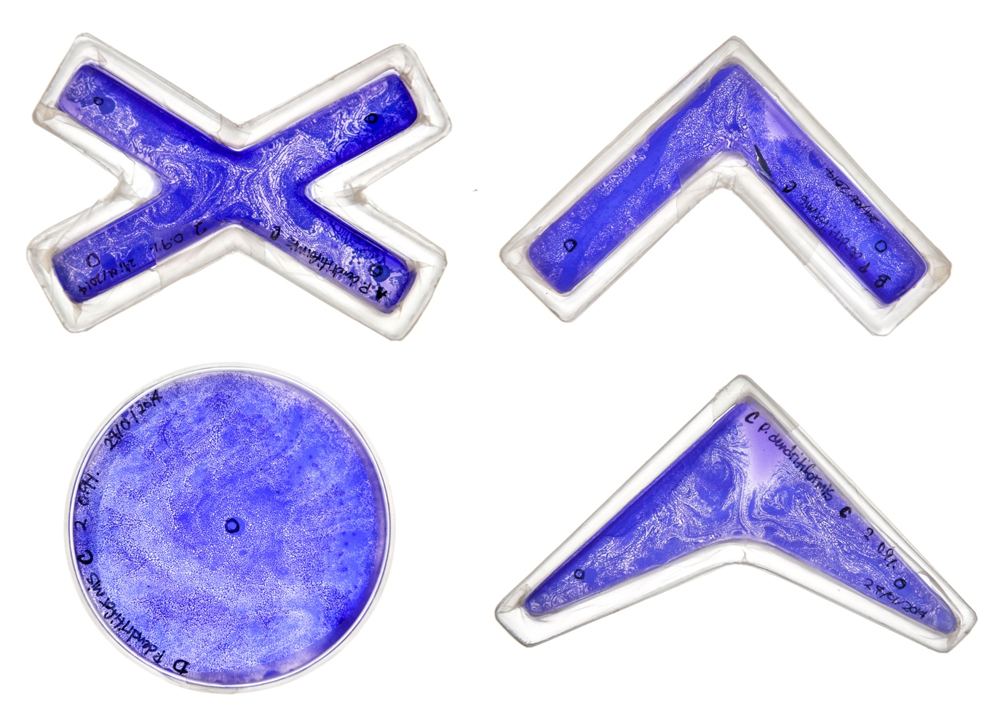
Figure 1. One of the experiments developed as part of Bacterial Assemblages. Petri dishes are custom made to influence the physical ‘state-space’. Chemical conditions are altered by changing the composition of the growth medium. The growth patterns are developed by Paenibacillus dendritiformis C morphotype, Paenibacillus vorte, and Paenibacillus dendritiformis T morphotype
We defined three state-spaces which influence biological form: cellular, chemical and physical. The cellular state-space is defined by the boundaries of the cellular membrane, and it is used to define all the processes that take place within it, including, for example, DNA transcription and translation, as well as protein production. The chemical state-space refers to conditions in the environment, such as pH levels and nutrient concentration, which are thought to trigger specific sections of the genetic code that result in the development of form. Finally, the physical state-space includes the physical forces and energy within the environment and that are often confined by the agar plate such as the temperature of the growth environment, and the physical structure of the agar itself.
Bacterial Assemblages suggested that, in addition to the original state-spaces, there are also contingent aspects of working with living systems which are crucial in accounting for the interaction between living systems and human designers and that had an important effect on the design outcomes that result of this exchange. The original model of three state-spaces is expanded to include three further spaces of contingency: spaces of practice, cultures of crafting and social interactions. Spaces of practice refer to the way that the spatial configuration of workspaces and tools conditions the development of activities, in the way they embody a specific script that refers to different frameworks of knowledge. Cultures of crafting concentrate on the frameworks and techniques that enable things to be done within disciplinary boundaries. Social interactions refer to the governance of spaces that enable certain things to happen, and which depend on exchanges between individuals.
Figures 2 to 4 show some of the diagrammatic strategies used in Bacterial Assemblages to reveal and analyse the spaces of contingency. The influence of institutions, epistemologies, spaces and social interactions are difficult to trace directly to the development of bacterial form, like the one shown in Figure 1. These diagrams, however, operate as a form of provisional cartography

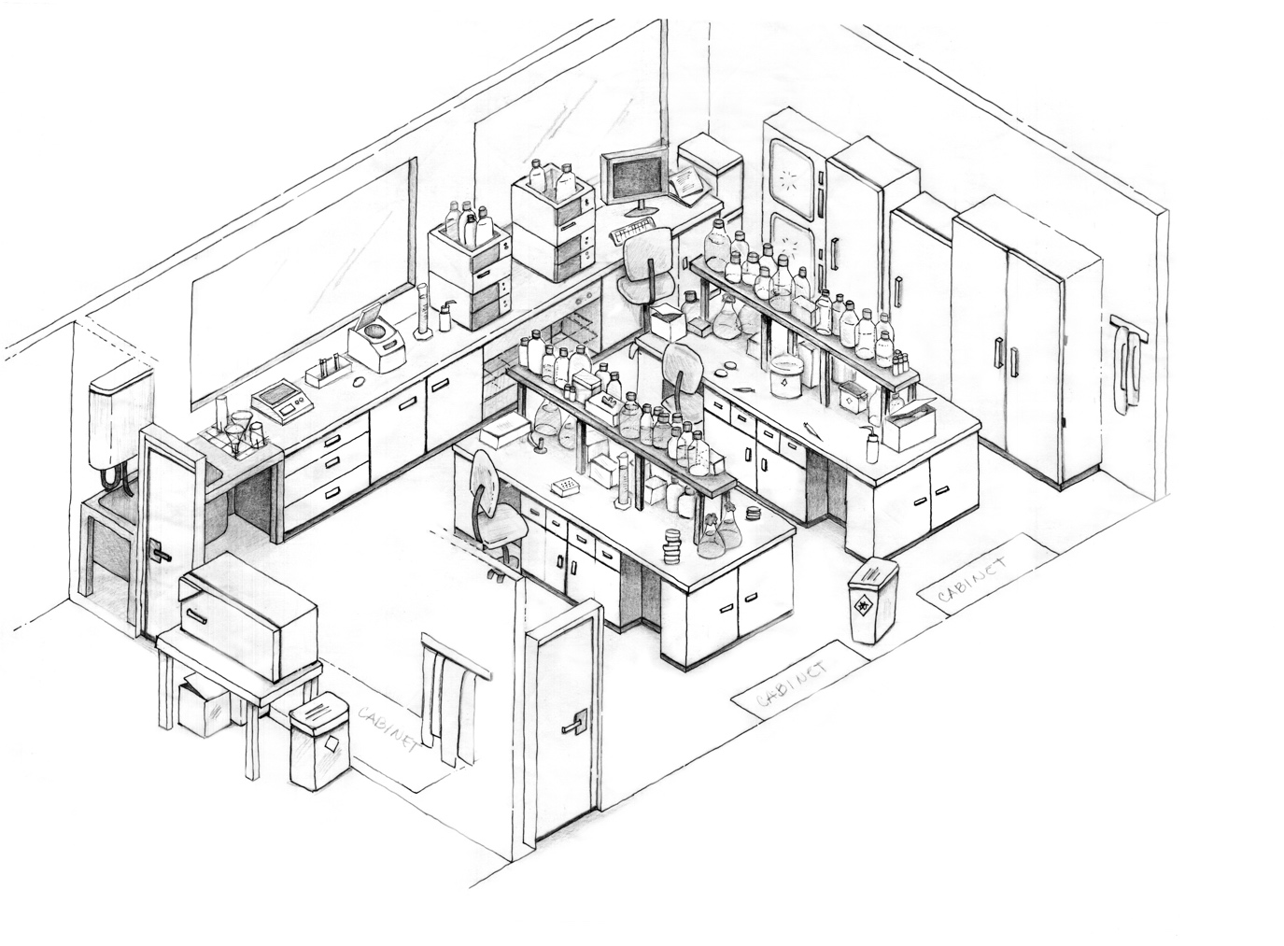
Figure 2. Isometric diagram of the main microbiology laboratory used in the exploration.
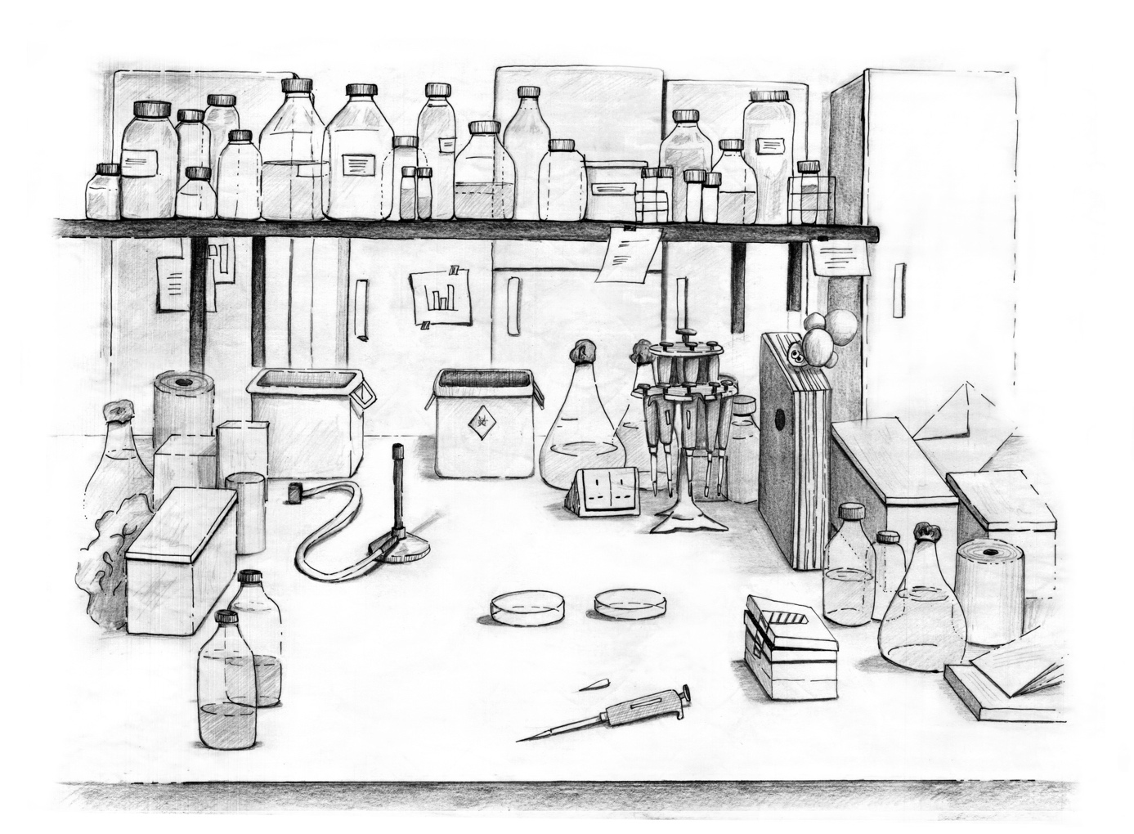
Figure 3. Composite diagram sketching working area.
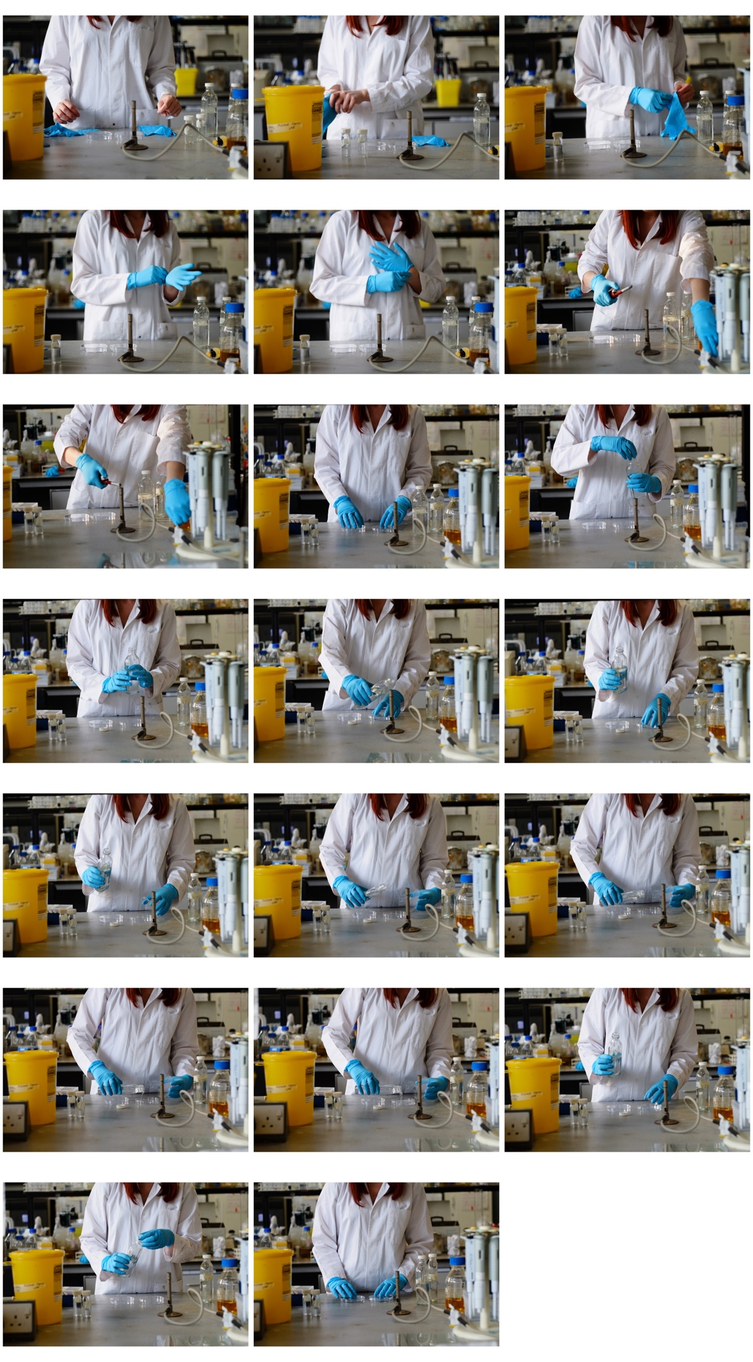
Figure 3, Photographic study of the hand choreographies involved in pouring agar into a plate

4. Conclusions
More than a prescriptive framework for design, biomaterial probes are a suggestion than there are new ways of engaging living systems beyond remediation and substitution. In keeping with the lineage of derives, the methodology is intended to produce situations where prevalent assumptions and order can be questioned.
Engaging then with biological systems from a design perspective requires a form of engagement that challenges and upends instrumentality. The notion suggests not only a more thoughtful approach when integrating living systems in the process of design — it suggests an entirely different form of design. Bacterial assemblages suggests that designing with living systems involves engaging with a thick mesh of non-humans that go beyond the organism itself, and that extends to a number of encounters between the designer and materials, physical spaces, institutions and other researchers. The extended set of interactions involved in designing with living systems suggests that the boundary of the design space — the things a designer needs to engage with in working with living systems — expands exponentially. The living system, and the mesh constituted by the design assemblage, are hyperobjects, to borrow the phrase coined by Timothy Morton (2013).
Designing in a hypercomplex environment involves doing so without a clear idea of the outcome in advance. In this situation, there is a need for instruments that perform a cartographic function, in that they assist to navigate through an unknown design space. The bio-material probe performs this function. They constitute maps which are in constant change, drawing and redrawing their boundaries as the exploration progresses and providing a way of reading into an unreadable situation. At the same time, bio-material probes represent conversation starters — a way of developing a language to engage with non-humans.

References

Agapakis, C. M. (2014). Designing synthetic biology. ACS Synthetic Biology, 3(3), 121–128. https://doi.org/10.1021/sb4001068
Antonelli, P., Hunt, J., Fisher, M. M., & Slaughter, A. M. (2015). Design and Violence. Museum of Modern Art.
Bedau, M. a, McCaskill, J. S., Packard, N. H., & Rasmussen, S. (2010). Living technology: exploiting life’s principles in technology. Artificial Life, 16(1), 89–97. https://doi.org/10.1162/artl.2009.16.1.16103
Breithaupt, H. (2006). The engineer’s approach to biology. EMBO Reports, 7(1), 21–23. https://doi.org/10.1038/sj.embor.7400607
Biodesign for the bioeconomy: UK synthetic biology strategic plan. (2016). London: SBLC.
Cameron, D. E., Bashor, C. J., & Collins, J. J. (2014). A brief history of synthetic biology. Nature Reviews Microbiology, 12(5), 381–390. https://doi.org/10.1038/nrmicro3239
Catts, O., & Zurr, I. (2014). Countering the Engineering Mindset : The Conflict of Art and Synthetic Biology Oron Catts and Ionat Zurr. In Synthetic Aesthetics: Investigating Synthetic Biology’s Designs on Nature.
Chastain, T., Kalay, Y. E., & Peri, C. (2002). Square peg in a round hole or horseless carriage? Reflections on the use of computing in architecture. Automation in Construction, 11(2), 237–248. https://doi.org/10.1016/S0926-5805(00)00095-9
Church, G. M. D., & Regis, E. (2012). Regenesis: How Synthetic Biology Will Reinvent Nature and Ourselves. Basic Books.
Chieza, N. (2018). Reflections from Ginkgo’s first creative-in-residence.
Debord, G. (2006). Theory of the Dérive. In K. Knabb (Ed.), Situationist International Anthology. Bureau of Public Secrets.
Debord, G., & Knabb, K. (2014). The Society of the Spectacle: . Bureau of Public Secrets. Retrieved from https://books.google.co.uk/books?id=0h5jCgAAQBAJ
Delgado, A. (2013). DIYbio: Making things and making futures. Futures, 48(0), 65–73. https://doi.org/http://dx.doi.org/10.1016/j.futures.2013.02.004
Dosier, G. K. (2011). Methods for Making Construction Material Using Enzyme Producing Bacteria. Unted States of America.
Ednie-Brown, P. (2013). bioMASON and the Speculative Engagements of Biotechnical Architecture. Architectural Design, 83(1), 84–91. https://doi.org/10.1002/ad.1529
Ednie-Brown, P. (2013). bioMASON and the Speculative Engagements of Biotechnical Architecture. Architectural Design, 83(1), 84–91. https://doi.org/10.1002/ad.1529
Ehrman, E., & Watson, E. (2018). Fashioned from Nature. Harry N. Abrams.
Ford, S. (2005). The Situationist International: An Introduction. Black Dog.
Gaver, B., Dunne, T., & Pacenti, E. (1999). Design: Cultural probes. Interactions, 6(1), 21–29. https://doi.org/10.1145/291224.291235
Ginsberg, A. D., & Chieza, N. (2019). Editorial: Other Biological Futures. Journal of Design and Science. https://doi.org/10.21428/566868b5
Jonkers, H. M. (2007). Self Healing Concrete : A Biological Approach, 195–204.
Jonkers, H. M., Thijssen, A., Muyzer, G., Copuroglu, O., & Schlangen, E. (2010). Application of bacteria as self-healing agent for the development of sustainable concrete. Ecological Engineering, 36, 230–235. https://doi.org/10.1016/j.ecoleng.2008.12.036
Landrain, T., Meyer, M., Perez, A. M., & Sussan, R. (2013). Do-it-yourself biology: challenges and promises for an open science and technology movement. Systems and Synthetic Biology, 7(3), 115–126. https://doi.org/10.1007/s11693-013-9116-4
Mackenzie, A. (2010). Design in synthetic biology. BioSocieties, 5(2), 180–198. https://doi.org/10.1057/biosoc.2010.4
Meyer, M. (2014). Hacking life? The politics and poetics of DIY biology. Meta Life. Biotechnologies, Synthetic Biology, Life and the Arts, MIT Press, Leonardo EBook Series.
Morton, T. (2013). Hyperobjects: Philosophy and Ecology After the End of the World. University of Minnesota Press.
Peccoud, J. (2016). Synthetic Biology : fostering the cyber-biological revolution. Synthetic Biology, 1(1). https://doi.org/10.1093/synbio/ysw001
Pfaffenberger, B. (1988). The Social Meaning of the Personal Computer: Or, Why the Personal Computer Revolution Was No Revolution. Anthropological Quarterly, 61(1), 39–47. https://doi.org/10.2307/3317870
Seyfried, G., Pei, L., & Schmidt, M. (2014). European do-it-yourself (DIY) biology: Beyond the hope, hype and horror. BioEssays : News and Reviews in Molecular, Cellular and Developmental Biology, 36(6), 548–551. https://doi.org/10.1002/bies.201300149
Steadman, P. (2008). The Evolution of Designs: Biological Analogy in Architecture and the Applied Arts. London: Routledge.
Schyfter, P. (2011). Standing Reserves of Function: A Heideggerian Reading of Synthetic Biology. Philosophy & Technology, 25(2), 199–219. https://doi.org/10.1007/s13347-011-0053-4
Telhan, O. (2016a). Design.bio. Bio Newsletter, (September), 33–43.
Telhan, O. (2016b). Designature: The Nature Of Signatures In Art And Design. Revolver Publishing.
Van Eck, C. (1994). Organicism in Nineteenth Century Architecture: An Enquiry Into Its Theoretical and Philosophical Background. Architectura & Natura Press.

