Developing a mixed reality playkit to help children who need an MRI scan
Dr Dylan Yamada-Rice, Dubit Limited
Professor Steve Love, The Glasgow School of Art

The main aim of this project (funded by InnovateUK) is to bring about a step-change in children's preparation for an MRI scan. Children are often given a general anaesthetic prior to undertaking an MRI scan because it is perceived that they will be unable to keep still for prolonged periods within a confined space and be exposed to loud noises.

Preparing children for what to expect, such as is done by hospital Play Specialists for inpatients at children’s hospitals can help children go through the scan without a GA. In a similar vein our playkit aims to use a range of different play types to help children prepare. By enabling more children to complete an MRI scan without a GA, our product will have substantial financial benefit to the NHS and will obviate the medical risks of GAs to a greater number of children.

To manage their imaging procedure, children need clear information, encouragement and confidence building using distraction techniques and constructive play. Current provision tends to focus upon information giving, with imaging services using various media to illustrate patient journeys. These make limited use of distraction or play. Interventions using mini/toy MRIs or Mock MRIs allow children to explore what will happen to them in a scanner: these have shown benefit, and reductions in GA rates. However, they are highly resource intensive, requiring significant input from play specialists who are seldom available in adult hospitals. The space and cost requirements of model and Mock MRIs also limit their utility. Finally, although the importance of including a child's parent/s in preparation for MRI is acknowledged, current applications focus predominantly or exclusively on the child.

We aim to achieve our goal by developing a digital health innovation product that addresses the current patchwork of resources available for children aged 4-10. The innovation will be achieved by producing the first digital MRI preparation that uses cutting-edge gaming technology to create a mixed reality experience that foregrounds design expertise in digital play. It will create a play-centred digital experience that crosses multiple platforms: physical play, augmented and virtual reality, thus linking to research that has shown that play is the best way for children to make sense of the world and their experiences.

Our approach is also innovative in the constitution of the project team. To date current market products have been largely medically defined. Switching the collaboration so that the lead business is an expert in gaming, which specialises in digital experiences for children, will enable us to create a product that has play experience at its heart, while also integrating essential clinical information. In this way the product will maximise opportunities to engage children in vital preparation needed to undergo MRI without a GA.

So where are we in this process? Well, we have just completed our first round of design workshops with schoolchildren in Sheffield and Glasgow. The children were split into two age groupings 4-5 years of age and 9-10 years of age. In these workshops, all the children took part in two specific activities over a period of about one and a half hours. In the first activity, they were asked to draw the kinds of physical and digital things they like to play with. The idea behind this activity is that it would provide us with insights into the children’s play activities and this would help us understand the kinds of play that are popular with children of their age. For the second activity, the younger children were provided with a teddy bear and a model MRI scanner. They were asked to work with friends and use cardboard, tape, coloured papers and pens to find a way to help teddy get used to the MRI scanner. For the older age group, they were asked to come up with design ideas for a playkit.
The results from these workshops were very enlightening. The children produced some very interesting design ideas as can be seen in Figure 1 below where a group four-year-old children decided to make the roof of the MRI scanner openable so that it was possible to check if the patient (bunny) was OK inside. In general, the younger age group appeared to be focussed on emotional support and comfort whereas the older group seemed more interested in distraction from the actual MRi scan procedure.
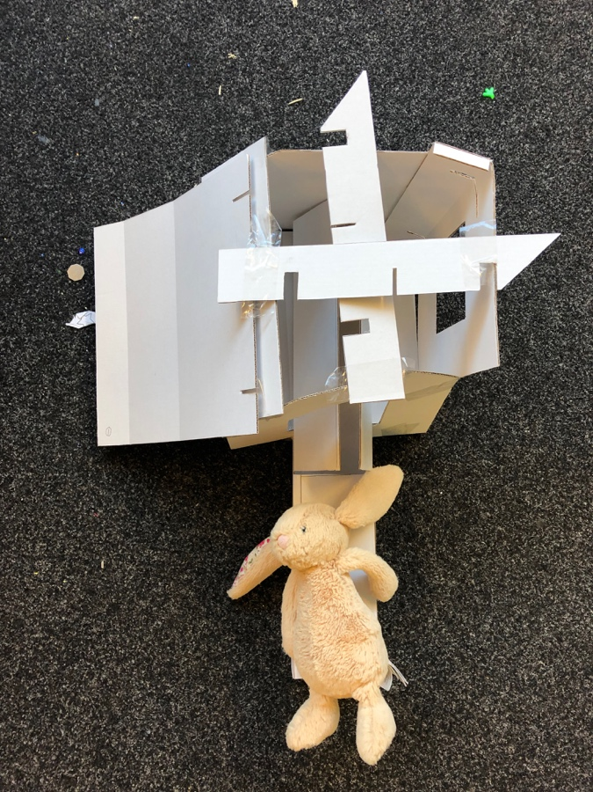
Figure 1 MRI scanner with open roof
The next steps for the project will be to take the design ideas put forward by the schoolchildren and develop an initial prototype for user testing with our co-designers. Watch this space!

