**‘Joyful Journeys’: putting wellbeing at the centre of future travel**

Harmer L.(a) , Cain R .(a), and Mausbach, A. (b),

aLoughborough Design School, Loughborough University, Loughborough, United Kingdom;

bIntelligent Mobility Design Centre, Royal College of Art, London, United Kingdom;

**Journeys are changing - how can future journeys can be joyful?**

Mobility has become essential for our modern way of life. It provides people the access to services, opportunities, entertainment and health. Mobility is traditionally associated with progress, contributing to, and a consequence of, economic development in industrialised countries; while in less developed countries it is viewed as a necessary requirement for sustaining economic growth and is a perceived as the benefit of such growth (Andrews et al., 2006). Nevertheless, the environmental impacts of current mobility have been questioned and the industry is facing the challenge to shift its paradigms towards new and more sustainable mobility (Gott, 2009).

Ettema et al., (2013) demonstrate the connection between wellbeing and good access to mobility. However, The Office for National Statistics, (2014) discovered those who commute report lower levels of happiness and satisfaction; higher anxiety and a reduced feeling that their activities are meaningful, than those who don’t commute. The motivations behind mobility appear critical to wellbeing; people enjoy travelling it appears, but on their terms.

Whilst mobility may bring wellbeing (De Vos et al., 2015) efficient mobility provision is an increasing issue for the UK’s future (Chartered Institution of Highways & Transportation, 2016).

Shifting work and leisure patterns, congestion, sustainability and autonomous vehicles pose significant challenges, changes and opportunities in transport. These future challenges and changes also present opportunities for the development of more inclusive vehicle designs (Alessandrini et al., 2015) thereby extending the impact of mobility wellbeing to a greater number of people. Advances in autonomous technologies could provide solutions for mobility for those with limited access to transport as shown by concepts demonstrated in the Gateway project (Greenwich Automated Transport Environment, 2018) shifting interaction from ‘human to human’ to ‘human to machine’. However, the Connections project at the Royal College of Art (RCA) with rural communities in Ireland (Kunur and Gheerawo, 2007) found that access to transport is not the only mobility aspiration respondents have from their transport, and the fears of social isolation and loss of privacy are also present as mobility changes occur. Fagnant and Kockelman, (2015) discuss these social concerns related to autonomous vehicles and the additional risk of the technology encouraging urban sprawl. Meyer et al., (2017) and (Guerra, 2016) suggest autonomy will reduce the viability of public transport for all but the most highly trafficked areas and (Currie, 2018) shows future predictions of autonomy are already being used as rationale for limiting public transport spending.

The need to develop a new mobility paradigm, that builds in greater empathy and understanding of design for wellbeing is therefore needed, to ensure that the technological opportunity of mobility is met with solutions that are increasingly human-centred, inclusive and ‘joyful’. They ‘joyful journey’, is defined in this chapter as not only a journey that is enjoyable, bringing pleasure or happiness, but one that is imbued with meaning and that might be described as ‘joyful’ in spite of difficulty or hardship faced.

Advances in computing, navigation and autonomy are creating a technology push (Di Stefano et al., 2012) with the social benefits of future transport solutions redolent to those muted with the online social network revolution. As with autonomy, social media promised increased social connectivity. However, we are beginning to understand some of the unintended consequences that social media is having, for example social exclusion and challenges to mental wellbeing (Baccarella et al., 2018). The potential unintended consequences of autonomous mobility in this context are therefore worthy of exploration. For example, in rural areas where the connections between the social and transport are complex and interwoven, autonomy could improve transport accessibility but degrade wellbeing by fostering social exclusion.

Designing for positive experiences requires user involvement (Desmet and Pohlmeyer, 2013) In the ‘Joyful Journeys’ research we have begun by identifying and understanding the positive attributes of a current rural journeys so that the most appropriate features can be built into new journeys. For current journeys, both those which are public and private, the research aims are to understand what makes a journey joyful, the tools required to design meaningful future mobility experiences and the features that need to be built in to promote wellbeing.

***‘Joyful Journeys’ in Leisure and Commuting***

In this chapter we discuss historical perspectives of enjoyable journeys and exploratory studies with travellers to understand where ‘joyful journeys’ are undertaken now and how they might be undertaken in the future. It finally offers reflections on these and how these might be incorporated into future solutions and designs.

Mobility is freedom. Travel freedom if characterised by the ease of unrestricted, affordable movement as we wish, and mobility is a key indicator of contemporary notions of subjective wellbeing (SWB). Along with the resultant mobility, the physicality of travelling is part of objective and subjective notions of wellbeing. However, mobility wellbeing doesn’t have to be characterised by predictable, uneventful and benign physical transport. Whether comfortable or uncomfortable, the physicality of travel is rooted in historical notions of movement. A journey can be both painfully necessary return home such as in Homer’s Odyssey (Knox and Fagles, 1990), rewarding as the German *Wanderjahre* apprenticeships (Ericson, 1984), or the ill-fated, individualist Don Quixote (Watt, 1997). The travel stories told often incorporate some, of these elements (Moscardo, 2010), stressing the purpose to which the mobility itself created such adventure and mis-adventure.

Mobility wellbeing is much richer that efficient transportation. In describing designing for experiences that promote wellbeing c identify and define six factors that can be applied to SWB and mobility. These are; Autonomy (personal independence), Stimulation, Competence, Relatedness, Popularity, and Security. From the definitions offered by Hassenzahl, these last four factors have a direct social component and personal experience underlines that transport and mobility (especially public) are rich sources of social interactions; wanted or unwanted, planned and unplanned.

The grand tour, once a wealthy rite of passage, has transformed to a universal ‘right’ of tourism (Towner, 1985). The experience of the journey however, has remained an integral part of a holiday throughout the expansion of tourism. These expectations, initially popularised by Thomas Cook (Brendon, 1991) of an enjoyable, managed experience of travel, as important as the final destination, are still prevalent today. The distinction between leisure and commuting travel was explored by Stradling et al. (2007), their work discovered that for commuting respondents were concerned with the functional convenience rather than the emotional aspects of their journeys. For leisure journeys, however, an equal emphasis was placed on the functional and emotive.

The distinction of ‘Joyful Journeys’ as ones undertaken for leisure against the drudgery of commuting necessity is not one shared universally. Certeau, (1984) describes walking in the city in voyeuristic terms and travel in a railway carriage as an ‘incarceration vacation’ creating a ‘melancholy pleasure’ that comes from the forced separation between the external and the internal as we look out through the window. A space in which thoughts, memories and dreams might flourish as your gaze looks out through ‘glass and iron’. These interstitial experiences appear increasingly at risk as we become gadget enthralled, connected and constantly entertained (Gardner, 2018).

The commute is not without emotion. Commuting can be a means of ‘catharsis from the pressures and frustrations of everyday life’ (Freedman, 2002) and a buffer between work and home. There are those whom enjoy their commute; as preparation, relaxation, time available to work or explicitly not to work, an opportunity for exercise, and for sociability (Lorenz, 2018). Guell et al.,(2012) reported that SWB in commuting is linked to modal choice. They reported that enjoyable commuting journeys aren’t typically to be had whilst driving but by those whom reported being more aware of their surroundings because they cycled or walked. Those respondents that used the park and ride also found a ‘welcome time out’ and amongst those that enjoyed their commute it appeared they took note of the natural world and experienced these sensual joys because their transport choice enabled them to do so. Commuting is not just about functionally travelling between home and work, it can be psychogeography(Richardson, 2015) or as the Flaneur(Tester, 2014), enriching experiences of the spaces we inhabit.

Guell et al.,(2012) also discovered that switching from car driving to active travel improved a commuter’s wellbeing and that whilst wellbeing increased with travel time for walkers, it decreased for drivers. Commuting can quickly become frustrating if the scenery remains unchanging or it is not possible to enjoy or make use of the time, typified as the driver experiencing congestion.

SWB in mobility concerns more than just promoting a change in transport modes. Logistical and environmental factors often play a significant part in creating real and perceived poor-quality mobility experiences. Barriers to creating ‘Joyful Journeys’; Infrastructure, punctuality, congestion, low quality, unsavoury social interactions, fear and time pressures deter those from the public transport into the perceived independence and security of the personal vehicle.

**Choreography of Mobility**

‘Joyful Journeys’ is a stage of the Choreography of Mobility research project between the RCA and Loughborough University. The Choreography of Mobility project is an attempt to rethink how we design our journeys. It explores the concept of mobility wellbeing in the transition from materiality to immateriality, the transition from physical products to services of future mobility designs. The project explores the importance of social empathy to wellbeing and proposes to design mobility as a collective subject, observing the dynamics and interactions between people, vehicles, internalities and externalities, as part of a choreography.

**Exploring methods to investigate ‘Joyful Journeys’**

Experiencing ‘Joyful journeys’ and mobility wellbeing have a direct link to established research in SWB.  Until recent developments in mobile technology the majority of SWB travel studies were captured through surveys and interviews undertaken after completing a journey. Friman et al., (2018) highlight the gaps in SWB transport research, ‘Joyful journeys’ seeks to explore these gaps, particularly the contributions of the physical vehicle and the functional nature of mobility that are layered with meaning that contribute to wellbeing*.* Through investigating the extremes and contrasting joyful and joyless travel, urban and rural, old and young, commuting and leisure it seeks to expose the differing perceptions about key mobility aspects; between age groups, countryside and city.

Our research employed a mix of contextual methods as a means of discovering the components (Johnson and Onwuegbuzie, 2004)) that make up current ‘Joyful journeys’ in the context of SWB. An exploratory user-centred approach to understanding the whole journey experience was used undertaking the following stages to explore qualitatively how travellers express wellbeing about their journeys:

1. **Journey shadowing and interviews.** Four semi-structured interviews with older people exploring how they express their experiences during their journeys.
2. **Current and Future Journey mapping and rating.** Exploring how travellers express their experiences after their journeys and imagine their future journey experiences. (London Design Festival – 37 respondents and a workshop with 8 participants at Loughborough Design School)
3. **Journey shadowing and interviews**

The research began by seeking out ‘Joyful Journeys’ that were part of everyday mobility but outside the requirements of commuting.  At this first stage the research began by engaging with those in a position to be able to choose or ‘choreograph’the journeys they make, creating journeys that are intended to be pleasurable (figure 1).  Retired or semi-retired older age groups in a desirable rural context were therefore selected to investigate how the most ‘Joyful Journeys’ might be choreographed by those in a position to choose how they travel in an environment that is pleasant and aspirational, all outside the purposes of commuting; the drive, the lift, the bus journey and the cycle ride.

Journey shadowing and semi structured interviews were selected to provide deep qualitative data, particularly useful when investigating the intangible elements of services (Penin, 2018). The method allows for gathering insight on general behaviour, actions and social interactions, rather than collecting specific information from individuals.

The use of video and semi- structured interviews (Kallio et al., 2016) was chosen as a means of engaging respondents in their environment during the activity, allowing participants to add context and inspiration to their responses.

Key questions and responses are shown in Table 2. covering observations from the journey, current experiences and thoughts about the future, capturing people’s perceptions, emotions and aspirations. Four journey shadows and interviews took place in rural North Norfolk making use of researcher familiarity with the area.

***Identified themes from journey shadowing and interviews***

All the interviewees were drivers and owners of cars but their relationship to their car in each instance was subtly different. However, it was clear that owning a car in a rural environment allowed a confidence to choose other transport modes. The two driving interviews conducted illustrated how the car met social and logistical needs; car ownership compensating for the sometimes-sporadic nature of public transport in rural areas.

*“I love driving and it’s lovely to take people. One of the things I like to be is useful, it’s one of the better parts of my life. I’m getting old. I can’t do much, but one of the things I can do is get in a car and drive”* Interviewee 1

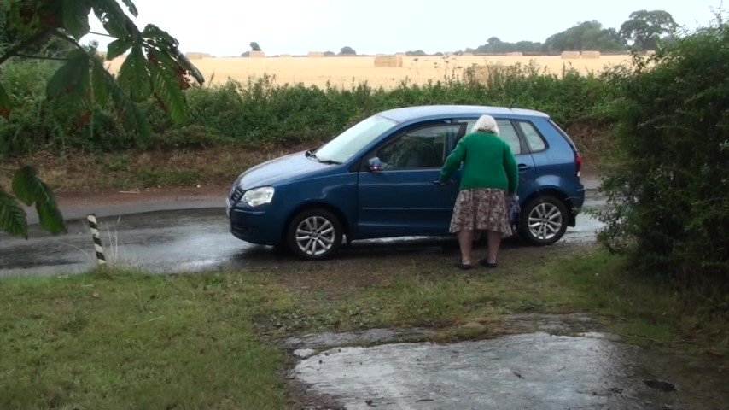

Figure 1: Giving a lift - Journey Shadowing and interview 1

The responses in Table 1 are selected are from the main themes of the semi structured interviews.

|  |  |  |  |  |
| --- | --- | --- | --- | --- |
| Journey |  |  |  |  |
| Transport Mode | 1. Lift | 1. Car | 1. Bus | 1. Cycle |
| Approximate Distance | 2 miles | 9 miles | 42 miles | 11 miles |
| Journey Rationale | Giving a less physically able person a lift to church | Hair appointment | Leisure trip to City to visit Castle Museum | Trip to Pub |
| What do you most enjoy about your journeys? | *“I love driving and it’s lovely to take people.”* | *“The independence…I can listen to music and can do errands on the way”* | *“…for a day out, time is irrelevant to us and also its enjoyment to sit back and relax and not think about the traffic.”* | *“ I Cycle weekly for the exercise but most enjoy pub crawl cycle trips with friends”* |
| What was the most memorable, ‘Joyful Journey’ of this type? | *“ I used to do was to drive to Scotland …It’s just the most wonderful place to go and awe inspiring in so many ways. Scenery and good companionship”* | *“We went to Blakeney and Cley… and that was really lovely… we were with friends so we were chattering away as we went.”* | *“Being stuck on a bus that could only do 35mph…”* | *“Cycling with friends in north west Norfolk earlier in the year – when there was no traffic -* |
| What would you do if you could no longer travel this way? | *“I’d take the bus”* | *“I might take taxis but I’d also try to get lifts with friends” I’d hate it having to ask… I’m so used to being independent....”* | *“If I’d still able to drive I’d take the car”* | *“…I don’t know, it would take away something from my life…”* |
| What music would you choose to describe your journey? | Beethoven No. 6 Pastoral symphony | A Mozart symphony- calm and peaceful | Vaughan Williams: The Lark Ascending | Vaughan Williams: The Lark Ascending |
| How will your journey be done in 50 years’ time? | *“ I always think of having an aeroplane attachment… “* | *“… we’ve always said people will be flying to work in helicopters, but I don’t know, it’s hard to imagine”* | *“Would hope there is still public transport… in 50 years’ time… it might be all electric.”* | *“…maybe we will have autonomous bikes …but human beings will still want to do their own thing.”* |

Table 1: Comparison of responses to journey shadowing pilot

**Discussion of Journey Shadowing and interviews**

For all the interviewees, as the need to commute has diminished, the psychosocial in mobility wellbeing came to the fore. Interview 1 (where the purpose of driving was to provide a lift) perhaps gives the best indication of how SWB can be promoted in mobility. Comparing the actions of the lift provider onto the six factors presented by Hassenzahl et al., 2013 suggests that providing lifts can create not only the social benefits necessary for SWB but the competence and stimulation as a car driver. Musselwhite (2018) reports that for older people the car can be a critical part of maintaining wellbeing satisfying utility, psychosocial and aesthetic needs and that: *“transport provision beyond the car neglects psychosocial needs of mobility and sporadically meets practical and aesthetic needs depending upon the wider social context.”*

After the introduction of bus passes in England for older people in 2008,bus travel, particularly in rural communities, has according to Andrews et al., (2012) taken on a richer purpose and meaning. Outside the requirements of the commute and without the pressure of time the bus is a social entity for many older users. These attributes suit the nature of the rural bus; its progress is often considerably slower than the car and its use requires planning and preparedness only marginally different in practice than the earliest omnibus. Rural cycling too now exists more as a leisure and social activity than a functional one, suiting the lifestyles of those able to choreograph their journeys.

All of the interviewees reported a social aspect to their ‘Joyful Journeys’, but this social element did not come to the fore when they described how they imagined future transport.

1. **Current and Future Journey mapping and rating**

*Journey shadow video as provocation*

A provocation piece for the London Design Festival used the video of the first journey shadow and interview. Through editing and augmentation with illustration festival attendees were encouraged to explore their current journeys and how they would like to choreograph their future journeys (Figure 3). Design provocations are used to start a discussion and engage people’s imagination to produce their own responses.  This video explores a journey in the countryside, where people independently organise lifts to the local church. The interview shows surprising social aspects of mobility and the significance of experiences of driving and sharing. At the same time, it presents a view about comfort provided by technology and innovation, from handle-start to flying cars. The attention to these issues is enhanced by the addition of drawn animated cartoon inserts to the video. The casual drawings style adopted aims to connect to the audience and invite them to also make drawings in response to the video.

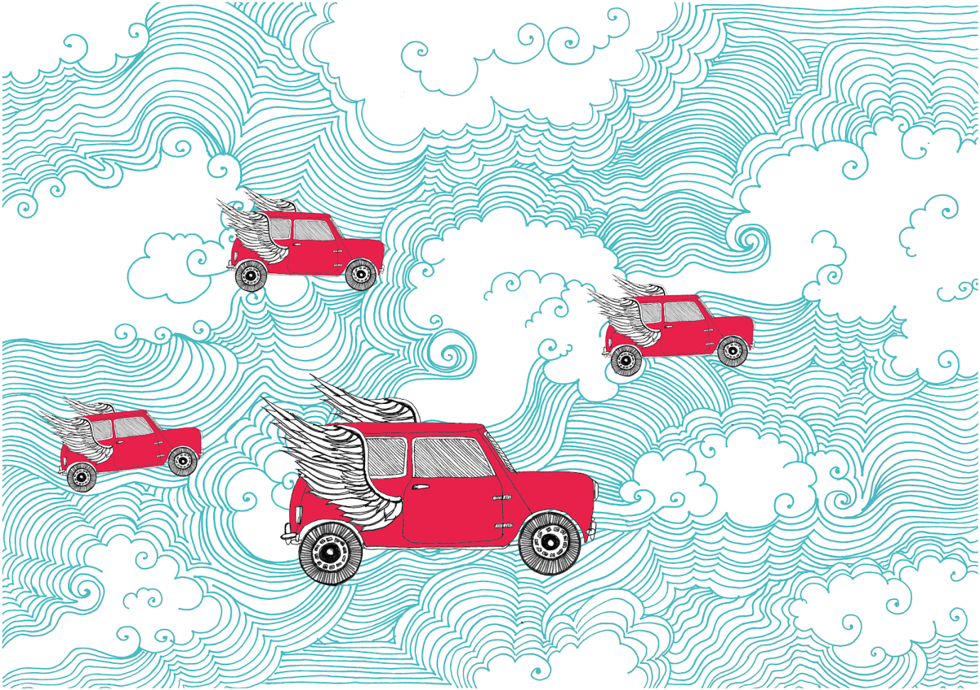

Figure 2: Still from video provocation (drawing by Luka Kille-Speckter) see weblink…

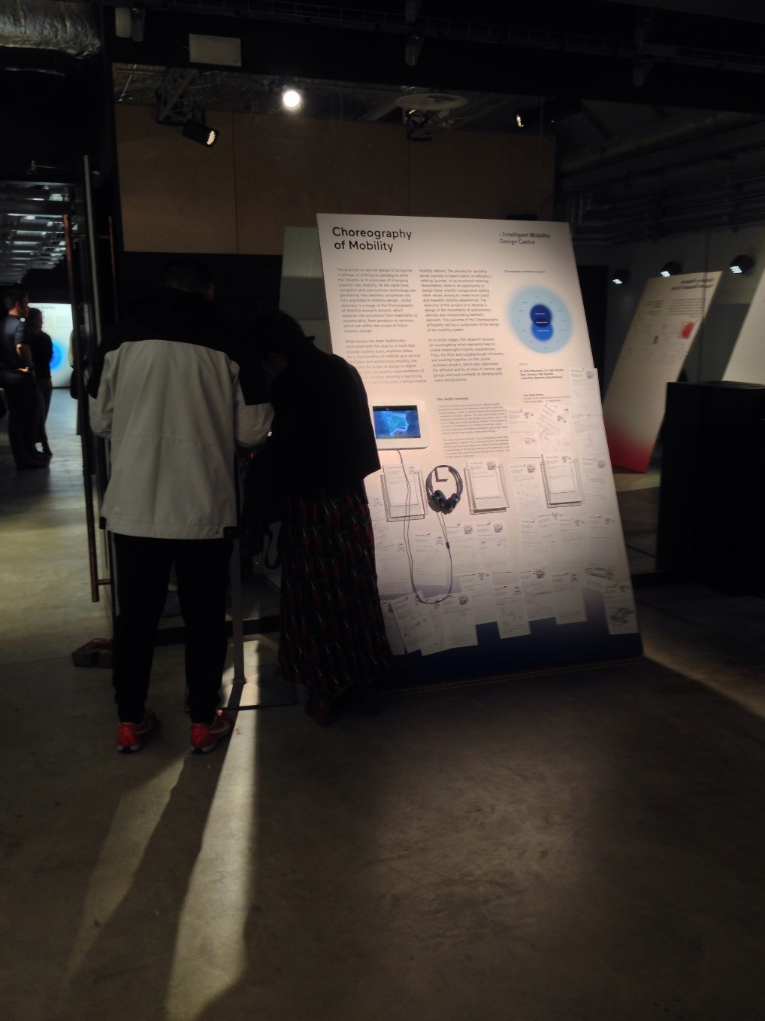

Figure 3: Video provocation installation at the 2018 London Design Festival

*Responses to provocation*

The process was trialled as part of the Design Festival and validated as part of the workshop at Loughborough Design School as described later. Attendees to the Festival were asked to draw a cognitive map (Golledge, 1999) of how they see their current and future ‘Joyful Journeys’ by writing and drawing on three different cards, which present the following questions:

* Your Current Journey card: (1) How do you normally travel? How far? (2) Please draw a map of one of your typical journey’s (include landmarks). (3) if your journey was a piece of music, what would it be?
* Your Joyful Journey card: (1) What was your most joyful journey? (2) Please, can you draw what this joyful journey looks like? (3) If this joyful journey was a piece of music, what would it be?
* Your Future Journey card: (1) What has changed the most in your journeys in the past years? (2) Can you draw and/or write how people will undertake your joyful journey in 50 years’ time?

During the 4 days of the exhibition 37 response cards were filled. The responses showed that the provocation was an effective method to engage the public to draw, write and also talk about their mobility experiences. The outcomes were also used to identify which aspects of a Choreography of Mobility were mentioned and remembered by the attendees.

It was observed that the responses about joyful journeys were more complex, with drawing including references to landscape, weather, wind, trees, other vehicles and animals. The social interaction with family, wife, and friends were also found in joyful journeys. The current journeys maps were more informative, including the requested landmarks, but less inspirational on variety of choreography elements. On the future journey cards, it was found references to flying vehicles, but respondents had greater difficulty imagining future journeys appeared to be the most difficult to have.

The responses indicated that meaningful experiences are more complex than the functional view of mobility; elements of companionship, music, environment are essential to the’ joyful journey’ experience. The responses suggesting that considering a choreography of mobility could be more effective to promote wellbeing than mobility planning.

**Workshop at Loughborough Design School**

To further validate the methodology the exercise was repeated with eight younger people, PhD students, as part of a formal workshop at Loughborough University. The responses were intended to create the beginnings of journey choreography and the participants were asked to watch the video provocation and then asked (without conferring) to create visual descriptions of their current, joyful and future journeys. They were then asked to rate these using a radar diagram with the key factors attributed to SWB as identified by Hassenzahl et al., 2013. The definitions of these factors were made available and the visual responses were used to promote group discussions.

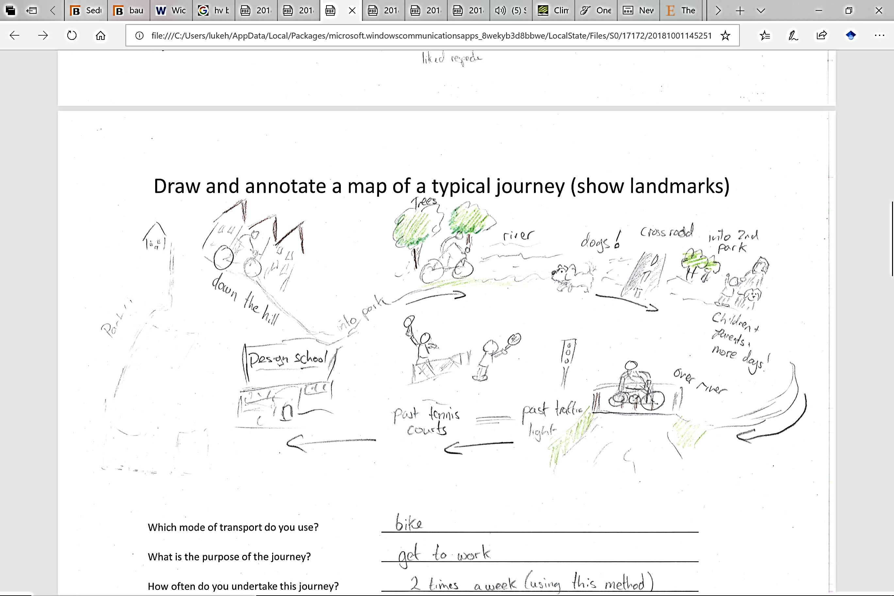

Figure 4: Example of participants response in the video provocation workshop

*Discussion of observations from research, SWB, modal choice and future journeys*

The participants of the workshop reported the most pleasurable current journeys were walking or cycling, explaining a connectedness to environment as positive factors. By contrast their ‘Joyful Journey’s’ were often imbued with meaning – the expectation of meeting with a loved one rather than just the pleasure of the journey itself. The radar ratings revealed overall that regular journeys undertaken by cycle or foot scored almost as highly as those described as ‘Joyful Journey’s’. It was the future journeys however, which gave some of the most telling clues of perceptions of enjoyability, seen generally as more negative than their contemporary counterparts. Whilst pop and rock music were selected as ‘soundtracks’ for current journeys, future journeys were described predominately by Jazz. Future journey maps included travel by autonomous vehicles and respondents reported lower perceived levels of connectedness and popularity but increased security. Youthful predictions of future travel were overall focused on autonomous vehicles and appeared less adventurous than those from older people in the journey shadow interviews.

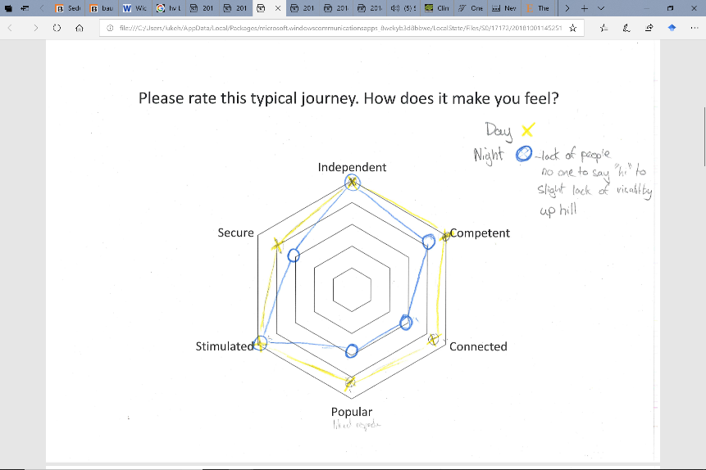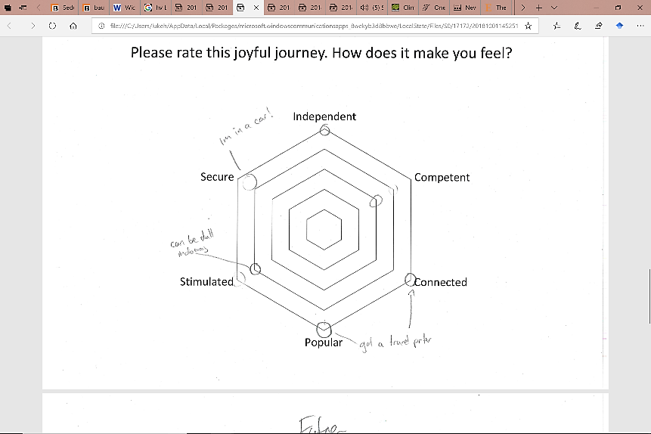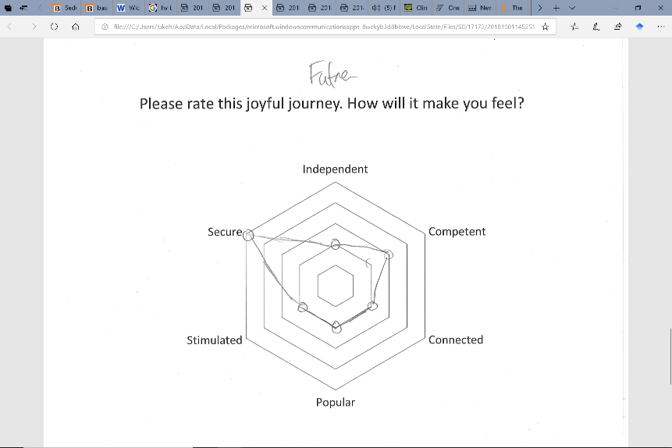

Figure 6: A workshop respondent radar maps of wellbeing factors for current journey (cycling), joyful (car journey) and future (autonomous vehicle)

**Investigating F­­uture ‘Joyful Journeys’**

As vehicles become more refined, they can become increasingly like other transport and stationary environments we experience. The budget bus, train and aeroplane ride are broadly similar and not significantly more experientially rich to the waiting lounges that often proceed them. In these similar environment’s passengers rely increasingly on the electronic, virtual and augmented for security, information and entertainment. For example, online journey planning is now considered a normal part of the mobility of many. Both in the public and private transport domain, connected devices now form part of the information and entertainment landscape of journeys. In 2018, some 86 percent of respondents in the UK stated they make use of their Smartphone for navigation (Statista 2018).

Aesthetic properties in transport have been traditionally associated with the vehicle itself, it is the physicality of the object that creates emotive resonance (Bayley, 2008). The transition to intelligent and autonomous vehicles and the muted ‘mobility as a service’ (Holmberg, 2018) has extended the scope of potential emotive resonance to digital components and graphic representations of movement. This scope extends from simple interfaces of navigation systems, which might include avatars in some cases to more complex artificial intelligence interaction on future autonomous vehicles.

Historically, modal choice for our regular journeys has been based to a large degree on practical and financial constraints – mobility as function. This focus, with an emphasis on controlling the natural environment and the utilitarian corresponds to Maslow's first two levels of the hierarchy of human needs: physiological and safety needs. Transport has expanded to include social needs, belongingness, love needs, cognitive needs and aesthetic needs. As the remit of mobility has expanded the objects that transport us have become imbued with more complex, subjective meaning – mobility as beauty.

The physicality of transport is being eroded by the virtual experience. Nevertheless, it is possible to design with these new mobility components and add in values that promote SWB, to create more joyful and beautiful mobility experiences that in turn could encourage wellbeing. Design has the capacity to create the complete ‘Joyful Journey’, including but beyond the transporting object, to avoid the potential monotony, exclusion and resulting loss of SWB that automation could bring.

It appears probable that the efficiency, ease and the cost reduction promise of future autonomous vehicles will mean increasing amounts of time spent travelling. The technology that enables our future travel may make our vehicles more sterile and promote the melancholy that Creteau describes which occurs in the isolation and confines of the railway carriage. In this future generation of the amalgamated personal and public transport, travel frustration may become more acute as on occasion the vehicles inevitably slow or stop. These situations may be more frustrating than current congestion if perceived personal control is no longer possible.

More time spent travelling, virtually connected but physically alone could mean a lonely autonomous future. Humans are of course social, emotive physical beings. Commuters increasingly disconnected from those around them, may not easily be able to share their frustrations. A challenge for nurturing mobility wellbeing in future journeys is to allow and encourage social interactions and experiences of the natural world and its sensual joys; safe and secure regular travel that can be less cossetted and allow for the stimulation and relatedness of pleasant sights, sounds and smells. These factors question the form and function of the autonomous vehicle and how these experiences translate to future designs that will promote wellbeing; the autonomous - bus, taxi, convertible, sports car or bicycle.

**Conclusions and Implications for Designers**

The social import of ‘Joyful Journeys’ has become apparent through this explorative research. For both young and old, many of the ‘Joyful Journeys’ involved engaging with others and with the environment. They were ‘choreographed’ in the sense that mode travel time, vehicle, musical accompaniment, distractions and company were chosen. The selected soundtrack of these journeys reflected both the landscape and the attitude of their aspirational journeys, particularly with the older respondents in the journey shadowing citing pastoral music.  These individual journeys are a reminder of individual actions and contrast to city travel where collective movements dictate.

The provocation video shows how the act of driving can be treasured as well creating empowerment for the driver as well as the driven. When designing future mobility, in particular SWB in mobility, a cognizant effort is required to design for all of six factors (Hassenzahl et al., 2013) linked to wellbeing. Future vehicle autonomy, whilst making the possibility of transport for those currently excluded possible, also risks creating new types of social exclusion. For example, a future of driverless pods may make a local bus service and the lift giving car driver redundant – removing an important social aspect of rural community. A ‘Joyful Journey’ is facilitated by the vehicle and its design, not as might be the case of the autonomous vehicle, dictated by it. However, autonomy also creates potential to increase social inclusion and opportunities for others to assist those who are less able to undertake these journeys. Autonomy creates the potential to control our journeys more, to choreograph the elements that make up the experience. Current travel creates limits to distractions which may result in un-communicated but wanted time from usual pressures. Whilst driving we may be limited (legally) to audio distraction but the potential for other distractions with autonomy becomes an almost limitless continuation of our other activities, risking further social ‘siloing’ or exclusion.

This research exploration suggests some key areas that can assist designers and planners in considering future mobility. Transport is only one component of mobility, the social component of unintended or intended interactions occurring both inside and outside social or family groups appear to be key components of ‘Joyful Journeys’. Using journey shadowing and semi structured interviews to determine the ‘joyful’ is a first step in choreographing and allowing space for these elements in new modes and design solutions. Music, cognitive maps and rating wellbeing elements of journeys could also provide insight into SWB factors. Through considering not just the functional, but the ‘Joyful Journey’, new types of differential, social and meaningful journey experiences can be choreographed and in so doing avoid some of the potential potholes of vehicle autonomy.

**References**

Alessandrini, A., Campagna, A., Delle Site, P., Filippi, F., Persia, L., 2015. Automated vehicles and the rethinking of mobility and cities. Transportation Research Procedia 5, 145–160.

Andrews, D., Nieuwenhuis, P., Ewing, P.D., 2006. Living systems,‘total design’and the evolution of the automobile: the significance and application of holistic design methods in automotive design, manufacture and operation.

Andrews, G., Parkhurst, G., Susilo, Y.O., Shaw, J., 2012. The grey escape: investigating older people’s use of the free bus pass. Transportation Planning and Technology 35, 3–15.

Baccarella, C. V, Wagner, T.F., Kietzmann, J.H., McCarthy, I.P., 2018. Social media? It’s serious! Understanding the dark side of social media. European Management Journal 36, 431–438.

Brendon, P., 1991. Thomas Cook: 150 years of popular tourism. Secker (Martin) & Warburg Ltd.

Certeau, M. de, 1984. The practice of everyday life. Berkeley.

Chartered Institution of Highways & Transportation, 2016. A Transport Journey to a Healthier Life: A discussion paper on how transport policy and procedure can contribute to the health and wellbeing agenda. London.

Currie, G., 2018. Lies, Damned Lies, AVs, Shared Mobility, and Urban Transit Futures. Journal of Public Transportation 21, 3.

De Vos, J., Schwanen, T., Van Acker, V., Witlox, F., 2015. How satisfying is the Scale for Travel Satisfaction? Transportation Research Part F: Traffic Psychology and Behaviour 29, 121–130.

Desmet, P.M.A., Pohlmeyer, A.E., 2013. Positive design: An introduction to design for subjective well-being. International journal of design 7.

Di Stefano, G., Gambardella, A., Verona, G., 2012. Technology push and demand pull perspectives in innovation studies: Current findings and future research directions. Research Policy 41, 1283–1295.

Ericson, K., 1984. The Wanderjahre: New Lessons From an Old Way of Learning. Change: The Magazine of Higher Learning 16, 42–46.

Ettema, D., Gärling, T., Olsson, L.E., Friman, M., Moerdijk, S., 2013. The road to happiness: Measuring Dutch car drivers’ satisfaction with travel. Transport Policy 27, 171–178. https://doi.org/10.1016/j.tranpol.2012.12.006

Fagnant, D.J., Kockelman, K., 2015. Preparing a nation for autonomous vehicles: opportunities, barriers and policy recommendations. Transportation Research Part A: Policy and Practice 77, 167–181.

Freedman, A., 2002. Commuting gazes: Schoolgirls, salarymen, and electric trains in Tokyo. The Journal of Transport History 23, 23–36.

Friman, M., Ettema, D., Olsson, L.E., 2018. Travel and Wellbeing: Future Prospects, in: Quality of Life and Daily Travel. Springer, pp. 255–265.

Gardner, C., 2018. iPhone, in: Schofield, L. (Ed.), The Future Starts Here. V&A Publishing, London, pp. 28–34.

Golledge, R.G., 1999. Wayfinding behavior: Cognitive mapping and other spatial processes. JHU press.

Gott, P., 2009. Is Mobility As We Know It Sustainable? SAE Technical Paper.

Greenwich Automated Transport Environment, 2018. This is Just the Beginning: Positioning the UK at the forefront of automated mobility.

Guell, C., Panter, J., Jones, N.R., Ogilvie, D., 2012. Towards a differentiated understanding of active travel behaviour: using social theory to explore everyday commuting. Social science & medicine 75, 233–239.

Guerra, E., 2016. Planning for cars that drive themselves: Metropolitan Planning Organizations, regional transportation plans, and autonomous vehicles. Journal of Planning Education and Research 36, 210–224.

Hassenzahl, M., Eckoldt, K., Diefenbach, S., Laschke, M., Len, E., Kim, J., 2013. Designing moments of meaning and pleasure. Experience design and happiness. International Journal of Design 7.

Johnson, R.B., Onwuegbuzie, A.J., 2004. Mixed methods research: A research paradigm whose time has come. Educational researcher 33, 14–26.

Kallio, H., Pietilä, A., Johnson, M., Kangasniemi, M., 2016. Systematic methodological review: developing a framework for a qualitative semi‐structured interview guide. Journal of advanced nursing 72, 2954–2965.

Knox, B., Fagles, R., 1990. Homer, The Iliad. Trans. Robert Fagles. New York: Penguin.

Kunur, M., Gheerawo, R., 2007. Connections-mobility, ageing and independent living. London, The Helen Hamlyn Research Centre.

Lorenz, O., 2018. Does commuting matter to subjective well-being? Journal of Transport Geography 66, 180–199.

Meyer, J., Becker, H., Bösch, P.M., Axhausen, K.W., 2017. Autonomous vehicles: The next jump in accessibilities? Research in transportation economics 62, 80–91.

Moscardo, G., 2010. The shaping of tourist experience. The importance of stories and themes. The tourism and leisure experience: Consumer and managerial perspectives 43–58.

Musselwhite, C., 2018. Mobility in Later Life and Wellbeing, in: Quality of Life and Daily Travel. Springer, pp. 235–251.

Office for National Statistics, U., 2014. Commuting and Personal Well-being [WWW Document].

Penin, L., 2018. An Introduction to Service Design: Designing the Invisible. Bloomsbury Publishing.

Richardson, T., 2015. Walking inside out: Contemporary British psychogeography.

Stradling, S.G., Anable, J., Carreno, M., 2007. Performance, importance and user disgruntlement: A six-step method for measuring satisfaction with travel modes. Transportation Research Part A: Policy and Practice 41, 98–106. https://doi.org/10.1016/j.tra.2006.05.013

Tester, K., 2014. The Flaneur (RLE Social Theory). Routledge.

Towner, J., 1985. The grand tour: A key phase in the history of tourism. Annals of tourism research 12, 297–333.

Watt, I., 1997. Myths of Modern Individualism: Faust, Don Quixote, Don Juan, Robinson Crusoe. Cambridge University Press.