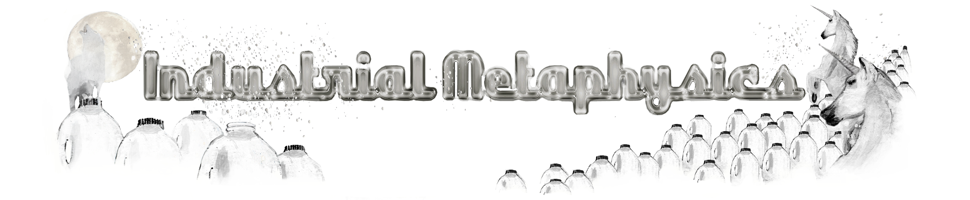

Melanie Jackson and Esther Leslie

Milk is right in front of our eyes. It is on the breakfast table. It is in the endless cups of tea and frothy coffees. Milk is milk and it is there to hand. We know milk. It is that white stuff. Or it becomes it somehow or another. White milk is an ideal-type or a norm and, as such, it is a product of our fantasy, just as it is a product of industry. Its uniform white colour is achieved by separating all of its constituent molecules, then recombining them in complex formations. Milk comes to us via the supermarket shelf radiant with an even whiteness, glowing through its glass or plastic vessel. Milk is opaque. This solid body of white is about 87% water and 13% solids. If the fat is removed from milk, a bluish tinge results. If there are plentiful riboflavins, it can take on a greenish glow. Some milk, such as that of Guernsey and Jersey cows has carotene in it and appears yellow to the eye. The whiteness of milk might offer itself up as a palette, a canvas on which to test out colouring. Or it might become the body colour. Milk was the matter used for the first paintings – the models of boats and people and furniture exhumed from Tutankhamen’s tomb were painted in milk paint, milk mixed with lime and iron oxides and other earth pigments.

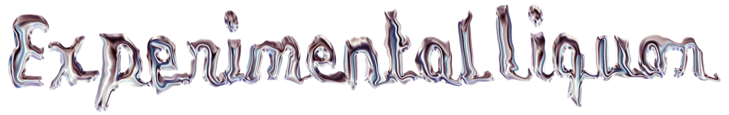

Edward Hussey Delaval in his ‘Experimental Inquiry Into the Cause of Changes of Colours in Opake and Coloured Bodies’ (1777) used milk coagulated with boiling Oil of Tartar to explore the spectrum of colour. ‘It passes’, he notes, ‘through every gradation of yellow, orange and red as it thickens’. As it dilutes it turns blue. ‘Thus’, he announces triumphantly, ‘from one and the same liquor, the five first colours of Sir Isaac Newton’s table are produced in their regular order, in proportion as the component parts are united into larger masses’. Milk provides the proof of Newton’s shattered rainbow.
Milk has also been black: Black milk of morning we drink you at dusktime, we drink you at noontime and dawntime we drink you at night, we drink and drink*. We drink too the milk that glows so white it seems to fizz, extends outside the contours of the vessel holding it, as when Hitchcock placed a light inside the glass of poisoned milk carried upstairs by Cary Grant in Suspicion.

- Death Fugue, Paul Celan, 1948

Milkiness was the proof of Goethe’s colour theory – for milk is a turbid substance, as a result of the casein protein’s fat content. The molecules that make up the turbidity scatter and deflect light uniformly throughout the visual spectrum, for it absorbs none of the colours in light. In his late explorations of colour, Goethe replaced an interest in light with a concern with turbidity, as he studied entoptic colours, colours made by the eye and dependent on medium and ambience and other circumstances of cognition – against the more objectively analytical procedures of Newton. Turbidity describes a cloudiness or the presence of particulates, which makes of a substance a medium, without which there would be no colour. Turbidity is no obstacle to colour – as had been thought, when it was seen as a blockage, a fog, a fuzz that obscured seeing. Goethe defines turbidity as ‘turbo, turbidity, tobio, trouble’ and refers to ‘a collection of transparent and non-transparent, meshed coating of non-transparent atoms and their transparent vacuums.’ Turbidity reaches from transparency to milky-whiteness. At its more troubled, it evokes, for Goethe, associations of clouded thinking and melancholy, the turbidity of the mind. But turbidity is also what is in the atmosphere, Turbidity makes clouds and haze. Turbidity completed is pure whiteness – and it is, as such, ‘the initial rudiment whence is developed the whole science of chromatics’.

Turbidity in Goethe’s account is on the threshold between the physical and the spiritual realms, and as such affects any perception of colour. The medium of turbidity is the canvas on which colours appear. The opaque turbid medium allows the most brilliant colours to flash up – indeed engenders the process of chroagenesis, the formation of new colours. Visible and invisible, subjective and objective collude in the production of colour. Milk stops being homogenous and given and becomes fractured and active. The filtered becomes a filter.

That milk is the substance in which these chromatic arrays are monitored finds a parody-echo today in the plethora of frozen novelties. Emulating the full colour spectrum of mineral crystals, milk ice crystal products appear in kaleidoscopic colours, drawn from their permitted additives such as: Alkanet; Aluminium Metal; Allura Red; Amaranth; Annatto; Anthocyanins; Beet Red; Brilliant Blue FCF; Canthaxanthin; Carbon Black; Carotene; Charcoal; Chlorophyll; Cochineal; Erythrosine; Fast Green FCF; Indigotine; Iron Oxide; Orchil; Paprika; Riboflavin; Saffron; Saunderswood; Silver Metal; Sodium Copper Chlorophyllin; Sunset Yellow FCF; Tartrazine; Titanium Dioxide; Turmeric; Xanthophyll.

Milk’s whiteness is a transferable characteristic. When Herbert Hoover made an address in 1923 on the milk industry at the World’s Dairy Congress in 1923, he affirmed that ‘Upon this industry, more than any other of the food industries, depends not alone the problem of public health, but there depends upon it the very growth and virility of the white races.’ The whiteness of milk demands a white body capable of digesting it, or so think those voices who attribute the development of European civilization around 11000 years ago to the lactose-tolerance of Northern Europeans. Milk’s fortunes are entwined with those of national health. William Prout, the London physician who developed ideas of nutrients through his chemical analysis in the 1820s, alighted on milk, ‘the only article actually furnished and intended by nature as food’, which he decreed to be composed of the three necessary ingredients for healthy life, for milk alone, and the mechanism by which milk is secreted, ‘were designed, and made what they are, by the great Creator of the universe’: ‘In milk, therefore, we should expect to find a model of what an alimentary substance ought to be – a kind of prototype, as it were, of nutritious materials in general.’ Industry and the market came rapidly to deliver this ever-so natural and simultaneously divine substance to the masses, in ever more new and improved versions.

After Prout, the last century hosted a battle over milk, over who milked, how made the products and how, and who got to drink them. Milk no longer came into being in the home buttery. It was commandeered by the creameries and what was known as ‘the whole milk system’. Farmers conveyed their whole milk supplies to the factory or creamery daily or at regular intervals. Machines lightened the labour. Where before cream had been skimmed off by hand, after setting for some time, centrifugal separators, most successfully deployed by Gustaf de Laval in Sweden and patented in 1894, separated cream from milk quickly and easily. De Laval also worked on milking machines. Milk was a factory matter. In the process, women were squeezed from their roles in the making of dairy products. They stayed in the home, which became not a place of production, but of reproduction, social reproduction, domestic activity, that was not to be conceived as labour. Men took over dairy production. No longer were there female churners with big arms. The logics of separation set in. Home and work separated. Women and labour separated. Cream and milk conveniently, automatically, efficiently separated. Lenin wrote of this mechanisation in The Development of Capitalism in Russia, from 1899, as part of a revolution in agriculture. A whole system of incorporation and separation is in train:

By buying up the milk, capital subordinates to itself the small agriculturists too, particularly with the organisation of the so-called “amalgamated dairies”, the spread of which was noted in the 70s (see Sketch by Messrs. Kovalevsky and Levitsky). These are establishments organised in big towns, or in their vicinity, which process very large quantities of milk brought in by rail. As soon as the milk arrives the cream is skimmed and sold fresh, while the skimmed milk is sold at a low price to poorer purchasers. To ensure that they get produce of a certain quality, these establishments sometimes conclude contracts with the suppliers, obliging them to adhere to certain rules in feeding their cows.

Amalgamating the dairies, he notes, performs a role analogous to that of elevators in commercial grain farming. By sorting grain in relation to its quality, the elevators turn it into a product that is not individual, but generic. That is to say, they adapt it fully to exchange. Milk too is fully adapted to exchange. It must be standardised, while at the same time, being differentiated. This is the dialectic. Milk is abstracted. As abstraction it is a commodity and adapted for quantification. But it is also specific milk, milk of varying qualities. There is creamy milk and the rest. The small producer and his ‘milkmaid wife’ are left to look after the cattle in the field, diligently, and so they bear the ‘brunt of the hardest and roughest work of tending the milk-yielding machine’, but the cream will not be theirs.

Capital possesses the latest improvements and methods not only of separating the cream from the milk, but also of separating the ‘cream’ from this “diligence”, of separating the milk from the children of the peasant poor.

Milk is a liquid representation of an annihilation of nature over time. There is no seasonal cycle lasting months as calf embryos gestate and milk is production for offspring. Rather there is the endless time of ever increasing and ever adapted milk yields. Milk flows across the political body, its stream an emblem of progress and perfectability of modern times. It is a fluid that flows though and brings into being modern distribution networks. It exemplifies the mass operations that often invisibly, or only in the corner of our eyes, never right before them, guarantee the social reproduction of our existence. Where water, in Bachelard’s account, a dream liquid, cleansing, pure, is as fluid as the imagination, milk, a complex mix, lends itself more readily to formation, regimentation, the rule of the Nanny and the boss, the kinds of flow that economy demands.

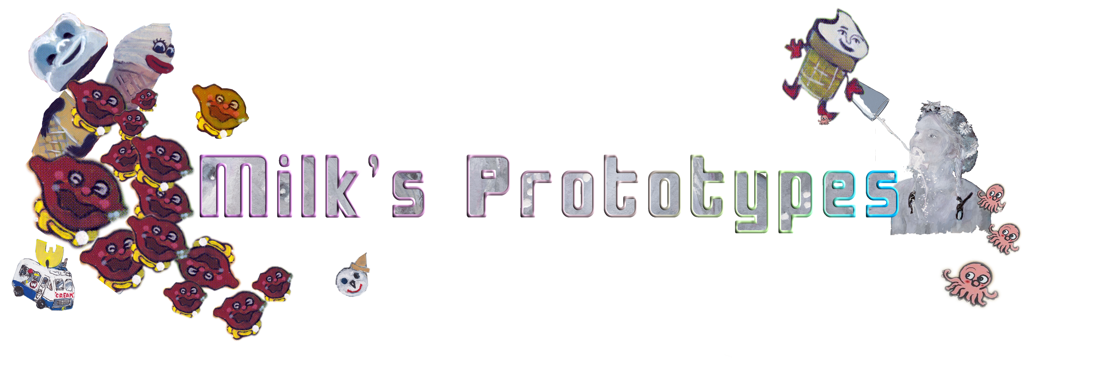

Milk adopts a multiplicity of forms. Historically, it has formed the basis of thousands of products. The geographical specificity of these different articulations of cheese is notable. Different cows, different grass, different air and soil and nutrients, different vessels and practices. Milk has generated a busy activity of human and bovine transformations. Its multiplicity is also evident in the variety of forms that it is shaped into in today’s modern, industrialised dairy environment. In frozen, liquid and powder forms, it is the matter of infinite innovation. It is dairy turned airy – in ice creams that swell up with nothingness injected. It is frozen into colourful crystals with personality, in a crowded frozen treats market, whose products bear ever less tangible relations to milk. Its capacities can even be signalled as a weakness and overcome – as in the ice cream ‘sandwich’ that never melts. Its various forms are met by its invariant standardization. It is refined, homogenised, monetised, mechanised and modernised. It is processed and recombined to extend its functionality.

Milk is a substance that can be shaped into anything and any colour. It has flirted promiscuously with genders. Once there were milkmaids. Later there were milkmen. Now milk is entangled in mass operations: milk machines, remote from human touch, except once it passes into the realms of consumption – shelf stackers, till operators, consumers. Milk occupies the refrigerator like denizens of a white army, badged blue, green and red, according to fat content. It is standardised and rationalised and quantified. In this form it provides an emblem of a social quest for normativity. It is the concept of itself. But milk is not rendered inert. It has entered into all these reformings as if it were up for entanglement.

Milk mingles. It mingles with people. It catalyses – as its lactic acid does when it triggers processes of transformation. Milk is an agent. It appropriates life to itself. It appears as an elemental fluid – like semen, like ojas, like soma. In Vedic literature, milk is seen as a virile liquid, a kind of female semen. Semen itself is called bright milk. Some people think that in extracting semen, men are milked, which saps them of their strength. Man milk is another name for cum.

Milk’s sprinkles, flavours, toppings propose a rainbow panoply of infinite possibility. These colourful concoctions adopt any shape too. Milk has the propensity to adopt endless forms. It is new nature. Milk products proffer the names of a new galaxy - a milky way – of industrialised milk products: Whippy 99s, Dairy Queen Blizzard, Cheese String, Tastee-Freez, McFlurries, Milk is playful. It becomes colourful. It is for ever associated with the realm of the child. Milk is gentle. Milk, Barthes notes, is the opposite of fire: ‘by all the denseness of its molecules, by the creamy, and therefore soothing, nature of its spreading’. It ‘joins, covers and restores’.

But it is also the case that milk’s way leads to destruction, to the black milk of annihilation, to Galaxias, to the via lacteal — the Milky Way. The Milky Way is a silver slipstream of turbulence, a galactic minefield. But it is also a silver screen, a place where time’s beginnings can be plotted. It is also where catastrophic futures are modelled. It emits bubbles, stretching 27,000 light years from its centre. It spurts ghostly jets, after-images from a million years ago – these are still recordable. New wavelengths reveal the oldest glitter from the beginning of time. This vast gleaming white spillage is wrapped in a cocoon of dark matter. The blurry spill is really a condensation of all time, past, present and the explosive future to come.

In ancient Greece the galaxy came into being when the Goddess Hera knocked the suckling baby Heracles from her breast, Her divine milk spurts into the heavens, an arc of milky droplets across the sky, away from the mouth of a wannabe usurper, a mortal who would milk a system not intended for his kind.

In Roman myth the Milky Way forms from the milk spilt from Opis’s breast in her attempt to save her newborn son Jupiter from being devoured by Saturn, King of the Skies. She wrapped a rock in swaddling cloth to foil the hungry God, but forced to nurse it one last time, her milk splattered into the heavens when pressed against the rock’s hard body. Jupiter is taken away and brought up by the Nymphs, suckling milk from the goat Amalthe.

Hathor, Egyptian lady of the stars, is a wet-nurse to the gods. She is linked with the Milky Way, a pool of milk, a milky river, a heavenly correspondent of the Nile. In her earthly form as a dairy cow, Hathor, presides over music, dance, sex, birth, love. In her own origin story, her first incarnation is as Ra, Goddess of destruction. She is variously Ra’s eye, Ra’s mother, who gives birth to Ra every day, and Ra’s wife who has sexual congress with him each day.

In Sanskrit the Milky Way becomes the Ganges in the heavens,

In Japan a silvery shining celestial stream is the stream that flows between lovers.

Spilt milk is the milk of death and destruction. What should give life denies it too.

Milk and pain: In Andean legend, raped women spread to suckling babies through mothers’ milk their fear and misery. The milk does not nourish. In thinking this, the Andeans followed their European overlords, who chose their wet nurses with discriminating care, certain that bodies and minds were shaped through the qualities of breastmilk.

Through Galileo’s lens the smooth splash of the Milky Way is revealed as cluster, points, pixels. The Ancient Greek philosophers had thought that the Milky Way might be a vast collection of stars, too dim to make out individually. But proof came when Galileo Galilei pointed his crude telescope at the Milky Way in 1610, and was able to see that the Milky Way was made up of countless stars.

Milk communicates with the lens in pursuit of death and disease. Microscopes peer into raw milk, watching and counting bacteria and somatic cells, and, in this act, remind us that body fluids formed some of the earliest matter for the microscope. In 1646, Athanasius Kirchner magnified the blood of fever patients and found much of interest there. In 1658, in his Scrutinium Pestis, he wrote of deadly microscopic ‘worms’ in the blood of plague victims – though it is impossible that he could have seen the Bacillus, but was rather viewing pus cells or red blood cells. Leeuwenhoek, the lens grinder, saw much through the microscope, including dental tartar, crystals of sodium urate that form in the tissues of gout patients and spermatozoa in humans, dogs, swine, molluscs, amphibians, fish and birds. In 1683, Leeuwenhoek saw the lymphatic capillaries, containing ‘a white fluid, like milk’.

Milk, well used by then to the lens, met the camera as its perfect accessory. From the early days of photography, there was an interest in photographing liquid, making a record of its shapes and trajectories. What could evince the powers of photography better than the freezing of fluid, caught as it splattered, spilt or gushed? Water let light through and evaded visibility. Milk, opaque, even in tone, pale, outlined itself before the camera, filling out its dribbled contours or leaping into its splashes or sprayed coronets and fronds. A.M. Worthington observed and photographed for thirty years the collision of a milk drop on a surface, making visible evidence for the science of fluid dynamics. These were published in 1908 as A Study of Splashes. As the lenses got faster, milk’s fluid action was captured in split-microsecond dramatic shots, such as those of milk forming crowns, carried out again and again by Harold Edgerton. Actually at stake was the gaining of knowledge for a more violent activity, for the milk drop studies provided information for ballistics. Worthington, for one, was awarded the Order of Companions of the Bath for his services to warfare, as the droplet could be substituted by a bullet. Bullet trajectories, their flight behaviours and effects, could be mimed in milk. That which is associated with the establishment of life in its early days is re-routed for purposes of death. Such recordings reveal the extent to which photography is a medium of death. Milk’s fluid action was captured in split micro-second stroboscopic shots by Harold Edgerton from 1931. His images capture the sense of shock by which they came into being, and his techniques were immediately adopted in the promotion of commodities. Edgerton’s techniques later detonated and simultaneously photographed the H bomb. Bullet trajectories were mimed in milk. That which is associated with the establishment of life in its early days is re-routed for the purposes of death.
The affinity of the lens and fluid is extended for the commercial screen where the desideratum of digital real world simulation is the convincing reconstruction of fluid dynamics. Computational CGI fluid simulations delight in liquid rapture, from originary drips, splashes, swarms, swathes, streams, falls to spills of fluid, floods, storms and waves of annihilation. Spilt milk as tragedy and ecstasy.

