**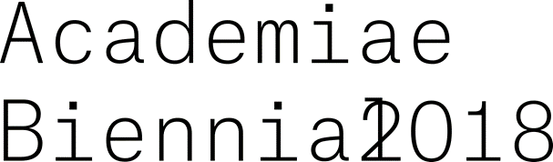**

Franzensfeste Museum – Brixen/Bressanone (BZ)

7 July – 31 October 2018

Grand opening 6 July 2018

18:00-21:00 art-performances

19:00 opening speeches in the presence of the authorities and the guests.

This summer there will be the second edition of the exhibition “ACADEMIAE – Biennale 2018” at the Franzensfeste Provincial Museum. At its centre are works by young artists from the leading art academies in both Europe and further afield, selected by their professors who are themselves established artists on the international scene.

This edition of the biennial, ACADEMIAE 2018, is being curated by Christian Jankowski, himself an artist recognised for his conceptual and performance art. He is active internationally as a curator (Manifesta 2016, Zurich) and he teaches at the “*Akademie der Bildenden Künste* [Academy of Art and Design]” in Stuttgart.

Christian Jankowski is internationally known and appreciated for his “art performances” that involve ordinary people. The collaborative nature of this is a crucial aspect, because every participant – even unintentionally – contributes to the creation of the artwork. On the basis of this concept, it is the curator’s wish that the opening night of the event should feature a series of performances by young artists from the various academies participating in the biennial.

Inspired by the great philosopher Plato, Jankowski has given the title “Where Plato Taught” to this edition of the ACADEMIAE biennial.

In his words: “I want to make the Biennale a place where differing conceptions of teaching become art”. In this way he wishes to create an exhibition that will become a space for encounters between widely differing approaches and trends in the most recent contemporary artistic production, while at the same time analysing the potential of the latest training methods in the field of art.

The exhibition will be staged throughout the various rooms of the Franzensfeste fortress, where each Academy will have its own “pavilion”.

The exhibition will also be accompanied by an extensive catalogue that represents an additional tool for considering and investigating the role of art schools and the methods of artistic training. Interviews and statements will investigate the whys and wherefores of art and the role that it plays, its importance in this day and age and which model of thought it represents.

In parallel with the exhibition at Franzensfeste, on 4-5 July two important meetings/conversations will be held in collaboration with the Free University of Bolzano. These will feature some of the famous artists/professors of the academies that have been invited to the Biennale, and will be hosted by the Dean of the University’s Faculty for Design and Art, Professor Stephan Schmidt-Wulffen.

**Invited Professors and their related Academies:**

Akademie der bildenen Künste, Wien, AT

Prof. Heimo Zobernig

Academy of Arts, Architecture and Design, Prague, CZ

Prof. Aleksandra Vajd

École nationale supérieure des beaux-arts, Lyon, FR

Prof. Marie de Brugerolle

Staatliche Akademie der Bildenden Künste, Stuttgart, DE

Prof.Christian Jankowski

Bezalel Academy of Arts and Design, Jerusalem, IL

Prof. Gilad Ratman

NABA Nuova Accademia di Belle Arti, Milano, IT

Prof. Adrian Paci

Institute of Fine Art, Bergen, NO

Prof. Brandon Labelle

Academy of Fine Arts, Warsaw, PL

Prof. Miroslaw Balka

Faculdade de Belas-Artes da Universidade de Lisboa (FBAUL), PT

Prof. Joao Onofre

Rodchenko Art School, Moscow, RU

Prof. Sergey Bratkov

Konstfack University of Arts, Crafts and Design, Stockholm, SE

Prof. Emily Roysdon

ECAL École cantonale d’art, Lausanne, CH

Prof. Valentin Carron

Royal College of Art, London, UK

Prof. Sarah Staton

Dirty Art Department/Sandberg Institut, Amsterdam, NL

Prof. Jerszy Seymour, Saadane Afif

Mimar Sinan Fine Arts University, Istanbul, TR

Professor: Gülçin Aksoy Özdem

**Associazione ArtintheAlps Verein**

The Association was founded by personalities living in the provinces of Innsbruck, Bolzano and Trento with different professional backgrounds, but a common love and dedication to culture. The *mission* is to promote cultural activities and events - with particular regard to the field of visual art - to enhance cultures, the artistic heritage and local artists, to stimulate the connection between the territory and international art circles and to help consolidate the bridge between different languages and cultures that has always characterised the territories in the heart of the Alps.

**ACADEMIÆ | YOUTH ART BIENNALE 2018**

**“Where Plato taught”**

Fortezza/Franzensfeste - AltoAdige/Sűdtirol – Italy, 7 July - 31 October 2018

Inauguration: 6 July 2018, at 7 p.m.

Info: [www.academiae.eu](http://www.academiae.eu)

**Contacts**

Associazione ArtintheAlps Verein:

President Patrizia Spadafora

Mob. 0039 335 7355820

[Patrizia.spadafora@academiae.eu](mailto:Patrizia.spadafora@academiae.eu)

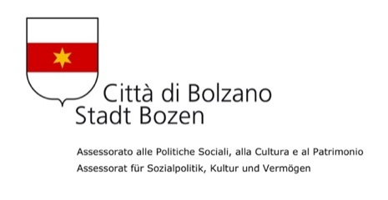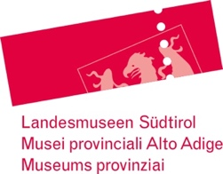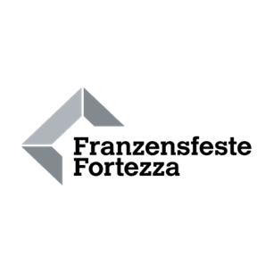loghi/2-%20PROVINZ-%20ohne%20Abteilung%20_3Sp-GKB.pdf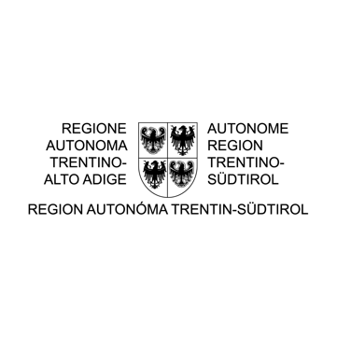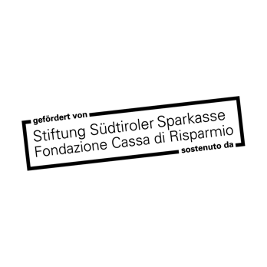loghi/11%20KETTMEIER.pdf