Designing Play for Dark times
Dylan Yamada-Rice, Royal College of Art

Abstract
This article reports on a Knowledge Exchange network project that had the core aim of informing the development of a videogame for hospitalised children. To do this it brought together hospital play specialists, academics and representatives from the digital games industry to coproduce knowledge that could be used in the future production of such a product. The project came about in relation to having identified a lack of research about, and actual physical-digital games designed specifically for children living in adverse (‘dark’) times. This is despite the fact that there is a substantial body of research that has shown how play is beneficial for helping children make sense of what is happening to them, and thus results in better mental, emotional and physical wellbeing. The article describes a selection of the knowledge exchange presentations and activities that were used throughout the project. Specifically these activities used arts and design-based methods as a means of knowing through making. The methods are discussed in relation to how they generated knowledge that responded to the objectives of the project. These were (1) to allow children to express emotions about their illness and/or being in hospital, (2) offer information on the hospital experience, and (3) to develop a design that could cross physical and digital platforms with a space for open-ended child-directed play. As the overarching intention of the project was to generate knowledge across the stakeholders, the project ended by materializing the core findings from the project into a paper prototype of a game on which a hypothetical digital-physical version could be based.
Introduction
This article discusses a project that explored the design of videogames for hospitalised children. It relates to a body of research that has shown how play has therapeutic properties for children’s health and wellbeing, particularly in times of adversity such as natural disasters (Woolley & Kinoshita, 2014; Mutch, 2014; Bateman et al, 2013; Walker et al 2010) and hospital settings (Tonkin 2014; Weldon & Peck, 2014). Given this established connection between play and wellbeing, the project discussed in this article started with the premise that there would likely be benefits in designing play specifically for children living in adverse contexts. This was considered especially pertinent at the time of the project because children living in adverse conditions, such as after large-scale natural disasters are often left without play equipment (Wooley & Kinoshita, 2014), or in the case of hospitalized children using digital games that were not designed specifically to meet their needs.
As a result, this article reports on a project that came about in response to an Arts and Humanities Research Council funding call for networks to look at the development of videogames within specific contexts. It discusses a Knowledge Exchange (KE) project that considered the development of videogames for hospitalized children. The project was framed with the idea that knowledge exchange was essential in this area because videogame designers would be unlikely to have specialized knowledge of hospital play or access to this context. Even though the focus was on digital play, the project was based on a stage prior to the production of an actual videogame. As a result it utilized material rather than digital arts and design-based methods, which were considered a good means of generating knowledge between the network members, who came from three diverse disciplines and thus did not all have specialized technical skills. The network members were Academics with specialisms in physical and digital play and the visual portrayal of emotions in physical and mental health, Hospital Play Specialists and Videogames Designers and Producers.
The paper examines the material methods used in relation to how these generated knowledge from across the network, which used a series of workshops to explore the perspectives of the key stakeholders as a starting point. The article is structured into three parts, firstly a literature review which illustrates the importance of designing play specific for ‘dark times’ in children’s lives. The second section outlines the project methodology that centered on the use of arts and design-based methods as a way of knowing (e.g. Ingold, 2013; Barry, 2015; Douglas et al, 2014; Mäkelä, 2007). Finally, the findings and discussion part is split into four sections that relate firstly to the three project objectives, which were: (1) to create a means for patient-users to express emotions, (2) to develop a design that would be informative of the hospital experience and treatment, and (3) to develop an understanding of how the design could cross physical and digital domains. Each of these three sections describes some of the presentations and practical arts and design methods that were used as a means of knowing. It also discusses how these facilitated knowledge exchange and understanding. Following this the final section shows how the knowledge generated was materialized as a paper prototype of a game on which a future videogame could be based. It is hoped that the processes could be used to think about game design for children living in ‘dark’ times more widely such as after natural and man-made disasters.
Play and Wellbeing in Dark Times
This section provides a brief outline of the literature that has looked at the beneficial connection between play and wellbeing, particularly in relation to ‘dark’ times in children’s lives. In doing so it illustrates why the design of play materials for children specifically in such circumstances should be given greater consideration. The term ‘dark times’ is used here to refer to periods in a child’s life when their everyday play practices are disrupted by adverse events. However, I write this in the sad knowledge that many children live in constant adverse conditions.
Play has long been considered essential to human development and wellbeing (Whitaker et al, 2014). It has also been documented as an effective way to promote health and wellbeing in hospitals (Tonkin 2014). Several researchers have shown how play allows children to make sense of their experiences, express fear, normalise unusual events and thus reduce anxieties (Jun-Tai 2005; Jun-Tai et al 2014; Erikson 1963). In relation to play within hospital settings in particular Jun-Tai (2008) writes:
Play produces comfort and reassurance at a time of unfamiliar and potentially frightening experiences. Play helps to coordinate developmental and learning strategies to help children understand their environment. The multifaceted nature of play contributes to the non-pharmacological approaches to hospital procedures; play is not just for passing time pleasurably or relieving boredom (though both are crucial for a positive experience within this setting).
(Jun-Tai, 2008, p.233)

The above quote shows how the benefits of play are multi-facetted. Play has also been shown to protect against specific types of illnesses that can emerge for children living through an adverse circumstance. This is because it has both therapeutic values that aid recovery (Bateman et al, 2013). Additionally, it has been identified as one key way of building child resilience (Landreth 2002), by ‘afford[ing] children natural resources to meet intellectual and emotional challenge’ (Fearn & Howard 2012, p.456). Also because children become resilient when they are able to make sense of the world (and their ‘dark’ experiences) on their own terms (Werner, 1993). Landreth (2002) states that children’s ‘own terms’ and ‘natural medium of communication…is play’ (p.9), a view that is also held by Fearn & Howard (2012).
The notion of play as a means of resilience in times of adversity appears even more important when taking into consideration the fact that child mental health issues such as depression, anxiety and Post Traumatic Stress Disorder (PTSD) have been shown to be widespread in relation to life altering disasters. For example, Iwadare et al (2014) and Hayashi & Tomita (2012) have reported on the negative impact the 2011 Japanese triple disaster (earthquake, tsunami and nuclear meltdown) had on the mental health of children in the region. The same has also been found to be true of children living in post-disaster environments in other global contexts (e.g. Mullet-Hume et al 2008; Balsuri et al 2010). Further, studies such as Chemtob et al (2008) show children process traumatic experiences in ways that are different to adults. For example, children’s brains are able to process information several times quicker than an adult’s which means they can also develop PTSD faster (Hayashi & Tomita, 2012, p.685).
Given that research such as that outlined above shows the strong link between play and wellbeing in a wide range of adverse situations, it is exceedingly unfortunate that other studies have shown that in times of extreme adversity children are often left with unsuitable play environments and equipment. For example, Woolley and Kinoshita (2014) noted that following the 2011 Japanese disaster children were left with no or very limited play resources. Indeed they observed how children were playing in car parking spaces between temporary accommodations that were not only unsuitable but also dangerous. This means that play environments and resources would seem not to be prioritized in adverse conditions such as natural and man-made disasters, even though play is defined as a fundamental right by Article 31 of the UN (1989) Convention on the Rights of the Child.
Finally, an emerging and important body of research is developing on how play used as ‘therapy’ should take account of the relationship between specific environments and children’s play within them (Hedges, 2014). This seems to suggest that different types of adversity and related environmental contexts might necessitate different types of play materials. However, as yet there is no research that considers the design of play made specifically for environments related to ‘dark’ times in children’s lives, or how the production of this type of game might have additional or different health and wellbeing benefits than those outlined above.
In summary, the overview of the literature on children in living in adverse conditions and play has shown three key connections to its importance. Firstly, that play is a natural medium by which children can make sense of the world. Secondly, that play can bring about resilience and protect against mental ill health, which children can develop more quickly than adults in times of adversity. Finally, that children are often left with little play equipment or spaces that relate to those they would use if they were in calmer/ non-hospitalised times. As a result it would seem that there is space to explore the development of a bespoke physical-digital game for children living in a range of adverse conditions. To this end the project discussed in the remainder of this article focused specifically on creating ideas that could be fed into the design of a videogame for hospitalized children.
Methods and Methodology
As stated previously the project was funded as a Knowledge Exchange (KE) network with the core aim of generating information from varied stakeholders that could be used to inform the development of a videogame for hospitalized children. The intention of ‘informing’ a videogame design meant the project did not create a digital product. Videogames are expensive to produce and so this network project was a first step that focused purely on collating information to inform a videogame design at the next stage. To this end the project had a series of objectives in order to address this core aim. These derived from initial conversations with key stakeholders when writing the bid for funding:
- to allow children to express emotions about their illness and/or being in hospital

- to find ways for a videogame design that informs children of what to expect form their time in hospital, for example helping children to become familiar with hospital spaces and understand medical treatments

- to develop a design that makes use of both physical and digital platforms for play and provides some space for open-ended gaming in which players can use their imaginations to add to the videogame content
The network addressed the above objectives across a series of four, one-day workshops. The workshops focused on the perspectives of each of the key stakeholder’s in turn. These were (1) Hospital Play Specialists (from Sheffield and Birmingham Children’s Hospitals), (2) Academics with specialisms in physical and digital play (Elizabeth Wood and Dylan Yamada-Rice), as well as the visual representation of health issues and emotions (Richard Finn and Matthew Cheeseman) and (3) members of the Videogames Industry (Stripey Design and Distinctive Games). It then concluded with a final workshop day that focused on bringing the themes and ideas that emerged from the three stakeholder disciplines together.
Each workshop included a mixture of presentations and a series of hands-on art and design-based activities such as drawing, re-design, animation and sculpture. These were used to explore the above three objectives. This approach was considered a good fit for two reasons, firstly because the project was focused on pooling knowledge from diverse disciplinary backgrounds, where each member was an expert in their field but with little or no knowledge of the other disciplines. Thus the activities were seen as offering a neutral space of exploration such as in the following example:
The project started with a provocation in the form of a collection of model houses produced by the Artist, Jo Peel (Figure 1):

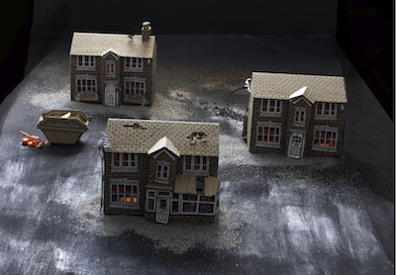
Figure 1 Jo Peel’s Artwork

These models were Peel’s response to a brief asking her to create an artwork that represented her thoughts on what it would mean to be a child in hospital. The brief was deliberately open in order to see what emerged, and use it to create a space for the network to reflect on the project’s starting objectives in ways that might not have been considered before, and thereby launch the project. Peel described how she had created the model houses to symbolise being in a hospital bed. She went on to explain that both houses in a street and hospital beds on a ward look the same from the outside but what happens inside is harder to see or understand. The hospital play specialists described how Peel’s artwork resonated with one of their key concerns for the videogame development which was that it should find a way for isolated patients, confined to beds, to play with others, but also take account of the fact that they might not be able to do this physically due to immobility or contagious illnesses and so began the project…
(Exert from field notes)
Secondly, the art and design methods were playful and creative and therefore blended with the idea of feeding into a hypothetical product for play. Indeed drawing and creating paper prototypes/models are also part of well-established digital game design processes.
Research methods based on making as a means of knowing, such as the ones used in this project are relatively new to social sciences. However, as Ingold (2013) points out humans have a deep connection with materials and a long history of thinking through making with them:
What is the relation between thinking and making? To this, the theorist and the craftsman would give different answers…one makes through thinking and the other thinks through making…The way of the craftsman…is to practice what I would like to call an art of inquiry.’ In the art of inquiry, the conduct of thought goes along with, and continually answers to, the fluxes and flows of the materials with which we work. These materials think in us, as we think through them.
(Ingold, 2013, p. 6)

Similarly, Barry (2015) references a fitting quote by Follett (1930) that ‘concepts can never be presented…merely, they must be knitted into the structure of…being, and this can only be done through [our] own activity’. In response to this Barry (ibid) writes: ‘the only way to understand this is by making things. Thinking about it, theorizing about it, chatting about it will not get you there’ (p.72). Ideas such as these seemed particularly relevant to a KE project where talking about the design would unlikely have lead to producing a concrete idea. In other words the network needed to start making in order for physical game ideas to emerge more tangibly.

Two Information Experience Designer, Caroline Claisse and Xinglin Sun, who at the time were postgraduate students at the Royal Collage of Art, recorded the presentations and data that arose from the making in a series of field notes, photographs and collated artifacts. Some of which they posted on a project blog:
(https://iedgameresearch.wordpress.com).

The blog helped keep track of the project and it was used to draw out key ideas from the first three workshops and inform the plan of the last workshop that focused on bringing them together. In addition to the blog, the field notes taken by network members and Tweets about the workshops, along with all the artifacts that materialized from the arts and design methods were considered as data. They were analyzed using deductive thematic analysis meaning that the project objectives were a core motivation in the seeking of themes (Braun & Clark 2006). In turn this led into the process of materializing the findings as a paper prototype of a game that represented the knowledge generated from the KE activities. In turn it also created a playable prototype for a game that a future videogame product could use as a starting point.

The next part of the article discusses some of the knowledge that derived from the arts and design-based methods in relation to the three project objectives. It shows how each of the methods described brought about a deeper understanding that could be fed into the design of any potential videogame created for hospitalized children.

Findings and Discussion
In order to show how the arts and design methods generated knowledge exchange and understanding that could be fed into the development of a videogame for hospitalized children this part is divided into sections that relate to each of the project’s three objectives. These are (1) creating a means to express emotions, (2) imparting information about the hospital experience and treatment, and (3) finding a way for the game design to cross physical and digital platforms. Each of these three sections discusses some of the key presentations and art and design-based methods to show how these brought about knowledge that could address each of the project objectives.
Creating a means to express emotions
This section shows how some of the presentations and hands-on activities allowed for exploration of project objective one that was to explore how a videogame design could incorporate the need for children to express their emotions about their illness and/or being hospitalized.
Overall the play specialists expressed the desire to be able to personalise the types of play they included in their work in order to allow patients to be able to express their own emotional experiences of hospitalisation and treatment. Other presentations suggested how this might be done through the inclusion of graphic novel/ comic-style visual aesthetics. For example, the academic Sarah McNicol gave a presentation about her previous research looking at the positive impact of graphic medicine on patient emotions (McNicol, 2014). Likewise, Matthew Cheeseman talked about his involvement in the Phoenix project (Hammond, et al 2015) that matched graphic novelists and illustrators with cancer patients so that they could draw the patients’ emotional experiences. Similarly a wide range of literature has shown how comic-style images offer a powerful means of expressing emotions of physical or mental health such as by academics that have focused on graphic novels within the medical humanities genre (see e.g. El Refaie, 2014; Foreceville, 2005; Abbot & Forceville, 2011). The link between comic-style images and the expression of emotions can also be understood further when considering the work of visual mode theorists such as Kress and Van Leeuwen (2006). Kress and Van Leeuwen use the term ‘modality’ to refer to the marker of an image as closely or more distantly related to visual reality. As such the term ‘low-modality’ is term applied to less visually realistic images such as comics and graphic illustrations. This is in contrast to high-modality images such as photographs, which are commonly seen as more realistic. Theorists on high-modality texts such as photographs describe how since the evolution of the medium they have been used to represent ‘miniatures of reality (Sontag, 1977, p.4). Thus photography becomes the medium best suited to representing reality in terms of sight, and comic-style images offer a powerful means of expressing the reality of issues that do not relate to vision, such as those that deal with the emotions of physical or mental health.
The ideas described above were not familiar to all the network members and were indeed just emerging in the work of myself and two other academics in the project, Cheeseman and Finn. As a result two drawing activities led by artists allowed the network members to explore how low-modality graphics such as those used in graphic novels or comics can be used to convey emotions. The first drawing activity was lead by the artist Isobel Williams who started by showing examples of her work that have used drawing in situations were other mediums might have been considered invasive such as allowing cancer patients to express very private emotions and experiences and recording proceedings within legal courts. Following this Williams encouraged the network members to draw items we used as comforters in our childhoods (Figure 2):
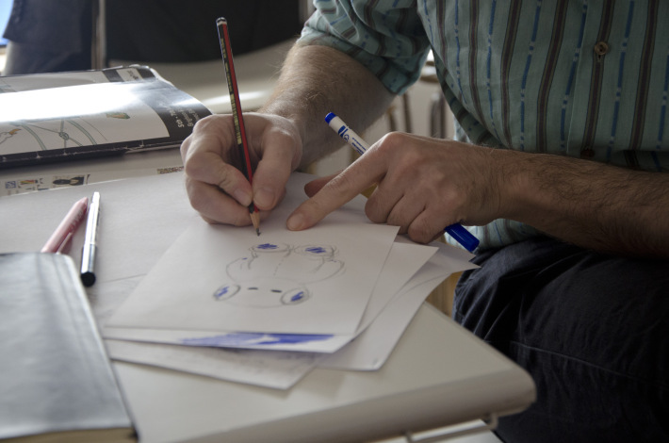
Figure 2: Drawing childhood comforters
The act of drawing made it possible to connect to these objects and memories in a way that Barry’s (2015) words show is powerful:
…using these simple things- our hands, a pen , and some paper- as both a navigation and expedition device, one that could reliably carry me into my past, deeper into my present.
(Barry’s, 2015, p.4)
These words show how the act of drawing allows for the exploration of past memories. In the latter part of the same book, Barry (2015, p.72) goes on to show how such practices also form an essential part of knowledge making. The reason for this also seems to be supported by the work of Kress (2010) who describes how different modes of communication (and thus also the processes we undertake to make them) affect the message. For example, English writing is linear and based on rules that have a strong relationship between time and subject. Conversely, images draw largely on affordances of space. Thus the act of drawing our childhood comforters allowed the network members to remember and think about the emotional comfort of childhood objects in ways that could not be achieved through other modes of communication such as speech or writing. In any case the act of drawing also brought about a great deal of talking too.
Another graphic artist, Andrew Godfrey instigated a second practical exercise were all network members drew self-portraits with a decreasing number of lines (Figure 3).
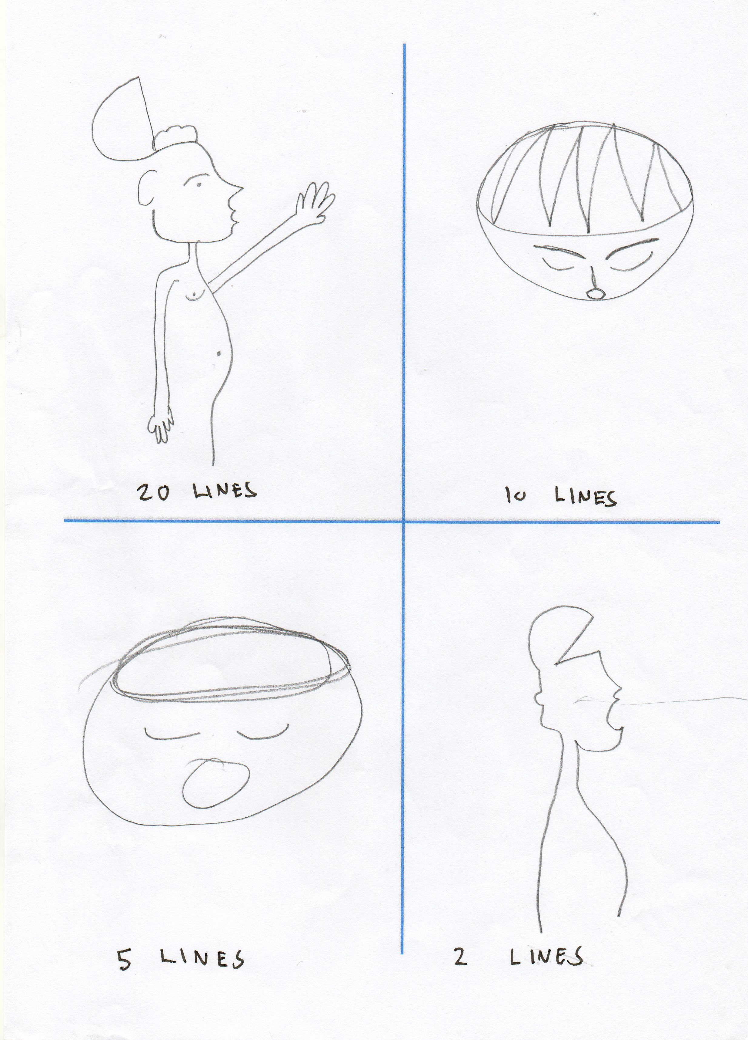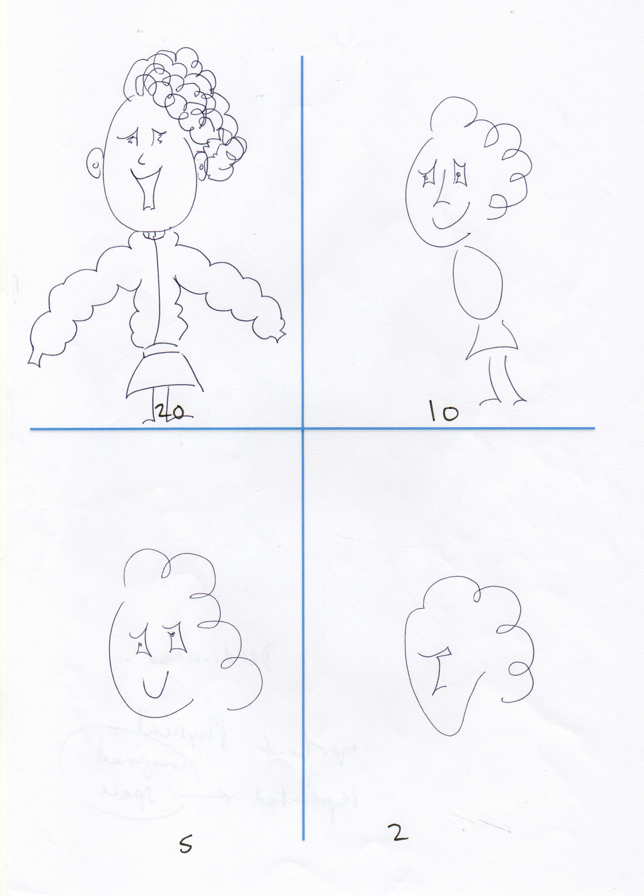
Figure 3 Self-portrait made with a decreasing number of lines
Drawing with a decreasing number of lines made it possible to understand how the modality of the image changed. Specifically the lower the number of lines the more simplistic the image became and thus the lower its modality. As a reminder the lower an image’s modality the further it is from reality sensed through vision. Further, discussion emerged about what can be removed from a visual text without affecting the overall meaning being conveyed. Also how simplifying a visual text not necessarily depleted the message but allowed other parts of it to be conveyed such as emotional representation. The comic theorist McCloud (1993) shows another important affordance of low modality images:
When you look at a photo or realistic drawing of a face you see it as the face of another. But when you enter the world of the cartoon you see yourself.
(McCloud, 1993, p.36)
McCloud illustrates this through a diagram that starts with a photographic depiction of a face through to a gradual reduction of modality until it reaches the representation of a face as a simple circle with two dots to represent eyes and a line for the mouth (p.31). McCloud’s diagram and above quote shows how extreme simplicity in visual depiction makes it easier for a wider range of viewers to relate to the image, because the more simplistic an image the more the viewer is able to overlay their own experiences and sense of self onto the character and wider narrative being depicted. This was of great importance to this project as the videogame’s aesthetics would need to be such that the narrative conveyed could be relatable to children from a wide range of backgrounds.
The combination of the presentations about first-hand experiences of working and researching within medical contexts, as well as from the producers of graphic narratives and the drawing exercises above made it possible for the network to understand how simplifying visual texts altered and changed the message conveyed with them. As a result the network concluded that if low-modality images were used to depict characters in the videogame’s narrative it would likely make it easier for hospitalised users to personalise the story by being able to bring in their own experiences and emotions into their play.
The next section describes some of the presentation and hands-on activities that were used to respond to the second project objective of exploring how the videogame design could be used to impart information about the hospital experience and treatment.
Imparting information about the hospital experience and treatment
The presentations from the play specialists working at the Sheffield and Birmingham Children’s Hospitals described how current play practices are primarily used to help familiarise children with the hospital experience and the processes they will go through. Kevin Hartshorn from Sheffield Children’s Hospital talked about his experiences of using play to help patients express their emotions in relation to different aspects of the hospital experience. These included preparation for a hospital stay, as well as play for distraction, developmental and rehabilitation, post-procedural and bereavement purposes. Medikidz, a medical education company that produces superhero comics explained how they use the medium as a means of explaining a range of illnesses to children. The network members explored the idea of how illustrations and comic books could incorporate ideas of being hospitalized and treatment through a practical workshop. Specifically, I led a re-design sessions in which members were asked to choose a children’s picture book and alter it so that the context of the narrative became about being hospitalized (Figure 4).

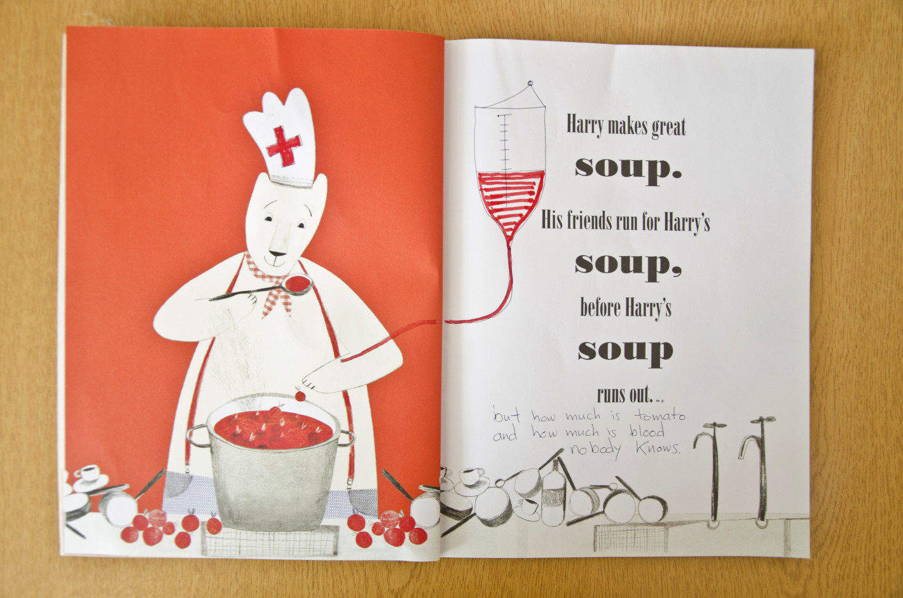
Figure 4: Redesigning picture books

The activity showed how it was possible to have fun with serious narratives in a way that would seem to make it possible to give factual information and allow children to experience playful texts at the same time. This tied with discussion that arose in relation to a presentation by Elizabeth Wood that showed how children often play with ‘dark’ narratives (such as the one shown in Figure 4) but that adults are often uncomfortable with this. Wood described how adults have a tendency to change children’s play to suit adult needs such as by trying to use it to bring about specific learning goals, or in a hospital setting to acclimatize children to the medical context. As a contrast she drew on the work of Michelle Hill, who at the time was Wood’s doctoral student to describe how without adult intervention some types of play are troubling for adults. Hill’s (2015) research shows how children regularly incorporated the theme of death and dying into their play. She collected data of children acting out a shark attack. This included photographs of children lying motionless on the floor with their faces and bodies covered in tissues to represent death. The hospital play specialists described how such themes of play were initially troubling for them because the narratives were very close to the realities of their working lives, which included child death.

Through the process of redesigning the picture book narratives the network began to consider how it might be possible to include factual information in a more playful manner compared to more traditional means such as patient information sheets. This is supported by the work of McNicol (2014) who states that although the information contained in medical humanities comics may be similar to patient information leaflets, comics have many additional benefits, such as ‘the way they can offer companionship, helping patients to address fears and negative feelings’ (p. 49). Further, a presentation by Andrew Chantry a Hematologist and Academic about a videogame he had created to visualize Blood Cancer showed how likewise videogames might be able to offer additional benefits for patients beyond imparting medical information too. This was an idea that also emerged from the second redesign activity.

In the second redesign activity network members were asked to alter an existing children’s games to connect to a hospital context and thus explore some of the ideas of playing with dark themes such as death and dying that research such as Hill’s (2015) above shows children do naturally. In relation to this one group used the board game Simpsons Monopoly as a starting point (Figure 5):
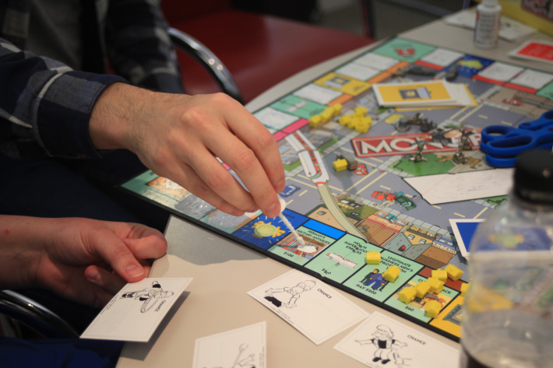
Figure 5: Zombie Game

The group began the redesign process by thinking about how the game could be used to convey information about different hospital departments and spaces. The idea came from a presentation by Jo Birch on her involvement in the ‘Space to Care: children’s perceptions of spatial aspects of hospitals’ project (Curtis, 2007) which showed how children wanted more information about what happens in the range of hospital spaces and departments. As a result the different areas of the Monopoly board which relate to streets and property were turned into different hospital spaces. In so doing when players moved around the board instead of receiving cards representing land they would receive information about the hospital spaces. In order to embed a narrative in keeping with the findings of Hill’s work (2015) that children like the opportunity to explore ‘dark’ narratives the game was recreated to have a zombie theme in which the aim was to move around the board avoiding treatment in the different spaces of the hospital and thereby remaining dead. The process of redesigning the board game brought about a discussion across this particular group of network members about how many of the digital apps and narratives for hospitalised children had a very strong narrative around pushing the information of the hospital perspectives and also how children’s play is often manipulated by adults in this way. The group wanted to take the design back to children’s initial interests in death and dying.

The two redesign activities (books and board games) allowed the network members to co-produce an understand that children might need a space to play with topics connected to their feelings about being hospitalized, but at the same time it should be taken into consideration that adults connected to the child might find this difficult. Therefore the network began to explore how an open-ended space within the videogame design could allow children to explore their emotions while not making this an explicit part of the gaming narrative. It is difficult to understand how such knowledge could have come about had it not been through making. The processes of cutting, drawing and sticking promoted understanding and conversation in ways that academic discussions rarely do. Indeed this was illustrated by the difficult silence following the first academic presentation by Wood on Hill’s (2015) research, which the Hospital Play Specialists found difficult listening. .
Overall the activities described in this section and the last showed how the best aesthetics for the game design would likely use both low and high modality images; low-modality to allow users to convey their emotions, and high-modality to depart factual information about the hospital and treatment.
The next section describes the findings in relation to crossing physical and digital platforms of play and how these arose in relation to specific presentations and hands-on art and design methods.
Crossing physical and digital platforms of play
Presentations on crossing physical and digital platforms were given by network members and other invited guests from the videogames industry. Claudio Franco from Dubit talked about narrative in game adaptations from other media to show how they changed across a range of media. Specifics about how physical-digital games can cross platforms were given by Steve Taylor from Stripey Design who showcased an augmented reality app they had designed and produced called Squiggle fish. The design of which is a digital aquarium that children can add to by drawing physical pictures using pens and paper of things they would like to put into the aquarium. The drawings are uploaded to the app using a tablet’s inbuilt camera. Once upload the drawn images are animated and swim around in the digital aquarium. All network members tried out Squiggle Fish in order to think about differences in play across the physical and digital platforms (Figure 5):
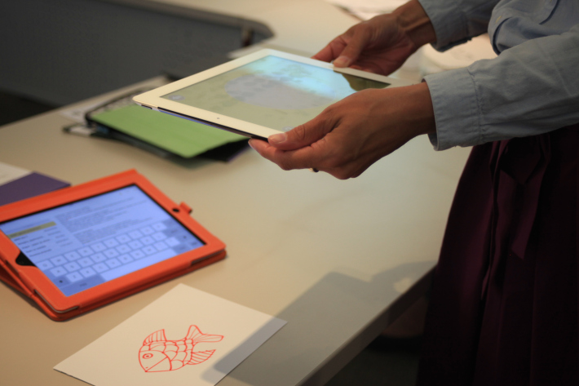
Figure 6: Squiggle Fish app
Playing the game was a good way of understanding how the narrative of a game changed across platforms. This was an area the network explored further by playing digital and physical versions of the same game narrative such as, the Angry Birds app (Rovio Entertainment Ltd) and the physical game Angry Birds: Starwars Death Star Jenga.
Using these ideas the network members were also asked to explore the use of the physical and digital domains in the board game redesign session (outlined above). In relation to this one group designed a game called Cancer Tower based on the three-dimensional game Jenga. The idea of Jenga is for each player to remove one block from a stack of them and place it on the top without the stack falling over. The team redesigned Jenga so that the stack of blocks would represent the body, and that some of the block ends were coloured red (Figure 7):

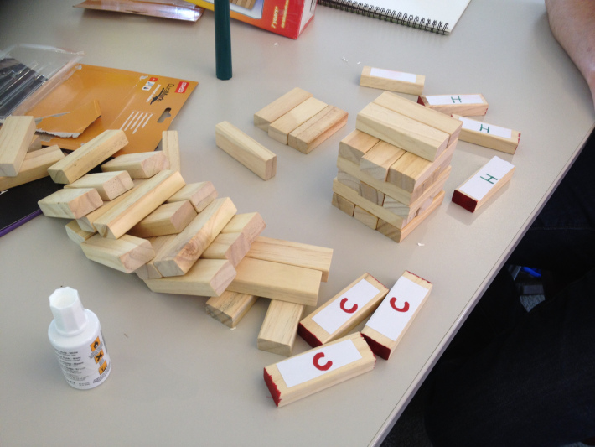
Figure 7: Cancer Tower

The colour was used to indicate cancerous parts of the body, which players could get extra points for successfully removing. After playing the game a few times the group decided to add a twist to ensure the game remained interesting. This twist was that after removing some of the red blocks players might discover that the piece was actually healthy (marked with an H) and then loose points. For the digital layer they described how each red block would be capable of being scanned with a tablet to get health information related to being in hospital. The designers described their feeling when playing the game:
We know, this sounds horrible but it is an experiment! Indeed, it was surprising how using game and play enabled us to go a bit “crazy” and dark with such a topic…So with this new version, players would hopefully understand that you can have things taken out from your body but you could still stand up ok (…) Once taken out, the red bit which were thought bad could be revealed as being indeed healthy parts (green H). This illustrates the risk taken sometimes by doctors in order to cure their patients (https://iedgameresearch.wordpress.com).
The redesign activity showed again how it was possible to combine children’s interesting in ‘dark’ themes while also conveying factual medical information. Further, it also facilitated understanding across the network on how narratives made on either physical or digital platforms will differ from one another. For example, screens foreground image (moving and still) and sound whereas physical gameplay allows tactile forms of communication that are not yet possible in digital forms. Again Kress’ ideas (2010) were useful in thinking of the importance of this. In particular about how with each shift in modal foregrounding the elements of a text’s message alter. The redesign activity brought about discussion in relation to which parts of the game’s narrative would be better suited to the physical and/ or digital domains.
The final section looks at how the knowledge that was generated from the workshops and shown above were materialised as a paper game prototype.

Materialising the findings
The findings that emerged from across the four workshops in relation to the three objectives of the project were materialised in the form of a paper prototype for a game called Hospital Heights (Figure 8).

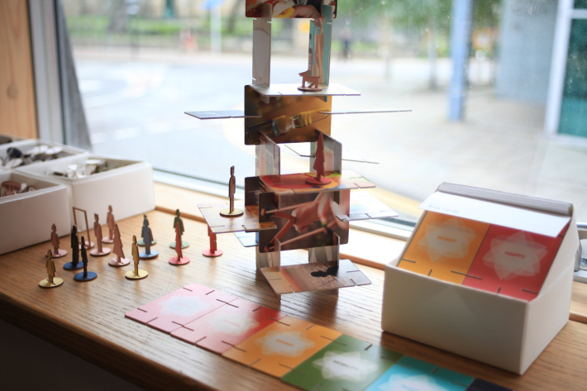
Figure 8: Hospital Heights (© Caroline Claisse/Xinglin Sun/Dylan Yamada-Rice/Elizabeth Wood
Hospital Heights is three-dimensional game based on a combination of ideas from traditional physical games such as Top Trumps and Eames House of Cards. At the start the game is played in a similar way to Top Trumps where each player has a series of cards with categories and related scores. On their turn a player calls out a category and everyone playing checks their score for it. The person with the highest score wins the cards of all the other players from that round. In the Hospital Heights version the cards are toughened with photographic images on one side of play and medical equipment and spaces. On the other side the categories relate to physical and emotional themes in relation the image on the other side of the card, such as mobility, opportunity to have your own space, playfulness and worry. The representation of these spaces and equipment in photographs tied to the findings that high-modality images are best connected to conveying factual information.

In the second stage of the game play, when a player wins cards they slot them together to form a structure of their choice. This idea was drawn from the Eames House of Cards design. It also related to one of the project findings that children would benefit from having an open-ended space of play. It this sense building with the cards allowed players to make a unique structure and develop the narrative in their own way. This drew on ideas such as those that emerged from considering Hill’s work (2015) on how children require free-play spaces to explore ‘dark’ themes.

The final game feature was that for each card won the player was rewarded with a simplified figure that related to family members or hospital staff. These could be placed and played with within the card structure each player had created with his or her winning cards. The low-modality of the game’s characters responded to the project finding that this would allow children to add their own experiences and emotions and thus provide the opportunity to form characters that relate to their own experiences of being in hospital.
Overall the production of the Hospital Heights game materialized the themes that arose from the network project in relation to the three objectives. In doing so it also addressed the core aim of the project, which was to produce information from across the stakeholders on which a future videogame design could be based. Finally materializing the findings in this way also brought the concept of game design to the heart of their dissemination.
Conclusion
This article has focused on the experimental art and design methods used in a network project to encourage knowledge exchange between Hospital Play Specialists, Academics and Videogames Designers in order to generate insight that could be used to inform the design, and ultimately production of a videogame for hospitalized children. The methods took place across a series of four one-day workshops that explored the perspectives of these stakeholders and the bringing together of insight from them.

Each of the making activities was led by an artist, animator or designer, which was considered fundamental to the success of the project because their skills were vital in creating a series of activities that could be used with members from a wide range of backgrounds. It is increasingly popular for social scientists to include artists at the impact stage of research in order to design dissemination means. While this is a good activity for encouraging a wider range of audiences to interact with research findings, this project believed creative professionals have skills that can be embedded more deeply within social science research processes. The power of including creative practices were felt in this project where they helped participants from very different backgrounds come together and generate understanding to be included in the production of a hypothetical videogame for hospitalized children. These were (1) the need to use low-modality visual aesthetics within the gaming narrative to allow children to bring in their own experiences and emotions into the game play, (2) the need to use high-modality images in the portrayal of factual rather than emotional information, (3) the need to include medical narratives in a way that was both informative and also allowed children to play with ‘darker’ themes of being hospitalised or ill, and (4) the need to consider the affordances of the physical and digital platforms of play and which offers the best platform for different parts of the game narrative. Overall the adult network members felt that the inclusion of these aspects within the production of a videogame could potentially respond to the specific needs of hospitalised children. As a next step before production it would be important to see how children themselves respond to the ideas of the knowledge exchange project.

Hopefully this project can act as a springboard for others considering the design of play to support children in ‘dark’ times more widely, such as during conflict or in the aftermath of natural or man-made disasters. As well as to encourage the videogames industry to think about making games specific for children living in adverse conditions. In doing so, it is thought that the creation of videogames specifically for this context might add to the findings of research to date that have already shown how children’s emotional wellbeing can be promoted by play in adverse conditions (e.g. Iwadare et al, 2014; Hayashi & Tomita, 2012; Mullet-Hume et al, 2008; Balsuri et al, 2010). In this sense a hospital stay was used as an example of a ‘dark’ time but the methods described could be applied to the development of play in relation to other difficult periods too.
References
Abbott, M. and Forceville, C. (2011) Visual representations of emotion in manga: loss of control is loss of hands in Azumanga Daioh volume 4. Language and Literature, Vol. 20, No.2, p.91-112.
Balsari, S., Lemery, J., Williams, T.P. & Nelson, B.D. (2010) Protecting the children of Haiti. N Engl J Med, Vol.362, e25.

Barry, L. (2015) Syllabus: Notes from an Accidental Professor. Drawn and Quarterly: Malaysia.

Bateman, A., Danby, S. and Howard, J. (2013) Everyday preschool talk about Christchurch earthquakes, Australian Journal of Communication, Vol.40, No.1. Available online at: <http://austjourcomm.org/index.php/ajc/article/view/21>. [Accessed 15/11/14].

Braun, V. & Clarke, V. (2006) Using thematic analysis in psychology, Qualitative Research in Psychology, Vol. 3, No. 2, p.77-101.

Chemtob, C. M., Nomura, Y. & Abramovitz, R. A. (2008) Impact of conjoined exposure to the World Trade Center attacks and to other traumatic events on the behavioral problems of preschool children. Arch Pediatr Adolesc Med, Vol.162, p. 126-33.
Curtis, P. (2007) Space to Care: Children's Perceptions of Spatial Aspects of Hospitals: ESRC Full Research Report, RES-000-23-0765. Swindon: ESRC.
Douglas, A., Ravetz, A. Genever, K., Siebers, J. (2014) Why Drawing Now? Journal of Arts and Communities, Vol, 6, No. 2-3, p.119-131.
El Refaie, E. (2014) Looking on the dark and bright side: Creative metaphors of depression in two graphic memoirs. a/b: Auto/Biography Studies 29(1), 149-174.
Erikson, E. H. (1963) Childhood and Society. New York: Norton.

Fearn, M. & Howard, J. (2012) Play as a Resource for Children Facing Adversity: An Exploration of Indicative Case Studies. Children & Society, Vol.26, No.6, p.456-468.

Forceville, C. (2005) Visual representations of the Idealized Cognitive Model of anger in the Asterix album La Zizanie. Journal of Pragmatics, Vol. 37, p.69-88.
Griesharber, S. and McArdle, F. (2010) The Trouble with Play. Maidenhead: Open University Press.

Hammond, N., Cheeseman, M., Chantry, A. and Peng, A. (2015) ‘Visual methods, surviving cancer and sexuality: a reflection on negotiating ethical issues and developing academic/artistic partnerships’.Journal of Families, Relationships and Societies, Vol. 4, No.3, p. 483–492.

Hayashi, K. & Tomita, N. (2012) Lessons Learned from the Great East Japan Earthquake: Impact on Child and Adolescent Health. Asia-Pacific Journal of Public Health, Vol. 24, No. 4, p. 681-688.

Hedges, H. (2014) Young children's 'working theories': Building and connecting understandings. Journal of Early Childhood Research, Vol. 12, No. 1, p.35-49.

Hill, M. (2015) Dead forever: young children building theories in a play based classroom. Unpublished Doctoral Thesis, University of Sheffield.
Ingold, T. (2013) Making. London and New York: Routledge.
Iwadare, Y., Usami, M., Suzuki, Y., Ushikima, H., Tanaka, T. , Watanabe, K., Kodaira, M. & Saito, K. (2014) Posttraumatic Symptoms in Elementary and Junior High School Children after the 2011 Japan Earthquake and Tsunami: Symptom Severity and Recovery Vary by Age and Sex. The Journal of Pediatrics, Vol. 164, No. 4, p. 917- 922.

Jun-Tai, N. (2008) Play in Hospital. Pediatrics and Child Health. Vol. 18, No. 5, p.233–237.

Jun-Tai, N. (2005) Factsheet No.6. Play in Hospital. Available on line at: <http://www.ncb.org.uk/media/124842/no.6_play_in_hospital.pdf>. [Accessed 01/11/14].

Kress, G. (2010) Multimodality: A social semiotic approach to contemporary communication.
Oxon: Routledge.

Kress, G. & Van Leeuwen, T. (2006) Reading Images: The Grammar of Visual Design. Routledge

Landreth, G. L. (2002). Play therapy: The art of the relationship (2nd ed.). New York & Hove: Brunner-Routledge.

Mäkelä, M. (2007) Knowing Through Making: The Role of the Artefact in Practice-led Research. Knowledge and Policy, Vol. 20, No.3, p.157-163.
McCloud, S. (1993) Understanding Comics. Northhampton, MA: Kitchen Sink Press.
McNicol, S. (2014) Humanising illness: presenting health information in educational comics. Medical Humanities, Vol.40, p.49-55.
Mullett-Hume, E., Anshel, D., Guevara, V., & Cloitre, M. (2008) Cumulative trauma and posttraumatic stress disorder among children exposed to the 9/11 World Trade Centre attach. Orthopsychiatry, Vol. 78, p.103-8.

Mutch, C. (2014) The role of schools in disaster settings: Learning from the 2010- 2011 New Zealand earthquakes. International Journal of Educational Development.

Sontag (1979) On Photography. Penguin
Tonkin, A. (2014) Introduction. In: Tonkin, A. (2014) Play in Healthcare: using play to promote children development and wellbeing. Routledge: Oxon & New York.

Walker, M., Whittle, R., Medd, W., Burningham, K. Maran-Ellis, J. and Tapsell, S. (2010) Children and young People ‘after the rain has gone learning lessons for flood recovery and resilience, final report for ‘children, Flood and urban Resilience: understanding Children and young People’ s experience and agency in the flood recovery process. Lancaster University, Lancaster, UK.

Weldon, C. and Peck, H. (2014) Play and Recreation. In: Tonkin, A. (ed) (2014) Play in Healthcare: Using Play to Promote Child Development and Wellbeing. Routledge: London & New York. Chapter 5.

Whitaker, J., Barbour, F. & Weldon, C. (2014) The Development of play and recreation in Healthcare Settings. In Tonkin, A. (2014) Play in Healthcare: using play to promote children development and wellbeing. Routledge: Oxon & New York.

Woolley, H. & Kinoshita, I. (2014) Space, People, Interventions and Time (SPIT): A model for understanding children’s outdoor play in post disaster contexts based on a case study from the triple disaster area of Tohoku in north east Japan, Children and Society. Early online version available at: < http://onlinelibrary.wiley.com/doi/10.1111/chso.12072/abstract> [Accessed 5/12/14].

