THE PRAGMATICS OF ARCHITECTURAL ENUNCIATION

Authors: Godofredo Pereira and Susana Caló

[forthcoming Architectural Theory Review – PLEASE DO NOT CIRCULATE]

1
From local political transformations to territorial and geopolitical ones; from real-estate projects to disciplinary debates; from technological developments to mutations in domestic life – architecture participates in, transforms and reorganizes very different socio-material assemblages. And yet very little of this gets adequately framed in architectural theory. While critical analyses commonly disregard the multiplicity and heterogeneity of the forces at work in the design in their quest for overarching ideas and concepts, the pragmatics of architecture’s existence are frequently simplified by the reification of the architectural object as the site for innovation. Often, the reaction to this focus on the object is equally problematic, abandoning architecture to sociological or anthropological accounts, the result of which is the introduction of an apolitical distance between object and use. The work of philosophers Gilles Deleuze and Félix Guattari offers an important perspective from which to engage in this discussion. Their joint work on abstract machines and, particularly, Deleuze’s interpretation of Foucault’s diagram as a cartography of relations between forces have often been mobilized for discussions of how power operates through architecture. However, it is Guattari’s solo work that we think provides the most effective basis from which to understand the pragmatics of the architectural project, including the multiple assemblages that architecture enters into and how it does so.

2
In an essay first published in Schizoanalytic Cartographies, Guattari elaborates on what he calls ‘architectural enunciation’. The concept of enunciation is generally attributed to linguist Émile Benveniste. Benveniste proposed shifting the question of language from a study of the internal relation between signs (as pioneered by Saussure) to the act and circumstances of producing a statement. This act and circumstances of production were defined as enunciation. In his view, language was dependent on enunciation to be realized. Guattari’s use of the term echoes Benveniste’s focus on the pragmatics of the statement. However, Guattari’s notion can be applied beyond the linguistic domain. Enunciations can be spatial, musical, technical, political, etc. Moreover, for Guattari enunciation is not the product of an individual as it was for Benveniste – the speaking subject – but of a collective, a multiplicity rather than a self, a collective pragmatics of sign production that goes beyond linguistic structures alone. Hence, enunciation is never really a matter of the linguistic statement only, but of an intervention in a particular context. It is, in essence, an existential matter. Likewise, it is also something that cannot be repeated.

In this conceptualization of enunciation we find an opportunity to precise the concept of project in architecture, conceptualized as an intervention with a transformative character. However, this requires some additional unpacking as Guattari differentiates two different modalities through which enunciation works: the ‘polyphonic’ and the ‘ethico-aesthetic’. The polyphonic modality refers to expressive materials and the ethico-aesthetic to affective materials. This distinction is crucial both in reference to Guattari’s broader philosophical and semiotic project and also for our current purpose. Let us start by focusing on the polyphonic modality. Guattari defines eight types of the key assemblages of enunciation of which architecture is part, each providing different expressive materials: these are Geopolitical, Urbanistic, Economic, Functional, Technical, Signifying, of Existential Territorialization and Scriptural. To exemplify, a land-use regulation corresponds to an urbanistic assemblage of enunciation; the determining of the thickness of a wall according to materials and their behaviors such as insulation coefficients or load is part of a technical assemblage of enunciation; and a signifying assemblage of enunciation can refer to the allocation of content to a built form such as the cruciform plan of a Catholic church. As we mentioned before all of the above correspond to Guattari’s understanding of enunciation as polyphonic: it consists of expressive materials with a concrete material and spatial existence, and is termed polyphonic in the sense of the multiple ‘voices’ at play. Of primary importance is the fact that the different expressive materials are coexisting, interacting yet autonomous and showing distinct standpoints.
Let us now turn to the other dimension of Guattari’s schema, the ethico-aesthetic, which corresponds to the affective modality of enunciation. Guattari argues that in addition to expressive materials that result from the different assemblages of which architecture is part, architectural enunciation also involves materials that are not expressive but affective. Crucial here are the processes that the architectural object elicits, not as a ‘gestalt’ or ideal form closed upon itself but as what Guattari describes as a ‘catalytic operator’. Guattari referred to these as ‘spatialized affects’, examples of which would be the intimate memories, passions or fears that are brought forward by composing a space that resembles one from our childhood, or the sensation of repetition produced by a certain rhythm in the setting out of a building’s elevation – sensations that act upon us regardless of us perceiving them or not.

With this brief introduction to the polyphonic and ethico-aesthetic modalities of enunciation we have sketched out how Guattari’s semiotic framework is able to foreground the multiplicity of processes at work in the project. Conceived in these terms the project emerges as an intervention that operates through the composition of expressive and affective materials – an intervention that is collective and unrepeatable.

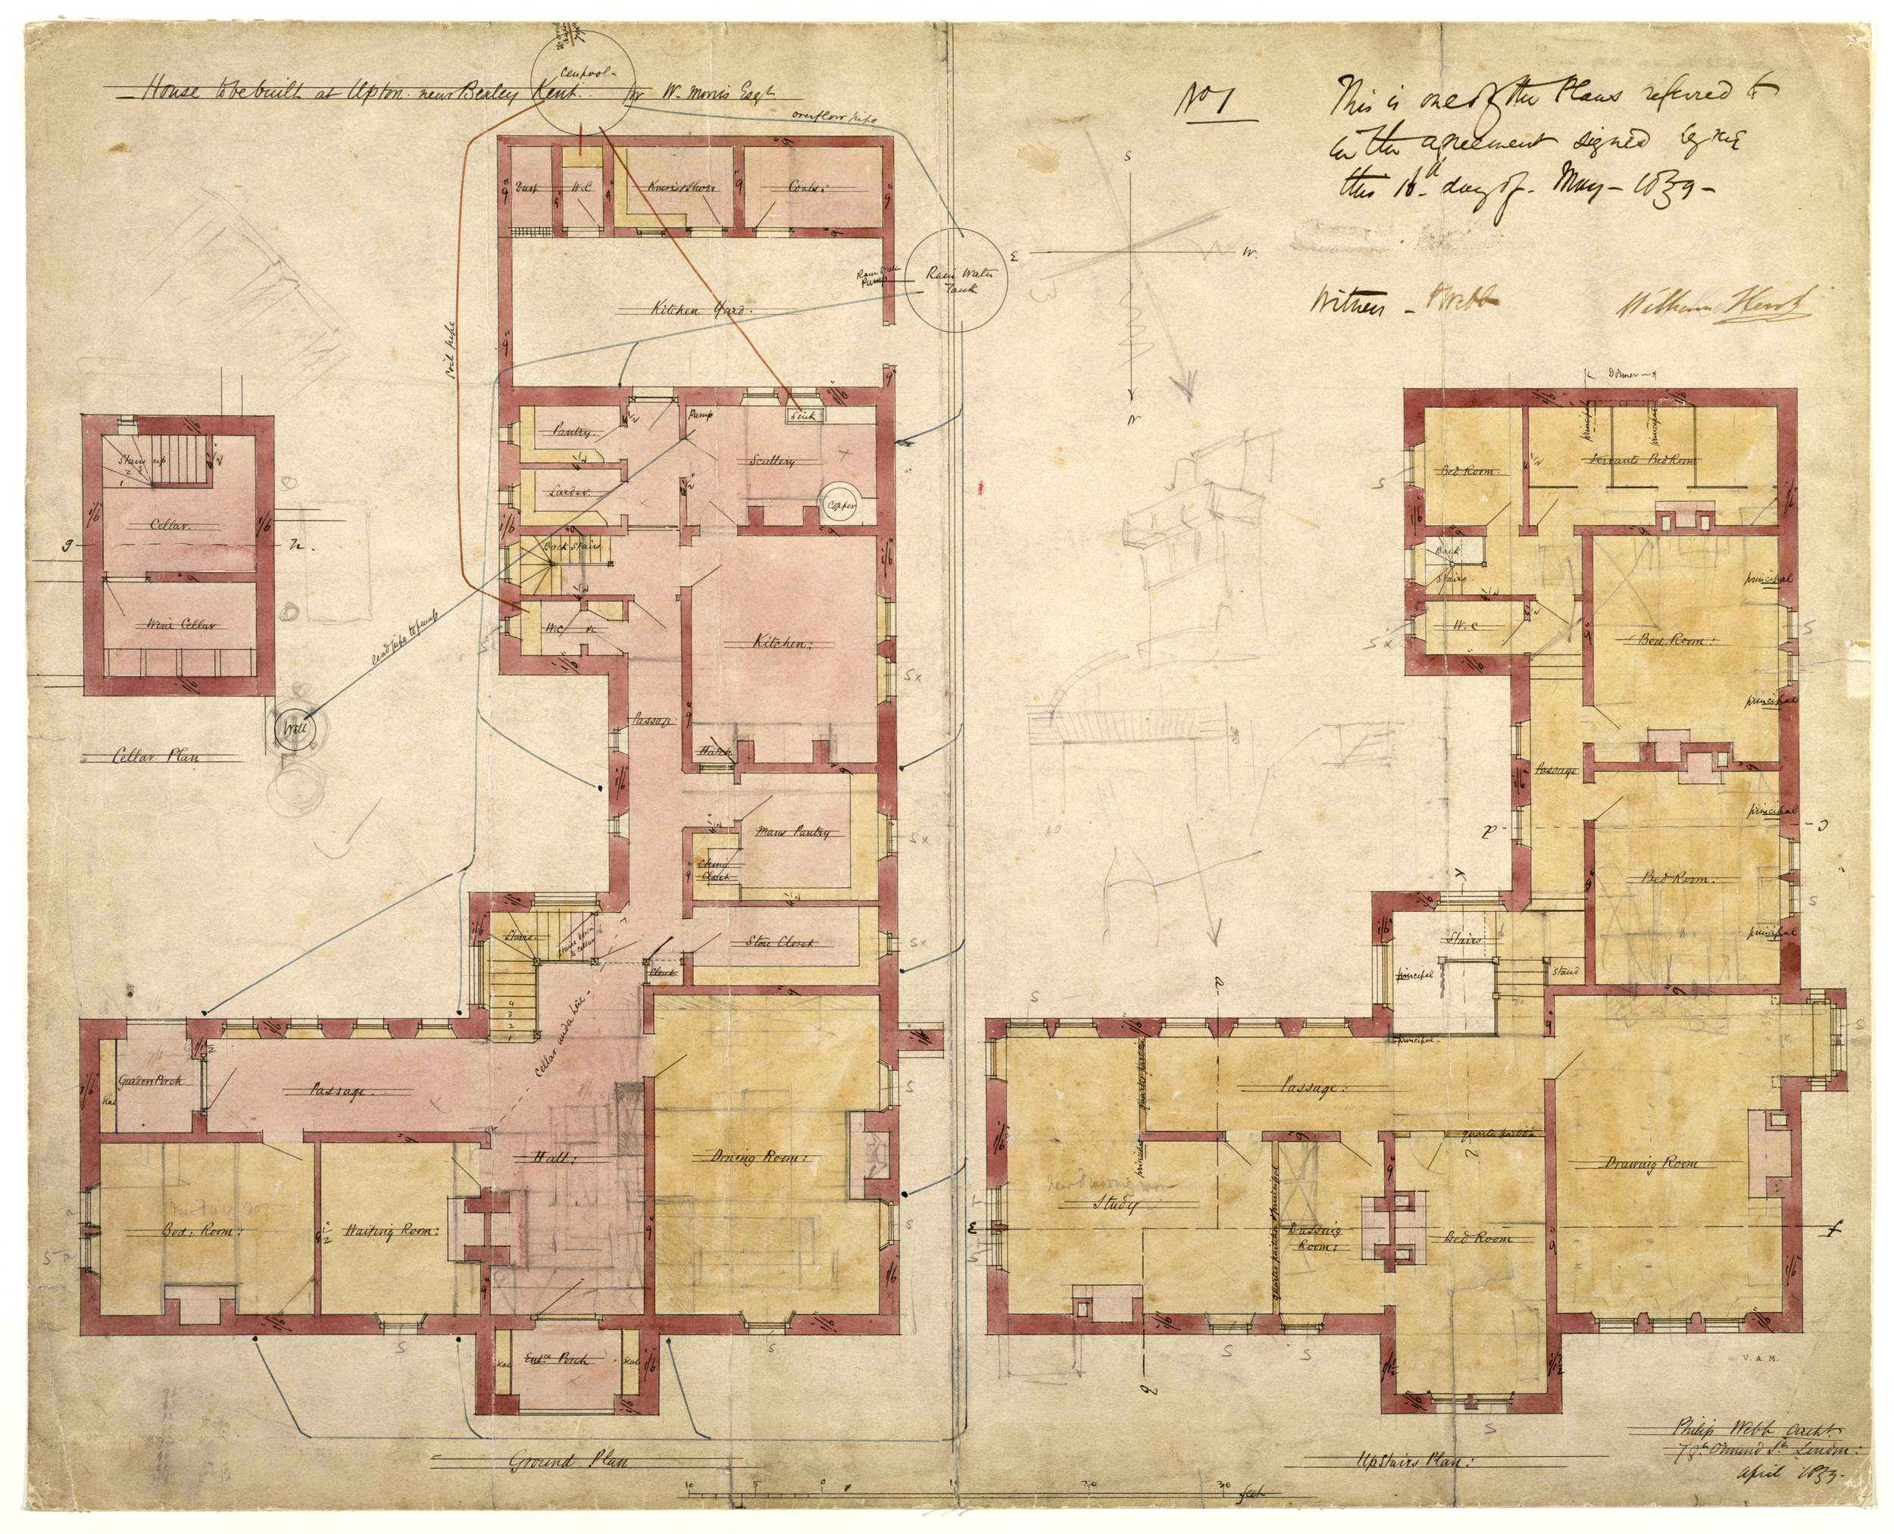
Design for Red House, Upton, Bexleyheath, by Philip Webb, 1859. Contract drawing showing plans of the ground and first floor of Red House, designed by Philip Webb for William Morris. The plans are shaded with orange and pink wash and annotated in black ink. There are pencil sketches throughout, showing alterations and details of the chimneys. The drawing is signed and dated by Webb in the lower right corner, and by the builder, William Kent, in the upper right corner. © Victoria and Albert Museum, London

3
To clarify the relevance of this conceptualization to a renewed understanding of the project and its pragmatics we will discuss the Red House designed in 1859 by Phillip Webb for William Morris in Bexleyheath, which would become the birthplace of the Arts and Crafts movement. To make matters clear, we will address these two modalities separately, starting with the polyphonic.

The basic architectural layout of the Red House is an L shape that is two stories high. The L delimits a patio at the center of which lies a well. An existing orchard of apple and cherry trees encloses the other half of the patio. From the outside the Red House has a castle-like appearance with gothic windows and simple red brick. The chimneys and different shapes of the windows give rhythm to its volume. On the inside the rooms are oriented in an unusual way, with sitting rooms and drawing rooms facing north (with the exception of Morris’s studio), whereas the corridors and staircases face the sun-lit patio. Between 1859 and 1865 several people lived in the Red House together with the Morris family. Collectively they designed its wallpaper, painted the walls and designed and built its furniture. The Red House functioned as the testing ground for Morris’s company ‘The Firm’.

The historiography of the Red House is disputed in terms of its revolutionary character and importance. Hermann Muthesius described it as ‘the first house to be conceived and built as a unified whole inside and out, the very first example in the history of the modern house’. In a similar vein, for Nikolaus Pevsner, it was one of the pioneering buildings of the Modern Movement due to the relation of the simple elevation with the interior. However, for Brandon-Jones the Red House was far less unique as it followed closely G. E. Street’s designs. Similarly, for Henry-Russell Hitchcock it was little more than a typological variation of both Street and William Butterfield vicarages and parsonages, with their red brick walls, simple lines, high-pitched roofs and functional internal circulations. In all these readings, the key critical factors to understand where the Red House stands in the history of architecture are its use of red brick, the medieval construction techniques, the simplicity of its lines and the styles and influences manifest in its design and decoration. These are particular components or aspects whose presence is seen either as evidence of a breakthrough (precedent to modern architecture) or as following a tradition set up by Webb’s masters.

Following this critical method a particularly insightful analysis of the Red House is that by Robin Evans, in his essay entitled ‘Figures, Doors, Passages’ from 1978. In it Robin Evans addresses the paradox between Morris and Philip Webb’s radical questioning of Victorian society and their tacit implementation of nineteenth-century accepted spatial conventions. Evans referred to the lower- and upper-floor corridors, which not only allowed for familial ideas of privacy but also structured divisions of labor between master and servants. The corridor, Evans reminds us, has a fairly recent history, making its first appearance in England in the late seventeenth-century and becoming widely accepted during the nineteenth-century, as a replacement of the thoroughfare. For Evans, the existence of the corridor indicated that the Red House was far more common in social principles than might be expected from Morris’s notorious social extravaganza. In his view, Morris’s interest in the medieval period was mostly spiritual and did not extend to its carnal aspects. To further this point, Evans mentions the abstract diagrams of trajectory and position that Robert Kerr used to promote the privacy standards of Victorian society. According to Evans, the Red House would be the perfect illustration of these diagrams as ‘rooms never interconnect, never have more than one door, and circulation space is unified and distinct’. Evan’s analysis is both beautifully written and sharp, cutting through accepted conventions to reveal the underbelly of Webb and Morris’ project, and, indeed of modern architecture itself. His point is that at the heart of Morris and Webb’s socialist ideas was in fact a fairly bourgeoisie imagination. The corridor is the give-away in its promotion of a frictionless living.

And yet, is there not a limit to this very modern practice of revelation? What we see in Evans but also in all the previous interpretations of the Red House is a method of analysis that draws upon singular aspects to derive general conclusions about the project as a whole. Each component of the design (the red brick, the corridor, etc.) is treated as evidence of the overall project’s intentions. While there is nothing wrong with the method when used for specific purposes (for instance, the use of neo-gothic windows allows the Red House to be located in a specific historic period), an overall critique of the project requires far more nuanced and careful approaches. In detaching the evidence from its pragmatic context, i.e. from a broader design, a very problematic reduction takes place. It is as an alternative to this rhetoric method whereby components are removed from their composition so that a revelation of what is ‘essential’ might take place that Guattari’s framework proves more useful.

Let us return to the Red House. By all accounts, Webb followed Ruskin's advice on how to detail architecture: ‘Do not be afraid of incongruities—do not think of unities of effect (…), find out what will make you comfortable, build that in the strongest and boldest way, and then set your fancy free in the decoration of it.’ The simplicity of the layout that has been noted by many authors attests to Ruskin’s influence over Webb. But so does the medieval approach to construction techniques, which requires a degree of formal autonomy from each part, from the steep roofs and the prominent chimneys to the cross gables and exposed-beam ceilings. Overall ambitions were also apparently incongruous: if on the one hand it manifested socialist principles in the choice of red brick instead of stucco, it also embodied a romantic understanding of landscape as is revealed by its location in a Chaucerian path of the Canterbury pilgrims. This allowance of difference and autonomy of parts is even more clearly felt in the treatment of each detail in the house, from furniture and murals to textiles, wallpapers and tiles, as each was product of an artistic intervention. Most of the time, the making and decorating of the house was a collective labor, investing in each of these elements the quality of a social and affective register. From the paintings to the stained glass or the tapestry, the Red House was both site and object of collective material experimentation. We can safely argue that multiplicity of modes of expression was central to the project from the start.

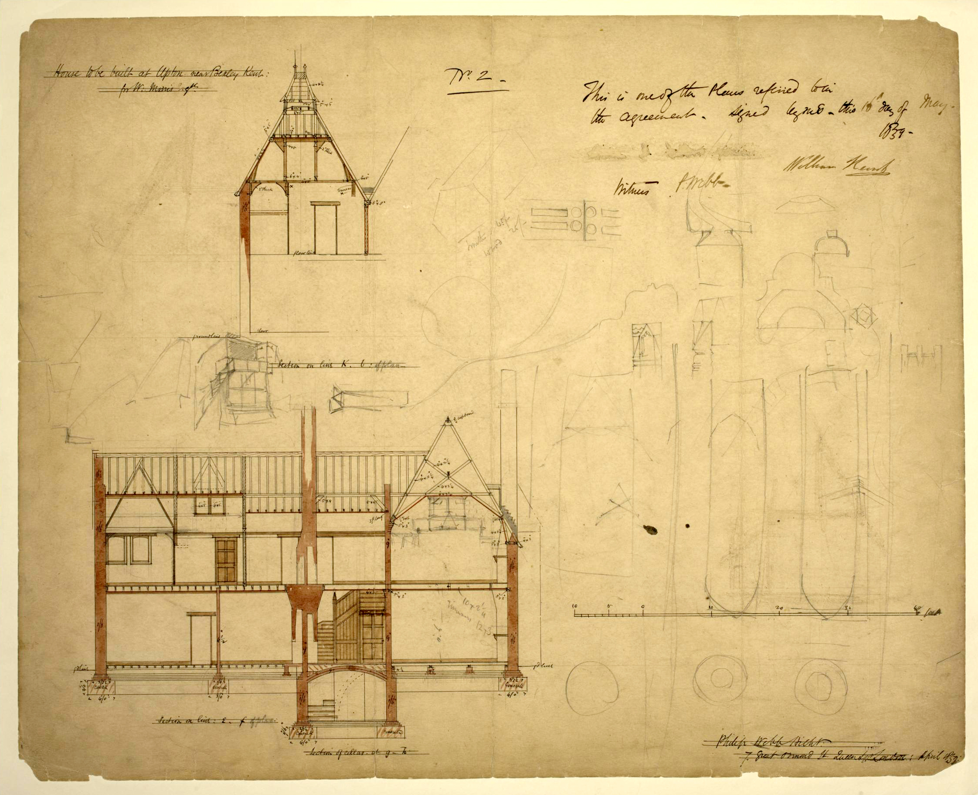
Design for Red House, Upton, Bexleyheath, by Philip Webb, 1859. Contract drawing for Red House, designed by Philip Webb for William Morris. The sheet shows elevations of the house at two points, marked E-F and K-L on the ground plan (E.59-1916). The sections are drawn in black ink and shaded with red and brown watercolour, with pencil annotations throughout. To the right of the sheet there are pencil sketches showing details of the windows and chimneys. The sheet is signed and dated by Philip Webb in the lower right corner, and signed by the builder, William Kent, in the upper right corner. © Victoria and Albert Museum, London

All these and many more are examples of the veritable polyphony of voices that are speaking in the Red House and of the complex nature of Webb’s project. To speak of autonomous voices is not to say the house lacked a sense of unity – quite the opposite is noted by H. Muthesius as we mentioned above; nor are these voices something unique to the Red House. To speak of polyphony is to identify the many modes of expression at work in a certain project and the different ways in which these complement each other. Polyphony, thus, undermines the critical search for the essential by foregrounding the multiplicity of possibilities in play. Is it not possible, for instance, that the collective modes of living produced a different conception of privacy that the one of a typical Victorian family; that the wallpapers designed by Morris gave consistency to the formation of new subjectivities; that certain aspects of the layout would counter-balance the role of the corridor? For instance, Brandon-Jones provides an almost inverse perspective regarding the plan: ‘more revolutionary than any of the architectural features was the raising of the kitchen from its customary position in the basement, and the provision of windows allowing the servants to overlook the garden’. The problem of Evan’s analysis in this sense – and that of many other critics – is the reduction of the project to the singular aspect that has been identified. That the corridor was unaddressed by centuries of architectural theory is an important critical insight. But only by taking into consideration these different types of expressive materials, and how they enter into composition with each other, can a rigorous discussion of the Red House take place.

The Red House provides a clear example of the polyphonic nature of an architectural project. It brings to the forefront the different ‘expressive materials’ that architecture composes, with their interrelated and yet autonomous elements. Evans’ analysis, brilliant as it is, is a perfect example of how these have been silenced by the modern tradition of critique. And in doing so, it tends to disregard not only the multiplicity of processes at work in architecture but also the continuing and shifting balances of power between all these voices. That these different expressive materials come together to form a singular architectural project does not mean they are not autonomous. And it is this coexistence within the project that, in not being subsumed to a totalizing unity, in our view allows differences to remain productive of novel and unexpected consequences.

4
Recall Guattari’s two modalities of enunciation. He distinguishes them in order to capture the very different modes by which architecture operates. Having discussed the polyphonic modality, let us now move on to the ethico-aesthetic. For Guattari, it is the architect’s role to compose ‘spatialized affects’. A spatialized affect is not something one can draw or measure; it is not extensional or susceptible to be numbered, nor something the architect can clearly determine. In Guattari’s terms, an affect is ‘a pre-personal category, installed before the circumscription of identities’. A spatialized effect, therefore, corresponds to relations established through architecture – and by this we mean both through the drawing or the built object – such as the creation of an ambience, the unleashing of architectural imaginations, the producing of a sense of intimacy or feelings of repulsion. For Guattari, through learning from one’s experience of spaces and the way they act upon us, the architect is able to compose, or at least not to block, a series of spatialized affects. Importantly, it is not simply that the architect composes, in the modern sense of the term. By composition, we mean entering into composition with – allowing oneself to be traversed by a collective subjectivity.

Let us return to Webb’s Red House corridors. As noted by Evans, these imply ideas of privacy and class difference resulting from the separation in plan between a circulation space and a private space. But the corridors did more than imply this: they actually promoted these as sensations. The reason for this is that the simple introduction of a door, for example, might promote curiosity when left ajar or powerlessness when one has to ask for permission to enter. The corridor itself, in its lack of other apparent purpose, reinforces feelings of efficiency and organization in daily life. If we follow the tradition of certain architectural historiography, we find that so much attention is devoted to what architectural forms or signs mean. The way in which the corridor articulates relations of privacy, however, is not a matter of representation or signification: the corridor’s shape or size does not communicate the feeling of intrusion that is induced by the opening of a closed door and nor does it represent the sensation of moving through it at night. The same type of operation – even if with different social consequences – happens when bringing the kitchen to the ground floor. It is not the symbolic dimension of this gesture but the daily repetition of movements – no more heading underground, to an inferior space – that directly affects modes of inhabitation. This simple assertion takes us to a key point in Guattari’s thought, which is that spatialized affects are a-signifying: regardless of the motives behind design options, spatialized affects consist of pre-personal and pre-signifying relations between bodies. The moving of the kitchen perhaps symbolizes something but how it affects bodies does not.

Let us take a second example, focusing on the design of Morris’s wallpapers. At dawn the multi-colored lights coming through the stained glass windows and shining upon the wallpaper might cause a child to have fear, or elicit a sensation of melancholia that is exclusive to that time of the day. The lining of entire rooms with floral motifs and textures might directly affect sensations of comfort or claustrophobia. Architecture is full of such refrains that, day after day, allow the constitution of existential territories. And most of these are not even conscious; they are simply working on us, in the background of our attention. Staircases are particularly powerful sites in the multiple ways they act upon bodies, from determining movements to composing lines of sight. In the Red House, the staircase occupies a central role, articulating the key circulations and open to the sunny courtyard. It is frequency and resonance that is at work in a-signifying affects: the repetition of a certain view or movement, and the catalytic capacity of certain ambiences or atmospheres. Spatialized affects are not a direct result of a particular style, but of how that style promotes certain kinds of sensation. They result from expressive components that are decoupled from the overall object and enter into unpredictable relations.

Any project implies the orchestration of a multiplicity of voices or modes of expression. But the importance of this lies not only in recognizing their existence and the multiplicity of what is being expressed through architecture but also in the fact that these voices allow the catalyzing of multiple spatialized affects. In other words, architecture operates both through expressive materials (signs that have indexical, signifying or communicational capacities) and through spatialized affects, which are inseparable and yet independent from these expressive materials. Consider for instance religious or ritual events, where objects such as relics or icons catalyze processes of ecstasy or collective delirium: an icon in a Catholic church is an expressive component that belongs, in Guattari’s terminology, to a signifying assemblage of enunciation. However, the icon does not simply signify or represent a saint. More than that, it also potentially opens ‘a territory of enunciation to a believer, making her enter into direct communication with the Saint’. Importantly, the opening up of a territory of enunciation is not a matter of signification – it is a matter of architecture, through spatialized affects, being able to operate as a catalyst for existential processes. That such processes cannot be predicted does not diminish the intentionality of their composition. Contrary to architectural theory’s habit of focusing on what icons mean or try to communicate, here we speak of a displacement of the focus from what is being represented to what enunciations a certain representation, within a specific pragmatic context, opens up. What spaces represent matters, but what both spaces and representations do or catalyze matters even more.

We come then to the understanding that affects, conceptualized as a-signifying relations, are essential for capturing the multiple ways in which architecture acts in the world. In particular, they are indispensable when constructing a political critique of architecture, as so much of what architecture does results from aspects of the design that have neither symbolic nor representational dimensions (the dimension of a turnstile in a border, the change of thickness in a passageway, the color of corridors might, under certain circumstances, contribute to the production of immensely violent spatialized affects in the context of a detention center); and even all those aspects that do have a signifying dimension, from icons to advertising logos, are equally operating at the level of affect and in ways that are not necessarily related to their represented content. Thus, the fact that what architecture expresses and how it acts upon us are inseparable and yet independent processes allows us to grasp how it is often deployed to other ends than those clearly expressed in the drawing.

'Trellis' wallpaper pattern, thorned rose bush, with red flowers, growing on a wooden trellis, with birds and flying insects, with a pale blue ground; Block-printed in distemper colours, on paper; Inscribed in ink on the back 'Trellis 9 / 8/8'; The first paper designed by William Morris, but the third to be issued; The birds were designed by Philip Webb; Part of 'Volume 1', a pattern book containing 25 Morris & Co. patterns from 1862-81 (E.441-529-1919); England; Designed 1862; Registered and produced 1864. Given by Morris & Co. © Victoria and Albert Museum, London

We can understand now the ethico-aesthetic dimension of enunciation (and of the project): it is a matter of composing expressive components (aesthetics) in ways that open up a series of existential territories and spatialized affects. In Guattari’s texts, this is typically presented in a positive light: ‘It is up to the architect, if not to compose all these fragmentary components of subjectification harmoniously, at least not mutilate the essentials of their virtualities in advance’. But from the example above we can see how this refers as well to the catalyzing of a series of negative reactions, such as the famous internalization of control in Bentham’s panopticon or the promotion of social hierarchies in the Red House’s corridors. The fact that architecture is not a matter of exactly predicting consequences does not mean that the composition of spatialized affects is not one of its key objectives.

5
In this essay we have introduced Guattari’s idea of architectural enunciation as an entry point for an alternative conceptual framework with which to grasp the pragmatics of the project in architecture. We have already exposed its main implications, but it is worth returning to them now, in a systematic way. The first set of implications result from thinking the project qua enunciation as an orchestration of multiple voices. The immediate consequence of this is a better capacity to understand the multiple assemblages the project is part of, the diversity of factors that influence it, and the multiple constituencies to which it matters. Equally, it recognizes the autonomy of the constituent elements of architecture and how they work both in support of the project and independently from it. In doing so, the polyphonic undermines the totalizing focus on form, organization and program as the almost exclusive objects of architectural analysis, bringing back the importance of discarded topics such as decoration, furniture or lighting. The second set of implications results from an attention to how a project operates in both perceptive and affective ways. This allows complementing an attention to indexicality, representation, symbolism and signification with an attention to the non-representational and a-signifying ways though which buildings and spaces work directly on bodies (mostly in imperceptible ways). This implies shifting the focus of analysis from what the drawing is (determined according to what it expresses, symbolizes or represents) to what the drawing aims to do (the project). Ultimately we can say that understanding the project through enunciation allows it to be anchored in the pragmatics of design and to avoid its reduction to an ideal concept. If the context changes, the project will necessarily change as well, even if most of its broader social or political commitments remain the same.
These insights are extremely important if we are to critically access the ways in which architecture exists in the world. Through enunciation we gain a far more precise cartography of what a project does and of the possibilities it opens up. The project emerges as an intervention in a pragmatic context, via the composition of both expressive and affective materials, without ignoring their autonomous nature – an orchestration of voices and a catalyst of spatialized affects.

Apart from his well-known work developed in collaboration with Gilles Deleuze, Félix Guattari was a prolific writer on semiotics and paid particular attention to the a-signifying operations of signs. This serves to ground both a critique of the place of language as the prime semiotic register and also a critique of structuralism and its implications for psychoanalytic and political theory. Specifically, his work is key to the theory of assemblages made famous by A Thousand Plateaus (1980). First introduced in Kafka (1975), the theory of assemblages owes much of its conceptualization to Guattari’s semiotic project. This is clear from Deleuze’s preface to Psychoanalysis et Transversalité (1972), in which he credits Guattari for the early conception of the ‘machinic’ (from Hjelmlsev’s “the semiotic machine”) allowing them to escape from the impasse of a structuralist theory of meaning. The full potential of a theory of the machinic that cuts across psychological, linguistic or political registers can be found in Guattari’s The Machinic Unconscious: Essays in Schizoanalysis (1979), published prior to A Thousand Plateaus. It is due to its specificity in addressing issues of semiotics and pragmatics that we refer here to Guattari’s solo work, but also because Guattari found in architecture – one of his passions – a valuable space for testing out and précising the conceptual and practical dimensions of his theories.
Félix Guattari, ‘Architectural Enunciation’, in Guattari: Schizoanalytic Cartographies, translated by Andrew Goffey (London: Bloomsbury, 2013 [orig. 1989]), 231–239.
For a full understanding of Guattari's pragmatic theory of enunciation we would have to draw upon his reinterpretation of the Hjelmslevian semiotic model of substance-form-purport interactions and the reciprocal presupposition between expression and content.
In the latter sense, it is Foucault’s notion of the statement that Guattari’s pragmatics of enunciation is closest to.
It is important to distinguish between the concepts of design and project in architectural theory. Whereas a design refers to the set of formal, material, legal, technical or programmatic decisions made explicit in the drawings of a building, the project refers to something (an idea) that lies beyond the concrete design. The concept of project carries a transformative political potential. For Pier Vittorio Aureli, it concerns “the possibility of architectural thought to propose an alternative idea of the city rather than simply confirming its existing conditions.” Pier Vittorio Aureli. The Possibility of an Absolute Architecture (Cambridge MA: The MIT Press, 2010). In Latin languages the progetto (Italian), proyecto (Spanish) or projecto (Portuguese) refers to these two aspects at the same time, although in English these are two different words. As a consequence, the concept of project is often detached from the concrete material pragmatics of the design and in particular from the political spaces these open up. As we will demonstrate, enunciation allows for a stronger anchoring of the concept of project to its conditions of existence.
It is important to note how this categorization draws on a broader set of 20 categories devised by Philip Boudon in Sur l’Éspace Architecturel. Essai d’Épistemologie de l’Architecture (Paris, Dunod, 1971); for Guattari the eight categories he devised corresponded to what he thought to be the most relevant assemblages traversing architecture. Despite this fact, he notices how, from the perspective of enunciation, categorizations such as these are potentially infinite.
This is actually a far more complex issue, requiring reference to the concept of formalization: within Guattari's semiotics, formalization corresponds to the distinct processes at work in each given sign and which are mutually presupposing. The sign is the result of the interaction between the dimensions of content and expression with the dimensions of non-formed matter, substance and form. This allows Guattari to discuss enunciation – say, the signifying assemblage of enunciation manifest in the cruciform plan of a Catholic Church that we mentioned above – according to two distinct yet reciprocally presupposing processes of formalization: a formalization of content (the history of the cross in Catholicism) and a formalization of expression (the history of the cruciform plan). This distinction is paramount in semiotics, as it breaks with the understanding of content and expression on the basis of an association, relation of correspondence or representation. Such a semiotic framework is derived from Louis Hjelmslev's theory of the sign, cf. Louis Hjelmslev, Prolegomena to a Theory of Language (1943).
The concept of polyphony is a concept developed by Bakhtin in Problems of Dostoevsky’s Poetics (1963). Borrowed from music, it means multiples voices. It refers to the diversity of voices within a novel and their autonomy from a common and single denominator, in the form of the voice of the author.
Hermann Muthesius, The English House, edited by Dennis Sharp (London: Frances Lincoln, 2007 [orig. 1904]).
Nikolaus Pevsner, Pioneers of Modern Design: From William Morris to Walter Gropius (New Haven, Conn: Yale University Press, 2005 [orig. 1936]).
In particular Hitchcock identifies a clear reference to All Saints Clergy House in Margaret Street, London, and St. Saviour’s Vicarage in Coalpitheath, Gloucestershire, cf. Henry-Russell Hitchcock, Architecture, Nineteenth and Twentieth Centuries (Harmondsworth, Eng: Penguin Books, 1977 [orig. 1958]).
Robert Kerr, The Gentleman’s House (London: J. Murray, 1864).
Robin Evans, Translations from Drawing to Building and Other Essays (London: Architectural Association, 1997 [orig. 1978]) 55–91.
‘You must expect at first that there will be difficulties and inconsistencies in carrying out the new style; but they will soon be conquered if you attempt not too much at once. Do not be afraid of incongruities—do not think of unities of effect. Introduce your Gothic line by line and stone by stone; never mind mixing it with your present architecture; your existing houses will be none the worse for having little bits of better work fitted to them; build a porch, or point a window, if you can do nothing else; and remember that it is the glory of Gothic architecture that it can do anything. Whatever you really and seriously want, Gothic will do for you; but it must be an earnest want. It is its pride to accommodate itself to your needs; and the one general law under which it acts is simply this,—find out what will make you comfortable, build that in the strongest and boldest way, and then set your fancy free in the decoration of it. Don't do anything to imitate this cathedral or that, however beautiful. Do what is convenient; and if the form be a new one, so much the better; then set your mason's wits to work, to find out some new way of treating it.’ John Ruskin, Lectures on Architecture and Painting, Delivered at Edinburgh in November 1853 (London: Smith, Elder, and Co, 1854).
John Brandon-Jones, ‘The Work of Philip Webb and Norman Shaw’, Architectural Association Journal, June 1955, 9–21; July 1955, 40–5.
Félix Guattari, ‘Refrains and Existential Affects’, in Guattari: Schizoanalytic Cartographies, translated by Andrew Goffey (London: Bloomsbury, 2013 [orig. 1989]), 201.
We should note that terms such as composition or affect enter Guattari’s lexicon most probably through the influence of Gilles Deleuze and his reading of Spinoza, cf. Gilles Deleuze and Félix Guattari. A Thousand Plateaus: Capitalism and Schizophrenia (London: Continuum, 2008), 257. Our concern, however, is not with the genealogy of concepts used by two authors that mutually influenced each other, but with making use of Guattari’s work on semiotics and enunciation. This was a work initiated before his collaboration with Deleuze, and remained central both to his solo writings and to those written in partnership with other authors.
It is important to distinguish between a-signifying and non-signifying. For Guattari the matter is not to avoid signification but to understand it as a function of a more abstract relation between bodies. It is such relation that is a-signifying.
Félix Guattari, ‘Refrains and Existential Affects’, in Guattari: Schizoanalytic Cartographies, translated by Andrew Goffey (London: Bloomsbury, 2013 [orig. 1989]), 209.
For an excellent exposition of these politics of a-signifying operations in architecture see Adrian Lahoud, ‘Fallen Cities,’ in The Arab City: Architecture and Representation, edited by Amale Andraos and Nora Akawi (New York: Columbia Books on Architecture and the City, 2016).
Félix Guattari, ‘Architectural Enunciation’, in Guattari: Schizoanalytic Cartographies, translated by Andrew Goffey (London: Bloomsbury, 2013 [orig. 1989]), 238.

