**David Rayson**

**The Field – *Looking and thinking aloud.***

**(As seen and thinking through John Berger - from a train**[1]**)**

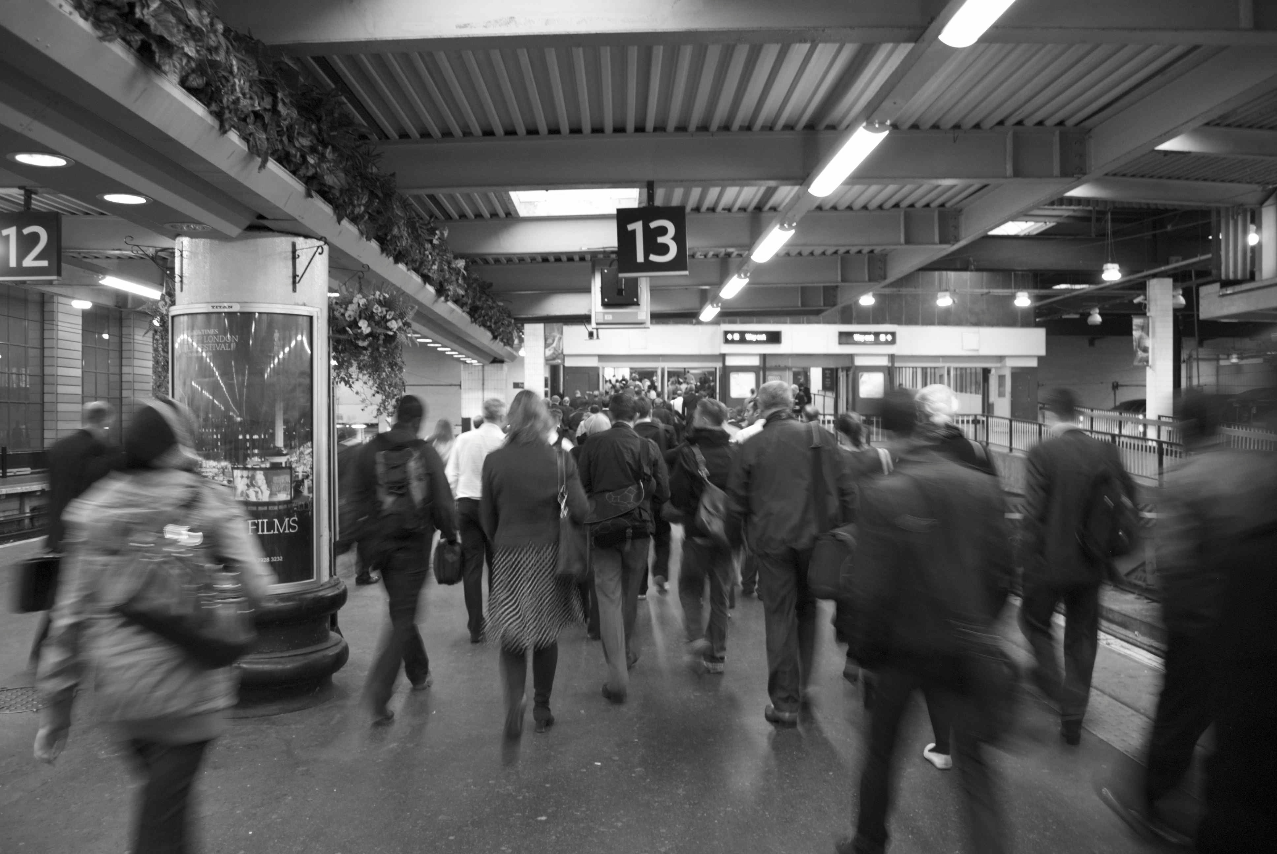

*The next train at platform 13 is the 19.12 to Milton Keynes Central… calling at Watford Junction and Leighton Buzzard…*

(After piling down to the platform with everyone else heading north, we find the platform empty, and so as I wait for the train I find a bench and I read from my laptop what I have written so far for my essay and forthcoming paper on John Berger for the conference *‘Thinking with John Berger’,* at Cardiff Metropolitan of the summer 2014[2]):

In John Berger’s 1971 essay *The Field* we witness Berger thinking aloud reflecting upon the phenomenological potential of a field[3]. He dwells at a railway crossing and looks across an open field and we witness then a rolling narrative of Berger surveying the space before him and through his reflective and seemingly ‘real-time’ manner of writing, we think along with him.

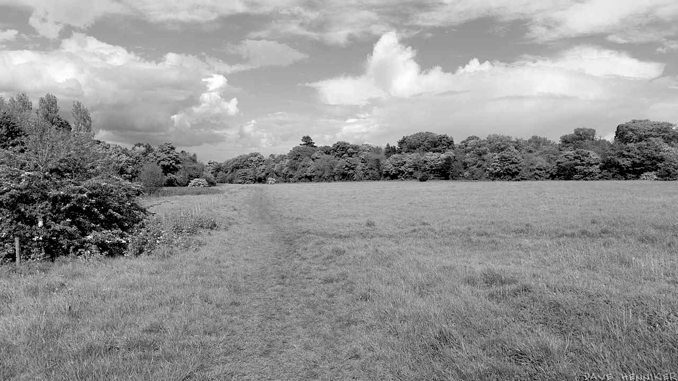

He foregrounds a high degree of authorship, thinking and making moves in the present time of writing. All at once he considers the formal structures of the frame, the conditions of the space, the field as a stage, a projectionists screen, or a painter’s canvas where a myriad of possible narratives can be activated and witnessed. Here in this state, one becomes immersed in a cycle of being audience-activator-audience-activator…..

This can be said of many of Berger’s essays where his interior reflections are made available creating a highly charged space where we, are able to look, think, relook, rethink, and look again.

*Before my commute home I feel activated to look, even before I get to my over-ground station, the looking and thinking begins underground. Look at the conflicting relationship between us as commuters underground to the promise of this advertising image…*

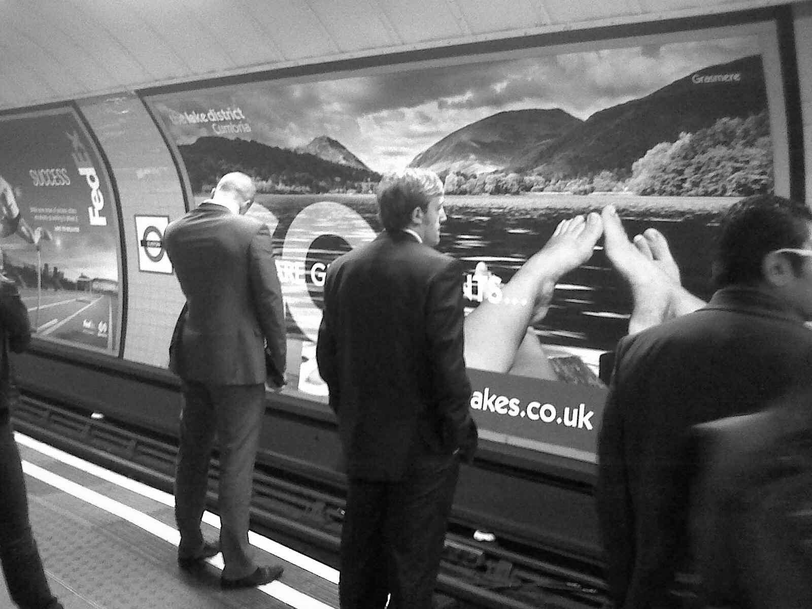

*GO it says. The paradox which Berger wrote and spoke about in Ways of Seeing, is very evident*[4]*. The paradox of being able to afford to GO and enjoy this mountainous open space, one needs to commute and work for most of our waking and working year. This essay will be touching upon wish fulfillment and notions of escapism, along with my reflections upon the actual realities of the situation.*

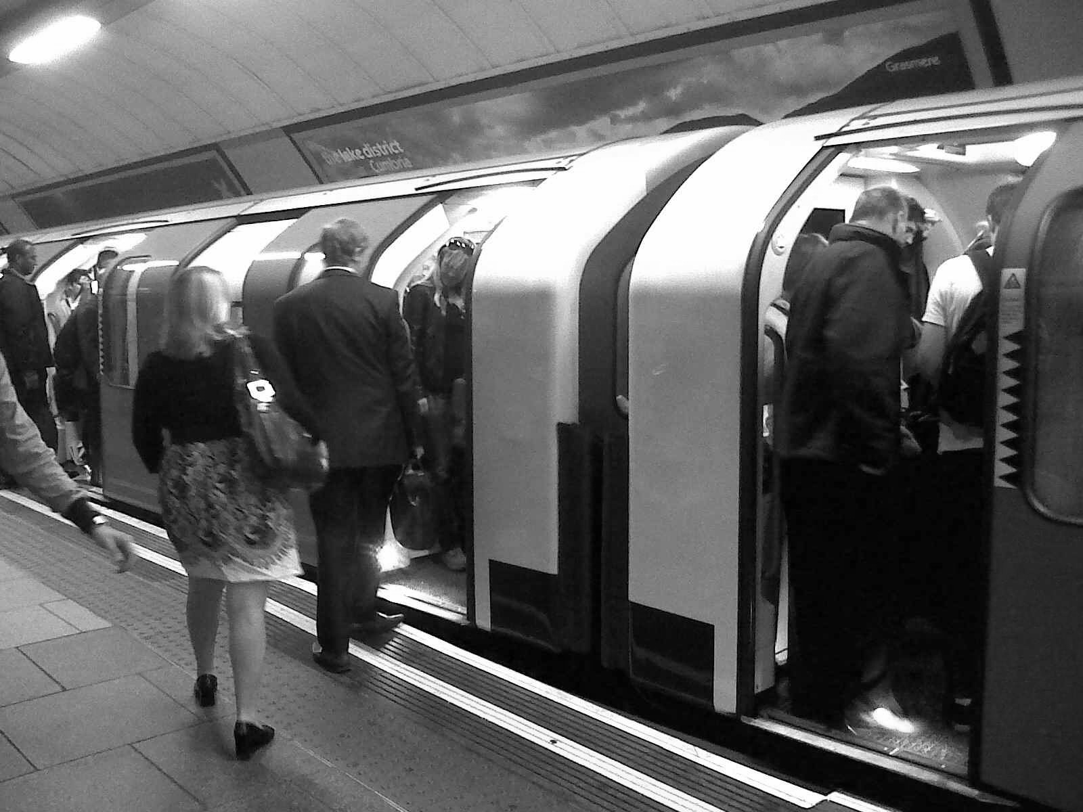

*.*

*As commuters we are not really able to GO, when the train comes in the image has been internalised – sure – but we are getting on that train, we are going to work, or commuting home.*

*Eventually I get to Euston overland station and board my train, I reopen my laptop, as people pile on, conversations start up…sometimes loudly as in the case of this man in charcoal suit for the whole carriages’ benefit….*





*…and on the ‘hush-hush’ between these two friends for everyone else’s ears only…*



The ‘*Oh I know’* is enough for me to reach for my headphones and so I block out all the train conversations…. a dream-space track kicks in and even though I have opened my laptop…I take a moment to sit back and look out of the window…. out of the window the fields pass by, like scenes framed by hedges and fences………

***……Fields with seeming nothing growing or in them pass by at the same speed as fields overgrown and occupied……***

***…..There then is a field nobly supporting a group of trees at its’ centre…..***

***…..In another a woman is walking her dog, her coat the same colour as the dogs’…..***

***…..Dry ploughed fields…..***

***…..Poly-tunnels…..***

***…..Allotments…..***

***…..Car parks full of cars parked…..***

***On the edge of a town a house with its windows and doors looks like a face looking back at you.***

***After the view being blocked by an embankment finally dips down again a large new housing estate is revealed.***

***The embankment returns and dips again and into view comes a huge loading depot for Morrisons’ Superstore, with a row of lorries backed up being unloaded.***

***Suddenly it goes dark as we enter a tunnel, and in the windows we see the interior of the train reflected back at us. The two women opposite are still talking away. I look down and carry on writing on my laptop.***

With the advent of the Internet, the worldwide web, our collectively hot-wired experience of the screen, and with our headphones or car stereos often supplying the soundtrack to our experience of our daily lives, I wonder what are the positive and negative consequences of this level of mediation on our relationship and reflections upon the physical world around us? As I write these thoughts, I am listening to my ipod – tapping onto a laptop scene. In Nicholas Bourriaud ‘s catalogue text for his exhibition project *Altermodern* of 2009, he sights these ever connecting levels of technical networks of communication as a phenomenon that is self perpetuating as a self-generating matrix[5]:

In the introductory text, Nicolas Bourriaud states:

*A new modernity is emerging, reconfigured to an age of globalisation – understood in its economic, political and cultural aspects: an altermodern culture. Increased communication, travel and migration are affecting the way we live. Our daily lives consist of journeys in a chaotic and teeming universe. Multiculturalism and identity is being overtaken by creolisation: Artists are now starting from a globalised state of culture.*

*This new universalism is based on translations, subtitling and generalised dubbing. Today’s art explores the bonds that text and image, time and space, weave between themselves*

*Artists are responding to a new globalised perception. They traverse a cultural landscape saturated with signs and create new pathways between multiple formats of expression and communication.* [6]

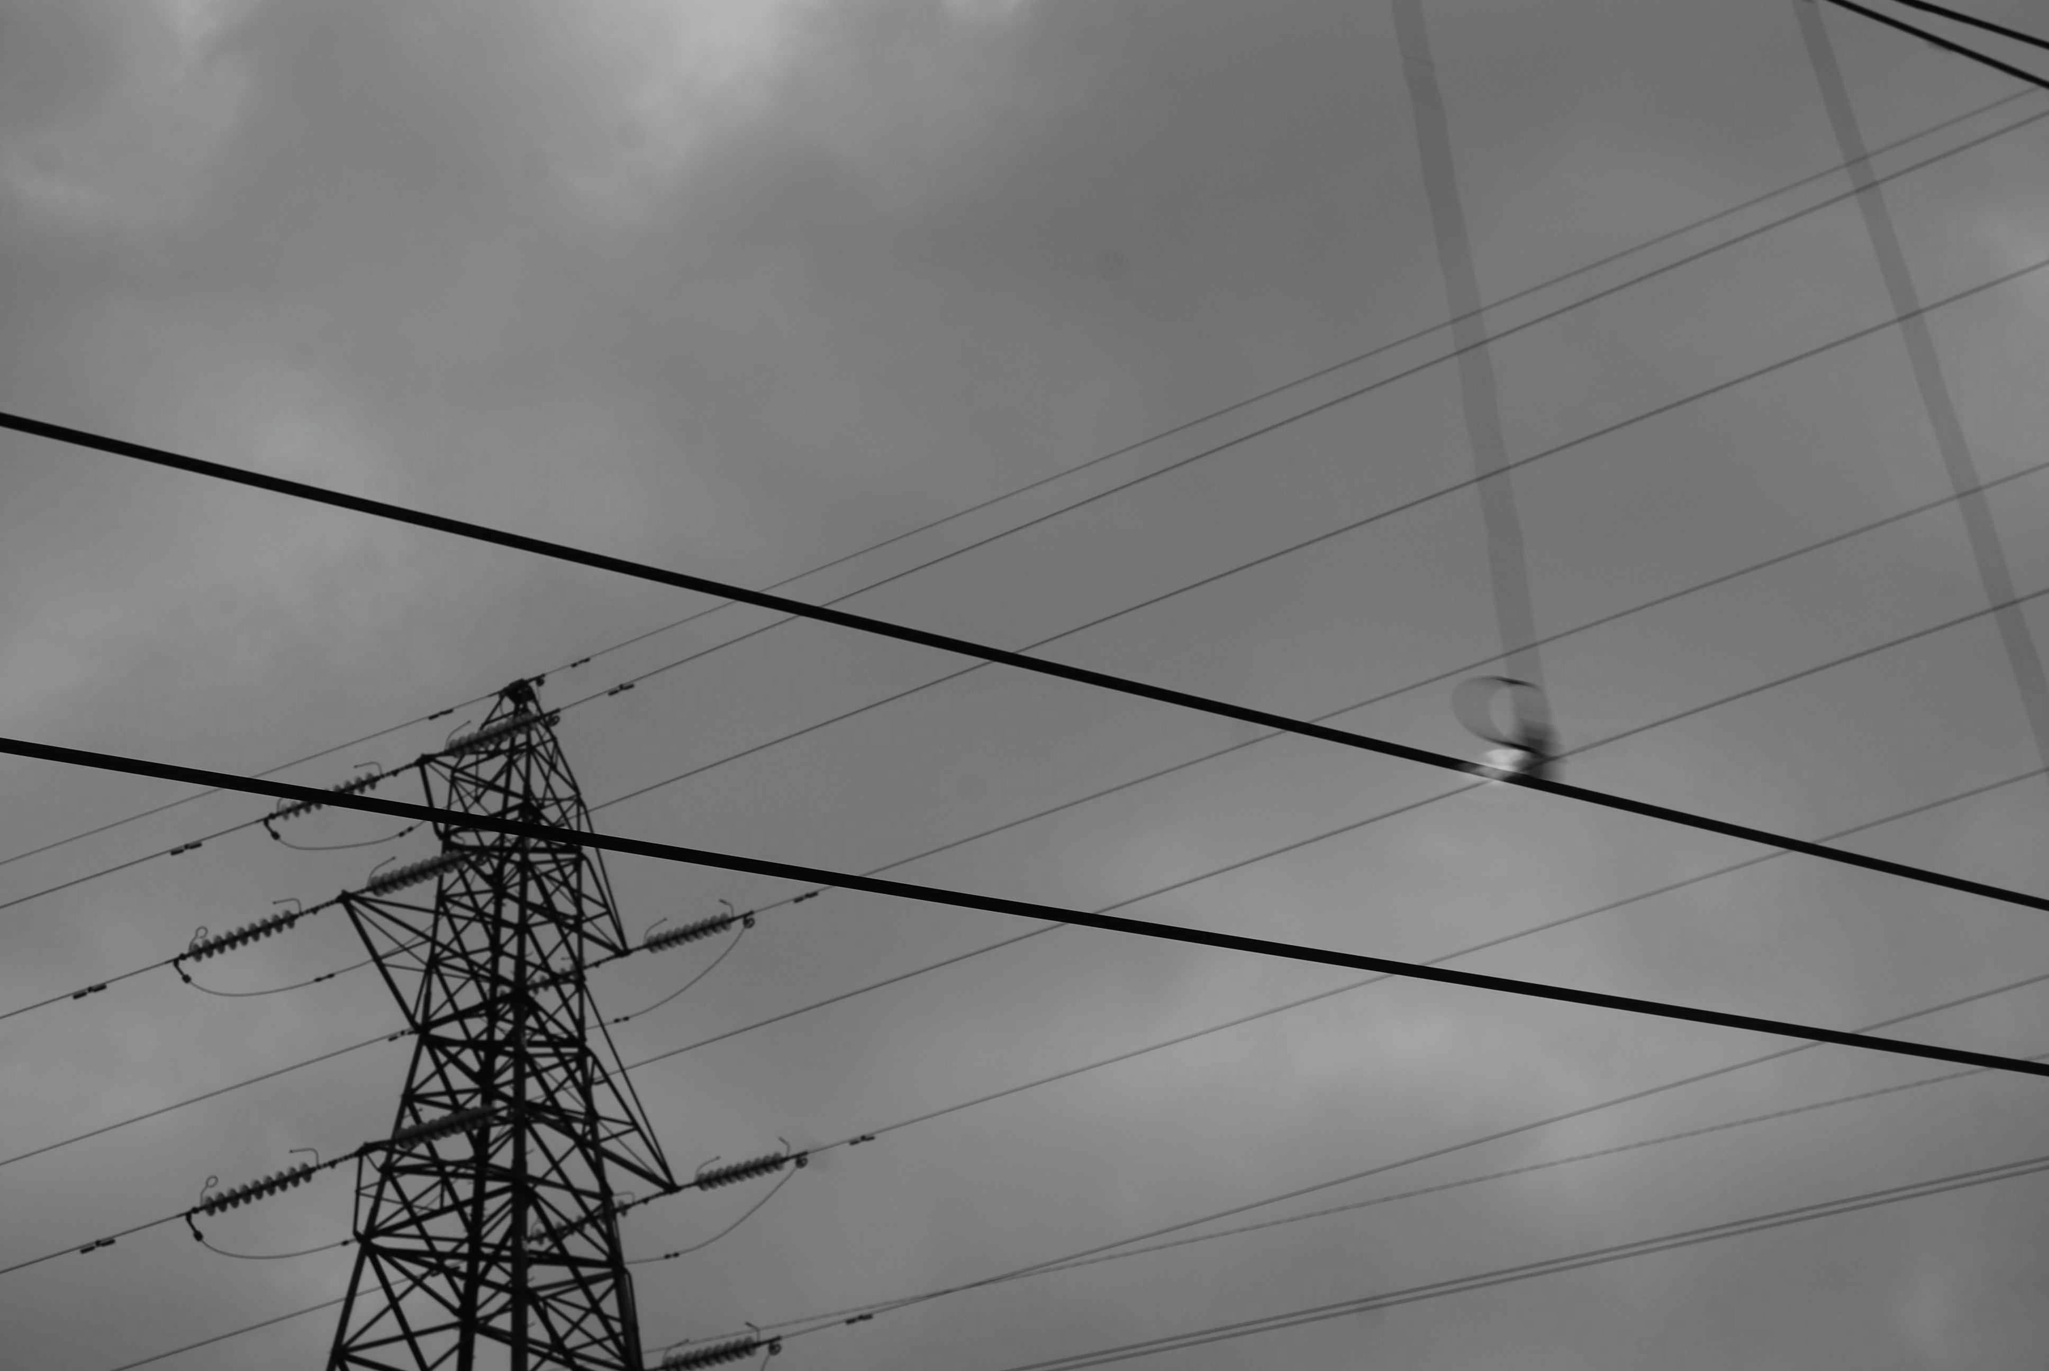

So what too of our internal narratives? How much are they our own?

How do these many modes of mediation shape our sense of place, how does all we have received and heard impact upon our powers of perception? As I read along with Berger, and so stand alongside him in the early summer of 1971 by the level crossing, I feel I am enabled again to look and think across an open field, in a space and state of mind of the flâneur as observer.

Perhaps this is a more romantic and empowering state to be in? Perhaps here’s a state devoid of the seductive and well-manicured forces of our communication technologies that seemingly afford us the impression of being able to be everywhere, to seemingly have open access, and seemingly everything being available to us?

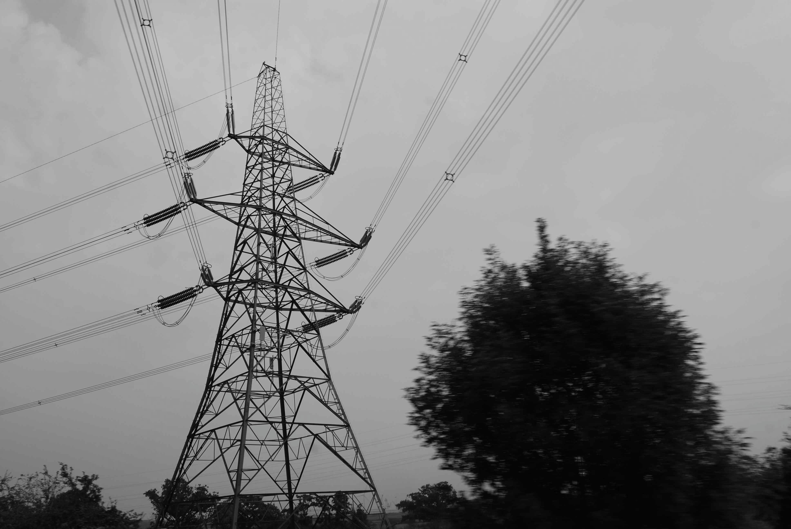

Look see here this pylon having a heated debate with this small bush - each taking a particular position - Nicholas Bourriard’s receiver/transmitter to John Berger’s flâneur as shaman.

At the turn of the 20th century Henri Bergson’s wrote of a desire for a direct channel between our interior realm with that of the physical world, which both prophesied both Berger’s ability to look, see and think, as well as prophesying our new technologies that enable our flat-line relationship to our exterior world.

*If reality could come into direct contact with sense of consciousness, if could we enter into immediate communion with things and with ourselves, probably art would be useless, or rather we should all be artists, for then our soul would continually vibrate in perfect accord with nature.* [7]

As the train tracks dip or the landscape rises up either side of the train windows again, the fields are turned towards the vertical, and present more fully a series of frames. This then becomes a durative filmic experience, which Patrick Keiller foregrounds early in his book *A View from a Train:*

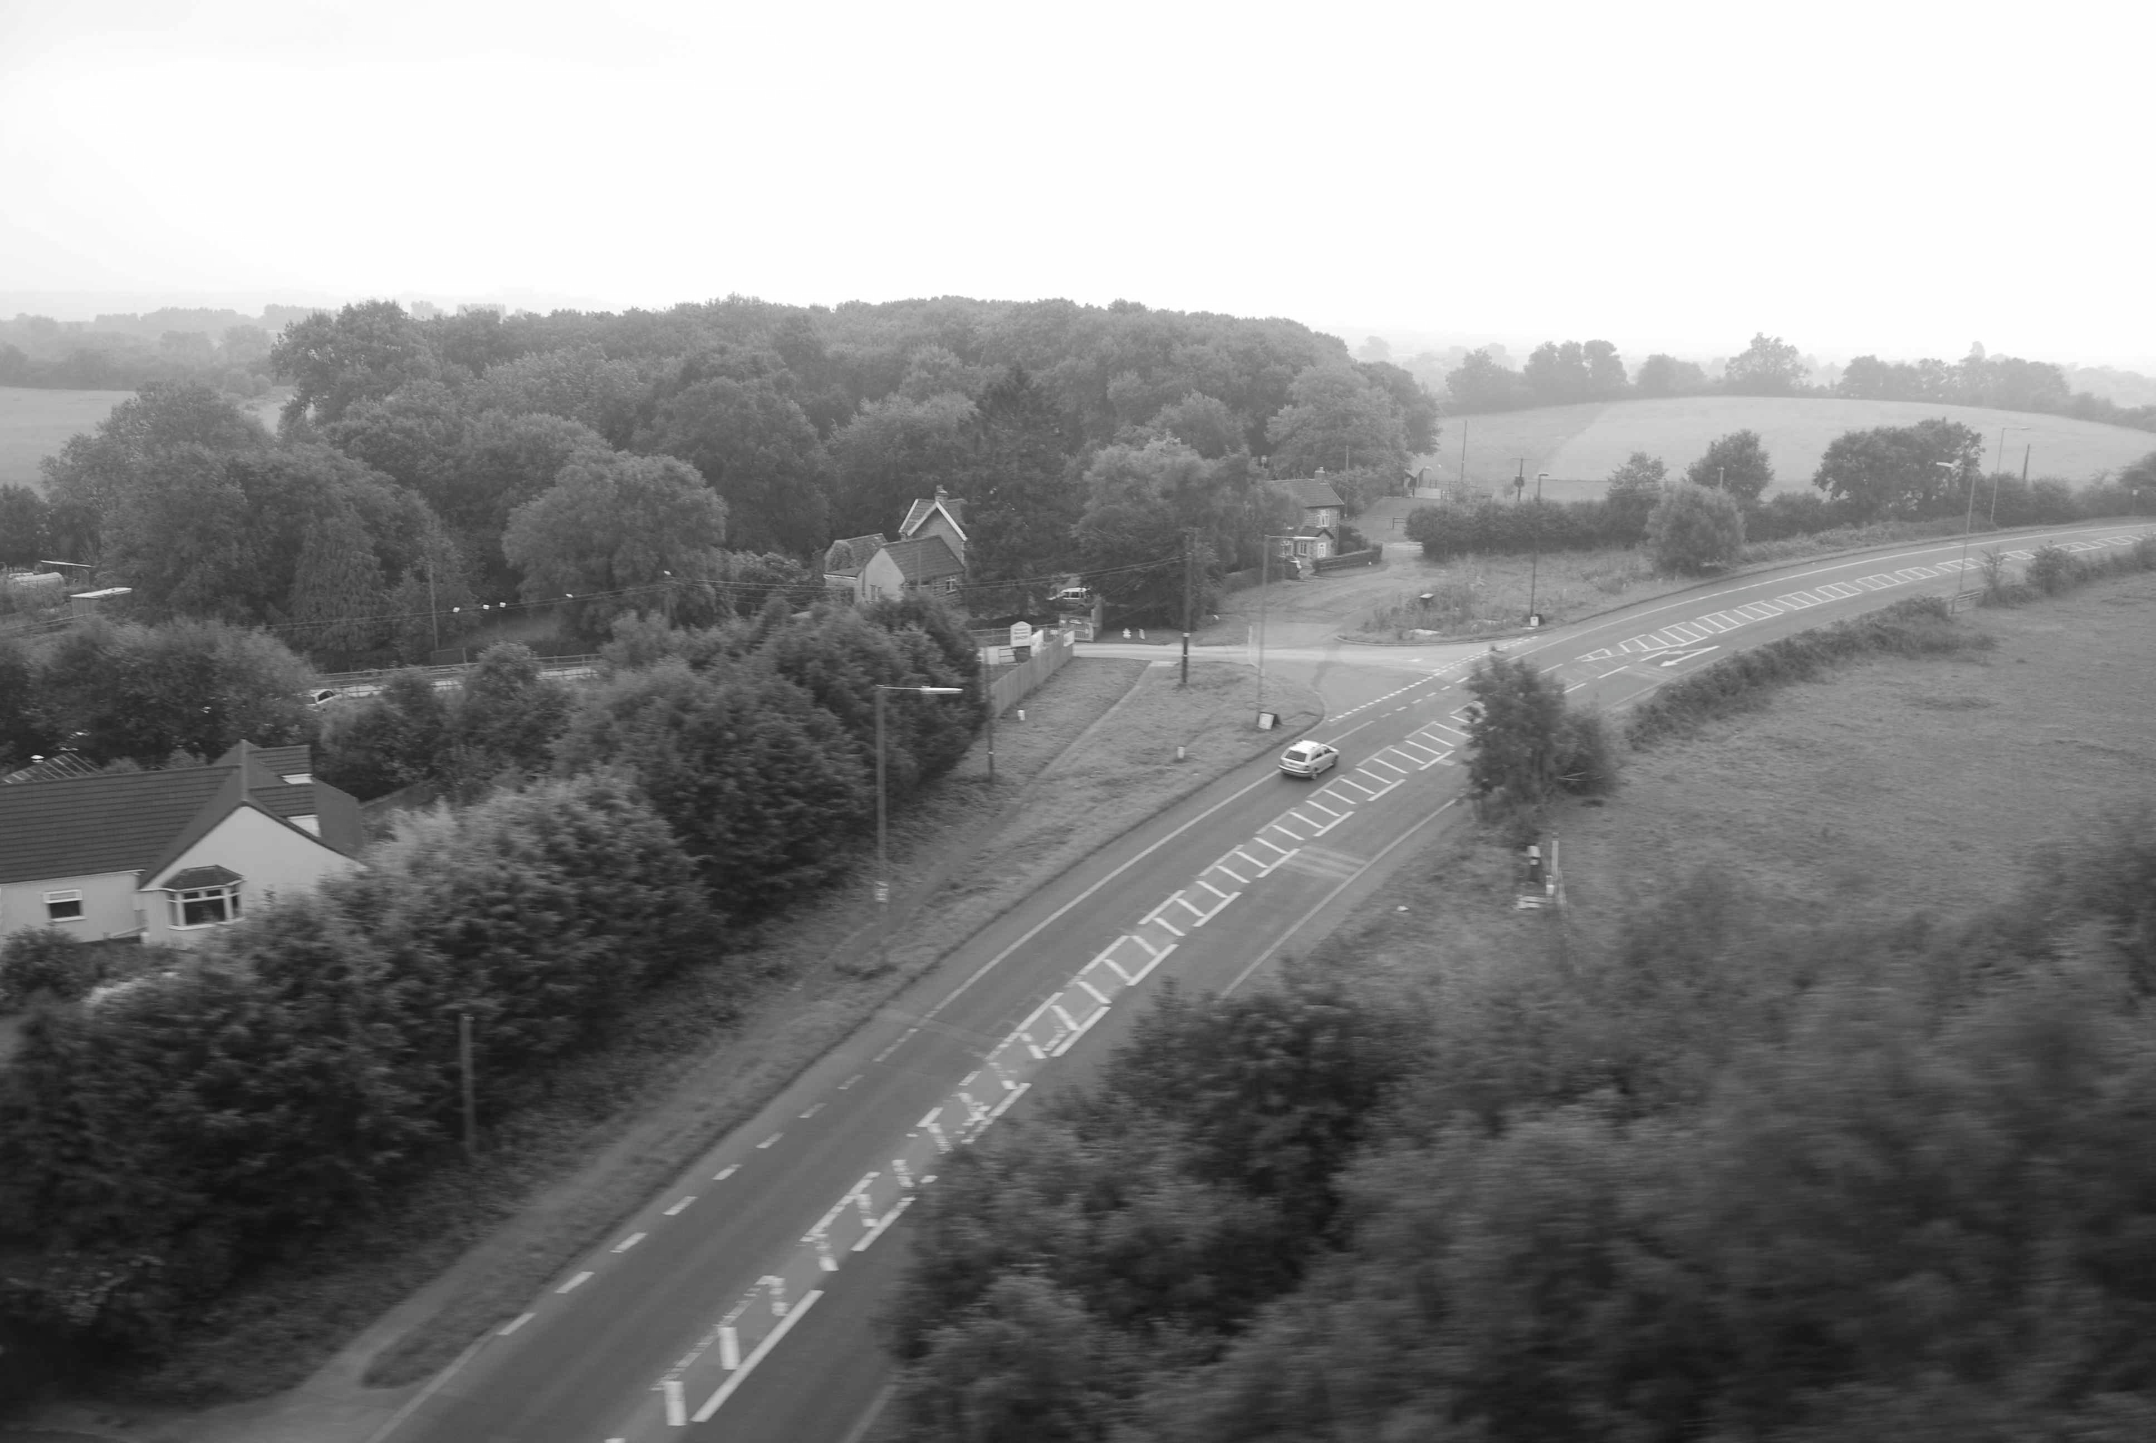

*‘Both cinema and the railway,’ Keiller writes, ‘offer more or less predetermined and repeatable spatio-temporal continuities, so that it is perhaps not surprising that railways crop up in cinema as often as they do.’ The view from the train thus offers both immersive time-travelling – when the point of view is forward-facing – and a framing of discrete moments, when the view is an oblique one from a window.* [8]

Rosalind Kraus in *The Optical Unconscious* writes:

*“The relationship between the field and the figure is simply not spatial at all: it is purely and wholly optical: so the figure created by removing part of the painted field and backing it with canvas-board seems to lie somewhere within our own eyes, as strange as this may sound”.* [9]

So in short: in this optical realm we internalise the visual experience.

Berger in his essay the wills the view to be tipped up and become image, and states why:

*A field on a hillside, seen either from above like a table top, or from below when the incline of the hill appears to tilt the field towards you – like music on a music stand. Again, why? Because then the effects of perspective are reduced to a minimum and the relation between what is distant and near is more of an equal one.* [10]

And so as audience we internalise the experience of looking at artwork, we pull everything toward us as image and enter into a visual conversation.

As I speed now towards my station, I feel as if I have been travelling along in a film. A life span, witnessed from my window the ‘tipped-up’ screen version of lives playing out. Births, new builds, home-extensions, loft conversions, boom towns, derelict non-spaces, redundant ruins, dumps, land fills, and graveyards. But with each rise and tilt of the train these are shuffled in and out of order….

As the train pulls into Milton Keynes, I can hear over my headphones, the automated voice announcing that I have reached my final destination……I cut and paste a closing quote from Berger……taking the risk of staying seated, writing on my laptop, ……with the threat of being sent back down the line again…….But this is of no matter, because having spent the journey sensitised by Berger’s heightened sense of looking, each new commute will now become the next instalment of an ever – rolling film. I am enabled to look, look again, ask questions, script-write stories, and project images across these open fields that span my daily commute.

*At first I referred to the field as a space awaiting events; now I refer to it as event in itself. But this inconsistency parallels exactly the apparently illogical nature of the experience. Suddenly an experience of disinterested observation opens in its centre and gives birth to a happiness which is instantly recognisable as your own.*

*The field you are standing before appears to have the same proportions as your own life.* [11]

**Bibliography**

Ballard, J.G *The Drowned World* (1962), [*The Burning World*](http://en.wikipedia.org/wiki/The_Burning_World_%28novel%29) (1964)

Berger, J, (1971) *About Looking*. London: Bloomsbury.

Berger, J, (1972) *Ways of Seeing,* British Broadcasting Corporation and Penguin Books,London.

Krauss, R. E (1993) *The Optical Unconscious.* Cambridge, Massachusetts: MIT Press.

Keiller, P. (2013) *A View from a Train: Cities and Other Landscapes.* London: Verso.

Bourriaud.N (2009) *Altermodern* Tate Publishing, London.

Bergson. H. (1911) *Laughter: An Esssay on the Meaning of Comic.* Macmaillan Company, New York.

Self. W. (2013) *The Frisson.* London Review of Books. <http://www.lrb.co.uk/2014/01/20/will-self/the-frisson>

1. The paper I delivered at Cardiff Metropolitan was written on two train journeys, one to Milton Keynes from London Euston, and the other from Milton Keynes to Cardiff Central, and all the images were photographed from the train or sourced from my photo library during those two journeys.
2. [Thinking with John Berger](http://www3.cardiffmet.ac.uk/english/education/enterprise/conferences/pages/conferenceoverview.aspx) conference (04-05 September 2014).
3. Berger, J, (1971) *The Field,* from the publication *About Looking*. London: Bloomsbury.
4. Berger, J, (1972) *Ways of Seeing,* British Broadcasting Corporation and Penguin Books,London.
5. The Tate Exhibition *Altermodern* of 2009 presents itself as a collective discussion around this hypothesis of the end of postmodernism, and the emergence of a global altermodernity. Curated by Nicolas Bourriaud, with accompanying texts. (See Bibliography)
6. Text from the publication to accompany the Tate exhibition *Altermodern* of 2009 curated by Nicolas Bourriaud. Tate publishing (2009).
7. Text extract taken from Bergson. H. (1911) *Laughter: An Essay on the Meaning of Comic.* Macmaillan Company, New York.
8. Keiller, P. (2013) *A View from a Train: Cities and Other Landscapes.* London: Verso.
9. Berger, J, (1971) *The Field* taken from collection of essays in *About Looking*. London: Bloomsbury.
10. Berger, J, (1971) *The Field* taken from collection of essays in *About Looking*. London: Bloomsbury.
11. Berger, J. closing passage from the essay *The field,* taken from the collection of essays in *About Looking*. London: Bloomsbury.