ME-WE Pr0ductions Presents:

The St0ry of Aphr0dite Umi

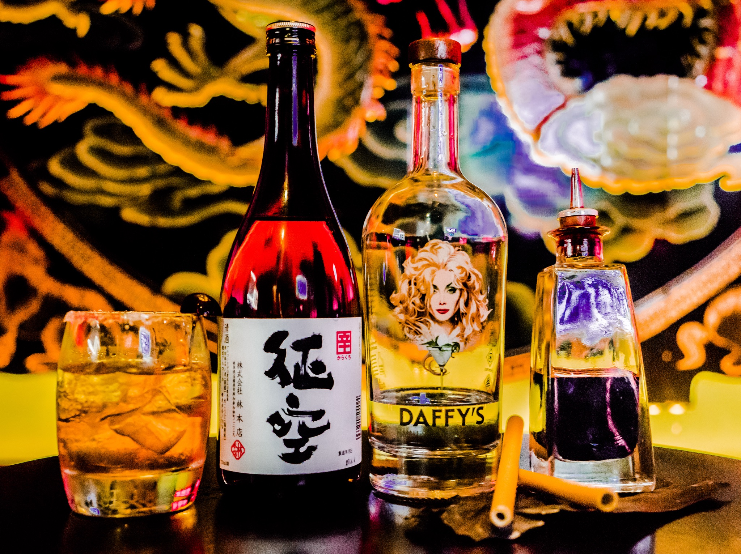

Deal Pier Arts invited Kate Davis and David Moore as ME-WE Productions to lead their first Festival. In the spirit of Kate Davis’s solo exhibition headhearthole at the Wordsworth Trust, centre of British Romanticism in the Lake District, Kate Davis and David Moore wished to bring together diverse multi-disciplinary elements for the inaugural Deal Pier Art festival that could involve the whole local community.

Elements they believe that when experienced together represent a complete sensory intellectual and human testament to our existence with art being at its centre: it’s heart.

For this event they also set out to devise a new cocktail that would conjure up Aphrodite the Greek goddess of love and pleasure who arose magnificently from the spume after Uranus’s genitals were thrown in the sea.

The cocktail was devised by us introducing SJ Ross, master mixologist to Chris Molyneaux creator of Daffy’s Gin, recently voted number one in the world and distilled in Edinburgh.

The combination of seaweed and cherry flavours with gin and sake conjure up the spirit of the sea and ripe fertility and the warmth of summer.

Pause for a moment while you consider where you are standing, surrounded by the sea and know that you are the first gathering of people to have experienced this bespoke cocktail at the inaugural Deal Pier Art Festival
