//////////////////////////////////////////////////////////////
PRESS RELEASE NOVEMBER 2013
//////////////////////////////////////////////////////////////

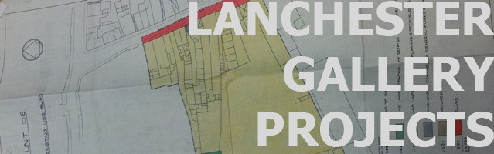

////////////////////////////////////////////////////////////// JASPAR JOSEPH-LESTER
GRAND CANAL: 22 NOVEMBER – 31 DECEMEBR
GUIDEBOOK LAUNCH AND DISCUSSION: SATURDAY 14 DECEMBER 1800
//////////////////////////////////////////////////////////////

Jaspar Joseph-Lester has been LGP’s artist in resident during the early Autumn months and from this, has produced a guidebook for the city. The guidebook sticks to a traditional format and tone but presents an incongruous script of the city.

Joseph-Lester has interpreted Coventry’s landscape and histories through architectural fragments and logged it under the classifications STAIRWELLS; TILES; CARPARKS and WATER FEATURES. These prosaic features are examined through the past, present and future and by promoting them to iconographic status, reveal alternative, contested and repressed histories. Their collision with one another creates a displaced ashen landscape.

For the launch of the guidebook, Joseph-Lester will be discussing the synergy between architecture and fiction with the curator and writer Wouter Davidts.

LGP will be exhibiting Joseph-Lester’s video work Grand Canal on the big screen in Millenium Place, Coventry. Grand Canal is a dreamlike repeated journey of a gondola ride through artificial (Las Vegas Casino Hotel resort) and authentic Venetian canals. The work deliberates on the cultural and architectural components that narrate geographical space. Screened at a prominent public site, the work cuts an odd ethereal vision into Coventry’s concrete civic space.

Grand Canal will be screened at the following times every day from 15 November – 31
December 2013: 07.30, 10.00, 12.30, 15.00, 17.30, 20.00, 22.30.

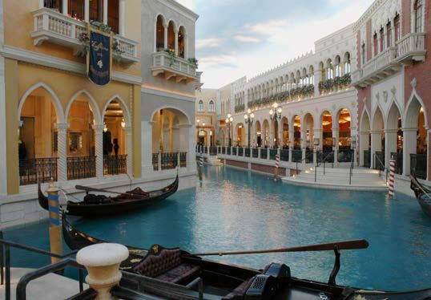
Still from Grand Canal (video 2 mins 30 secs)

///////////////////////////////////////////////////////////// NOTES TO EDITORS
//////////////////////////////////////////////////////////////

Jaspar Joseph-Lester is an artist based in London whose work explores the role images play in urban planning, social space, and everyday praxis, latterly focusing on conflicting ideological frameworks embodied in urban regeneration projects. In 2010 he was invited to curate the Dallas Pavilion, launched at the 2013 Venice Biennale. Recent exhibitions and publications include: ‘Modern Interiors’ Five Years (2013), ‘A Guide to the Casino Architecture of Wedding’ for COLLAPSE: Philosophical Research and Development (2013), ‘Revisiting the Bonaventure Hotel’, Copy Press (20013) and ‘Transmission Annual’, Artwords. He has exhibited widely in the UK and abroad with exhibitions at Asprey Jacques Gallery and The British School at Rome. He is currently collaborating with Susanne Prinz and Julie Westerman on TEGEL: Speculations and Propositions, an international video project that explores the architecture of Tegel Airport through a series of cinematic narratives (Greenbox, Berlin, 2013). He is Research Tutor in Sculpture at the Royal College of Art.

/////////////////////////////////////////////////////////////
INFO
/////////////////////////////////////////////////////////////
Lanchester Gallery Projects (LGP) is a programme of exhibitions, publications, events and residencies, which examines the conditions, task and terminology of the art institution.
BIG SCREEN: MILLENNIUM PLACE. COVENTRY. CV1 1JD LANCHESTER GALLERY PROJECTS (LGP)
JORDAN WELL, COVENTRY, CV1 5QT

LANCHESTERGALLERYPROJECTS.ORG.UK
LGP is funded by Arts Council England in partnership with Coventry University. PRESS ENQUIRIES - LGP@COVENTRY.AC.UK
/////////////////////////////////////////////////////////////

With special thanks to the Events and Production Department, Coventry City Council.

