DARWIN’S DREAM:
THE SIGNIFICANCE OF PAINTING AND ITS COLLECTION AT THE ROYAL COLLEGE OF ART 1948-1998

JULIET THORP

A thesis submitted in fulfilment of the requirements of the Royal College of Art for the degree of Master of Philosophy

MAY 2012

THE ROYAL COLLEGE OF ART

This text represents the submission for the degree of Master of Philosophy at the Royal College of Art.

This copy has been supplied for the purpose of research for private study, on the understanding that it is copyright material, and that no quotation from the thesis may be published without proper acknowledgement.

CONTENTS

Abstract iv
Acknowledgements v
Author’s declaration vi
List of Illustrations vii
Introduction 1
Historical Background 20
1948-1968 31
1968-1986 71
1968-1998 101
Conclusion 131
Appendix 1 – Recommendations for future 151
Appendix 2 – Index to Interview Transcripts 154
Appendix 3 – Visits to Collections at RCA 318
Appendix 4 – Analysis of the Collection 323
Bibliography 324

Abstract
Darwin’s Dream: The significance of Painting and its Collection at the Royal College of Art 1948-1998

This thesis considers the significance of Painting at the Royal College of Art (RCA) and the value of the Collection that grew out of the work of the Painting Department. It reflects on Principal Robin Darwin’s perception that having works of art hanging on the walls of the College would help impart prestige and status to the institution and looks at how he embarked on building up the Collection with works by graduates of the Painting Department.

The research examines the history of the Painting Department and analyses the ways in which a changing post-World War II society affected the students who contributed their paintings to the Collection. The period of research starts when Darwin was appointed Principal in 1948, and concludes with Professor of Painting Paul Huxley’s retirement in 1998. This fifty year period covers decades when the work being produced in the Painting Department was very influential, such as the 1950s when Frank Auerbach, Leon Kossoff and the Kitchen Sink painters attended the College, the 1960s with the birth of British Pop Art, through to times when painting was overshadowed by new media during the 1970s, the commercialisation of the art world in the 1980s and changes engendered in the practice of painting in the 1990s. I have researched educational reforms over this period to consider how they shaped the painters who studied at the RCA and looked at how the works accessioned to the Collection build up a narrative of the institution. I have considered what the paintings say about the artists that produced them and the institution in which they studied, who the teachers were that influenced the students, and how the Collection reflects the position of British painting post-World War II.

I conclude that, although the Collection is an uneven accumulation of works that has been built up in a haphazard fashion, it has helped to achieve Darwin’s dream of raising the status of the RCA. At the same time it is a valuable asset that expresses the importance of an august institution through the history it reveals and which, as well as providing distinction, has pedagogic significance and potential.
Acknowledgements

Many people helped to make this course of study possible. First of all thanks must go to Garry Philpott, the former Director of Administration, my first boss at the Royal College of Art. He introduced me to the Collection soon after I arrived at the College in the Autumn term 1995, and to Susie Allen and Professor Paul Huxley, who looked after the Collection at that time. Susie Allen generously shared the work of the Collection with me and introduced me to the paintings, various stores, endless lists, card index boxes and related correspondence. When Susie left the RCA in 1996 she handed the work on to me, for which I am very grateful.

This whetted my appetite for working with collections and I am grateful to Teresa Gleadowe, at that time Head of Curating Contemporary Art, for suggesting I pursue the distance learning MA in Museum Studies at Leicester University, which the RCA helped to support. My thanks also to Professor Sandra Kemp, former Director of Research, who encouraged me with my MA, took the time to read it through and discuss it with me, and suggested I take my studies further. Her suggestion led me to apply to the Department of Critical and Historical Studies to undertake this MPhil, also generously supported by the RCA.

Thanks to all my colleagues in the Rectorate at the RCA who have been so supportive over the years and who have all been encouraging of my studies, particularly my subsequent bosses, Professor David Hamilton and Professor Alan Cummings. Special thanks must go to Professor Sir Christopher Frayling for his unfailing encouragement and for taking the time to read through my draft chapters, discuss them with me and for providing invaluable information about the RCA and its history.

Other RCA colleagues have also been incredibly helpful – Nick Frayling with whom I worked on digitising the Collection, who is always ready to provide decent images; Neil Parkinson in the Special Collections and Archives who unfailingly alerted me to documents I might find interesting; Cathy Johns in the Library who helped me with the referencing system and kept me in touch with conferences, papers and articles. There are others who have also helped in many ways but who are too numerous to mention here – thanks to you all.

Many thanks to my splendid supervisors, Martina Margetts and Lucy Soutter, from whom I learnt a lot and who have always been ready to offer useful advice when needed. Without their help I would have struggled. Thanks to Jonathan Miles, who suggested the direction my thesis should take, which was also extremely helpful.

Finally, huge thanks to my family, specially my husband David, who has been so supportive, always being there for help and advice when needed and whose library has been a vital source of information.

AUTHOR’S DECLARATION

- During the period of registered study in which this thesis was prepared the author has not been registered for any other academic award or qualification.

- The material included in this thesis has not been submitted wholly or in part for any academic award or qualification other than that for which it is now submitted.

Juliet Thorp
May 2012

LIST OF ILLUSTRATIONS page no

All illustrations are from the RCA Collection unless otherwise stated.
Collection images by Nicholas Frayling.

Classroom in the School of Sculpture and Modelling around 1905 21
RCA Archive (illustrated in Frayling, 1987, p.85)

Caricature of Henry Cole by James Tissot for Vanity Fair, August 1871 22
RCA Slide Archive (illustrated in Frayling, 1987, p.30)

Rothenstein, William, Self Portrait, 1930 25

Etty, William, Standing Male Nude, 1849 25

Spear, Ruskin, Portrait of Robin Darwin, 1961 27

Sickert, Walter, Camden Town Nude: Conversation, 1908-9 28

Ardizzone, Edward The Senior Common Room of the RCA
(Cromwell Road), 1951 29

Moynihan, Rodrigo, Portrait of Victor Pasmore, 1939 35

Moynihan, Rodrigo, Grey Violet, (undated) 35

Moynihan, Rodrigo, Portrait Group (The Teaching Staff of
the Painting School at the Royal College of Art 1949-50), 1951,
Tate Collection 36

Spear, Ruskin, Ennui, 1944 (work destroyed)
Illustrated in Levy, M, 1985, Ruskin Spear, p.13 39

Sickert, Walter, Ennui, c.1914, Tate Collection 39

Minton, John, Street and Railway Bridge, 1946,
Tate Collection 40

Weight, Carel, Country Lane, 1962 41

Auerbach, Frank, Building Site, Earls Court Road: winter, 1955 43

Kossoff, Leon, Untitled (Willesden Junction), 1956 44

Freud, Lucian, Portrait of John Minton, 1952 46

Herbert, Albert, Children Playing, 1952 47

Smith, Jack, Interior with Child 1953 48

Bratby, John Mural Studio RCA, 1954 49

Messenger, Anthony, Life Painting, 1958 52

Green, William, Hollywood Hornet,1958 53

Smith, Richard, Yellow, Yellow, 1957 58

Harding, Gerald, Susannah and the Elders, 1957 58

Blake, Peter, Preparation for Entry into Jerusalem 1955-56 59

David Hockney and Derek Boshier in the Studio 1961
RCA Archive, Photo: Geoffrey Reeve 62

Kitaj, R.B., Homage to Hermann Melville, 1960 64

Hockney, David, Cliff, 1962 65

Hockney, David, I’m in the Mood for Love, 1961 66

Boshier, Derek, Birthday, 1962 68

Towards Art? Poster designed by David Hockney, RCA Archive 69

Woods, Roger, Seated Man, 1972 82

Carter, Mary, Untitled, 1971 82

Photograph of Peter de Francia, RCA Archive
Photographer unknown 84

De Francia, Peter, Disparates (A little night music) 1969,
Tate Collection 84

De Francia, Peter, Three Quarrymen, c. 1968, National Galleries of Scotland 85

Harris, Mark, Untitled, 1982 86

Farthing, Stephen, Louis XV Rigaud, 1975, Walker Art Gallery Collection 89

Crowley, Graham, Untitled, 1975 91

Carr, Susan Rape, 1975 92

King, Judith, Untitled, 1982 95

Farthing, Stephen, Flat Pack Rothman’s, 1975 97

Photograph of Paul Huxley, 2009, image taken from
http://www.aarat.org/AARAT/Paul_Huxley_RA_files/Paul-Huxley-2009.jpg 103

Bonham-Carter, Eliza, Untitled,1988 105

Emin, Tracey, Friendship, 1989 113

Emin, Tracey, Reverse of Friendship, 1989 114

Grassie, Andrew, Untitled, 1989 115

Cotán, Juan Sánches, Still Life with Quince, Cabbage, Melon and Cucumber,
c.1600, San Diego Museum of Art Collection 115

Chapman, Dinos, Mummy do they taste nice?1990 116

Huxley, Paul, Modus Operandi VII, 1991 117

Norland, Ben, Float, 1990 118

Greenwood, John, Strange but true, 1990 119

Rausch, A, Taxi, 1990 120

Ofili, Chris, Public Enemy, 1992 122

Tuymans, Luc, Silent Music, 1993, image taken from Searle, A,1994,
Unbound catalogue 124

Donachie, Kaye, Nursery, 1997 125

Rayson, David, In the beginning, 1996 126

Shaw, George, Scenes from the passion,1997/8 127

Scott, William, Reclining Nude, 1956 134

Bratby, John, Self Portrait with Others, 1957 135

Bell, Richard, Natural History Studio at the RCA, c.1970 140

Lewandowska, Marysia, Recreation of the SCR in the RCA Galleries, 2011 143
Image taken from RCA Show Gallery

INTRODUCTION

When I speak of art I mean an educational process, a process of upbringing; and when I speak of education I mean an artistic process, a process of self-creation. As educators, we look at the process from the outside, as artists we look at the same process from the inside; and both processes, integrated, make the complete man. (Read, 1966: viii)

The Royal College of Art (RCA) Collection is a body of works consisting predominantly of donations from students and staff of the Painting Department. For many years it was a requirement that each graduating Painting student give one work to the Collection before leaving the College. This method of acquisition, along with a few purchases, donations by artists associated with the College and a number of works that were simply left behind in the studios, means that the Collection is now large, comprising over 1,200 items, mostly paintings but also including prints, drawings, sculptures and works in mixed media. The majority of these are stored off-site with about one hundred works hanging in College buildings at any one time and a few of the more significant ones on loan to other institutions. Other collections exist in the College but the Painting Collection (which from now on I will refer to simply as the Collection) is the most high profile with works displayed throughout the College buildings.

The research will demonstrate that the Collection reveals itself to be idiosyncratic and the quality uneven. It contains work by eminent artists as well as by those who are no longer known. There have been years when many additions were made and times when little was added. It costs money to house and insure and there are members of the RCA community who do not even know of its existence. Yet it is considered an important asset by the institution, which raises several questions.
Why have successive Rectors and Professors of Painting thought it important to keep a physical record of work by painting students? Was it to be used as a teaching collection, to provide an historical record of the work of the Painting Department, or to enhance the status of the College? Is there something about possessing original works of art that increases prestige and imparts an aura of importance to an institution? In what way does the Collection reflect the institution and what kind of insight does it give into how painting has been taught and understood at the RCA over a fifty-year period from 1948-1998? My research seeks to answer these questions in order to establish the significance of the Collection.

The research starts with the history of the RCA and its Painting Department, and in particular developments in painting from 1948, when Robin Darwin was appointed Principal after World War II, until 1998 when Paul Huxley retired as Professor of Painting. This covers the tenure of four Professors of Painting – Rodrigo Moynihan, Carel Weight, Peter de Francia and Paul Huxley. Darwin inaugurated the Collection in 1948. There are a few works that predate this and which were probably acquired by his predecessor, Sir William Rothenstein, who was principal from 1920 – 1935. I have been unable to find any recorded history of collecting prior to 1948. Hilary Cunliff-Charlesworth (1991: viii-ix), in her MPhil thesis covering the history of the RCA from 1900-1950, states that the RCA archives were destroyed in the Liverpool blitz of 1942 while in transit to Ambleside for safekeeping during the War, which would explain the lack of available documentation regarding the pre-war period.

The decision to end with the retirement of Paul Huxely, who was Professor of Painting at the RCA from 1986-1998, rather than the present day was driven by the fact that Huxley was the last Professor of Painting to take an active interest in, and actually work with, the Collection. I also consider that the fifty-year period 1948-1998 covers the most significant period in the history of the Collection.

Much has been written about many of the artists represented in the Collection. The main sources of information come from the catalogues of two major exhibitions that used the Collection as source material, both of which were initiated by Paul Huxley. The first, Exhibition Road: Painters at the Royal College of Art published in 1988, is an invaluable resource of information about staff and graduates of the Painting Department from 1887-1988 containing examples of their work and short biographies. The essays are predominantly about painters and phases in painting at the RCA. Works illustrated are mostly from the Collection, alongside more recent works by the graduates and staff. Although this catalogue provides comprehensive information about the RCA Painting School and background into the various artists, eras and movements, it does not refer directly to the Collection.

The second catalogue The Royal College of Art Collection: A selection of Paintings and Drawings, which was produced in 1998 to accompany the exhibition Painters Progress held at Pallant House Gallery in Chichester, expands a little on the Collection. However, it mainly comprises illustrations with a short introduction by the cultural historian and previous Rector of the RCA, Professor Sir Christopher Frayling, and a more comprehensive four-page essay by Paul Huxley giving a brief background to the Collection. Works from the Collection are discussed in many other exhibition catalogues, but again with reference to individual artists rather than the Collection itself.
Neither of the histories of the RCA by Frayling, The Royal College of Art: One Hundred & Fifty Years of Art and Design, published in 1987 and Art and Design: 100 years at the Royal College of Art published in 1999, discuss the Collection in detail, although both allude to it briefly.

To put this in context, there is little written specifically about other university fine art collections in the UK. In 2005 University College London produced a fully illustrated catalogue of its collection, part-funded by the Public Catalogue Foundation, entitled Oil Paintings in Public Ownership in London: The Slade School of Fine Art & University College London Art Collections. This provides comprehensive information about the paintings, but little about the formation and history of the collection itself. Another publication, UCL Art Collections: An Introduction and Collections Guide published in 2008 gives a brief historical background to the collection, but does not address its purpose. The rest of this publication comprises a catalogue of 70 major works from their collection. Making Their Mark: Art, Craft and Design at the Central School 1896-1966, edited by Sylvia Backemeyer who looked after the Central St Martin’s collection for many years, is a valuable history of the Central School and how its collection was built up but does not address the reasons for collecting in art schools. It therefore seemed important to look not only at the history of how the Collection was formed but also at its significance, meaning and what it says about the institution that cares for it.

This study concentrates solely on the Painting Collection. However, as part of my research, I reviewed other collections in the College, such as Printmaking, Photography, Goldsmithing, Silversmithing, Metalwork and Jewellery (GSM&J) and the Special Collections and Archives. I interviewed current and past members of staff who cared for the collections to elicit their views on how the College has dealt with the physical records of its history over the years. Interviews with former Heads of the Departments, David Watkins of GSM&J, Chris Orr of Printmaking and Paul Huxley of Painting, were recorded, transcribed and included in Appendix 2 (p.154). Initial visits to other Departments that hold collections and archives were carried out in 2008 at the start of the research and the findings are recorded in Appendix 3 (p.318).

There are few written documents in the RCA Archive relating to the period covered, apart from official ones such as minutes, prospectuses and annual reports. I felt it was important to back existing written sources up with personal recollections in the form of oral history to give the narrative a greater depth. Although there is a debate about the accuracy and reliability of oral history when narrating the past, in many respects it can prove to be no less accurate than written sources. Some of the letters I found in a file in the Painting department, which covered Peter de Francia’s time as Professor of Painting from 1972-1986, are just as biased in their content as any of the recordings I made. As the historian Paul Thompson (1988: 103) points out:

Letters have the advantage of often being the original communication itself. But this does not free them from the problem of bias, or ensure that what letters say is true, or conveys the real feelings of the writer. They are subject to the kinds of social influence which have been observed in interviews.

I tried to bear in mind that what people were saying was their interpretation of what happened at a particular time. As Thompson (1988: 5) also notes, “Reality is complex and many-sided, and it is a primary merit of oral history that to a much greater extent than most sources it allows the original multiplicity of standpoints to be recreated”. I was aware that different people experience the same thing in different ways and, particularly with the interviews I conducted with graduates and members of staff, what I wanted the interviews to convey was a feeling of the time in which the interviewee was present at the College. As the oral historian Graham Smith (2008) discusses, oral history is not just about describing a dead past, it is about using the past to shape the present and my intention was to try to bring the history alive through the use of oral histories.

I interviewed a selection of staff and graduates who attended the RCA during this time, starting with the artist Stuart Brisley, who studied in the Painting School from 1956-59 and ending with David Rayson, a student from 1995-97 and the current Professor of Painting. These interviews cover each decade of the period of research and give insights into the workings of the Painting Department and the RCA over the fifty-year period. Seventeen interviews have been transcribed and are included in Appendix 2 (p. 154). Although they provide an overview, given more time it would have been useful to interview at least this many again in order to get different perspectives and possibly a more balanced view of how the College worked and what students and staff experienced. In the interview with graduate Vanessa Jackson (2010: 263) she mentions that her partner, John Dougill, had a more negative experience than many of his peers while attending the RCA during the early 1960s, and this view is not reflected in the interviews. The arranging, execution and transcribing of interviews is very time consuming and in the event I was only able to undertake the seventeen that are included.

The purpose of the interviews with staff and graduates was to investigate the experience of being at the RCA as well as class and gender relationships. They give a feeling of what it was like to be a student or member of staff at a particular time and what the interviewee’s perception of the Collection was during his/her time at the College. They also give an insight into the social history, politics and economics of the times that I have been able to draw on when considering these issues in the chapters that follow. In choosing which people to interview I aimed to achieve an equal gender balance, although in the event I interviewed more males than females. This reflects the male domination of the Painting department at the RCA during this time, which is referred to in some of the interviews. Given that many of the male students who studied at the RCA during the early sixties, such as David Hockney and Derek Boshier, are high profile, I particularly wanted to speak to a woman who had attended at the same time as them to get the female perspective. It was harder to locate women as they tended to change their names on marrying at that time. In the event I found Beryl Lewis, who attended the RCA from 1961-1964 and overlapped with David Hockney. She is still a practising artist and was able to give me enormous insight into the daily running of the Painting department and her experiences of being a student at that time. My criteria in choosing interviewees was to talk to those who had been through the system and were still practising as artists, not necessarily those who are now high profile in the art world.

As well as graduates I interviewed members of staff who had been particularly involved in the care of the Painting Collection over several decades, such as the Painting Technician Peter Allen, who worked in the Painting Department from 1979 – 2010, Peter de Francia who was tutor in General Studies in the 1960s before becoming Professor of Painting and Paul Huxley, Professor of Painting from 1986-1998. These interviews gave me insight into the way the Collection had been formed and cared for over the research period. I also interviewed people who looked after similar collections at other institutions such as Emma Chambers at University College London and Sylvia Backemeyer at Central St Martin’s to record their views on the importance of keeping an institutional collection.

Interviews were conducted throughout the period of study. I started in October 2008 with Peter de Francia, Professor of Painting from 1972-1986, as I was aware of his great age and the possibility that he might die before I had a chance to talk to him. The interview was held in his studio and, because of his frail state, was necessarily brief and attended by his partner, Alix MacSweeney, who also took part. I was unable to arrange a meeting with another source of valuable information, John Golding, artist, historian and Senior Tutor during de Francia’s time at the RCA, as he did not feel well enough to undertake an interview and died soon after we had spoken briefly on the telephone. Two others it would have been valuable to talk to died before interviews could be arranged; James Trimble, Senior Technician in Painting, and Alan Miller, Senior Tutor in Painting, both of whom worked in the Painting Department during de Francia’s and Paul Huxley’s time as Professors of Painting.

When arranging interviews I gave the interviewee the option of coming to the RCA or visiting them at a place of their choice. Some, such as graduates Beryl Lewis, Stuart Brisley and Stephen Farthing, were happy to revisit the RCA, others such as Eliza Bonham-Carter and Vanessa Jackson preferred to be interviewed at their place of work. Some such as Paul Huxley and Chris Orr were interviewed in their studios. With those that worked at other institutions, such as Emma Chambers at University College London, Sylvia Backemeyer at Central St Martin’s and the staff at Manchester Metropolitan University, the interviews took place at their institutions. I conducted an interview with Professor Sir Christopher Frayling, former Rector of the RCA, and also recorded a subsequent discussion we had towards the end of the research period, both of which took place at the RCA. In all cases I wanted to ensure that the interviewees felt comfortable in their surroundings and relaxed enough to be able to give a full and frank interview.

I devised a set of questions that varied slightly depending on whether the interviewee was a graduate, a member of staff or from another institution. The questions were designed to allow the interviewee to narrate as fully as possible their experiences of the RCA or of their work with collections. Each interview was recorded on a digital recorder and transcribed. The transcriptions were then sent to the interviewees for them to correct any inaccuracies. In most cases very few changes were made.

What came through with some force from the interviews was the strength of feeling graduates and staff had about their time at the RCA and I have been able to reinforce some of the known facts about particular times through the use of material gathered orally. In some cases interviewees came up with valuable additional material of which I was not aware. In other instances I was able to research original material held in the College to back up what had been said. Sometimes I had to take what had been said at face value and ensure that when using the quotations in the thesis I made clear that the views expressed were those of the interviewee, not necessarily actual fact. As Alessandro Portelli (1981: 100-103), an expert in the use of oral history, suggests:

What makes them [oral histories] unique and necessary is their plot – the way in which the narrator arranges materials in order to tell a story. Subjectivity is as much the business of history as the more visible ‘facts’. What the informant believes is indeed a historical fact (that is the fact that he or she believes it) just as much as what ‘really’ happened. … Oral sources are not objective. This of course applies to every source, although the holiness of writing sometimes leads us to forget it.

Portelli (1981: 97) also points out that transcripts (all of which I have included as appendices) are once removed from the reality of the interview, in the same way, for example, that the written minutes of a meeting are once removed from the actual meeting itself. A transcript can be edited and, although I have attempted to keep the transcripts as true to the recording as possible, they are, none the less, not the original source document. The real source is the actual recording. I have saved all the original recordings and will be lodging them in the RCA Library for anyone to listen to in relation to my research.

Oral history is therefore a significant method of my research and often linked to the conventional methods of researching books and archives. For example, in exploring the institutional history of the RCA going back to its inception in 1836, in addition to reading books on the subject and consulting documents in the College Archive, I spoke at length to Christopher Frayling, who for many years was the College historian in his position as Professor of Cultural History (transcripts in Appendix 2, pp.235 & 309). These interviews and discussions gave me an insight into the thinking behind collecting at the College and its purpose, as well as an historical overview.

In order to evaluate the state of the Collection, I looked at examples of other relevant university collections, most notably the Slade School of Art Collection at University College London; Central St Martin’s, part of the University of the Arts London; and the Manchester Art School Collection, now part of Manchester Metropolitan University. I interviewed personnel who cared for these collections and discussed issues relating to collecting within an educational institution (transcripts in Appendix 2). This led me to consider the definition of collections and how best to define the Collection, which does not easily fit any classic definition.

Institutions keep collections either as an educational resource, such as a teaching collection, an historical record of its past or to reflect the nature and importance of the organisation. Susan Pearce (1994: 158), who has written extensively on collecting, when talking about how to define collections, suggests that, “A good deal of ink has been spilt in the effort to pin down the difference between ‘collecting’ and ‘accumulating’ or ‘hoarding’”. A brief look at various definitions will give some insight into how best to classify the Collection.

A teaching collection is fairly easy to define. Educational institutions gather together works they think will be of benefit to their students, either to act as examples of good practice or to provide inspiration. The first art and design schools in the UK all had teaching collections to be used to educate and inspire the students. Even before it moved to South Kensington and linked to the Victoria & Albert Museum the Government School of Design (as the RCA was then known) had a teaching collection. In those days the organisation of art schools was highly prescribed by the government. Although all the students were being given training as craftsmen and women or designers, the objects they studied to gain inspiration were fine art related. The First Report of the Department of Practical Art published in1853 (Anon: 73) advised on the items that should be bought for the educational benefit of students. The emphasis was entirely on the human figure, reinforcing the view that in order to produce good designers it was necessary for students to study the body and be inspired by the fine arts.
When the original school moved from Somerset House to smaller premises in Marlborough House there were so many casts they could not all be accommodated. Eventually, under Henry Cole who became Director of both the V&A and the design school after the Great Exhibition of 1851, these became part of the museum collection in South Kensington, with the museum becoming, in effect, the College teaching collection.

Although in 1864 some of the design students at the National Art Training School (as the RCA was then called) complained that the items in the museum were of limited use to them (Denis, 1997: 113), later cohorts of fine art students did find the works inspirational. Janet Robinson (n.d.), who attended the RCA from 1897-1900, reminisced in a letter to the College long after she graduated that, “What I most gained in those three years was getting to know the Museum, not as beautifully arranged as it is now, but a glorious possession all the same.” Stephen Farthing (2009), who studied in the Painting School from 1973-76 when it was still situated in the buildings attached to the V&A, reiterated how useful it had been being able to move easily from the School to the Museum when he said, “we used to walk through it at least twice a day which I think did have a tremendous effect, more so than this building on Kensington Gore. You felt you were part of the museum”. Obviously the consequence of being attached to such an important museum did have some influence on the students, although not because the objects were being specifically used for teaching by the staff but rather through the osmosis of viewing what were considered to be world class artefacts on a regular basis. However, it is many years since the Fine Art Departments at the RCA used a teaching collection to educate or inspire its students, and although there has been a recent move to re-introduce the use of its archive for this purpose in the Printmaking Department, certainly one was never used during the period of this study. Although the Collection could be used as a teaching aid, there is no appetite within the College to initiate this and in general the students are not particularly interested in studying an historical collection (I have had only one enquiry from a Painting student regarding the Collection in the 15 years I have been working with it). It appears that they gain most inspiration from their fellow students, the current staff and the contemporary art world they are exposed to outside the College.

The Printmaking and Photography Departments have chosen to call the selection of works that they have gathered from graduates Archives. Art historian, Sven Spieker (2008: xii) points out that the purpose of archives changed in the nineteenth-century from being legal depositories to being places where historical research could be carried out. In fact he thinks that archives became places where “historians hoped to find the sediments of time itself. Not history, I hasten to add, but time in flux and ongoing”, (ibid: 6) which would make the word archive more suitable for the Collection as it is acting as a record of the ongoing history of Painting at the RCA. In a lecture given at the Freud Museum in 1994 the philosopher Jacques Derrida (1996: 1) attempted to define the word Archive:

Let us not begin at the beginning, nor even at the archive. But rather at the word “archive” – and with the archive of so familiar a word. Arkhe, we recall, names at once the commencement and the commandment. This name apparently coordinates two principles in one: the principle according to nature or history, there where things commence – physical, historical, or ontological principle – but also the principle according to the law, there where men and gods command, there where authority, social order are exercised, in this place from which order is given’.

He went on to explain that the word archive comes from the Greek arkheion, which means the residence of a superior magistrate – citizens who held and signified political power. Because of their publicly recognised authority it was in their dwelling that official documents were filed and they were the documents’ guardians. (ibid: 2). The fact that the Collection is kept in a recognised place of learning, which has authority in its own field, means it might be better defined as an archive, which would also bring it in line with the other Fine Art Departments at the RCA. However, historically it has always been referred to as a Collection, this title elevating it from the dusty image of an archive as something to be rummaged through in order to find ancient documents that are being saved for posterity.

Definitions of collections are many and varied. The writers Douglas and Elizabeth Rigby (1944: 4) suggest the following:

True collecting may be briefly defined as the intentional and selective gathering of related objects which, when assembled, form a unified and meaningful entity. … collections are ordered accumulations which frequently, though certainly not always, contribute to knowledge and interpretation.

The Collection at the RCA only conforms to this definition due to the fact that all the works are fine art related. It is questionable whether they form a unified entity and it is not particularly ordered. However, it could be argued that it contributes to knowledge and interpretation. Perhaps the art historians Elsner and Cardinal (1994: 101) provide a better definition when they say:

Collecting comes to mean collecting precisely when a series of haphazard purchases or gifts suddenly becomes a meaningful sequence. This is the moment when a self-conscious narrator begins to ‘tell’ a story, bring about a semiotics for a narrative of identity, history and situation.

Certainly the growth of the Collection has been through haphazard purchases and gifts and it narrates a history of the Painting Department at the RCA. But, more than just telling a story, it helps to reveal the identity of the institution in a visual way. The works in the Collection act as signs that reveal myriad elements of the direction taken by painting in the twentieth century and how this shaped the education provided at the RCA. This will be explored further in the following chapters.

Possibly the title accumulation is more appropriate. Pearce (1994: 158) suggests that the line between collecting and accumulating is a very fine one and what distinguishes a collection from an accumulation is the notion of its value. The word collection implies intentional selection and a specific value being given to the group by whoever owns it. The Collection is in fact an accumulation of works that has been built up partly through selection, partly through donation and partly by default, and looked after by the Painting Department since 1948. It does not have the usual consistency that defines a collection. However, value is placed upon it by the institution, which is enough to transform it from a random accumulation into a collection.

The American journalist, Joseph Alsop (1982: 70) suggests, “To collect is to gather objects belonging to a particular category the collector happens to fancy, as magpies fancy things that are shiny, and a collection is what has been gathered.” This is still not appropriate, as the works in the Collection have not necessarily been consciously selected by a specific collector. They have often been chosen by the giver and handed to the institution, therefore little selection has taken place. In 1949 the College introduced a clause into the prospectus stating that work by painting students might be chosen for inclusion in the Collection, and this selection has continued ever since to a greater or lesser extent, depending on who the Professor of Painting was at the time and the generosity of the students. Some Professors seemed to have had a good eye for selecting works, but there is no way of telling if they did actually select or if they just happened to have a particularly talented group of painters under their tutelage at a given time who were generous with their contributions. As Paul Huxley (1998: 7) suggests:

Robyn Denny remembers that even in the early fifties the staff would tour the Diploma shows chalking the wall with a blue cross next to the works they wanted to retain. The students would appear later that evening, rub out the crosses and mark them against the works they were willing to lose. Negotiations with students over what would be retained for the collection have continued in various forms to this day, not all of which have been successful.

Selection of student work was more prevalent in the fifties and early sixties when it is clear that staff did make choices. According to both Stuart Brisley (2009) (student 1956-1959) and Beryl Lewis (2010) (student 1961-1964) the students were not asked to donate a work, one work or more was selected by the staff without the student being present and taken for the Collection. This method of selection continued into the seventies, although, as time went on, more work was being sold at degree shows and paintings were sometimes chosen from students’ studios rather than from those exhibited. According to Vanessa Jackson (2010) (student 1975-1978) she felt obliged to give one of her best paintings as her perception was that prestige was attached to having a work in the Collection at that time. During the eighties little selection took place and either students did not contribute or they left something that was not their best work. Eliza Bonham-Carter (2009) (student 1986-1988) says that she donated a painting that she did not consider to be her best as all her other work sold at her show.

Sometimes works have been accessioned that were never intended to enter the Collection. When asked what he had donated on graduation David Rayson (2010) (student 1995-1997) confirmed that he had left a number of his early works in the studio to be put in the skip at the end of the year, but they were slipped into the Collection by the senior technician in the Painting Department, Peter Allen, who could not bear to throw anything away. Peter Allen (2009) himself said there was an element of informality in the way works were chosen. His input was to try to persuade students to leave one of their best works, rather than something they did not value as he explains:

… for instance, the student leaves a work and you know it isn’t one of their best, not even representative, they just want to get rid of it, so you have a chat about that and allude to it and start telling a story about how someone else left a work that is now hanging in the SCR … you exaggerate a bit and say it is pointless leaving lousy work.

He was not always successful and sometimes students left with the promise of a work to follow, which never materialised, or work was borrowed for an exhibition and never returned. There have also been a number of bequests from graduates and staff over the years, some of which have been welcome, such as the painting by Peter de Francia donated by the son of a deceased tutor, and others which have been less significant or appropriate but impossible to refuse, such as several insignificant watercolour landscapes left to the College in a former student’s will.

All this builds up a picture of somewhat ad hoc collecting at the RCA, often undertaken in an unorthodox manner. Much of the time the selection has been left to the students. In a sense, the staff concerned did not choose to assemble these objects. The objects came their way by default. Huxley (1998: 4) says of the painting collection:

This rich and varied collection largely reflects two themes: the history of the College’s attachment to painting; and the progression of painting students who have passed through its doors. It is a growing collection even though by accrual rather than acquisitiveness.”

I have been able to draw on my background in Museum Studies for these discussions in order to evaluate how collections in university institutions have been assembled and cared for. The dissertation for my MA in Museum Studies, completed in 2002, addressed the problems associated with acquisition, disposal, storage and access of the RCA Collection. I compared the management of the RCA Collection to five similar institutions and made recommendations for policies that could be used at the RCA. This research provided valuable insight into collections and collections management. Although the current study is concerned with cultural value rather than practical management issues, I have been able to utilise the information gathered for the MA to enable me to think about the history of the Collection from a museological point of view and assess it in relation to other similar collections. Researching the history of the RCA also led me to consider the related art historical paradigms for the period 1948 to 1998.

I have researched certain paintings in the Collection in some detail during the course of my investigations. This has allowed me an insight into how painting was taught at particular times, what the trends in painting were both in the UK and overseas during the period of the study, and how internal and external influences affected students during their time in the Painting Department at the RCA. I have also researched the history of art education in the UK to provide a context for the work of the Department during the period 1948-1998. Although the level of accomplishment of the work it contains varies enormously, as a whole the Collection gives a representative account of what was happening in Painting at the RCA, and in fine art education in the UK, during this particular time and I will relate this story in the following chapters.

The period of my research is divided into three chapters. The first, 1948-1968, covers the period that Robin Darwin was Rector of the RCA and the way in which he built up the institution from, as he put it, an extinct dodo to a phoenix rising from the ashes (Darwin, 1954: 174). This included reviving the study of the fine arts and the inception of the Painting Collection, making it into something tangible and coherent. The chapter covers the period when Britain was emerging from the austerities of WWII. Postwar regeneration led to a change in the kind of people who attended art school and the way art education was structured. It follows the growth of the influence of art from the USA and how this affected students at the RCA. It covers the emergence of a golden era for Painting at the RCA, from students such as Frank Auerbach and Leon Kossoff, who both used new techniques in painting to produce their distinctive impastoed style, to the so called ‘Kitchen Sink’ painters such as John Bratby and Jack Smith up to the emergence of British Pop in the early 1960s when artists such as David Hockney and R.B. Kitaj graduated. The chapter looks at what influenced these particularly significant cohorts of students and how their work helped to lift the profile of the RCA after a period during the War when it had declined.

The second chapter, 1968-1986, sees the RCA through further changes to the way art was taught in the UK with an expansion of further education and the birth of polytechnics. This expansion led to student unrest in the late 1960s, particularly in art schools. The chapter discusses how this affected both the staff and students at the RCA with the students questioning the validity of the institution. The chapter follows the appointment of a new Professor of Painting, Peter de Francia, in 1972 and discusses how he took the Painting Department into a new phase during a time when painting was being devalued in the art world, partly due to a rise in new media being used for artistic expression. The chapter discusses how the RCA addressed the growth of alternative ways of working and how this affected the work of the Painting Department. It also looks at the way de Francia introduced a more rigorously intellectual element into the Department and a return to the influence of European art after the brash, consumer oriented influence of America on the UK after the War.

The Third chapter covers the period 1986-1998. This encompasses the appointment of a new Rector with a business background, Jocelyn Stevens, the first Rector who was not a practicing artist or designer, and the tenure of Paul Huxley as Professor of Painting. It looks at the direction Huxley took the Department and the way he developed the Painting Collection. The chapter covers the growth of the art market, the consumerism of the late eighties and early nineties and the way this affected the Painting Department at the RCA, with additions to the Collection becoming increasingly patchy as students start to sell work direct from their degree show. It covers the rise of the Young British Artists (YBAs), some of whom attended the RCA, and the way they developed their careers on graduating from the RCA.

In all three chapters I consider the kind of work that was being executed by the students in relation to art being produced in both the UK and the Western world, in order to put it in context. I discuss the relationship of the students to their tutors and peers and what influenced them on their path to graduation.

I have concentrated solely on the Painting Collection for this study, not just because it is the most high profile group of works at the RCA through its display in the College and loans to prominent public institutions, but because of the perception that it adds prestige and value to the institution. I will look at how possessing original works of art offers secular immortality (Buck & Dodd, 1991: 105) and whether the prestige and satisfaction this brings raises the profile of the College. The reason for keeping a Collection has never been specifically spelled out by the RCA. Because it is not displayed to the public in the College galleries it is ostensibly a private collection held in a publicly funded institution.

In the conclusion I will evaluate what the significance and meaning of the Collection might be and whether the value it offers the institution outweighs the burden of caring for it.

Art versus Design at the RCA:
Some Historical Background

Before embarking on a study of the history of the Collection from 1948-1998 and analysing what its significance is to the institution, it is useful to provide a brief picture of the current state of the Painting Department and some background into the birth of fine art at the Royal College of Art.

Currently the students in the Painting Department are fairly mature (average age 27 years old) and are already on the path to becoming artists. Some of them have established themselves as artists and have come to the RCA in order to have two years to further their practice and spend time with like-minded people who can help expand their knowledge and introduce them to opportunities they may not find when working in isolation. The Painting Department no longer has a highly prescribed curriculum. Life drawing has not been compulsory for many years and there are no more set compositions to be examined. It is assumed that the student arrives with certain skills already in place and ideas of how he/she will take his/her practice forward. It is hoped that the education provided at the RCA is a process of self-creation that will enable the fine art graduate to go out into the world a more confident and complete artist.

This attitude is a sea change from the spirit in which the RCA was originally founded when it was set up by the British Government in 1837 as the hub of a network of ‘branch schools’ to educate solely in design and was initially called the School of Design. At the time of its inception government ministers were insistent that the education it provided should not include fine art. They thought the proper place for training in fine art was at the already established Royal Academy School.

As Cunliffe-Charlesworth (1991: 3) suggests:

The Royal College of Art is unique in that it was founded and maintained by government funding, with a moderate income from fee paying students. The educational tenet of the College was to train individuals who would be of value to the British Nation either by designing for industry or educating the consumer to appreciate good design.

However, Christopher Frayling (1987: 132), explains, “It was agreed that the College ought to provide facilities for the study of the fine arts, not as an end in themselves, but as a means of enlarging and enriching the background of design students”.

The first principal, William Dyce, introduced a life class, but said this was strictly “for the purpose of ornament” and the initial classes, which were held at Somerset House, were elementary outline drawing of ornament and the human figure, shadowing, drawing from plaster casts, modelling and colouring and instruction in design for industry. (Frayling, 1987: 18) It was always felt that drawing or modelling from the figure was essential training for the designer.

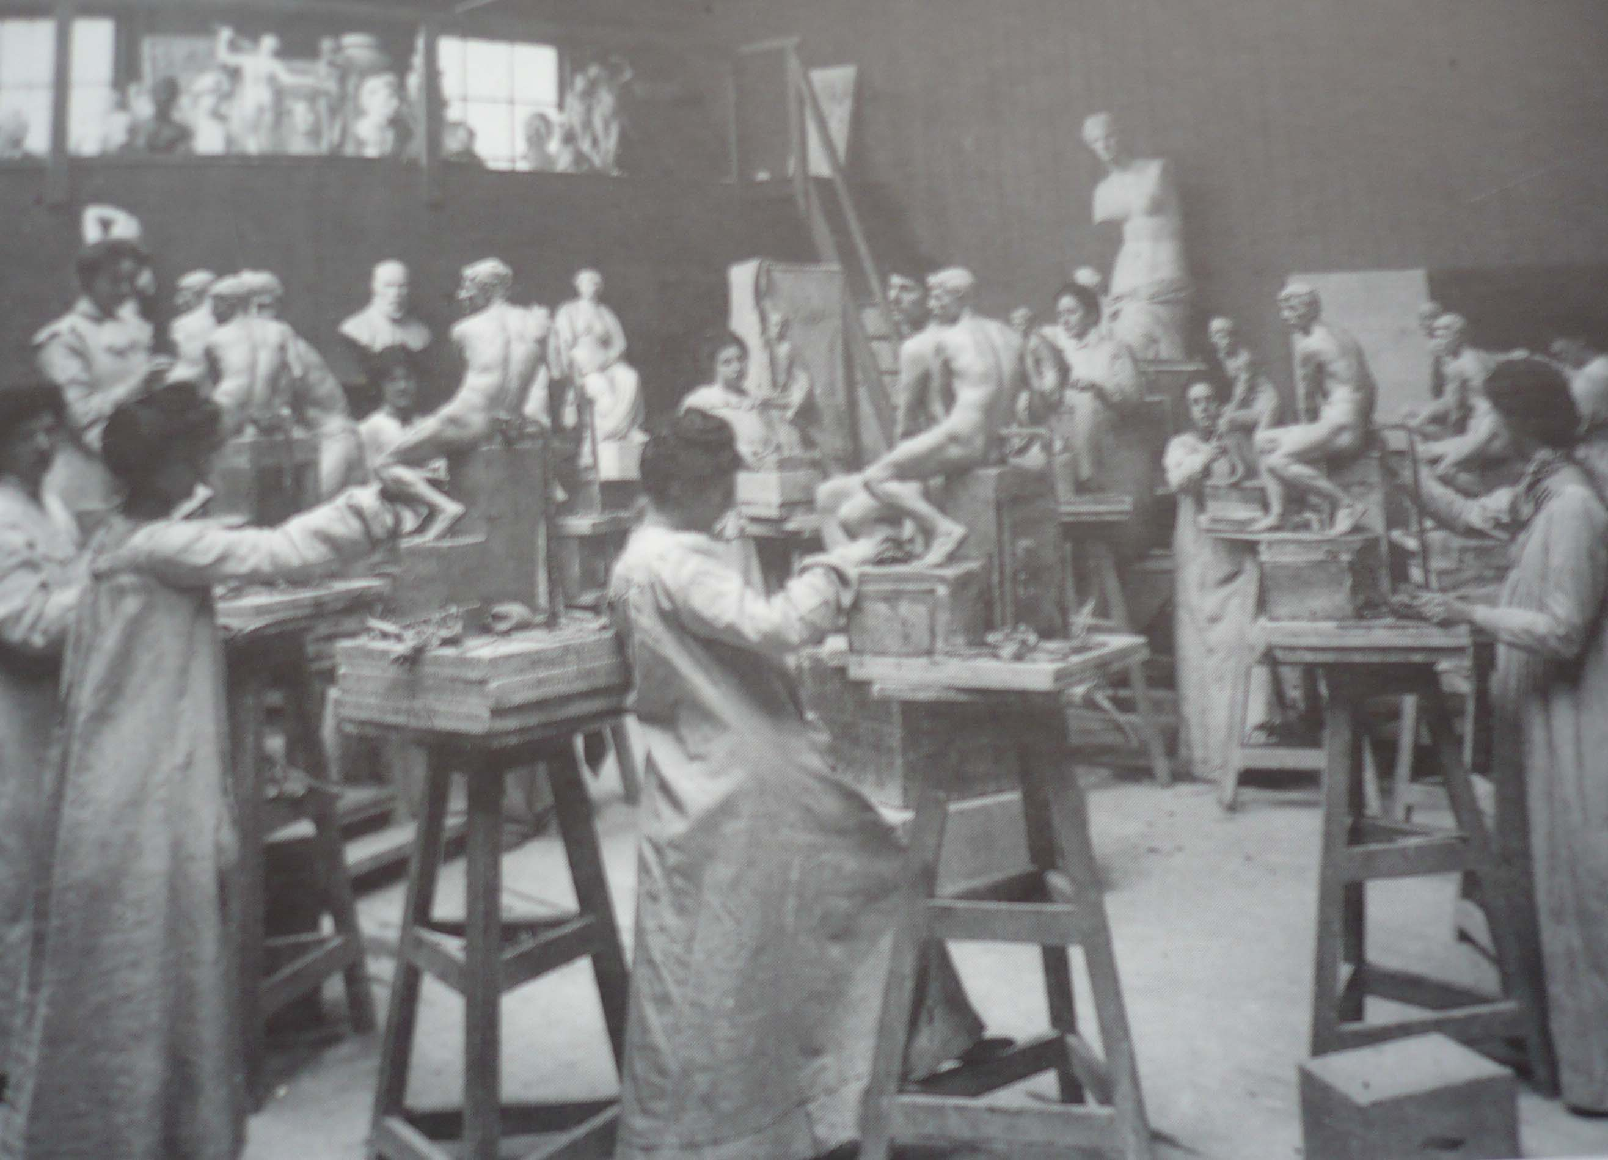
Classroom in the School of Sculpture and Modelling around 1905

From 1857, under Henry Cole’s dynamic leadership, the school flourished. According to museum director, Michael Conforti (1997: 27):

… in 1851, in the wake of the Great Exhibition, the School of Design was incorporated into a museum that opened at Marlborough House under the directorship of Henry Cole. By 1853 with the museum and school incorporated into a newly named Department of Sciences and Art an organised programme of lectures and classes had begun. … From 1857 Cole’s museum at its South Kensington site became the most imitated and programmatically influential museum of the late 19th century. The purpose the government assigned to the new organisation became the foundation of its long-term goals: the founding of a London-based museum with “the most perfect illustrations and models” connected with “a school of the highest class”.

Cole hoped the connections between these two institutions would help to perpetuate the work done by the exhibition in raising the standards of design in Great Britain.

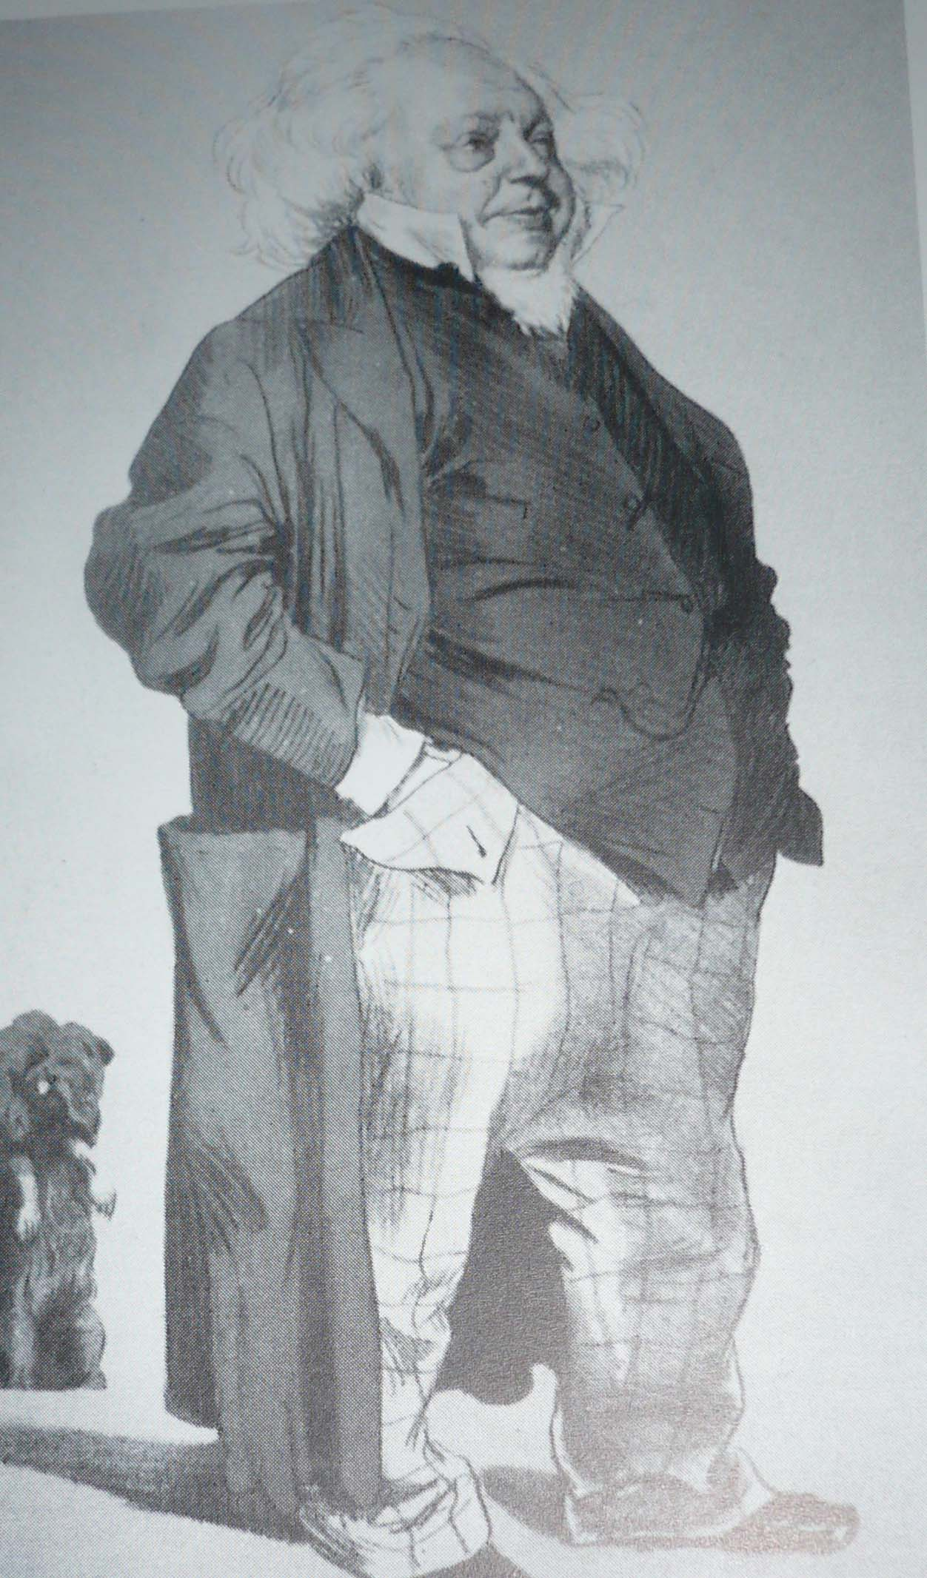
Caricature of Henry Cole by James Tissot for Vanity Fair, August 1871

The Department of Sciences and Art countered criticism in the early days from those who thought the museum was too commercially driven by insisting it was important as a pedagogical aid and that the main purpose of its collections was to serve as examples for the training of students. However, by 1864, despite the move to South Kensington and being embedded in the V&A building, the students complained in a written statement that the museum “was of extremely limited utility, even to them”. (Denis, 1997: 113) The idea had been that by looking at the objects accumulated, many of which had been brought from the Great Exhibition, standards of design would improve. It seems the educational mission of the museum quickly became separated from the collecting activities. As the writer Rafael Denis (1997: 115) points out:

… the abundant indications that collections were often funded by diverting investment away from the direct training of artisans and designers might suggest that their primary purpose was not didactic but, rather, ostentation and display.

It is apparent that from a very early stage there was tension about whether the objects on display were useful to the students or not, as well as confusion and unease about what the College was trying to do. As Quentin Bell (1963: 1-2) notes:

The Schools of Design were the first state-supported art schools in England: their history is one of scandal, confusion and disaster; they were distracted by feuds, encumbered by debts and convulsed by mutinies. … But behind and apart from the personal quarrels, the government fumblings and tergiversations, the political chicanery and office-seeking that must inevitably play so large a part in any account of this educational adventure, there was an important discussion of principle, a debate concerning the nature of art schools which turned upon the question of whether they should be workshops or academies.

With successive Principals the argument about whether the College should be providing practical workshop training or be a higher-level academy continued, as well as discussions about whether a design school needed a fine art strand in order to provide a rounded education for the designer.

In 1896 the school changed its name to the Royal College of Art and Walter Crane, artist and illustrator, became principal. In 1905 a Fine Art strand was introduced by tutor Frank Short through the opening of a Department of Etching and Engraving. By the early 1900s the College was considered a training place for potential art school teachers from the provinces.

The fact that the College was primarily for the study of design is a thread that runs through most of its history. When Robin Darwin was introduced by the Chairman of the RSA at his inaugural lecture in 1954 he was said to be in charge of “the greatest college of industrial design in the world”. (RSA, 1954: 174) Darwin himself said that “Five years ago the College decided that its primary object was to train designers and not craftsmen”. (ibid:185) However, he did concede that, although the RCA was predominantly a school of design, he recognised the importance of the influence of fine artists. (Frayling, 1987: 136)

Darwin and his predecessor as Principal before the WWII, William Rothenstein, were both painters of some repute, particularly Rothenstein who included artists such as Augustus John, Henry Tonks and Wilson Steer among his friends. In a letter to Herbert Fisher, President of the Board of Education who appointed him in 1920, Rothenstein said:

It has been suggested that the school at South Kensington should limit itself to the education of designers and teachers and industrial craftsmen, while schools elsewhere would provide training for students of fine art. But the separation between craftsmen and artists is already too wide. Each has a lesson of value to learn from the other. … To make, then, too sharp a division between the training of craftsman and artist would not appear to me to be wise. (Speaight, 1962: 308)

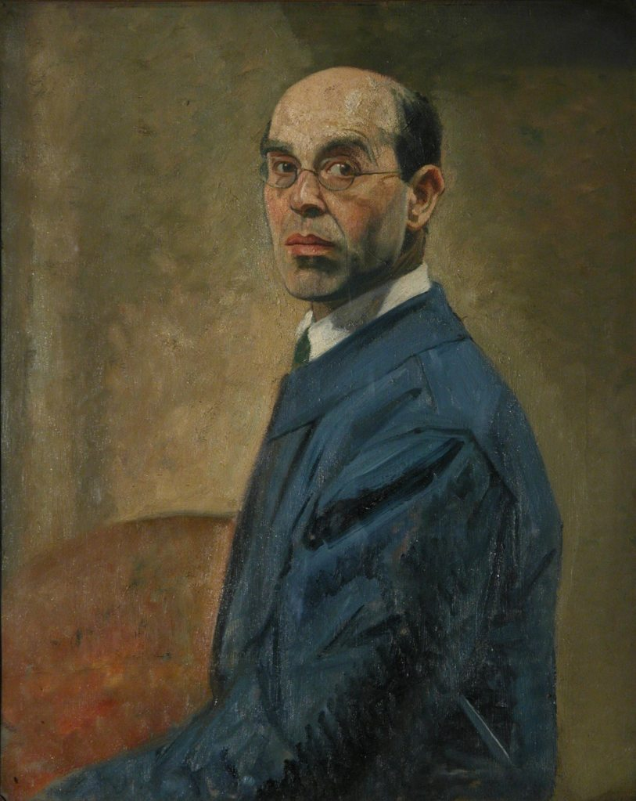
William Rothenstein, Self Portrait, 1930, 73.5x58.5cm

It was Rothenstein who introduced the study of fine art as a discipline in its own right to the College to inspire the already established design disciplines. The earliest works in the Painting collection are from his time as Principal, such as his self-portrait of 1930 and a William Etty Standing Male Nude dated 1849, which was probably acquired to enable students to study the human form.

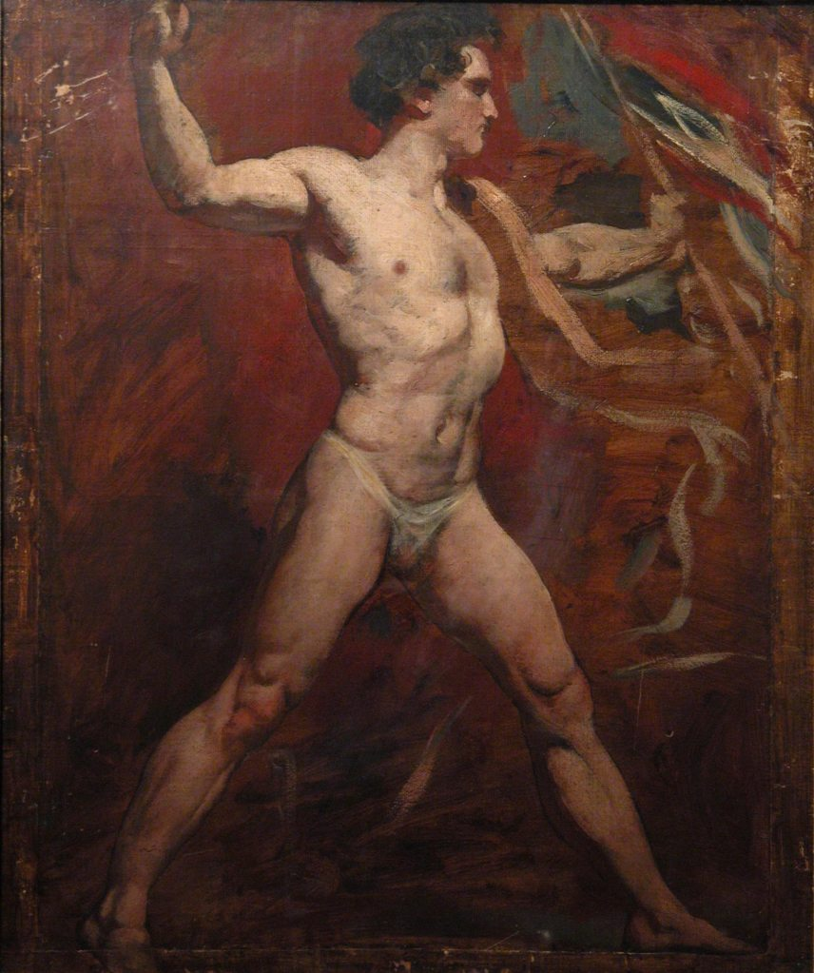
William Etty, Standing Male Nude, 1849, 63x52.5cm

Rothenstein was both Principal of the College and ran the Painting School, which was unprecedented and showed the importance with which he regarded the practice of painting at that time (Huxley, 1988: 80). He was very involved with the students, even joining life classes to demonstrate and advise. He brought in writers and poets as well as artists to inspire the students. He always thought of himself as first and foremost a painter. (Speaght, 1962: 320) One of his more illustrious students of the time, Henry Moore, stated, “Rothenstein brought an entirely new outlook into the College. He’d known Degas and he’d known Rodin, and he didn’t regard the College primarily as a teacher’s training college.” (Brighton & Morris, 1977: 15)

Initially under Rothenstein the College appeared to want to rival the well-established Slade School of Fine Art but soon settled down to its intended function of teaching fine art in the context of design. Rothenstein introduced the idea of the part-time tutor who was also a practising artist or designer. He was convinced that in order to educate properly designers needed to feed off the fine arts. He was aided by the fact that he had particularly gifted young students in the form of Henry Moore and Barbara Hepworth in the Sculpture school (1921) and Eric Ravilious and Edward Bawden in Design (1922). They certainly helped to lift the profile of the College as he had hoped. However, it raised the question of whether prestige among gallery owners and art critics should really be the main objective of the College and there continued to be tension between fine art and design. (Frayling, 1987: 107)

When WWII broke out the College moved to the Lake District. Unable to take any heavy equipment with them, a new genteel era of easel painting, textile and mural design resulted. Leslie Duxbury, a printmaker who arrived as a student in 1941, said that one of the good things about the time there was that, “… students could move from department to department – without any barriers; everyone did everything, before Robin Darwin came along and pulled it all asunder”. (Frayling, 1987: 123)
After the War Robin Darwin, great-grandson of Charles Darwin, embarked upon a complete reorganisation of the College. Among other things he started building up a collection of paintings that he could use to adorn the walls of the College.

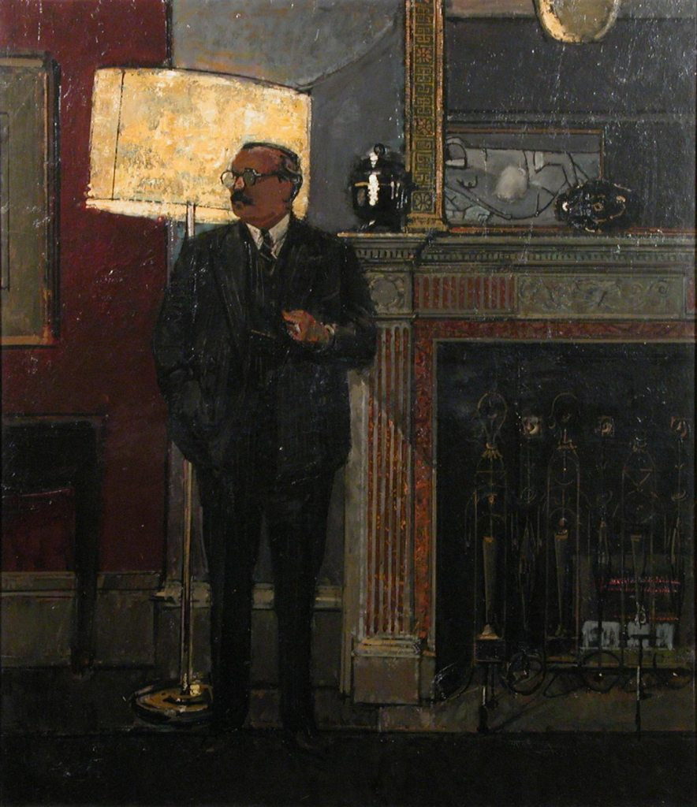
Ruskin Spear, Portrait of Robin Darwin, 1961, 130 x111cm

Any teaching collection that previously existed had been absorbed by the V&A and very little was housed in the college studios by the time he arrived. Darwin was a talented painter himself and recognised the potential importance of the work being produced at the College both by the students and the staff who were teaching there. However, no work was being collected at this time and there was nothing available for him to hang on the walls of the College to lift the spirits of the staff and students and act as a showcase to visitors. He was determined to make the RCA the greatest school of art and design in the world and wanted to reflect this in work hanging on the walls of the College.

A letter from Darwin to his secretary in 1971 explains how he started collecting in 1949-50 with the acquisition of a drawing by Walter Sickert, which he was advised to purchase by his Professor of Painting, Rodrigo Moynihan. In it he says, “The RCA began to undertake commissions in 1949-50, at which time it had no possessions at all”. Other works he added were a small drawing by Lowry and the design for a fan by Lucian Pissarro.

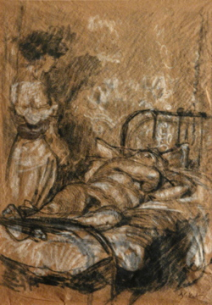
Walter Sickert, Camden Town Nude: Conversation, 1908-9, 34x24cm

The significance of the Sickert drawing cannot be overestimated. Although it is small and spare (only 34 x 24 cm), as artists, Darwin and Moynihan must have been aware of the influence Sickert had exerted, and would continue to exert, on both the students and staff in the Painting School at the RCA, most of whom continued the realist tradition so influential in Sickert’s work. Sickert portrayed everyday life with particular concern for the way he utilised his media. The drawing is from his Camden Town Nudes series and demonstrates his use of gritty realism. A quote from the publicity for an exhibition of these works at the Courtauld Gallery in London in 2007 states, “The uncompromising realism of Sickert’s nudes, set on iron bedsteads in the murky interiors of cheap lodging houses, challenged artistic conventions”. Sickert opened up a path for many artists who followed, with his influence as both an artist and teacher being passed down to a generation of painters. His importance is reinforced by the writer Richard Shone (1992: 1-2) who states:

Painter, etcher, writer and teacher: Walter Sickert heralded in his work the ‘age of the common man’. With his subject matter drawn from … unglamorous, even sordid, domestic life, he captured the world as seen by the man in the street … [he] developed a sparse, understated style uniquely his own. … his work has been seen as the forerunner of some of the most vital figurative painting of our time.

The purchase of this work was a symbolic way to start what was to become the Collection, which contains many works that follow his figurative tradition.

But where were these works to be displayed? When Darwin arrived there was no staff common room. He was very keen to have one based on the Oxbridge model and created it in two large rooms on the ground floor of one of the College’s buildings on Cromwell Road with marbled and gilt columns. (Frayling, 1987: 169) This came to play an important part in the life of the College, as it still does, and this is where the works of art were exhibited.

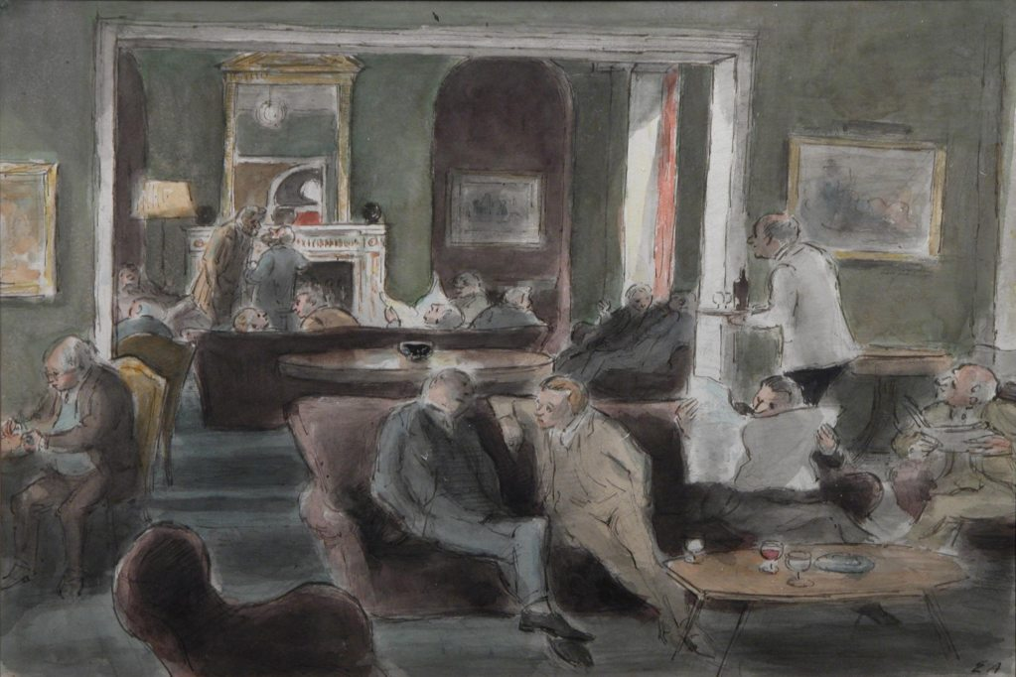
Edward Ardizzone, The Senior Common Room of the RCA (Cromwell Road), 1951, 37.5x56.5cm

The Collection was not intended as a teaching aid but to give prestige to the College – to make it seem of Oxbridge quality. Darwin displayed the works he purchased in the newly formed Senior Common Room (SCR), where he could show them off to guests in order to impress. Subsequently the Collection has been added to by donations from graduates and members of staff and is now a large, varied, gathering of works, a selection of which is still displayed in the SCR.

The following chapters outline the postwar history of Painting at the RCA and analyses the work produced by the students, the influence of the staff who taught them and the events that helped to shape the works that make up the Collection. The chapters build up a picture of the institution and reveal the issues associated with caring for such an eclectic Collection.

1948-1968

How the tatty mess of 1951 became the exciting mess of the ‘swinging sixties’ is a miracle yet to be fully explained …. (Seago, 1995: xi)

1948-1968 was a transitional and transformational time in the UK leading to a complete reappraisal of the way art should be taught and the purpose of art education, which will be discussed in this chapter. It was not going to be a quiet transformation and the late 1950s and 1960s ushered in a bold new era for painting. The above quote from Len Deighton, who was a student in Graphics and Illustration at the RCA in the 1950s, sets the scene for the way events would unfold in Britain and at the RCA over the course of the next two decades. However, not everyone was aware of what was to come, hence the conservative view of the future from Jack Smith (1960: 42) who studied painting at the RCA from 1950-53. After his 1959 exhibition at the Whitechapel Gallery, he is quoted as saying:

I feel that the age of public challenging like that [referring to Dada] is past. Whatever might come out of the next fifty years will be done with a strange kind of silence, I feel.

He could not have been more wrong. Everything was to be challenged over the next decade in a loud and uncompromising way.

In 1948 Britain was in recovery from the ordeal of WWII. What the art historian Serge Guilbaut, (1983: 8) said of the USA at this time was equally appropriate for the UK, “The whole social structure had been pulled down, political life had been reoriented from top to bottom, and intellectual life had been blown to bits.”

To set the scene for this postwar regeneration one must look at what influenced British art in the early twentieth century. Prior to WWI British artists had predominantly followed European art movements such as Cubism and Futurism, but following this war there had been a move towards more naturalistic subject matter. The art historian and critic Frances Spalding (2009: 232-4) suggests that, “The pity and horror of war had knocked the stuffing out of the avant-garde… This loss of confidence permitted the return of a more conservative approach and more traditional styles.” And, as the art historian Werner Haftman (1961: 288) explains, “All over Europe the need was felt for a new confrontation with nature.”

Art in Britain did not move in any one particular direction. Various groups were founded such as Unit 1 formed around Paul Nash whose spokeman was Herbert Read and who took their influences from Romantic Surrealism and Abstract Constructivism. Artists such as Victor Pasmore, Rodrigo Moynihan and William Coldstream experimented with abstraction as a means of expressing the feelings aroused in them by nature. (ibid: 291) There was the Euston Road Group who focused on landscape, still lives, figures and nudes, and whose influences were Cézanne, Corot and Bonnard. In Haftman’s view there was no one movement that dominated and no particular individuals that stood out. He goes on to point out that:

The new intimate nature painting was extremely popular among the English public, which was glad to escape from the confusing, aesthetic theories and ‘metaphysics’ of modern art. At that time the general public believed that England was finished with modern movements for good. But very different forces were in the making and the experience of total war with all its terrors was to change the perspective completely. (ibid: 292)

In fact, all the art of the Western world felt the influence of Europe at that time. Although eminent European artists and designers passed through the UK immediately before WWII, the nationality bar that operated for all types of teachers prevented them from gaining employment in art schools and many ended up in the USA. One such person was Walter Gropius, who had founded the Bauhaus in Germany and arrived in London in 1934. The RCA contemplated appointing him Principal to succeed Rothenstein, but was unable to do so because of the rules and language difficulties. In 1937 Gropius and his wife left for America where he ended up teaching at the Harvard Graduate School of Design. (Frayling, 1989:118) The migration of prominent European artists such as Hans Hoffman, Piet Mondrian and Marcel Duchamp to the United States between the wars ensured their influence on American art, which had until then been very parochial. The young artists they taught and interacted with were, in their turn, to have a great influence on British art after WWII, but this would take at least a decade to become apparent.

When Robin Darwin was appointed of Principal of the Royal College of Art in 1948 the institution was in some disarray. During WWII activities in London had closed down and what was left of the staff and students decamped to Ambleside in the Lake District in 1940 where they remained until the end of the war in 1945. So isolated were they at Ambleside that they remained quite unaware of the presence of the internationally recognised German abstract artist, Kurt Schwitters, who was living in the same town. According to Duxbury, “he’d scarcely been heard of by the RCA residents, and certainly not by the majority of students”. (Frayling, 1987: 124)

In his July 1945 Convocation speech, the Principal, Percy Jowett, said, “After their training at Ambleside, and with a more mature outlook, the students will approach the Old Masters with far greater eagerness and reverence”, unaware of the irony that they had been lodging next door to one of the more avant-garde artists of the time and remained unaffected by his influence. (ibid: 124-5)

As discussed earlier, from its inception, there had been resistance to painting being taught at the RCA. Although it had been introduced as a separate subject during William Rothenstein’s time as Principal, a committee set up by the Board of Education and the Board of Trade tried to take this in hand after he retired. A confidential discussion paper of 1942-3 stated, “I do not think that the College should continue to cater for the easel painter as is done at present. He should go to the Slade or the Royal Academy”. (ibid: 126) A whole list of departments was suggested, that did not include painting. However, painting was to continue under Darwin and to have something of a renaissance, but in a different form. His first academic year he introduced Faculties, including a Faculty of Fine Art composed of Schools of Painting, Engraving, Sculpture and Architecture. The following year he produced a properly bound prospectus, rather than the loose-leaf affair of the previous year, which had been produced in haste. Architecture moved from the Faculty of Fine art into a School of its own and Stained Glass was introduced to Fine Art. Darwin was convinced, as Rothenstein had been before him, that design needed the influence of fine art in order to flourish and it was necessary to have them both working together in close proximity.

A look at the prospectuses for the RCA from before and after WWII show a stark difference in focus from the traditional academic approach of working from the life figure and set compositions, to a much more open approach allowing room for individuality. Prior to Darwin’s appointment the emphasis at the College had been on good design, craftsmanship and teacher training (Anon: 1946). However, due to reinvigorated postwar thinking, this was all about to change.

From 1928 until 1948 the entry for the School of Drawing and Painting states: “Every student is expected to produce a composition monthly, and to work out one or more finished figure compositions during his career at the College.” This remained unchanged until the academic year 1949-50 when the entry for Painting states: “The aim of the School is to provide facilities for the student to practice all forms of painting and to enable him to discover and develop his own particular talent”, thus introducing an element of self-expression into the curriculum which was able to thrive with the appointment of new staff. The historian and curator Martin Harrison (2002: 82) notes, “When Robin Darwin became principal of the RCA in 1948 he immediately set out, like William Johnstone at the Central School and William Coldstream at the Slade, to engage tutors who might raise the Painting School into a prominent position once again.”

Darwin appointed Rodrigo Moynihan as Head of Painting. Moynihan was associated with the Euston Road School and, although he had been through a period of abstraction in the 1930s, had returned to figuration by the time of his appointment. There are examples of both in the Collection. One is a formal portrait of his friend Victor Pasmore executed in 1939. The other, entitled Grey, Violet, although undated is likely to have been executed in the late fifties when he had, once again, returned to abstraction.

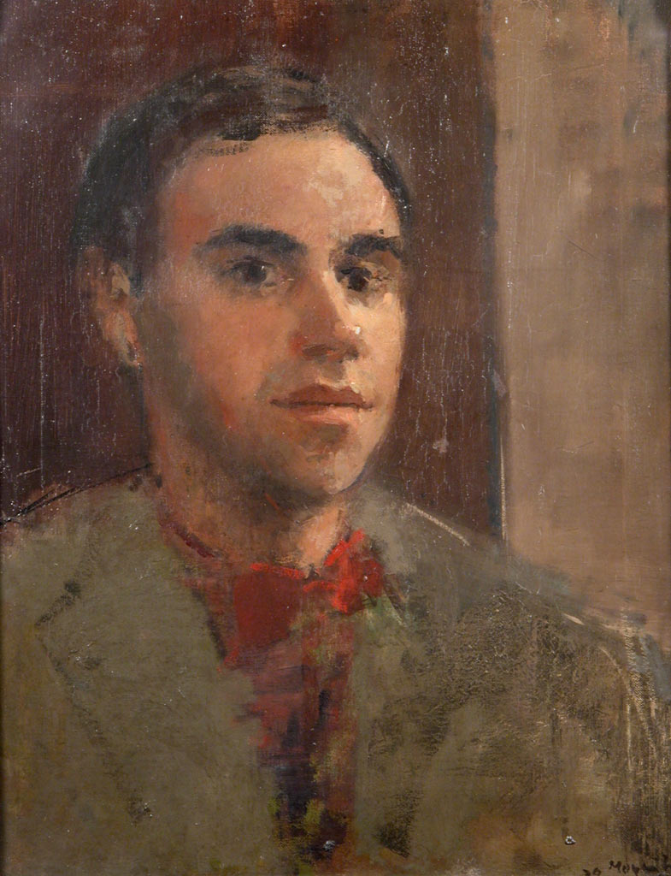
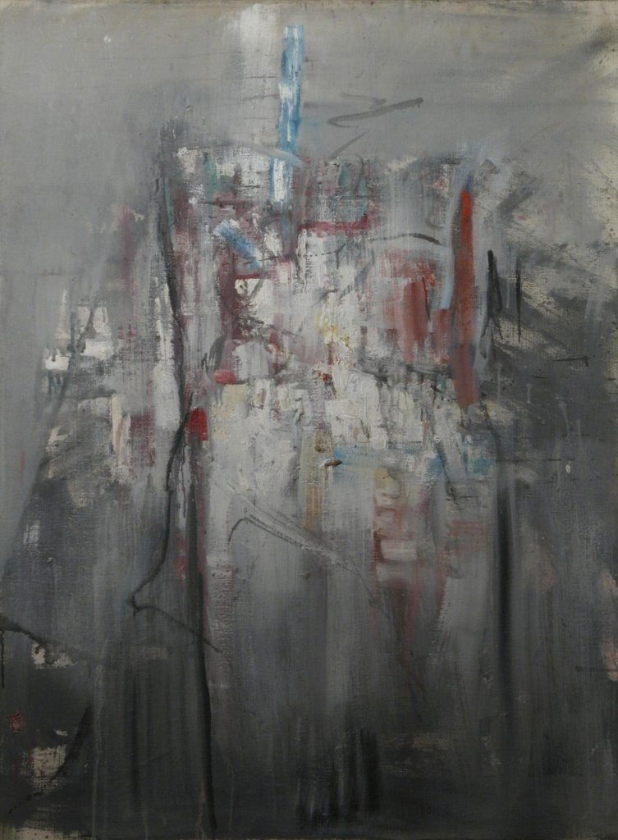
Rodrigo Moynihan,
Portrait of Victor Pasmore, 1939 Rodrigo Moynihan, Grey Violet,
49x39cm (undated) 102x76.5cm

Moynihan was joined by Colin Hayes, Ruskin Spear, Robert Buhler, Rodney Burn (who was the only member of Painting staff to have taught at the RCA before the war) and John Minton all of whom already had reputations in the art world. They were predominantly figurative painters in the European tradition and this eventually led to clashes between staff and students as the students looked to other areas for their inspiration, such as the Abstract Expressionist movement sweeping in from America, as well as changes in the contemporary world around them.

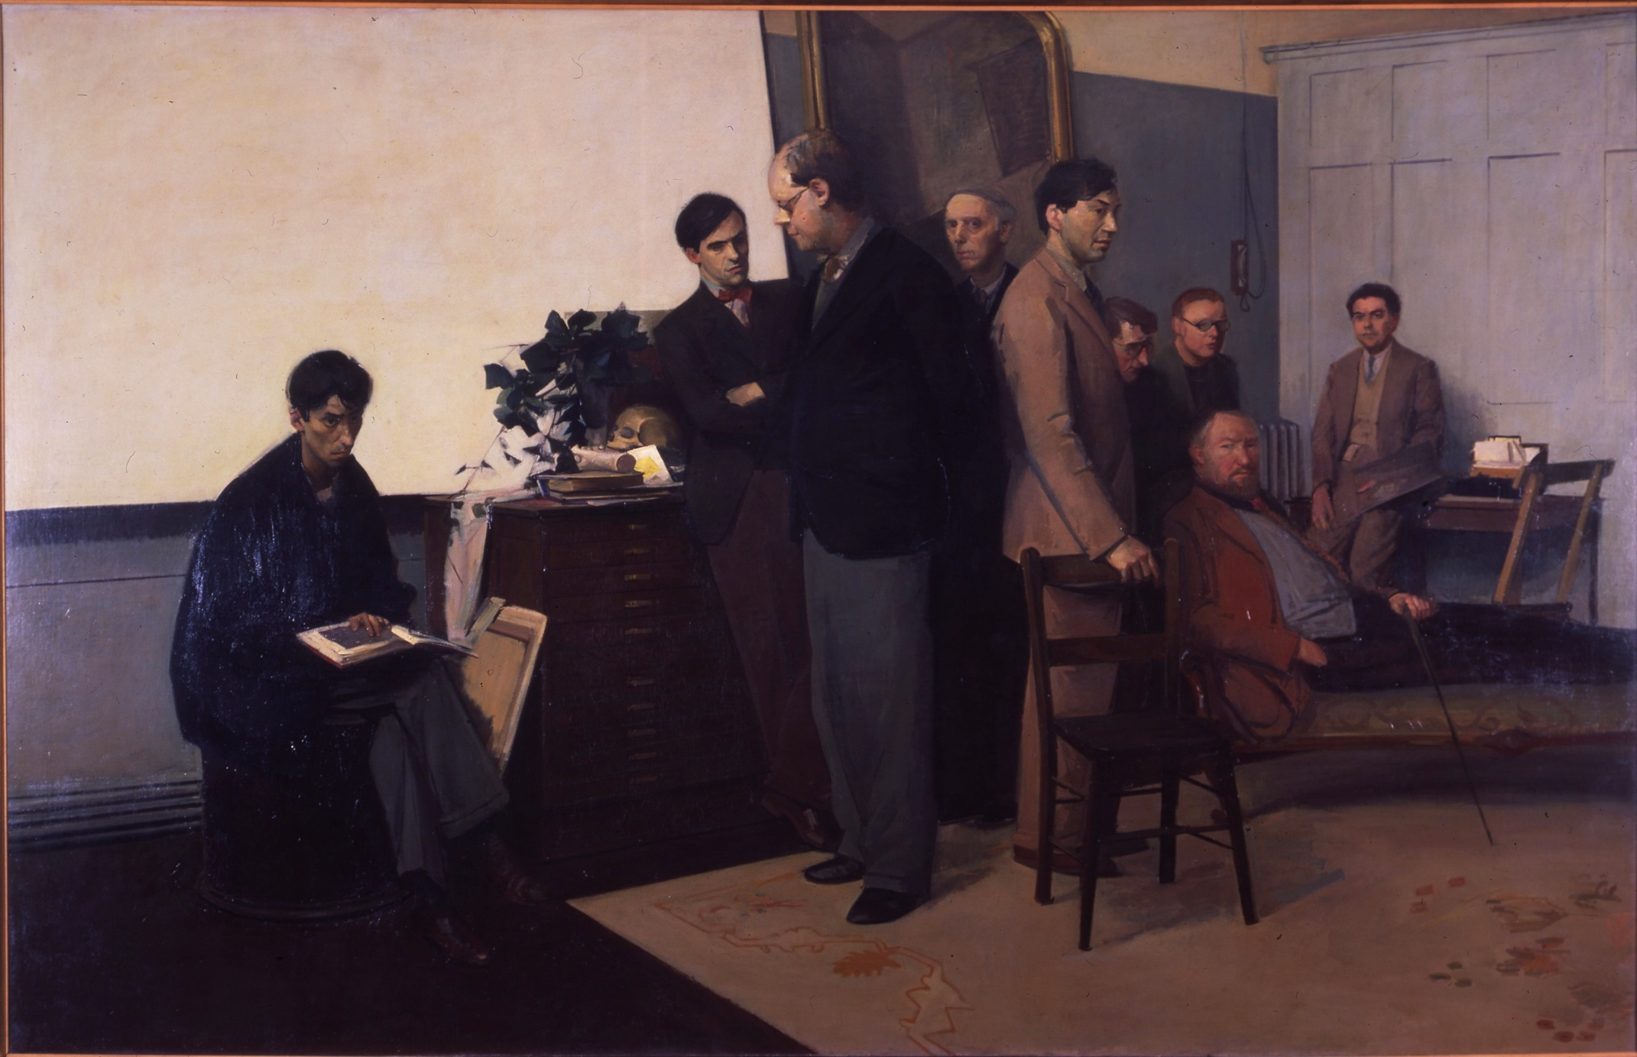
Rodrigo Moynihan, Portrait Group (The Teaching Staff of the Painting School at the
Royal College of Art 1949-50), 1951 Oil on canvas (Tate Collection) 213.4 x 334.6cm
(from left to right: John Minton, Colin Hayes, Carel Weight, Rodney Burn, Robert Buhler,
Charles Mahoney, Kenneth Rowntree, Ruskin Spear, Rodrigo Moynihan)

These clashes were exacerbated by a change in the kind of person attending the RCA after the war. Going to art school to study painting was no longer going to be the privilege of the middle and upper classes. Those from working class backgrounds now saw an opportunity and were enabled by the introduction of ex-servicemen’s grants that allowed them to consider further education as an option. (Garlake, 1998: 28) Robin Darwin said of this new type of student:

Students were older … the sequence of their education had been interrupted by war or National Service; they had known experiences and discharged responsibilities far outside the orbit of their interests and returning to them they were primarily concerned in the rediscovery of themselves as individuals. (Frayling, 1987: 160)

Entrants included Peter Blake, who had studied at Gravesend Art School and who, post-RAF service from 1951-53, attended the RCA from 1953-56 and William Green, who enrolled in 1954, but was a conscientious objector from National Service and was consequently imprisoned in January 1955 for three months. Many had been on active service and were more mature and sure of themselves than previous cohorts. Another student, Joe Tilson, is quoted as saying:

What happened at the RCA then will probably never happen again. It was very much a class thing. Len Deighton, Peter Blake and I all came from working-class backgrounds from the London area. We were the kinds of people who would never have gone to art school before the war. (Seago, 1995: 80)

The writer Robert Hewison also points to the fact that there was a growing trend for those who would not have considered it before the war to seek new experiences through education:

[the postwar art school was] a haven for imaginative people otherwise neglected by the educational system … the relative freedom of art schools encouraged experiments with style. For working class students they were an escape from the factory, for middle class students they were the entry to bohemia. (ibid: 9)

There is no doubt that the effects of WWII and the introduction of the Welfare State in Britain afterwards changed the traditional patterns of entry to art institutions. Many people were empowered by their experiences and felt they could try their hand at anything, which included the non-traditional route of studying at art school. When interviewed about his time at the College Stuart Brisley (2009), a graduate of 1959, had this to say of his pre-RCA experience when studying at Guildford art school, where he started at the age of eighteen:

There were a few people of my tender age and then there were loads of people out of the army and people with numbers on their arms – you name it – it was a very extraordinary mix of people. … People had been in concentration camps, in Japanese prisoner of war camps – they all exhibited different sorts of difficulties in readjusting to the extent that I remember one man committing suicide. It was quite an education which wouldn’t take place now because circumstances are completely different. This was a war that affected everybody and had its physical effects on the country as well.

This new wave of students often arrived with ideas already formed by their life experiences. Len Deighton is quoted as saying, “The problem at the College was that all the instructors were still thinking in terms of the 1930s while the students were living in the 1950s”. (Seago, 1995: 80) Being a youthful student at the time, Deighton may not have been aware of the kind of experiences and influences that had affected the newly appointed tutors who had been brought in to re-model the Painting Department. They may have appeared to come from a stuffy, realist tradition but Carel Weight, Ruskin Spear and John Minton had also been shaped by their involvement in the Artists International Association (AIA) in the 1930s and 1940s. The AIA was a radical force whose aim was to, “fight for peace against Fascism, to establish a social role for the artists, to broaden the audience for contemporary visual arts.” AIA artists came from many different stylistic backgrounds, from surrealists and constructivists to post-impressionists and members of the Royal Academy, and all these movements had influenced the participants. (Morris & Radford, 1983) Although Minton, Spear and Weight were painters in the European tradition, following figurative conventions that had been employed by Walter Sickert, nonetheless their work, their world-view and experience would have an affect on their students.

Ruskin Spear was particularly influenced by Sickert. Born and brought up in Hammersmith, Spear did for Hammersmith what Sickert had done for Camden Town, adopting his locality almost exclusively as the subject matter for his paintings. He was so enamoured with Sickert’s subject matter that he even recreated Sickert’s painting Ennui in his own 1944 version, which portrays the lethargic couple, frozen in time, perhaps for Spear symbolising the tedium of a war which, by 1944, seemed to be never ending. The affects of the war intrude through the bombed wall of the comfortable house to show the street outside, bomb damaged buildings and war slogans, starkly making Sickert’s subject relevant to the present day. (Levy, 1986: 13-16)

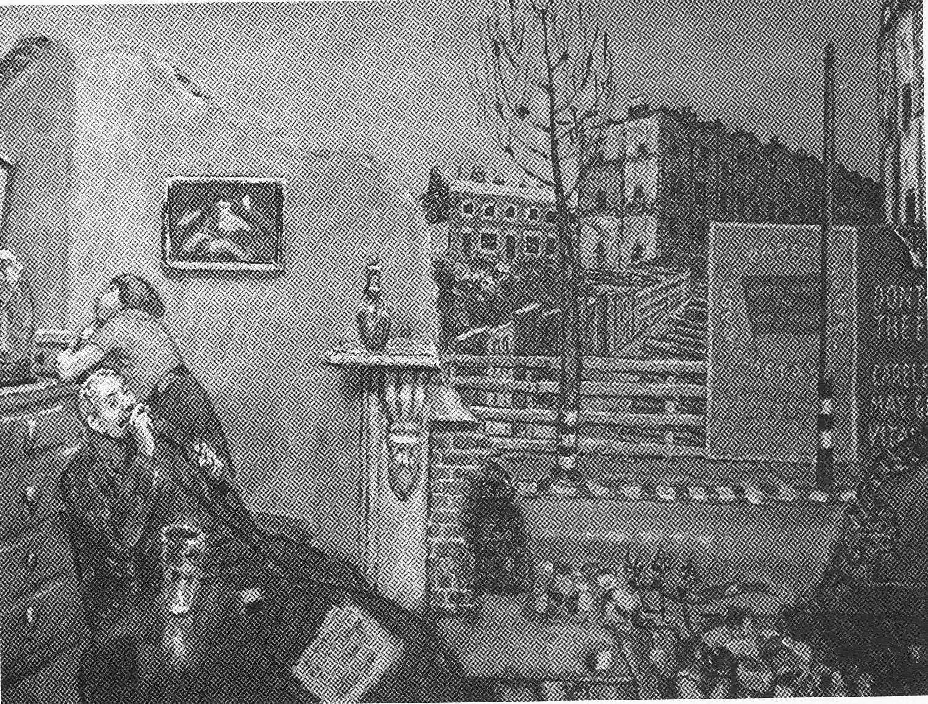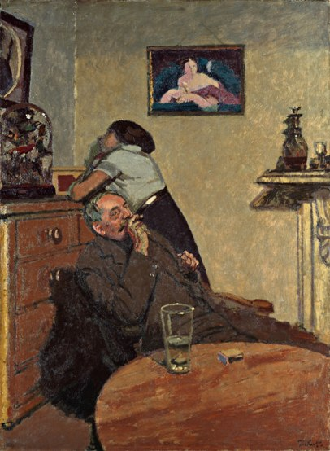
Ruskin Spear, Ennui, 1944 (work destroyed) Walter Sickert, Ennui, c.1914
(Tate Collection) 152x112cm

The theme of the damage being wreaked on London was also present in the work of tutor John Minton. His work was generally more illustrative and romantic – he classed himself as “an English expressionist, slightly Cubist” (Spalding, F,1991: 216) – but he was obviously affected by what he saw around him during and after WWII and depicted this in his work (pictured overleaf) – a theme also pursued by some of his students in the immediate postwar period.

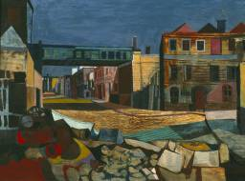
John Minton, Street and Railway Bridge, 1946,
(Tate collection) 45.7x61cm

Carel Weight was another artist who depicted his life experiences. Brought up by a foster mother in a run-down, working-class part of London and appointed a war artist during WWII, the scenes he witnessed throughout his life provided the source material for his work. His paintings often have an eerie, magic realist, quality which makes for unsettling viewing. The work in the RCA Collection entitled Country Lane (pictured overleaf) is typical of his style. It appears that a storm has just passed. There are puddles on the path and the sky is dark and gloomy. Perhaps the people in the foreground have come out after the storm to discuss the event. The angle of the trees and the looming sky, as well as the strange placement of the figures, make the painting both intriguing and disquieting.

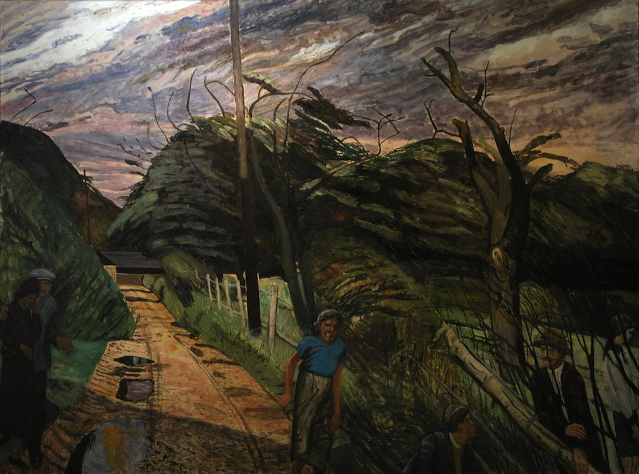
Carel Weight, Country Lane, 1962, 146 x 201cm

Robin Darwin’s careful choice of staff for the Painting School meant that there should have been much to inspire the immediate postwar students. Stuart Brisley (2009), when talking of the influence of the tutors in the late 1950s suggests that he learned much from them:

Rodrigo Moynihan I learned a lot from. … Ceri Richards was the person I had the warmest relationship with and learned the most from. William Scott was friendly with Ceri Richards and suggested that he talk to me. … He said some things to me, William Scott, that were also interesting because I can remember them now and they actually had an effect on what I was doing. I had a lot of good influences.

However, these members of staff had themselves been taught in a very conservative tradition, which suited Brisley who at that time was working in a conventional figurative way, but which was unacceptable to some of the new tranche of students. As the historian Margaret Garlake (1998: 79) points out:

Mature students, all too aware of lost time, rejected authoritarian teaching and old disciplines of meticulous life drawing and tonal painting, the formal skills essential to the academic artist. Acceptance of these conventions would have suggested that the War had changed nothing …”
Among the first students after the war to move painting at the RCA in an innovative direction were Frank Auerbach and Leon Kossoff. They had both been influenced by David Bomberg, whose classes they attended at Borough Polytechnic prior to attending the RCA. Through Bomberg, who had himself been taught by Sickert, they found a chance to express themselves. He allowed real experimentation, the lessons were extremely free in structure and, because they were evening classes, students were encouraged to work quickly. Auerbach commented that there was a sense of quality and a lack of fear in the classes. (Lampert, 1978: 21)

Auerbach and Kossoff followed their own already emerging style, with their reference points particularly focused on the landscape of London in a way that was reminiscent of their tutors. They were seen as part of a group, loosely termed later by the artist R.B. Kitaj, as the School of London. This school included Francis Bacon and Lucian Freud, both of whom had associations with the RCA, not through teaching but through friendships with staff. Auerbach’s and Kossoff’s independence of mind is demonstrated partly through their subject matter, where they found their own particular way of depicting the landscape around them, but more importantly through their use of paint. Helen Lessore (1986: 57), who first showed both artists in her Beaux Arts gallery in London, noted:

Auerbach seems determined to restrict his painting to the representation of parts and aspects of the physically visible world familiar to him … It has always been the case with every good painter that his work is a very subjective, personal and peculiar reflection of the visible world.

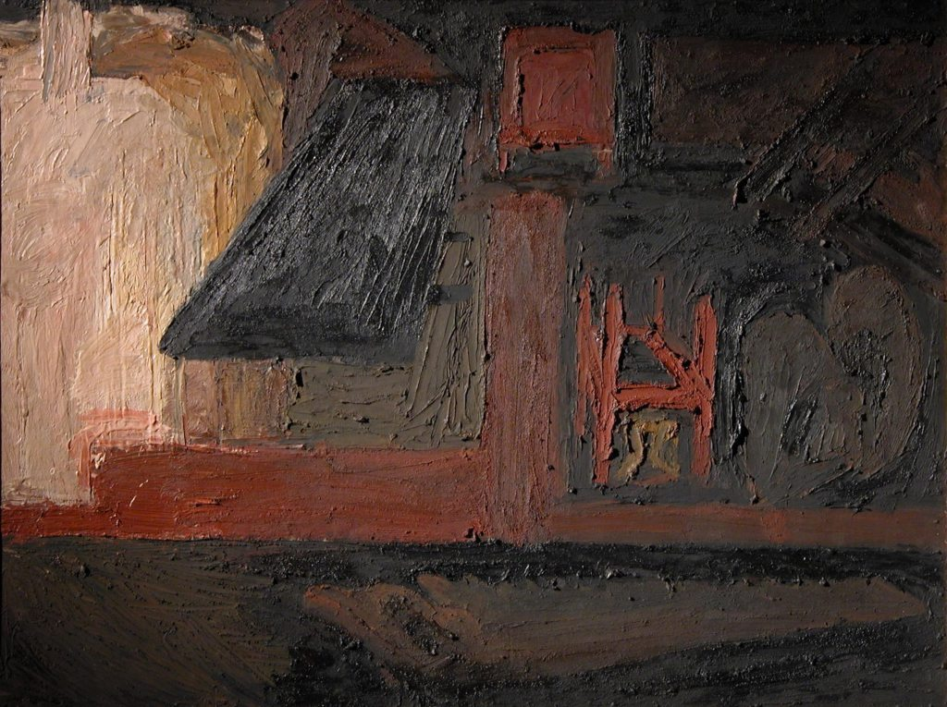
Frank Auerbach, Building Site, Earls Court Road: winter, 1955, 90.5x120cm

Building Site, Earls Court Road: Winter, which Auerbach donated to the Collection on graduating, is a replica of one that he exhibited at his first solo show at the Beaux Arts Gallery in 1956, the year after he graduated, in which he exhibited six building site paintings. As the curator Barnaby Wright (2009: 80) comments:

His thickly built-up paint surfaces presented a considerable and unexpected challenge to most reviewers. Some dismissed the work as “eccentric” or simply “clumsy”. But several others recognised that Auerbach had, as [the art critic] David Sylvester put it, “extended the power of paint to remake reality”.

Auerbach started the work from sketches and drawings he had done at the building site, which was a technique that had also been used by Sickert. He called this exploration through drawing “mental grasp”, a term he picked up from Bomberg. He sometimes set up a still life in front of the canvas in his studio, strategically placing tools that were then included in the painting. As Auerbach explains, “I actually posed a still life in front, of a saw and a pair of pinchers and a hammer, and thought I would create some sort of connection between painting from life and painting from drawings”(Wright, 2009: 80), both standard concerns for painters at art school in this period.

One can see in the works by Auerbach and Kossoff in the Collection a mixture of realism and abstraction that shows the influence of European expressionism that was not present in the work of their tutors. As Wright (2009: 30) suggests of Auerbach’s building site works:

For Auerbach, the building sites were a contemporary equivalent of a sublime landscape – one that could inspire the fear, excitement and strangeness of an uncharted mountain terrain… Auerbach’s paintings are an evocation of his experience of the sites recast as his own battle for expression in paint rather than an attempt to capture a sublimely picturesque view.

These works are examples of the start of a new interest in the medium being used, in this case paint, which would increase as the decade went on.

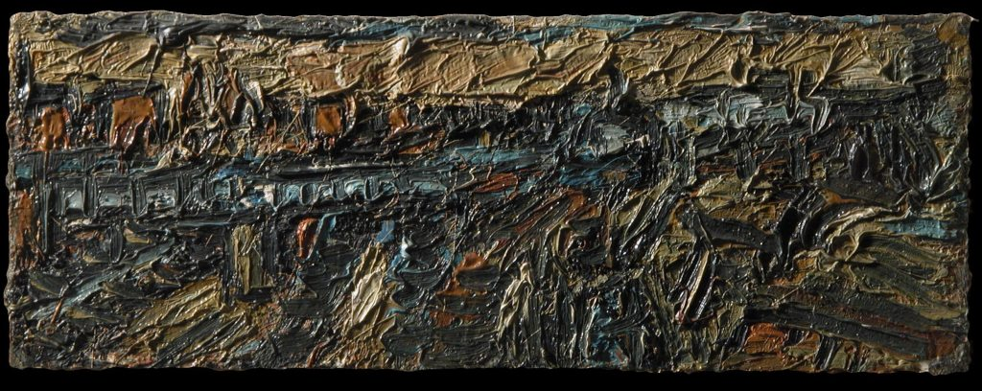
Leon Kossoff, Untitled (Willesden Junction), 1956, 19 x 51cm

Kossoff, similarly, used London as the inspiration for his work and the two paintings by him in the RCA Collection reflect this. One is of Willesden Junction near where he lived, and the other entitled City Building Site. His use of paint is similar to that of Auerbach, with the viewer barely able to make out the subject though the thick paint. Nevertheless, these are not purely abstract paintings and the artists intended the subject matter to be apparent thus emulating the previous generation’s interest in depicting the world immediately around them. Their technique also built on the idea put forward by Sickert that applying the pigment thickly gave the paintings an increased sense of reality.

The critic Robert Hughes (1990: 77) points to the fact that the RCA after the War was a strikingly liberal school. Before the war art school education had been rigid and mechanistic. It offered no opportunity for creative thought. Postwar this was turned on its head. The idea was to liberate the students from this prescribed curriculum so that they could find themselves. Although the tutors’ own styles and ideas about painting may have appeared old fashioned, and there was still some semblance of a curriculum with set subjects, on the whole the staff, who were liberal people, did not put particular pressure on their students to conform. Darwin allowed the tutors a free hand to set their own agenda. Ruskin Spear said the idea was to liberate the students from the burden of set criteria and throw them into a vacuum where they had to re-think and re-evaluate what they were doing. (Levy, 1986:54)

John Minton was instrumental in implementing these changes. He suggested to the students that their new discoveries could be made directly on the canvas – not necessarily through working drawings and colour planning. In the past, staff had expected everything to be worked out before the student put paint to canvas, even down to vetting the colours they would use. (Spalding, F, 1991: 176) Minton helped to do away with these outmoded methods.

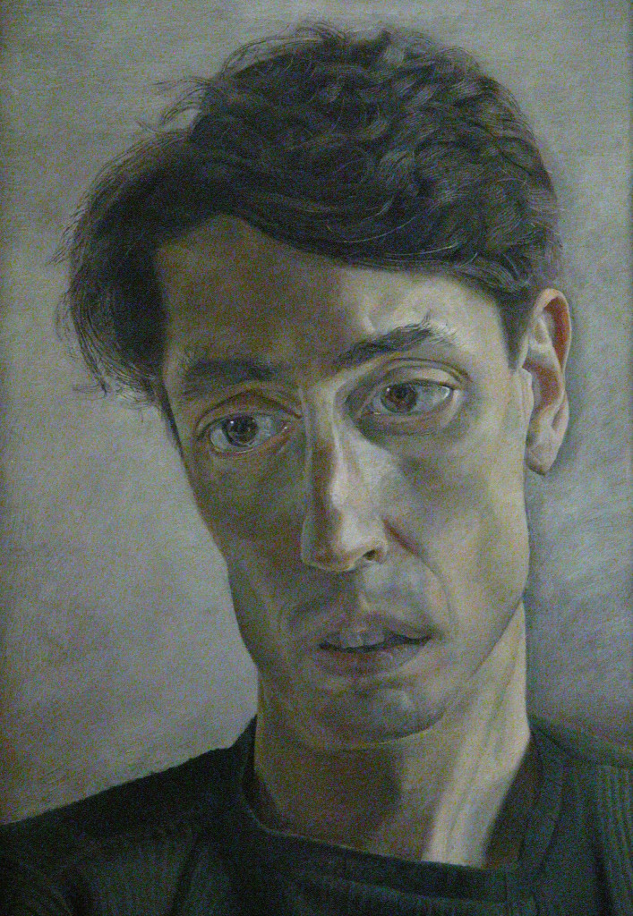
Lucian Freud, Portrait of John Minton, 1952, 41x26cm

Minton was Auerbach’s personal tutor. He recognised that Auerbach already had a sense of the direction he was going and agreed to leave him alone to work it out. (ibid: 177) It was during his three years, left alone to paint, that Auerbach developed what was to be his unique and enduring style. The fact that he was not under pressure meant he could start to make sense of the world around him, his various influences and his own personal vision.

It was in 1950 that John Minton asked his friend, Francis Bacon, to cover for him at the College while he had a term’s sabbatical. Bacon accepted on the condition that he did not have to undertake any formal teaching. Although he did not have a direct influence on the students they were indirectly affected by the presence of his work in the College. Harrison (2002: 81) suggests that Albert Herbert’s 1952 painting Children Playing (pictured overleaf) was influenced by Bacon, noticeable in the way Herbert painted the movement and overlapping of the central figures.

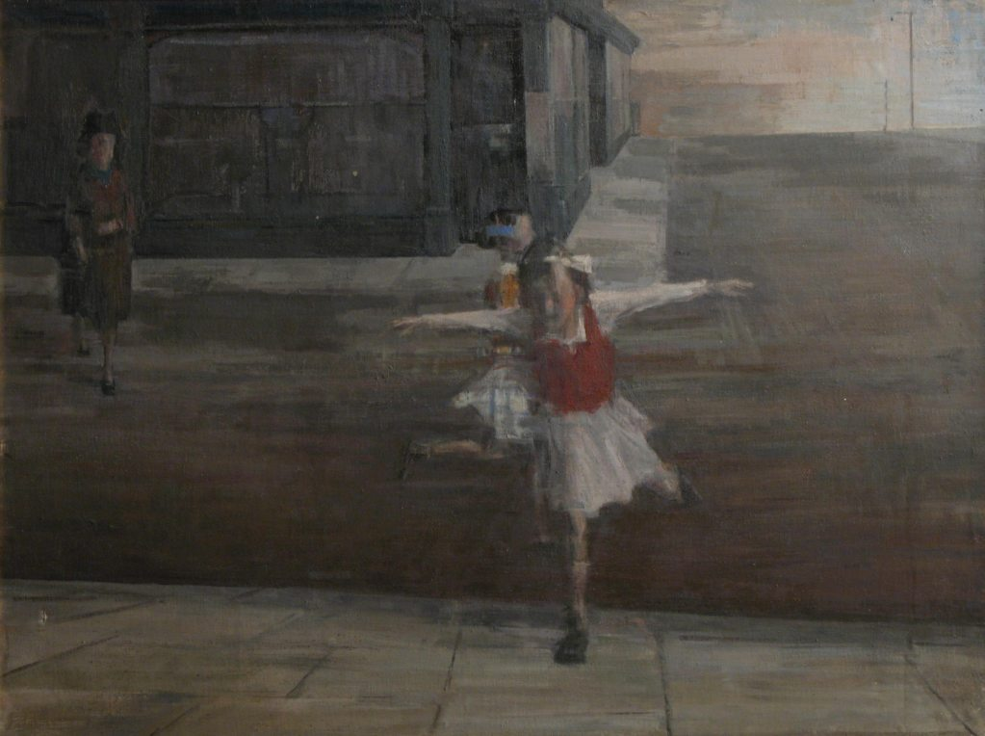
Albert Herbert, Children Playing, 1952, 92 x 122cm

Many paintings executed at the College during the early fifties reflected a rather drab postwar palette and were influenced by the style of tutor, Ruskin Spear. According to Harrison (2002: 85):

Spear is credited with influencing RCA students towards such Sickertian devices as using a coloured ground to unify composition, working with a limited palette, and a kind of tonal painting that retained elements of the Euston Road School linearity. He was undoubtedly the conduit for Sickert’s famous dictum that ‘The more our art is serious, the more will it tend to avoid the drawing-room and stick to the kitchen’.

Other students from the early 1950s such as John Bratby, Jack Smith, Derrick Greaves and Edward Middleditch fell into the social realist Kitchen Sink School – a term coined by David Sylvester, who was harking back to Sickert when he coined the phrase. Sylvester was very influential to the students at that time. Harrison (2002: 80) goes on to point out that:

Albert Herbert is among RCA alumni who testify to the importance of David Sylvester’s 1951 lecture at the college, ‘Towards a New Realism’, which argued that art ‘must show that experiences are fleeting, that every new experience dissolves into the next … must be images in which the observer participates’, an existentialist thesis that he illustrated with slides of the work of Giacometti and Bacon. Herbert, who ‘instinctively wanted to make figurative, emotive symbolic paintings’, felt liberated from the imperative to engage in ‘Euston Road realism or some sort of formalism.

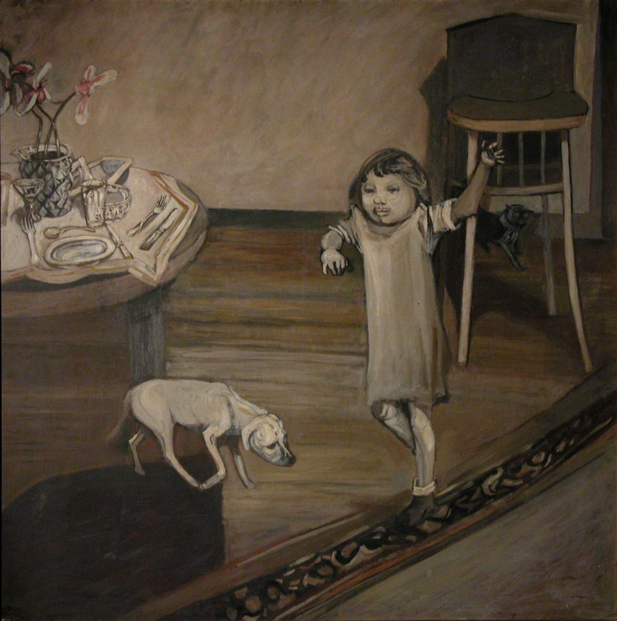
Jack Smith Interior with Child 1953 oil on board, 122x122cm

The Kitchen Sink works in the Collection are less abstract than the works of Auerbach and Kossoff and refer directly to domestic life in fifties Britain rather than to landscape. Interior with Child by Jack Smith is a key example. Painted in flat browns and beiges it is a dreary reflection of the austerity of postwar family life and looks as if all colour has drained out of Smith’s world, leaving an air of disconnectedness and boredom. His contemporary, John Bratby, likened Smith’s use of colour to “the general feeling of sackcloth and ashes after the War”. (Spalding, J, 1984: 14) Like Auerbach, Smith had Minton as his personal tutor. Minton allowed Smith to work in a studio in Kensington away from the Painting School, which Smith found too crowded and noisy, to allow him free rein to paint as he wished.

John Bratby arrived at the RCA in 1951, a year after Smith. He too produced paintings depicting his immediate surroundings. During his time at the RCA he started to apply his paint very thickly, although not in the same semi-abstract way as Auerbach and Kossoff. Like Smith, he concentrated on domestic settings. His use of brighter colours and more middle-class subject matter distanced him from the other Kitchen Sink painters, who predominantly represented the seamy, working-class side of life. The Mural Studio at the RCA, painted in 1954, a year after Smith’s Interior with Child, shows that, although the domestic interior was still the subject of choice, colour was starting to seep in.

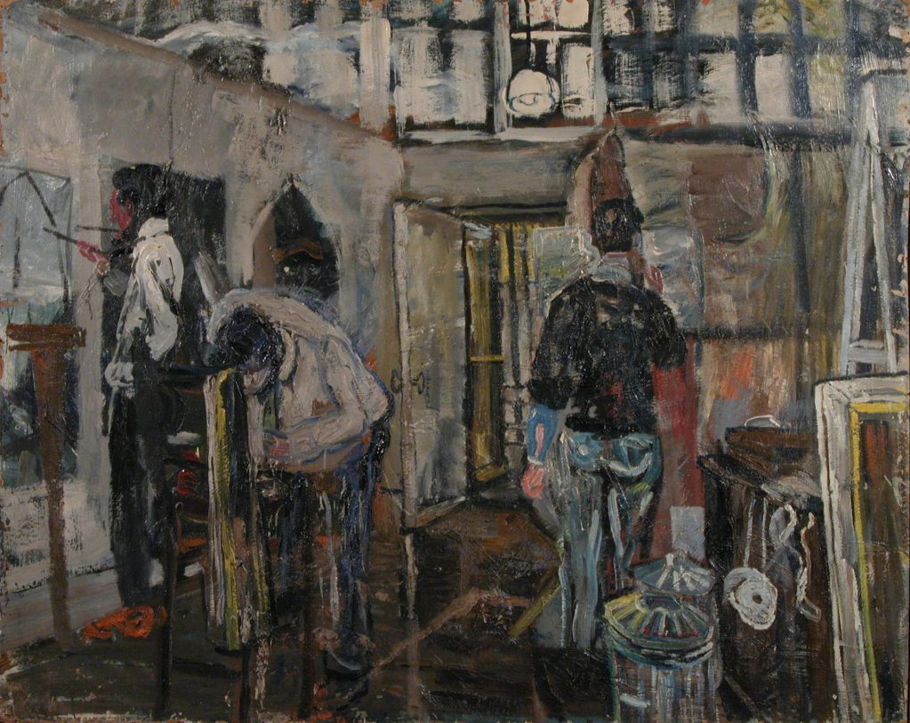
John Bratby, Mural Studio RCA, 1954, 98x127.5cm

Bratby was the first British artist to paint a Kellogg’s cornflakes packet on a table in 1954 (Spalding, J, 1984: 14) and his interiors moved him in the direction of the British Pop Art movement that was to follow, as gradually painting at the RCA moved from the darkness of postwar Britain to the light of new found consumerism and ideas coming from America. Harrison (2002: 85) suggests that the Kitchen Sink School contributed to the breakdown of cultural hierarchies and helped to pave the way for this new wave that followed in the early sixties.

Academic and historian David Thistlewood, who writes about the history of art and design education in the UK (1992; 152), talks about a new creativity in British art education between 1955-1965, by which time the students discussed above had graduated and a new wave, with increasingly innovative ideas, had enrolled. He refers to the fact that the system of education pre-1950 was one of conformity and of clinging to classical tradition, as well as a belief that art was essentially a technical skill that could be taught. What started to emerge during the fifties was the idea of individual creative development. Art students started to experiment with their own ideas in their work and to manipulate the medium used to reflect these ideas.

This shift can be seen in the work of Robyn Denny and Richard Smith who both attended the RCA Painting School between 1954-1957. Seago (1995: 122) says of them, “Everything which young painters like Denny and Smith represented seemed to challenge the most cherished attitudes and values of the Painting School”. Students such as Denny and Smith were starting to be influenced by work coming from the USA rather than the tradition of looking to Europe for inspiration. Suddenly truly ground-breaking work was being seen in London, particularly when the Tate mounted the exhibition Modern Art in the United States in 1956, which proved very influential. Although the exhibition included many works by traditional figurative painters such as Andrew Wyeth and Edward Hopper it also included examples of Abstract Expressionism which had never been seen in the UK before, including paintings by Jackson Pollock, Mark Rothko and Willem de Kooning. The concern of these artists was with the medium and the surface of the canvas itself rather than attempting to depict something from outside the picture plane. As Homer Cahill (1956: 24) of the Museum of Modern Art, from the collection of which all the work had come, said, “The subject matter had become the medium”. The innovative use of materials and the introduction of action painting into the RCA Painting School was undoubtedly influenced by this body of work and later by the 1958 Jackson Pollock and 1961 Mark Rothko retrospectives at the Whitechapel Gallery, as well as by what the students were starting to see in art magazines such as Studio International and ARTnews, both published in the USA but available in the UK.

Margaret Garlake (2008: 8), in her text accompanying an exhibition of Denny’s work in 2008, discusses the way in which the College was changing from a traditional institution into something much more progressive:

In the mid-50s the Royal College of Art was the epicentre of creative thinking in the visual arts, having transformed itself from a site for established values to a place of cutting-edge experimentation that flaunted a new kind of progressive aesthetic, where consumerism and popular culture, film and the urban dynamic – American scale and more aggressive in tone – were celebrated. As Denny vividly expressed it years later: ‘Suddenly art was future-oriented; it was no longer historically oriented’.

She goes on to note that throughout the College students were free to experiment. Painting and Graphic Design students, who were located next to each other in the studios on Exhibition Road, combined verbal and visual ideas in the student magazine, Ark. According to Christopher Frayling (2011), “People have argued that Pop Art happened because you walked through the Graphics studio to get to Painting. Ridley Scott remembers they were doing Colgate ads while the painters were painting toothpaste tubes. It’s obvious”.

In her thesis for a doctorate in Conservation at the RCA Harriet Standeven (2003: 85), when talking about new techniques adopted by students in the 1950s and in particular Anthony Messenger’s Life Painting 1958, says that:

This change in emphasis was by no means welcomed by all the tutors, many of whom had been traditionally trained, and whose sensibilities tended to lie with Neo-Romantic and Euston Road School aesthetics. Many neither liked nor understood these more radical forms of art, a trend reflected in the teaching, which placed great emphasis on tradition.

Life Painting shows that Messenger fulfilled his obligation to work in the life room, but branched out in his use of new materials. Sand and marble dust were mixed with paint to create heavily textured surfaces which were then scratched away. A rotund pink figure takes up most of the canvas. She is quite crudely executed with the paint and other materials thickly impastoed onto the canvas and scraped off in places to provide vague features, such as her face, hair and breasts.

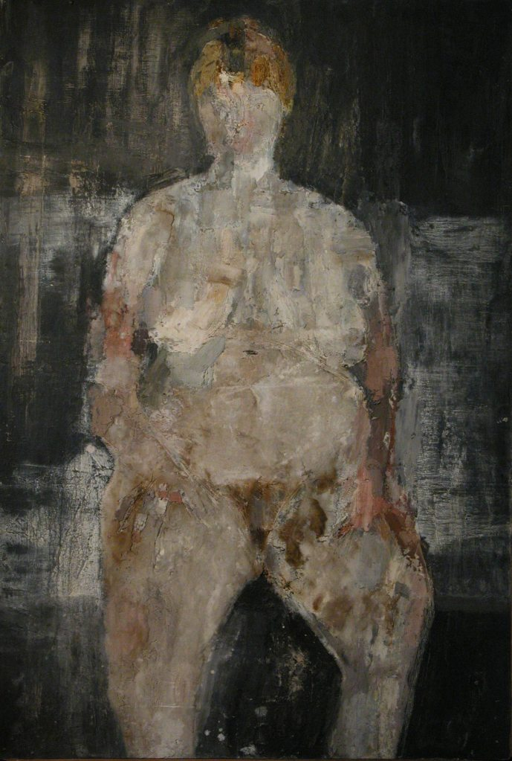
Anthony Messenger, Life Painting, 1958, 181x122cm

William Green was another artist influenced by the Modern Art in the United States exhibition at the Tate in 1956 during his second year at the RCA. He made a conscious decision to become a non-figurative painter. He had already experimented with bitumen on canvas at home before he started at the College, but now he was able to take this further and began working on large sheets of hardboard on the floor, instead of on canvases, using black bitumen which “he subjected to increasingly more brutal gestures and mark making, including attack by fire” (England, 2001). Green was even filmed by Ken Russell bicycling over a black-bitumen-and-enamel painted board for the BBC arts programme Monitor. (Harrison, 2002: 147)

His painting in the RCA collection entitled Hollywood Hornet, which has bitumen dripping down the front of the board, is typical of what he was producing at the time.

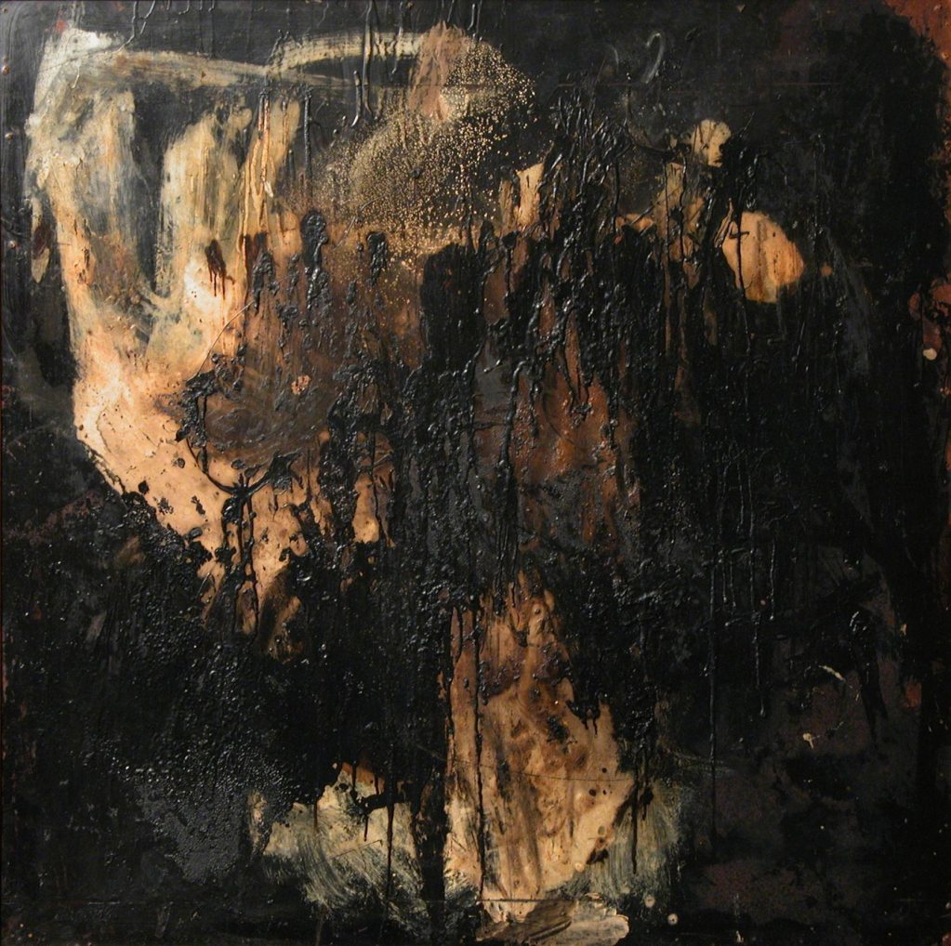
William Green, Hollywood Hornet,1958 , 122 x 122cm

New forms of abstraction and the novel use of materials were markers of a rising trend, breaking away from previous models. The excitement generated by the recent American art was reflected in an increase in large, abstract paintings often using unusual materials. Sandra Blow’s 1966 panting in the Collection, entitled Tea Painting, is literally painted using tea as the medium.

Stuart Brisley (2009) had this to say about his experience of changes taking place in the Painting School in the late fifties:

In 1959 when I was in my final year funny things were happening in the Painting department. For example, suddenly fibreglass appeared and people were beginning to think about different mediums – whatever it might be, so within the notion of Fine Art the actual substances were being expanded and some students were really interested in that.

In this interview Brisley goes on to discuss the differences between the ideas of the staff and those that were emerging in the work of the students and particularly refers to the influence of Robyn Denny and Richard Smith, who graduated in 1957, when Brisley had been at the RCA for one year.

The Smith and Denny duopoly was like a shock in a way and that was backed up culturally with the Americans. The sophistication of the knowledge of Denny was rather critical in relation to this … it all links up. Then you have a body of staff who are coping with this. They are not trying to stop it but it is not of their essential interest… I came into the RCA with notions of figuration and absolutely fixed realism which suited the staff of the time and that is why I got on with, and learned a lot from, Moynihan in this regard.

From his description of his time at the College it is clear there was a clash between the emphasis the staff put on figuration and realism and the fact that the students were beginning to experiment with abstraction, the medium itself and a form of non-academic figuration which was to come to the fore at the College in the late fifties and early sixties.

Seago (1995: 122) suggests that the staff of the RCA Painting School were either indifferent to the growing influence of Taschisme, Abstract Expressionism and hard edge abstraction or positively hostile to it. Christopher Frayling (2011) suggests of this era that:

The key thing for a tutor in the Painting Department was to have a strong point of view. The cardinal sin was to be liberal and spongy and agree with everything. It was very important for that generation to define itself in opposition to practitioners they sort of respected but didn’t agree with and out of that collision came something new.

These irreconcilable differences of opinion led to an incident in the RCA’s Sketch Club in 1956 when John Minton is said to have:

… launched into a prolonged attack on American Action painting… Rounding on a poured-bitumen painting by Robyn Denny and an abstract, gestural work by Richard Smith, [he] violently condemned their lack of finish and arbitrary markings, declaring of Denny’s painting, ‘You could call it Eden Come Home if you wanted to’. Shortly afterwards Denny adopted Minton’s random reference to the Prime Minister, scrawled Eden Come Home on a large board painted in bitumen and scorched the surface: to compound the mischief Smith then signed the work. (Harrison, 2002: 146)

John Minton’s death by suicide in 1957 marks the end of a decade dominated by English parochialism and domestic figuration, and the start of the major influence of the USA on art in the UK. In 1948 Clement Greenberg announced that American art was foremost in the world. (Guilbaut, 1983: 168) It took nearly a decade for this idea to filter through to the UK. However, the students who started at the RCA in the late fifties and early sixties such as David Hockney, R.B. Kitaj and Derek Boshier were about to put the UK very firmly on the map with their own version of British Pop Art.

It was by no means just new forms of art from America that were opening the eyes of UK art students. Just as influential was the work going on at the Institute for Contemporary Art (ICA) and its offshoot, the Independent Group (IG). The importance of the founding of the ICA in 1946, out of which grew the IG, cannot be overestimated. The purpose of the new institution was to provide a forum where artists, writers, musicians and anyone else concerned about contemporary culture could discuss and exchange ideas. Out of the ICA and its avant-garde views grew the IG, made up of younger artists, architects, critics and thinkers. As David Robbins (1990: 8) says:

The Independent Group would not have been what it was – iconoclastic, professional rather than academic in outlook, prodigiously urbane and yet idealistic about the capacity of the common man for criticism and change – were it not for the unprivileged “street-smart” background of most of its members. They were commercially trained, self-educated, at home in the city, with a profound underclass suspicion of social and academic privilege.

In 1956 the IG organised the This is Tomorrow held at the Whitechapel Gallery which was to be another strong influence on art students. The exhibition was iconic in its conception and realisation, based on collaboration between artists, architects, designers and theorists, with 38 participants formed into 12 groups. Each group worked towards producing one artwork. The result was an interactive space full of installations, the like of which had not been seen before. One of the organisers, Lawrence Alloway, summed up the zeitgeist by saying:

The collapse of old-hat aesthetics was hastened for me by the discovery of Action Painting which showed that art was possible without the usual elaborate conventions. … My sense of connection with the mass media overcame the lingering prestige of aestheticism and fine art snobbery. The pressure of the mass media and the failure of traditional aesthetics combined to unsettle fixed opinion and hint at new pleasures. (Robbins, 1990: 165)

Members of the IG included the artists Richard Hamilton and Eduardo Paolozzi, who both taught at the RCA – Hamilton from 1957-61 and Paolozzi in various roles between 1968 and his death in 2005. In his book about the IG Robbins (1990: 39) cites the connection between the ICA and the RCA as being important during the late fifties:

At this time at the RCA Richard Smith was painting abstract canvases of transparent, dripping and scumbled colour passages. He was still a student and worked on two issues of ARK with the editor Roger Coleman. Both issues contained articles by IG members as well as other pieces on American culture. RCA students such as Peter Blake, Robyn Denny, Smith and Coleman frequented the ICA.

From this it is possible to see that students in the Painting School were being bombarded by new ideas, both American and home grown. It is said that the idea of British ‘Pop’ was spawned by the IG, and their thinking must have had an effect on those students who were studying at the RCA in the mid-1950s and early 1960s.

Although one can see the influence of American abstract painting at the RCA in the 1950s, much of the work remained largely figurative. One of the progenitors of the Pop Art movement that grew out of the RCA was Peter Blake, who studied at the College from 1953-56 and was a tutor from 1964-76. Seago (1995: 154) points out that:

Peter Blake maintained friendships with many RCA students, even at the height of painterly abstraction. His example was crucial in maintaining the continuity of a non-academic figurative painting at the College; this and the arrival of R.B. Kitaj in 1958, was a key factor in the emergence of British Pop at the RCA in 1960.

Stuart Brisley (2009) recalls vividly the group of students who entered the RCA the year after he graduated in 1959 and the emergence of British Pop Art that was often concerned with figuration:

It seemed to me after we left and the following year came it was like the College found its feet in a very big way after Denny and co. with Pop suddenly appearing and you find a connection with what the staff were doing. Firstly it is representational and another interesting thing about it is that it connects with applied arts as well in the sense that an earlier person like Peter Blake is very close to notions of illustration, very close to commercial concerns.

The nature of the teaching at the RCA during the 1950s changed far more slowly than the ideas of the students. They were still expected to undertake paintings on set subjects, much as they would have done in the 1930s. Some students tried to test the boundaries. They used the opportunity to stretch the subject to its limits and match it with their own ideas rather than those of their teachers. The set subjects often had biblical references and there are a selection of works in the Collection from the fifties that were painted to these themes such as The Mocking of Christ, The Temptation of St Anthony and The Deposition [at the cross]. Richard Smith’s 1957 painting entitled Yellow, Yellow is an entirely abstract work with areas of yellowy-orange and dark blue paint brushed roughly over the surface. It was seemingly influenced by Taschisme and Abstract Expressionism and was his interpretation of the set subject ‘Susannah and the Elders’. (Harrison, 2002: 157) In Gerald Harding’s painting on the same subject, the work is entirely figurative and expressed in a literal way. These two works appear to have very different concerns. They were both executed the year after the 1956 Modern Art in the United States exhibition, which seems to have had more affect on Smith than Harding. As Stuart Brisley (2009) points out, “One of the things that lots of students rebelled against, although I never did, was that we were required to draw every day from the figure.” Both Smith and Harding would have been obliged to work from a life model. There are examples of Smith’s life paintings in the Collection that demonstrate his skill in this area, but by the time he executed Yellow, Yellow all elements of figuration had disappeared from his work. As the writer Tom Wolfe (1975: 9) suggests, the meaning of painting had changed so much since 1900 that, “Art should no longer be a mirror held up to man and nature. A painting should compel the viewer to see it for what it is: a certain arrangement of colours and forms on a canvas.”

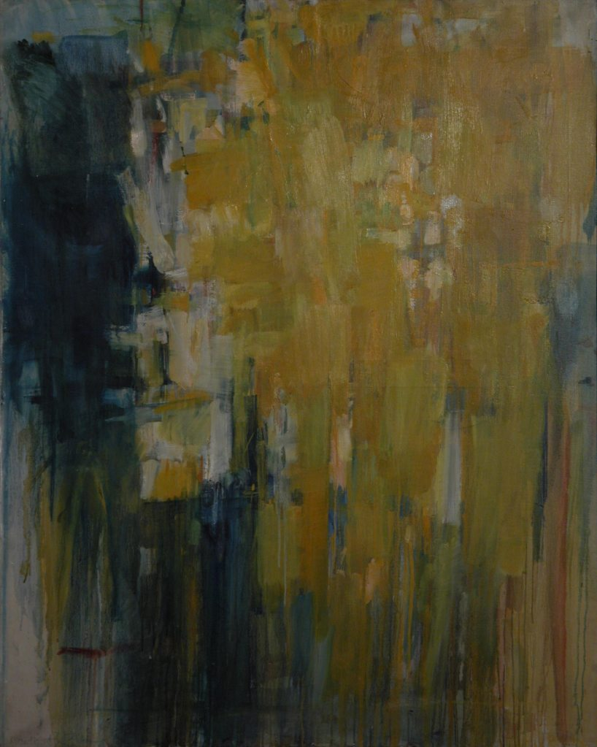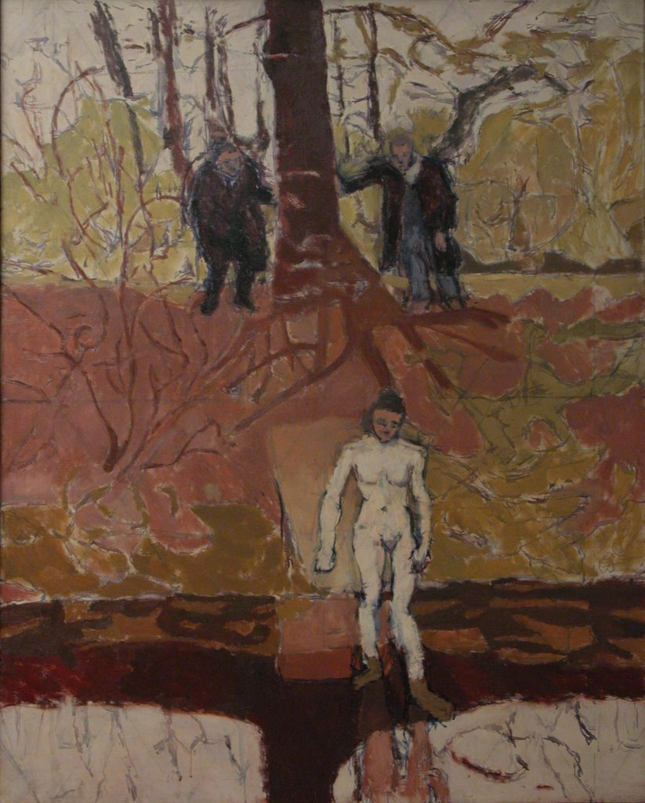
Richard Smith Yellow, Yellow Gerald Harding Susannah and the
1957, 127 x 101.5 cm Elders, 1957, 127 x 101.5 cm

Peter Blake put his own interpretation on the set subject Entry into Jerusalem. The work is figurative and reflects his interest in everyday ephemera, which he was to develop during the late fifties and sixties. The painting shows further development of the ‘Pop’ sensibility, started by Bratby, who overlapped with him by one year. It depicts a boy in 1950s school uniform holding up what appears to be a drawing of the city of Jerusalem. The people waiting for Jesus’ entry are in modern dress and the only animal to be seen is a Mobo bronco horse, a typical child’s toy of the fifties. There is no reference, apart from the map of the Jerusalem of Jesus’ time, to the set subject. In the centre he has meticulously painted a fragment of contemporary newspaper.

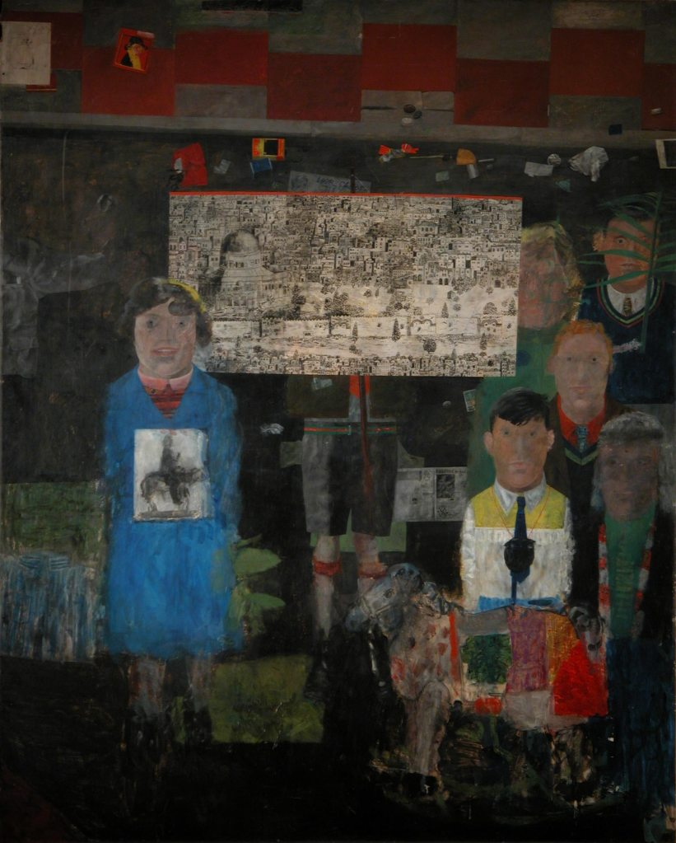
Peter Blake Preparation for Entry into Jerusalem 1955-56, 125x101.5cm

One of the undoubted graduate successes was David Hockney who attended the RCA from 1959-62 and arrived at a time when art and design education was being completely rethought in the UK. Thistlewood (1992: 152), in his history of art and design education, suggests:

The aims and objectives underlying a post-school art education in Britain changed utterly during the working lives of a generation of teachers. What prevailed before the 1950s was a system devoted to conformity, to a misconceived sense of belonging to a classical tradition, to a belief that art was essentially technical skill. What came to exist is a general devotion to the principles of individual creative development. There is no compromise between these two states, and so it is appropriate to describe the succession as ‘revolutionary’.

Art education was to be reformed over the next decade due to the education authorities’ new ideas about how art education should be administered and through consideration of student objections to these new ideas, culminating in a student sit-in at Hornsey art school in 1968.

Part of this student discontent was a reaction to The First Report of the National Advisory Council on Art Education published in 1960, which came to be known as the Coldstream Report after its Chairman, William Coldstream, who was Professor of Fine Art at the Slade and a prominent public figure. He had been commissioned to write the report for the National Advisory Council and provide advice about the future of art education. He had eminent advisors on his committee including Robin Darwin, Misha Black, head of Industrial Design at the RCA, the painter Victor Pasmore and art historian Nikolaus Pevsner. Their recommendations were to introduce a new academicism in order to make art schools more equivalent to universities. As Paul Huxley, previous Head of Painting at the RCA, says:

In the 1960s William Coldstream and his committee made a report which effected change. Maybe he thought there had been too much emphasis on craft and skill and that intellect was being undervalued. Maybe he even saw that the acceleration of technology with the burgeoning quantity of recent art history and theory demanded more mature minds. Certainly he saw that art schools would not receive a fair share of the public purse in the future unless they became academically respectable and awarded something like a degree. (Raein, 2003: 3).

The report recommended introducing a new award of Diploma in Art and Design with recommendations that would enforce prerequisites and define educational aims. It insisted that entrants to art schools should have some academic qualifications (5 ‘O’ levels and a year’s pre-diploma were normally required), complimentary studies and art history would comprise 15% of the courses which should be devised to provide a liberal education in art. These recommendations pushed art schools in the direction of greater academicism, which was not welcomed in all quarters.

None of this directly affected the RCA as a postgraduate institution that could set its own standards and already had a general studies department that insisted on a written element to the course, but it reinforced the fact that art education was no longer just about skill and technique, it should also be about ideas, history and theory. David Hockney objected to having to undertake the general studies programme at the RCA. Interviewed for ARK (41: 44) in 1967 he said:

My main quarrel with the College wasn’t to do with the Painting School at all really – it was to do with the General Studies Department. I’m still against them in a way. I still think it’s a great waste of time. … I think anything that suggests that painting itself is not enough is rather a terrible thing to have in an art school.

His refusal caused him to be threatened with failure of the whole course. He was not the only one in his year – there were six other students in the same position. In the end the College decided that “a deviation had occurred in the computation of the numbers of this examination and that all the students, including David Hockney, be adjudged to have passed the examination”. (Hockney, 1967: 46). This is a situation that would not be tolerated now but some still debate whether painting students should have to undertake a written component or whether their work should ‘speak for itself’.

Hockney had, throughout his time at the RCA, gone his own way. He kept his head down, got on with his own work and later claimed that he tried to keep out of the way of the teaching staff as much as possible. He talks in the same interview of the studio he worked in:

It was like a maze. The staff just couldn’t get in at all. And I worked right over in the far corner. So they didn’t really know I was there. I was the luckiest of all because they just couldn’t get through.

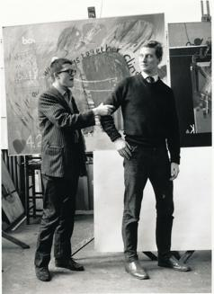
Hockney and Boshier in the Studio 1961
Photo: Geoffrey Reeve

The Collection holds nine of Hockney’s paintings undertaken between 1960 and 1962 as well as a suite of prints, which is far more than he would have been obliged to leave. There is no record of how the College came to acquire so many. These paintings typify the concerns of the day, with references to the USA, the media and popular culture, and show the continuing style of non-academic figuration that runs through the Collection. However, although affected by his trip to the USA in 1961 and the wealth of American art then being exhibited in London, he was also being influenced by great works from Europe and, according to art historian Marco Livingstone (1981: 23-24), visited the Picasso exhibition in London in 1960 six times. Livingstone goes on to say, “The figure style of Hockney’s paintings from 1960-62 owes much to the example of Jean Dubuffet, whose works were first exhibited in London in 1955.”

There was a definite spirit of optimism in Britain in the late fifties that paved the way for new possibilities. Frances Spalding (2009: 241) refers to this time, after American art had made its splash in the UK:

There followed an art boom – a joyful confidence and optimism that chimes with an economic resurgence and Harold Macmillan’s famous remark, ‘you’ve never had it so good’. London became a hotbed of cultural activity.

Hockney would be the first to admit to the formative value of his time at the RCA when, as with many students before and since, he learnt as much from his fellow students as from his teachers. (Huxley, 1998: 5) He was particularly influenced by R.B. Kitaj, who, at the age of 27, was a more mature student. Kitaj had already studied in New York, Vienna and at the Ruskin School in Oxford. He was well travelled and widely read. Marco Livingstone suggests that:

Kitaj’s work revealed ways in which picture-making could, and should, be a vehicle for intellectual as well as sensual communication. The making of images was viewed [by him] as the construction of a language of signs which could be “read” in the way that words can be read. (Morphett, 1994: 14)

Kitaj certainly used literary themes, as is evident in his painting in the Collection entitled Homage to Herman Melville (pictured overleaf), referencing the American writer, and reading was important to him. He is quoted as saying, “There were at least two students at the College who were great readers and they damn well knew that books and art are inseparable companions in many art lives. Those who think otherwise don’t know their stuff.” (ibid: 44)

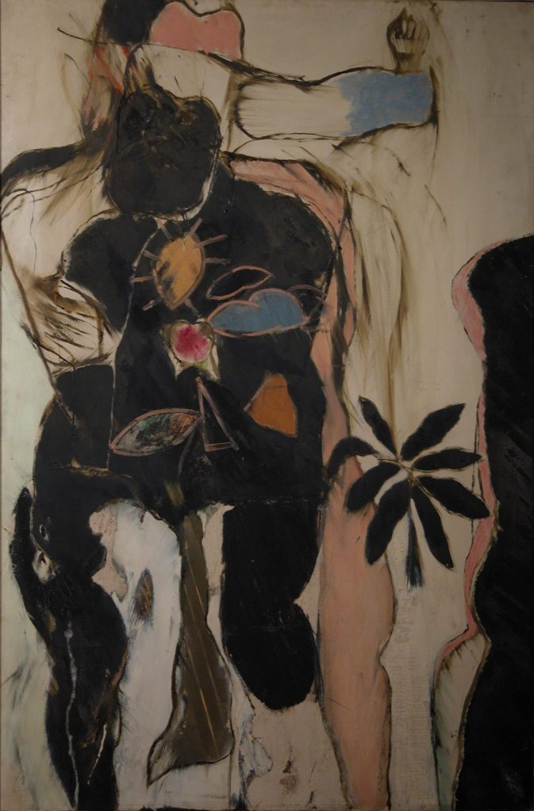
R.B. Kitaj, Homage to Hermann Melville,
1960, 137.5x90cm

Hockney himself acknowledges:

The one student I kept talking to a lot was Ron Kitaj. Ron was slowly doing these strange pictures and I talked to him about them and about my work … I’d talk to him about my interests: I was a keen vegetarian then, and interested in politics a bit, and he’d say to me, why don’t you paint those subjects? And I thought, It’s quite right: that’s what I’m complaining about, I’m not doing anything that’s from me. So that was the way I broke it. I began to paint those subjects … And I thought, well, it’s better. (ibid: 14)

Inspired by Kitaj to paint in a more personal way Hockney began to write on his work. Livingstone (1981: 19) points out that, “When Hockney began writing on his paintings it was with the intention of communicating his interests to others.”

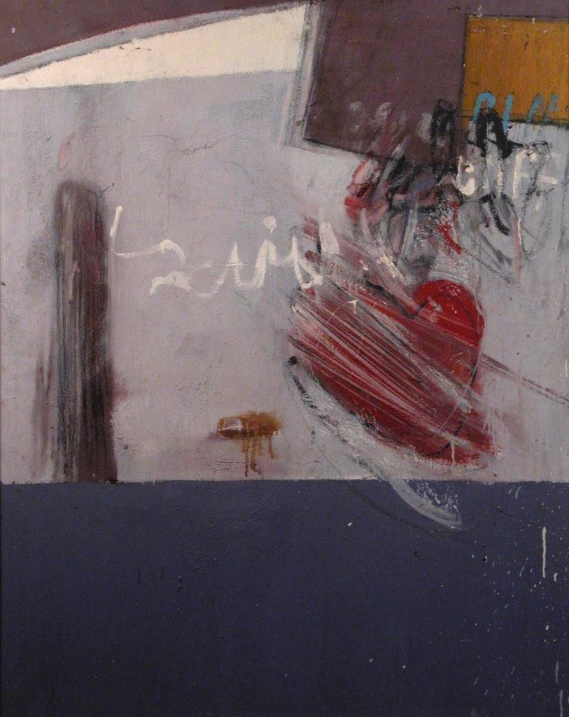
David Hockney, Cliff, 1962, 127 x 103 cm

Cliff was inspired by one of his heroes of the time, the pop star Cliff Richard, and a headline he saw in the newspaper about two boys who had been stranded on a cliff that stated Two Boys Cling To Cliff All Night Long, which he imagined in a quite different way to that intended. Like Kitaj, he used literature as an inspiration for his work and the title of this painting also refers to the Walt Whitman poem ‘We two boys together clinging’, the subject of another painting, now in the Arts Council Collection (see photo on p.58 with painting in background) and to his homosexuality, which was still illegal at that time. It is a good example of the way he used text and literary themes in his work as is the painting Big Tyger, executed in 1962, which directly refers to the poem, ‘The Tyger’ by William Blake. As the writer and curator Jasia Reichardt (Madoff, 1997: 17) explains:

Specialising in the literary translation of imaginary events which are usually triggered off by some personal escapade is David Hockney. … His painting have the irresistibility of allusions to passion in the form of small tokens and shared secrets.

I’m in the Mood for Love is the result of his first trip to America in 1961 and reflects what he experienced there. Again, he uses text to express himself and the word Queens refers both to the area in New York that he visited and his homosexuality. He depicts himself as a devil figure, heading for a period of debauchery in a new city. Paul Huxley (1998: 5) suggests that Hockney encoded his paintings with various numerical devices and initials which publicly announced as well as concealed his secret loves. In this painting the number 9 more innocently refers both to his birth date and the date he departed for New York. Both paintings are examples of Hockney expressing himself in a very personal way and developing his individual style, which is something his three years at the RCA allowed him to do.

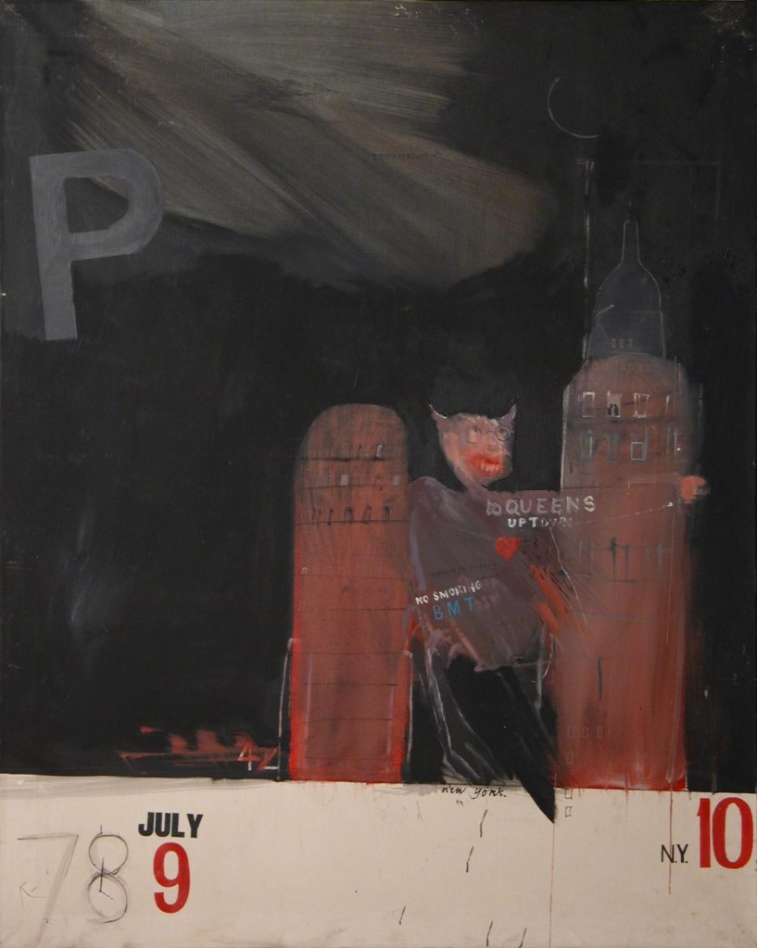
David Hockney, I’m in the Mood for Love, 1961, 128.5x101.5cm

Kitaj himself realised that he was having an influence on his peers and is quoted as saying:

I believe it’s common knowledge that I encouraged more than a few young painters to introduce dramas and ideas that interested them into their pictures (as I was doing myself). One wished to subvert the dead hand academic notion, widely prevalent then and less now, that the world is flat beyond the picture-plane. All the bright young painters were doing abstraction at first – even Hockney. (Morphet, 1994: 44)

The 1961 Young Contemporaries exhibition was the first real showcase for British Pop art featuring the work of RCA students David Hockney, Derek Boshier, Allen Jones, Patrick Caulfield, R.B. Kitaj and Peter Phillips. The introduction to the brief catalogue (no images included) was written by the curator and critic Lawrence Alloway (1961) and gives a good insight into how art was developing at the RCA at that time:

A group seen here for the first time is of artists (mainly at the Royal College) who connect their art with the city. They do so, not by painting factory chimneys or queues, but by using typical products and objects, including the techniques of graffiti and the imagery of mass communications. For these artists the creative act is nourished on the urban environment they have always lived in. The impact of popular art is present, but checked by puzzles and paradoxes about the play of signs at different levels of signification in their work, which combines real objects, same size representations, sketchy notation, printing and writing.

The painting from the Collection by Derek Boshier entitled Birthday (pictured overleaf), another set subject, is a good example of the artist using text and found objects in the form of children’s building bricks and small dolls, relating to everyday experiences. It is unlikely that Boshier had seen the actual paintings of Jasper Johns, who exhibited in London for the first time at the Whitechapel Art Gallery in 1964, although he may have been aware of his work and that of Robert Rauschenberg, who was working in a comparable way. However, this 1962 work has very similar sensibilities and, like Johns, Boshier was trying to produce work grounded in the real world he saw around him yet experimenting with the process of painting using themes of popular imagery.

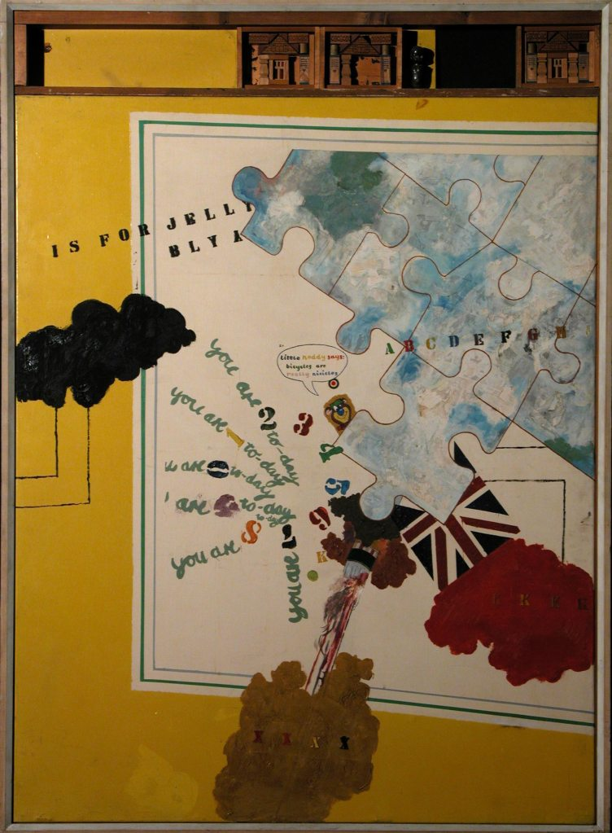
Derek Boshier, Birthday, 1962, 146 x 106.5cm

As artist and critic Andrew Forge said in the introduction to the 1962 Young Contemporaries catalogue:

If, fifty years from now, the impression remains that English painting took a turn during the last decade towards something a bit more adult, a bit more professional and a little less precious and pinched than it has been, it may also be seen that the Young Contemporaries played a part in this change.

The cohort of artists that came out of the RCA during the early sixties was instrumental in effecting this change and the Young Contemporaries would not have been the successful exhibition it was without them.

Also in 1962 the first exhibition to include works from the Collection were shown in the new galleries of the recently completed Darwin Building on the Kensington Gore site. The exhibition is remembered by Beryl Lewis (2010), then in her first year in the Painting School, as being a revelation about the Collection:

In my first year 1961/2, when the new building at Kensington Gore was built, there was an inaugural exhibition of works from the RCA Painting Collection in the foyer and hall. One was suddenly aware of the scale of the collection and the quality of the paintings.

The exhibition Towards Art? (Darwin insisted on the questions mark, which he thought made the title less pretentious (Frayling, 2011)), was intended to show the contribution the College had made to the fine arts from 1952-62.

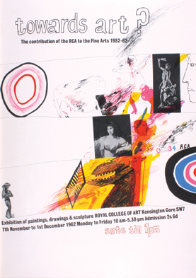

Towards Art? Poster designed by David Hockney

Graduate works from the Collection were shown alongside more recent works by the graduated artists – a model Paul Huxley was to repeat in his Exhibition Road show at the RCA in 1988. Some of the works exhibited remain seminal works from the Collection, such as the paintings by Hockney referred to earlier, and reflected the rich variety of styles and subject matter being carried out in the Painting School during the decade. Carel Weight (1962), in his introduction to the exhibition catalogue, states:

The great variety in this exhibition reflects the policy which has encouraged every student to develop his art in his own way. Rodrigo Moynihan laid the foundations of this policy in the Painting School and it has developed in this way ever since: when Mark Rothko recently visited the College he seemed astonished that students painting in such contrasting styles could work together in such complete harmony, often stimulated and inspired by one another.

There was to be discontent in the future, both at the RCA and in other art schools. Much of this was related to the Coldstream report and the later Summerson report of 1964, which were to engender further changes in art school education in the UK. This will be covered in the next chapter. However, no time since has seen the speed of change in art practice as that of Robin Darwin’s time at the RCA, brought about both by world circumstances and a great desire for something new following WWII.

This chapter covers the postwar period up to the point when the RCA achieved university status in 1967, which was the zenith of Darwin’s career. He was a man trying to make his mark on the education system. He wanted the RCA to become not just any university, but The university of art and design. He saw the importance of the high profile activities of his students. He raised the status of fine art and allowed a free rein to his staff, who in turn allowed experimentation from their students. It is possible members of staff were unable to control these intakes of opinionated, original thinkers and it was easier to let them get on with it. They may have realised that leaving motivated students to develop their own style in their own way would lead to interesting developments. Through allowing this to happen the RCA was now training artists focused less on looking to the past than on developing innovative ideas for the future.

1968-1986

Sir Robin had built a battleship. In the discussion which followed, the battleship was described as being pleasantly moored in the Gore; as being just a producer of glossy artefacts, and as providing Fine Artists with the opportunity to be nice little neurotics. … The battleship having been solidly constructed, there is no doubt amongst the students at least, that it or its Captain had any clear idea of what it should be doing. (Owen, 1968)

As is evident from the previous chapter, the nature of education at the RCA had changed enormously since the War and students were beginning to question what they were getting out of their experience at the College. The above quote by the editor of the student union magazine in 1968 illustrates that they were not sure the College was providing the sort of experience they felt they needed, particularly in Fine Art. Neither were they sure of the direction they were being steered, despite the fact that Painting had been through an era of great achievement with the success of students such as David Hockney, Derek Boshier and R.B. Kitaj. However, Darwin, the great reformer, was continuing with his drive to make the RCA the greatest art school in the world and in 1967 it was granted university status during a period when the nature of art education was changing even faster than during the fifties and early sixties. Gaining this status was a significant achievement and Darwin’s desire for the RCA to become a university was probably driven by more widespread attempts to rationalise all university education during the 1960s following the recommendations of the Coldstream Report.

Another important factor in taking these changes forward was the publication of a report in October 1963 by a team led by Lord Robbins, which was the outcome of a government-initiated consultation on the future of universities in the UK. This report recommended the immediate expansion of higher education and suggested that all Colleges of Advanced Technology should be given university status. This was the birth of Polytechnics, which were able to award degrees, on a par with the established universities, but validated by a central body, the Council for National Academic Awards (CNAA). There then arose the possibility of art schools being absorbed into these much larger institutions and losing their autonomy.

These changes, which were principally aimed at undergraduate education, led to institutions of higher education re-assessing their own constitutions. Even the RCA, which as the only wholly postgraduate institution in the UK was fairly cushioned from interference by government, set about looking at the way it organised itself. In response to the Coldstream and Robbins recommendations, and the ongoing work of the Summerson Committee, chaired by Sir John Summerson, who was to produce a report for the new National Council for Diplomas in Art and Design (NCDAD), in December 1963 Darwin set up a committee to look at the length and nature of courses at the RCA and their relationship with the new Diploma. The report concluded that the College should continue with the model of a three-year course that provided specialist education. The committee felt this was more important than ever in the light of the fact that the new Diploma courses were much broader in content than the previous National Diploma in Design (NDD) courses had been. Darwin (1963: 11) stated in the report:

… when the whole system of art education throughout the country is being considered with a view to its general improvement, it is clearly of importance that nothing should be done to prejudice the level of achievement of the single College which, although outside the mainstream of art education, stands at its head.

Darwin fought hard during his time as Principal to keep the RCA at the apex of art education and this was part of his drive towards achieving university status, which he pursued further by setting up an Academic Advisory Committee in 1964. Members included William Coldstream and John Summerson, both of whom had a great deal of knowledge in the area of art and design education. The committee also took advice from such art luminaries as Sir Anthony Blunt of the Courtauld Institute and Sir Ernst Gombrich of the Warburg Institute. Its remit was:

To consider and advise generally on the future development of the RCA and on academic matters related thereto, in the light of the Government’s decision announced in their statement of the 24th October 1963, on the Robbins Report that the College should be brought within the ambit of a University Grants System. (Anon, 1964: 1)

The Advisory Committee reiterated that the RCA should retain the three-year courses at post-graduate level and devised ways of making them more equivalent to university standard.

Thistlewood (1992: 20), when discussing the changes engendered by the various reports and recommendations of the 1960s, points to the fact that art school training had moved largely away from vocational, useful and specialised training towards a more liberal education or, as he says, “The type of art education dominated by high art and tall talk”. There had been an increase in students studying fine art and by 1969/1970 there were almost twice as many as in 3D Design or Fashion & Textiles or even Graphic Design. The various changes in art education, particularly the idea of merging art schools into the new Polytechnics, did not go down well with many art students, who by 1967/68 were numerous and had become unionised, politicised and in some cases militant.

Unrest among UK art students in 1968 was not isolated. It was concurrent with general youth unrest around the world, particularly in parts of Europe, spurred on by university students of all kinds. There were violent demonstrations in Paris and Prague where riot police were sent in to quell the rebellions. There were anti-Vietnam war demonstrations around the world. In Britain the sit-in was the preferred method of students for making their voices heard. A look at what was happening during the years 1967/68 shows a litany of sit-ins, riots and demonstrations mostly perpetrated by youth, who were flexing their muscles after years of being kept in the background. As the writer Martin Amis (2008) says of this time:

… the real reason was the consolidation of the youth movement. The ’68 riots were a celebration of youthfulness: for the first time in three generations, young men weren’t being sent off to die at war. And, as a result, the young celebrated being young.

One outcome of this agitation in the UK, which would peter out by 1969, was students being given a greater role in the decision making process of institutions. This was partly a result of unrest at Hornsey College of Art, triggered initially by a dispute between the student union and the college authorities over control of the student union funds. The students organised a sit-in and invited speakers to spark debate, which led to discussion of all aspects of art education. The protest escalated and, as Lisa Tickner (2008: 14), who was there at the time, explains:

[The sit-in] led to six weeks of intense debate, the production of more than seventy documents, a short-lived Movement for Rethinking Art and Design Education (MORADE), a three-day conference at the Roundhouse in Camden Town, an exhibition at the ICA, prolonged confrontation with the local authority, and extensive representations to the Parliamentary Select Committee on Student Relations.

It was not just the students at Hornsey art school who were involved. Art students from other art schools and universities joined in. Hornsey became a centre for debate with discussions led by the likes of Buckminster Fuller, R.D. Laing, Richard Hamilton and even Robin Darwin. The fact that changes in art and design practice were not properly reflected in art education became part of the debate. As Marshall McLuhan said in a letter of support at the time:

It is a matter of the greatest urgency that our educational institutions realise that we now have civil war. … The classroom is now in a vital struggle for survival with the immensely persuasive ‘outside’ word … Education must shift from instruction, from imposing of stencils, to discovery – to probing and exploration … The teach-in represents an attempt to shift education from instruction to discovery, from brainwashing students to brainwashing instructors. It is a big dramatic reversal. (Students and Staff of Hornsey College of Art, 1969: 105)

The unrest at Hornsey had some affect on the RCA. In a letter to his staff dated 24 June 1968 Robin Darwin explained that the second-year students had met to organise a campaign against assessment in the Final Examination, which, as he said, was one of the main planks in the Hornsey students’ manifesto. As a result of this campaign Darwin did agree that it was time to have final-year gradings reconsidered and he set up a committee to look at this. It is evident from his correspondence at that time that he had offered some support to the Hornsey students. In a later letter to all academic staff he asks them to “recall my own intervention in the Hornsey crisis last summer when, on the part of the College, I offered hospitality to a considerable number of their students.” (Darwin, 1969) His letter goes on to give his staff advice in the light of the fact that they had been asked to support the ‘revolutionary’ movement and urging them to do so only from a personal point of view, not as the voice of the RCA. Although Darwin wanted to be seen as progressive in his approach to the Hornsey affair, he was very protective of his institution and would not have wanted anyone to think of it as being a hotbed of revolutionary thought. Neither would he have wanted to deal with rebellion amongst his students, which, fortunately for him, did not happen.

It is also clear from student newsletters of the time that the students at the RCA were questioning the status and validity of the institution. In Newsheet No. 16, published in March 1968, the year after the RCA gained university status and before the Hornsey uprising, there was a report from a Junior Common Room (JCR – the RCA’s students’ union) meeting entitled “What is the RCA For?” It states that:

Although the college’s newly gained University Status confirmed its postgraduate nature, concern was felt over the college’s position in relation to the Dip A.D., other post diploma courses, and alternative design education outside the field of the Dip A.D. course. (Owen, 1968: 3-5)

Their feeling was that the RCA was lagging behind in both the quality of its education and staff, many of whom now taught both at the RCA and in other institutions awarding the Dip A.D. It is clear from the newssheet that opportunities for debate had, in the past, been few, apart from those arising from the general studies programme. As in many other art schools, students at the RCA, having formed an effective union, were finding their voice. In fact, the Student Union president says that it would not have been possible to have this sort of open discussion even a year previously:

This year has seen the emergence of the J.C.R. as a new kind of force in the College. It has taken an ever-increasing interest in academic matters and College policy and has shown its desire for involvement in every aspect of the College. It has come to regard this involvement as a basic right of the student body and a necessity for the health of the College. (ibid)

This was a theme echoed by art schools throughout the country and showed that students were trying to take more control over the relatively short time they had to study and the manner and quality of the education they were to receive.

Newsheet No.18, produced in June 1968, was particularly scathing about the state of the Painting School under Carel Weight’s regime. It reported:

That the Painting School is in a state of apathy, fragmented isolation and stagnation, was the subject of a meeting held between staff and student representatives on Wednesday 22 May. The students’ position, that the staff are refusing or failing to involve themselves with the aesthetic and expressive problems confronting the majority of first year students – resulting in an obvious lack of cross-fertilisation of ideas between the “opposing” groups – was partially upheld by staff representatives.

It was clear from this that the students expected changes to be made in the light of the current debates. Newsheet No.19 in July 1968 contains an article entitled The Critical Torpor in which it accuses the Painting School staff of “being out of touch with the activity as practical in our time”. One student had been working on minimal structures for his final year exhibition and had been informed by the staff that they were unable to assess him on the basis of this body of work. He was told to bring out his first year work, on which he was assessed, and consequently only achieved a 2:2. There follows a tirade about the “out-of-touchness” of the staff, who were unable to assess work that, “is clearly within the world defined by Stella, Noland, Caro, Poons, Olitski – the list is endless. And the clearest singular influence on his work was recently deified into the stylistic establishment [Donald Judd retrospective at the Whitney]”. The unnamed writer (Anon, 1968: 12) goes on to conclude that:

The art of our time should be expressed in the idiom of our time and unless those artists acting as teachers carry to that task a wide and contemporary linguistic and ethical consciousness then their formative influence is a destructive one and cannot be justified.

Although the term postmodernism had yet to be coined, this was a transitional time that heralded a move away from modernism precipitated by a plethora of new ideas being introduced in fine art practice. Modernism was in crisis, although not everyone was aware of it. Tickner (2008: 93) sums up by saying, “The old debate, as to whether art could be taught, was supplanted by the more specific question of how art could be taught after modernism.”

This was a debate that did not concern the Professor of Painting, Carel Weight, who had been at the RCA since 1947 and was entrenched in past ways of thinking, but was of more concern to his successor, Peter de Francia, who became Professor of Painting after Weight’s retirement in 1972. De Francia had been a General Studies tutor prior to this appointment. He was to bring a new, intellectual edge to the department that had been lacking during Weight’s time. Beryl Lewis, who had Peter de Francia as a tutor for General Studies during her time at the College from 1961-64, found him a thought provoking and stimulating lecturer. She said that the only written feedback she received was from the General Studies tutors. The Painting staff talked to the students on a one-to-one basis about their work but did not provide intellectual stimulus. Upon telling Carel Weight that she would be writing a General Studies essay over the holidays, he responded saying that would be a waste of her time and she should concentrate on producing ‘lovely paintings’. (Lewis, 2010) This way of working would change under de Francia as the Painting School at the RCA moved into a new era.

During the early sixties, although there had been significant changes in painting practice – in ideas, content and execution – it was still predominantly a matter of putting paint on canvas. The late sixties and early seventies saw great changes in the practice of fine art with a move away from the primacy of painting. As curator and writer Anne Rorimer (2001: 37) suggests, “Because of the more pervasive decision by Conceptual artists to work with media other than paint, the 1970s are often associated with painting’s demise”. Donald Judd, the American minimalist artist, talked of the death of painting as early as 1965, a time when some thought painting had run its course and should be left to the amateurs. Although many artists continued to paint, it was no longer the central activity of visual art as it had been for several centuries. (Godfrey, 1986: 1)

The questioning and challenging of the sixties created opportunities for thinking about alternative ways of working and led to the rise in the use of new media such as film and photography. Although words and word fragments had been introduced into paintings in the sixties, the seventies saw the use of language itself as a vehicle for expressing ideas in art. For instance, the work of Art and Language, a conceptual group formed in the UK in 1968, tried to steer art away from non-linguistic forms towards more theoretical ways of working. Using the human body itself as a form of expression in performance art and other impermanent ways of working were to compete with traditional methods. An example of this is the early work of Bruce Maclean who in 1971 posed his body in a parody of the work of Henry Moore, which was recorded photographically.

The educationalists, Elma and Harry Thubron (1977: 27), in an article in Studio International in 1968, urged radical changes in the nature of art education when they said, “We would abolish the Fine Art Departments as they exist generally, in both name and aim, replacing them with Environmental-Light-Sound-Movement-Workshops”. (Brighton & Morris, 1977: 27) They saw the merger of art schools into Polytechnics as a chance to produce new ideas and get rid of outworn attitudes and practices. They suggested that, “The ‘new’ education must aim to put a student in a superior and more critical way of ‘learning how to learn’ for himself, in a more open and imaginatively dynamic situation”. The opposing view was put by the eminent painter Patrick Heron who wrote an article for The Guardian in 1971 entitled Murder of the Art Schools voicing his view that this was “a disaster of massive proportions”. He talks about, “The brilliant success of the British art school during the past ten years” and suggests that the art schools will be “engulfed and dismembered by a gigantic all-embracing impersonal polytechnic”. (Brighton & Morris, 1977: 28)

The art historian Edward Lucie-Smith (1980: 8), when writing about art in the seventies, echoed others such as Tickner in suggesting that it was now possible to speak of ‘the end of modernism’. He went on to say, “One can go further still and say that artists of the 1970s, sometimes without fully meaning to do so, have overturned a whole system of categories”.

Although it seemed that there was a sudden explosion of experimentation with different media in the early seventies, there had actually been a gradual build-up during the sixties of artists experimenting with new ideas and forms of practice. This was evident in the work of Kitaj and Hockney when they introduced text and symbols into their paintings. The growing trend of representing ideas in the work rather than merely depicting the world was typified by the Fluxus movement, which originated in the USA in 1962. This became an international network of artists and composers from both the USA and Europe who came together to exchange ideas. Ken Friedman (1998: viii) analyses Fluxus as being more important as an idea and a potential for social change than as a specific group of people or collection of objects. The movement bought in ideas across the arts and politics and, as Friedman (1998:18) goes on to say:

… in the activities of the 1960s and the 1970s Fluxus works and performances were intended to transgress boundaries, decentre their own activities, and, for some, gradually lead to the elimination of the category of fine art altogether.

There was a gradual move towards the idea predominating over the material used in the growth of Conceptual art. More intangible works of art had to be documented using photography, text, sound or film recordings or even written or typed instructions or through publications. (Moseley, 2001:154) This kind of experimentation was starting to be seen as vital in the UK and was even filtering through to the art schools.

Malcolm Le Grice (2010: 149), who taught at St Martin’s School of Art during its most experimental phase in the late sixties, points out:

Not only was the medium-based model unsustainable, even the assumption that an artwork must be a physical entity was questioned by a conceptualism that could happily accept a theoretical proposition as an art work.

In 1968 the Antiuniversity was founded in Shoreditch, London. It had artists and writers such as John Latham and Alexander Trocchi listed as its faculty members and required no entrance qualifications. It was opposed to artificial divisions between disciplines and art forms. It was founded ‘in response to the intellectual bankruptcy and spiritual emptiness of the educational establishment’. (Walker, 1995: 73)

Although artists such as Latham were part of the system – he taught part-time at St Martin’s School of Art – they also represented an anarchic streak that was kicking against it. Latham is remembered for organising a collaborative event with his students. He borrowed Clement Greenberg’s influential book Art and Culture from the St Martins library, which at that time was being read and digested by most art students, invited his students to chew it up and spit it out, distilled it and put it into a glass phial that was then returned to the library, somewhat overdue. (ibid: 84) As a consequence he lost his job.

Another example of Latham’s anarchic outlook appeared at the RCA in 1975 in the exhibition Structure and Codes where he displayed a further example of his low opinion of higher education. His contribution was entitled Senior Academic Institutions and consisted of a photographic enlargement of the following words:

John Latham
Senior academic institutions have been defrauding the public and students for 300 years. They are not concerned with education, still less with the truth – they are run for the benefit of the staff.

As Walker (1995: 86) points out, “Naturally, this abrasive statement did not endear him to the teaching staff of Britain’s most prestigious postgraduate art and design college.”
This plethora of new ideas did not fundamentally change the workings of the Painting School at the RCA. Students continued to paint in a fairly traditional manner, examples of which are Seated Man by Roger Woods, 1972 and Untitled by Mary Carter, 1971, both competent, formal figurative paintings which give no indication of being influenced by these new trends.

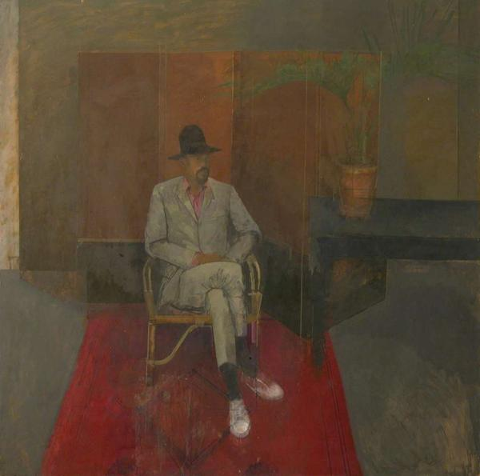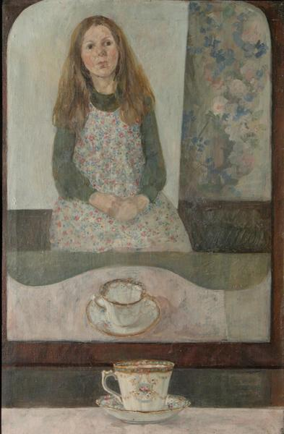
Roger Woods, Seated Man, 1972 Mary Carter, Untitled, 1971
122 x 122cm 79 x 91cm

However, following Darwin’s retirement in 1971 and the appointment of a new Rector, Lord Esher, the College did take note of the fact that there was a market for a course that would introduce new concepts to fine art students and started the Department of Environmental Media in 1971. From 1973 the course was led by Peter Kardia, who was an educator first and foremost rather than an artist and came from St Martin’s where he had been running the very experimental Advanced Course in Sculpture. He simultaneously taught media students in the Sculpture School at the RCA under Bernard Meadows, who then invited him to lead the new course. Under Kardia it became separate from Sculpture and provided an educational experience for those students who wanted to experiment. The course outline in the 1972/73 prospectus is quite vague and states: “The Department is concerned with the study of environmental structures which may involve both material and behavioural elements. These studies are not based on specific media …“, thus allowing students who wanted to move away from traditional media to do so.

Stuart Brisley (2009), who was a visiting tutor in Environmental Media, had this to say when asked about the structure and ethos of the course:

Everybody who has taught there would say the same thing – it is very difficult to say. It was run by Peter Kardia. He was an interesting man because he had a very strong sense of order and discipline, which was applied to the students with a certain brutality. My immediate sense of it is of a great seriousness and demand for an application to study by Peter Kardia supported by his own capacity to discuss, to actually engage with students. But it was hard – it wasn’t soft – and tough. Some students really flourished under it and some went down and suffered from it. We were allocated students in the usual way and they would go through these series of seminars and if they didn’t perform Kardia was very tough. I think the reason for this was that the subject was kind of indeterminate as to what its actual frames were. He was trying to give it a rigour, which he did.

According to Vanessa Jackson (2010), who was a student in Painting from 1975-78, this course had no affect on the Painting School. Environmental Media was in the main building on Kensington Gore, Painting remained down in the studios at the V&A, and Sculpture in huts behind the Science Museum. Having the Fine Art departments spread out over South Kensington meant these areas remained discrete disciplines with little or no cross-over at a time when other art schools were thinking about bringing fine art practice together under one umbrella – not something that has ever been seriously considered at the RCA.

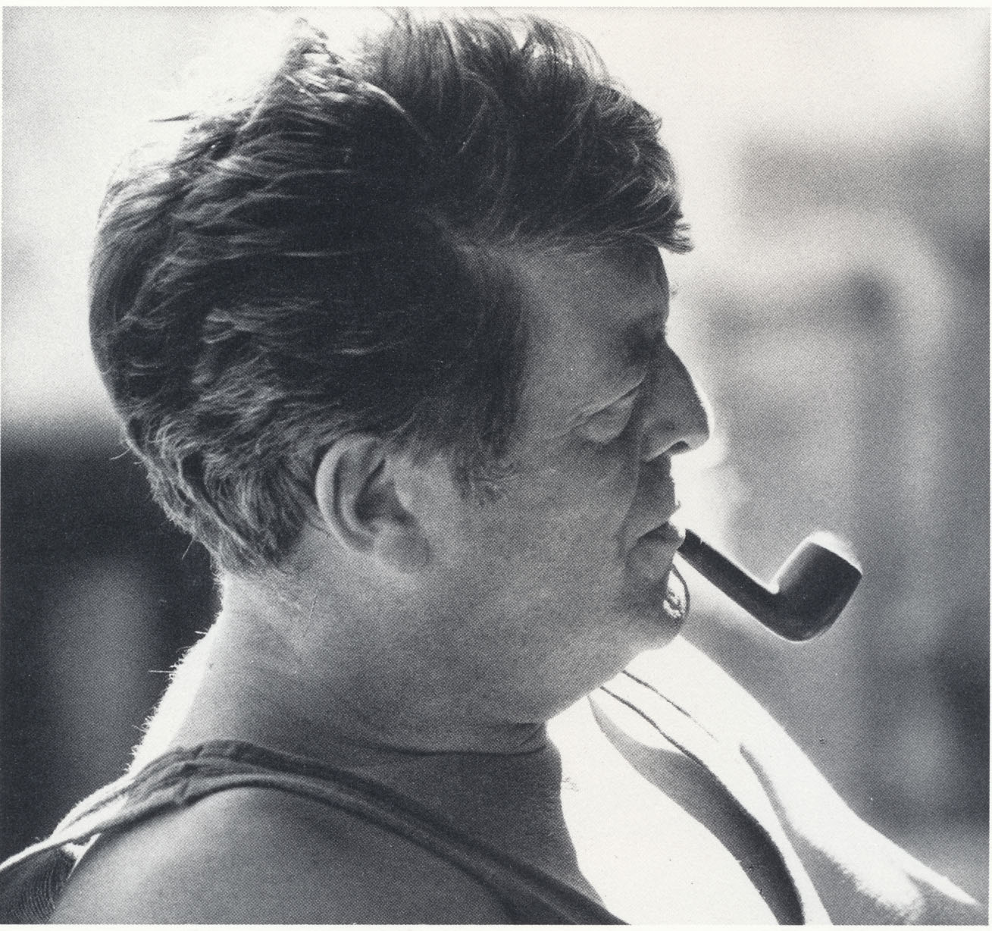

Peter de Francia

Peter De Francia’s appointment as Head of Painting in 1972 heralded a different focus for the department. He saw the benefit of reading and debate and was politically motivated. Politics had not traditionally been talked about in connection with painting at the RCA, but had been brought to the fore during the Hornsey rebellion, so his arrival was timely for retaining a political focus. His own practice was figurative in the European tradition, with a particular focus on social and political themes, such as his Goya-inspired painting Disparates (A little night music).This depicts an uncomfortable scene with a figure strung up in an auditorium suggesting unspeakable things about to happen in front of a jeering audience.
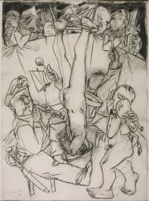
Peter de Francia, Disparates (A little night music) 1969
(Tate Collection) 77.5 x 57 cm

De Francia’s own influences were Picasso, Léger, Beckmann and Goya. The painting Three Quarrymen is typical of his social realist approach and depicts workmen at rest with a Mediterranean landscape in the background. It is possible to see the influence of Renato Guttuso, with whom de Francia shared a studio in the early 1950s, in this work.
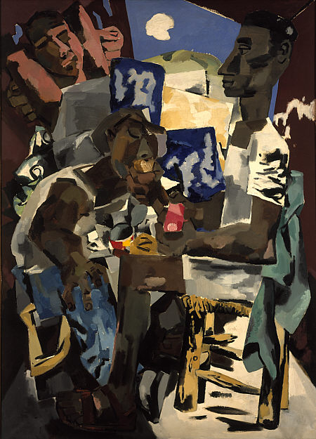

Peter de Francia, Three Quarrymen, c. 1968
(National Galleries of Scotland) 212 x 152 cm

Mark Harris’s work from the Collection (pictured overleaf), executed 14 years later, appears to have been influenced both by de Francia’s personal style, with the subject matter so similar to de Francia’s 1968 painting, and by the work of Léger and Guttuso, who were among the artists de Francia introduced to his students.
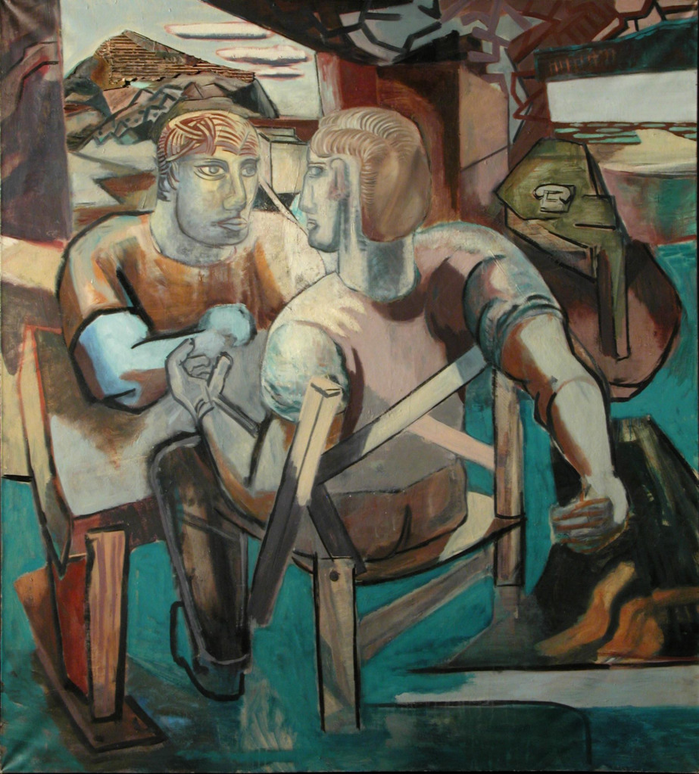

Mark Harris, Untitled, 1982, 199 x 178.5 cm

At the centre of Weight’s regime had been the idea of the young artist cultivating his individual talent. In de Francia’s it was the painter as intellectually well-equipped cultural worker. (Huxley, 1988: 61) Things were not made easy for him due to the fact that he was leading the Painting School at a time when painting was not the predominant fine art medium, with the rise of conceptualism and a strong surge in sculptural practice permeating art schools. There was no question that painting would continue at the RCA. However, under de Francia it moved into a different, more intellectually based, theoretical position. Andrew Brighton (Huxley, 1988: 61) points out:

De Francia is an academic: that is, I take him to believe, like Reynolds, in the power of reason to understand and shape the practice of art. … I do not presume to know what debt, if any, for instance, Graham Crowley, Stephen Farthing, Andrzej Jakowski, Michael Heindorff, Eileen Cooper, Arturo di Stefano, Thérèse Oulton and Tim Jones would accept they owe to de Francia’s teaching and professorship, but all of their work is informed by a European imaginative high culture.”

With a rapid and almost complete change of staff, the School under de Francia offered a much more rigorous experience. As his successor, Paul Huxley (2009), explains:

I understand that when Peter de Francia took over as Professor following Carel Weight that he was something of a new broom and made quite a lot of changes that upset many of the resident staff at the time. For instance, he ousted them from the common room where they used to spend too much time in his opinion. The staff of the Painting School had one of the studios as their common room. People like Ruskin Spear used to gather there and that is where they would spend their time when they weren’t around the studios. I think Peter got fed up with them. The first summer holiday after this happened he cleared it out and turned it into studio for the students so when the staff came back they couldn’t sit in there any more. They were pushed out to do their work.

In a lengthy handwritten letter to de Francia dated May 1973 Colin Hayes (1973), who had been teaching in the department since 1949, offered him advice on many aspects of the course. The letter is diplomatic but touches on the fact that the staff studio had been turned over for the use of students. He points out that Darwin had in the past been prone to giving priority to space for staff. De Francia was obviously more sympathetic to his students’ needs. He also felt the need for a clean sweep so that he could bring in the sorts of people he felt would stimulate the students and give a broader intellectual framework to their education.

The artist Sandra Blow, a tutor during the early seventies, seemed to have had some concerns about the balance between the theoretical and the practical and commented on de Francia’s choice when appointing tutors. In a letter to him written a year or so after he was appointed when he was starting to make these changes, she says:

One negative reaction is a doubt about the balance between scholarship and practice being kept. With two nominees [for tutorial posts] the scholarship appears to just outweigh the practice and if future appointments are similar the Painting School might be less of a Painting and more of a General Studies Department. (Blow, 19 May)

De Francia’s ideas for the course were set out in a promotional document produced by the RCA for the 1974-75 academic year. He talks about the importance of continuous dialogue in seminar situations and the fact that there should be no separation between theory and practice. He writes, “The questioning and analysis of prevalent ideas on art and a continuous investigation into the history and development of modernism should be a permanent feature of a postgraduate course.”

Stephen Farthing (2009) was a student at the start of de Francia’s time as Professor of Painting. When interviewed he recollected how the course was structured:

It was three years. It didn’t seem to be structured in any way. You just turned up and were given a tutor. We were down in Exhibition Road in one of those studios on the top floor. We were thrown in there with a bunch of other people and told to get on with it. We had an art history session which was always held up here at the Gore. We came up here once a week and used the library. Apart from that it was entirely down at Exhibition Road with afternoon cups of tea in the V&A.

When talking about the paintings he was undertaking during his second year at the College in 1974, Farthing refers to this transitional period, which he realised in retrospect was the start of a shift from modernism to postmodernism:

The funny thing was, and it is up to other people to decide this, but I suspect those paintings were really very, very early examples of post-modernist painting that I was doing without any knowledge. Postmodernism hadn’t really been thought up then in terms of painting.

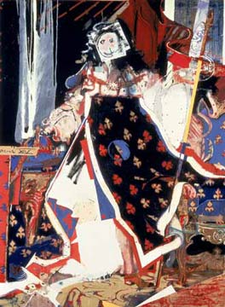
The painting Louis XV Rigaud was executed in 1975 from collages he had made while at the RCA’s Paris studio during his second year. This work was bought from his degree show by the Walker Art Gallery in Liverpool and reflects postmodernist concerns by mixing collage, caricature and graffiti alongside more traditional devices. The entry on the Walker Art Gallery collection web site suggests that this work “put him at the vanguard of a return to strongly figurative imagery in painting in the late seventies”. (Anon, 2009)

Stephen Farthing, Louis XV Rigaud, 1975
(Walker Art Gallery collection) 189 x 137 cm

Although de Francia succeeded in making the Painting School more intellectually rigorous and challenging, in 1974 his outlook on the state of the school appeared somewhat gloomy:

It would be tempting to envisage the Painting School as a repository of enduring calm and order reflecting stability and tradition. But since there is no stability and little tradition such attitudes are fruitless. One cannot post oneself in some imaginary crow’s nest forever scanning the dawn for the appearance of a ‘natural painter’. Some may occasionally appear, but at present they are as rare as white whales. (de Francia, 1974)

At this point he had only been in post just over a year and still had a cohort of students he had inherited from Carel Weight. It is possible the way they were working was not to his liking and a study of the work of the graduates of 1973 and 1974 (of which there are few in the Collection) shows very differing styles, as will be discussed, but nothing of the intellectual and political edge that De Francia hoped to inject into the department. As Brighton (1988: 61) points out when talking about de Francia’s inaugural lecture of 1973 entitled Mandarins and Luddites:

De Francia’s Professorship began amongst a high tide of what in his lecture he called Luddism, one instance being the Conceptualist attack on painting. … I understand de Francia as believing in art as offering something other than a symptom or expression of the dominant culture.

He may have felt that he was single-handedly trying to overturn a whole decade of thinking during which painting had moved in a direction to which he was unsympathetic. Michael Archer (2002: 143) suggests of this time:

There is no longer one, linear ‘story of art’, but a multiplicity of attitudes and approaches jostling for attention. One of the consequences of art being released from step-by-step development was a freedom to look anywhere for inspiration.

Style in the Painting Department ranged from Graham Crowley’s 1975 abstract painting (pictured overleaf) on a shaped canvas to the purely figurative drawings executed by Susan Carr in the same year.
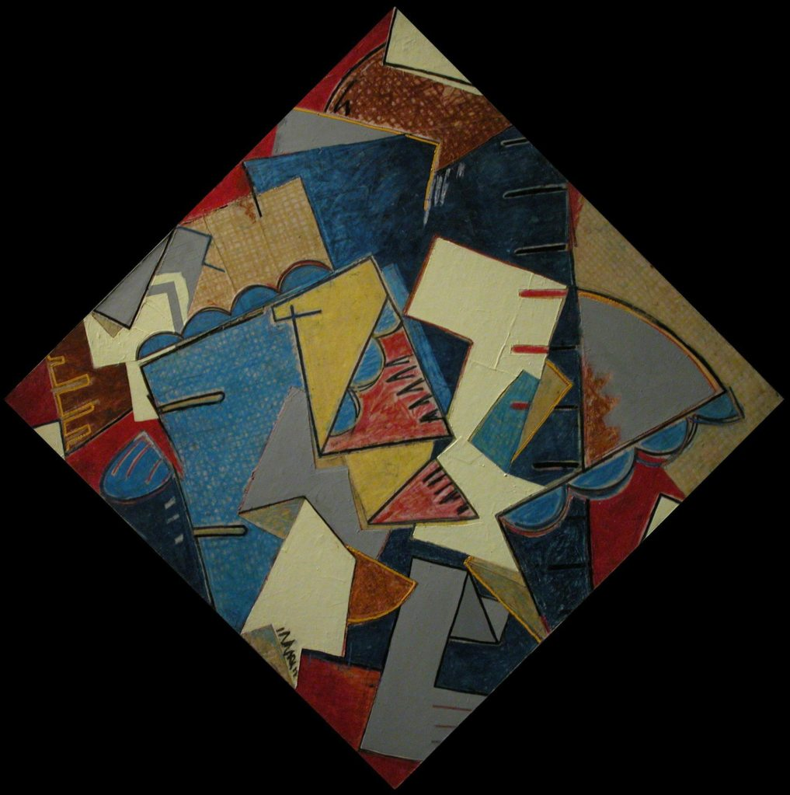

Graham Crowley, Untitled, 1975, 142 x 142cm

Crowley undertook his undergraduate studies at St Martin’s at a time when Peter Kardia’s ‘A’ course was in full swing. Many students at St Martin’s were embracing conceptualism and there was a strong emphasis on sculptural practice. Crowley chose to study painting. Martin Holman (2009: 11), when writing of Crowley’s work, says that “Crowley’s decision to choose painting was influenced by wishing to avoid the emerging orthodoxy, a kind of institutionalised revolution with, as it seemed to him, little time for history.” He then moved on to the RCA and, as Holman goes on to point out, as an institution the RCA was more sympathetic to painting than St Martin’s. Here Crowley was introduced, by his tutors Peter de Francia and John Golding, to the pictorial language of Fernand Léger and other European painters. His work from the Collection reflects these influences. Holman suggests it shows conscious references to the early, idealist modernism of Mondrian and the Cubist reliefs of Henri Laurens. (ibid: 15) Crowley returned to more conventional figuration after leaving the RCA and in 1998 was appointed Professor of Painting at the College, a post he held for eight years.
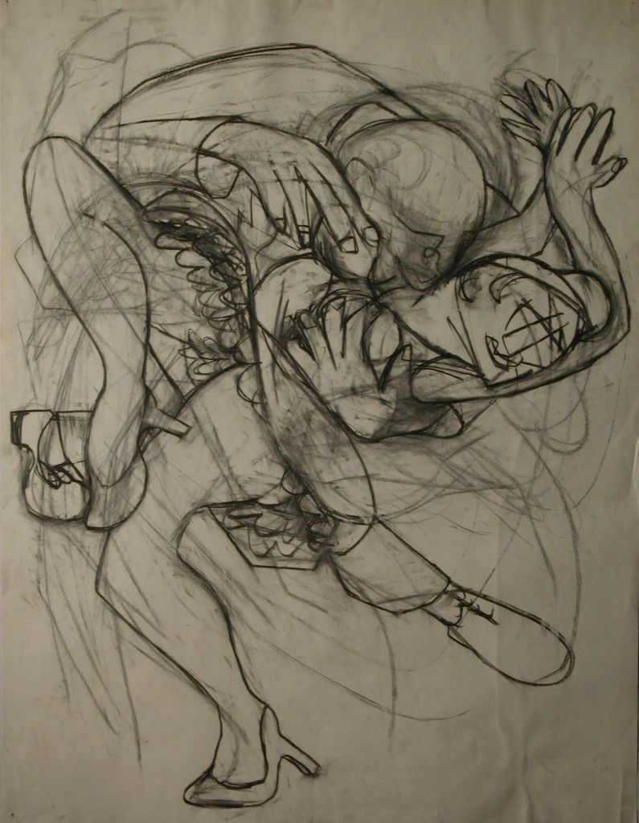

Susan Carr, Rape, 1975, 99.5 x 76 cm

Susan Carr’s drawing follows the continuing figurative tradition of the RCA, which still relied on studies in the life room. However, it is far from traditional in the way it addresses feminist themes. The seventies saw the rise of feminism as a radical movement which had a profound affect on the way women artists approached their work and Carr’s drawing reflects the concerns that were being discussed at that time. As the writer Lucy Lippard explains, “Some feminist artists … have opted for a realist or conceptual celebration of female experience in which birth, motherhood, rape … figure prominently”. (Lippard, 1976: 7) Female students are not well represented in the Collection during the seventies and Carr’s work is alone in addressing overtly feminist themes. It is also an example of the way painting was shifting during the late seventies in a move back to the pictorial but with an emotional and imaginative edge.

During the late seventies and early eighties there was resurgence in the practice of painting. As the German-based curator Christos Joachimedes wrote in 1981, “The artists’ studios are full of paint pots again” (Archer, 2002:143) This renaissance was in part a result of new economic conditions brought about by financial deregulation in the early eighties, precipitating a growth in those wealthy enough to speculate on art, with the focus on buying and selling paintings, thus pushing up their value. The seventies had seen a predominance of art that was difficult to sell and artists who were actively against selling their work. This would change during the eighties leading to a return to the pre-eminence of painting in the art world. As the critic Achille Bonito Oliva, who coined the term International Transavantgarde to describe this new era in painting, said:

The dematerialisation of the work and the impersonality of execution which characterised the art of the seventies, along strictly Duchampian lines, are being overcome by the re-establishment of manual skill through a pleasure of execution which brings the tradition of painting back to art. (ibid, 143)

This was encapsulated in an influential exhibition entitled A New Spirit in Painting at the Royal Academy in 1981. As Joachimides (1981:14), who was one of the organisers of the exhibition, said in the catalogue, “In art too, the extrovert 1960s were followed in the next decade by a contemplative, inward looking view, an art-about-art that its proponents considered the latest emanation of the avant-garde spirit.” The sixties had been a time of great optimism after the stringency of the immediate post-war period. The seventies were blighted by industrial unrest and economic recession and this was reflected in the work produced. The eighties would see a resurgence of painting, as academic and writer Tony Godfrey (1986: 153-4) points out when talking of the new style of painting:

Painting has not been ‘reinvented’, but its importance has been rediscovered. In a period of economic and spiritual crisis not only does it maintain old traditions but it encourages personal expression and confidence in the face or moral chaos and the manipulation of the individual by the state, capital and mass-media. … Above all else New Painting is concerned with the problem of the relationship between meaning and matter, and with the related question of how we are to live in a seemingly dislocated and secularised word.

This period was also driven by a return of the influence of European art after the dominance of America during the sixties. Sandy Nairne (1987: 16), Director of the National Portrait Gallery, pointed to this dramatic shift at the end of the seventies as being, “the end of twenty-one years of American dominance of the international art world. A younger generation of Europeans began to steal the limelight.” De Francia was already introducing his students to great European artists and this was helping to shape the future of painting at the RCA.

The painters in A New Spirit in Painting exhibition included heavyweights of the School of London such as Frank Auerbach, Francis Bacon and Lucian Freud but also introduced newer, younger European artists such as Anselm Kiefer, Sigmar Polke, Markus Lüpertz and Mimmo Paladino who had rarely been exhibited outside their own countries. The exhibition was not exclusively European and included elder statesmen of the American art scene such as Andy Warhol, Frank Stella and Philip Guston as well as relative newcomer Julian Schnabel. The organisers of the exhibition talk about how they made their choices:

Younger painters hardly known to the general public are also included in the exhibition. Their work seems to hold the greatest promise of the many younger artists whose work we have seen, though the selection is meant not as a prophecy, but rather as an assessment of the present.” (Joachimides, 1981:11)

This exhibition gave a significant overview of the direction painting was going at the start of the eighties with the emphasis on highly expressive figuration. Joachimides (1981: 14) states that:

This new concern with painting is related to a certain subjective vision, a vision that includes both an understanding of the artist himself as an individual engaged in a search for self-realisation and as an actor on the wider historical stage. The subjective view, the creative imagination, has come back into its own and is evident in a new approach to painting.

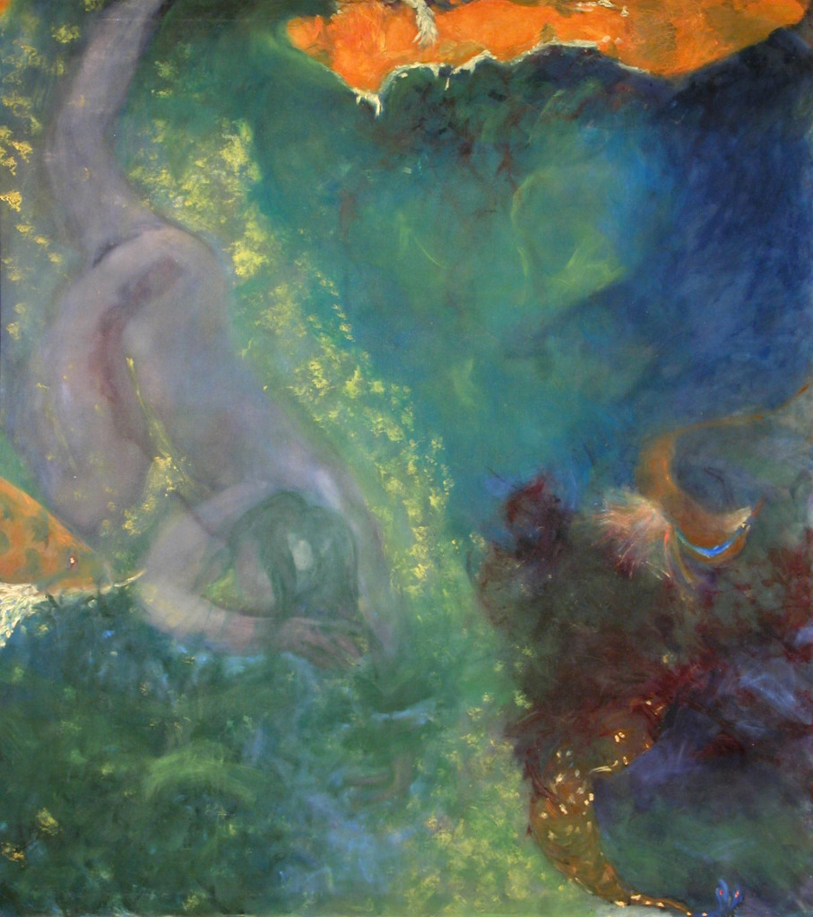
As Godfrey (1986: 10) pointed out, “New painting born in the early eighties took up the old ambition of painters to express their feelings and to show the wishes, dreams and conflicts of modern life.”

Judith King, Untitled, 1982, 125x158cm

Much of the work being executed in the Painting School at this time fitted with these contemporary concerns. Judith King’s painting, with its very painterly and dreamlike qualities, nevertheless continuing with figuration as a means of expressing an idea, is one example. De Francia considered that the New Spirit of Painting movement was lightweight and lacked political edge. He referred to it as “fast food figuration” (Frayling, 2011). He was not at all interested in current trends, fame and fortune for his students or raising the profile of the Painting School. Timothy Hyman (1987: 16) says in his catalogue introduction to de Francia’s 1987 exhibition at Camden Arts Centre, which marked the end of his time at the RCA, “At the Royal College, he favoured the pattern of a research institute; students were expected to grapple with the intellectual content implicit in their work.” De Francia, referring to the RCA Pop artists who had gone on to be so high profile after graduating, is quoted as saying, “Under Darwin we were geared up to produce stars. We are not in a period of stardom now. It is far better to work without the illusion of a Bond Street show just around the corner.” (Huxley, 1988: 14)

De Francia did not expect his students to adhere to his own theories about art although he expected intellectual rigour. He made a particular effort to introduce many interesting artists as part-time lecturers and visitors to the Painting School. Students were able to make suggestions of those they would like to talk to and he would try to engage them. They included John Walker, Howard Hodgkin, Bernard Cohen, John Golding, Philip Guston and the Chilean surrealist artist, Roberto Matta, who worked in the Professor’s studio as an artist in residence for a term.

Vanessa Jackson (2010) had concerns about the total lack of female tutors at this time. With her fellow students she drew up a list that included many women artists and took it to de Francia. She says of him, and his reaction to the list:

Peter was the most dedicated man – he believed in education and being an art educator. I think people are so worried about their own glorious career and they think it is not so noble to be an educationalist. He really believed in it and it came from his Marxist, Socialist principles. He had these big felt tip pens and I remember him going through this list saying, “Good God”, “Don’t know”, “Why?” All the way through ending with him saying, “Well, who do you really want?” and there was a poster above his desk of a Sonia Delaunay painting and I said “She’ll do” and he paid me off, he gave me £50 out of his own pocket and a letter written to Sonia Delaunay who lived in Paris and so I got an introduction and the money to go and so I shut up.

Jackson goes on to say that in her final year de Francia did engage a female tutor, Gillian Wise, who he considered would be able to help her with her work.

Stephen Farthing (2009) said his tutors included Leonard Rosoman, Robert Buhler, John Walker and Howard Hodgkin. He talks of how tutorials were conducted during his time as a student:

Peter de Francia, who was quite an organiser, was very keen on structures. He instigated these group tutorials which weren’t groups of students but groups of staff. You would have about five or six tutors in a room with your work and I can remember when mine came up towards the end of the first year and taking my pictures up to what was called the Professor’s studio. He started talking and there was a lot of discussion about these pictures. I can remember very little about it apart from John Walker, who was teaching there at the time, who I had never met before, saying in defence of me, “that is probably the best bit of brown paint that has ever been put down in this painting school, leave him alone”.

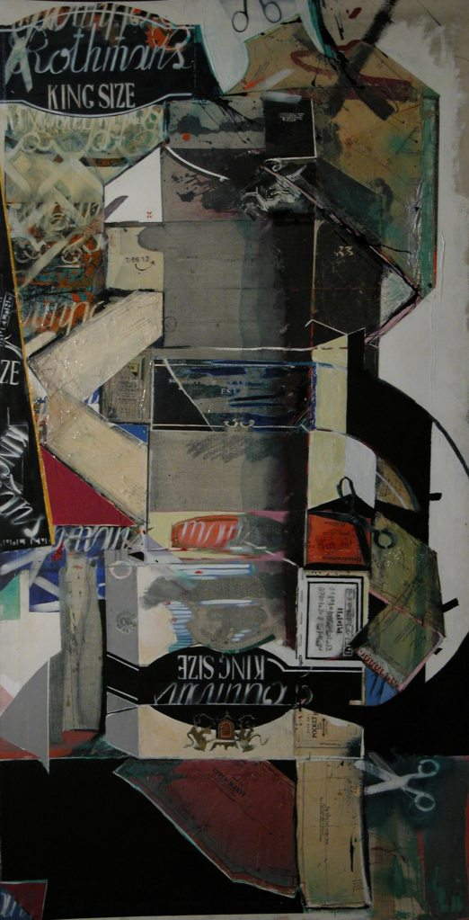
Stephen Farthing, Flat Pack Rothman’s
1975, 213x109cm

With Flat Pack Rothman’s (pictured on previous page), the work that Farthing left for the Collection, he did not pursue his style of the previous year, which had been driven by his experience in the RCA’s studio in Paris, where he worked from collages of court paintings by Hyacinthe Rigaud he had seen at Versailles. However, the painting makes use of the collage and text included in his previous work as well as showing strong echoes of the style of artists such as Hockney and Boshier from the sixties.

In the catalogue for the final year Painting show in 1986, the year of his retirement, de Francia’s introduction pointed to the direction the Department had moved during his time at the RCA:

Final year exhibitions of the work of postgraduate students have undergone a very marked change in recent years, less in terms of how they are evaluated and judged by visitors and critics than in the manner in which the participants tend to see them. Degree shows were perhaps formerly thought of as a variant of Crufts annual dog show in which supreme champions were selected. Groomed and combed the winners triumphed, though these triumphs were sometimes short-lived. Degree shows were envisaged as make or break affairs. Naturally enough they still engender high expectations amongst graduating students. But it has become evident to me that they are now evaluated in a manner which reflects far greater maturity and seriousness.

Few of the painters who graduated in 1986 went on to make a living from their work, like the Pop artists before them or the Young British Artists (who became know as the YBAs) who followed in the late eighties and nineties. However, they were, and many still are, committed painters who often reflected the seriousness of the ideas of their Professor. In the same catalogue Robert Macdonald talks of his time in the department as a mature student under de Francia:

His attitudes were not fashionable then, for the ‘painting is dead’ bandwagon had been rolling for some time, and clinging to it were all those who dismissed painting as irrelevant. De Francia set his face against such nonsense. To him painting was very much alive… Such passionate convictions about painting … bought the Professor into collision not just with the zealots who see no value in things which have no obviously practical application to their immediate goals. He displeased the tame aesthetes of the College life too. … I would set these things against the enormous encouragement which the Professor offered to younger painters oppressed by the purist reductionism of the sixties and the seventies. (Anon, 1986: 33)

Peter Allen (2009), who was a technician in the Painting School under de Francia, sums up how different the seventies were compared to the eighties:

When you look at the late seventies, no one bought things at degree shows, the economy was dead, we had the winter of discontent. For all those reasons there was a sort of ethos, more like being in Yugoslavia, of state sponsorship of artists.

Eliza Bonham-Carter (2009), a Painting student from 1986-88, explains that “When Vanessa [Jackson] graduated [in 1978] the point of the show was to get teaching work. Everybody in Vanessa’s year left with the offer of teaching”. Bonham-Carter graduated ten years later and sold everything she exhibited, an indication of the growing art market that was emerging in the late eighties. With this change in direction the Painting School moved into yet another phase that reflected new ideas and a changing relationship to the art market.

De Francia, who was unsympathetic to this new commercially driven art scene, retired in 1986. He had been Professor of Painting during the reign of three rectors: Lord Esher (1971-78), Richard Guyatt (1978-81) and Lionel March (1981-83). In 1984 Jocelyn Stevens was appointed Rector with the remit to re-organise the College after a long period of relative stagnation. One of the first casualties of his regime was the Department of Environmental Media, which was closed in 1986. The next was the loss of the purpose-built studios at the Victoria and Albert Museum where Painting had been based since the College originally moved to South Kensington, which will be discussed further in the next chapter. Although this did not happen during De Francia’s time, he knew the move was being planned. De Francia had found it difficult working with Richard Guyatt, who had tried unsuccessfully to get him to leave during his time as Rector, and even more so under Stevens, with whom he had nothing in common. He was succeeded by Paul Huxley, already a tutor in the department, who was to see it into both a new building and a new era in Painting.

1986-1998

A painting has become the commodity par excellence – a venal symbol of the commercial degradation of art. The more sublime and autonomous a painting the more readily the wealthy buy it, reducing it to ‘pure wall decoration’. It is elitist entertainment, a status symbol, an investment property – everything except the sacred object it purports to be.

Donald Kuspit (2000: 2), the American art historian and critic, here sums up his view of what happened to painting in the UK, USA and Europe over the last two decades of the twentieth century. In the UK there was a mood for change after the austerities of the 1970s which had seen oil shortages, the introduction of a three day working week to save energy, a miners’ strike, low economic growth and high inflation. A Conservative government under its first female Prime Minister, Margaret Thatcher, came into power in 1979 and, following a recession in the early eighties, brought in an era of economic growth that boosted the art markets throughout the decade. As the curator Gregor Muir (2009: 2) points out, “the friendly naivety of the sixties evaporated as hardnosed businessmen took the helm and steered the ship in the direction of high earners”.

By 1984 the Conservative government had been in power for five years and Britain was moving into an era in which market forces were to predominate. Margaret Thatcher’s neoliberal views were very much the prevailing ethos. With this new emphasis in mind the Council of the RCA appointed Jocelyn Stevens, the first Rector without an art or design background, as a trouble-shooter to try and save it from financial difficulties after the tenure of two rather ineffectual Rectors, Lionel Brett (Lord Esher) and Lionel March, both architects. To quote Christopher Frayling (2011), “As someone said in Oscar Wilde fashion ‘to have one architect called Lionel you might say was a mistake, but to have two…’. [They had] Big visions, big structures, not very good at the detail”.

Stevens’ previous career had been as owner of Queen magazine, and editor of the Evening Standard and Daily Express. The Council of the RCA felt that the institution had been run like a gentleman’s club for too long and it was time to appoint a manager rather than a practitioner.

Stevens instigated major changes. As well as replacing many senior members of staff who he felt were old fashioned and redundant, he also introduced a two-year, rather than the previous three-year, MA course, which boosted the throughput of students. As Frayling (2011) points out, “In the boom times of the Thatcher era a lot of students found three years too long – they wanted to get out into the world and didn’t want to have to study for three years.” Stevens also oversaw the move of the Painting department from the generously sized studios at the V&A, where it had been housed since the 1870s, to purpose-built, but far less spacious, facilities in the new Stevens building, named after himself, on the main campus on Kensington Gore. Although it was undoubtedly a good idea to try to keep as many departments as possible together on the main site, anyone who had spent time in the studios at the V&A bemoaned their loss. Paul Huxley (2000), who was working in the Painting department at the time when these decisions were made, deplored the proposed changes:

Financial stringencies which affected the whole College were about to bite into our privileged state. The principal effect from the students’ position was an immediate cut in the length of the course from three to two years. On a more local level I was appalled to learn that there were completed plans for an imminent relocation of the School to a new smaller building. The wonderful suite of old studios adjoining the V&A Museum would be lost to artists forever. Put simply this would mean the reduction of two prime commodities for our students, time and space.

Some thought Stevens had been brought in with the remit to abolish fine art at the College, as his focus appeared to be primarily on design and industry. Frayling disputes this and suggests Stevens saw the value of fine art and was himself a collector of paintings. According to Susie Allen (2009), who looked after the Collection during this time, Stevens became aware that part of the enormous history and reputation of the RCA had been built on the reputation of the Fine Art departments and that it would be foolish to destroy this. Also, by the mid-eighties a market for contemporary painting was starting to develop for the first time, which Stevens, with his business background, understood. Bonham-Carter (2009) said of Stevens:

We always understood he had been put in there to close Fine Art, that was the sub-text, but actually once he got there he understood that print was alright, because it was about multiples and you could sell them and he came eventually to understand that painting was alright because people bought paintings.

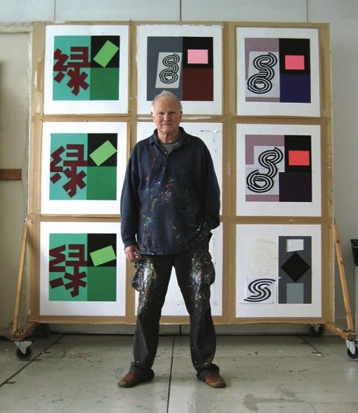
Paul Huxley, 2009

With Paul Huxley’s appointment as Professor of Painting following de Francia’s retirement in 1986, the Painting School moved into a phase that was more commercially driven, in common with the times. Huxley had previously been a tutor at the RCA both in Painting and Printmaking. Vanessa Jackson (2010), who had been a student under de Francia and then a tutor under Huxley, was critical of the transition:

… it came down to a two year course, which made a difference. Leaving the V&A was the tragedy and there was nothing that could be done. The design of the Stevens building was obviously never really thought out. All of those things were pretty catastrophic.

This change of regime at the RCA coincided with the growth in the marketplace for contemporary art, heralded by the opening in 1985 of the advertising magnate Charles Saatchi’s gallery in north London. There were very few commercially-run galleries showing contemporary art in London at this time. The Lisson Gallery and the Nigel Greenwood Gallery had been leading the way since the early seventies, but few had followed until the markets were opened up during the late eighties. Bonham-Carter (2009) describes the beginning of this boom:

There were a lot of people beginning to buy art who hadn’t bought it before but it wasn’t as informed as the kind of boom that happened later in the nineties. Lots of small galleries opened up in Notting Hill around Portobello and they were run by a mixture of people, many of whom didn’t really know what they were doing, but there they were, and they were buying work.

She goes on to say that when she graduated in 1988 she sold all the work she exhibited in her final year show - one to the Contemporary Art Society, two to the Government Art Collection, one to Bernardo Bertolucci, the film director and one to an art consultancy. The only student to do this previously had been Thérèse Oulton who graduated in 1983. Paul Huxley (2000: 9), who was a tutor at that time, explains that Oulton broke new ground in receiving immediate acclaim for her work on graduating and, unusually, all her work was bought by public collections. He goes on to say that “such early success was an exception for the times but it signalled a shift in ground of the alertness of art specialists towards emerging talent”.

This would have been unthinkable even a few years earlier and highlighted the fact that collectors and galleries were increasingly buying work direct from MA graduates in order to snap up the best talent as early as possible. The downside of this was that students were less inclined to give one of their best works to the RCA collection. Although works would have been selected for donation to the Collection by the Senior Tutors in Painting prior to exhibition, if they sold during the show then either a substitute had to be found or there was a gap in the Collection. Because Oulton was in such demand there is nothing by her at all in the Collection. Bonham-Carter describes her own choice as decidedly second best: “I was slightly strapped for something to put in the Collection. The one I ended up giving I don’t think was the best painting – obviously it wasn’t as I hadn’t shown it.”

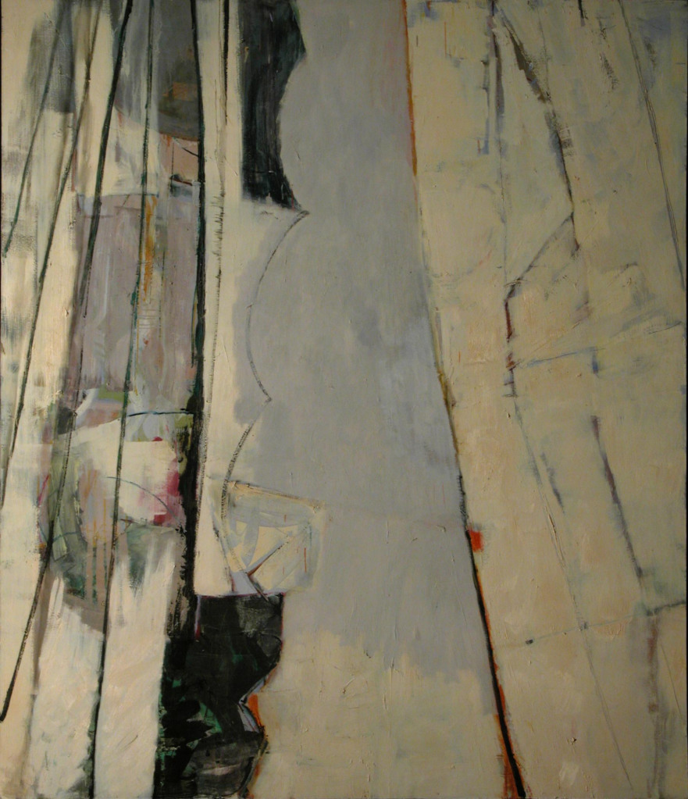
Eliza Bonham-Carter, Untitled, oil on canvas, 1988, 213.4x183cm

Nevertheless, the work Bonham-Carter donated is a strong and striking abstract painting that made a good addition to the Collection in a year in which work was collected from nearly every student. Many were working on a large scale and the works vary from abstract to figurative, monochrome to highly coloured with none showing a predominant style – a reflection of the change of regime that was taking place at the College.

The first exhibition at the Saatchi Gallery was of American painters from Saatchi’s own collection including Cy Twombly, Andy Warhol, Donald Judd and Brice Marden and helped to establish London as one of the most significant places to see contemporary art in the world. The next show was of work by Anselm Kiefer and Richard Serra. The gallery, housed in an old paint factory, was designed in a minimal style with the exhibitions both carefully hung and notable in their content.

One device Saatchi used at that time was to exhibit the work of established artists alongside the upcoming, for instance showing Carel Weight with Lisa Milroy and Avis Newman, thereby helping to market the younger artists by allying them to the achievements of a previous generation. (Meyric-Hughes, 2002: 283) These exhibitions gave art students unprecedented exposure to the world’s most important contemporary artists and, because Saatchi was unashamedly an art dealer, precipitated the continued rise in the commercialisation of the art market. The impact on the priorities of young artists was profound as could be seen in 1988 by the Freeze exhibition organised by Damien Hirst and a group of Goldsmiths students. It was the first time art students had come together to organise an exhibition themselves outside their institution and given it a professional and commercial edge by producing a proper catalogue and by marketing the event. As the writer Julian Stallabrass (1999: 5) points out, “Artists also became their own curators, making shows for themselves and their acquaintances in the numerous industrial spaces emptied out by the recession.”

Charles Saatchi visited Freeze and bought work. The show was also visited by Norman Rosenthal, Exhibitions Secretary of the Royal Academy and Nicholas Serota, Director of the Tate Gallery, which reflected the importance of the exhibition to the London art world. It also highlighted the pre-eminent position of Goldsmiths at this time. As the art historian and curator Richard Shone (2002: 292) points out:

Several factors determined this high profile (on a level with the centrality of the Slade School before World War One or the Royal College of Art in the 1960s) – freedom of choice; the abolition of departmental categories; a variety of artist-teachers holding a range of viewpoints (e.g. Jon Thompson, Michael Craig-Martin and Richard Wentworth); intellectual stimulation and an emphasis on the preparation for being a professional artist out in the world – which took advantage of the prevailing culture of slick entrepreneurship that was current in British life, i.e. corporate sponsors were pursued, proper catalogues produced, critics and collectors buttonholed.

Abolition of departmental categories is something that has always been strongly resisted at the RCA. The one Department that supplied some interdisciplinarity in the fine arts had been Environmental Media, which had been closed in 1986 by Jocelyn Stevens. The closure was considered at the time to be a backward-looking, money saving exercise, but Frayling (2011) suggests that this was not entirely the case:

He closed the department partly in the hope that the sort of activity [that took place in Environmental Media] would spring up elsewhere, which didn’t happen. It wasn’t entirely destructive. There was a vision behind it of energising the heartland of Fine Art. He wanted to re-inscribe the avant-garde within the traditional disciplines”.

His vision did not materialise and the Fine Art Departments remained discrete and focussed on their own practice. However, the Painting department at the RCA started to professionalise and market its degree shows and invite in corporate sponsors. With the reduction in the length of the course and new financial stringencies imposed by Stevens, Huxley (2000: 12) was determined to give his students the broadest experience he could over the two years of the course and the additional funding provided by sponsors would help. He thought they needed a more realistic introduction to being professional artists through making exhibitions, learning to present their work to an audience and defending their ideas. As he (2009) commented in a later interview:

I think it is not unfair to say that under me, during the eighties and nineties, the Painting students and their degree exhibitions got more and more profile and success, partly because I did have some very good students who excelled, but also because of the times – there was a move towards collectors and galleries trying to second guess one another by going earlier and earlier and eventually going to degree shows looking for talent and works to buy, so during my time as professor the degree shows got a great deal more successful and a lot of sales happened, which wasn’t the case when I first started teaching at the College.

Unlike Goldsmiths, where the students did their own exhibition organising, promotion and marketing, the RCA employed Susie Allen in 1986 both to look after the College Collection, which had previously been cared for by the Senior Technician in Painting, to undertake promotion of the work of the department and to find corporate sponsors. Prior to this she had been working in the Printmaking Department, where she had helped put together and market their first commercial portfolio of prints. For the Painting department she found a corporate sponsor in the TI Group, a large engineering firm, who not only supported the students and their exhibitions but also started to buy graduate works for their own collection. Over the next decade the TI Group built up an important collection of works by RCA graduates, taking advice from Huxley and Allen. They approached graduates directly and were also invited to pick the best works from degree shows before they opened to the public, leaving works the students considered less important to be accessioned to the RCA Collection. Huxley noted that TI had enhanced its image as a company through having works by RCA graduates hanging in their offices. This range of activity had never been undertaken in the Painting Department previously and mirrored the increasing commercialisation of contemporary art in the world as a whole.

Although the directors of the TI Group said their relationship with the RCA would enable them to build a unique collection of works that would be of historical importance, such is the fickle nature of business that when they were taken over in 2001 the new regime auctioned off the entire collection, raising just over £300,000. Unfortunately, nothing was offered to the RCA and the College had no funds to purchase works from the auction that might have filled significant gaps in the Collection, such as Thérèse Oulton.

An early project undertaken by Huxley and Allen after their appointments to the Painting School was to research and organise a large exhibition entitled Exhibition Road using works from the Collection. Huxley recollects that Jocelyn Stevens was keen to find a way to celebrate the RCA’s one hundred and fiftieth anniversary and had asked for suggestions from his staff. Huxley (2009) thinks he was one of the few people to put a project forward, and Stevens supported it. It was organised along the same lines as the exhibition Towards Art? mounted by Carel Weight in 1962 and showed graduate works alongside current works by the artists included. The aim of the two exhibitions was the same, as Huxley (1988: 6) says in the introduction to the catalogue: “In formulating the exhibition the aim was to reflect the highlights of achievement in painting during the College’s history.” It was also a valedictory exhibition for the studios in Exhibition Road and the work that had been undertaken there.

Exhibition Road was a far more ambitious affair than Towards Art? Allen found several sponsors including Christie’s and Jaguar, eminent writers such as Richard Cork and Marco Livingstone were asked to contribute essays to the catalogue and many hours of research were undertaken on the artists to be included. The catalogue produced a comprehensive history of Painting at the RCA and includes short biographies of all the major artists who both attended and taught at the RCA, from Jack Yeats who was briefly a student in 1887 to Thérèse Oulton who graduated in 1983. The exhibition itself gave an insight into how students develop by exhibiting student work alongside mature paintings, for instance showing a traditional life painting by Bridget Riley executed in 1955 next to a 1987 abstract typical of her later style. As Paul Huxley writes in the catalogue, “The resulting juxtaposition may often be a surprise, and it is hoped that they will provide insight into the learning process during formative years.”

Susie Allen (2009) said of the exhibition and catalogue, “I still to this day think it was one of the most exciting shows I have ever curated. … It pulled the history together.” Exhibition Road succeeded in raising the profile of painting at the RCA and highlighted the fact that the College had a Collection, which had rarely been promoted in the past.

Working on the exhibition took the Professor’s time away from the department, for which he apologises in the catalogue saying, “To the staff and students of the College’s Painting School I would like to offer my apologies for a winter of neglect. In return I offer them this exhibition as a tribute to their heritage and a challenge to their future.” (Huxley, 1988: 7) Huxley, as a committed teacher, saw this as a way of inspiring his students by giving them a chance to see what past graduates had achieved and, by using examples from the Collection to reinforce a sense of history and tradition. He (2009) says of the Collection:

From a historical point of view I think it is terribly interesting and useful to have examples of work from artists when they were students. Okay – some of them aren’t very good paintings but it is an insight into the level of talent they had, the way they were thinking, to what extent they were influenced by their fellows and their teachers, to what extent they were very independent.

In the introduction to the exhibition catalogue he also raises the perennial issue of whether art can be taught by saying:

The answer is yes, and it must be. That people are born with talent is unquestioned, but it should be made clear that, as in the case of writers or composers, dancers or actors, talent must be trained by constant practice, informed by the great achievements of others and challenged with intellectual rigour so as to nurture its continuing development. Painting is not a mere act of physical dexterity, it is first a statement of the intellect, and as such it is perceived and understood. As John Constable remarked in a lecture at the Royal Institute in June 1836: “A self-taught artist is one taught by a very ignorant person.”

Changes took place in the style of teaching in the Painting Department under Huxley. Whereas during de Francia’s time the emphasis had been on intellectual activity, with the 1976/77 prospectus stating that “there is a strong emphasis on discussion and research as a basis of the course”, under Huxley, despite his statement above about the importance of intellectual rigour, there was a move away from theory. The emphasis was on the development of the student’s own practice and in 1988/89 the entry for Painting stated: “the aim of Painting is to provide the opportunity for exceptionally promising students to extend their talents, ideas and field of expertise, and to develop their faculties of self-criticism and self-sufficiency necessary for their future independence as practicing artists.”

Bonham-Carter (2009) said her two years at the RCA provided an opportunity to develop confidence rather than to re-appraise her way of working, which is what she had been anticipating. She also said there was hardly any theory and the dissertation was not perceived by the Department as an important part of the course. Peter Allen also recalled how, during the previous regime, de Francia would push the students to articulate their work, as he expected it to have an intellectual base. This disappeared when he left. Allen (2009) said of de Francia’s way of teaching that, “… he would be testing all the time – sharp, because his own work was like that, everything had an intellectual base. This went straight out of the window immediately [when he left]”. Bonham-Carter remembers the style of teaching as being “much more hands off” with practically no theory at all.

Bonham-Carter thought her fellow students, who started in 1986 when Paul Huxley took over as professor, might have been considered something of a ‘joke’ year as they had been interviewed and selected by Peter de Francia and John Golding, who both left at the end of the 1986 academic year, but studied under the new regime. This transitional time is often difficult for a new Professor, but by 1989 Huxley had seen through a cohort of students that he had chosen himself that included Tracey Emin, Dexter Dalwood and Andrew Grassie, all of whom have gone on to become successful artists, two of them Turner Prize nominees.

During the 1980s contemporary art had moved into a phase of increasing emphasis on the individual and often on their personality, a phenomenon that had begun with the American artist Andy Warhol in the sixties. Curator and writer Julian Stallabrass (1999: 18) points to the fact that, “… the personality of the artist, far from shrinking, has greatly expanded, sometimes overshadowing the work”. This was not a new concept in the UK. British artists such as David Hockney and Gilbert and George had used it successfully in their own art practice. Younger American artists such as Jeff Koons and Julian Schnabel went on to use their larger-than-life personalities to promote their work in the eighties.

The cult of the personality took a little time to filter through to British art schools, but was developed by Hirst after graduating from Goldsmiths in 1988 and was pursued by Emin after graduating from the RCA in 1989. As Nick de Ville (2002: 297), a Professor on the Goldsmith’s Fine Art course, points out, “On the whole, art schools reflect cultural changes they have done little, consciously, to set in train. If anything they are, as cultural institutions, representative of what was”. This is reflected in the trajectory after graduating of artists such as Emin, Gavin Turk and the Chapman brothers, all of whom attended the RCA in the 1980s. Although some art schools tried to embrace this new trend of commercialism in the art world, they were in many ways still based in past ways of working. It took a few years after graduation for these artists to really develop their artistic practice.

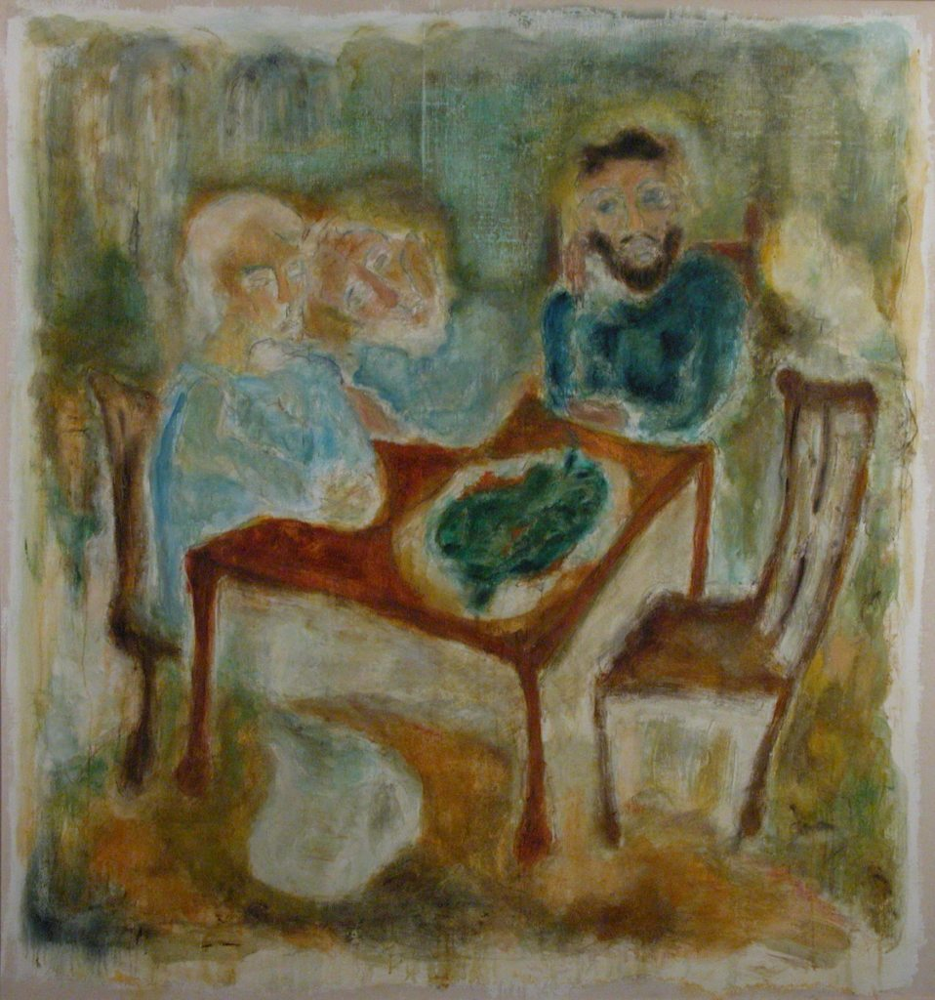
Tracey Emin, Friendship, oil on canvas, 1989, 182.5 x 171.5 cm

Emin’s work was beginning to move into her trademark self-referential style while a student at the RCA. However, the work she left for the Collection entitled Friendship hardly reflects this and is a straightforward narrative, figurative painting showing a family at the dinner table. They look as if they are waiting from someone to arrive – or perhaps someone has left suddenly, and the three around the table are sitting in silent contemplation. The back of the painting is more suggestive of what she was to go on to produce. A large note hand-written directly onto the canvas states that she had been asked to leave another work for the Collection, but in the end made her own selection. The inscription states: “Really sorry, But I love my Nan to [sic] much to part with her (I could have sold this one). It’s a good picture too. Thank you, Tracey.” As Huxley (1998: 7) said some time later:

Tracey Emin’s Friendship, left to the College in lieu of the painting originally selected, reveals in a message on the back the sort of defiant self-confession that has subsequently characterised her work. Emin herself said she might be better represented by the reverse side of the canvas.

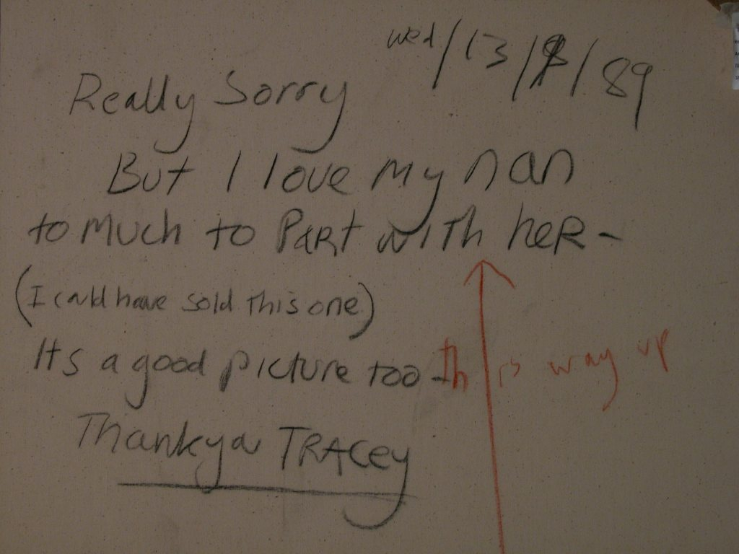
Reverse of Friendship

According to Patrick Elliott (2008: 22), in his essay about Emin for her 2008 exhibition at the National Galleries of Scotland, she was disillusioned by her two years at the RCA, which she has said was not a happy time for her, and had decided she would never be a painter. He says, “She destroyed all the work she had done at the RCA, but instead of a dramatic final act she simply took the works off their stretchers and slipped them quietly into a skip”. The subject of her Nan, May Dodge, was something she returned to post-graduation. However, the painting of her Nan that she should have left for the Collection was probably among these works she destroyed.

Emin did abandon painting on leaving the RCA and went on to use mixed-media as varied as video, embroidery, neons, a tent and a bed to express her concerns, predominantly about herself, her personal relationships and significant events in her life.

Andrew Grassie graduated the same year as Emin. His 1989 work from the collection appears to reflect more painterly concerns relating to composition, colour and form. His more formalist method contrasts with Emin’s personal approach to her work.

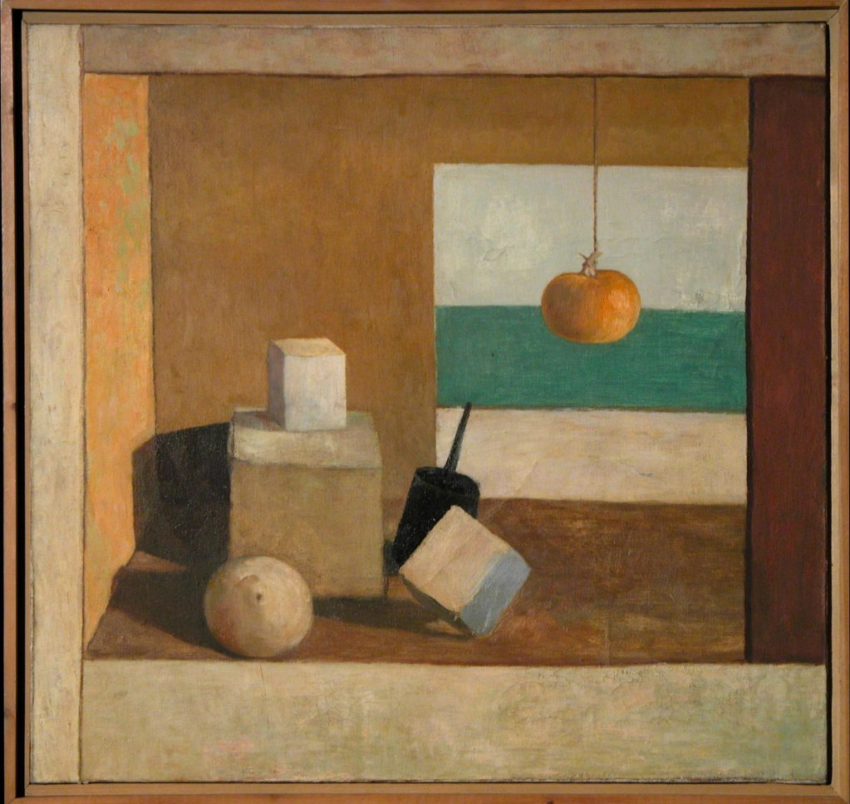
Andrew Grassie, Untitled, oil on canvas, 1989, 53.5x56 cm

His 1989 Untitled represents the sort of still life that the majority of art students over the years would have grappled with, possibly even during school art classes, dealing with perspective and the placing of classic cubes and round shapes in the picture plane. He also utilises a device used by the Spanish painter Cotán around 1600 where fruit and vegetables are hung by string.

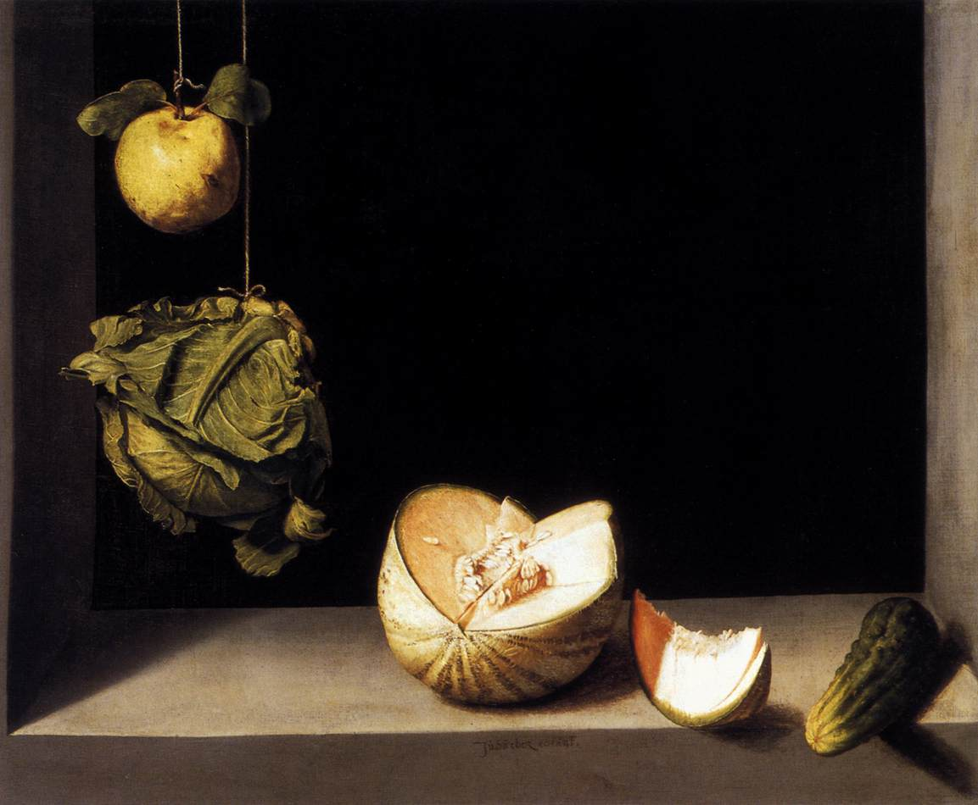
Juan Sánches Cotán, Still Life with Quince, Cabbage, Melon and Cucumber, ca.1600,
69 x 85 cm, San Diego Museum of Art

In the middle of this rather old-fashioned set-up Grassie has included what appears to be an electronic device such as a mobile phone or baby alarm, thereby relating the work to the twentieth century. After graduation, Grassie continued to paint realist still life paintings of various settings, particularly in art galleries where he was exhibiting. When showing at the Tate in 2005 Grassie moved works from the Tate collection into the exhibition space, photographed them, and then made super-realist paintings of the set-up. As the Tate website explains:
Grassie’s starting point is a re-examination of the fundamental question of what to paint. He turns this question on its head, producing paintings which present a series of compelling propositions about painting itself, recording and representing scenarios such as the circumstances of their own production or display.

These are subjects he was starting to grapple with while at the RCA.

Another of Huxley’s student choices, graduating in 1990, was Dinos Chapman who went on to collaborate with his brother Jake, who attended the sculpture department at the RCA at the same time. Their collaborative work post-graduation has been largely sculptural, but Dinos Chapman was an abstract painter whilst at the RCA.

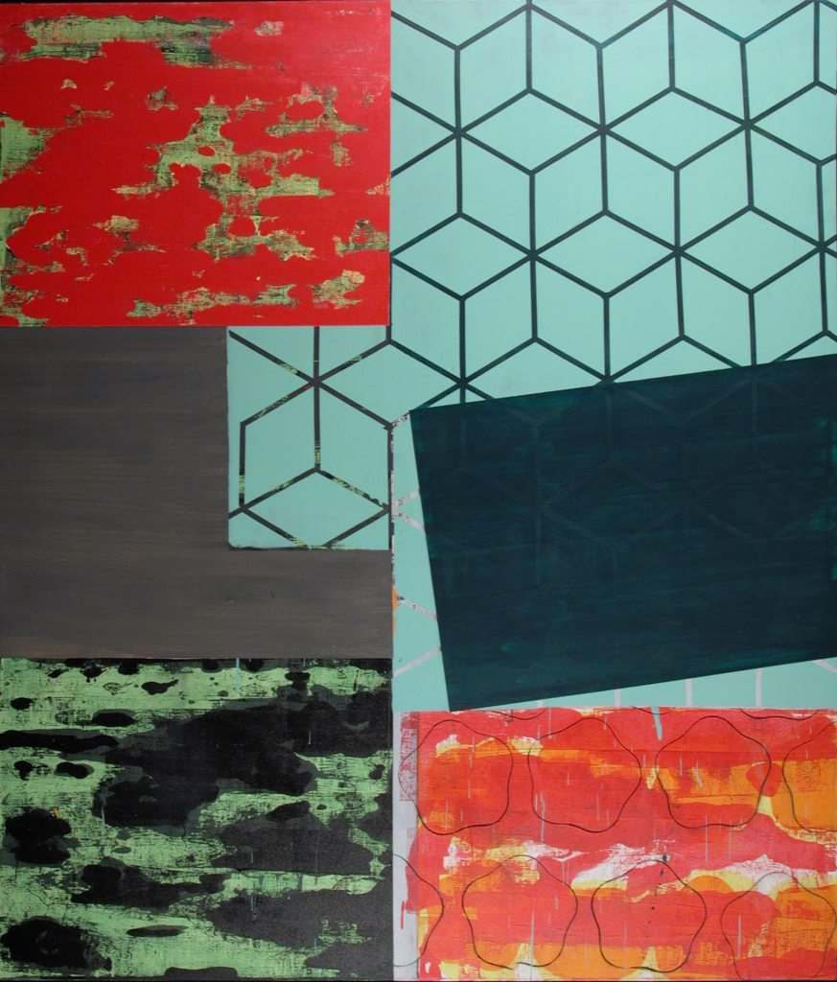
Dinos Chapman, Mummy do they taste nice?1990, 212x183cm

His large abstract work has the canvas divided into sections with a different approach to texture in each. The layout and use of colour are similar to the ideas of his Professor, whose work has always reflected these concerns. Huxley’s painting entitled Modus Operandi VIII executed in 1991 and later donated to the Collection, is typical of his methodical style developed over several decades, where the canvas is similarly divided into blocks of colour and different geometric shapes. Although Chapman’s work is quite formalist, the title Mummy do they taste nice? is hard to relate to the painting and reflects his already developing dry wit, displayed in much of his future work. Huxley (2000: 12) said of Chapman’s work:

… Dinos Chapman as a student gave little away to indicate his future direction. He was a painter of some sophistication and elegance making skillfully constructed abstract works. These were far from complacent works showing at times an undercurrent of the sort of anarchic spirit he would later reveal.

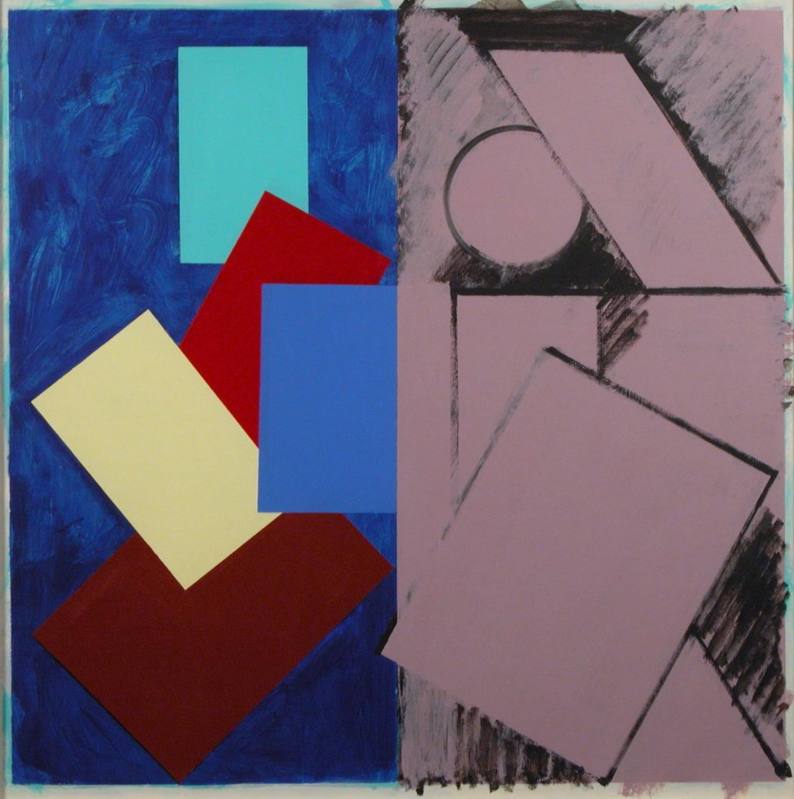
Paul Huxley, Modus Operandi VII, 1991, 102x102 cm

Although by the early nineties the Professor of Painting no longer had a studio at the RCA his students would have been aware of his practice and his influence can be seen in some of the work produced during his twelve years as Professor. Another work expressing these concerns is Ben Norland’s 1990 painting Float, similarly dividing the canvas and using geometric devices and blocks of colour.

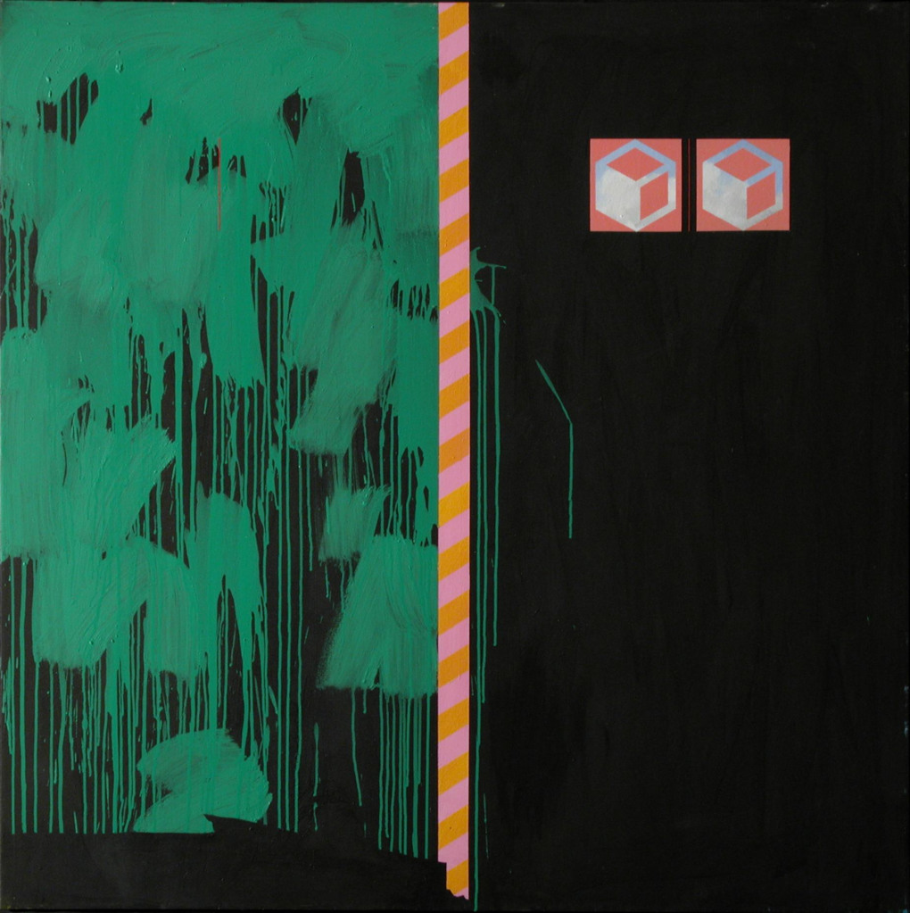
Ben Norland, Float, 1990, 152.5 x 152.2 cm

However, as throughout the history of the Painting department at the RCA, the work being produced under Huxley was varied and his influence was not predominant. Many of the paintings were not exclusively concerned with colour and form and, as Huxley (1998) himself pointed out on his retirement, he had resolved, during his time as Professor:

[To] open the school to the broadest interpretation of painting. The result of this pluralist approach has been an interaction between students who otherwise would not have met. An unpredictable mix which was at times volatile, but more usually highly fruitful. … It has been the time of the rise of postmodernism where styles have been borrowed and mixed. Working from imagination rather than from observation continues as the general practice to such an extent that memory itself has often become the subject. Imagery has been evolved through memory or as an extension of the painterly process or by direct transference from other media such as film, photography, print and electronic technology. Appropriation and the democratisation of style have led to multi-levelled paintings which have the capacity to tease and undermine received values.

The paintings illustrated here only represent a sample of the kind of work being executed in the Painting department during Huxley’s time as professor. In his essay on abstract painters at the RCA the curator Bryan Robertson explains that “… figurative art has never been allowed off stage for more than five minutes. It is our national, established taste … [and] is still in the ascendant” (Huxley, 1989: 75). This tradition carried on by de Francia in the seventies still prevailed in the eighties and nineties with students also producing figurative work based on the imagination as well as real life. An example of this is John Greenwood’s carefully executed drawing entitled Strange but True completed in 1990, which has a surreal quality to it and completely contrasts with Ben Norland’s painting above. At first glance the drawing appears to show figures, but on closer inspection these are not creatures but naturalistic forms moving strangely across the paper, leaving the viewer to guess at what is being depicted.

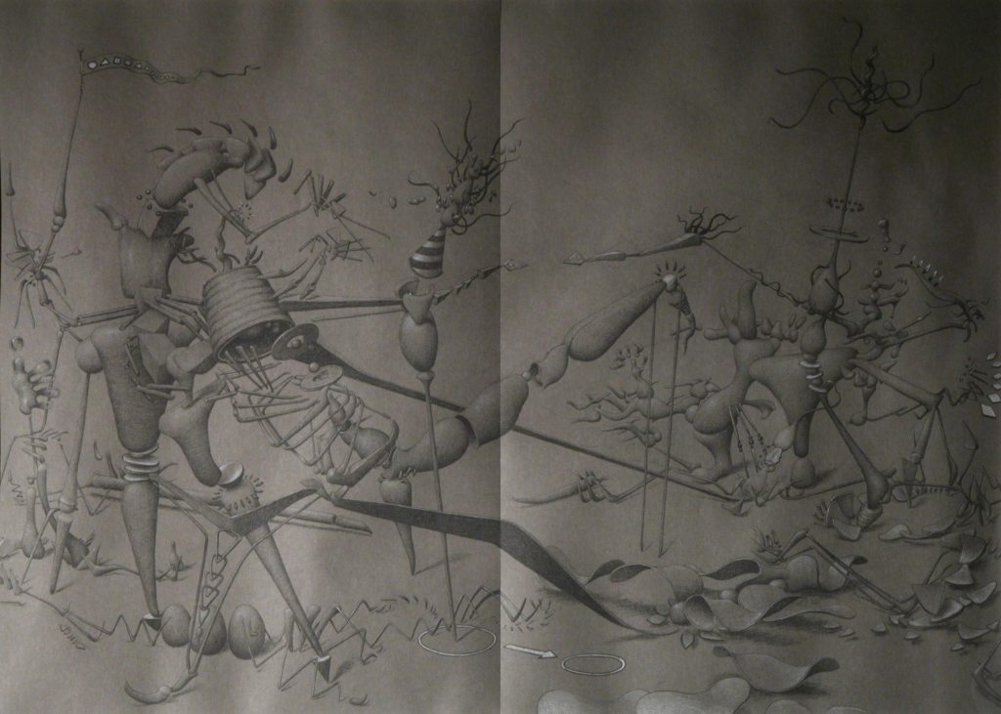
John Greenwood, Strange but true, 1990, 67 x 93 cm

Another is A. Rausch’s Taxi (pictured overleaf), executed in the same year. This is a disturbing figurative scene apparently of two people waiting for a taxi who appear to be in some distress. A devil’s tail curves up through the middle and it is hard to escape the feeling of impending horror. One hopes this is not self-referential but based on a surreal dream or conjured up from a vivid imagination.

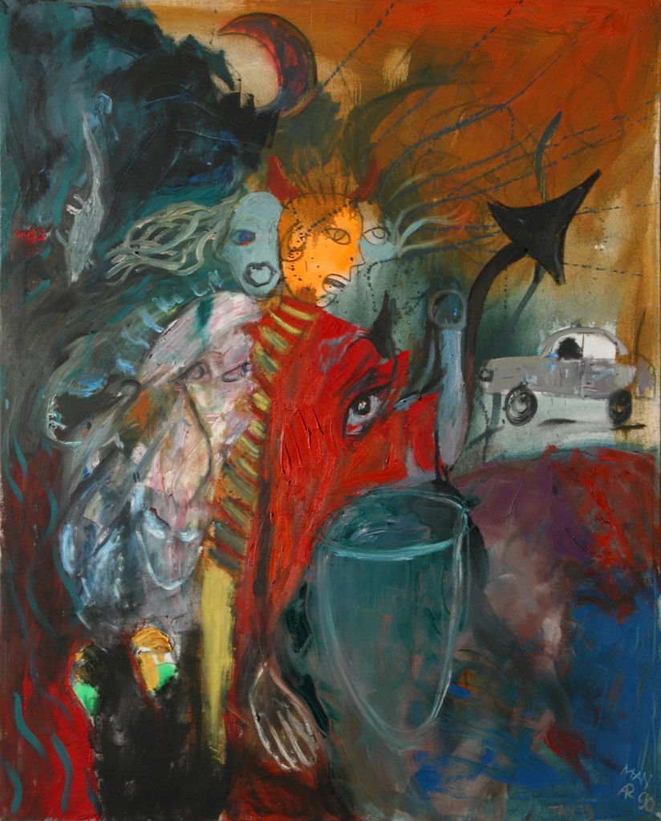

A.Rausch, Taxi, 1990, 152 x 122 cm

These works participate in an expressive symbolist or surrealist vein that has persisted in the work of a minority of students from the seventies onwards.

Stallabrass (1999: 5), when talking of the recession that took place at the very end of the 1980s, points to the fact that many artists, as in the 1970s, moved away from making permanent objects such as paintings and sculptures. There was a revival of performance and installation as well as artists, out of necessity, becoming their own curators. He also suggests that, “there was a turning away from the inward-looking concerns of the art world to new subjects, especially to those which might appeal to mass media”. David Rayson (2010), the current Professor of Painting at the RCA who was a student at the College from 1995-1997, suggests that in the years following the recession of the early 1990s painting was downgraded, as it had been during the recession of the early 1970s. In an interview Rayson said, “All those arguments about painting is dead and painting as a rudimentary or secondary occupation were in the air. In the early 90s everything was conceptual or film”.

At a time when many art schools were merging into Fine Art departments that functioned without barriers between disciplines and the activity of painting decreased, the RCA stubbornly retained subject specificity. Painting continued vigorously and it was a time when most students were persuaded to leave a painting for the Collection upon graduating, with some leaving more than the one expected by the College authorities. An example of this is Chris Ofili, who graduated in 1993 and left five paintings behind. None of these is typical of the sort of work he is now producing as a high profile artist who represented Britain at the Venice Biennale in 2003 and won the Turner Prize in 1998. The works he left for the College Collection were executed in his first year. At this point he had not been influenced by his trip to Zimbabwe in 1992, funded through a British Council travel scholarship, after which he started using the signature elephant dung in his paintings as a means of incorporating the essence of Africa into his work. The paintings executed in his first year at the RCA use images from popular culture and black identity, which are themes he continues to use in his more mature work. They are striking paintings that reflect an angry energy. Susie Allen (2009), who was working in the Painting department at the time had this to say of them:

Looking through the archive you can see different periods of work coming out and what other influences there were and where people were coming from– such as the Chris Ofili’s. We were very lucky to get so many of his works. I remember his work going up in the little Hockney Gallery and he just covered the walls with those paintings. I went in very early one morning and I remember walking in and seeing them and you got goose pimples and you realised there and then that a star was born. You can’t say it but you just know it. That’s incredible excitement.

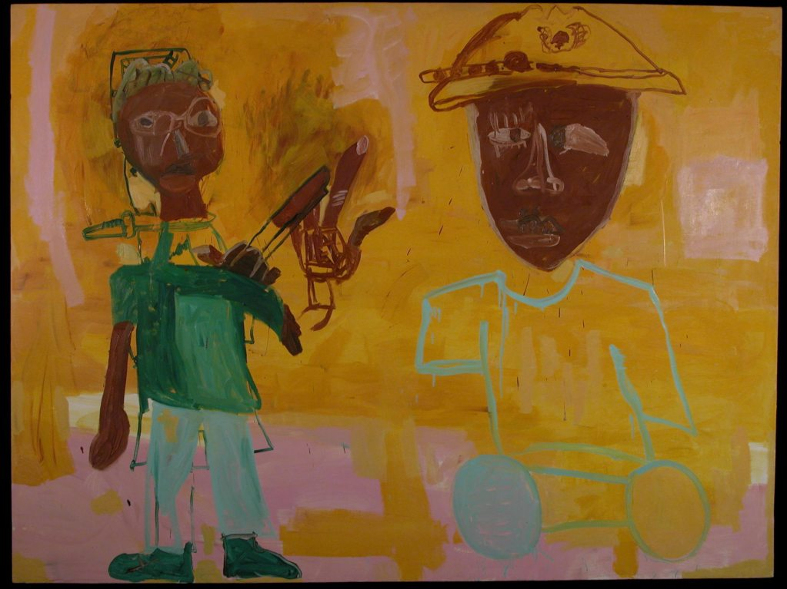
Chris Ofili, Public Enemy, 1992, 182 x 244 cm

Public Enemy, named after the American hip-hop band famous in the late 1980s, depicts two men, one without legs using wheels as a means of transport, the other looking as though he has been horribly attacked, with weapons sticking out of his neck and shoulder. There are definite similarities between his student work and the work of Jean-Michel Basquiat, who was the first black painter to become internationally famous. Ofili was obviously influenced by Basquiat’s work and its graffiti style. Vanessa Jackson (2010), who was his tutor at the time, confirmed that he left these first-year paintings at the College because he did not want them – by the time he graduated he had already moved on in his thinking. She remembers saying quite categorically to him when she saw these works;

“Oh, you are not going to grow up to be Basquiat are you?” And nobody had said it – nobody dared. It was so obvious that he was doing that and I said, “Come on, let’s get real”. He was quite cross with me for an hour or two and then got over it. He left his first year works because he didn’t want them.

The works he exhibited in his final year show are far more representative of paintings for which he is now famous, none of which was selected for the Collection.

When David Rayson arrived as a student at the RCA in 1995 he typified the growing trend for students to have had some time out of the education system before embarking on their MA. Rayson had been working at the Arnolfini gallery in Bristol in the education department. He was encouraged to attend the RCA by the gallery director, who had made a visit to his studio and realised that he needed the opportunity to focus on his work in order to develop his artistic practice. He points to the fact that the RCA gave him not just the opportunity to concentrate entirely on painting, but allowed him to network. His tutor was the painter Peter Doig who introduced him to people such as the curator Matthew Higgs and the artist Paul Noble. After graduation he was taken on by the gallerist Maureen Paley and given three solo exhibitions at her gallery in East London. Being at the RCA and meeting the people he did provided Rayson (2010) with the opportunities he needed to develop his practice as an artist. He said, “Coming to the RCA was essential really. Being in London and meeting all those people. If you are going to be active and buoyant you have to do it in the right place. … I had to go somewhere where I could network.”

He went on to say that academically he was also introduced by the staff, particularly the artist John Stezaker who gave lectures on art history, to a whole raft of artists and notions of painting that he had not known about before and this fed into his practice. He cites the Unbound exhibition curated by the critic Adrian Seale at the Hayward Gallery in 1994, the year before he started at the RCA, as one of the key influences on him and his fellow painters. He said of the exhibition:

It had Peter Doig, Luc Tuymans, Raoul de Keyser, and for the first time lots of these artists were being introduced to the public. They are now common currency but lots of artists saw this and were energised by it. It was about painting unbound with artists like Jessica Stockholder – it was very broad. Seeing that just before I got to the RCA was a real boost because painting had become slightly downgraded.

As the foreword for the exhibition by Adrian Searle (1994: 5) states, “Painting has in recent years been spectacularly successful at both burying itself and returning from the grave”. He talks of a greater diversity in painting being reflected in this exhibition, and certainly he included a diversity of artists. The influence of the painter Luc Tuymans can particularly be seen in the painting left for the Collection by Kaye Donachie entitled Nursery (pictured overleaf) executed in 1997. Tuyman’s painting Silent Music from 1993 depicts a very similar setting and the same flat, monochrome style. Searle (1994: 102) says of Tuymans’ work:

What the paintings depict seems inconsequential, even dull: somewhat baffling still lives, odd corners of rooms … But there is something compelling about the painter as though what he really intended to paint were a kind of nausea or irritation with the things about him, or to show what it is like to be a certain sort of man, living in an uncomfortable era.

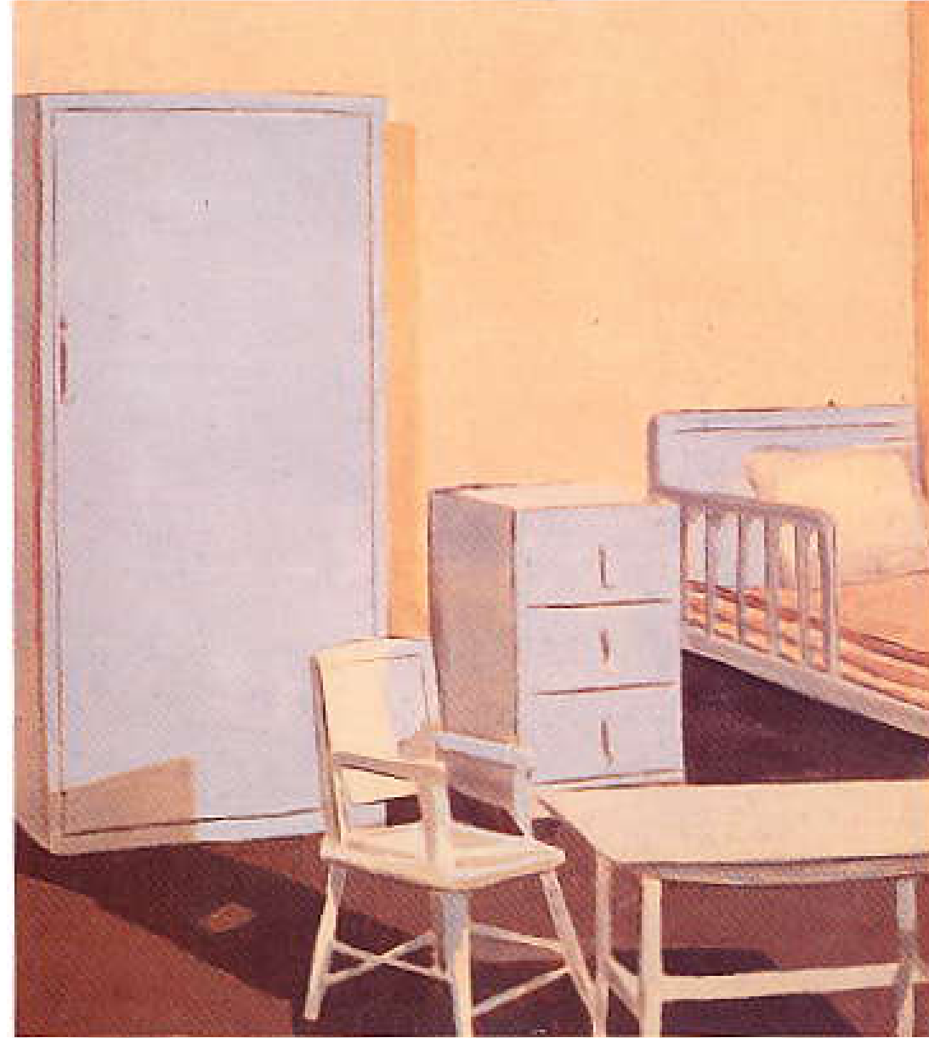
Luc Tuymans, Silent Music, 1993 (from Unbound catalogue)

Tuymans’ paintings often appear to represent banal subjects. However, they are about memory and history, often referring to cataclysmic events not evident when simply glancing at the work. Robert Storr (2001: 33) suggests that, “… his work is about what we do not know, but suspect. … analytical not gestural”. When discussing Silent Music he refers to it as revealing “an unhomely home”. Donachie’s Nursery is in the same vein. It has a discomfiting feel – the grey, empty nursery with the odd electric fire misplaced in the middle of the room. It is not a room in which one would be happy to place a child. Searle goes on to say that, “Tuymans invests his painting with an extreme discomfort”, also felt in Donachie’s painting.

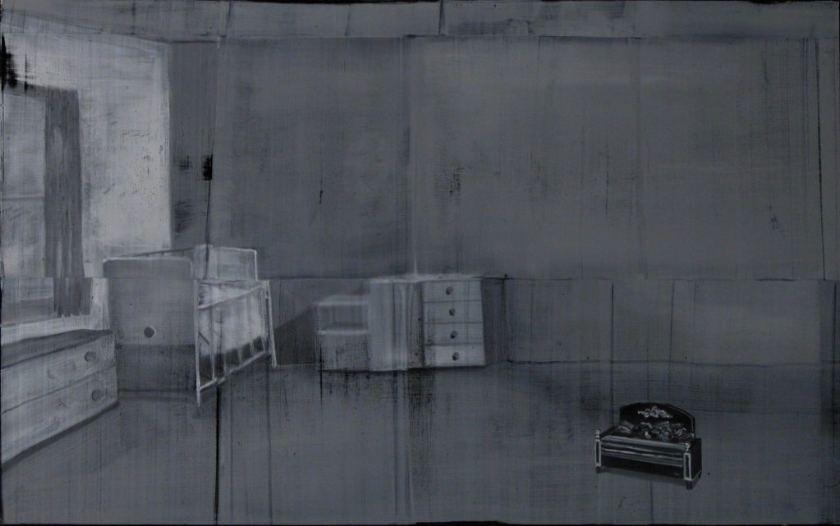
Kaye Donachie, Nursery, 1997, 76.5 x 122 cm

In some ways this painting and the works by fellow students Rayson and George Shaw hark back to the concerns of the Kitchen Sink painters, so prevalent at the RCA in the 1950s, whose paintings reflected domestic life. Kitchen sink works depicted similarly drab domestic interiors, the difference being that they almost always included people. This is not the case in the work of Donachie, Rayson and Shaw, which are devoid of people, adding to a feeling of uneasiness. Rayson’s paintings express this, but his use of colour is far more vibrant than Donachie. His work has for many years reflected his fascination with portraying the world around him and living in suburbia, as seen in his painting from the Collection entitled In the beginning (pictured overleaf) executed in 1996.

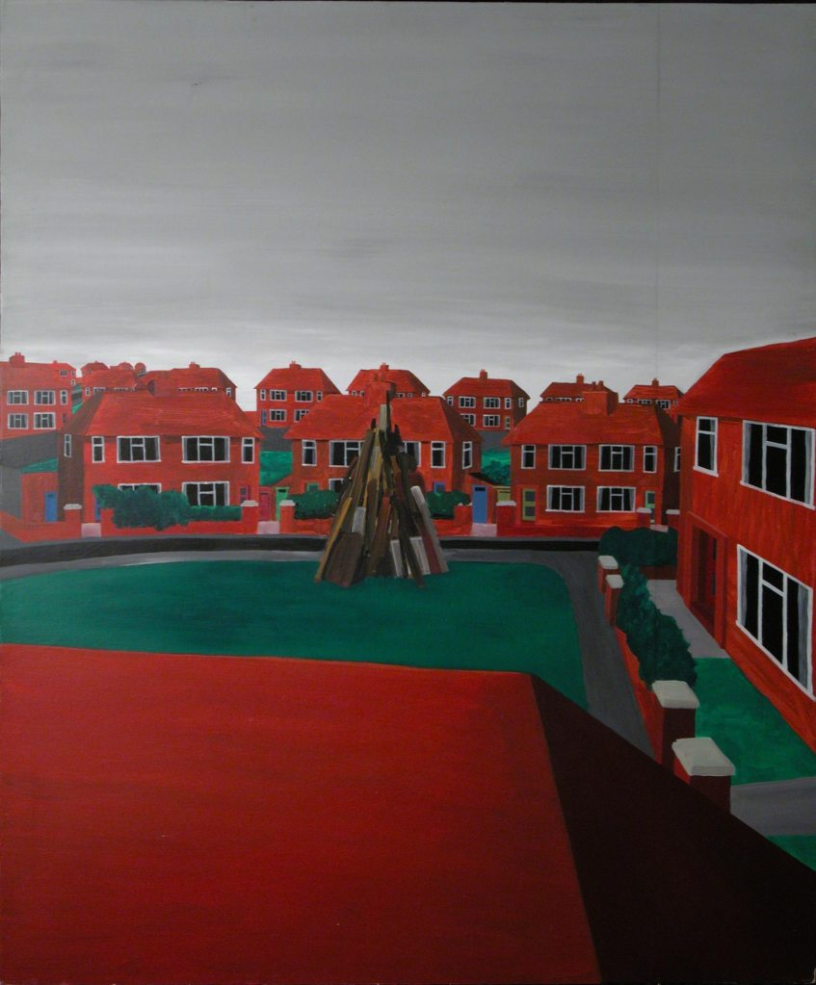
David Rayson, In the beginning, 1996, 182.5 x 152 cm

The rows of identical buildings are painted a vivid red with the paint applied in a very flat way. The structure erected in the middle of the green is possibly being prepared for bonfire night but there is no sign of activity. There is a deliberate lack of people, as if suburbia has been completely depopulated. Where Rayson does include people, as in another untitled 1996 work, they are depicted in a comic book style with the work verging on illustration.

Only two years after graduating Rayson was included in another painting survey exhibition at the Whitechapel art gallery in London entitled Examining Pictures which included painters as varied as Georg Baselitz, Philip Guston, Damien Hirst, Marlene Dumas, David Hockney and Gary Hume. The entry for Rayson’s work explains what he was trying to do through his work:

Rayson’s pictures of forlorn suburban spaces, … takes a deadpan view on the world as created by developers and city planners. Painted in a flat, uninflected manner, the regulated environment plans for conformity, even as it breeds deviancy. (Bonami & Nesbitt, 1999, 76)

This is a theme also reflected by fellow student George Shaw.

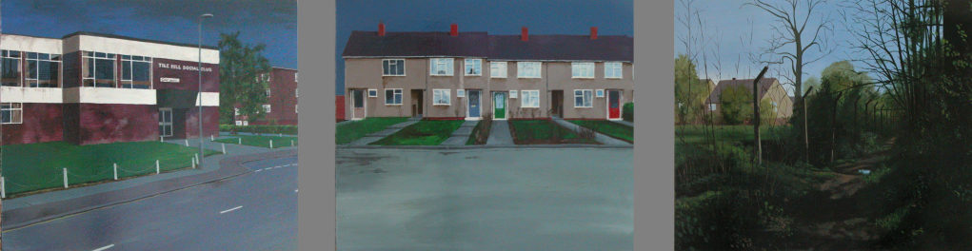

George Shaw, Scenes from the passion,1997/8. 43 x 53 cm each

Shaw’s paintings in the Collection come from a series entitled Scenes from the passion. However, there is no evidence of passion or religious themes, no people to inhabit the spaces, simply unpopulated settings familiar to anyone who has grown up in suburbia. As Huxley (2000: 18) states:

David Rayson and George Shaw each in their own way make paintings which painstakingly recreate the details of remembered past. A past revived by nerve cells triggered in the brain, making the journey again down the childhood pathways and across housing estate. There is something compellingly potent about the places which are not picturesque, not chosen destinations, the wrong side of the tracks.

Shaw’s medium is Humbrol enamel paint, usually used to paint Airfix models, which gives the painting a highly polished, reflective surface. This is a look favoured by Gary Hume, another artist included in the Unbound exhibition, whose medium is domestic gloss paint on board.

Talking about the works he left for the Collection, Rayson admitted that he sold everything from his degree show. Like Chris Ofili, works that were accessioned to the Collection were ones executed early in his time at the RCA. He had expected some of them to be put in the skip when the studios were cleared but instead they were kept by the Painting technician and found their way into the Collection. Of the five, there are only one or two that he felt would be representative of the way he was working as a student in 1997. His comments illustrate how arbitrary the collecting of works for the Collection had become, certainly during Huxley’s time as Professor of Painting, with work sometimes being accessioned without the student even knowing about it. Huxley admits it was always a struggle to gather works from graduating students to add to the Collection. It is interesting to speculate how different the Collection would be if he had managed to accession one work by each student from their degree show, which was the original intention. However, examples for the period 1986-98 are varied and rich and often reflect the concerns of the art world at large. It appears that students during their time at the RCA were happy not to follow particular trends but were spending their time forming their own individual practice as artists.

Just before he retired in 1998 Huxley organised a further exhibition from the Collection, bringing the achievements of the Painting department up to date by including works from recent graduates as well as historical paintings. This exhibition did not take place in the College galleries as a slot in the busy events calendar could not be found, but was exhibited at Pallant House Gallery in Chichester, where the gallery director was pleased to both host and fund it. It was a survey of painting from the RCA Collection ranging from William Etty’s Standing Male Nude 1849 to Kaye Donachie’s 1997 painting Nursery. The title of the exhibition was Painter’s Progress and, as with Exhibition Road at the start of Huxley’s time at the College, highlighted the rich heritage afforded the RCA by its Painting Collection.

Of all the Professors of Painting at the RCA over the years Huxley, more than any of the others, promoted, used, cared for and saw the value of the Collection. As he points out in the catalogue, “However wayward in its development, [the Collection] provides an illustrated history of its own kind, and a heritage to the College.”

Perhaps this era can be best summed up by Eliza Bonham-Carter when she says her years at the RCA gave her time, confidence and a chance to mix with like-minded people grappling with similar concerns. This is reiterated by David Rayson when he talks of his two years as being a time when he “could suspend reality and really get on with it and forge links”.

Although there was a shift away from the intellectual rigour of Peter de Francia’s time, students were given a chance to experiment and find themselves, to network and make important connections with artists, curators and critics in the fine art world. The critic Louisa Buck (2004: 25) may be right when she expresses her view that:

All art schools can be expected to do is to provide a supportive, stimulating, reassuring and informative environment that enables artists to find their voices and the means to express them. They cannot and should not ‘make’ artists, but they should offer a sympathetic space for development, questioning, risk-taking and play.

The curator Daniel Birnbaum (2009: 240), when talking about art education, agrees that, “A great faculty attracts interesting students, who teach each other. It is about participating in a collective sphere of challenging and critical exchange rather than being taught specific techniques.” This is what the RCA provided for the Painting students throughout Paul Huxley’s time as Professor. As Huxley (2009) himself says of the student experience at the College:

It is an important place where a huge number of interactions have taken place socially from people of different disciplines. I think it is one of the big virtues … [it] is a wonderful opportunity to meet their own generation in many fields who can stay colleagues for the rest of their lives.

Paul Huxley and Susie Allen’s interest in the Collection raised its profile and meant that it was left in better shape than when they arrived. For the first time many works were stored in a purpose-built store in the College. Other works were safely housed with a fine art storage facility rather than being precariously kept in a self-storage unit. They even raised money to undertake some much needed conservation work, such as repairing the Auerbach painting, which had been loaned to Imperial College in the early seventies, hung on its side for all those years, and returned damaged in the nineties.

Huxley (2009) did not always manage to persuade students to leave their best works. When talking about the Collection he admitted that, “…although I was very interested in it and valued it, it didn’t help me to be better at acquisitions. I always found it difficult to get works from students”. At least he tried. Huxley’s successor, Graham Crowley refused to have anything to do with selection, which meant that the Collection increased in size but not quality and continued to be an accumulation rather than a considered collection, an issue that will be discussed in the Conclusion.

CONCLUSION

…what is the point of mining the past if not to tell us something significant and potentially useful about the present. (Rehberg, 2010:19)

In the previous three chapters I have presented a history of the Painting Department at the RCA over the fifty years from 1948-1998 and a profile of the work produced. I have discussed principals, rectors, professors, tutors, students, influences and events, both internal and external, affecting the work executed in the Painting Department, now encapsulated in the RCA Collection. The purpose of my research is to assess the different kinds of value represented by the Collection. In order to do this I have considered the way cultural capital has been built up through the Collection over a period of time and identified the rich history revealed through the works that have accumulated since Robin Darwin became Principal. Through discussion of the definitions of collections in the Introduction it appears that the RCA does not have a clear idea of why it keeps the Collection and what its role is within the institution. It is not used for teaching and its main function is as decoration inside the College. Does it serve the purpose that Darwin had intended of adding prestige and status to the institution and, if so, does this outweigh the burden of caring for it? Or is its true function simply to act as an historical record of Painting at the RCA and, if so, is this enough to make it worth nurturing?

On Robin Darwin’s arrival at the RCA there were only small remnants of the previous teaching collection left in the College. When he made the decision to start to build up a collection again it was not with the intention that it be used for pedagogical purposes. What he wanted was something that would express the importance of the RCA to the outside world. Pearce (1995: 232) suggests that:

…frequently collections are undertaken in order to impress contemporaries, to arouse admiration and amazement and to secure an immortal place for the collector through the building of the collection as his monument. Prestige has unquestionably been one of the principal collecting motives over the last five centuries

Darwin was not trying to build a collection as a monument to himself. His intention was to do this for the institution he was leading. Christopher Frayling (2009) explains Darwin’s motives when he says:

Darwin had a great sense of the esprit de corps of the College. Creating the Senior Common Room and that famous quote in The Dodo and the Phoenix, his lecture in 1954, where he talks about the fellowship of Cambridge and as a member of the Darwin clan he grew up with that fellowship and wanted to establish it at Kensington Gore. That was very much a part of the reason why the collection became more systematic from 1947 onwards.

Frayling (2011) also discusses how the display of works in the Senior Common Room (SCR) helps to create pride and belief in the institution:

I think it is like a coral reef. You accrete all these barnacles as the tide comes in and out and these things attach themselves to the College and it becomes more and more encrusted. It becomes part of the patina of the place. There is that famous quote from Darwin in his inaugural where he says, “I walked across the lawns at King’s (in Cambridge – because the Darwins were one of the great baronial Cambridge families) and I saw the lights flickering in the Fellows’ rooms and I wanted something of that spirit”. It’s clever people thinking about the future but existing in these very old buildings. I think that is what it is about. It doesn’t hold you back and you don’t become antiquarian. It is a visual fellowship which people want to be part of.

Comments from other past members of staff come from former Professor of Printmaking, Chris Orr (2008), who states that, “to see works on the wall, such as in the SCR, is more than nice. It describes what the institution is about … so it is crucial, it is a foundation stone for what the College is. … The cultural value is enormous” while Susie Allen (2009) sees the SCR as a showcase acting as a tool for the College when she says, “It is where you bring sponsors and they see the works and think they are somewhere wonderful and that is one of the reasons they support the College, It gives huge value – it is absolutely the jewel in the crown”.

The works displayed in the SCR are only accessible to students if invited by a member of staff. As Beryl Lewis (2010) stated, on being asked if she had ever visited the SCR when a student in the early sixties, “No, you didn’t, it was staff only. It was all rather them and us”. The works were not intended for students to study in order to gain inspiration or refine technique. The objective was to impress visitors and elevate the RCA in the eyes of the outside world, as suggested by the writers Charlotte Gere and Marina Vaizey (1999: 10) when they say that, “Art – its commission, collection and display – has always been an integral part of the complex of wealth, status and power”.

The historian, Donald Kuspit (2000: 2), also proposes that original paintings symbolise power and wealth. Darwin was aware of this when he was appointed Principal and, although his first acquisitions to the Collection were modest, his intention was to build up the status and power of the College, not just through improvements to the educational model, but through the reflected glory of having fine art hanging on the walls.

As a government funded educational institution the College was not able to spend money on acquisitions that were not specifically for teaching purposes, so initially Darwin paid for these himself, starting with the drawing by Walter Sickert, a Camille Pissarro watercolour and small drawings by L. S. Lowry and Stanley Spencer. He was then able to persuade his colleagues in the Painting Department and their friends to donate paintings of greater magnitude such as Country Lane by Carel Weight, Reclining Nude by William Scott (pictured overleaf), several portraits of members of staff by Ruskin Spear, including his portrait of Darwin standing in front of the fireplace in the SCR, all of which added to the feeling of authority bestowed on the College.

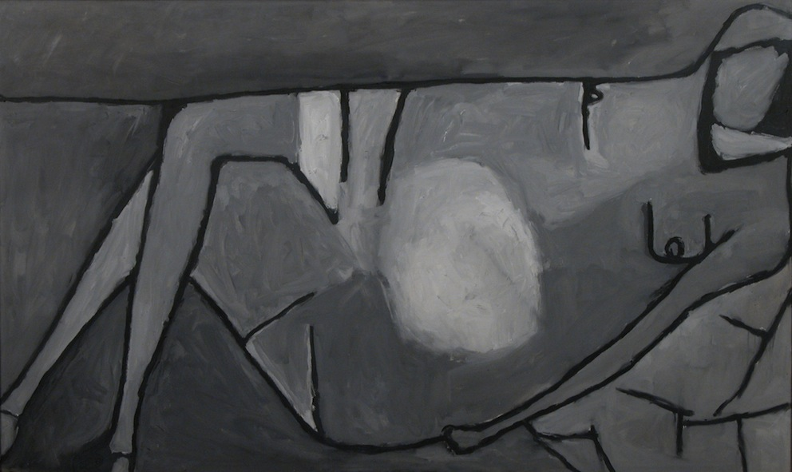
William Scott, Reclining Nude, 1956, 90.5 x 151 cm

Even though the RCA during Darwin’s time was still predominantly a College of Design he never thought it appropriate to collect examples of design, as Frayling (2009) explains,

Darwin was obsessed with the fact that design was about production. The apotheosis of design was seeing your product in the shops. There was no design museum – the V&A was fundamentally thought to be a craft museum, not a design one – it was mainly one-offs. So design didn’t do museums in those days.

It was the fine art that Darwin used to express his ambitions for the College. What was displayed in the SCR was there to reflect the aspirations of the foremost institution of art and design in the world, and this was done using works from the Collection.

By the late sixties substantial status was attached to having a work hung in the SCR. Correspondence between the artist John Bratby and Darwin show that Bratby was concerned that the graduate painting he had left for the Collection, and which was hanging in the SCR, was not of good enough quality to reflect his increasing status as an artist. In 1969 he wrote to Darwin suggesting he donate a much larger and more imposing work (pictured below) that he had recently executed and goes on to state that it is, “the best work I have”.

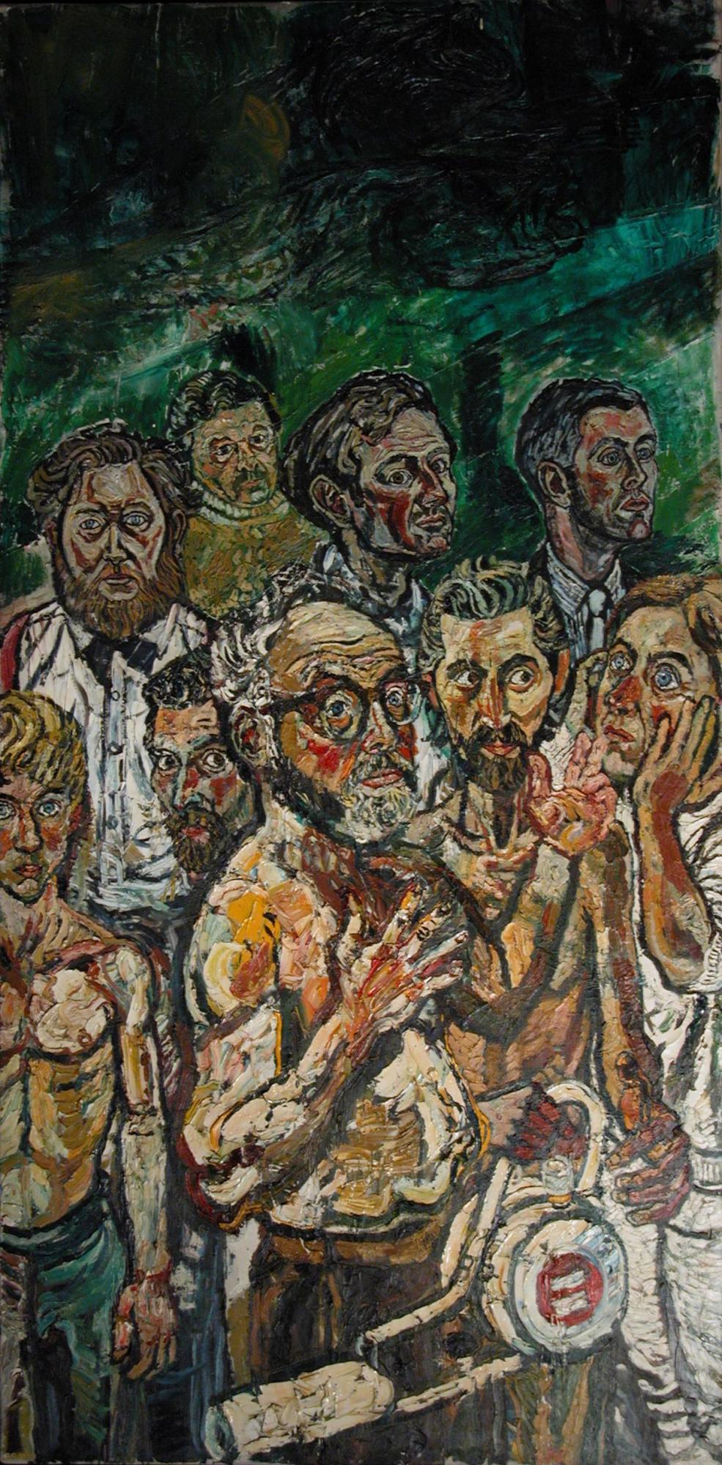
John Bratby, Self Portrait with Others, 1957, 246.5x122 cm

Darwin’s perception of this generous offer was that Bratby wished to try to rival the painting by Francis Bacon, which Bacon had donated to the College in lieu of rent for a studio he had borrowed from the Painting School for six months, and which was hung in pride of place in the SCR. In a letter to the then Professor of Painting, Carel Weight, Darwin (1970) says:

I have looked round the SCR this morning at luncheon and find it very hard to discover a site for a picture of such large dimensions … I suspect that John Bratby has been stimulated by jealousy of Francis Bacon to give this large picture so generously.

Darwin’s efforts to raise the status of the RCA through the display of fine art in the SCR was, by the late sixties, achieving its purpose, at least among artists.

Usually a collector picks a particular category of artefact to collect. Fine art is, of course, a common ingredient of many collections. Often works are chosen because they were created during a particular era or were executed by a specific artist. There is usually a theme that ties it all together. Darwin consciously chose to inaugurate a fine art collection. He understood the worth of original works of art, their value (both in financial and cultural terms) being the main incentive for collecting them. Much has been said and written about the importance of painting as an art form. These discussions point to the fact that owning a collection that consists predominantly of paintings raises the status of the collector. It is evident that there is something singular about original paintings. They are high prime value objects and ownership of them offers increased standing to the institution or the individual who owns them. (Appadurai, 1986: 162). The American art historian, Douglas Crimp (2011: 26), when summing up the eminent critic Barbara Rose’s view on painting, says:

… painting is a high art, a universal art, a liberal art, an art through which we can achieve transcendence and catharsis. Painting has an essence and the essence is illusion, the capacity to materialise images rendered up by the boundless human imagination. Painting is a great, unbroken tradition that encompasses the entire known history of man. Painting is, above all, human.

Every painting is unique. It captures a moment in time and space that is different from work that can be reproduced, such as prints, photographs or design objects. It is far easier for the Printmaking student to donate one of an edition of prints to their Archive than it is for a Painting student to part with a work that is unique and particularly valued for its uniqueness. Walter Benjamin (1973: 222) suggests that paintings are elevated not only due to their uniqueness but also because of their actual presence:

Even the most perfect reproduction of a work of art is lacking in one element, its presence in time and space, its unique existence at the place where it happens to be. This unique existence of the work of art determined the history to which it was subject throughout the time of its existence.

The presence of the paintings and other works of art in the RCA points to another important reason for an institution to keep a collection – to help build up an historical record or archive and through this provide a unique identity. The Printmaking Department has kept an archive that is in fact the oldest and the most comprehensively collected in the College dating back to 1912. Chris Orr (2008), had this to say about it:

The Printmaking department was interwoven with other departments [it was previously part of Graphic Design] – but as it became a fine art department it became more conscious of its own identity again – part of that was trying to create a history – trying to describe a history and I have always contended that something like Printmaking is under-researched and under-valued as a resource because the situation has tended to be that painters make prints and sometimes they are rather cynically produced for commercial reasons. But people have actually believed in it as a separate voice. That has meant that you have to describe the history of what that is and why that voice works, and that has been a function of what I thought an archive could be.
He is not alone in thinking that it is important for the RCA to record its history. The majority of the people I have interviewed, both inside and outside the RCA, have cited this as being the main function of a collection. As former Head of Sculpture at the RCA, Glynn Williams (1994: 25) states, “Knowledge of the past is implicit in any idea of progress or originality”, suggesting that, in order for the RCA to continue to be the progressive institution it purports to be, it must take an interest in the past that has helped to shape it and make it the institution it is today.

The historian Alan Carr (1990: 30) says that history is an unending dialogue between the present and the past. He goes on to suggest that the past is intelligible to us only in the light of the present, and we can fully understand the present only in the light of the past (ibid: 55). Christopher Frayling (2009), when referring to a conversation he had with Robin Darwin when first appointed to the College, discusses Darwin’s take on the past:

Darwin asked me what I did. I said, “I am an historian”, and he paused and said, “always remember that the College is about the future and not the past,” and this was the modernist mantra – the end of history. Don’t look back – we have got the solutions. … So they, almost as an article of faith, didn’t look back. … Darwin had this curious paradox of publicly saying “don’t look back” when actually the root of his being was as a heritage person.

Frayling goes on to explain that although the modernist view at that time was against looking back, this view was unsustainable. The more people studied modernism the more they became aware of its connections with the past. The paradox is that, although Darwin’s ideal was to look forward, he started the Collection with historical works that he thought would provide greater gravitas. Contemporary work followed which inevitably became historical. Nothing remains static for long and what is current soon becomes a part of history. As the writer Matthias Winzen (1988: 22) suggests, “… all collecting can be seen as an ongoing attempt to cope with the fact that time goes by”, and this is what the Collection reflects. It provides insight not only into the activities of the Painting School at the RCA but also into aspects of the history of British art over the last half of the twentieth century.

As has been illustrated in the previous chapters, an examination of the Collection shows that the Painting Department at the RCA oscillated between leading or following predominant art movements. With the interest in abstraction and pushing the boundaries of paint and other materials in the late fifties, Painting at the RCA led the way, as it did simultaneously with Kitchen Sink figuration. The continuation of figuration and use of graphic symbols in the British Pop Art movement in the late fifties and early sixties was a time when the Painting Department was particularly ascendant and influential. In the seventies, a time when painting was not the dominant medium in the art world, the influence of more avant-garde movements such as conceptualism on the Painting Department is not visible. Vanessa Jackson (2010) confirms that there were students working in a conceptual way:
Don’t forget there were students like that under Peter de Francia too – Peter had a whole bunch of people like John Wilkins, John Blandy, Peter Challis – they all worked in this one studio opposite Peter’s office. … There were so-called conceptual artists in Painting.

However, none of these artists is represented in the Collection. Perhaps it was not the kind of work that was considered by the tutors to be suitable for inclusion. According to Jackson, de Francia did understand conceptualism, but it was not an area he was particularly sympathetic to. Despite the intellectual rigour and seriousness of thought that de Francia bought to the department, Painting at the RCA was not at the forefront of British art education during his time as professor, a time when St. Martin’s was in the ascendance.

The Painting Department was to be eclipsed again in the eighties by Fine Art at Goldsmiths, which produced many of the Young British Artists who dominated that decade. However, by the late eighties and nineties, with a resurgence of interest in painting, the Department had started to build up a reputation again, partly through having some strong students and partly through the staff’s avid promotion of the work. Even though the times of greatest strength in the Painting Department were in the fifties and sixties, the Collection as a whole reflects a lasting interest in painting, which declined in many art schools in the second half of the twentieth century, and a continuing interest in figuration, that has always been strong at the RCA.

Winzen points out that many public institutions build collections of one sort or another and that these collections are intended to help guarantee their identity. The Collection is an example of this. It is a manifestation of the RCA’s identity, a public proof of the fact that it is a renowned institution and therefore has an eminent collection, built on its past. It resembles a photo album or diary, as one can go back through it and see who attended the College at a particular time, what they were doing and who influenced them in their work. This is particularly true of the more representational works that depict members of staff or interiors of the buildings – portraits and self-portraits of Rector’s, paintings of parts of the College that no longer exist, such as Richard Bell’s painting of the conservatory that used to be located on the 7th floor of the Darwin Building or John Bratby’s Mural Studio which shows the former Painting School studios at the V&A.

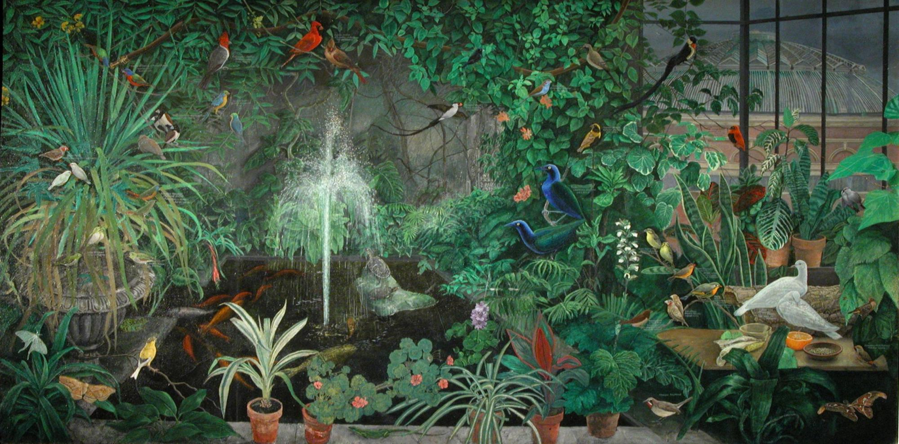
Richard Bell, Natural History Studio at the RCA, c.1970, 122 x 244 cm

However, the paintings that do not simply portray people and places also help to build an image of the institution, not necessarily through what they depict – many are abstract – but through the influence of the institution that is revealed through them. The art critic and writer John Berger (1972, 19) points out that:

Originally paintings were an integral part of the building for which they were designed. Sometimes in an early Renaissance church or chapel one has the feeling that the images on the wall are records of the building’s interior life, that together they make up the building’s memory – so much are they part of the particularity of the building. The uniqueness of every painting was once part of the uniqueness of the place where it resided.

In the same way the paintings that make up the Collection help to build up a picture of the uniqueness of the institution and record the history and memory of the College both literally and symbolically.

Art historian Stephen Bann (1994: 78) proposes that, “ to collect is to consolidate identity”. He sees the objects in a collection as sign bearers and discusses what is fundamental to all collections when he says “the individual exchange value of each object is insignificant, measured against the accumulated value of the whole” (11). Although the commercial value of the Collection is substantial due to an increase in market value of a minority of the works, the majority of works are of no significant financial value. Their importance lies in the cultural worth that, together as a whole, they assign to the institution.

It is impossible to imagine the RCA without its history. The history of the institution makes it what it is today. People want to study and work there because of what they know has happened there in the past, with the hope that it will enhance their future. Because it has been such an influential institution for over 150 years it has a rich history which has been well recorded in writing by staff both at the RCA and the Victoria &Albert museum who saw the importance of relating its story. However, having accumulated many artifacts over the years, the College has seldom found ways of using these pieces to express its history visually to the outside world. Despite having dedicated exhibition space, the RCA has rarely shown the Collection to the public. The College galleries are used almost exclusively to display work by current students and there are few spaces in the exhibition calendar to show work from any of the collections or archives. The reason for this is mainly financial, as much needed income is raised from letting the galleries for commercial purposes. The exceptions have been four exhibitions since Robin Darwin became Rector in 1948. The first, Towards Art?, mounted by Carel Weight in 1962 as part of the inauguration of the new Darwin building, had a mixed reception by the press. On 26 April 1963 The Times Literary Supplement suggested that, “For some reason it was not quite the microcosm of British art that might have been expected”. However, an article in The Studio in January 1963 correctly highlighted Derek Boshier, Peter Phillips, Frank Bowling, Peter Blake and Richard Smith as artists to watch in the future.

It was not until 1988 that the Collection was shown again at the RCA by Paul Huxley in Exhibition Road: Painters at the Royal College of Art. This was a higher profile event with 12,000 visitors and substantial publicity in the national press. Huxley highlighted the Collection once more publicly a decade later in 1998. The exhibition Painters Progress was not considered high enough priority by the College for space to be found in the busy exhibition calendar and was therefore mounted at Pallant House Gallery in Chichester. It was well received at a local level but had little national coverage and because it was not held in the RCA galleries it had a lower profile within the College.

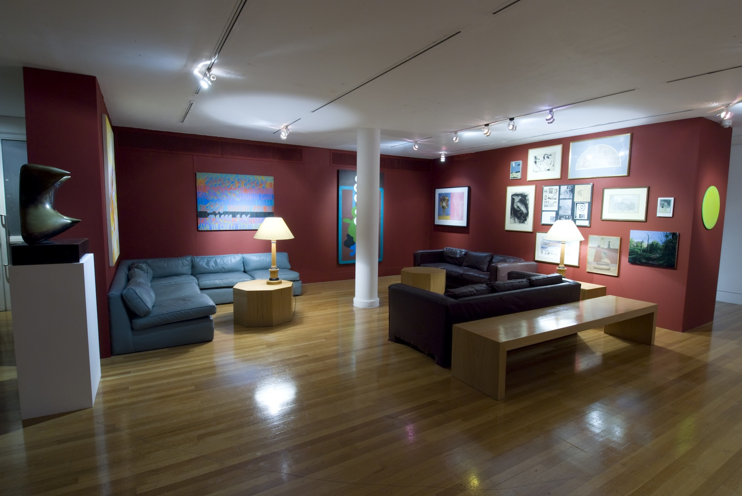
Recreation of the SCR in the RCA Galleries by Marysia Lewandowska, 2011

Most recently the Painting Collection was used by artist Marysia Lewandowska in 2011 when she was invited by the RCA Curating Contemporary Art students to produce an intervention in their final year show. As part of this she recreated the SCR in the lower galleries of the Darwin Building. She borrowed furniture from the SCR and invited staff to choose their favourite work from the Collection, which she then hung, salon style. These were exhibited alongside slides from the archive showing Charter Day in 1967 when the RCA was granted university status. Her take on the SCR was ironic, making the normally private area public for the duration of the exhibition and allowing the general public to see works that may never have been exhibited before. As the text in the catalogue produced by the students explains:

Marysia Lewandowska’s project reflects on the Royal College of Art, its past and its present. The project focuses on moments of resistance against the politics of the institution, when students have questioned the hierarchical structures of education. The project brings to light the controversial Environmental Media Department, which existed between 1968 and 1986 for students seeking a ‘redefinition of conventional fine art boundaries’; a lineage of student protests; and an installation that usurps the Senior Common Room, a members-only space in the College, including selected work from the RCA art collection.

In this way she highlighted the problem of housing what appears to be a private collection within a public institution, a difficulty shared with other academic institutions such as University College London, which also has few display areas and has to exhibit many major works in their SCR, with similarly limited access.

The RCA has been able to provide greater public access to its Painting Collection through an AHRC funded digitisation project and images are available, not through its own website, but via the Visual Arts Data Service (www.vads.ac.uk). It will also be making its paintings visible through a digitisation project funded by the Public Catalogue Foundation in collaboration with the BBC which is trying to catalogue every painting in public collections in the UK. However, digital images are never a substitute for viewing the real thing.

There is a problem inherent in all collecting in art and design educational institutions in that, although the collections that have built up are perceived to be important to the institution, dwindling funding has to be spent primarily on the education of the students. Because the collections are not seen as a vital teaching resource they are not given priority. They are seldom used as promotional tools to attract potential students. Where the interest lies is in their use as an historical record, and this is often of more interest to researchers outside the institution than those within.

As Darwin said, the College is about the future, not the past. But it would not be the institution it is today without its past and it makes sense for the record of its past to be housed within the institution. There have been various discussions during the time I have looked after the Collection relating to its use and future growth. When a think-tank was put together in the late 1990s to discuss the method of collection it came to the conclusion that the Painting Department should not select but should continue to ask graduates to donate one piece of work each annually, The members, who included both staff and outside experts, felt that any selection would mean possibly missing the work of the artist who might go on to become prominent in the art world. Paul Huxley said he would not have chosen a work by Tracey Emin, who after graduation became one of the UK’s leading artists representing Britain at the Venice Biennale in 2009, if he had been asked to make a selection, as he did not at the time consider her to be a strong student. The reason that there is a painting by her is due to the fact that each student was asked to leave a work and she complied. In the event Emin did not leave the work that had been chosen by her tutors and substituted another one, so ultimately her choice was by self-selection.

More recently it was agreed that the Collection could not continue to grow by up to twenty works per year as its size was becoming unsustainable and there is an inherent danger, when an institution feels it has to keep everything, of the collections and archives becoming chaotic and untenable. Some policy for collecting had to be found. In 2009 funding was raised, for the first time, to buy works from the end of year show rather than relying on donations from students. A panel, consisting of the sponsors, members of staff from the RCA and an external expert, now purchase five or six works from the Painting show that they think are representative of the ideas and concerns of the students at that point in their development. The objective is to retain works that give a snapshot of the concerns of students in the Painting Department in a particular year. It is possible that some of those chosen will go on to become high profile artists. However, not all of them will and this has always been the case. A minority of the works in the Collection are by artists who have become successful. The majority were executed by committed students, many of whom have continued to practice as artists, but who are making their livings in different ways. Nevertheless, their work helps to define the practise of painting at the RCA over a sustained period of time and builds up the history and identity of the institution that sees itself as the “the world’s most influential school of art and design” to quote from its own website.
Compared to some of the great fine art collections that can be visited in London alone, the RCA Collection appears idiosyncratic. It has grown through accumulation rather than by design. It is hidden away and relatively unavailable. It contains immature paintings by graduates who have yet to fully develop their practise. At least 35 of the works are unattributed. Although attempts have been made to identify the artists this has so far been unsuccessful. During the digitisation project carried out in 2002 it had been anticipated that these works would be de-accessioned. However, the conservators working on the project were fascinated by the method employed in the paintings and the use of paint and colour. They insisted that these works were important as examples of painting style and technique, if nothing else. It was subsequently agreed that the works would not be de-accessioned and that further efforts would be made to identify them once they had been made available publicly in digital form.

Despite its inconsistency, for the RCA the Collection is an important asset both financially and symbolically. My research is not concerned with the financial value of the Collection, which is used as an asset by the College for accounting purposes. Its greater value is in the way it provides a pictorial history of the RCA and in the art historical information it reveals for the second half of the twentieth century. Art historians and writers such as Lynda Morris, Martin Harrison and Marco Livingstone to name a few, have delved into it when writing about artists that attended the Painting School. Many of the works have been displayed in major art galleries around the world, particularly the paintings by David Hockney, even though they are rarely shown in the College.

The Collection does require annual funding of about £40,000, mainly in storage and insurance costs. It could be argued that this money would be better spent on the education of the students. However, all the people I interviewed thought the Collection had enough merit to justify the expense. Christopher Frayling (2009), when asked if he thought the Collection was important, said, “Definitely – it is a very important part of the College. Anyone who visits gets that immediately.” Others had ideas about how it should be used. Stephen Farthing (2009) thought it should become a teaching collection with students being encouraged to look at the works. Beryl Lewis’s (2010) comments were:

I think it should be kept. It is a real, tangible presence. It is there as a reminder of the merits of students’ work. It is a history of art movements, a record of the achievement of the College. It gives it status. It should be kept but not necessarily by the RCA.

She suggested that a major institution such as the Tate might be better able to look after it, a route that was taken by the GSM&J Department at the RCA when it sold its visiting artists’ collection to the V&A Museum. The Head of Department, Professor David Watkins (2008), pointed out that in accessioning the collection to the museum it enabled far more people to see it. He suggested this was, “another brick in the wall for the College. How many other colleges in the world have stuff in a leading museum.” Another advantage is that the pieces are now properly looked after and conserved to museum standard. However, this collection was made up of world-class pieces, executed by established artists (not necessarily RCA alumni), and was therefore of considerable value to the museum. The RCA Collection of Paintings only contains a minority of works that might be of interest to a major museum such as the Tate.

The views that have been expressed above are by people who have an association with the RCA and may be biased in its favour. From among the people interviewed who are not associated with the RCA Emma Chambers (2009) at UCL makes a strong argument for retaining a fine art collection within an institution, when talking of the Slade collection:

There are two ways of looking at it – there’s the decorative aspect, which as a curator is less important to me but quite important to people who meet at the College and use the rooms, and there is the archival aspect. To a very great extent we are archiving the Slade’s history so it has a really, really important function as an archive. You would remove the whole history of one of the major departments of UCL if you didn’t have the collection. So this is a bit of history.

The rich history provided by the works in the Collection is not widely seen or known about. Even within the RCA some members of staff and most students are unaware of its existence. When members of staff do ask for a painting to hang on the walls of their offices they are sometimes disappointed, as the works in the Collection are not of a standard they expected. Of course, they were never intended for office walls. They are experiments in fine art, a reflection of students finding their way and extending their practice. This is where it differs from a collection where work has been carefully selected from mature artists.

Susan Pearce (1995: 159) says, “… a collection is a group of objects, brought together with intention and sharing a common identity of some kind, which is regarded by its owner as, in some sense, special or set apart”. She suggests that collectors have control over their collections – they make choices about what to collect and what to discard. This is not the case with the RCA. The only common identifier is the fact that the contents of the Collection are all fine art based. Apart from this there has been little quality control and often no selection. At different times status was associated with having a work in the RCA Collection. At others making a donation was seen as a burden and not something that was career enhancing. Sometimes work was accessioned that was never intended to go into the Collection. Occasionally this has been beneficial, such as the five Chris Ofili paintings that he left in his studio on graduation. They are not representative of his current practice but do provide an interesting insight into his work whilst at the RCA. Donations have often been received without question whether relevant or not. All of this has led to very uneven collecting, something that is now being addressed through the new annual purchase scheme.
Whether the Collection adds status and prestige to the institution is hard to quantify. Most evidence is anecdotal through verbal comments by visitors to the College (which are not recorded). The Suggestions Book in the SCR records more observations about the food than the Collection. However, through the fact that it contains some high profile paintings such as the Lucian Freud Portrait of John Minton and works by the cohort of British Pop artists, the Collection does afford a certain amount of prestige to the institution, which was Robin Darwin’s original intention. The status it offers has decreased as the growth of collecting generally has made more prestigious and substantial collections accessible to the public, and accessibility to the RCA Collection remains very limited. The educational model of the RCA is still design oriented and the track record of the Painting Department is not as strong as it was. The SCR is now hung with works borrowed from other departments as well as from the Collection. Fewer historical works are hung, which means the history of the RCA is not reflected in the way it used to be and the SCR is now more representative of the general work of the College. But this is not to diminish what the Collection says about Painting at the RCA. Although its role as a teaching collection is non-existent and it is no longer used to reflect the prestige of the College, the overwhelming purpose of the Collection is as an historical document or archive. As Professor of Painting, David Rayson (2010), says, “It is about longevity and about continuing a historical archive. It is an archive and culturally it is an important thing to do”.

This research reveals that the Painting Collection of the RCA is a major asset that not only embellishes the interior of the College buildings but which, more importantly, articulates the post-War history of painting at one of the most interesting and eminent art schools in the world and adds to the art historical knowledge about this period. As Christopher Frayling (1998) says of the Collection (referencing Tracey Emin’s famous tent):

If the names of all the artists represented in the Collection were to be embroidered into a tent, the tent would cover a history – not the history, but a history – of one of the greatest art schools in the world, of the longest-lasting experiment in art and design education ever to have happened, and of some of the key moments in the development of twentieth century British art. The moments don’t always seem key at the time – but they do in retrospect.

The Collection is a confusing, ambivalent, cultural text that records the successes and failures of the Painting Department at the RCA. Its strength lies in its diversity through which is revealed the multi-faceted nature of a great cultural institution. It is a record of the ways in which Painting at the RCA has reinvented itself over a fifty-year period and reinforces the constantly changing nature of painting in the 20th century. This research is the first time a spotlight has been focussed specifically on the Collection and highlights its strength and weaknesses, its richness and deficiencies with a view to bringing its significance to the attention of the RCA. It is hoped that the research will help reinforce its importance to the institution and that the College will be able to sustain the tradition of recording the history of Painting through works from the Collection and find ways of making it a substantial asset for the future.

APPENDIX 1

Recommendations for the future of the
RCA Painting Collection

My research has concluded that the Collection is a significant and valuable source of information about the history of Painting at the RCA that is worth preserving. However, it is large and unwieldy (c. 1,400 works) and only a fraction is ever seen, as the majority of work is in storage. The RCA would benefit from making the Collection more cohesive. This could be achieved with some re-organisation and de-accessioning.

One way to reduce numbers would be to retain only one work by each graduate. In certain cases there are two or more by the same student. Unwanted works could be offered back to the artists concerned. Works that cannot be identified, of which there are about 40 with no title, date or attribution, could be de-accessioned. One way to do this could be to offer the canvas and stretchers to current Painting students for recycling (an unsanctioned system that was adopted in the 1960s and 1970s when the Painting students helped themselves to works, for re-use, from an unlocked storage area in their studios. There are examples of paintings in the Collection with a work by a completely different artist on the back).

Works that have no relevance to the Collection could also be de-accessioned and offered to a more appropriate institution, for example, the brushes used by Millais and a palette belonging to Holman Hunt would probably be more appropriate in the Tate or another museum collection.

A precedent was set for raising money through sale of work from the Collection when the RCA sold a painting by Francis Bacon in 2007. It was argued at the time that because Bacon had neither attended the RCA as a student nor been attached to it as a member of staff the work was not an essential part of the Collection. Bacon had given the work to the College in lieu of rent for a studio he had used in the Painting School when his studio had been damaged. Although nothing in writing could be found, there was anecdotal evidence that he had agreed his painting could be sold if the money went towards helping students. In the event the sale of his painting raised £7,500,000, which has been put towards the construction of new buildings, including Painting studios.

There are other works in the Collection that, similarly, do not fit the (un-ratified) policy of collecting works executed by students or staff. Examples are drawings by Walter Sickert, L.S. Lowry and Stanley Spencer, paintings by William Etty and William Scott and prints by Piranesi and Giuseppe Vasi. Substantial funding could be raised by auctioning these pieces. Before considering anything of this sort it would be important to have a ratified Collections Policy in place that could be referred to when defending the sale of works that do not adhere to it.

A more problematic undertaking would be de-accessioning some of the works that are considered to be of inferior quality. Making judgements of this kind are difficult and the task would have to be undertaken with the advice of outside experts. Works would have to be offered back to the artists (as outlined in the College Handbook – Section 6– Rights in Students’ Work (6.7 & 6.8)) explaining that the College was trying to consolidate its Collection to make it more manageable. When discussing the issue with Professor of Painting, David Rayson, he thought the time was right to consider de-accessioning. He suggested convening a panel, setting an agenda for keeping or rejecting works and then being quite ruthless. He suggested only keeping things that were seminal in their time. De-accessioning is often controversial, although as the RCA does not have museum accreditation it does not have to adhere to any official guidelines as laid down by the Arts Council. Consideration would have to be given to the fact that digital images of all works have been made public through external websites and decisions made on the best way to deal with the removal of images of de-accessioned works.

Undertaking these tasks would make the Collection more cohesive and concise. It is possible that the RCA could then find room to house it on College premises rather than in a commercial storage facility. Although it would be expensive initially to install a purpose built store, it would ultimately save money on external storage costs and facilitate greater access to the Collection.

Finding a way to consolidate all the collections held by the RCA, as they have done at Central Saint Martins (see website at http://www.csm.arts.ac.uk/museum/ ), would turn them into a more effective and accessible resource.

APPENDIX 2

INDEX OF INTERVIEWS

ALLEN, PETER 151
ALLEN, SUSIE 163
BACKEMEYER, SYLVIA 174
BONHAM-CARTER, ELIZA 186
BRISLEY, STUART 194
CHAMBERS, EMMA 208
FARTHING, STEPHEN 217
FRANCIA, PETER DE 226
FRAYLING, CHRISTOPHER 231
HUXLEY, PAUL 246
JACKSON, VANESSA 257
LEWIS, BERYL 267
MANCHESTER METROPOLITAN UNIVERSITY 276
ORR, CHRIS 283
RAYSON, DAVID 291
WATKINS, DAVID 300
FRAYLING, CHRISTOPHER (DISCUSSION NOTES) 305

Interview with Peter Allen, Senior Technician, Painting Department, Recorded at RCA, 22 April 2009

JT Perhaps you could start with a bit of history about yourself.

PA I started on October 15th 1979. Lovely autumnal day. I was a studio assistant at £17 per week. Peter de Francia was professor. His senior tutor was John Barnicoat and the senior technician was the very eminent James Trimble – he was a marvellous man. There was the usual bunch of tutors and it was a three year course then in the original RCA opposite the Science Museum in Exhibition Road with the wonderful studios. Everything was decrepit and no money had been spent but the studios were pretty good. Peter de Francia started about 1972/73 and he took over from Carel Weight. Roger de Grey wanted the job but didn’t get it because he wouldn’t fill a form out. But Peter had no qualms. Peter was not in Painting when he applied. I think he was in Cultural History.

JT I got a book out of the library that said he had done a stint in General Studies.

PA It is not surprising because he was an intellectual and an academic apart from being a painter. So it fits. He retired in 1986 the same year that John Golding retired. The students had a wonderful party for both of them. Neither of them wanted to be celebrated in that way but the likes of Dilwyn Smith, who was very charming and sweet, made it irresistible, so they were there. They had a great send off.

JT You had a little while under Peter.

PA I had just over 6 years. Very exciting – dangerous and exciting – you never knew which way he would jump. Steve Smith, who was a student then, said the thing he remembered about Peter was that, if you saw him, you got out of the way. If you saw him in the studio you got out as fast as you could and waited until he had gone – you never knew which way he was going to jump. But all his faults were outweighed, not everyone would say this – he was difficult with some women and got on the wrong side of some students – but on the whole the gain was much greater than his faults.

JT Paul Huxley told me that when Peter started he cleared out what had been the painting tutors common room and turned it into a studio and told them to get on with their work.

PT Yes, he did. He actually founded what is the current system in Painting and it has run ever since then.

JT Before that it sounded like it was a gentleman’s club.

PT It was. Apparently, in one of the pantomimes they actually had a sketch just based on them – the tutor comes in and he has an appointment to see a student at 10.30 – he has a quick chat about the work and then says, “I’m terribly sorry but I have got to go now”, and off he goes to the SCR in Cromwell Road and says, “I’ll be back after lunch”. They had a big clock on the stage and turned the clock round to 4.30 and he comes lumbering back absolutely plastered and says, “very good, very good – you’re doing really well – I’ll see you next week”. But Peter – obviously a lot of people didn’t like him and some of the tutors like Colin Hayes, who is a man I admired, went over to Photography. People either left or they tried it out for a year or two and then left. Peter Blake didn’t like him and left. He got in younger people Alan Miller and other – a mixed bag. He also had Keith Critchlow, a brilliant man, who went on to found VITA and is now part of the Prince of Wales Institute. He was a brilliant lecturer and he was the only person to give a lecture that Peter would introduce. Peter would stay to the end, he wouldn’t fidget, he wouldn’t get out his pipe and try to light it or clean it, and he would stay for the questions, which was pretty rare. So he had some interesting people. And they actually had one or two visiting artists like Roberto Matta. Peter wrote one of the standard books on Léger. I think he must have known Léger and he knew people – he knew Philip Guston. He went over to the show in New York and when he came back he gave a lecture. Peter, for all his awkwardness and European intellectualism and his sort of ideological stance was actually very progressive. He wasn’t always happy with the USA, being a left wing intellectual, because Philip Rawson knew him as a student and he said when Peter was a young man he got married and lived in a cottage with roses round the door and was very much the English intellectual. This came on more recently.

JT He was brought up in Europe?

PA He was of Italian and French as well as English origin. He was fluent in French and Italian. There was a big row down there with the Italian tea lady. She was passionate about food and someone got on the wrong side of her. She was really irate and went to see Peter about it. I saw her afterwards and asked her how it had gone. She said, “he is wonderful and speaks the most perfect Umbrian Italian – the sort that is the finest”. He was a pretty rare beast and elephantine sense of humour but at least he had one. Didn’t suffer fools. Got very impatient with tutors who waffled and there were one or two.

JT He obviously kept an eye on the teaching staff.

PA Yes, each student had one major group tutorial a year which was quite frightening for them. The student would be there with the Professor and an ark of tutors. They had it in the Professor’s room, which was the room where Rodrigo Moynihan painted that picture in 1951 of the staff. Peter would be there like a doge in the middle with all the tutors around. People used to put their work on the old studio easels. If you are a Marxist intellectual you are supposed to be very rational, but actually he was full of likes and dislikes and immediate reactions, which made it all the more interesting. It meant there were some students for whom it just didn’t work and they felt very much as though they had been crushed by a bear.

JT So Steve avoided them?

PA He was canny. He was a bit older. He had been at Camberwell and worked in a hospital for a few years and then came here, so he knew how to operate.

JT Who was Rector when you arrived?

PA When I arrived it was Dick Guyatt. He tried to get rid of Peter. He didn’t approve of Peter not having traditional things such as life drawing classes.

JT Peter had absolutely no time for Richard Guyatt.

PA I didn’t really know Guyatt, but I know the type. He was a mandarin – rather polite, gentle folk but he didn’t have the touch with students. I remember when we were putting the degree show up he went by and started chatting to one of the students, which I thought was really nice, but you could tell there was this feeling of, it was like the ancient regime speaking to someone who was fresh. There was no connection – it was sad really.

JT But he didn’t get rid of Peter?

PA No. He tried bloody hard. He tried to buy him out – I think they offered him quite a lot of money. That was about the worst thing you could do with him. I think it was a really horrible experience for him – really nasty. The thing about Peter was that he called all the staff, including James and I and the School secretary, to explain what was going on all the time – very democratic. And occasionally there would be meetings with the students so they would know what was going on. So Richard would come down and the things that really mattered he wouldn’t answer. He would say, “that is reserved College business, I can’t discuss it with you”. Of course, that made the students incredibly angry. Eventually Peter had this letter where he was offered something like £40K and a few other conditions. Peter read this out to all the staff – then he put it on his knee and said, “there is only one problem – I am not going”. And we all cheered. From then on the tide turned. He didn’t go and Dick Guyatt left about a year later.

JT Was it Jocelyn after that?

PA No, it was Lionel March, who was a disaster. They found there was some skulduggery going on – he had another job going on in America or something and he hadn’t told anyone. The whole thing was a shambles. In desperation they got Jocelyn Stevens. For all his faults, he did at least put the place on some sort of financial footing, which is what he was meant to have done. Peter overlapped a year or two with Jocelyn. I remember someone saying at a Senate meeting when they announced Jocelyn’s appointment that Peter made some rather damning comment about him, just an aside, something like, “at least the Medici’s sponsored great artists”. He knew with Jocelyn around things were not going to be good. But it didn’t matter as he was by then 65 and would be retiring. Paul took over. We were down the road until 1990. Then, because the new Stevens building wasn’t ready, we had a year in Waterloo at a school there. Then we came up here in 1991.

JT Peter de Francis only mentioned Joanna Drew in connection with the care of the Collection and implied she had something to do with looking after it or the loans, although this may have been in his imagination.

PA I didn’t realise she had anything to do with it. You may be right. In those days it was James Trimble, who spent one day per month dedicated to it. Some was stored in the old Mural Room on racks and some of it, the smaller items, were in no.25, the corner building we used to call the Yugoslav embassy. It was in the attic. I used to go up with him and he would put on all those Z numbers.

JT Paul implied to me that the letters were to do with the location.

PA No, I think it was to do with listing and size, though I may be wrong. James was a very methodical man. He continued to look after it till he left the College in 1987, the year after Peter. Then Susie moved in. All I did was actually collect them and move them. Susie looked after them – I am not sure how systematic she was.

JT Then she looked after loans etc. And she and Paul did Exhibition Road in 1988/89. This was the only time the Collection has been heavily drawn on.

PA Yes, you are right. The only picture they didn’t show was that 1951 Rodrigo Moynihan of the staff, which isn’t in the Collection, which is a hell of a shame. They were going to hang it on that double height wall. When the picture came over from the V&A with Derek Pullen, their conservator, he said “what do you think”. I said, “It is lovely to see it, the only trouble is that it is going to be hung very high, and the other is that there is a skylight above it and I hope it is watertight”. He then said, “That’s it, we won’t even risk it”. It saved me a tricky hang.

JT That painting was used in that other exhibition, Design of the Times here at the College in 1995/96. It was mostly about design but they did borrow that painting from the Tate.

PA Well everyone in that picture is dead now. I think Colin Hayes was the last about 4 or 5 years ago.

JT It is interesting to note that under the very conservative regime in Painting they produced a very un-conservative lot of students. They were obviously kicking against the regime. Under de Francia it was a very different School. It became completely different and remained predominantly figurative. He did bother to collect, there is quite a lot from that era, but nobody you could put your finger on to say this person sticks out.

PA There were de Francia types. Jim Mooney would be an example and there were one or two others, not exactly like Peter but with similar ideas, Beckmann like. Very interesting in the symbolic, the symbolism that was telling you something about ideology.

JT The previous era didn’t have that sort of effect on their students so their students could do what they wanted with their ideas. Was the next era much more prescribed and taught?

PA There were regular lectures in the Painting School by really good lecturers. When the Edward Hopper show came in the early 80s everyone woke up to Hopper. It might have been at the Hayward or the Tate. The women who curated it came over from New York and gave a wonderful lecture. So we did have really interesting people in the Painting School. Howard Hodgkin would come in and generally got up their noses.

JT Peter did get a good variety of artists in.

PA He was a civilised man. He wasn’t forcing everyone down a narrow path.

JT They obviously felt there was nothing to rebel against or something?

PA I think it was the times. When you look at the late ‘70s, no-one bought things at degree shows, the economy was dead, we had the winter of discontent. For all those reasons there was a sort of ethos more like being in Yugoslavia of state sponsorship of artists. The first year they had the degree show up here in 1986, the year Peter left and Paul was tutor at the time, with us and in Printmaking. That was the first year when suddenly people were buying and everything seemed to take off. People had been buying before that but it was dramatically more.

JT Was that a sign of the times do you think?

PA Well – there was Maggie Thatcher who liberalised the economy, government went back to Whitehall after NUM headquarters. It put more confidence into the capitalist market and this made a huge difference.

JT So Paul inherited this?

PA Yes, very much so, in a very big way because the moment he got the job, Susie came in with him. She took Peter’s old office, which was smaller than his, and Paul moved into one of the studios opposite and turned that into his office. So Susie was on the spot for what I call sales and promotion – you know what I mean. I did see this happen and I had very mixed feelings about it.

JT Was that part of her role?

PA It was entirely voluntary. She wasn’t appointed, she just came in to promote fine art, students, everything, especially painting. I was a little bit shocked at the brazenness of it actually. Probably, on balance, it was a good thing, it was part of the times. Students sold more stuff, showed more stuff. Things like the TI Group, a huge engineering conglomerate got involved. The wife of the chairman, both of them I think, were passionate and they used to buy all this stuff and it would be hanging in their head office, workers canteen, offices. Of course, this has now gone. They have sold it.

JT Yes, it’s a shame because they had a wonderful collection, but they were able to pick, they came in and bought what they wanted.

PA And they sponsored the show. There had to be a little bit of TI in the show but it was a small price to pay and they were marvellous about the whole thing. Once that company had been gobbled up by a bigger company that was the end of it.

JT This is the problem with corporate collections. Which is why our collection is important because it is shielded by the institution.

PA And it has continuity.

JT When James went, did you take over his role?

PA No, Susie took this and I just helped in small ways. The other point is, when James did it we had two workshops and he did the more interesting work, he would do everything to do with framing and presentation and demonstration lectures, everything like that. If the system had stayed like that I would have done the same and someone would have come in to do the donkey-work in the lower workshop. But they didn’t replace James and I got the lot. It was unbelievable tough. I knew it would be tough. When I came in at the beginning of term Paul just said, “You are on your own”. After two or three terms they realised it was tough and got someone in to help. But we didn’t go back to two full-time. If we had I would have done the unglamorous donkey work on the Collection. This is what it has been missing and stopped when James went. James was marvellous. He had a wonderful workshop looking into the courtyard at the V&A. He had time and it was a three-year course. He would get pictures in and clean them and, if the frames were falling apart or it needed a new stretcher, he would do that. But now there is never the time. Now it is all high pressure, a two-year course full of events. I don’t give any talks or demonstrations now. I don’t like to think there is no experience being passed on but it is done individually and informally, which is great fun and very rewarding.

I seem to remember that when, in the 1980s, the Collection all went into self-storage near Battersea, and then in fact they had quite a big area. I think Tony Jones was Rector. He was very interested in the Collection, which was nice. I had to plan a big racking system for it.

JT Susie and Paul had that storage put in Lecture Theatre 2 and this was very good for a while.

PA That outside wall was always a problem. The one name at the time was Térèse Oulton. She sold everything. She was mega before she left. But she hung on that wall where they eventually built the store. We put the degree show up at Easter that year and torrential rain came straight down inside the wall. She had very thick stretchers with big spacers and there was about a gallon of water in there. So we turned them over and tipped it all out. There was masses of water. Of course, then it dried out the stretchers warped. The College paid her £30 compensation, which was outrageous.

JT Would this have been under Jocelyn?

PA I think it was probably just before – could have been Lionel March.

JT Peter de Francia talked about Lord Esher. I think he liked Esher but said he was completely ineffectual.

PA He was. I think it was Esher who let the renewal of the lease for Exhibition Road go under his nose.

JT De Francia blamed that on Jocelyn.

PA No, it was Esher – it was before. Of course, subsequently he didn’t do anything about it, which was a terrible shame.

JT You have been involved in the selection of works from time to time.

PA Informally. You have to say that as a technician but at the Royal College that goodness you can have that element of informality. Only if, for instance, the student leaves a work and you know it isn’t one of their best, not even representative, they just want to get rid of it, so you have a chat about that and allude to it and start telling a story about how someone else left a work and it is now in the SCR and people comment on it, you exaggerate a bit and say it is pointless leaving lousy work. So I suppose in that respect.

JT Paul was quite dedicated to it, but Graham had no interest.

PA Graham was in and out. Paul definitely. He was good in his way. He had an even attitude about things in the Painting School and he was sympathetic to the whole idea. And he had Susie, which made a huge difference.

JT I feel there hasn’t been so much control over it since then.

PA David is very interested and he is sympathetic. He is actually sympathetic to the artefact heritage. Things like easels. You know the one we use for Misha Black and we have two plaster casts in the workshop. They are only tiny things, plus College Collection stuff which is predominantly painting. He is very sympathetic – when they were planning the new building he wanted to know what the old Painting School was like and we went over to the RA and he was very interested in the general ethos of previous eras in a way that none of the previous professors have been. None of them have been very interested because life is moving on. But for David being much younger – the heritage is more recent, within living member, and there are still one or two people around, such as myself who remember things. He had tutors such as Alan Miller and Michael Heindorff when he was a student so he had heard about people like Peter de Francia. So it has made him sympathetic to the past, which I like. I think it is conducive to the future.

JT It all seems to be going well in Painting.

PA Yes, the students seem really pleased. At the validation they went round and the students said it was great. David is great fun. He is charming and nice.

JT Do you think it makes any difference to the students having a Collection? Are any of them interested or do they leave works through a sense of duty?

PA I think it is a sense of duty but I think they like it actually. Not all of them. I think they see it as part of what makes the College the College, part of the ethos of it so I think they are sympathetic. Once in a blue moon they get a trip to the SCR.

JT That doesn’t happen very often.

PA No, it doesn’t, which is a shame. I am always telling them to get onto their tutors to arrange for them to go up there and have a walk around. But it doesn’t seem to happen much. As you know, there are recent paintings up there and I always explain this to them, so I think they are sympathetic.

JT Because they can say, “I have a painting in the RCA Collection”. But it probably wouldn’t make any difference to the functioning of the Painting Department if we didn’t have the Collection.

PA No, but on the other hand it is one of those things – what makes a difference and what doesn’t. Does it make a difference if we don’t have the rest of the College next door? I know what I think about it. But we will probably find that it functions just as well when we separate.

JT I feel that the College would be a different place without the Collection.

PA Oh, it would be awful. It would be colourless.

JT You wonder what would happen – I went into the old Manchester Art School and, admittedly it was holiday time, but there was nothing on the walls.

PA I think that is shocking. It is vital. It is really nice when you go to the V&A and see the walls that have been painted by eminent painters. And the RA has stuff around done by people who have been RA’s. I hate to think of the place being devoid of its history. It makes the place bleak. It is like going into a house that is empty. You know there were generations of families living there, but there is no feel of it.

JT I am trying to build a case for the Collection being very much part of the College’s heritage.

PA I think it is self evident, but it is no good saying that to someone you are trying to convince. You have got to actually come up with the evidence.

JT Yes, on the one hand it is costing £35K a year.

PA But that is a tiny amount for a big collection.

JT That is because we don’t do anything with it.

PA It is just keeping it ticking over really. But even on that basis it is hugely worth having. No question.

JT Do you think it is an asset?

PA I think 300% - no question. I think it is really hugely important. Thinking about this thing of influence – one of our students has done a very nice little representational painting where there is no interest in texture or anything like that, not like an Impressionist, just what it is. It is actually of Howie Street and the building is the house that will be knocked down for the next phase. There is a picture of the house with a car and you can just see a foot, like someone nipping over the parapet of the wall. As it is topographical I mentioned it to David because I thought it would be nice to have it for the Collection. Also, of course, the illustration painting of the tropical house and the Ardizzone of the SCR. I think these are fantastically valuable to the College and should have a wider audience. People really love the tropical house picture. I am absolutely thrilled, having rescued it from a corridor.

JT It does record something that was like that. I never saw it.

PA I used to go up there – it was just wonderful. It felt like an act of barbarism when they got rid of it, which was to do with costs. It was when Jocelyn came and he was looking at the cost of everything. As I understand it John Norris Wood, who was very much the man behind it, managed to get sponsorship, quite a lot of money and that was to save it. Then the sponsors found out that the College was spending 17 million on the new building. They wondered why they were having to hand out money when we had money like that to spend and they pulled out. But that may not be a true story. Now it is the Drawing Studio, which is marvellous. There is no question that it was a phenomenon. You either went to Kew or you went up there. It was staggering that the College could have it. There were a lot of things I didn’t like about the 1960s but there was this rather exotic feel to a lot of it having kicked the austerity of the ‘50s, which was part of it.

JT Here we have the high of the ‘60s and the rather lower ‘70s and then it came up again and in Paul’s time things picked up. You had people like Tracey and Chris Ofili and the Chapmans. Suddenly there were people who were great self-promoters.

PA The strange thing is that most of those people ideologically would have been left of centre. They were not Peter de Francia’s students but he would have been sympathetic to their views, although he would not have condoned that sort of self-promotion and all the rest of it.

JT Paul, with Susie’s back-up, she was a great promoter of these people.

PA Very much. She would promote them as part of the show and the actual course and when it came to degree shows I think she was very good at getting outside people with money to sponsor them, which was great.

JT My last question is, what do you think is the Collection’s value to the institution?

PA Just look around at the offices and other areas in the College and the fact that when people move, or jobs change, they can chose pictures and they love doing it and it is rewarding. You have it on your wall and it feeds you every day. When we moved into the Stevens Building the workshop was blank, just a box, and I was able to do what I wanted with it. It is much better working in a space that suits you. And for me, probably 75% of that was aesthetic. I wanted it to feel right and look right. It is an art school – we should be thinking that way.

An insight into Peter’s mental attitude and his humour – I was down in Exhibition Road, hovering on a staircase and you could either go up to the top floor or down onto the street. Peter comes padding up to me and said, “Peter, good morning, how are you?” I said, “I’m fine thank you”. He said, “Are you going up or are you going down. I am not talking metaphysically”. It did make life great fun, even though it was dangerous at times. Some of the other stories are much more tricky than that. He walked out of one of those big tutorials because the student in question used a chess analogy. He said, “Well, you have got to think, when I do my work I think of it as a chess game”. Peter said, “Do you play chess?” He said, “I don’t actually”. And that was death. He said, “Get out – what’s the point”. The thing is that once you have established that sort of attitude you really think about what you are going to say. You are not relying on mutual understanding of things unsaid.

JT One of the things I read about him in that 1986 booklet was that he did get people to articulate about their work and to think about it. There is no point in painting and not being able to talk about it.

PA If it was a student like that he would be checking on whether there was an extra meaning in the fact that they were depicting, for example, someone breaking through the clouds. He would be testing all the time to see how much you had thought about it and were you aware, i.e. if you are going to use different imagery do you realise what all its meaning really are. He would be testing all the time – sharp – and because his own work was like that. Everything had an intellectual base.

JT Did that go after him?

PA It went straight out of the window immediately. It disappeared. A lot of people would say that Peter was a bully and all sorts of things like that, because he could be and that’s fair enough. Sometimes the fearful aspect of him was difficult to work with. I actually liked that rigorous attitude and in the end it was much more rewarding.

JT On any MA you need to have that sort of rigour. People are here to learn something new.

PA We had one or two tutors, like Mario Dubsky, who used to challenge the students and fight it out with them in a tough way, which I admired him for. He was brilliant at wrenching them around and stopping them from being accepting.

Interview with Susie Allen, Freelance curator
Former curator of RCA Collection
Recorded at her offices, 27 March 2009

JT How did you get involved in the RCA Painting Collection?

SA When Paul took over as Professor the Painting School had just been told that it had to move out of the building at Exhibition Road which was a real blow, especially as we heard afterwards that that was not necessarily the case. This was under Jocelyn. it was because they decided everything should be on one site. These were purpose built studios for the College. It was very sad but we also realised that there was quite a thrust away from fine art and the new building going up meant that fine art would shrink. We also realised there was an enormous history and the reputation of the College, an enormous chunk of it, was on the reputation of the fine art schools. Paul thought it would be a good idea, with the 150 anniversary of the College coming up, for the College to put on an exhibition of the history of the RCA Painting School. I had just finished doing a big exhibition for the Contemporary Art Society in Vienna, which was a British Art Show, which had been a huge success. I had curated that – this was partly a design show and partly a big painting exhibition and when Charles and Diana came out to visit it I was doing everything from curating the show to writing speeches for Prince Charles. I suppose I felt that doing the College painting show wasn’t going to be too much of a curating job but I didn’t realise how difficult it would be, especially with Jocelyn there. I think I was sacked at least six times during that show, including Jocelyn doing his famous karate chop on one of the dining tables in the SCR.

We started researching and we decided to make the exhibition very much about now and then. We decided to do it on the idea of a painting during the student’s time at the RCA and then a current painting. We looked at the last 100 years and started researching that. I still to this day think it was one of the most exciting shows I have ever curated. I was totally passionate about the College, having been a student there, and having taught there. Then Paul invited me back to do this exhibition. We wrote to museums all around the country and did a huge amount of research looking into various different books right back to all the Rothenstein books, going to libraries, and suddenly you realised how rich the College was and you were very aware of the artists in the 60s and some of the Kitchen Sink school, but it was artists prior to that and some of the stories that were coming out and anecdotes. We met all sorts of relations and the museums all round the country were delighted because a huge number of these paintings were in their basements. We put a list together of all the students that we wanted that we kept building on. The College hasn’t got a huge archive really so it was quite a lot of work trying to delve into the library etc. But it was fantastic because it pulled this history together. We had something like a year to do it in – not very long at all – it might have been a year and a half altogether. By the time we had done the research and had it approved by the College, found sponsorship, curating, catalogue, etc. It was basically myself and Paul. I took on a graphic design assistant and I took on people to help with registration of the works, but it was really a two and a half man band doing it.

JT Did you have someone helping with Research?

SA No – but we met some incredible people and found some incredible treasures along the way and saw all sorts of incredible places. There was one trip when my father wasn’t very well at the time and he lived in Scotland. So we were up in Scotland and suddenly realised that we had two weeks before term started and had an awful lot of research for the exhibition. We were ringing museums up and saying, “There is a work of yours on our list? Can we come down and see you”, so we were doing Leeds, Halifax, the Lake District on the way back from seeing my father. It was wonderful – places we had never even visited. And I have still only seen the museums and in their vaults. The curators and the museum directors were absolutely fabulous about the whole thing. We persuaded a lot of them to do restoration on work. Paul, because he had been a trustee at the Tate, had quite a lot of pull around the country. If it hadn’t been for his reputation there is no way I could have pulled together anything like that. The research on the whole period during the War was wonderful. We had a wonderful trip up to the Lake District which we did separately. Robert Wolf helped us enormously up there. We discovered all sorts of things because the College had been based up there during the War. There was a Schwitters show on then at the Tate and I kept bumping into Schwitters’ mistress, but I didn’t know it was her and I remember her standing in front of one of his collages and she was reciting a Dada poem – I was absolutely riveted, mesmerised by this woman. Then she told me who she was. A lot of the people at the College didn’t know that Schwitters was there. Absolutely extraordinary. To me that was a real tragedy. Then there were other things such as coming across some incredible War drawings that a widow had, and she was absolutely penniless and she was desperate to sell these. Now I would know exactly what to do, but in those days you were thinking, these are incredible, beautiful big watercolours, and there must have been 20 of them – complete museum gems. I think we did tell the Imperial War Museum. But we discovered amazing things like that – whole War period was fascinating because the RCA had so many War artists, not only that but there was the whole Ravilious /Bawden period that was fabulous at the College. I think they were actually in the Illustration Department but we actually adopted them into Painting. Certainly they had ended up being painters. But that time was so rich in finding out about all those artists. Evelyn Dunbar was another discovery. We had never heard of Evelyn Dunbar before. We suddenly discovered she did all these incredible land girls. I think there has since been a show of her work. They were amazing and she is totally still unknown. We kept thinking the whole time we were doing it – these are incredible exhibitions the College could foster at a later stage. So we started getting very excited about the whole history of the College and realising that this is something the College could build on. We actually put forward several ideas after we finished Exhibition Road about how the College should really be thinking about setting up a gallery as a gallery for past students’ work, and exhibitions to do with the college, its history and how they could tie into other departments. It was a total gem that was not being utilised that could make those galleries really important because the College galleries still aren’t a known destination. They are totally underused. They are fabulous galleries and not properly used. We put forward some proposals, at least twice.

JT What happened to those proposals?

SA Probably got them stored away somewhere. It was something that I really wanted to do. I said we could have a small gallery with changing exhibitions and I would really like to do it. I remember asking Chris (Frayling) what had happened. He said. “ you were only asking something like £6K for doing something like this so we totally dismissed it off the budget. We didn’t think it was worth doing”. I had spent months but it was because he didn’t want to do it. It was crazy because it was at a really good point where the College could have done that. It had had so much publicity from Exhibition Road.

JT It is about the only exhibition from the Collection that has been shown in the College galleries.

SA There had been exhibitions out of the College showing little bits and pieces of it but the College is still entrenched. When there is a big exhibition happening – they are talking about the Olympics now and every time the college is used. The other thing we discovered was the Great Exhibition of course, then the Festival of Britain. That was a huge landmark and the RCA was very involved in it - all the different departments. During other periods there were lots of mural paintings done by the students in the Mural Studio and there is no real record of this. And that was a most fantastic situation. People talk about wall drawings now. Murals are not a good word to use as it sounds like community work. But if you think about artists doing wall drawings now in the same way as artists in those days started off doing mural paintings and there are some amazing ones. Again we found some fantastic records and Rothenstein was particularly good at promoting all that. Just fabulous stuff in churches and town halls. There is so much research that needs doing into the history. At that time we didn’t have the chance as we had to stick to what we were doing as there was only Paul and I could do it and Paul was also running the Painting School.

Again, the other huge big thing we realised was there were lots of relations who had incredible archives which they had no idea what to do with. It is something I have tried to champion ever since, but I haven’t really had the time. But the older I get the more I realise how valuable it is. You could find yourself in a similar situation. At least with Paul and I, if one of us dies we know what the other one is doing, but if you have a household where no-one knows the value of anything in relation to what they have been left it is really tough, so we found ourselves trying to advise people and put them in touch with galleries and trying to help people. It was really awful when you realise how difficult this situation is and again that is something that we felt the College could have a huge part of and could basically end up getting quite a lot of endowments from. That is something that could be done. We battled for years to try and move this forward. I remember going to Eastbourne. You probably remember near the front of the Exhibition Road catalogue there is a lovely picture of Bridget Riley with all her rolls of paper and of course there is the wonderful portrait that Ravilious did of Bawden with similar rolls of paper. And they were fifty years apart, but a similar studio set up and those sort of things were lovely. We actually found the cartoon for the Ravilious painting in the Eastbourne gallery along with a huge archive. But there were things like that where you were suddenly discovering cartoons and photos in archives and letters but we didn’t really have enough room for. We tried to put a few cabinets together but we didn’t have enough time to research these fully. On the one hand the research was incredibly valid, but that was just the start of a much bigger research programme, of which there is a huge amount of material around. I don’t know how long it is going to be around as the people we were speaking to were very old then and heaven knows what has happened to them now. So it is really important to get those sort of things done about the College history. It is not just College history, it is about British history and I think the history of British art because so many of those artists are becoming so well known in their own right and collected and they are part of British history. Take Ravilious and Bawden. When we started Edward was still alive. I went on to do projects with him afterwards. So was Piper. It was fantastic to meet them and Bawden still had a twinkle in his eye, even at 80.

JT Peter Allen was saying I must talk to James Trimble, but we discovered that James died a year ago. There is whole layer of people who have gone.

SA There are total treasure troves there and you get very caught up in it. Having studied and taught at the College one feels emotionally attached, but I think it was all those personal stories and things you learnt during that period that I will never forget. It was really quite magical and emotional.

JT This was your start with your association with the Collection?

SA Did Paul tell you the story of the Auerbach?

JT Yes he did. Hanging on its side with a hole in it in Imperial College. He said he thought James Trimble had arranged those loans.

SA He had. I had quite long talks to him about it all because he had been looking after it. You probably still have the little filing boxes he put together. I started adding to those and he also had those boxes made up for the drawings. The big thing we realised was, although James had been looking after it, it was stored in all sorts of places. They were stored in the loft of the mural studio but of course students would go up there all the time and if they didn’t have any canvases they would paint over things. It wasn’t locked away at all. There were other paintings that we discovered in another store up in the main building somewhere, in a flat in Jay Mews there were more. There were 3 or 4 locations and we had to really hunt them down. Works had been loaned out and there were no proper records. As well as doing the exhibition I started trying to make a catalogue and trying to photograph as much as we could and locate them. Then we had to move out and I think during the time I was looking after it, it moved at least three or four times. We had to move it into Christie’s at one stage, which helped to get quite a lot of the basic photography done. Then Christie’s moved and we had to move the whole lot again. Jocelyn ended up being very supportive of Exhibition Road, Chris was the one who wasn’t supportive and I should actually show you the article he wrote. The article he wrote for it was absolutely awful – the introduction to the book. We totally rewrote it. I will show it to you. And that really sets the agenda.

JT Why, as a cultural historian, was he not supportive?

SA He was so adamant that he wanted the College to be a design college. This is so ridiculous when you think about the situation nowadays when there is so much fusion between design and art.

JT Which was the intention at the beginning so that they could feed off each other, particularly under Rothenstein.

SA It was just unbelievable. It was because of Chris’s attitude that the design school and the fine art school started becoming pitted against each other and it was completely crazy and totally unnecessary. It became highly politically charged. The brilliant thing was that Jocelyn actually agreed, because in those days the Gulbenkian Galleries had a balcony going round them with a stage at the bottom end and then there was a gallery that went round three quarters of the balcony. So when Sue and John Miller were there we told them we would have to build a mezzanine for the exhibition. We then sat down with the Millers and Jocelyn and Jocelyn said, “break the balcony down”. which gave him the excuse to rebuild the galleries. At that point the floor went in and the Millers redesigned the whole of that space and the College started using the Albert Hall for Convocation. So Exhibition Road had a huge legacy to it. All the museums were lending to us as they thought we were doing a proper exhibition programme so we had a backing of lots of the museums.

JT As far as the purpose of the Collection, do you think it is useful as an archive of student work - in a way it is not a collection in that is not consciously collected, it is more of an archive, and as an archive how useful do you think it is.

SA I think it is terribly useful. I don’t know what the current reasoning behind the collecting is but there has always been a joke about how works were collected. Certain staff would put Xs against the work and student would rub this out, so there is a lot of rubbish in the collection. On the other hand you never know when a piece of work will become incredibly important. I think from that point of view it is very useful. That is what Exhibition Road showed - the sort of work a lot of students were doing at the time and what they were currently doing. Bridget Riley was a very good example. She was very unsure whether she wanted to be in the exhibition. She didn’t like her time at the College, a bit like Tracey, she had a very bad experience. She much preferred it when she went on to Goldsmiths. It might have been because there weren’t many women around. But she was doing figurative drawings in those days and I think to her all she wants to be known for are her stripes or abstract works. She is such a strong and powerful woman that she found this quite difficult. But she relented and she even agreed for Snowdon to take her portrait. To have works that show what a student was doing, whatever period, it shows not just the history of what that student was doing but it is very much about the period in time. Looking through the archive you can see different periods of work coming out and what other influences there were and where people were coming from– such as the Chris Ofili’s – we were very lucky to get so many of his works – I remember his work going up in the little Hockney Gallery and he just covered the walls with those paintings. I went in very early one morning and I remember walking in and seeing them and you got goose pimples and you realised there and then that a star was born. You can’t say it but you just know it. That’s incredible excitement. In certain works you can you can see the threads of where things are coming from. If they are not there it is sometimes even more magical when you see someone’s work afterwards. Paul always says you can have a brilliant student but they may not be a brilliant artist afterwards. It is very hard to tell. Sometimes you can get some brilliant work. During the period that Auerbach was studying there was another work that we thought was an Auerbach, but it wasn’t. It was actually better than an Auerbach and I can’t remember the name of the artist – it is like an Auerbach but with much more colour – absolutely stunning. But the artist has disappeared completely. There are things like that – like the history of art anyway – sometimes artists are incredibly famous but the next generation has never heard of them. I remember when I was a student one of the huge stars was Richard Smith and what young artist has heard of Richard Smith now, but he is an incredibly good artist and his work is being collected now. I have had lots of people come to me and say I want to try to get some sixties work – but you couldn’t even store them at one stage. It was the same for Kossoff. When we were doing Exhibition Road Auerbach and Kossoff were two important people, but Auerbach went shooting ahead and Kossoff was left behind. He was showing with Fisher Gallery at the time but Fisher couldn’t sell him. D’Offay took him up and suddenly he was representing Britain at the Venice Biennale. Absolutely started hitting the big time. He had a quarrel with D’Offay. D’Offay closed down. He disappeared again. It was the same with Carel Weight. I think Bernard Jacobson took him on and started selling them for ten times what Carel was selling them for but it suddenly put Carel’s work in a different light. Carel’s work is probably right back down again now. This whole chart of up and down is absolutely fascinating and I think the College collection shows all sorts of different things so I think it was about the times they were painted as much as the artists. And there are some absolute gems amongst the collection which probably got in there by default.

JT I think of it much more as an art historical archive rather than, when you are looking at the definition of the collection.

SA I think there is a core of works which will continue to materialise as these artists gather momentum and their work start being put in museums. This sometimes only happens 10 or 20 years later on. There are two kinds of collections – works that were given to the College. Of course, Rothenstein actually bought works for the collection and then Darwin set up a fund. I think it was Rothenstein – you know the Etty was bought by Rothenstein. He bought a lot of paintings for teaching students what to look at so that Etty was a very important work and part of a teaching collection. That was key to his thinking which was a wonderful way of starting a collection- things that were relevant to students at that time.

JT How do you think the collection is perceived by the outside world

SA I don’t think anyone knows about it. I think there are a few museums. Exhibition Road put it on the map and after that we had a lot more requests for paintings. I think the fact that the Slade School has a collection makes people aware that other art schools have collections. The Senior Common Room makes people realise that there are some extraordinary works there. The Senior Common Room is the one showcase and it actually acts as a tool for the college and it is when you bring sponsors up and they see the works and they think they are somewhere wonderful and that is one of the reasons they end up supporting the College.

JT In a way the showcase is the works in the SCR and this gives added value to the College as a whole.

SA It gives huge value – it is absolutely the jewel in the crown that is not utilised enough and anyone connected to the college would be idiotic not to realise the value that has. Can you imagine if you just had plain walls.

JT This is something I am looking at – if the college said we can’t store this stuff we can’t have it – what would you do – would you have a few Ikea prints on the wall.

SA It is totally unthinkable. The whole atmosphere and ambience of the SCR is absolutely fabulous. I always felt so proud taking people into the SCR because this was our history – this was the College – this was the foundation. The saddest thing about the College – I could never understand why people didn’t want to come back. Some students have a love/ hate relationship with it. I know Paul and I don’t come back much but when we do it always the staff in the SCR who welcome you with open arms, it is the car parking attendant, it is the salt of the College. It is always very nice being back – you forget. I do think that there is part of the work there by the students and other people associated, but that is not cultivated enough in any way and I think a lot more people would be a lot more giving if that was nurtured more. It needs to be a much friendlier place and not everyone likes coming back. It is an interesting thing. It is not like other places.

JT What do you think of other art schools.

SA I am courted right left and centre by other art schools. But I am never courted by the RCA. At the moment we are in the Design Museum with 3 projects which I have done with design students from the RCA because I come back to the College time and time again. And I have a fantastic relationship with the ex students both in design and fine art, that’s what was so stupid about Christopher because I am so involved in those sort of things and one is superficially very friendly, but it is the people, but it should be the institution and I find that very sad. Like everyone I have a total love hate relationship with the college. I feel I have been shitted on but I still go back there. I go back for the talent and the students. Even when I was working there I was there because of the students, and that was the first and foremost thing.

JT This is the dilemma as the College is there first and foremost for the students and the resources just aren’t there for something like the Collection.

SA But it should be because that is part of it – it is also what gets money into the College but it has not been seen in that way and it should be, it is a total tool for the College. How many works are borrowed back for retrospectives for instance?

JT Works are out on loan all the time as you know, particularly the Hockney’s

SA Some of the other works would be really great to get back out for different things. I know when I was doing shows and borrowing things from you, it was fantastic getting things back. I would love to continue to do that really. It is absolutely fantastic some of those things and there are some fabulous examples of work there that just show the thinking of students and thinking of the staff. It very definitely shows the teaching elements that are going on at the time as well and this is a very interesting aspect of it as well.

If you look at the Carel Weight period, the student got totally against the staff during that time but there was a fantastic group of student there so it must have been something about the staff. Peter’s period produced a funny lot of students, quite intellectually aware, but Paul’s period was like a complete stardom and many people will say it is because of the way he chose the students and the reasons he chose them. I remember Peter Doig running into us in the street and saying to Paul, ‘it is only now that I realise how clever it was what you did with the College’. It was amazing really. And it is funny also because in that particular period you had the Michael Criag Martin Goldsmiths thing going on. Paul is very quiet but what is interesting was that there were more students coming from the RCA than Goldsmiths but they were doing more marketing although the RCA was accused of doing the marketing. The other thing is the TI Group, which was a really important aspect and it was a huge tragedy that it had to be sold. What we tried to do with that was very carefully build the collection for the College, which we were able to buy and they supported us in many ways from the period of Exhibition Road so the last 25 years were well recorded. It was a complete tragedy that it was sold. It would have been a good collection. We spent something like 7 years working with them to try to change their attitude. At first they wanted to buy work for the offices but they became totally sold on the whole idea of building a collection and they became one of the best sponsors ever. We did the interim shows with them. We bought the best works from student for that. At least there is a complete record of all of that including the Sotheby’s catalogue from the sale.

JT As far as the collection goes there is not a lot of interest from the students. I don’t know how important this is. In a way it is an asset for the College as a whole rather than for the students.

SA It is – a total asset for the College. It is like many things – the students don’t need a lot of things until several years after they leave. When we were trying to get a good work out of the students we used to say “you realise we are safeguarding this for you in case you want to borrow it in the future, that’s why we want a good work”.

JT I don’t think that is being explained now.

SA That is really important because when you have your retrospective later on you will have something that has been kept well.

JT Rosemary Phipps, who is now Rose Hilton, got her work out for a retrospective at the Tate last year.

SA That’s when it becomes something really special. Also staff left things at certain stages too, which was really important. We also did the show in Chichester.

JT That show should have been at the College and should have toured.

SA The best show would have been like Chris Orr did when he left, there should have been a show of all his past students.

JT Chris Orr was always good at raising money. He almost had a business enterprise going on in Printmaking.

SA You know I started that? I put together the first portfolio for them when I was working in Printmaking.

JT Who was the Professor of Printmaking then?

SA Alistair Grant. I started teaching at the RCA as his assistant so I did the very first portfolio, of the modern ones, the 35 printmakers portfolio, and I got it onto television and I did all the work for all the prints and I got a lot of the artists in for that. Then we started doing it every year. Tim Mara carried on with that.

JT I am concentrating on the painting collection in that I see that as being the jewel in the crown. Printmaking is great but prints can always be reproduced. They are never one-offs. The painting collection is unique.

SA That’s what was so lovely – having worked in printmaking. Alistair had met the new woman, Joan Strickland, and I had been working in printmaking for about 3 years and then Joan started coming in and he decided to give Joan my job and my contract was ended. I left the College for a year and came back to do Exhibition Road and carried on in various different aspects.

JT My last questions is – What is the Collection’s value to the RCA – although I think we have covered that really.

SA I think it is very, very important and I think what you are doing is particularly important because of what you are going to find out about it and the various different family trees and one will realise that it is not only a wonderful tool but it is also to do with archiving the periods of history and it is also a safeguard for the students. All these things are important. I still think there could be a lovely space in the College, even if it was for 10 paintings every month. If you could achieve that, that might be something. One of the things for getting money is having them on show and the SCR is not public enough, but if it could be highlighted in some way like that it would be amazing and if I could ever help with that I would be delighted.

Interview with Sylvia Backemeyer, Head of Museum at Central St Martins School of Art and Design
Recorded at Central St Martins in the Study Room 11 Feb 2008

JT I am very interested in how the collection started at CSM

SB Well the core of the collection is the teaching examples collection which was started by Lethaby, the first principal of the Central School. In fact it was started before he before he became principal in 1896. I think it was three or four years earlier. He was appointed as an inspector for the LCC and he and his colleague Frampton they were both inspectors and part of their brief was to set up a teaching collection of outstanding examples of artworks sculpture artefacts which people could use in teaching students and initially it was housed at Boult Court and it was a collection for use by any HE establishment in the field of art and design within the LCC. When Lethaby became head of the Central School jointly with Frampton who was rather a sleeping partner I suppose this collection seems to have come with him and we still have to this day quite a number of items from the original teaching examples collection and we can tell which ones they are because they have either got a label on them or a number and some of them actually say teaching examples on them. the early minutes of the Central School were very detailed, very interesting – much more interesting than minutes we have nowadays which just says one or two works and then action – these were proper minutes for instance it would say Professor Lethaby reported on his shopping list and his shopping list might have included Japanese prints or prints by Dürer or various other items and so from that we can see if the things we still have in our collection are part of the original collection – we can’t do that for everything of course but we can for quite a few things.

JT Where did he get his money from – was this Government money?

SB Well it was the LCC funded the College and I imagine the money came out of their budget. To our contemporary ears it sounds chicken feed like 2 and 6d but it was probably quite a proportion of the budget for that period. And I think people also gave things.

JT What sort of examples was he buying – where they prints and drawings?

SB Yes, there is a book which I will show you. In 1996 I produced a book to go with an exhibition which was about the key sections in the museum and also it gives information about the history of the collection. He clearly was using his connections with other people in the Arts and Crafts movement that he knew. For instance there are a number of pages of William Morris’s work, things that William Morris must have produced for the Kelmscott Press so there are a number of individual sheets which would have been part of made-up books. Then there are William Morris wallpapers that were produced and sold at Morris and Co. Then we have the Durer prints, we have a lot of early prints because printmaking. One of the things about the early Central School was that it was a place where dying arts were revived so William Johnson who later went on to the Royal College, he actually revived the art of calligraphy, which he started at the Central School. And Noel Rook revived the art of wood engraving and F. Ernest Jackson revived the art of printmaking because during the 19th century many of these arts had either died out totally or become rather debased. So Lethaby was very keen to go back to the beginning and try and restore the quality of the work so he bought in examples for the students to be inspired by and you can see in this photograph it does actually say teaching collection. I think there is a number on the back. We have a couple of tiles by William de Morgan. One of the biggest collection – the so called teaching books, they were full of pictorial examples and are very rich in botanical drawings which were a great inspiration for the Arts and Crafts people. So we have a lot of books with very beautiful images.

JT Were these well looked after over the years.

SB I am not sure you can say that because I think that until relatively recently, probably after the Second World War, and that’s already 50 years since the collection was started, the books were probably in the library although they had been rescued before I came along. And when I came into my post in 1981 when I took over in the Library, I was head of the library at central school I was dimly aware that there was a store in the basement where books that had been withdrawn from the library were stored. They were books that people wanted to get rid of but they hadn’t got rid of them and it was a whole mish-mash. And this is now one of our stores. So there was a whole mish-mash of books that needed to be withdrawn. New stock that needed to be put into stock but hadn’t because before I came along there was a long period when there was no qualified librarian at all so they had somebody who was really a clerical officer and he was doing his best and someone said ‘You had better spend the money Jim’, so he had bought all these books and no-one had time to put them into stock so they were all sitting in the basement and underneath all that there was another layer of things that I was almost totally unaware of because I had my time cut out just running the library and I didn’t have time look in store cupboards. Anyway, 1984 it was the centenary of the birth of Lethaby and the college decided it was going to do something with this, have an exhibition and one or two people remembered that there were a few things somewhere in the library. And then we found this treasure trove – it was quite exciting.

JT Prior to your finding these things was there any sort of museum collection

SB No, nothing – it was existing but it wasn’t available – it wasn’t shown, nobody saw it

JT so really the collection as it is now and the fact that it is a museum has really been initiated by you?

SB It has really, yes, and we did have a very supportive head of college, Margaret Buck, who became had of college in the early 90s and she was very keen to promote the collection and then ultimately we worked together to get museum registration because you do need this support and it is not just someone saying what a nice idea, yes get on with it – you need financial support you need space you need enough staff to run it and Margaret realised that and she did her very best to bring it up to the standard which the Museums Association was happy with.

JT And at the time you embarked on museum registration were you just working with the teaching collection or were you adding to the collection at that time?

SB We already had added to the original collection. The first major thing we added was the Joyce Clissold archive and that had been given some time in the 80s to the Textile Department. Joyce Clissold was a textile designer. She taught here, she was a student at the Central School and she was known for her hand block printed textiles and when she died her family bequeathed a large part of her collection to us because the nature of textiles is that there are lengths and lengths of it and there was quite a lot of it and some of it has gone to other places.

JT She actually gave you lengths of textiles?

SB Yes, we have got pattern books, garments, ephemera, things to do with her – headed paper and things to do with the business and also things that she had personally done when she was quite young even when she was a school girl, sketch books and illustrations and also lengths of fabric. The second thing that happened while I was still the head of library, we had this big Lethaby exhibition and we borrowed a lot of things from outside and all sorts of sources, including the Royal College, and we also showed things that we had discovered in our own collection. So that raised the profile and then we started adding by putting in the Joyce Clissold archive but I think before that happened it was already in the Textiles Department. We then had what seemed a disaster at the time, really one of the most horrendous moments I have had. One day I was sitting in my office in the Library and two of my staff came rushing in and said quickly please come downstairs there is water and steam and everything in the store room. So I rushed down of course and one of the pipes had burst and hot water, which was what was creating the stem, was about 2 inches deep on the floor. And of course we were still in chaos in that room – we had found a few things which were in cupboards but there were still piles of things on the floor as we had no idea of whether they were worth looking at. We weren’t just being careless – we were very, very busy at that time and myself and someone yo may have come across called Sue Price who was to become the Head of the Courtauld Library, she and I had our work cut out because the book collection had been catalogued but in such a weird and wonderful way so we had to reclassify the whole library, so you can imagine our minds were not on whether we had any special collections. Anyway, people were wonderful and by some great good fortune there was no exhibition in the main gallery downstairs so Norman Ackroyd, who worked here for many years , a printmaker, he happened to be working that day so I rang him up and said “Norman – Disaster”, so he rushed down and contacted a friend of his who was a conservator who had an office in Soho not very far away and the chap came along and said, well you have got to get some large, enormous sheets of blotting paper and cover the floor in the gallery and take all the works there, so we had all these students running up and downstairs with these things. It was great actually – everybody rallied round and did the best they could. We weren’t the University of the Arts and we weren’t associated closely with other college but someone said what about Camberwell because Camberwell has always had a conservation course. So they put me in touch with Camberwell and the head of conservation was Gillian Roy at that time and she is now retired, she came along and she said well if you would like me to I will arrange to have all these taken away and we will start to look at them. So when all that had had happened and we had cleaned out that room we then got the College to value them, I think the management changed by then, I don’t think Margaret had become head of college, and we decided to get Sotheby’s in to value works so we had Sotheby’s here for a week and they unpacked everything and they found all sorts of treasures. It was awful but yet it galvanised us into action and I think the next thing after that was that we were able to get a Leverhulme grant and we employed somebody to catalogue the collection. First of all I got two external experts in, Peter Cormack, was head of William Morris Gallery in Walthamstow, and someone else who also helped us, so we had two individual reports done on the value of the collection and that together with various other things supported the application to the Leverhulme Trust and we got money to employ someone for three years. So someone came in and decidated themselves, cataloguing everything, so that was the beginning of it.

JT When was this?

SB It was in the late eighties and then the London Institute was started between 87 and 89, well Central St Martins was amalgamated as one college and the two colleges came together and Margaret Buck became our head and the first Rector of the university was John McKenzie who was actually very interested in collections and museums and it was just about the time when research funding was produced – before the RAE as such, that sort of time and he was given by HEFCE an enormous sum of money for research which had to be used in a relatively short period of time and I think all the schools were given a chunk and had to come up with projects. He came up with money and because he knew a bit about the collection and was interested he said to me, well, what could you do. If I gave you 20 thousand pounds, or 30 thousand, what could you do and I said, well, lots. So I think at that time we started – we got the proper archive quality shelving and storage. I think there was some conservation paid for and then he funded the production of this book – or he gave money and we managed to do all that within that research funding. That really started us off.

Sylvia produces a list of all the things she has done, dates etc. Said she would send me a copy electronically.

There seemed to be a lot of money around at that time, which has now changed. But it is always comforting to look back to think that it might happen again. We had all this additional funding. We also started our database. Pam Inder was employed, the Leverhulme fellow, she created the records then we got money to appoint someone who created the database and then we started to input the records. We still did not have a dedicated person for our collection. It was a spare time activity for me. I was very interested in it but it wasn’t my full time job. I see I did do several exhibitions but goodness knows how I fitted those in. When you look back you wonder how you did it. You were asking me about other collection. I suppose, apart from the Clissold collection, which was given to the Textiles Department which they eventually put into the main collection because they couldn’t look after it and they wanted it properly looked after. In fact that one we got the Textile Conservation Centre who at that time was at Hampton Court – they came over which some of their students and had a look at it and we employed them to take the collection. They took the whole collection and they advised and they had a budget and they produced a storage plan and we couldn’t afford to have a unit made for the rolls of fabric at the time but they produced a plan that enabled us to get money at a later stage which has now been made to house it properly. that was a bonus really. Then we had a really big exhibition called Bold Impressions which was to make people aware of the Joyce Clissold collection but also we borrowed other things from other collections – all textile related. it was all about hand printed textiles. We borrowed from other collections works from places like the Crafts Study Centre and Warners archive and individual collections so we could show the work of other people who had been influenced by the College. Quite a lot of people from the College but it was mainly – I suppose it was 50/50 really. It was mainly to do with people who did hand block textile production in that period of time. And that was very successful and the thing about that was that it led to all sorts of other people wanting to give us things. Because I think the best way of getting people to give you things is to actually show them what you have already got and that you are looking after them and they don’t want to be left out. It wasn’t just in the area of textiles.

JT In your leaflet you have a number of different collections don’t you?

SB Perhaps we could go back briefly to textiles. After we had the exhibition some of the people whose work is actually illustrated here saw the exhibition and who were looking possibly for a good home for their work. They expressed a desire to give us part or all of their collections and the work we acquired since that exhibition was Colleen Farr collection. Colleen Farr was head of the Textiles Department here when I first came in 1980 and she was a former head of the Design Studio at Liberty – the first head apparently. She had quite a big collection of samples. She didn’t give us any garments but she gave a lot of fabric samples and she also gave us a lot of photographs and cuttings about her career – all very informative about that period in the 1960s when she did most of her work. The other two pictures by Mary Oliver and Mary Harper, they are actually both now dead. I went down to Cornwall to see Mary Oliver who gave us quite a large collection. Mary Harper’s husband gave us lots of her work as well so now we have acquired since 1995 when we had the Bold Impressions exhibition Colleen Farr, Mary Harper, Mary Oliver and Diana Armfield, the painter. She was a student here for a brief period and she gave us some of her samples and wallpaper.

JT Are these all alumni of the college?

SB One of the things you have to do is be very firm otherwise all sorts of people try to give you things. They think it is art and we are art. And even with work by alumni, because of our space constraints we don’t take everything. We have to be selective and people accept this.

That was the ceramics, the other large collection we have acquire recently in the same sort of period, in fact it was about 2000, a woman called Pegaret Anthony who taught Theatre Design for many years, died and her family had a huge collection of her costume drawings and it also happened that she was a war artist and they had some of the war art she had done, but it is manly costume designs. We bought that. Margaret Buck found money to buy that. We now have an extensive collection of her work and through word of mouth and other collections we had an exhibition in which we displayed her work and work of Alix Stone, who was a theatre designer I got to know well through some other connection. In a short period of time like a couple of years we acquired quite a lot of costume designs by different people so we are now quite a viable concern as far as costume design goes. It is all works on paper.

We were very fortunate because we had a grant from the AHRC as part of another proposal I made, we got some money from them and part of this went to conserve some of this items. It had to actually go to their studio. That was theatre design which is all relatively new.

If we go back to Fine Art, Prints and Drawings – that was always our largest collection and we have added to that because, as collections have become available I have tried to either buy or ask people to give us things and I think through your good offices we were put in touch with the National Art Collection Fund for Cecil Collins – we were delighted with that because we have shown those a number of times and we might be doing a Cecil Collins exhibition later this year for his centenary. So we didn’t have to pay for those. We had to pay for digitising the images – we had to pay the Tate Gallery actually because they own the copyright. People like Noel Rook died many years before but his widow finally died as a very old lady and then we bought the remaining things in his estate and one connection leads to another and also I have got to know personally a number of printmakers and I always feel that with printmakers I don’t mind asking them to give me something as they work in editions.

JT You do have some money for purchases?

SB We do have a budget and can make small purchases without breaking the budget. I bought 2 prints from the Royal College – they had a sale and two of our people were in that collection – Anthony Gross and someone else – so we were delighted to be able to buy those and a lot of people have given us quite a lot of things so that has grown. So that is quite a big collection – our most important collection really.

I didn’t mention ceramics – that is our newest area in the museum collection. We have had a number of donations, surprisingly, somebody left us in their will some works by Bill Newland, a ceramicist of that period, and we have bought a few examples by other people and we acquired as well collections of the papers of one or two twentieth century ceramicists so we have got the beginnings, the nucleus, which is quite recent and I hope the fact that we have got these things will attract others then it will become a worthwhile collection. One is always hoping it will attract people who want to do research around these. I would have thought that should be your strength really.

JT It should be but at the moment people are not aware of what we have.

SB Your database should help. When it was agreed that we would apply for museum registration in 2000 we actually got it in 2001, we had somebody come to see us from the MLA (Resources as they then were). By that time we had already started to acquire quite a lot of contemporary work because one of the things that Margaret Buck did when she was head of the college was initiate a collection of contemporary work by staff, students and alumni and mainly produced since 1992.

JT Did she ask graduates to leave works or was she buying works?

SB We buy works from students from the end of year shows but we do get things given to us.

JT Is this just Central St Martins?

SB Yes, just from our College and it also includes work from people who might not have been students recently but who have got quite famous like for instance Will Alsopp. He was a student at St Martins and he gave us design on paper for Peckham Library. The earlier category, the historical bit, goes up to about 1970. Everything after that is in the Contemporary Collection. It is not very satisfactory the way it is separated and in fact one of the reasons it has to be separated just for storage is that we don’t actually have an online database for the Contemporary Collection.

JT The Contemporary collection, is that hung around the college?

SB Yes, it is displayed in all the college buildings but we have three storage areas for that – one here and two in Back Hill. It is not terribly convenient but what we have done with that we have selected work, not just from the contemporary but things from the museum collection that are very rarely used that we keep at Back Hill. But we have had a few gifts like for instance this little row of dresses in the brochure, which were given us by the Terence Higgins fund – it was a benefit that they did for Aids and all of the designers whose work was involved were asked to design a garment which had some sort of connected theme – they were all red and some of them have got that aids logo. Among these designers were quite a number who had trained at St Martins, which is why we have got those – we have all of the dresses but only some of them were at St Martins.

I was very fortunate to get money. I put in a bid to the AHRC for £30,000 and it was for making the textiles, costume and fashion in the collection – giving it proper storage and making it more accessible and what we committed ourselves to do was to have certain number of things restored and costume drawings mounted. And the thing was to get the textiles storage that had been designed a few years before, to get it made and then have dress bags made in archival quality and wardrobes produced, bought for the dresses and then to display things, I think it was about 20, maybe more, mannequins to display the dresses.

JT You managed to do that within the grant?

SB Yes, we did rather well really, obviously I wasn’t paid – everyone did it as part of their work – in fact putting on the show was paid for by the college. It was quite expensive and had a huge catwalk. The College pays for all the exhibitions and this comes from a media relations budget. I forgot to say that when we put our bid in the MLA suggested that as the collection doesn’t have a permanent display area, it would be a good idea to include our gallery in the bid. So our museum registration is for the museum, contemporary collection and the gallery – all three of those was part of the deal so that is what is included in our registration.

JT And the gallery is used mostly for current student work?

SB We try and we have succeeded more or less in having an exhibition every year from the collection or partly from the collection so for instance the Picture This exhibition I did a few years ago with works by illustrators from Central and St Martins a lot of that was borrowed from outside but we still 25% came from our collection – it is quite a good idea to have a mixture.

We can only do it in a small way and it will be factored into the new building a permanent display but at the moment all we can do with the museum collection is to have display cases like the ones you see in here. It is a study room, people make appointments and we have groups of students and we bring things across and they can sit here – some people spend all day or several days.

JT The main people who are interested – are they current students or people who come in to do research?

SB The majority of serious research is done by people from outside and people who are researching some aspect of the Central School. Sometimes individual members of staff from Central St Martins. For instance we have a woman who is doing a PhD on Muriel Pemberton who started the fashion course at St Martins and she has found a lot. it is that sort of thing mainly. Often it is a great plus for us because we often get additional information for our database from researchers come in. We had a woman last year who came from Wagga Wagga University in Australia and she was passionate about a woman called Doris Carter who had worked for Footprints with Joyce Clissold. Joyce Clissold’s workshop was called Footprints. I had heard her name and we had a couple of things by her in the collection and she is on the database which is how this woman saw we had something by her. This woman had been researching Doris Carter for years. Apparently after she married she went and lived in Australia and she wanted to see what we had on Joyce Clissold and the rest of it but then she had loads of information and so she brought it all with her and added to our information and this happens a lot. We help them and they help us. We do have groups of students coming regularly and sometimes it leads to them coming back again and asking other things. What the long-term aim is, which has been a long-term aim for a long time, is that it should be part of the courses – timetabled in – there is one course that has a curation aspect called Criticism, Curation and something else and those students have used it quite a lot. I did an exhibition last Autumn and those students were very much involved and helped with research and that was good. That would be the ideal and I am sure that can go on in the future.

I didn’t mention the German Film Posters which was one of the original collections. We have no idea how it was acquired but I can give you the catalogue because it explains how I thought it was probably acquired but it is only a guess.

JT Now you collect the contemporary and you are adding to all the collections apart from the teaching collection?

SB Yes, we acquiring donations. I mean we had a huge donation by a woman called Eileen Ellis who is an RDI who taught here and is a student here and she has given us all of the hundreds and hundreds of samples from her company Weaveplan. She was a textile designer. We have samples by Marian Straub also.

JT Do you show these to the textiles students?

SB We show them and we hope they will come back. What we did when ours was catalogued was to create a teaching collection. I don’t know what your textile collection is, but with the Joyce Clissold we discovered there were lots of duplicates and samples so we put together a teaching collection and we employed Mary Schaser and we employed her to do that and so it is a handling collection. I suppose it depends what form the textiles are. I feel what is the point of having them if people don’t use them. I suppose the thing about the collection here I have always been very interested and have spent a lot of time working on it. If I hadn’t been an enthusiast I guess the money wouldn’t have been found so you have to have somebody like that who is pushing it.

JT One of the things I am interested in is whether collections – colleges of HE and FE – whether having a collection actually give something back to the institution in the form of greater prestige or greater interest from the outside world?

SB I suppose there are several things. If you have a collection and it becomes a registered museum the amazing thing is that you can apply for funding so I think that had we not been a registered museum the NACF might not have given us the Cecil Collins works and we have applied and got sums of money, they may not have been very large, which has enabled us to buy things. Through the V&A it is called a purchase grant fund – they are the people who manage that sort of funding for the Museums Association, so being a museum entitled us to that and to a lot of things I applied to I wouldn’t have been able to at all if we hadn’t been a registered museum. Of course it gives you prestige, you can have a little logo on your notepaper and it just shows that you have that something extra, particularly if you actually have a collection and it is worth making the effort to actually have it acknowledged in that way.

JT Do you think it enriches the institution?

SB Yes, I think so.

Re: RCA collection – SB: I suppose you could say that it is enjoyed by members of staff on the walls in the senior common room. In a way it would seem rather sad if an institution like the Royal College hadn’t actually got works by its former alumni. The history is obviously important I would have thought. I am just thinking that you were part of a group at UCL.

JT I went to the meeting which Emma Chambers convened of the London art schools museums – it was myself and someone from the RA and someone from the UAL, Medea, and Emma from UCL.

SB I seem to remember that Emma is their art collection person.

JT The Slade collection is very similar so I will certainly be in close contact with her. What they did was quite clever. They got a new Head of the Slade and they managed to get SRIF funding, which the RCA got and was put into areas such as digital print and rapid prototyping. But at the Slade they got some of that money for putting in a proper storage area. I am not sure how that fitted into the scientific side of things. They do have science collections then Emma looks after the Slade collection and the Strang print room – they are a museum.

SB What about the Courtauld? They are a post-graduate institution?

JT I shall probably be investigating them. The collection came from private hands originally and then turned into an institution so that might be interesting to look at.
Your funding is partly by the college and partly from outside bodies?

SB Yes.

JT Do you employ people apart from yourself?

SB There is money for 9 working days per week. The way they are going to replace me is that we have a full-time administrator at a slightly lower grade. I have worked 2 days per week since I retired 10 years ago now. We also have Anna who works 2 dpw. So they decided that when Catherine left – this is one of the reasons I decided to go – Catherine left so we had this empty post and obviously they could have just advertised and filled that and I could have gone on but I realised I didn’t really want to go on for years so it seemed the moment for me to resign so there is going to be full-time person at high level who will manage and run the collection and take my place and then Anna’s post is still there for 2dpw term time only. I am not sure how that will work.

JT But at the moment there have been 3 of you?

SB But of course I expect I have done a lot more than my 2 dpw – I have organised the exhibitions, done the labels at home etc. the new person will be Head of the Museum but one of the key things that will happen is that it will now be under Research – it will come under the Research Department. We were under Academic Affairs but in theory we have a line manager who is head of academic affairs and that grouping encompasses the library, the buildings and all sorts of different and disparate things. Now, although this person who is my line manager, I really work directly to the head of College because she was always so interested in what was going on. If I needed some money I would go to her and say what do you think and this was easier. I think it is a very good idea and I am delighted that it will go under research.

It wouldn’t hurt to get someone in to talk to you from the MLA to talk to you about museum registration. A very nice woman came to talk to us recently and I could send you her details if you like.

JT Everything will move to Kings Cross eventually – will you get more space?

SB I don’t know but I am glad I don’t have to think about it as it won’t happen until 2012.

JT Do you ever sell anything or de-accession?

SB No we haven’t. There is an acquisition policy and we would have to take it to the governors of the university if we wanted to do this. I would think the first thing you need to do is find out everything that exists in the College.

JTI think we have covered all of my questions so maybe that’s enough. Thank you very much.

Interview with Eliza Bonham-Carter
Student at RCA 1986-88
Recorded at the Royal Academy Schools 20 November 2009

JT Tell me something about your time as a student at the RCA.

EB-C I was the first year of Paul Huxley, which was 1986, which meant that sometimes we were referred to as a joke year because we were interviewed and selected by Peter de Francia and John Golding. They both went at the same time and there was a sense that maybe we were a nasty trick for Paul. But that was a joke.

JT Peter was quite good at selection wasn’t he?

EB-C Yes, but it was the beginning of something. I wasn’t sure about Peter. I had respect for him as a painters painter, but I think I had always got the impression that he took men more seriously than women, so in a way I was quite relieved not to have to deal with him. I was more sad that John Golding left. That wonderful combination of being a published writer as well as a respected artist. My feeling is that one of the very good things about the De Francia/ Golding pair was that Golding as the Senior Tutor – well they were both highly intellectual, he took that theoretical side. The Senior Tutor was the person who looked after the theory side and the Professor stood for the practice. That isn’t something that Paul continued.

JT There must have been quite a change of regime?

EB-C Paul found it very difficult to appoint a Senior Tutor. He ended up with a fudge. He wanted Norbert Lynton and I think that he wasn’t allowed to have him. The powers that be turned him down. Then he appointed Adrian Berg who was a rather fantastic character. He was the Senior Tutor. He was quite funny Adrian. I sat on the interview panel as a student and I remember his input there very clearly but I don’t remember him as tutor. I remember him coming to my studio quite regularly towards the end of the day and having a chat and being a brilliant story teller. Not really talking about the work. Then he left – I don’t know why- and then he appointed Alan Miller and Michael Heindorf as joint Senior Tutors and I think that was a mistake because they had a role anyway. In a way it was missing the opportunity to add something, but I think by then he was exhausted by the whole thing.

JT Was the intellectual edge taken away?

EB-C Yes, I think so.

JT I don’t think he had any writers? Peter bought in writers and people who weren’t artists.

EB-C There was a full-blown intellectual who was a regular visitor called Yehuda Safran. He was the kind of person I would have liked to have fulfilled the role but I don’t think that suited Paul. I don’t think Paul wanted someone who was cleverer than him. He felt threatened by it. Alternatively, I think that he did think that of Adrian, but it was a kind of intellectualism that was more his own kind.

JT Were you involved in the move from Exhibition Road?

EB-C No I wasn’t, I was entirely down there but I was a student rep so the plans for the move were under way and the discussions about it.

JT Was it a two year course?

EB-C Yes it was, I was the second lot doing two years. So when I arrived there was a third year and a second year finishing at the same time.

JT Paul came in with the two year regime?

EB-C Yes that was already done. But there were a lot of discussions. Because I was a student rep I sat on Senate which was a real eye opener, was quite shocking really. Jocelyn was Rector. it was quite funny the Senate because the SCR was set out with the tables with a hole in the middle. The students sit at the bottom where the servery is and the Retor up the far end, which means you can see their feet. And Jocelyn and John Hedgcoe would sit up there on one side and Christopher Frayling on the other. I have never ever been to meetings that were as frightening or shocking as these. One of the things that would amuse me was that John Hedgcoe’s feet wouldn’t touch the ground because he was quite short. The very first Senate meeting everyone was sat down. Jocelyn hadn’t arrived. Then he came in through the sliding door and slammed the door shut and he had a wodge of paper in his hands. He threw this paper down – it was very theatrical. The paper was the five year plan. Everyone should have had this before the meeting of course to consider it. He threw it down and said “we are not going to leave this room until everyone has agreed to everything that is in this paper” and nobody had had a chance to read it. There were discussions about the building and I remember Paul being very good at making well timed and well pitched enquiries about the plan. I remember for example that Photography had 20 sq m per student and Painting had 10, there was a discrepancy in a way that was illogical.

JT Paul said to me that when he was interviewed for the job nobody had told him about the move.

EB-C I can’t remember when it first came up. It might have been in my second year. Another time the students had complained to Jocelyn about something, when I was in the first year. He came down and he screamed and yelled. He stormed down to Painting and screamed and yelled. He was really frightening. Ever since then I have been interested in how people acquire that ability to be frightening.

JT Did any of the staff have an influence on your work?

EB-C I think it was very different than it is now. It was much more hands off. There was hardly any theory at all. We had to write a dissertation but there was no support for it at all. As far as I recall we had Frank Whitford who would lecture us on his research so we had endless very art historical lectures on German Expressionism. We had no input as students and that is one of the things that I tried to get discussed as a rep but I wasn’t very successful. Paul Overy did give lectures that were quite interesting but not necessarily relevant. Again, it was very much art history. We didn’t have to go – no-one would have noticed if you didn’t go. But then you had this thesis to write. I can’t remember having a tutorial but I must have had something at least a tutorial. Really I just remember handing the thing in and then just getting it back. There were comments and there were people who got distinctions. You got it handed back by an administrator you didn’t get a chat about it.

JT So it wasn’t perceived to be an important part of the course.

EB-C No. There were attempts in the Painting School by people like Yehuda, who was still there when I started. I remember he did a couple of seminars. I think it was just him trying to get some kind of theoretical discussion going. Then John Dougill, who was my tutor in the first year, he set up in the first year a tutor group who would meet and talk a bit. But it was very DIY. It wasn’t formal. Here at the RA we have a weekly lecture that I programme and I do this in discussion with the students. Third years don’t have to come if they don’t want to but second and first years do and in the second year they write a thesis. Here it is very much pitched for people to become professional artists, it isn’t a preparation for PhD, so we encourage people to write in a way that is useful for them. Some people do very academic pieces of writing and other people don’t. For me the important people were Vanessa Jackson and John Dougill. There were loads of visiting tutors.

JT Did that work well?

EB-C I think so. Sometimes there were people who weren’t very useful but that is always the case. Once someone’s name went up you could sign up to see them. From the sign-up an appointment sheet would be produced and they would come and talk to you in your space. There were people I am really pleased I spoke to – Gillian Ayres, Sandra Blow, in a way I am pleased I spoke to them because they are part of British painting history. Sandra Blow was enthusiastic about my work so that was very nice. I am trying to think if there was a really important tutorial I had from a visitor that made be understand things differently, but one doesn’t come to mind.

JT I suppose it gave you two years to develop your own practice.

EB-C I think that the way that the course was organised it was really an opportunity to develop confidence rather than to re-appraise. I thought when I went that I was going to be really challenged in what I did and that it would be a period of reappraisal and I quite wanted that. But in fact it wasn’t that.

JT How important was the final year show?

EB-C It was important. When I left it was the mid to late eighties and there was a little boom going on. A very interesting one. It wasn’t likeFreeze. There were a lot of people beginning to buy art who hadn’t bought it before but it wasn’t as informed as the kind of boom that happened later in the nineties. Lots of small galleries opened up in Notting Hill around Portobello and they were run by a mixture of people, many of whom didn’t really know what they were doing, but there they were and people were buying work so the Show was very different. The gap between me and Vanessa is interesting. When Vanessa left the point of the show was to get teaching work. Everybody in Vanessa’s year left with the offer of teaching. I think everyone in my year would have sold some work. Quite a big difference in 10 years. Certainly before in Fine Art there wasn’t a market. There was also a politics about it. Vanessa wouldn’t have shown with a commercial gallery. She would only have wanted to show with an artist run or government sponsored space. So there was a really different way of thinking. Hard to imagine now.

JT They would have relied at that time on making a living as a teacher?

EB-C Yes, and that was really respected. I think it is different now especially as fine art teaching is being professionalised so that it is actually a career. Then it kind of worked as an economy. You could earn enough doing two days a week to spend three days a week in your studio. Now, most places where you teach you are not supported to make your work, you are supported to make the sort of work they want you to make as it is important for research.
The deal is it is no longer acceptable to go to your studio and make the work. The work has to be seen to pay via the AHRC or something. And if you get an AHRC grant then the work has to be of a certain nature, you are no longer a free agent.

JT We haven’t reached that stage yet at the RCA as far as I can see . One of the things about the collection – it is there with over 1000 works. It is a burden but on the other hand the College likes to have it and has it in the SCR etc, but there is no income generation from it. I am looking at the balance between prestige and cost.
If the tutors and staff weren’t necessarily influencing your work were you rubbing off on the other students?

EB-C Apart from John and Vanessa the really important person was Rosa Lee, who was in my year. There was Rosa and Ian McCorcoran and Peter Lelliott and we talked. They were all very important in the discussion – Peter and Ian had very different positions and work, but Rosa and mine had areas of overlap. Very different, but greater areas of overlap. She was very bright, well informed and an amazing painter, so that was important.

JT What do you think you got out of your time at the RCA? Was it time?

EB-C Yes, Time, confidence, again it was completely different from now. Having said there were the galleries in Portobello Road, we knew they were not that interesting. There was so little compared with what there is now. Here for instance the students are going off to private views every night, or at least three days per week, there are openings all the time. There is such a wealth of stuff, and that just wasn’t the case then. All the East end thing started as a result of the recession in the late eighties and early nineties because space was cheap. Chisenhale and Matts were always there and Maureen Paley on Beck Road. The other thing that happened for me is that I got the Abbey Scholarship to go to Rome and that was amazing. I spent 9 months there and then I lived in Rome for a couple of years after that, and that was really important. There is no way I would have got that otherwise. Again, there were those contacts – I am still around people I was with at the College – David Cheeseman, John Wigley, Henry Rogers who was in the year below me. Those were all people who I still see and have contact with. That shared experience thing. I feel I have been negative about it and I don’t feel negative. I think the other thing that was important, and I felt it the day I walked in, was that all the people in my year were used to being in the elite – being the top achievers, the people who were doing well. Suddenly you bring them all together and there is an ego clash.

JT Do you think the gender thing was better under Paul?

EB-C Yes, it was very even – you didn’t feel like you were in the typing pool. The other thing was that as you walked in you realised what a sense of itself this place has – it was instant. I remember Michael Heindorff taking Malcolm Morley round – it was a big thing that he was visiting the painting school and Michael came round and he didn’t realise I was there and Morley was saying “blah blah blah any art school” and Michael was saying “This is not any art school”. The other bit of that thought was that along with being with the people who are used to being top dog, people were coming from really different places. A lot of BA’s were a sort of monoculture – there was a sense of going into something much more diverse. I did my BA at Ravensbourne.

JT Did you know there was a collection and how was that chosen?
EB-C Going back to the question about how important the show was, I had quite a surprising result in that I sold everything. It was an incredibly successful show. I was showing very large paintings. The one in the Collection is small in comparison. I showed two diptych’s which must have been 8 or 9 ft long. These were shown in the main building. I showed two really large diptych’s and one large painting and two or three much smaller works and they all sold. I sold one to the CAS, two to the Government Art Collection, one to Bernardo Bertolucci, the other diptych I sold to an art consultancy.

JT You had quite a lot of space in the galleries?

EB-C Yes - then I was slightly strapped for something to put in the collection. The one I ended up giving I don’t think it was the best painting – obviously it wasn’t as I hadn’t shown it.

JT We don’t have a completely comprehensive collection as some people we have missed and some graduates haven’t left their best work. Over the years more and more people have left what they didn’t want to take home with them.
You teach as well and you were at Reading. How different was it there from the RCA?

EB-C Completely. I was teaching across all levels. I taught at Leicester and Loughborough for a bit. I have done visiting all over the place but Reading was my longest and most wholehearted commitment. I really loved working there. I think I was incredibly lucky to be there a at the time I was there – it was a kind of golden moment, the way art schools go through those golden moments, through the nineties. Stephen Buckley was the Professor and he was rather wonderfully hands-off. That worked very well. He left people to get on with it. But he was also very clever when there were opportunities to employ someone he put together a very good team, that was party him, but he also consulted and acted on other people’s recommendations. The reason Reading was so different was that already it was the age of the theoretical, also its history was very different to any of the places I had studied. And it was very much a Fine Art course. I had always studied in subject specific places. In Ravensbourne, although Painting was right next to Sculpture, it was very much a painting course and in a way it was always very much British abstraction. Reading had a little bit of history of that but actually by the time I got there it was much more Fine Art.

JT We haven’t done that – Christopher was very keen to keep the disciplines separate. Practically everyone else has gone over to fine art.

EB-C Wimbledon I think is the last place. And maybe Edinburgh.

JT I wonder how it works when it is all rolled into Fine Art?
EB-C I thought it worked extremely well but maybe these things are about time and change. Sometimes change is enough because it invigorates and throws light on how you think about something. So to me teaching on a Fine Art programme was really important and exciting because it reflected a lot that I had been thinking aobut painting and trying to expand the field of painting so that it mirrored some things I had been thinking about and helped me to think about these more. It was a very good group of people teaching and I was learning a lot from them.

Also it was very collegiate. Now I know no-one has time to stop for lunch but actually we did stop and have lunch together. I remember Amikam Toren teaches there and he is a brilliant artist and also a great thinker and I remember really enjoyable and demanding conversations about different artists or some other subject. The great thing about Amikam is that he is always categorical. He started one lunch by saying “Photography isn’t art” and that was very basic but led to good debate. So Reading was very good and when I meet graduates from that period they make me understand that it wasn’t just me that thought it, they found it interesting. At the RA it became Fine Art in 2000 with the arrival of Brendan Nieland. This place, as you probably know, was incredibly conservative and backward. The Keeper before Brendan had taken it back even further by insisting that all the first year’s spend the first term in the life room, which is a bit like being asked to wash cars for a week. It was such a foreign idea and I think applications had dropped. Brendan for all his faults, he was a little bit like Jocelyn Stevens, but sometimes it is very useful to have that. I think he sacked everybody and turned it into a new model of art school based on the Slade and RCA, and totally changed it and he made it Fine Art.

The Slade is complicated – the BA is medium specific but with the MA I think you apply for a specific area. One of the things when I worked at Leicester is that it was Stalinist modular. It was one of the first places to introduce modularity and it was absolutely strict. It was unbearable but a brilliant thing to experience because it helped me understand how structures affect how people think. One of the things you try and do as a fine art tutor is you try and dissolve structures, inherited structures. But in fact this imposed a whole new structure which was completely un-useful and nothing to do with art. So in Fine Art you would go and talk to someone about their work in a tutorial and they will have modularised themselves. They will say, this is my abstract painting, and this is my figurative painting. The Stalinist bit came at assessment, which took almost longer than the teaching. Everyone had to be assessed in all their different modules twice a year. But technically you weren’t allowed to bring your knowledge of someone from one module to another. So you could only assess them on the evidence. It is not like that any more.

JT Is there a collection at the RA? Do your students have to leave anything?

EB-C They have never done that, until the last four years. The current Keeper Maurice Cockrill has introduced a purchase prize. They choose one work and it is added to the Academy collection. The Academy also has storage issues as it has a work from every Academician. So now they are adding one student work a year and it has always been a painting. I don’t think contemporary art fits this subject specific pattern – contemporary artists mostly cross-over disciplines. If you are in a specific discipline and wish to shift your work in another way then the first thought would have to be how am I going to do it, is it practical, who am I going to talk to about this, can I manage it and I don’t think that is a useful thought. The other problem that there has been, which I imagine is now resolved by the new building, is that the exhibition space at the main building in Kensington Gore is very difficult if you are making something that it an installation. Whereas if the show is down in Battersea it might be easier. Also it is more adaptable space. The other thing that happened when Jocelyn arrived at the College was the closing of Environmental Media. His first act was to close that.

JT That course obviously opened to fill a gap in the early ‘70s.

EB-C Maybe he was right to close it if he wanted to maintain that subject specificity. What potentially was there was a fine art department with all those people who wanted to do that cross over stuff. That was a really exciting development. Stevens wasn’t dumb. It seemed to me that one of the things he had done in design was to eradicate the one-off. What his drive was, as far as I understood, was to make sure people were designing for production.

JT That was always the intention of the College – to improve design for production.

EB-C It was about industry. But what he did was redesign the design departments so it was physically impossible to do one-off’s. We always understood he had been put in there to close fine art, that was the sub-text, but actually once he got there he understood that print was alright because it was about multiples and you could sell them and he came eventually to understand that painting was alright because people bought paintings. When he congratulated me on selling all my work it was the most awful moment because it confirmed that I had done what he wanted. But he could never get to grips with sculpture. And there was the famous Gavin Turk moment, which was after me. There was something else that went on when I was there about sculpture and installation which he didn’t understand and he did banish it to Battersea.
Interview with Stuart Brisley
Student at the RCA 1956-59
Recorded at the RCA, 4 December 2009

JT These were terraced houses weren’t they? [referring to the Darwin Building]

SB Yes, these were houses for the police. They were bought by the Royal College and then they were let out to students and they were very strange because on the ground floor was an Indian temple built in to the room. Either in this house or the next one, on the first floor facing out onto the gardens was a ships wheel. Apparently an admiral had lived there. John Furnival used to live a little bit further down but his house didn’t have a back wall because of War damage and his bedroom actually faced out into the open. It was pretty extraordinary. These houses were full of students.

JT What year did you start here?

SB 1956-1959. I took the examination with Richard Smith.

JT You were here at the same time as him?

SB No, I wasn’t. Because he came out of the airforce and then took the exam and got in. I took the examination and then went into the army for two year as everyone had to unless they were conscientious objectors, like our friend over here – Mr. Hockney. So I started in 1956. By then Richard was starting his last year and he was in the same year as Denny. The year before that were people like Clairmont and Messenger – I don’t know if you know them. Then came our year. And after us came Pop, as it were.

JT You were the precursors?

SB Yes. Norman Stevens was in the year after us but I can’t remember who else.

JT Who was your Professor?

SB Rodrigo Moynihan, who I learnt a lot from. I got a lot from him. Then came Carel Weight. I find Carel Weight’s painting rather interesting, I rather like it. He has a real authentic vision. But we didn’t get on at all – not at all.

JT When did he arrive?

SB At the beginning of my second year [became Professor in 1957] and it was not good for me at all, unfortunately. We just didn’t hit it off – God knows why, but we didn’t. I had Robert Buhler and also Leonard Rosoman as my tutors. I liked Leonard Rosoman – I actually liked his work as well. But the people who helped me really the most were part-time teachers like William Scott and specifically Ceri Richards was the person I had the warmest relationship with and learned the most from I think. William Scott was friendly with Ceri Richards and Ceri Richards suggested to him that he talk to me and that was sort of how it worked. I think they worked as a kind of duo. He said some things to me, William Scott, that were also interesting because I can remember them now and they actually had an effect on what I was doing. I had a lot of really good influences.

JT So it was worthwhile?

SB Oh, undoubtedly it was worthwhile in all kinds of way. Maybe not in the ways that if you were thinking about it from the institutional point of view, because the institution holds something that has lots of different dimensions in it and they are not all prescribed, they actually occur because of what is being prescribed. In that sense it was a very productive time for me.

JT You were down in Exhibition Road?

SB That was also very good because then there is the V&A.

JT Did you make use of that?

SB Yes, well, socially I did and also just walking about and looking at things.

JT Was there a door through?

SB Yes, there was and also up on the first floor there was a mysterious studio and in it was reputed to be Francis Bacon. It was true, but I never saw him.

JT John Minton took a sabbatical and Francis Bacon took over his studio for the duration but said he wouldn’t teach. Did you ever see him?

SB No, never. But I saw Minton. We were the first years and we had to have an exhibition of work and he made a strong statement as a criticism of the work which was very interesting and I can remember what he said about my work as well, which was accurate at the time and six weeks later he committed suicide. Only in the first term of the first year did we have him before he died. Also events in the world were extraordinary at that time as well. I can remember the funeral of Gulbenkian coming down Exhibition Road with a gun carriage and people walking and it was an extraordinary dark, stormy kind of day, late Autumn day, and that was at the same time as the Hungarian uprising was taking place, so these two things were sort of resonating. The third thing in relation to that first term was a big exhibition of American art at the Tate. So all these different events were taking place and it was really a dynamic time – and then it kind of faded. I had been in the army before. I had been in Germany and actually right on the East German border, so all these things, it actually wasn’t like this was something new. It was something I had lived with beforehand.

JT This is one of the big differences with the students from that era and later on – the whole War, National Service thing.

SB The other interesting thing was, I don’t know how the army did it but some people I knew came to the Royal College. In other words, we were all in the signals and it seemed as though this activity we were doing required a certain sort of sensibility or whatever, and of course there were other national servicemen with us who had been to art school, so there were a lot of art students wandering about in military uniform.

JT It is quite strange isn’t it? You can’t think of it as a way of progression now – but it obviously was at that time.

SB If I went back to when I was at Guildford art school, there were a few people of my tender age and then there were loads of people out of the army and people with numbers on their arms – you name it – it was a very extraordinary mix of people. It was quite an amazing thing for an 18 year old to be with all these people who had been majors. It was an odd mixture of people and also the effect of that. People had been in concentration camps, people had been in Japanese prisoner of war camps – they all exhibited different sorts of difficulties in readjusting to the extent that I remember one man committing suicide and so on. It was quite an education which wouldn’t take place now because circumstances are completely different.

JT I don’t think there has been anything like that since.

SB This was a War that affected everybody and had its physical effects on the country as well.

JT As a young man you had to do National Service, although you didn’t fight in the War.

SB Yes, If I hadn’t been a student at Guildford I would have been available for the Korean War. That kind of anxiety was there.

JT Then you came to the RCA and that was for three years?

SB Yes, three years. I thought it was very good –the three year period. In retrospect having done a lot of teaching – the three year period was excellent.
It took the idea of being a student very seriously. The idea of the vocation and what the subject was and how one progressed with support and so forth. It was a privilege really. Looking back it was – of course it didn’t last.

JT What happened when you came out of College?

SB I had quite a problem with Professor Weight and we really didn’t get on, but I was a very pushy kind of kid so I applied for every scholarship I could find. I got a Abbey Minor scholarship to go to Rome. I got a Bavarian scholarship to go to Bavaria. I got a Fullbright scholarship to go to America and I got something else but I can’t remember what it was now. I got the money to go to Rome but I went to Munich instead. On the Fullbright I went to the States. I lasted five years in the States after that.

First I went to the academy in Munich for a year. The reason I went there was, in the interview there was someone called Margaret and I was the first student she had interviewed. She was new to the job so she was enthusiastic. I know this all from later information – I didn’t know at the time. I had applied for Belgium, Germany, France and Italy and the German one came up first. I had been in Germany before so this was my first choice. I had been a soldier in Germany and I wanted to go back. So they said why do you want to go to Germany. I said, I want to go to Colmar to study the Grünewald, which I did. They all started laughing and said, but Colmar is in France. I said, Yes but it probably was in Germany at some point. And they said, Yes you are right. So that broke the ice and I know from contacts in the British Council that this person Margaret, who must have retired by now, was really rather excited by the whole thing. So I went to Munich – I never went to Colmar. But subsequently I have been to Colmar lots of times to look at Grünewald. At that point my interests were really – put it this way, the interview was directed in a certain way so I was kind of trying to be smart by saying I wanted to study Grünewald as it had this historical ring to it, but it wasn’t what I wanted to do. I got to Munich for a year in that way. The Bavarian scholarship wasn’t very much, you could just about survive on it. My Abbey Minor helped a lot so I survived.

Then I went to the States after that. I arrived and I had been accepted on a position as a lecturer by the head of department at Florida State University at Tallahassee, which was North Florida in the Bible belt. What an extraordinary place to go to. He had come to London and interviewed me. Everything was fine and I went. In the meantime he died and the new head of department was an Orientalist and she said to me, we don’t accept your degrees. I said, well it is the equivalent of an MA – an ARCA is equivalent. She said we don’t accept it – you will have to be a student. So I wrote to the Federal educational centre and it was verified that it was equivalent to an MA and she said “but not in the State of Florida”. So there I was. I became assistant to the Professor, who was originally from Munich. He was a nationally known American painter. I took an MA in Fine Art and Art History. The Art History was American architecture from the nineteenth century to the twentieth century, which I did. Then I applied for jobs and I wrote to Robin Darwin and asked him for a reference, as I knew I wouldn’t get one from Carel Weight. It was a very interesting letter he wrote – he wrote back saying “Thank you very much for your letter. My grandmother died, unfortunately I won’t be able to give you a recommendation”. What his grandmother had to do with it I don’t know. He didn’t want to give me a recommendation. As a result of not getting a recommendation I eventually got a job at Cornell. They said to me in Florida – there is absolutely no point applying to the North because you won’t get a job in the American system. They were saying it was a waste of time. I got a phone call and had an interview on the phone and the head of department when I arrived said, “I don’t know whether you know why you got the job”. I said, “No I don’t”. He said, “well, you didn’t say the word actually once”. So it was about style not about content or an accident.

I worked at Cornell for two or three years but I was only in Ithaca for a short time. They sent me to New York to run a programme of final year undergraduate painters in New York and that was where I was, so I was suddenly in New York in the early sixties – about 1962-64. A very good time to be there – it was amazing. Then I overstayed my visa. The Fullbright was for a certain time and because nobody ever went back after they got Fullbright scholarship you were required to leave the country for two years and then come back again. I had just got this job and got caught by it. I was interviewed by a man who seemed to be as tall as a tree and I was given six months to get out, which was actually quite generous and I went back to London.

JT You did teach at the RCA.

SB Yes, I was in Environmental Media.

JT What was Environmental Media all about?

SB Everybody who has taught there would say the same thing – it is very difficult to say. It was run by Peter Kardia – Peter Atkinson then he became Peter Kardia. He was an interesting man because he had a very strong sense of order and discipline, which was applied to the students with a certain brutality. My memory is that, I was then teaching at the Slade and running something part-time – undergraduate sculpture. I started undergraduate sculpture at the Slade. They had graduate but not undergraduate. My immediate sense of it is of a great seriousness and demand for an application to study by Peter Kardia supported by his own capacity to discuss, to actually engage with students. But it was hard – it wasn’t soft – and tough. Some students really flourished under it and some went down and suffered from it. He had a body of staff around him. Brian Young I remember who was completely different to Peter and much more socially easy with the students. A guy called John Stevens. These were people who were part-time but permanent. We were allocated students in the usual way and they would go through these series of seminars and if they didn’t perform Kardia was very tough. I think the reason for this was that the subject was kind of indeterminate as to what its actual frames were. He was trying to give it a rigour, which he did. I must say I respected him to a large extent.

JT Was it based in Sculpture?

SB No, it wasn’t – it was in the main building somewhere. There were some very interesting students as well. That’s the other thing to say and the procedure of support – they went through his system and they did have the opportunity to recover themselves. I have a lot of respect for it.

JT It obviously fitted the time.

SB Exactly, that’s right. I had the same problems in a different way and my view was, having come out of Hornsey College of Art sit-in and all that, we have to change the nature of art education, and that was something that I had thought all the way through, from being in Hornsey, which was probably the biggest educational thing you could have in so many weeks. The ideas that I had at that time I still have in relation to education in that what Peter Kardia was trying to do should be the centre of the art school. The specialisations, departmentalisations, is something I would be entirely opposed to. What you get is a centre thoroughly monitored, then you can transport yourself out to the disciplines, rather than the other way round. I made these arguments when I became professor at the Slade in 1994. I had been associated with the Slade from 1968. My reason for that was that Coldstream thought that the Slade needed to have something of the ethos coming out of Hornsey. I am the only person who was appointed at the Slade by the students. In other words, there was a position coming up that Coldstream had invented and it was Student Advisor and through a vicarious route I found out about it. I had just been in the Hornsey sit-in and my job had gone. So I was looking for other work. I applied for this position and had an interview and I became the student choice. The students actually had the final say – the only time they ever did. I was appointed and I did that for two years. The idea was to offer opportunities to students which were not available within the frame of the educational offer at the time, which meant a lot of engagement with … it was very difficult to do because you had students wanting to invite dead people to come in and talk and all kinds of stuff going on and things happening like a German student coming to me and saying, “I know two people, they are very interesting and they would like to do a performance at the Slade”. They were called Gilbert and George. She kept on at me about this and it was decided they could come. It was very interesting as when it got to the day this was to take place a lot of things started to happen. There was a lot of publicity. I got very nervous and thought, my god, what are they going to do. Is my job on the line? On the day they were standing outside the main entrance to the Slade giving marshmallows to everybody and I thought Oh God. It came to 2pm and it was in one of the steep lecture theatres at UCL and they sang Underneath the Arches. What I learnt subsequently was that they had contacted all the governors of the Slade and had done everything to get an audience. So on the day it was packed. After this event was over I was wandering about in the courtyard and I bumped into Coldstream. He said to me “that was a remarkably innocent way to spend a few minutes.” So I knew it was alright.

I used to bring in Metzger quite a bit at the time and Coldstream called me in and said, “Don’t let that man out of your sight – he is an arsonist”.

JT It must have been an interesting time?

SB The connection between Environmental Studies and what I was doing was different but the conditions were similar. Art and Language is another interpretation of that taking place elsewhere.

JT There was this break away from traditional media.

SB Yes, that’s right and there was a lot of separation. In the Slade, for example, the Euston Road, which may have gone now, I don’t know. When I left it was still going on. So on the one hand you would have that and on the other there would be this open ended situation, put on one side and it never fitted. Because actually within it was the idea that the whole thing needs turning over. So it wasn’t capable of feeding out. Here (at the RCA) it is different. There it is the academy model not the workshop model, which the RCA is, so it is completely different in that sense. Whereas here it was within a much bigger context. One didn’t have the same sense of limitations or the relations in what was being done being so close. But I know that Kardia had a lot of work to do to try to persuade the Rector that what was being done was viable. It also goes against the idea of the workshop. The RCA was set up in relation to the burgeoning industrial revolution so design was the central part. In a sense fine art is an adjunct and in fine art you have got this break up and you have got another one which is environmental which was sitting out there on a limb.

JT I think that is absolutely right because the RCA still has the focus on design, which is what it was set up to do.

SB It is interesting – in 1959 when I was in my final year funny things were happening in the Painting department. For example, suddenly fibreglass appeared and people were beginning to think about different mediums – whatever it might be, so within the notion of Fine Art the actual substances were being expanded and some students were really interested in that, but mostly they weren’t because the RCA in a different way from the Slade. The staff were by and large oriented in relation to the Royal Academy then you have got the visiting staff opening that up with people like Scott and Hamilton Fraser I seem to remember at that time, and Bratby. Then there was the kind of staff who were very much interested in realism. I think that my own sense of the politics when I was a student, the Smith and Denny duopoly was like a shock in a way and that was backed up culturally with the American’s, the sophistication of the knowledge of Denny was rather critical in relation to this in relation to the ICA, Laurence Alloway, it all links up. Then you have a body of staff who are coping with this but they are not trying to stop it but it not of their essential interest. We come along in my year, which was kind of a dead year in a way, when you look at people who were known and it seemed to me after we left and the following year came it was like the College found its feet in a very big way after Denny and co. with Pop suddenly appearing and you find a connection with what the staff were doing. Although it is different, firstly it is representational and another interesting thing about it is that it connects with applied arts as well in the sense that an earlier person like Peter Blake is very close to notions of illustration, very close to commercial concerns.

JT There is the whole ARK thing with Painting and Graphic Design being very bonded

SB Yes, that’s right – it seemed that what appeared in the second half of the 50s was a sort of aberration to what the Painting department saw as itself. I don’t know whether my personal difficulties with Carel Weight actually have any source in that. They might have done because I came into to RCA with notions of figuration and absolutely fixed realism.

JT That must have suited the staff at the time?

SB Absolutely, and that is why I got on with, and learned a lot from Moynihan in this regard and others as well. One would expect that to continue with Carel Weight, but I was changing. The transition was connected to moving away from making a representation to recognising the substance, the matter, was the subject. This was logical for me, but in terms of looking at it from a point of realism it looks like everything has been abandoned.

JT There must have been a bit of a crisis point there? Lots of students must have been doing that?

SB Some students – not lots – were doing it. One of the things that lots of students rebelled against, although I never did, was that we were required to draw every day from then figure.

JT All the way through?

SB Yes, as far as I remember. I remember someone who was very prominent in our year called Peter Morrell who rebelled against it and they said you either do it or you leave. He was in his third year, so he caved in and did the drawing. I had no problems with it but others did. When I look at those early works now there is still figuration in it, there is memory of the body, and that goes back to William Scott saying to me, “you can think of the body as a map or landscape”, because that is what he was doing and he said you can think of it in this way. I didn’t really particularly like it but it was influential on me in spite of myself because if you are doing things with reference to outside it, then memory comes in and of course Ceri Richards was talking to me a lot about memory as well. This is probably in the last year I was there. I do think I was thinking about the political context with the staff thinking what are we about and what are we doing etc. etc. There was a definite attempt to reinstate their positions. That doesn’t make it negative in relation to education at all. A lot of the male students had come from the army so the idea of rebellion was running through national service from beginning to end and continued.

JT Do you think there has been anything like that again?

SB There has never really been anything quite like that again – I think that was unique or it appears to have been. Slowly there was a transition because my brother, who is seven years younger than me, didn’t have to go into the army, so that means there is a six or seven year period when it was faded out. What was critical when I was there in 1956, just before I came out, was Suez and what happened then was people who had been in the army and then came to the Royal College were sent back into the army. We were full of anxiety – those of us who were about to leave wondered if there was going to be a freeze on people leaving and we were on edge wondering if we were going to get out or not. Having done two years – 740 some odd days – I remember them very well. Those who had been out for a while also had the problem of being called back in because there was a system whereby you didn’t just leave – you became a reservist or something and then you were required to go back every year to do a refresher course. While I was in Germany these guys would appear who had been on National Service and they had to come back for their refresher course. It never every happened to me – thank God it didn’t, but that anxiety was all to do with the direct effect of Government policy relative to international events so there was a close connection between the individual and the events. It is true now with people volunteering to do reservist work and going to Afghanistan and dying – it is a bit like that but then it is a choice of theirs.

JT Of course, in your time there was no choice.

SB Well, there was a choice in so far as – I did try to get out of the army. I had to have a mastoid operation when I was 18 months old, so when I had my medical I wouldn’t let them touch my ear. I said it is not right. So they said they would send me to a specialist. I went off to the specialist. I remember the day, it was raining although it was June. I sat down and he said something to me and I answered and he said, “Get up, you can hear a whisper at 10 feet, get out” and that was it. The other thing was that my father was friendly with a family called the Dolmetch’s who made harpsichords and they offered to stand for me if I wanted to be a conscientious objector and I decided against it. I said I am not a conscientious objector, I am always getting into battles and fights. At the time I felt this was not me at all I was not a pacifist in any way, quite the reverse. So that was it.

JT How different was the education at the Slade?

SB There was a mystical centre at the Slade, which was the Euston Road School. Coldstream was central to it. In 1949 he became professor and was there for 29 years. He set up the Euston Road School. I have a lot of respect for Coldstream and his work and the authenticity in my view of his position coming from what he was doing in the early thirties, recognising what he was involved in didn’t seem to have social relevance, joining the Post Office and becoming involved in films with Auden and people like that and then finding that didn’t quite fit. A lot of working through things. He also ran an art school in the late thirties. His interest in film stayed with him so when he became professor at the Slade one of the things he introduced was the study of film department which was very influential doing MPhil’s. The Euston Road ethos became the core. The social pattern in it was interesting. There were upper class people being students in the Euston Road school and there was something abut the verification, the authenticity of making the mark in this way relative to what you could see, a kind of certainty or the aspiration to certainty, which seemed to fit that social milieu connected to things like portraits, so you could see how these people would progress – people like Emma Sargeant, grandaughter of Sargeant. You could see all that taking place. Coldstream’s social engagements had turned over to being a kind of place for an elitist activity. At the other end of the scale you had working class kids coming in, a lot from the North, with a different kind of adherence to calling a spade a space. Grimsby was a place a lot of these kids came from, up the North East coast. What was tying these two things together was a sort of puritanical position that everything needs to be pared down – let’s get to the essentials. Then Euan Uglow came, Coldstream faded away, by 1976 he had gone and Uglow was the key figure for a long time from 1976 through to the nineties. By that time so many other things were happening that the authority of this activity had dribbled out. It became an awful shell of itself, but it stayed in the centre with Gowing. I think it has now gone but I can’t be sure as I haven’t been back to the Slade since I left. It was on its way out when I left, as was the Theatrical Design department, which was set up in the 1920’s in order for painters to have work. That also was very interesting for a long time but died away and was finally got rid of after I left, but I found the more sophisticated people working in the Slade teaching were largely from Theatre Design. The more bohemian, intellectual, which was very interesting. Then you had the dour, Euston Road school. Then you had a Painting department and Sculpture department. Butler ran the Sculpture Department. Reg Butler had all kinds of complications in his mind. He was regarded at one point as possibly being a candidate for Prime Minister because intellectually he was very active, he was on the brains trust and things like that. This idea of reality and verification became part of his activity as well. If you follow Butler’s career, and not many people do, there is a moment in time, he has a kind of epiphany in relation to what is the nature of reality which has a strange connection to the Euston Road but at the same time there were complications in relation to his view of women and so there was a kind of pre-feminist position. It gave students something to focus on. The feminist activity at the Slade was coming mostly through the area that I ran because I was part-time we ran it as a democratic situation so all the part-time staff had votes etc. I often used to lose votes, so whether I was a feminist or not didn’t really matter as there were more women teaching than men, which was also my policy. It was very important to bring in women. This was in Mixed Media. I got to the point where there were more women than men. They were extremely vocal in their views, which is why they were there, so the whole thing turned over in that way. Someone like Butler became a figure to be questioned and challenged. Introducing more women to the Slade was something I contributed to. We had people like Liz Rhodes, a well-known independent film-maker, Mary Kelly, Jayne Parker, Sharon Morris etc. Then you have visitors coming in and lots of American connections. Gay as well. However, we had so few students because the way to control the department was to starve it of students.

JT How many were you allowed?

SB The numbers were dropping. If we had as many as 12 – 15 students that would be a very good year. The process of selection was interesting because when you have so few places, if you pick three Jewish students two years running, you have got a Jewish course and you have got a Jewish argument about blah blah blah. Irish, Black and so on. So you would go through these hoops. I was very concerned politically to get more ethnically based people working in the Slade. I used to get the staff to agree every year that they would appoint someone from an ethnic minority. It never happened but that was said and will be recorded in the minutes, because actually we need to open it up. I had been an external assessor in Belfast. Most of the staff were English or Welsh. Also they would bring students in from England. One or two were Irish. I thought this was appalling. One had to recognise a serious cultural difference. In my last year as external assessor I wrote my report stating that at least 50% of the staff should be Irish born. After that they didn’t invite me again. I have never been back to Belfast School of Art because of what I wrote and they were absolutely incensed. Even now people are saying to me, friends of mine working in Belfast, students of mine who went to teach there, would say to me, we would like to invite you back, but maybe you don’t want to come.

JT Did the Slade keep its disciplines separate or is everything lumped into Fine Art.

SB My impression is that it was like that but within that there were departments because actually it is not a school, it is a department of UCL. It is called the Slade School of Fine Art but it is a department. There are discrete departments within it. Let’s make an example of how it was. There was a strong, defensive sense in my view of the different departments. One thing I did, and students used to get irritated by this, if one of the Painting staff had exhibitions I would invite them into the Media department to discuss their work and say to the students, this is part of the art practice. If you have got arguments make then, but don’t let’s have prejudices without knowing about it. They never really liked that. It was never reciprocated, never. My sense was that this was a school so therefore we should be able to interact properly. It was always okay for them to come to us. For instance there was a well-known film-maker in the Painting department who used to use our department all the time. The best students you can’t teach, or you can’t get anywhere near them. Douglas Gordon was a student in our department. Was he a student – no, of course he wasn’t. I didn’t tolerate it by thinking it was a good thing because I thought we had an educational process, but he went when he chose because he had other motivations which have proved to be useful. Selecting students is very difficult. You have a bunch of people who are going to make a decision. Sometime I have been in a situation when I have thought, we will never agree. But actually we did – the social glue allows it to happen. Then we agree about someone. I remember this Scottish woman who we thought was really good – what a drag she was. She obviously rose to the occasion and afterwards she got into things like curating, but actually she should never have been where she was. There is usually a mistake like that every time, one just can’t be sure.

JT The Slade has a collection and, I believe, those works are chosen by the Slade Professor?

SB Yes, probably. There is a mystical centre I was never part of. It is not entirely connected to the Euston Road in any way but there are lots of scholarships for small amounts which 80 years ago would have been a lot of money. Lots of things like that and the collection that, as an individual and there will be others, I was an outsider. There was a lot of nepotism in the Slade – it has its own staff coming out of its own student body. Along with Malcolm Hughes and my generation I was definitely an outsider and never joined that mystical centre. That was made far more obvious when I became a Professor because after my inaugural lecture, the day after they tried to get rid of me but I survived until I retired. All my responsibilities were taken away from me because of what I had said. One is as one I,s and it can be useful but it can also be the reverse. I had the feeling that I had the invitation to join but never accepted it.

JT You left a work for the RCA collection, which I am afraid I cannot find.

SB I don’t think I gave it – I think it was taken. I got a 2:2 when I left the College, so they weren’t that enamoured of me but nevertheless they took a work from me and I remember seeing it exhibited. There is another painting which I have which I did in my first year under Moynihan and they have also exhibited that.

JT I am looking at why the College has a collection and why it thinks it is important.

SB It is interesting, the Slade collection, because it seems to me that the validity of the collection is in works that were done before the First World War, people like Spencer. Those are their big works which are in the Senior Common Room. Then there are some interesting paintings – for instance a person I haven’t mentioned who I was closest to at the Slade, Patrick George who was a Euston Road painter. I was the second in command at the Slade when he was the Professor. There was only one Professor and I was the Reader. And he thought I should be the next Professor because he absolutely didn’t want to have Cohen. I didn’t want to be the Professor. It was very difficult. I got into a position where there was a search committee to look for the professor. They met in March, 18 months before the turnover of professorships. When Patrick was professor, it got to be about October and I went to him and said, this committee hasn’t met since March. And he said, it’s got nothing to do with me, you do something about it – contact the Provost – so I did. I went to see the Provost who was not an artist, figure from science and a consummate politician and so on, very right wing etc. He said to me, You are going to be a candidate. I said I wasn’t thinking of doing anything about it. He said, You will be a candidate. I thought, right, but I am not going to be the professor, that’s for sure. The outcome of going to see about the committee meant that I became a candidate which was not my intention. The time came and in this meeting with the Provost he said, what do you think about Bernard Cohen? Bernard had been a Slade student, left, went to Wimbledon etc. I said, fine I have nothing against Bernard at all, knowing that Patrick thought he was dreadful, I don’t know why. So that was the first sign that they had somebody in mind. He got the job. So when I went for the interview I was asked several leading questions and I decided to take the Euston Road approach and say that Euston Road was actually dead. There were numbers of dead teachers wandering about and the whole thing needed turning over. We wanted to base it on a recognition of reality in some sense or another. This was far too brutal an assertion for the interviewing committee. I suggested, over a period of ten years, you turn over the staff to make sure it moves in a new direction, recognising the history of the place. That was the way forward in my view. They said, what about teaching performance and I said, I have never taught performance and I don’t intend to start and I don’t think it is teachable. If students wish to do it that is a different argument and we can discuss it, there will be no intent to make it into a performance school whatsoever, I am completely opposed to it. The Professor of Philosophy asked that question and then walked out because he knew that I wasn’t in the running, so I didn’t need to worry about it. I said all that and some other things as well and obviously didn’t get the job. Bernard came in. Took me off my job straight away. Tess Jaray, who was an enemy of his, got wiped out in Painting. He made such a pigs ear out of the area I had run that at the end of the first year he had to call me back and ask me to try and sort it out. I was marginalised right at the beginning of his time. My position was, I have to support the School and if I am going to support the School I must support the new professor, so I did that for five years and then it was so bad, what was going on in various ways in my view, I thought I can’t do this any more, it is against the School to carry on. I have got to have a different position. My first act after that was my inaugural speech, which caused all kinds of difficulties, not least on the night. The next morning Bernard Cohen’s secretary said to me, do you have a transcript of your speech. I said why didn’t you record it, because actually I made it up.

Interview with Dr. Emma Chambers
Curator, University College London (UCL) Art Collections
Recorded at UCL 23 January 2009

JT I wondered if you could start by outlining a bit of the history of the collection.

EC Originally the collection is not associated with the Slade at all because the Slade is not yet established. The first thing that comes in is a collection of Flaxman models in 1847 and around that time, late 19th century, they started to collect sculpture busts of professors.

JT So this is University College?

EC Yes, it was an institutional collection, and that’s small – around 120 Flaxman models.

JT Was that a bequest?

EC No – I can give you some information – we have just finished writing a new handbook for the collection, which I can give you – and this has got lots about the history.

Eventually it was an arrangement between Flaxman, his sister-in-law, and Henry Vincent who was on various committees at UCL. It was an issue to do with bankruptcy and the college taking on the collection to prevent it being sold to pay her brother’s creditors. It was a bit of a rescue operation. In the early 1860s they also bought around 800 Flaxman drawings by subscription. So this is the Flaxman Collection and is completely separate.

JT It belongs to UCL?

EC Well, these days everything belongs to UCL, so if you ask who owns the Collection it is not UCL art collections, it is not the Slade, it is all UCL. They are the owners, they have just changed who manages it and whether the college collections have been thought of separately or as part of a whole collection. At one point there was a bit of a split between what related to the Slade and what was college history. And that is partly to do with the physical location of things, because the sculpture and the portraits all stayed around the buildings and some still are, so they were part of the fabric of the building rather than portable. Flaxman was the first bit to come, then the odd portrait which came in every now and again, then the Slade was established in 1871 and the year after that there was a bequest of old master prints and drawings by George Grote who was Treasurer of the university and also on Senate of the university of London, so he had been associated with it throughout his career. In 1872 it was given specifically for the use of Slade students. So the fact that the School had been set up meant that this was the beginning of the gifts with the idea being that it would become a reference collection for Slade students. After that there were a couple of other big bequests of prints and drawings. The Vaughan bequest in 1900 again specifically for the use of Slade students, then the Sherborn which I think was just given to University College and there was a bit of a split in the way the collections were kept because the prints and drawings collection – it is difficult to untangle exactly where they physically were all the time and there is more information about that in the book, which will be more accurate that what I can remember. At one time there was a library over in the Slade where things like the Turner Liber Studiorum print were kept but also, simultaneously there seems to have been an exhibition room where things like the Rembrandt prints were displayed and some of them were kept in cases in the room, so there is a little bit of a grey area there.

JT Presumably they were for the education of the students?

EC Yes, whoever was managing it, they were originally intended for the use of the students and that is why they were given. So that’s the old master and 19th century prints and drawings collections. The other form of collecting was the collecting of prize works from students, and that didn’t start immediately. They awarded prizes from the second session 1872-3. 1871-2 they were just getting things set up. 1872-3 they started awarding prizes in many of the categories that were later collected in. But they didn’t collect those prizes – the students did not leave these works – so we don’t have anything between 1872 – 1892.

JT Do you have a record of the works that were awarded prizes?

EC Yes, luckily there was a thing called the College Calendar that recorded the prizes every year. So you can see who won but we don’t know what the works looked like. It is a product of a change of leadership, which is so often the case of course, the attitude to collecting, so Edward Poynter is the first Slade Professor and he is there from 1872-1876, then Alphonse Legros, 1876-1892, then Fred Brown and Henry Tonks start simultaneously. Fred Brown is the Professor and Tonks is the Assistant Professor and its from the second year of them being in place that they start collecting the prizes. They don’t collect all the categories.

JT What year was that?

EC I think the earliest thing we have got is 1895 but whether that is because things have disappeared I am not sure. I think 1895 is the earliest painting we have got but we might have drawings that are a bit earlier. And then from 1897-8 it becomes very systematic and this is when they really start collecting. This is under Tonks and Brown. They both carry on for ages. Brown was here up until 1917 and then Tonks takes over as Slade Professor in 1918 and is there until 1930. So there is a long stretch. And Randolph Schwabe, who takes over, again carried on in teaching and collecting and it is only when Coldstream comes in 1949-50 that things start to change in terms of the teaching but actually he is also very much in favour of the prizes and reinvigorates them by expanding and that goes on until round about 1966 when the records that were kept suddenly stop and become very unsystematic. And it is the product of a few different things – some administrative, some ideological, so administratively that is the period when the Art History Department is formed in 1967 and the Slade passes over the management of the collection to art history. Before it had been a lecturer in art history who was embedded within the Slade who had it as a part-time job. Then UCL decided that the collection should go with art history. It was still lecturers doing it as a part-time job for the first few years and then they appointed a full-time curator in 1971 so it becomes much more of a museum collection then but up until that period it was the collection of an academic department and the management was informal. When the link between the collection and the art history department starts that is also when the collecting starts falling apart. It is not just because of that, it is also to do with what is going on in art schools during that period because the curriculum changes at that time and the idea of painting prizes becomes obsolete somehow. It is the product of both things. There is a good catalogue that a group of our students did about Printmaking in the 60s and it has a little section about changes in the curriculum. It is very much ideological as well as practical. There is a very strong practical element to it as well. There is the issue of students being able to sell work for far more than the prize money available. People thinking what am I going to do with these huge pieces of work, from a collecting point of view, so it is a mixture of a lot of different factors. That is not to say we don’t have anything from the 60s and 70s because we do. It is patchy.

JT Did the prizes go on?

EC The first set prizes were given as category prizes. So you would have Summer composition, life painting, painting from the antique and portrait painting. For drawing there wasn’t a composition prize but there were similar categories, and there is a pretty comprehensive run of work in painting and drawing in these categories from 1898-1966. After 1966 they become medium prizes such as painting, drawing, etching etc. so they started collecting by medium.

JT Did they get some money? Were the prizes financial?

EC Yes, there is a small sum of money attached to prizes. What happens now is, 60s and 70s patchy collecting, late 80s when Bernard Cohen became Slade Professor he attempted to revive the Summer composition category so we have a small run of work from the late 1980s and 1990s. There was a set title for the Summer Composition prize. The early ones often had a biblical or mythological title and subject matter. And in the 50s Coldstream also revived the Summer composition prize. There were still biblical and mythological titles but also different subjects taken from contemporary literature. So up until the mid-60s when it changed to medium specific prizes. Bernard did a brief revival of the Summer composition, so we have a few that have clearly been done to titles. And then it seems to have fallen apart – although there were still painting prizes – even though they were called the William Coldstream prize or sometimes William Coldstream competition prize, the prize title changes every year as well purely because someone has written it out differently, so it is very fluid.

JT Who chooses the prizes?

EC The thing about the collection is that, even though the categories have changed, the selection has always been the same. It has always been the Slade Professor. He may have been helped by a tutor. There is a tradition of criticisms, particularly under Coldstream, during the criticisms he would go through the whole lot and select. So they were always chosen by the Professor and that is still the case. After Bernard, John Aiken took over and he abandoned the whole idea of competition prizes and it is now a purchase prize and it varies – sometimes we get a couple of things and sometimes we get one, but it is basically something selected from the end of year show. And they do get money for it, and then it comes into the collection.

JT Where does the Slade find the money for this?

EC They have it via donations and every now and again they will get money given for a specific kind of prize so we had a life drawing prize for a few years, then that disappears and we don’t systematically collect life drawings any more. We might get a life drawing if that is the thing chosen. Looking at a consistent run in a subject category after the 60s – you are not going to find that, but you will find examples of student work after that and that’s what it will be from then on – it loses its consistency. Recently we have worked quite hard with John to make sure stuff does come in, so we have work coming in every year and it is something they are really committed to.

JT He can see the worth of that can he?

EC Oh yes, he is very supportive of the collection which is great as you do need palpable support in a big institution. We have actually been making more links with the school. We are not embedded within it, there are lots of museums and collections which does mean we have to make the effort to keep the links going. Andrea has just this morning had a group of students from the Slade in using the collection as part of a media project, which is a new thing because traditionally they haven’t used the collection very much.

JT Are the students interested in the collection, and do they even know it exists? How do they become aware of it?

EC History of Art students are, because that was traditionally our parent department. It was very closely involved in the collection.

JT Do the student use it?

EC Yes, but like all students only if they have an essay or a set topic that connects with it so it is also very dependent on who the staff are and what their interests are in the collections and whether they actively use it. We do an introduction to the collection every year for all the first year’s but unless it gets embedded in somebody’s course then that is the last we see of them. They will deny all knowledge of even being there. They have a lot to absorb in the first week.

JT Do the Fine Art students ever ask about it?

EC We get the odd one that comes across us and comes in to use the collection, but this year is the first time we have had a large group come in that was brought over formally as part of the course. Some of the course work is going to be using works from the collection, which is great.

JT Is this because a lecturer has decided that it is a good idea?

EC Andrea is the one who works on teaching liaison with departments trying to drum up interest in the collection. She has been generally doing that with lots of departments across the College, so we are used by History, Geography etc.

JT Is this increasing because you have a dedicated person?

EC She has been focusing on this for the last two years and it has made a tremendous difference. Before we were very much embedded in History of Art and the staff of History of Art included a lot of people who were print specialists, which is not the case any more. So we are now trying to increase interest with new members of staff. It is a continual process and depends on what people’s research interests are and how the collection relates to those. Sometimes it won’t, because it is not comprehensive. Andrea has been working at building links with both departments we have worked with before and new ones but we also had a massive restructuring of Museums and Collections. We used to be part of History of Art but now we are in Museums and Collections. All the collections used to be embedded in their departments but we are now a separate department. It works slightly differently depending on the collections and how strong the links are physically, as well. We are in a different building to History of Art, which makes a difference. The Geology collection is actually in the Geology department so that makes a difference to how people see the collection. All the different collections are under a management structure that has a Director of Museums and Collections and as part of that there are central posts that deal with stuff that all the collections deal with and things that don’t fall within a particular collections remit, such as education and access.

JT Has this improved the whole educational/ outreach area?

EC Yes, it has. We have more IT support and things like that but there have also been a few posts that have been about collections and spaces in a more experimental way. We now have a contemporary projects curator who isn’t dealing with a specific collection. It is about working on projects with contemporary artists. Because he came, and has also been making links with the Slade, both he and Andrea together forged this new link. This sort of thing, central posts that aren’t necessary linked into particular collections, help to make links that will feed into the collections activity. We are still expanding.

JT Do you ever purchase anything or is it all by donation?

EC This is something that we have been talking about with the Development office. As a big institution we have a large Development office and that is some help, things like individual grant applications we do, but in other areas there are people who are dealing with legacies, big donations etc. and should they receive something collections related there are people dealing with that side of it. I have been talking to them for ages about targeting donations for a small acquisitions fund so that we can actually collect a bit more, actively collect. At the moment it is very re-active. The area of my research is late-nineteenth, early-twentieth century so I am keen to fill in gaps in the collection. The difficulty with the prizes is that every now and again you miss something. A lot of good choices were made, but there are always some who slip through the net. So I would like to fill in those gaps of people who don’t feature as part of the prize collection. It is important to the history of the school so we will try to collect student work or the period immediately after they graduated. We do collect later works every now and again, like the Paolozzi stuff that came from his estate. Generally it is the period that the person was a student that we are interested in. The person who does the other half of my job is a contemporary person and is trained in fine art, and she is interested in building up the contemporary collection so we are now working on both areas together. I am more interested in the historical collecting and she is in the contemporary artists. So we have a bid in to the Development Office for a small grant which will hopefully give us an annual amount of money that we can use as seed funding. In addition to that, yes, we do get offered donations all the time, most of which we turn down. It has to fulfil a need in the collection. We have a formal acquisitions and disposal policy that sets down what type of work we will take. The things we are interested in are prizes that were not collected at the time, things got taken away and we would quite like them back again. Sometimes if we haven’t got a prize for that year and someone offers us another work, particularly a composition painting. There was a literary title every year and if we don’t have the relevant work it is still good to have a painting from that year. We do sometimes get preparatory drawings for works we already own as well, and that is quite interesting. In Printmaking we want to collect stuff from the students annually, because this has always been a strong element of the collection that we want to keep collecting.

JT Has that been consistently collected?

EC No. Again it is a personnel issue. From around the 50s onwards there is consistent year on year collecting in all the different mediums. Not really woodcuts. We have woodcuts from the 30s and 40s but not more recently. We start to get silk screens from the late 60s. So that was collected very consistently. As far as the students are concerned, with prints, all they have to do is give an impression and they are not losing anything. That happened pretty consistently until 1996 which is when Barto dos Santos retired. It is so much about personalities. The person who came in after him wasn’t a traditional printmaker, Bruce Maclean, who is more connected with fine art actually. He wasn’t interested in traditional printmaking in the way that Barto was, someone who very much worked with the craft element of printmaking as well as the ideas. Barto was really interested in producing physical objects for the collection and he used to produce a student/ staff portfolio every year. That arrangement stopped when Botto retired and there was a hiatus when we didn’t get anything. Then Dennis Masi took over. At that point they had moved towards portfolios and books so it was more about artists books. I only really made contact with him in the last few years and negotiated with him – as they are multiples, as you say, they do have examples of them that they had kept in the department and they transferred quite a lot of them to us. Although some ended up going to the library as we don’t really collect artists books and there is an artists book section in the library. We collected single sheet portfolios really. Stuff that could come over came over as part of a big transfer just before he left as part of tidying up loose ends. As part of that we also set up a policy so that every time they made work that was collaborative staff/student work they would make one for us for the collection, so we should now regularly be getting stuff from the printmaking department (although they are not called that now).

JT How much do you think having a collection enhances the institution? Would UCL be diminished without having these works on the wall?

EC There are two ways of looking at it – there’s the decorative aspect, which as a curator is less important to me but quite important to people who meet at the College and use the rooms, and there is the archival aspect. To a very great extent we are archiving the Slade’s history so it has a really, really important function as an archive. You would remove the whole history of one of the major departments of UCL if you didn’t have the collection. So this is a bit of history. The Slade has archival material in books but if you want to know what work people were doing in the studios then that is what we record. There is that. There is also the teaching – and ideas about that fluctuate over the years. We are probably in a better position than, say, science collections where so much of it has moved to digital media. One of my colleagues in zoology says no-one is interested in studying whole organisms any more. Patterns of teaching students also change and if you have a teaching collection then obviously that is a big issue. So if it isn’t central to your teaching any more you have to make sure it is relevant in other ways. Again, you have the argument of the history of the college and all the different scientific developments and methodologies for teaching science. It has value as history then rather than current teaching. They do still have people using them but there are always fluctuations and trends in usage. You really have to take the long view, which is why it is so important that we now do have a Museums and Collections department because before it was all down to the whim of the head of department. If they decided these things were no longer relevant and they needed the space they would just get rid of it.

JT This has happened in universities quite a lot I think.

EC The Grant Museum, for instance, is now in a really strong position. It is the only teaching collection in zoology in London because all the others have gone. Some have actually ended up coming into the Grant, so sometimes you become a centre because no-one else doing it. For us, teaching methods do change but the history of art department is still very much about teaching with real objects. The problem about that for us is the huge range of places in London that offer something similar – the fact that modern and contemporary art is a big growth area in art history, which is where our collections at the moment are weakest. So that aspect is challenging, with the National Gallery, British Museum, Tate just down the road and you can take students there. On the other hand there are lots of other departments we are discovering that do have a use for it, so that balances it out a bit. It is always fluctuating – the argument about how useful a collection is for teaching and research – because it depends so much on the methodologies of research and teaching at any given moment, but you have to take the long view.

JT Presumably, as all universities do at some time, if you had a big drive to raise money and somebody said “let’s sell the collection” there would be an outcry?

EC Oh yes. It is difficult to tell, but I think there are some people who care very passionately about the collection and some people for whom it doesn’t really affect their day-to-day life in the college and they wouldn’t even notice.
There is the teaching / archival and decorative side to the collection. On that side we do have work all over the college and it does enrich the building. On the other hand, in some ways, we may have the wrong stuff and people might prefer other stuff to decorate the building. It is hard to say.

JT In my experience people don’t really know what they want to see – they either love it or hate it but don’t really want to make a choice themselves. They wait for you to make a decision and then make judgements about it.

EC In terms of value, which is something our Development office use a lot when they are bringing donors round, they will always bring them to see the collection and give them the various publications we produce. In those terms it is something that is an exploiting and interesting thing to show potential donors. Sometimes teaching spaces look exciting and interesting, but often they don’t so to have something interesting for people to see is important. It is not something that is particularly tangible, but definitely useful.

Interview with Stephen Farthing
Student at the RCA 1973-76
Recorded at the RCA, 26 May 2009

JT Can you talk about your time as a student.

SF I was interviewed by Carel Weight and I suppose that was sometime during Spring. He must have retired in the Summer and Peter de Francia took over. Peter was at the interview so presumably had some sway. People like Jean Cook, Colin Hayes and Ruskin Spear interviewed me. Jean Cook was a tutor at the time. She might have even been called Jean Bratby at that point. I was at St Martin’s when I was interviewed and got in. I was delighted.

JT Was it a three year course?

SF It was three years. It didn’t seem to be structured in any way. You just turned up and were given a tutor. We were down in Exhibition Road in one of those studios on the top floor. We were thrown in there with a bunch of other people and told to get on with it. We had an art history session which was always held up here at the Gore. We came up here once a week and used the library. Apart from that it was entirely down at Exhibition Road with afternoon cups of tea in the V&A because at that time the door was still open between the two and it was very easy to go in and out. Then the IRA bombings started and I think security changed in the V&A and life in London changed quite a lot. I suppose it was 1973 or ’74. But at first there was this big flow between the V&A and we used to walk through it at least twice a day which I think did have a tremendous effect, more so than this building on Kensington Gore. You felt you were part of the museum.

JT I found a letter in the archive from a very elderly woman who had been a student here. She recollected that it was great being attached to the museum.

SF I think it was important. One had a tutor and in my case it was Leonard Rosoman. He was a very nice man. He is still alive. I still see him sometimes at the RA. He is extremely old now. I assumed the whole time he taught me that he was gay, but he wasn’t. He was just a happily married man who wore white socks. He was a really good guy and I felt he looked after me. At that time I also had quite a lot of contact with Robert Buhler and that was about it. I don’t think I got anywhere in the first year at all. I was just completely confused.

JT Had you come from a structured course?

SF No, it was completely unstructured at St Martin’s. A very interesting thing happened. Peter de Francia, who was quite an organiser, was very keen on structures. He instigated these group tutorials which weren’t groups of students but groups of staff. You would have about 5 or 6 tutors in a room with your work and I can remember when mine came up towards the end of the first year and taking my pictures up to what was called the Professor’s studio. He started talking and there was a lot of discussion about these pictures. I can remember very little about it apart from John Walker, who was teaching there at the time, who I had never met before, saying in defence of me, “that is probably the best bit of brown paint that has ever been put down in this painting school, leave him alone”. I remember him saying something to the effect that the trouble is you don’t seem to have a subject matter. I suppose I was smart enough to answer him but not smart enough to get what he meant. So I said, what do you think I should paint? He said, you should paint about painting. I left with that thought. The next day Peter de Francia, who I had not had a lot of contact with, came up to me in the corridor and said, how do you think that tutorial went yesterday. I said, “I didn’t understand a word of it”. I was limpidly honest. He said, “I’m terribly sorry”. It was interesting because he started to make more of an effort after that. He said “What exactly didn’t you understand”. In the end, by the time I was in the second year, he became quite interested in what I was doing and started to talk to me about my work. He was extremely helpful actually.

In the second year I had Howard Hodgkin as a tutor. I had him for one term. It was interesting – I didn’t particular warm to him but I thought he was an interesting person. At that time he wasn’t famous. I saw him as a slightly uncomfortable person who was passionate about painting. Then, at the Christmas, he went off and became famous. He left and didn’t come back. What had happened, during that year, that Autumn, he had a show at the Serpentine and it had done very well. He became artist in residence at Bailliol College Oxford and it took off. Up ‘till then he was just a middle of the road kind of person.

At the same time I went to the RCA studio in Paris so I didn’t really miss him because I was gone. I went with another student called Chris Coy, who was in my year. I had a great time there. I could speak French quite well then so it was easy for me. The other guy didn’t speak any French at all so I looked after him. He didn’t like going out much so he stayed home and painted. But I went out a lot – I used to go to the Louvre and I had friends there, so I went out with them. He wasn’t interested. So I had a fantastic time. By the end of the Easter holiday de Francia, who every vacation on the dot went off to France, was coming back from his place via the Gare du Nord. I was at the atelier and he calls in to see us with two bottles of wine and cheese and looked at the work. I thought, this is fantastic, this is what being a postgraduate student is all about. Being abroad, having someone take an interest in your work.

Another very interesting thing happened there. Day one on arrival this guy from the British Council turns up, because clearly the RCA was doing its job. He turns up with a bunch of private view cards and it was Henry Meyric Hughes. I met him when I was 24 years old and I have known him ever since. He was the stuffy British diplomat but young at heart and we used to go and have a drink together. He liked coming down to the studio. He gave us pv cards to everything and we used to go off to openings at Sonnabend. I was reading somebody’s PhD the other day about Minimalism. It had lists of where people had shown during the growth of minimalist and I was looking at the lists for Sonnabend in Paris. I saw every one of those shows. That included shows like a Gilbert & George show called Bloody Life. This was in 1974. I can always remember that card actually came through the post and it was a great card. They are both pouring a bottle of gin from a great height into glasses, in black and white, and the title in red was Bloody Life. At that time it seemed quite shocking. We went to the opening of that. There was a great Jim Dine show. He was living in Paris at that time and was doing those self-portraits of the bathroom I think. It was fantastic.

I was there for a term and the Easter holiday. I did a lot of work there which I thought was quite good. I did some little collages there that kind of changed everything I did. I must have got the chronology wrong because when I came back Howard Hodgkin was still there so he obviously didn’t go at Christmas. I had some paintings that were okay and I felt good about my Professor, felt great about the way the RCA organised the studio, met a lot of foreign artists, the whole thing worked. I came back and was showing the work to Howard Hodgkin who said he particularly liked the collages I had done. I said, “Yes actually I do, but if I tried to turn them into paintings people would think I was insane”. He said, “I don’t think they would you know. I think they would make very good paintings”. So I said, “I tell you what, I don’t feel I can do them for me but I will do them for you”. So I painted three versions of these collages over the next term. They really were the most important paintings I did at the RCA which were paintings of Louis XIV and Louis XV that were done after Hyacinthe Rigaud.

JT Obviously influenced by your time in Paris

SF Oh yes, I went to Versailles and I was looking at these paintings which were basically court paintings. I painted these pictures and by this time Howard Hodgkin had gone and the people who followed on were Steve Buckley who took on some of his teaching and Keith Milo. They both did a bit and were both very supportive. Somebody said to me you should send one of those paintings into the John Moore’s. I sent it in. I won a prize. The Walker Art Gallery bought the painting and Edward Lucie Smith wrote a whole page in one of the art magazines about why it had nothing to do with art. It was the best thing that could ever have happened to me. The funny thing was, and it is up to other people to decide this, but I suspect those paintings were really very, very early examples of post-modernist painting that I was doing without any knowledge . Post-modernism hadn’t really been thought up then in terms of painting.

JT It was happening but people weren’t really realising

SF And mostly in terms of architecture at that stage, in Italy. What I was doing was slamming together the idea of the court portrait and modern languages. They were being whacked together, so much the worse for both of them, in quite an aggressive way and creating an aesthetic that was quite unfamiliar to me. I think that painting is actually still on display in the Walker and has been for the last 30 years. It has been put on the A level curriculum and people write to me from schools asking if I can tell them about the painting. It is cool really. That was really a very positive thing to happen. After that I didn’t pursue it as a line, I started to do other kinds of paintings and the last painting I did as a students at the RCA was the painting of the Rothman’s cigarette packet, which I was asked to leave for the Collection. There was one other like it but I am not sure where it is. That painting I did after the degree show, during and after the degree show.

JT Do you have any recollection about how works were chosen?

SF I can almost tell you exactly. Alan Miller was teaching there at that time and Alan Miller walked round and said can I have that one, that one and that one.

JT But the one you left wasn’t actually in the degree show?

SF I don’t think it was. The Louis XIV was sold and went to the Walker. I had two related ones that were in the degree show. One was bought by the CAS and the other I still have. I can’t remember the others. Almost certain Alan Miller did the selection. The only other person who would have a clear memory would be John Golding and I bet it was between John Golding and Alan Miller. Alan would have walked round and done the stuff. John Golding would have sat and chatted with him and said let’s have that. That’s roughly the way I understood the empire worked.

JT There were obviously quite a lot of choices being made and not actually being collected.

SF I came back and worked at the RCA, I was a tutor from about 1980-85.

JT Was that before Paul Huxley started?

SF Yes, it was. I worked for Peter. There were a few younger people working here at that time. Graham Crowley, Mario Dubski and myself and Chris Fisher, or Sam Fisher as he called himself later. He was another of the favoured boys. Graham was the year ahead of me as a student. When I was teaching here I think that one began to see that people were selling more and more work and I don’t know how they persuaded people to give work. It was all worthless during my time as a student because people didn’t sell anything. If you had a big painting, what were you going to do with it. It was like, yeah, you can have it.

JT You can see where that happened and people left work because they didn’t know what to do with it. In other instances there is nothing.

SF Also, I think there were people who weren’t favoured, or they fell out with the place and didn’t want to leave work. There was plenty of that. Not everybody leaves here a happy bunny. I can remember several people who wouldn’t have dreamt of leaving anything. A lot of people go a bit crazy – they are not as famous as they want to be. They imagined it would all be different so they begin to resent the place. I think there are probably as many people who come away thinking it was wonderful as who don’t.

JT I don’t suppose the Collection was thought of as being somewhere prestigious to leave your work.

SF I think at that time probably not. Because I don’t think it has ever been used in a way that has made people feel proud of it. I am a member of the Royal Academy and you have to give a piece of work when you are elected. What you know is that it is supposed to be your best and definitive piece of work. You get a letter saying you should consult with other members when making a choice. It is a big deal. They don’t have to accept it.

JT At the Slade there is a prize awarded every year and that is kept for the collection. It is not systematic here and there is no real incentive to leave anything.

SF It wasn’t securely stored for years. When I was at the RCA in the early 70s it was on the mezzanine floor above one of the corridors and people used to go up there and take pieces of wood etc and a fair bit of recycling went on.

JT I think it was when Paul Huxley started and Susie became involved they started to tighten up on things.

SF Students and museums don’t mix really.

JT That’s right and that’s why I am interested to know why the College thinks it is important to have it.

SF I think it should be a teaching collection.

JT Would students be interested?

SF If staff were – it is as simple of that. The very interesting dilemma for somebody teaching is which bit of history do they use to teach from and do you use primary, secondary and tertiary sources, or do you just pretend you know it? I think that, certainly recently, I have become much more involved in thinking about how you might teach drawing and I am baffled at how you teach drawing if you don’t show people drawings – real drawings. Not just books about drawing. I suspect it might be the same with painting. You can’t teach people about film making without seeing films. But people do teach painting without looking at painting.

JT I got some money to digitise the collection and I had conservators looking at each work and they were fascinated with the technique, materials etc. They are the only ones who have really seen it.

SF In a perfect world I think the RCA would have a museum and stacks beneath it with the collection in it and rotate it. The academics would be responsible for curating shows that would underpin what they were teaching. You could turn up here in 2010 and see a show of works produced in 1910 and spend a very productive term talking about, and thinking about, and looking at what has happened. I suspect people don’t want to teach art in that way any more. If they don’t, then there is not much point in having a museum all you need is a gallery to show off what people are doing. But RISD has got a fantastic museum. It is a teaching collection. They have got everything from Egyptian art to African art to contemporary stuff. They buy modern art and they continually buy. It is actually not their students work it is fine examples of work from around the world.

JT That is how we started – with the V&A.

SF To go back to my time here, another watershed for me, John Golding was my tutor in my final year, and I was talking to him about Matisse. I said to him that I didn’t understand how he organised his shapes – in late Matisse. What tells him how to organise his shapes – what’s the rule. And he said I don’t think there is one. We had a discussion about it. At that time there was a show on at the Tate which was from Picasso to Matisse, from the Guggenheim collection, and we went to it together and I stood in front of one of those late Braque paintings and he just talked about it. It sorted out for me what painting was forever.

JT You did that in front of an old painting?

SF Yes, at that time it was 70 years old. I think you have to decide how you want to teach art and it is pointless having a collection, other than for PR reasons I think, if you are not going to make use of it for teaching. If you just want stuff for PR reasons why not buy stuff at auction. The idea of buying student work is ridiculous. Storing all this stuff is creating trouble for yourself.

JT No-one has really thought about it coherently. Central Saint Martins has a museum. They use some of their collections for study but I don’t know how much interest it generates.

SF I bet it has nothing to do with fine art – just design. I think designers are quite good at it.

JT Although the RCA started as a school of design and has always had this strong design bias, it has never collected design.

SF The other important issue is that it is student work. Admittedly a lot of people don’t get better, but you wouldn’t look at student work for your greatest models of how to execute the craft of painting. Even if you don’t like them, you go to look at people who do it really, really well. This is how it works. You might loathe the painting but that is how you put down paint to make it look transparent. Go and look at someone like Ken Howard if want to see how to make a floor look wet. He can do it.

JT I don’t think you would use it in that way. What you can see from it when you look through is what was going on in painting. You can see a history.

SF I think maybe it is like a barometer of taste.

JT People do like to have works hanging in their offices.

SF In a way it would do a great service to disperse it to other collections in the country. Because it would relate to the collections and relate to the RCA influence in shaping their collections.

When I ran the Ruskin School of Drawing I stopped collecting. There was work all over the place, you couldn’t tell if it was simply unclaimed work. We had nowhere to store it and no-one looking after it and anything that was of any value I gave to the Ashmolean, who were happy to have it. They got some nice little bits and pieces. It was only a matter of time before someone knocked a bust over or damaged something else. I think if you can’t look after it you shouldn’t have it.

JT Our last Prof of Jewellery did build up a jewellery collection. He then proceeded to sell that to the V&A for the price of the precious metals, where it is now on display so that members of the public and our students can see it. No-one could see it here. This makes quite a lot of sense. 1000 paintings is slightly more difficult to deal with.

SF The trouble is, every one you take is a liability, not an asset. You can’t write it up in the books as a profit. The more famous they are the greater the liability.

JT Unless you sell one, like we did two years ago.

SF You could write around and ask the artists if you can sell their works.

JT What would you say if I wrote to you?

SF I’d say sell it. Probably the Walker gallery would like it – somebody might. It is a good painting.

JT I don’t know how the RCA would be perceived if it did that.

SF I used to be on the Serpentine Board ages ago and I was involved in the review of the Arts Council collection when Isobel Johnstone ran it. I did it with Nicos Stangos when he was still alive, from Thames and Hudson, Dawn Ades and Marc Chaimowicz. We went through all those scenarios. The interesting thing about the ACE Collection is that it is a working collection. They are not there to preserve it, you can work it to the ground. So the idea is if you store something for too long what are you keeping it for? You look at all the things that have never been lent out. You say, well this has never gone anywhere. We have had it for 40 years and it has never been used. Why do we want it? Someone says, it might come back into fashion. That is real though isn’t it. It is very interesting in that way. What’s great today can be crap tomorrow and vice versa. The idea is, well you never know what is going to be good in the future so you better hang onto it.

JT We put together a working group to talk about the collection and how it should grow and whether any selection should be made. Most people thought that you shouldn’t select because how will you know. You might miss things.

SF I fundamentally disagree with that. I think you have to select. I think it is gutless to do that. One person selects each year or something and it is one person’s taste. This has worked very well for the CAS. It is always one person. You don’t get committees to choose. Some people are daft and they get it wrong. However, it is interesting when you put their name next to it and look at this in the future. You say, is that what Chris Frayling chose or Charles Saumarez Smith. They are all people who should know. Some people are really good at it and some aren’t. It is not a committee decision and I think the idea of it being a consensus is ridiculous. You create such a liability.

JT What we have had recently is students just leaving stuff they don’t want to take home.

SF I suspect that should be destroyed. That is the principle I worked on at the Ruskin School. If it hadn’t gone by a certain time it was assumed that they didn’t want it and it got destroyed. The idea of putting it in the collection because someone walked away from it is ridiculous.
Has it been considered to use it as a revenue generator. Because you have such good stuff – amazing stuff that you could use. It is an unexploited asset. The quality of some of the works that are in the Collection are top end museum quality.

Interview with Peter de Francia
Professor of Painting at RCA 1972-1986
Recorded at his home, Friday 3 October 2008

Present: Juliet Thorp (JT), Peter de Francia (PdF) and Alix MacSweeney (AM)

JT: I don’t want to take up much of your time but I wanted to ask you about the Collection at the Royal College of Art. You were appointed under Lord Esher. Was he interested in the Collection?

PdF: He was the last person who was interested but the person who really nurtured that collection and really cared about it was Joanna Drew. More than anybody else. The other people involved (apart from Lord Esher), such as Jocelyn Stevens, eventually did their very best to destroy it and did absolutely nothing to help it or to promote it.

JT: During Lord Esher’s time did he add work to the collection?

PdF: I think it was always student work a far as I remember.

JT: During your time as Professor of Painting did you select work from the students?

PdF: I can’t remember – there was some system by which student work was set aside to go into the collection but I am not sure quite how it was done – I am bit hazy about that.

JT: There is quite a lot of work from your era in the collection, from the 70s and 80s, so obviously there was a system of some sort.

PdF: Yes, there was, but Jocelyn Stevens did his best to destroy it. He didn’t literally destroy it – he was too busy destroying other things.

JT: Were your students interested in looking at the work from the collection?

PdF: Oh Yes – the problem with the collection was that it was quite difficult to go and see it – as you certainly know the Painting School, at the time when the collection was being accelerated, was in the studios at the V&A. That finished in some disgusting arrangement between Jocelyn Stevens and Roy Strong. Between them they managed to claw back the studios so that the College did not have them and there was the problem of where to put the Painting School. They shoved Painting into some little building in the mews that was woefully inadequate.

JT: Painting is going to move to Battersea. ( JT explains about the move of Fine Art to Battersea to join the Sculpture Department. ) I think it is the same now as it was in your time that there is nowhere for students to look at the paintings apart from the SCR, that the students don’t get into very much (PdF laughs). For the first time this week we put some paintings from the Collection on the walls in the galleries so students could see them when they were enrolling. This was a start.

PdF: The collection was not only saved but nurtured by Joanna Drew for quite a long period of time, but I am a bit hazy about dates. As far as I can remember she looked after loans to other institutions. It was also looked after in the sense of restoration if needed and conservation, which she looked after. It was made far more complicated because people like Stevens were totally uninterested – couldn’t have cared less. Someone suggested the whole of the collection should be auctioned off at some point.

JT: Last year the College sold the Francis Bacon painting. The proceeds will go towards building the new fine art school to provide better facilities for the students.

PdF: What I don’t quite understand was who actually gave permission.

JT: There were letters from Bacon saying that the painting had been a gift to the College and the Rector felt it was College property and therefore could be sold. They did consult with solicitors who thought this was an ethical thing to do. Because it was actually gifted to the College it was no longer under Bacon’s estate. So that painting is no longer in the Collection. Hopefully the proceeds will help provide better facilities for the students, but I would be very resistant to anything else being sold.

PdF: Quite right too. People like Guyatt, whose imagination never went further than designing a wrapper for synthetic butter – you can judge him as a designer by looking at the wrapper for Anchor butter – never had time for the painting collection.

AM: How big is the collection?

JT: There are over 1000 works – it is a big collection.

AM: In that case why not make a selection from it and do a touring exhibition from which you can get some money?

JT: There is no money in the kitty for the collection although we do pay someone to store it. What I am looking at with my studies is whether the collection is important to the institution and obviously it is important because it is history but if it is important should the College be doing more with it?

AM: It is an opportunity to bring publicity to the College, to show the works and to get some income.

PdF: It is absolutely essential that there is somebody or some people who are really interested in it. Presumably that’s you?

JT: Well that’s me at the moment

PdF: It is very, very, very important because if there is nobody of that sort nurturing it and looking after the thing, generally speaking the people above, like Guyatt and Jocelyn Stevens, couldn’t care less about it. And they have got the sort of mentality where if somebody said to them, and this is not true of Esher by the way, that there was an unlimited possibility of cash they would have been the first people to have flogged it.

JT: The current Rector, Christopher Frayling, is a cultural historian and he sees the value of it but he is so caught up with other things that he hasn’t given it priority. He is going in the summer so they are currently appointing a new Rector. Hopefully, it will be someone who is interested.

PdF: Looking back I don’t think Jocelyn Stevens was very interested in the College except if it was promotional to some sort of image of the place, which meant image of himself, then he was active. But coming in after Esher, it was a horrible change – Esher was very nice.

JT: How long did you have with Lord Esher

PdF: A few years, but Esher was an absolutely admirable man, a very nice man, but couldn’t stand rows and as the College was absolutely packed with rows, there was nothing else, he adopted a tactic. He would be sitting in a meeting and a row broke out, as was frequently the case. Five minutes later you looked up and he had left. Just left the room – he couldn’t stand rows and he disappeared completely and left people rowing.

JT: He left them to sort it out between themselves?

PdF: Yes, it’s true I assure you. How long have you been doing this job?

JT explains her time at the College and how she took over from Susie Allen. It is currently just a small part of the job. However, she is trying to make it into a proper job.

PdF: You should. You have got to.

JT explains her studies, undertaking an MPhil at the RCA looking at the purpose of the Collection and why universities think it is important to have collections – what are they for?

JT: As far as I can see on the little bit of research I have done so far the Collection should be of value to the institution. We should be getting out there and making people more aware of it.

PdF: Oh absolutely. I am quite certain that during my time at the place there were very few people around who knew there was a collection sitting there.

JT: I think this is one of the problems. I am sure the current students aren’t aware of it.

AM remembers seeing a painting exhibition at the College.

JT talks about Paul Huxley’s exhibition at Pallant House. They agree that the exhibition she saw must have been Exhibition Road, also organised by Paul Huxley, as it was in the late eighties. This is probably the last time works from the collection were shown in the RCA galleries.

AM: It really seems like a valuable resource that should be looked after.

PdF: One of the things that people always used to brow-beat Joanna Drew about was that they couldn’t have anything valuable hanging up because it might be stolen.

JT: Actually that isn’t the case. We have a set of David Hockney’s Rake’s Progress and two of them were stolen, apart from that during my time nothing else has been stolen and we do have works hanging in corridors and in people’s office. The worst that happened was that one of the cleaners knocked an Eduardo Paolozzi print off the wall.

As I said, this week we did have a selection of works from the collection hanging in the galleries for registration and this may have helped to raise awareness of the collection amongst the students.

AM: It is also encouraging for students to see works that have been chosen from other students who have then moved on.

JT: The past Prof of painting, Graham Crowley, was against any sort of selection so he just asked each student to leave a work and they gave us whatever they didn’t want to take home with them. We need to change this.

PdF; What happened to him?

JT: He went to Ireland to paint.

PdF: I think it is very nice that you are there now and you weren’t there in the time of Jocelyn Stevens. I think you would have found life very difficult.

Interview with Professor Sir Christopher Frayling
Tutor, Professor and Rector at the RCA 1972-2009
Recorded at the RCA, 11 March 2009

JT When did you first become aware that the college had a collection of any sort?

CF My very first day, when I was interviewed for a one-day-per-week tutorship in 1972. I went to the SCR for lunch after the interview and on the wall was a print of Wellington’s Funeral Carriage. The recently retired Rector, Robin Darwin, pointed it out with great pride and said the RCA had been involved in its design. I asked if they had lots of archive prints in the College and he said, yes we have this collection. I thought of it as an archive rather than a living, growing thing so I didn’t understand at this stage that students and staff left work, I was certainly aware that we had back numbers and that they tended to be on the wall of the SCR.

JT That was just the painting collection – the fine art collection. Did you know there were other collections?

CF No I didn’t. The first non-SCR collection I discovered was Printmaking because I did some lectures in Printmaking in the 70s and by chance when I was up there someone was leafing through the print collection. The second one I discovered was jewellery. When David Watkins arrived, he was making a bit of a thing of representing the jewellery collection and making it part of the curriculum. He surrounded the seminar room in jewellery with examples of previous students work and he made a conscious effort to move this into the curriculum. I found out about them, not centrally, but when I happened to be in the Department giving a talk and I walked through the room where it was. Then I became aware of others by seeing things lying around. A couple of horror stories – the other way I encountered the collection – or rather the lack of it - it was twofold. One was in the Dept of Environmental Media, which was a mixed media, video and performance dept and grew out of coloured glass which grew out of stained glass. In the 50s it was stained glass, and eventually it evolved into Environmental Media. Each time it changed they would throw out the files of the previous regime because there was nowhere to store them. Famously somebody was walking past the skip when Environmental Media began, which was c. ‘73 and sticking out of the skip was this rather juicy looking portfolio and they yanked on it and it was copies of all the designs for Coventry Cathedral windows, which they had thrown out. It was behind a filing cabinet in Coloured Glass before it became Environmental Media and I could give you one or two other horror stories from that era. I got the impression that there wasn’t a way of the College looking after its own past. There were individual collections in some department and things in the SCR and there didn’t seem to be any coherent policy for looking after the College’s past. When I came to write the College history this became a killer, the fact that nobody kept anything about their own histories. And nobody seemed very interested at that time.

JT You probably found more at the V&A than you did here?

CF That’s right, but it stops at about 1900. Because we were the same organisation until about 1896 – the NAL has a very complete archive on the origins of the V&A in relation to the Government School of Design and the National Art Training School, there is a very full archive down there – you have to dig for it but it is there. For a brief period from 1900-47 it becomes the responsibility of the Public Record Office and notably in the 1930s when there was discussion of whether Walter Gropius should become Rector, I found all that at the PRO in Kew. But then Robin Darwin had this obsession with cutting loose from the Government, and said we want to look after our own archive, thank you very much, so it stops about 1947 at the PRO and then there is very little. Although we cut loose, it is only very recently that we have started collecting and archiving in a systematic way. 50s, 60s, 70s and 80s there was no attempt to get people to leave things behind and it is very patchy.

JT The more I look at it the more I question whether it is an archive or a collection. Printmaking call what they have an archive. There is a fuzzy line. What do you think the purpose of the collection is?

CF I think it is partly archival. It is partly a record of what successive generations thought was significant. So it is A history of British Art – not The history. But a very interesting one. It is a bit like the Arts Council Collection, or the British Council Collection, where successive acquisitions committees thought these things were significant so they should go into the collection. So ditto Prof of Painting. Printmaking is complete – that is the nature of print because they do editions. You can keep one and they can take away the whole edition so it is easier to collect.

No 1 is an archive of what successive generations have thought was significant. No 2 is kind of visual fellowship. There it is on the wall. One of the reasons the SCR feels like an old room in a new building is because it has those paintings on the wall and you feel the story of the place as you go in there and that is really important. It is not something that new institutions find easy to do and they are jealous of this. It breathes everyone who has been there and I think this is very important, it is the heart of the place, a visual fellowship. Partly, I think most recently, with the efforts you have made on-line, it looks increasingly like something you could use for teaching. Curricular work either here or round the country. This has never been the case before. It has never been possible apart from anything else.

JT They have started to do this in Printmaking and in GSM&J they did it.

CF Now it is online and therefore circulating and I can see ways it could be used for teaching but that hasn’t been the primary reason for it.

JT Initially when the College started they had teaching collections, which are now in the V&A and probably you can draw a line and start with Darwin in 1948 or ‘50. These had a different purpose.

CF Darwin had a great sense of the esprit de corps of the College. Creating the SCR and that famous quote in the Dodo and the Phoenix, his lecture in 1954, where he talks about the fellowship of Cambridge and as a member of the Darwin clan he grew up with that fellowship and wanted to establish it at Kensington Gore. That was very much a part of the reason why the collection became more systematic from ‘47 onwards. What have we got before that - Christopher Dresser’s medal and an Etty and Pissarro.

JT I think the Etty was bought by Rothenstein.

CF Darwin too bought the Pissarro for the College. So it is very patchy and doesn’t really tell you about the College. And obviously the Henry Moore maquette and prints. These are slightly different – the Henry Moore maquette, yes he was here.

JT We did actually buy that. I found some records and Darwin got an Arts Council grant to help to buy it. I don’t know about the Hepworth.

CF The reason we have so many prints is because Henry Moore actually used the department. He did the drawings and Alistair Grant and team did the prints. The printmaking Department was 50% of the effort so he gave them a copy. That is a bit different. Unfortunately, in the 20s, when Ravilious, Moore , Hepworth, Percy Horton, Burra were here there wasn’t anyone leading this so it is really ‘47 onwards.

Another role of the collection is that as the big public galleries become more squeamish about lending things, because of insurance, terrorism, aeroplanes falling out of the sky, and also because the big organisations are in a kind of swaps game – they will lend to people they hope one day to borrow from. Ours is a working collection and always was so we have a kind of responsibility to lend things. Ours might be the only Lucian Freud people see or the only Caulfield, so that is part of the role of the collection, not in a swaps way but in making things publicly accessible. One thing in terms of swaps. There are some paintings, notably Moynihan’s painting staff of the early 50s and John Minton’s Death of James Dean both of which are permanently in the basement of Tate Britain. Having lent things to their exhibitions I wonder whether it would be nice every now and again to ask for them. Better than mouldering in the basement as they are both College icons. We borrowed the Moyhnihan for the Design of the Times but not the Death of James Dean. There is a possible swaps element. We have a certain responsibility as an art school with a working collection to put our things on the road where possible. And we are very generous with this. There are some institutions, like the V&A for instance, where unless you give them about two years notice they won’t even consider them. As an educational institution rather than a museum that is part of our responsibility I think.

JT The RCA was initially set up as a design school and there is a lot of stuff in the history about fine art not being studied. Even in Rothenstein’s time he did introduce it with etching and life drawing, and yet in a way the College is quite well known for its fine artists but doesn’t keep any record of its design achievements. I wonder why this is?

CF I think it is partly the practical issue of storage. People who reproduce 3-D objects either in the form of actual things in craft departments or in the form of prototypes and models, they are a devil to store. I think it is partly that. Also only in the last ten years has design moved into gallery land, for better of worse, so they begin to think in more gallery terms about display. They were all supposed to be design for production in one form or another, so their display was when it was produced – when the car came off the production line or when the object appeared in Ikea or MFI or Habitat. It didn’t seem right to turn them into gallery things, so flat work was gallery, 3-D wasn’t, except sculpture. It was partly that, the feeling that they weren’t supposed to be display objects. The other thing is that drawings have suddenly become fashionable, architectural drawings for instance. So there is flat work to display now which there wasn’t in the past – people didn’t really rate those things, they used to just throw them away. I think it is partly that, I think it is partly practical – the space they take up – and partly ideological, that they just didn’t see themselves as in the display business.

JT Partly I am looking at the fact that paintings are a one-off – they can’t be reproduced, except some of the applied arts.

CF We used to have a display of applied art in the SCR. The trouble was that they were worried they would get knocked over and so they put them in glass cases, and they looked awful. At least the Dyson could go on the wall. I think it is great that the Dyson is up there.

JT Yes, that is our only piece of design display.

CF It was really interesting, the story of that. I was interviewing James for one of the College histories when we were doing reminiscences, and he said “would you like a vacuum cleaner” and I said “yes I would thank you very much” and then nothing happened. Then I visited him, the year we made the TV programme about the College. I visited him in Malmesbury and I saw this thing being created – 6 vacuum cleaners being cut up and put in a great perspex box, and I realised something was going on. Then it arrived and James said, and it is so interesting what you are saying about design and art, and he said it stuck in his craw for 30 years that he wasn’t up there with the painters. He felt deeply he would love to be up there with the painters. So he signed it with a flourish, which is a sort of metaphorical signature, because an awful lot of people were involved in producing it. It was interesting that here’s a man who is commercially the most successful graduate that we have ever had, but it sticks in his craw that he is not up there with the painters. So that is why he did that and I think it fits very well on that wall. That is the only reference to design. Applied art we tried, but it was the big vitrines and we had for a time a complete glass pyramid lent by Michael Butler, but this didn’t bear any relationship to the College. It was huge and out of scale and was plonked there. The attempts to do 3D haven’t really been very good ones.

I should add about the role of the collection, of course, ever since I have been here the SCR has been used for presentations, pitches, displays, one day symposia, prize givings and general industry-related events, and it makes a huge difference having those pictures around you when all those things happen. Outsiders are intrigued by them and it gives you something to talk about. It also makes the Common Room a serious place. So as a site for presentations in the sitting room area I think it is really important that they are there. I just think it wasn’t thought to be an appropriate mode of display for 3D and we didn’t know how to store them. The slide collection in a way plays a role as it does complete coverage of the Shows. Even with that there was a huge row in Sculpture in the ‘70s . Bernard Meadows refused to have his students work photographed.

JT Why?

CF He said, “I don’t approve of 2 dimensional representations of Sculpture. Sculpture is 3 dimensional – you don’t get any sense of the space – you don’t get any sense of walking round it. I won’t let the slide collection come into the huts in Queen’s Gate to photograph them”. You will see there are gaps for this reason – so even complete coverage with slides was controversial. Odd position to adopt. He has books about himself with lots of pictures of his work – but he felt strongly about it.

JT Obviously we don’t collect sculpture apart from a few pieces, for the same reason that we can’t store it.

CF With the Arts Council collection – there was this rather down at heel warehouse in Battersea where all the collected sculptures were – some of them in several pieces. They didn’t know quite how to store them or what to do with them. Lots of them in pieces because they were installation pieces and so on and covered in cloths. Many have now moved to the Yorkshire Sculpture Park and so on.

JT It is very difficult – and I will be looking at how one deals with that.

CF There are only three departments in the College that do flat work. There are 22 departments in the College – 19 don’t. Those three – they are the ones.

JT That’s interesting and can it be entirely to do with storage or is it to do with the fact that

CF That there is a first eleven and second eleven? I don’t think so – I think it is partly practical and partly ideological. Darwin was obsessed with the fact that design was about production. The apotheosis of design was seeing your product in the shops. There was no design museum – the V&A was fundamentally thought to be a craft museum, not a design one – it was mainly one-offs. So design didn’t do museums in those days.

JT Apart from the V&A?

CF Darwin always thought of it as a museum of craft, not of design.

JT But it was initially set up as a museum of design?

CF Yes, I know but he always used to say that the Science Museum does cars, televisions, computers, science – the V&A does craft, which actually is largely true.

JT But initially it had fine examples of design.

CF When I did the Henry Cole lecture last year I was researching and I found that Cole made a big effort to purchase objects of industrial design of the period, the sort of thing the Science museum now collects. Not only were they put in the store at the V&A when it became an applied/ fine art museum in the 1870s, they weren’t even accessioned – they don’t have accession numbers. They are still there – they have never thrown them away. I was doing some digging on the exhibition called ‘the Chamber of Horrors’ where he had all these designs that were thought to be bad. They are all there, but they don’t have accession numbers because they were thought to be so beyond the pale that they are not even in the museum properly – they said, “we will keep them but won’t give them accession numbers”. They were ashamed of that heritage of Cole collecting industrial design. Then, enter the Science Museum. I think the V&A is fundamentally an applied art museum with all the ceramics and metalwork and textiles. Even the things they display in historical collections are mostly one-offs. Even in haute couture they are –rather than prêt a porter. So it is quite interesting. Apart from the Design Museum – even there, there is big debate about whether it should have a permanent collection and what should it be.

JT Do they have a collection?

CF Yes, a modest one which is successive – they ask a celebrity designer each year to collect a number of objects which they add to the collection. Tom Heatherwick one year; David Constantine another. But it is a difficult one. In principle you should collect everything. You know, Andy Warhol once said – the best design museum in the world would be, to take Macy’s Department store in New York and seal it up for 100 years and then you open it and that would be a real design museum because what you have got in there is not just the greatest hits; it is everything. There is a cross-section of a moment in history – some of it is tat and some of it is great but that’s design. I think it is a really interesting thing to say and it makes you think about what people really do – how do people select, how were these choices made and to some extent, unlike fine art, there is all this other stuff out there that is also design. I love that idea of sealing up a department store to make a design museum.

With the painting collection you have those things that stand out as being worthy of putting on the wall but you also have those that capture an era. In a way those are the archive and show what they were doing in the ‘70s and ‘80s, who they were influenced by, what was going on a the time, much more than just looking at what is going to be the next big hit. I think it is important from that point of view.

I am sitting in a room that is absolutely surrounded by 36 years of archive and I have got some big choices to make in the next few weeks, which is what do I donate to the college archive and what do I junk. I am obsessed with not doing that, not throwing too many things away.

JT I did ask Neil to look out Darwin’s correspondence and there is practically nothing.

CF Do you remember when the Registry junked all those files and left them outside our office? I found the original report by Darwin which I will give to the archive. Darwin’s original report of 1947 when he worked for the Council of Industrial Design and he wrote about what is wrong with the Royal College of Art which was his mandate for getting the job. And there it was lying there. And that really got to me.

JT A lot of that has gone on, especially with building moves.
Do you think having the works hanging in the SCR changes they way people think about the College? Does it help to make it the prestigious institution that it is?

CF Yes, definitely. I remember when I went to a meeting just before the University of the Arts was invented. There was a summit meeting with lots of art people talking about what the institution should do to be a university when they were thinking of amalgamating all the London Colleges and Nick Serota said, what you need is a SCR like the RCA. That feels like an institution and breathes this tradition on the walls, and it is so key – it is the beating heart of the college for the staff in the way that the students’ show is the beating heart for the students. He said, it will take you a very long time to have one but wouldn’t it be great to say “shazaam” and have an instant SCR. I think that is true. Although the majority of people who are taken to lunch are by definition designers, they love it too. If they saw just pieces of design hanging on the wall they would think that was a bit peculiar. They like the fact that it is fine art too.

JT It is a conundrum I am battling with at the moment – how that works – the juxtaposition between the fine art and design. They were always intended to work with each other and staff like Darwin and Guyatt saw that as being very important.

CF In 1972 when I came for my interview the Duke of Wellington’s funeral car was on the wall – a piece of design and this is what Darwin drew my attention to. The reason it was there was because the College staff and students contributed towards the funeral carriage so there is a way of displaying design through printed work or drawings.

JT We have had some Ron Arad pieces and a couple of Nigel Coates 2D works.

CF When it turns into 2D work we can do it.

JT But it is much harder to get work out of the designers, maybe because they don’t have 2D work available.

CF Maybe – I am always amazed by fine artists who seem extremely chaotic when you talk to them but they have this really together attitude towards display and having their catalogue and cv up to date and having a complete record of every time they are mentioned in the newspaper because that is their stock in trade and rather surprisingly organised on that side of their lives when you think they aren’t going to be. So maybe they are better equipped to provide things to go on the wall.

JT I suppose they are. And also they are represented in a way that designers aren’t so they have a gallery that want their cv and that makes a difference.

CF I think it is really important for the College as a visual fellowship. The fact that It is staff and students. Darwin was right – you go to an Oxford or Cambridge college and you go to the refectory and along the wall there are portraits of famous staff and students who have been at the College. I recently went to Sydney Sussex and there was Oliver Cromwell, Laurence Sterne, all these famous people’s portraits that the fellowship had purchased over the years, or had been donated by grateful alumni, in their case portraits. That’s the equivalent. You feel as you have dinner there that it breathes this tradition. You are part of that fellowship. For the time you sit there having supper you belong to that club. It is great – there is Newton staring down at you. It is like lecturing at the Royal Geographic and knowing that Darwin stood there and gave his lecture about the origin of the species in the same lecture theatre.

JT So it is that sense of history?

CF Very much – a visual history. And I think it is more than portraits with us, it is staff and students and it is much more extensive. When we did the Exhibition Road exhibition taking a painting – mainly from the collection – when they were a student and putting it side by side with their mature work, and putting that side by side with work by the person like Carel Weight, who taught them, you had this wonderful interaction between the pictures. Here’s the student, here’s the teacher, here’s the mature artist. And it said so much that words would find it very difficult to do. What happens when people get taught. How was it that the Pop generation found their voice with Carel Weight, Robert Buhler, Ruskin Spear, Colin Hayes sitting there. Then you began to think about what is in the collection – it is both staff and students.

JT I am trying to find out if the importance of the collection outweighs the fact that it is a burden to the institution as well? It costs money to store it and there aren’t really the resources to look after it properly.

CF I think it would be incredibly short-sighted not to resource it properly in the future. Everyone is more heritage and archive conscious than they used to be. Paolozzi used to quote a book called ‘Junk Culture’ – he said you can find out a lot about societies by what they throw away. In England they throw away nothing – you see a piece of paper on the pavement, you pick it up and put it in your pocket and keep it. That’s what we do in England. The same with the heritage. That has been in the ether now for the last 20 years. That attitude to heritage – that you preserve everything at all costs. But it is more than that, its important and I think it would be unbelievably short sighted to in any way starve it.

JT What David Watkins did with his VP collection – he sold it to the V&A. He felt that it would be better resourced at the V&A.

CF Yes, I remember. He was sitting in that very chair. And we chatted a lot about the ethics of this and in the end I said, if it could be displayed as a collection and catalogued as a collection, as a watertight sub-section of the Metalwork gallery of the V&A– the RCA collection – so that it wasn’t dispersed – then, yes, it was okay. I think that was right.

JT And now it is on permanent display to a much wider audience than would ever see it here. That’s another question isn’t it. If someone else was looking after it might they be better looked after.

CF The trouble is that public institutions being what they are once they get sucked into this huge store of a national museum it is incredibly difficult to get them out again and it is very time consuming and bureaucratic. And every painting has to be docketed many times and catalogued. It would be really difficult for the College to borrow its own works back and have the kind of circulation that we have now where the hang changes radically about once a year, which is great and also the displays opposite the lift which relates to topical things; which changes more frequently. That would be murder. You would have to give them about two years notice and you have to know what you wanted and its also difficult to walk around the stores

JT We have the same situation ourselves, although I do have a digital record of most of it.

CF Although I can see the advantages of other organisations running it as far as conservation and storage is concerned, the disadvantage is that it would cease to be nimble on its feet as a College collection. I think we should hang onto it for as long as we possibly can.

JT And, in an ideal world, resource it better.

CF Yes, with a curator and proper storage and with people on the History of Design and History of Art actually writing about it. When I wrote those two College histories, plus Exhibition Road and Design of the Times, the pictures looked fantastic as a kind of visual history but I only scratched the surface. It is opening the subject out for people to come in and dig a bit deeper. There’s tons of research to be done particularly with the files. Sometimes there is provenance and background and this could be related to the archive. It is a wonderful resource for scholars and will increasingly become so. I think there will be more and more interest from young PhD and MPhil students who will come to the College to research aspects of the Collection. But that’s great. And the more it goes on-line the better.

JT The more you can put it out there the more people know about it and the more they will enquire about it.

CF I went to Pallant House to give a speech after they opened their new extension. It was extraordinary – theirs was a shadow version of the College collection. All the same artists. Not as good in some respects but better in others. It was Sandy Wilson’s personal collection. He knew all the artists. It supplemented the collection of Walter Hussey who was the Dean of Chichester who knew all those neo-Romantics. Again, most of them touched the College – Piper, Sutherland, Minton, Vaughan – all that crowd. There is the Hussey collection and the Wilson collection and it was uncanny – like being in the SCR. Here is a major museum in Sussex, incredibly proud of its collection, but in some respects not as good as ours. So ours is a first eleven collection – of its era.

JT One assumes that, as time goes on, there will be more eras because you don’t know at this stage, which is what makes the idea of selection so difficult.

CF As we get nearer the present day I find it odd that more aren’t borrowed. Why isn’t the Caulfield Chris at Emmaus always out. When there is a Caulfield exhibition they always put in his work after Delacroix [held in the Tate collection] which is in a very similar style. That’s the one that always appears in early Caulfield shows.

JT It might be because people don’t know we have it. Wolverhampton opened a Pop Art gallery and they have borrowed a lot of different works. There was also a gallery in Germany that borrowed different Hockney works from the ones we usually lend once they knew we had them. So people don’t know about our collections, because the core of what we do is to teach the students and people don’t think of us as a museum.

CF Yes, it is interesting. We were hearing yesterday from Peter Hassell about the big exhibition on colour at Tate Liverpool which we are lending to from the Colour Reference Library. And no-one knows about our CRL which is a disgrace really. It’s a national resource and nobody knows about it. I feel guilty we have it in a way – but we are really going to do something about that now – at last!. There will be RCA collection on about 100 pieces in that exhibition with any luck and it all helps put the word around.

JT However, it is peripheral to what the purpose of the College is

CF Yes but … in an ideal world, with a curator – part of the role of the curator could be to market the collection, maybe have a brochure made. Or would we want that?

JT That’s exactly it. They have done it at CSM because the woman who ran ILS took over looking after their collection when she retired. Her name is Sylvia Backemeyer and she was incredibly good at raising money and she got AHRB funding to put in a store and a Leverhulme fellow to archive stuff. So they are a registered museum and they have a brochure, etc. But they had someone there who was absolutely dedicated to doing it and had the right background. It is modest but it is there. There are a lot of cross-overs between the RCA and CSM. Their gallery is called the Lethaby Gallery. Their model is a good one but not one the RCA has been able to think about doing.

CF That is a very good way forward. It was good for them and promoted things about them.

JT They only have the use of the gallery once a year for an exhibition from the Collection.

CF Maybe we should do that.

JT But we would need someone to do it.

CF Here, I have been a one man band on this, writing the College history books, flying the flag for the heritage of the College, getting involved in all the exhibitions. It happens to be part of my biography because I have been here so long and I have done all that. Most people didn’t even approve of me doing it. They said what the hell are you doing. We don’t look back – we look forward.

JT From all the things I am reading at the moment it seems you can’t go forward without looking back. You need the past in order to be able to progress so it is important for the College to have a record of its past.

CF At the beginning of the first of the College histories when I talk about seeing the Duke of Wellington’s funeral car, Darwin asked me what I did. I said I am an historian and he paused and said “always remember that the College is about the future and not the past” and this was the Modernist mantra – the end of history. Don’t look back – we have got the solutions. Cubism, geometry, maths, modern architecture – we have found the solution. So they, almost as an article of faith, didn’t look back.

JT Did they really believe that? Because it is almost impossible to disregard what has gone before.

CF Darwin had this curious paradox of publicly saying “don’t look back” when actually the root of his being was as a heritage person. The Cambridge Darwins.

JT Also that whole Darwin thing – he came from that lineage. There is this great big place down the road full of his great grandfather’s stuff. It must have been hard for him to leave that behind.

CF Yes, but that was the public stance. We are modern, we are modernism. It is dead weight – don’t look back.

JT So Modernists really thought they were doing that without any reference to the past?

CF The more people study Modernism the more they realise the connections with the past so it was all rhetoric really. The Picasso exhibition is an absolute classic on that where the entire exhibition is based on the esteem of the old masters, and they were the ones to beat so that at all stages of his career it keeps going back to Goya, Delacroix, Velazquez, Manet – having another crack at ‘Dejeuner sur l’herbe’ – he had done it six times already but he does it in 30s, 40s, 50s, 60s, yet publicly it is the end of figurations. It is a very old paradox. It is rejecting the past having looked at it. Also harvesting its lessons – that’s what the exhibition is about. The myth of the avant-garde was that you conjured it out of thin air and originality and innovation – your pure innovation came out of nowhere and that was very strong in the 70s when I first arrived. The things that must have gone out in the skip in that era was part of that. The other good example was Randolph Caldicott, the illustrator in Edwardian times. Bernard Myers found a portfolio of original Caldicott’s in the skip. Probably thrown out when Illustration was down at the V&A and Printmaking went into Fine Art. You get these seismic shifts – god knows what’s gone out – it’s terrible really. We need a Backemeyer, we need a champion who does nothing else.

JT I can’t see it would work any other way. Obviously you must agree the College would be a very different place without its Collection and it does give a certain prestige – we want to see ourselves as the pinnacle of art education in the uk

CF Definitely – it is a very important part of the College. Anyone who visits gets that immediately. The two College histories were very popular - the first one sold about 25,000 copies, which is extraordinary. It puts the word around. It has its problems when you write about living people. I remember Paul Hogarth, the illustrator, coming to see me, his face black as thunder, he said, “I feel like Trotsky must have felt in 1927, I have been airbrushed out of history”. I said, “Why”. He said, “I’m not in the book”. I said, “Oh come on Paul, you can’t mention everybody.” The trouble is, that’s why scholars tend to stop in 1970, because if you get into the present day it all gets more difficult. The Backmeyer thing is a really interesting example. There was a moment with the AHRC where there was funding available for museums and collections, which has now passed, but it will come back again.

JT My final questions is – what is its value to the RCA?

CF I think I have covered this. One question is do we want to be registered as a museum/ gallery with top notch security etc. or not. This is a big question. Much flows from that. The plus is it gets you into the A league.

JT It also gives you more funding sources – but at the moment we have freedom.

CF It is like having the building listed – it is prestigious but makes it murder if you want to move a wall. There is a plus in the resources and people would take it seriously as a collection but it would cost a lot to get there.

JT Sylvia Backmeyer said she had a very supportive Head of School who helped her with what she was doing.

CF One thing as a footnote really – quite a lot of letters come in about Minton because he left us his copyright. I am surprised this does not happen more often. Cambridge depends to a large extent on alumni leaving them things like that.

JT We have never asked people to do it. For Minton the College was very central to his life.

CF It is a thought that part of giving the Collection a higher profile and identity would be to have a push on people leaving us things to nourish it.

JT Also resourcing it to an extent – we do make a bit of money out of Minton but not much.

CF Are there any other copyrights we own.

JT No – just Minton – apart from the student work, where we retan the copyright until such time as the work is returned to the artist, which we have never done.

CF I think the other thing that reassures me about the collection and its future, whereas in the old days when heads of schools came and had different attitudes to the Collection, that was the case here. For instance Peter de Francia didn’t really approve of the collection. He made no attempt to nourish it. In that intro that Paul Huxley wrote for the exhibition at Pallant House doesn’t he say something about the de Francia era where the collection wasn’t well looked after. He was Marxist, forward looking, and didn’t see the point.

JT De Francia did say he thought the collection was important when I spoke to him. He said Joanna Drew had been involved, then Susie took over. David Rayson is interested but is too busy to get involved.

CF Apart from yourself and me writing about it there is no keeper of the flame in the College. However, Chris Orr was very collection minded.

JT I think this may change in Printmaking under Jo Stockham as she may not keep on the archivist. Martina, as my supervisor, made me look at all the collections in the college as part of my research and this has been interesting, but I will be concentrating on painting otherwise it gets too large.

CF A central database of everything would be good. Everything digitised so you have a record, otherwise things will go walking. I am sure Printmaking will keep it going – they used to manage without an archivist.

Interview with Paul Huxley
Professor of Painting at the RCA 1986-1998
Recorded at his studio, 27 March 2009

JT I wanted to ask you about the RCA painting collection in particular and how you got involved in it when you first arrived at the College.

PH Well I arrived at the College as a tutor and Peter de Francia, who was the Professor at that time, he took me on for one day per week and it grew from there. I suppose things worked out well and later on I did two days per week and I was also brought into the Printmaking Department which in those days was in the same building in Exhibition Road. During my work as a tutor I gradually became aware that there was a collection. It was looked after by our senior technician called James Trimble, who had a wonderful little eyrie up the stairs near to the Mural room, which was the grandest, biggest studio we had – wonderful studio – and he had a little office and workshop next to it and this looked out onto the garden of the V&A – so he had a wonderful view and a wonderful workshop. There he sat with his pipe and he didn’t seem to do a great deal but he did look after the collection and I never really saw where it was stored, but I know that everything was numbered. As I got to know more about the collection later on when I became Professor and directly responsible for it, I realised they were stored in accordance with the shape of the loft they were in. Did you know about that? There was a loft with a pitched roof and I think it was probably over the Mural room and pictures were stored in racks there. All the smallest ones were in the eves and the biggest ones were in the apex of the roof, consequently I think all the small ones had a letter A as the code and then as you get to the middle of the roof you get higher up the alphabet. It was nothing to do with chronology as far as I know. The first part of the code was the letter depending on size, and then there was the month. I understand that the roof leaked quite often and a lot of the collection was damaged, and I understand that when Peter de Francia took over as professor following Carel Weight that he was a new broom and made changes that upset a lot of the resident staff at the time. For instance, he ousted them from the common room where they used to spend too much time in his opinion. The staff of the Painting School had one of the studios as their common room. People like Ruskin Spear used to gather there and that is where they would spend their time when they weren’t around the studios. I think Peter got fed up with them. The first summer holiday after this happened he cleared it out and turned it into a studio for the students, so when the staff came back they couldn’t sit in there any more. They were pushed out to do their work. He did all sorts of things, including getting rid of a lot of the tutors. One of the few people who survived was Colin Hayes, who was still teaching there when I started, and Donald Hamilton Fraser – I think they were about the only staff who survived.

He also cleared out the collection, but I am not suggesting he did anything destructive. I think he cleared out a lot of damaged work - water-damaged from leaking roofs. Who knows what treasures might have been lost then. He wasn’t particularly interested in the past – certainly in the past regime. The reason I told you that other little story is – he had no respect for Carel Weight and what the College was so he could have been more ruthless than he needed have been. Then he put it into the hands of the technicians to look after. I don’t think a great deal was done with it other than to follow certain neighbourly agreements to lend works to the common room, or some rooms in Imperial College, certainly the Senior Common Room. That’s an obvious one and that has been a tradition ever since I remember. But there were pictures out on loan to other places – Imperial College particularly. However, when I was appointed professor under Jocelyn Stevens it was shortly before the College had its 150th anniversary and Jocelyn was very keen that we all did something to celebrate. I think I was the only person to come up with something that inspired him which was to put on the show Exhibition Road. I got Susie involved and the two of us worked on it together. Susie was teaching a bit in Printmaking and we got together and researched towards that show which did happen with Jocelyn Stevens’ backing.

JT And that was your first big involvement with the collection?

PH Yes. But I knew about it and it was an exhibition based on the collection because the purpose was to draw from the collection, which was student works, and to bring it up to date by juxtaposing them with contemporary works by the same artists. So naturally we were weeding out. We were choosing artists who had a reputation at the time and going backwards to see what was in the collection to represent the student work. Sometimes there wasn’t one, so we had to go back to the artists or the artists’ families and see if there was anything we could dig up.

JT From their student time?

PH Yes, that was our self-made rule and that is what the show did. It was during that research and gathering together that we began to pull things back from the loans. We went to Imperial College and we actually got back the Auerbach. That had been loaned, probably by James Trimble. I would imagine at the time it was loaned it wasn’t considered a particularly valuable piece of art otherwise it wouldn’t have been loaned and more or less forgotten. On pretty much permanent loan. That Auerbach had a hole in it and it was hanging on its side. There were other works hanging in the same place and I don’t think we got them all back because we didn’t need them all. But we saw in the records there was an Auerbach and we thought we must track it down. We got it restored, the hole was filled by Clare Kirkman and you wouldn’t know where the hole was now as it was restored so well. I imagine it is quite a treasure now as Auerbach is a good case in point of an artist whose work is very, very recognisably his as a student. He was using that thick paint, he was even probably exhibiting at the Beaux Arts gallery before he left. He and Kossoff – I imagine when they were students they were also going to classes with Bomberg – they were Bomberg disciples.

JT I think Bomberg taught at Morley College? (actually Borough Polytechnic)

PH I believe so and they must have had a camaraderie as European refugees and they gravitated towards Bomberg. My guess is that amongst the RCA students there were relatively few of them, but many more at the Slade. In the 1950s when I was a student at the RA schools lots of my contemporaries at the Slade were Bomberg disciples. He had a huge influence. So that’s the story of the Auerbach. There was certainly hanging on the wall another Auerbach-style painting which must have been by another student, it wasn’t by Kossoff either. I remember it as being colourful. Auerbach’s were very mud-coloured when he was a student. He only used strong colour much later on.

JT So your involvement in the collection really started with the Exhibition Road exhibition, but after that you were quite involved in – or was it Susie’s involvement in loans and care of the Collection?

PH Yes, I gave her that job, to look after it – which you inherited.

JT But nobody had it before, apart from James Trimble?

PH No - because we did an exhibition together and we saw the collection as being a lot more interesting than I think people did previous to that. However, I have to admit that although I was very interested in it and valued it, it didn’t help me to be better on the acquisitions. I always found it difficult to get works out of students. They were always reluctant to leave works, and I think it is not unfair to say that under me during the eighties and nineties the Painting students and their degree exhibition got more and more profile and success, partly because I did have some very good students who excelled, but also because of the times – there was a move towards collectors and galleries trying to second guess one another by going earlier and earlier and eventually going to the degree shows looking for talent and works to buy, so during my time as Professor the degree shows got a great deal more successful and a lot of sales happened, which wasn’t the case when I first started teaching at the College. That is part of my justification, because when students sell a lot of work in their degree show and have an expectation of selling a lot they are much more reluctant to give a work away because they lose the income from it. It was always a struggle. I even tried at one point to shift the selection earlier so I winkled a painting out of the students before they reached their final term. Under me, of course, we switched from a 3 year course to a 2 year course, early on in my time, so in a way there was less of an oeuvre of painting accumulating and slightly more of a sense of pressure and getting things done within the span of the course. But I did try and I did, in a few cases, take a work that was not a final year or term work. Whereas, of course, traditionally it was to take one from the degree show. And you know the story, which I think I repeated in that booklet on the Collection that I remember talking to some of the artists who had been students at the College back into the ‘50s, I think it might have been Robin Denny or Dick Smith I was talking to. They said the staff used to go round their final year show and put a blue chalk cross on the back of or adjacent to the picture they wanted to retain for the Collection. Of course, by the evening, when the staff had gone home, the students would come round and rub out the chalk cross and put it on the one they didn’t want.

JT I think this is rather the way it has continued.

PH Yes, and perpetrated by this now famous slogan written on the back of Tracey Emin’s painting, “Sorry I love my Nan too much to part with her”. She confessed to me recently that she destroyed that painting in the end anyway. She said to me that she loved the painting and she loved the subject but she destroyed it anyway.

From a historical point of view I think it is terribly interesting and useful to have examples of work from artists when they were students. Okay – some of them aren’t very good paintings but it is insight into the level of talent they had, the way they were thinking, to what extent they were influenced by their fellows and their teachers, to what extent they were very independent. Look at the variety there is in the collection. I can’t speak for recent examples as I have been away from the College for 10 years, but Patrick Caulfield’s work, and Auerbach’s, they are mature works and would be recognisable as works by those artists today even though they were producing them as students. You look at what Bridget Riley did, I don’t think there is one in the Collection, I think I borrowed it from somewhere else, you wouldn’t know who did it. Not a very good painting. I think the one we had in that exhibition was a rather dull looking life painting. It just goes to demonstrate how very differently people develop and mature or not. Maybe there are cases that are less likely to come to light if someone does brilliant student work and falls apart later. You wouldn’t know who to look for. But I suppose looking through the collection you might see really good work by artists who you have never heard of and who haven’t built a reputation since. But I must say when I was there I used to keep a notice-board – we had a big notice-board that I thought was very important for communications. One would be devoted to announcements of exhibitions so students could see what was currently on. I used to get a flood of mail, private view invitations etc. which would be put up there. Subsequent to the Exhibition Road show I began to keep another notice-board, almost as big, entirely devoted to exhibitions that were of RCA graduates because I had learnt a lot by that time of the history of the students and I had discovered a lot of people I didn’t know were students at the College, so we used to pin them up on that board. I don’t know how interesting it was to the current students or whether they thought it was a joke, ignored it or what. I tried to do it as an act of prestige to say “look this is the Painting school of the RCA and look, at this very moment, this month, 15 or 20 cards are up demonstrating there are exhibitions going on, not just in this country but in all kinds of places, by people who studied at the College and I made a point of doing that. I know my secretaries got very fed up with this – they hated the notice-board – they hated the responsibility and the regime I inflicted on them of keeping up to date with the notice-board. That was an interesting aspect of it.

JT You have touched on it a bit saying the history is important. What do you think is the purpose of the collection?

PH I think I discovered a purpose for it which must be to do with showing it. We all know about study collections which are collections which remain virtually hidden and are there for research purposes, but I think works of art aren’t a great deal of good unless they are seen – that’s when they live and that is a difficult balance to maintain because by its nature, the Collection of student work is going to be big, it is going to contain a lot of works, it is going to contain a lot of works that aren’t great treasures but are there as curiosity and as historical data and then amongst them are treasures and that might be revealed at some time, but I think the value of it has to be history, and it has to be a better understanding of the way art is developed. It will be good if there was an opportunity to exhibit it more, exhibit selections from it themes and so on. I think Susie and I always nurtured the idea that we could do that. Of course, there is never the gallery space. The galleries in the College are big and better than a lot of art schools have but they are in huge demand for various things, for lettings, for revenue, for the degree shows, for the interim shows but it would be lovely to have even a modest gallery where you could have some sort of circulating show, 4 or 5 a year that were selections from the College Collection that focused on things. You could focus on a period, or subject matter, or style, associations between artists, in that way it could be illuminated better and be used more as a teaching tool than is possible at the moment. At the moment, of course, your permanent exposure is in the SCR where, by its very nature, you have to cherry pick really. There is not much point in a prestigious place like that not having the very best works hanging. I think in the past we used to pull out one or two little obscure things, but on the whole they didn’t meet with favour because of the very reason that people want it to be a prestigious place – quite understandably.

JT That is part of what I am looking at – this whole prestige thing. Obviously the collection does give some sort of added-value to the institution. People are taken to the SCR to be wined and dined and are always delighted with what they see there. Despite the fact that the RCA is in a way a Design School with Fine Art tacked on. It was set up as a Design School.

PH I object to that – it went through a huge period between then and now when fine art was really the jewel in the crown.

JT Under Christopher Frayling the focus has been on design. Even so, the first thing that Christopher will talk about if he is in the SCR is the paintings. And this adds something to the College and I am searching for what that thing is.

PH As you know, you described the College as an amalgamation of different departments, the majority of which are design. However, fine art is a very important core to the College. I was constantly having to fight its corner. But trying to be fair minded about it, the importance of having all these disciplines under one roof is the potential synergy between them and I am sure that with Christopher promoting design to such an extent, and also because of the different times we are in, there has been more synergy than ever before. I know from the work that Susie does curating that she is now constantly drawing on designers and particularly design students from the Royal College to curate into exhibitions, because they are making works that are really fine art – of course one can debate endlessly what is fine art and what is design. Design is shaping useful things and fine art is shaping un-useful things and there are certainly a huge number of designers working now making things that they want to exhibit as works of art and they don’t have a practical function. Do other departments retain works?

JT Printmaking has a huge archive. Photography has started to since Olivier Richon has been at the College. But the Design departments haven’t.

PH I think it is very important. Space is the problem obviously. I know Dan Fern never liked his department to be called Illustration, but does he have anything? It is not bulky stuff to keep.

JT No – I don’t think so. I have never heard of anything being kept there. Space is always a problem. In Design Products, which used to be Furniture, they have a collection of photographs of pieces of work. But it has not been kept up to date or archived properly. Nobody is really looking after it.

PH I think there is a huge potential there that is being neglected. The core of the question is the one you have put to me, which I am struggling with, is what is the point of it and I do believe there is a point to it but it is a struggle to illustrate that when, because of practical considerations, space, resources and so on, it has to remain hidden. If there could be some venue where it could be shown. You have a Curating Departments. I was very supportive of setting that up – it was Christopher Frayling’s baby and I was supportive as I was rather keen on the idea that the proposed number of students in that Department worked out at about one curator for every two of my students, and I thought that was a good ratio. Unfortunately they didn’t get together. But I would have thought there would be a vehicle there – you could have an exhibition room and it could be an exercise for you to lead and from time to time curating students to be involved in, to draw from the collection to illustrate theories and ideas about both fine art and design. If the design departments could accumulate parallel collections it would be a wonderful thing to do. I admit it is not the main purpose of the College, which is bringing students forward to be the artists and designers of the future, but I think in many walks of life we have had to acknowledge that you can’t build a future without understanding the past.

JT This is something I am just getting to grips with in that the history is important and in a way you need the history in order to move on into the future.

PH Yes, nobody worth their salt who is studying any discipline is going to do so in a vacuum. You have to build on what exists.

JT It is a question of how far back people are looking. I don’t notice the Painting students being interested in the Collection – but perhaps that’s because they don’t know it is there.

PH I am afraid that is largely true.

JT We had a function the other day – for David Rayson’s inaugural lecture. The students who attended came up to the Senior Common Room afterwards, and I don’t think they had ever been up there before. They were all wandering round the room looking at the paintings. They were interested. David admitted he had never taken them up there.

PH There used to be a couple of days at the beginning of the new year when the new students would be invited up to the SCR.

JT Christopher used to do that but Health and Safety has stepped in and said they can’t have so many up there at one time, which is a shame. In a way the collection is an archive of students work and might be better off being called an archive rather than a collection.

PH That’s a fair enough word, except for – I doubt that it happens any longer, it certainly didn’t happen in my time. There were donations to the collection that were not by students and I think it was really because there was an early ideal that the college would acquire works that would be teaching tools for students to look at. There is that life study of a male nude by Etty, which I think was probably acquired by Rothenstein. Either bought by the College or donated by him personally. Certainly he and other professors, I think Carel Weight donated things and Darwin did. I didn’t give anything apart from one of my own works. There are things that aren’t done by college alumni. But I don’t think very much was bought at all.

JT The only thing I know of that was bought was the Henry Moore sculpture.

PH What about the portrait of Darwin by Ruskin Spear? Did Darwin buy that?

JT I don’t know the history of that?

PH Everyone was frightened of Darwin and Ruskin did that painting from memory – he didn’t have him pose for it and Darwin didn’t know. Darwin wasn’t an academician, but Ruskin Spear and many of the other tutors were, I think he became an RA later but he was very jealous of the fact that he was excluded from that club. When Ruskin revealed to him, he had to admit it because it would have been publicly on view that he had got a portrait of Darwin that would be exhibited in the RA summer show, Darwin said, “Right let’s go and see it!” Ruskin told me this story – he said he was shaking in his boots – those were his very words. There was a terrible pregnant silence when Darwin stood in front of it, which was broken by him saying “Excellent painting”.

JT I don’t know if he bought it or if he made Ruskin donate it, but obviously it is a classic.

PH Jocelyn made me donate my painting. Jocelyn was a bully and it started out with him saying “You are in painting, why don’t you put your painting on the wall here”. So I did that. Then a few years later it was, “How dare you exhibit your own work in this prestigious place for selfish reasons”. So I was forced into standing up at an SCR meeting and saying I would happily donate the work.

JT There have been times when works have been missed and it would have been nice to have had them. There are gaps.

PH Some got away that I really regret. Chris Ofili left a whole batch of paintings. I don’t know if you still have them.

JT Yes, we have at least five. I assumed he had left them because he didn’t know what else to do with them.

PH That’s another thing that happens which is occasionally to the College’s benefit. If a student has to pack up and leave they suddenly don’t have anywhere to put all their works, so they leave them behind. Chris was very prolific. I expect David Hockney was very prolific which is why he left so many.

JT There are quite a few Richard Smith’s as well – drawings on canvas and a painting. But mostly life drawings.

PH And is the collection being added to?

JT Yes, kind of. Graham wasn’t very good at adding to it. He did not want to make a selection and he asked students to leave work and they generally left what they didn’t want to take home. David Rayson asked a few students this year and we got about 8 works.

PH 8 out of 22?

JT Yes, about 20 or 22 graduating.

PH It is not satisfactory is it?

JT On the other hand taking 22 each year might be a little bit burdensome on the storage, which is all with Constantine.

PH Over the years the store has moved all over the place. In my time it must have moved 6 times. We had to move from Exhibition Road to Roupell Street for a year because our lease in Exhibition Road ran out before the Stevens Building was completed. So we were in this old school and I think the collection came with us or was put in storage at that point. But we had that storage room in the Gulbenkian Galleries.

JT It never had everything in it. We had about 300 works in there until it started leaking.

PH That was always a bad wall. We even had degree shows where water was running down the wall.

JT It go so wet we couldn’t keep anything in there any more, so it all had to be moved out and is all stored off-site now, which makes it much harder and more expensive.

When you were at the college was there much interest in it from the students, or researchers or people outside the college.

PH Nothing to my knowledge at all from researchers. Susie might know more than me about that. The students, some of them were curious others not, but as your experience reflects today, they rarely saw it as most of it is in the SCR. It is funny actually what sort of silly small things are hidden benefits, as reluctant, and understandably reluctant a student is to lose one of their works right at the beginning of their career they find within months, when they are drawing up their cv they can put Work in Royal College of Art Collection and that looks good. So that is a little perk. Very occasionally somebody would ask to borrow one back in an exhibition. Because at that stage in their development they are moving quickly and changing quickly in many cases.

JT How do you think the collection is perceived by the outside world?

PH It’s a fairly specialised thing which people in the art world would probably know about. It is not absolutely unique. I was external examiner at Edinburgh College of Art for seven years and they have a collection of works kept back from students and I think the Scots being more disciplined than us probably managed to dragoon the students into making their appropriate donations. But it has to be a big art school to be able to cope with that sort of thing. I don’t know of any other collections of students work.

JT The Slade has one – they have an annual prize and so that work is kept for the collection and I think there have been times, stages, when it has been missed out, but that is just one work a year and the Professor chooses and says this is going into the collection

PH There were from time to time requests from people assembling an exhibition who want to borrow a work. But how do they know about it? Maybe from a publication. Do you have a web site now with it on?

JT There is a web site – you can get to it from the College web site, but it is not publicly available because we haven’t had the okay from the Rector or powers that be yet. It will be available digitally eventually.

PH The whole collection?

JT I think there are about 100 works that have not been digitised yet.

PH That will be a wonderful tool. But other than that people will know about it from what they have seen in the SCR and published in catalogues and books, but it would be a natural thing for a researcher to see if the artists studied there and see if the College has anything by them.

JT Yes, they find out from the artists themselves sometimes I think. We had an example recently with Rose Hilton who was Rosemary Phipps when she was at the college and she remembered that she had left two works. She had an exhibition at the Tate St Ives to which we lent her student works.

Can you try to imagine the RCA without its collection – do you think it would be a very different place? It is hard to imagine an art school without paintings on the walls hopefully that were done by the artists that studied there.

PH Well of course it would be a very different place – in a way – it is hard to look at it from the perspective of a student. I was never a student at the College – I was at the Royal Academy Schools. Once you went to the generation of being a teacher artist and therefore you are going to be perhaps visiting the college at that level or maybe a guest in the SCR or from the museum world, then you would know about the collection and you would see it was the tip of the iceberg which is shown in the SCR. But the RCA is a very important place socially. It is an important place where a huge number of interactions have taken place from people of different disciplines. I think that is one of its big virtues. What is important and unique about the college is the potential synergy of design and fine art. But every aspect, I don’t think students realise it well enough because they are all working so hard and so focused on their own discipline and I think they don’t realise this is a wonderful opportunity to meet their own generation in many fields who can stay colleagues for the rest of their lives.

Interview with Vanessa Jackson
Student at the RCA 1975-78, Tutor 1985/6 – 2005/6
Recorded at the Royal Academy, 14 May 2010

JT Tell me about the Hockney’s

VJ When I was a student we were still in Exhibition Road which was fantastic I had the pleasure of being in the Mural Room for the whole three years. In the second year I was there I noticed there were stairs that went up to a loft space and we didn’t know it was storage, it was open. We used to go up there sometime because you could look down onto the V&A – we loved being able to look down at the V&A lecture theatre where sometimes things were going on. Everything was covered in dust and just lying around and I came out one day, standing at the top of the stairs saying to somebody, “oh, you want some hardboard – there’s loads of it here”. Which of course were the David Hockney paintings – when we looked at them we realised they might be important. I remember saying to somebody on the door – are we supposed to be able to go up there? If there hadn’t been some kind of recognition, or if we had been a different group of students we might easily have stolen or painted over them. All those Hockney’s were in there and they were literally uncared for and unloved.

JT I have heard horror stories about other works and people reusing them

VJ You wouldn’t necessarily have known what they were.

JT What year did you start?

VJ I started in 1975 and finished in ‘78. There was a very big cupboard as you came down from the Mural Room, down a narrow corridor, round the corner was a big cupboard that had paintings in it. It was like a massive wardrobe. In those days everything was stored somewhere in the buildings of the RCA, there wasn’t proper storage and things were not looked after.

JT I believe it was looked after by James Trimble.

VJ He was the technician when I was there but I don’t think he was told to do anything specific with it.

JT You were there under Peter de Francia?

VJ There was still an old guard – still the remnants of the people who were there when he started – Bateson Mason, who then died, Colin Hayes, Leonard Rosoman. They were all there and Ruskin Spear. I don’t think Peter actually got rid of any of them – they managed to stay on. When we heard about the way Peter treated people it was usually people he had invited in like Peter Blake, who taught for about a year, then they had a huge row which we heard all the way from the Mural Room – it was awfully exciting. I am very glad I was there when Peter was there. It was very tough, it was quite frightening, he was quite misogenistic. I was going out with a guy who came in my second year and so we walked in to school together. Peter would turn to him and said “I have read this wonderful article on ??” and then turn to me and say, “That orange scarf really suits you.” He was tough, and I guess it was good to get tough. There were only four women in my year out of 18 and that was normal. You had to tough it out and you had to fearfully justify your practice, which is a good thing. As the years progressed and I visited and became a tutor myself. I think that actually the soft approach wasn’t as good as the tough approach although there were sides to it that were very difficult if you were a feminist coming from Saint Martin’s in Soho, it was quite difficult to handle. There were no female tutors, none. Sandra Blow had finished before I started. At the end of my first year or beginning of second year, in the Mural Room we were mixed boys and girls and we decided to do something about this and made a great long list of people we would like to invite in and we put a few wind-up names on it as well. There were a lot of women’s names some of whom we knew and it was put together by both men and women and I was the one who had to deliver it. Peter was the most dedicated man – he believed in education and being an art educator. I think people are so worried about their own glorious career and they think it is not so noble to be an educationalist. He really believed in it and it came from his Marxist, Socialist principles. He had these big felt tip pens and I remember him going through this list saying, “Good God”, “Don’t know”, “Why?” All the way through ending with him saying, “Well, who do you really want?” and there was a poster above his desk of a Sonia Delaunay painting and I said “She’ll do” and he paid me off, he gave me £50 out of his own pocket and a letter written to Sonia Delaunay who lived in Paris and so I got an introduction and the money to go and so I shut up. In my final year he got in Gillian Wise. There was a women’s Hayward Annual and she was one of the selectors of that in1978 – she was a constructivist. He invited her in which I think made sense for me but she wasn’t a very effective tutor. My raison d’étre after that was to make sure that the men I was being taught by were the people where the chemistry wouldn’t be too obvious. John Golding was working there as Senior Tutor and he was wonderful. I had him as my tutor in my second year and insisted on having him again in my third year. You were supposed to change every year but I didn’t. I demanded him back and Peter said why and I said because he is brilliant and because there is no chemistry as in male/female because it was so male oriented. I don’t mean sex in an obvious overt way but I didn’t want that “Oh you look lovely today”. Even in 1978 the conversations between a male tutor and a female student were not the same as a male tutor with a male student and that whole thing about “let’s go down the pub” all the issues that were normal for the boys were not normal to the girls and to have someone like John Golding who was brilliant, but also gay, was important.

JT Did you have more than one tutor?

VJ Yes, and I asked Peter de Francia to invite Paul Huxley in. He was already doing something in Printmaking. I knew Paul because the year before I started I had been “president” of the New Contemporaries in the years when students did it and Paul was one of the trustees, so I had met him then, and I knew his work. Peter was very good like that – he did respond – as long as it was somebody he didn’t loathe. He invited huge numbers of interesting people in – people like John Walker, who taught me at Saint Martins and was very valuable there, came to the RCA. That was interesting. It didn’t have to be artists that he had anything much in common with – it was about serious people, that gave a breadth. And students could request people if you were brave enough to make a good enough case. For a year, in my final year, we had Matta, the last surrealist, who actually worked in what was Peter’s studio. He was there as an artist in residence and people could sign up to talk to him. Robert Motherwell came to visit and Philip Guston, which was amazing. We were extraordinarily lucky. I had already got a little bit of Marx but we got more. It had been deeply lacking before.

JT I spoke to someone who was at the RCA in the early 60s and she said she had Peter as her General Studies tutor but this was the only intellectual input she had at that time.

VJ John Dougill was there under the past regime and he was a painter who found it so deeply depressing. He was there at the same time as Hockney and that lot, or maybe the year above. There were a lot of people who had done National Service and there were many different ages. He didn’t enjoy it at all and went off to do Photography. Kitaj and Hockney were the year below him.

JT Stephen Farthing who, was two years above you, said in his tutorials there was one student and a lot of staff.

VJ Yes, that’s right and they were terrifying. It was once a year and you really got prepared for them. They were good for you no doubt but you really were under the microscope. A lot of it was theoretical – what have you read and what have you seen. They were very much led by Peter and some staff were very quiet and would come up to you afterwards and say “I really liked the work and I hope you can look at this person”, something they hadn’t mentioned in the tutorial, because they were in a way as nervous as we were so they would come up later, which I found a little annoying but could understand. Peter led it and it was fine if you stuck to the track. I had to keep to the track that he saw me on which was Constructivism, Maholy Nagy etc., The reason I got in was because of those, but then if I talked about Al Held or Brice Marden or Elisabeth Murray or some other abstract artist he would be funny about it. I think this made it tougher and would make you look at artists that you perhaps might not have done, so I spent a long time looking at Léger, which I might not have done. And it tested our levels. You thought I’ve got to prove to him – he’s got to look at Brice Marden. We didn’t have full crits like they do now – getting students to talk in groups – they didn’t exist. But we organised our own groups. We used to have evening slide talks among the students, we would go to the library and get some slides and discuss them, which we organised ourselves. Then, we were all pretty much financed to be there. We probably all had jobs but not like they do now. So we had our evenings and we would have long days. Most people were very committed, you would be in by 9.30 or 10 and would be there until you were thrown out at 8pm. So you would do evening things. Exhibition Road was such a different environment and there wasn’t really a friendly local pub so you used the place. The irony was that our lunch was cheese rolls. For the many years I was a student there was a lovely woman who made tea and coffee and cheese rolls in Exhibition Road, in our bit of it, and that was lunch every day. That was my diet for three years. Otherwise it meant spending money. We only ever went up to the Gore for the Library, which I found appalling after Saint Martin’s library. The system was the worst thing i.e. John Berger would be in novels and elsewhere. It hadn’t got the ambience that I was used to. The library at Saint Martin’s was a hangout and you could have your lunch or coffee in there and you would go there and discover. I never discovered anything in the RCA library, you would look for it and couldn’t find it, and that would drive me mad. I was also a life model for a bit, which gave me a bit of extra dosh. I had been life modelling for many years before that so it was nothing new for me. We used to go up for Complementary Studies. Again, I had come from Saint Martins where that was vitally exciting and at the RCA it was fairly dull. We had Paul Overy doing contemporary art in a rather ploddy way and we had one or two people who were a bit more exciting. We had Lawrence Gane who did more interesting things like Zen and the Art of Motorcycle Maintenance, that was more fun but it was not very exciting and we didn’t really connect with it. It was curious, because we had privately connected with it by ourselves. I think we quite enjoyed being isolated in Exhibition Road. We had nothing to do with Print because they would have nothing to do with us. Trying to do an etching was almost impossible even though it was in the studio right below, because the man who did the etching was very busy editioning Paolozzi or Henry Moore, so it wasn’t as if there was any interaction between Painting, Printmaking and Illustration who were down there.

JT There had been a bit in the fifties and sixties when Graphics were down there and ARK was being produced.

VJ When I was there it was pretty dead and in fact I did silk screen but I did it somewhere else, which is ironic.

JT Did Peter de Francia introduce you to new artists?

VJ Probably most of them were familiar but he bought in more. The most unfamiliar was Guttuso. We had a lot of him. It was politics – you must know the politics of painting as well. He introduced me to Jean Helion, early works. I can see why. I think I already had a little bit of Stuart Davis. Stuart Davis was very important to him. It was people with a social commitment he was interested in. And the Constructivists like Moholy Nagy, who he knew. In 1977 or ‘78 he left a note on one of my paintings using one of his big felt tipped pens. He said “Moholy Nagy is dead’ and pinned it right in the middle of the painting with a great big drawing pin. I thought it was a criticism, I read it as a criticism and I thought “if you want to make a criticism say it to me and don’t pin it to my work” and I was angry. So I stomped off downstairs to tell him what was what and I met him in the corridor and he looked quite crestfallen because Moholy Nagy had died – he meant it, it wasn’t a criticism and I had to swallow my anger. He was difficult in an interesting way. There are some people who will tell you how ghastly it was but most will say it was quite extraordinary.

You were better off being male because he would take you out for dinner. Particularly if you had a working class background or your father had been a miner or you had been to the same art school as Beckmann e.g. Michael Heindorff. He never took women out to dinner.

Ironically I was there at the same time as Eileen Cooper, who was the year above and from Goldsmiths. If you talked to us simultaneously you would think we were taught on different planets but we were in the same place at the same time, which is quite curious, because she was nurtured by a natural figuration thing. Philip Rawson was very supportive of her. Philip Rawson was great to have around – a great intellectual. But he and I never connected. With Keith Critchlow I did – he was fantastic and very thoughtful. There were certain people who could be nurtured in a certain way and for some reason thought they didn’t need to read Adorno and Marx.

JT I think this happened all the way through.

VJ If I were to say who is out there now of my generation – there aren’t very many of us and you wonder what happened to them. Julia P-J certainly didn’t identify with any of the politics that were going on. Paul Huxley was her tutor and mine simultaneously. At the end of the year she said rather sadly, “he hasn’t been to see me all year”. So why didn’t she ask him.

JT At the time that you were there and there was this growth of conceptualism coming out of St Martin’s and the Department of Environmental Media opened at the RCA.

VJ We had nothing to do with it. Yve Lomax was in my year at St Martins’s, We were very close but there was a slight split towards the end or out time there where she moved towards conceptualism. There were two John’s at St Martins – John Stezaker and John Tagg – and I kept with John Tagg. He wrote the book The Burden of Representation and was a very serious photography person and he did history of art. There was very definitely a shake down between the people who were an avant garde that was the end of abstract painting and then there was the sculpture course. In painting there was very much a new conceptualism coming through. Yve and I were simultaneously students at the RCA, she may have gone a year later. She did Environmental Media with Peter Kardia. We were probably meeting at squat parties. We would have been seeing each other but we had lost our connection. Not for years did we become friends again. I don’t think we saw much of each other at all. I did go to sculpture a couple of times in the huts behind the Science Museum but it was under Bernard Meadows, and I knew a few people there. You had to get permission to go in so after a while I gave up. I think connections with anything apart from your own little territory were terribly slight. But I don’t remember minding. I don’t remember thinking that was bad. We did meet at the partys.

JT Environmental Media was obviously set up to accommodate those people who wanted to go in a different direction to painting.

VJ Don’t forget there were students like that under Peter de Francia too – Peter had a whole bunch of people like John Wilkins, John Blandy, Peter Challis – they all worked in this one studio opposite Peter’s office they were very much working on drawing boards and texts etc. and Peter Kennard. Peter de Francia used to give them a very bad time but he understood the work. There were so called conceptual artists in Painting. Because John Dougill was invited to come from St Martin’s to start teaching at the RCA to deal with those people because Peter was finding them quite difficult. Peter wanted them there, he wanted this other edge. The strange thing about Peter – on one hand social realism will prevail but on the other because he had the Russian Constructivist territory and then the Hannah Höch territory, he was much broader than people imagined and truly intellectual. John Wilkins, known as Will, he was running the RA Schools until recently, he now makes paintings but he was making very much more …There were others I can’t remember. They were all St Martin’s people, coming from the conceptualism of St. Martin’s.

JT There is very little Social Realist stuff in the Collection.

VJ I think Peter had a very broad categorisation. He wanted it – he couldn’t cope with it all so he made sure other people coped with the bits he couldn’t cope with. He was bringing them in – that would account for the fact that he had Philip Rawson and Keith Critchlow who were both something else. He didn’t necessarily give those people a good time, but there again people toughened up and had to answer for themselves in some way.
And I think Paul did too – but perhaps not so much. When Paul got there, there was less money but also there were more people who were professional about teaching in a way that people could teach across things rather than just teach what they knew. Then you get as far as Graham Crowley who is terrified of anything he feels he cannot control. What was interesting about Peter was that he didn’t mind having areas that he didn’t understand.

JT Presumably your time at the RCA was quite important to you in your career as an artist?

VJ Absolutely – most of us in those days went right the way through as well and I suspect nowadays it is healthier to take a bit of time off, but it seemed totally normal to go straight at it. Everybody wanted three years. I only wanted to go to the RCA. I had a vague flirtation with the Slade because I quite liked the idea of going to lectures on anthropology etc. But I might have turned into a blue stocking. I think Goldsmiths was there but it wasn’t really on the map. The RCA really was the place to go and you were amazed that you had got there. To get there you were interviewed by 12 men. It was terrifying.

JT You came back as a tutor? When was that?

VJ I am not quite sure about the actual dates. I did a couple of visits when Peter was still there. Then when Paul came along I started to do about 2 days per term. I remember the students were people like Dennis de Caires and Estelle Thompson – early eighties. Alan Miller probably invited me in and by that time he was the site foreman. He was also there under Peter. He was my tutor in the first year. In those days he was a day per week. But what Alan was good at was all the practical things. When he was really in his swing under Peter and then under Paul he was like the site foreman. He knew how to organise the van etc. He had stuff in his head too – he could actually bring up a budget. I remember sitting with them when painting students first went to Howie Street and I was asked to do a bit more time so that I could do more down there. I was sitting in a greasy spoon with Michael, Alan and Paul while they went through budgets to see what extra they could do for the students down there and Alan had it in his head. He used to keep a chart of visitors so that he could see which students had seen who so hopefully there wasn’t a student who was avoiding everything or missing out and he knew. He did it.

JT You were in the Department for quite a long time?

VJ Yes. It built up because I got a contract under Paul for one day a fortnight but I simultaneously Head of Painting at Winchester until 1997, where I was three-quarter time. I didn’t want to be owned by Winchester. It was great for me to be doing both. I found time to do my own work. I really liked that breadth of the two places. Winchester did not like it as it was the beginning of the RAE and they were afraid I would give all my brownie points to the RCA. The fact that at that point we seemed to get a huge number of Winchester students into the RCA didn’t seem to cross their minds. It was intellectually good for me as well going from the MA to the BA. Gradually I did more, but that was extra days filling in here and there. I have to say it was Graham who gave me a day a week rather than a day a fortnight. Then he wanted me to do more with the research students so I ended up doing a day and a half a week.

JT How different was Paul’s time to Peter’s? The time in the world was different.

VJ Yes, the time in the world was different. I think in many ways it was a fairly smooth cross over although they were completely different characters and Paul had been teaching under Peter, so he knew the ropes. As far as I remember I think Golding was still with him so he had this wonderful person there. It’s difficult because I was a tutor not a student, but I think it was fine. Most people respected Paul – staff definitely did. Paul wanted to know what you thought. At the end of a days teaching it was second nature to pop into his office and give him feedback on what the day had been like or if you had picked up on some problem or something fantastic. You knew he would like to have that. Paul does seem to be a little bit dreamy and at times students thought he wasn’t fully attentive. To be honest I don’t think that was true. He appeared like that but he was very sharp politically and knew exactly what was going on. The difference was that Peter didn’t have a life outside the College and was there until 8pm every night. Paul quite rightly had his own life and would go. Paul carried on that intense tutorial system with staff and one student. There was a slight shift – it came down to a two year course, which made a difference. Leaving the V&A was the tragedy and there was nothing that could be done. The design of the Stevens Building was obviously never really thought out. All of those things were pretty catastrophic. A lot of people were lamenting the loss for a long time. And the students didn’t have a choice. They were in the building they were in. It was a two-year course. In the first year Paul used to have two students with a group of staff, so that these student had slight protection and it was slightly softer. It wasn’t so relentlessly hard, but it was still quite tough. Graham stopped this. He said “I’ll see people when they need me” and literally dropped in on people. The rigour fell apart then. The rigour was still there with Paul. A different kind of rigour - polite and softer, with Michael Heindorff and Alan Miller. Michael was good on that side of things but he wasn’t to be seen much in the studios in terms of one-to-one tutorials. I was always keen to do group crits. It was odd with Paul and the others who never saw it as being crucial but students were crying out for it. There was another thing that shifted – Jim Mooney and I were working together. Jim had worked under Peter and then Paul and was more established than I was. When Paul was there, a slight bugbear was that there were certain things that we felt theoretically needed upping. When people did their dissertations nobody took much notice of it in the department. They rather felt that that is what they did there, but not here. And in lots of places such as Winchester and Middlesex there was a much greater synthesis. For a long time students would have to do a presentation which Susie used to run. The presentation was about their studio work. They would do these week by week one or two of them would show their slides and talk about it. That came to an end and Jim and I made it about both their practice and dissertation and made more of a point of it.

JT How was your work chosen for the collection?

VJ I felt we were under an obligation to give one of our best works so I did. I gave them one of the paintings from my degree show I think. We weren’t really aware of the collection. We never saw it out and were not sure what it was. We felt we would do the right thing. We were not political in a way that we didn’t have to pay for our course. After that students started to think about My materials and My money. We were much better catered for. We just felt duty bound to leave the best and something the College would remember us by. Obviously not everyone felt like this. You have got loads of Chris Ofili’s which just got left behind. They are ones from his first year, not his second year. I was his tutor and I remember saying to him very categorically, “Oh, you are not going to grow up to be Basquiat are you?” And nobody had said it – nobody had dared. It was so obvious that he was doing that and I said come on, let’s get real. He was quite cross with me for an hour or two and then got over it. He left his first year works because he didn’t want them. They are probably worth something now.

JT There is that side of it and it is so uneven because some people gave something that was going to be worthy of them and others didn’t.

VJ Is there a Peter Kennard? He was so angry by the time he left. As much as Peter de Francia had invited him in because of his left-wing views, he just used to beat him up verbally time and again. That might be why there isn’t a work by him.
I think it was the same as handing our library books back. You don’t get a degree until you have done it. It should have tried to keep that onus on the students to leave a good work. Once it is lost it is difficult to regain.

JT If the collection is very low profile people don’t see the prestige associated with leaving a work. Although some people do put it on their cv.

VJ I only have one collection on mine and it is the TI Group, which has now gone.

JT I am trying to work out how important the collection is to the institution. I think it is important as a record of student work. It would be a shame to only keep them in slide form as the actual works are important. Printmaking have a huge collection of course. GSM&J sold their collection to the V&A. Because of this the collection is on display to the public so that was quite a good solution.
Basically the RCA collection only gets tapped into when someone requests it for an exhibition outside the College. Paul was very good at getting the collection out and did two exhibitions during his time as professor.

VJ Note I wasn’t in those exhibitions. My painting was in the Exhibition Road one but got bumped out. I was pretty upset at the time because it was hung and everything was ready and then there was this whole conversation to do with somebody else’s painting that they had forgotten about and this was the only place they could hang it. It was somebody more important than me. I wasn’t in the book but there were quite a number of artists in the show who were not in the book. It is interesting, when you look at the generations of people who are in the book then and are not around now and I go, I am still here. Where are they?

JT I am gathering all this information and I am getting some of it first hand and some of it from books and that book is quite important to me.

VJ Absolutely, there are quite a few people in it that you think where are they now? And they were quite important at the time.

Interview with Beryl Lewis
Student at RCA 1961-1964
Recorded at the RCA, 22 January 2010

BL I was here 1961-1964. It was all very exciting. Starting from the first day, we assembled in the Painting room in Exhibition Road. The new building was being prepared but it wasn’t for the painters it was the design building. So we were due to stay for some years until another place was found. Roger De Grey who was the second in command, welcomed us and told us the rules and regulations. We were all very nervous. One thing he said was that painters were two a penny, so don’t get any big ideas. We thought we were the bees knees because we had got here after four years at a provincial art school. I was at Beckenham, near Bromley. We thought it was jolly good getting to the RCA after a lot of competition from all over the UK. We were told to just cool it and not get any big ideas. We were all standing in this room – 27 of us – 8 girls – they had all come from various provincial art schools although there were also six or so posh, rich students who had already had a year before we arrived. They did a course of painting and drawing with Colin Hayes at the College. Colin Hayes was their expert and special tutor. They hadn’t had the benefit of four years of art school so they had to work extra hard to catch up and one or two made quite good progress. I think it stopped eventually and I didn’t think it was a good idea because they didn’t really catch up. They hadn’t had the time and experience and everything else that went with it. You asked about the gender balance in my year, but it wasn’t too bad. Fellow students came from all parts of England, a lot came from St Martins. I had particular friend. We were good pals. She came from Hornsey art school. Very tall girl and I was short and fat – an odd couple. I admired her drawings immensely. There is one in Colin Hayes’s book.

JT What were your fellow students like?

BL It was a wonderful time to be a first year student. Really wonderful because there was a buzz.

JT The three years of students did mix?

BL Oh yes. We were all under one roof. It was quite a family spirit, although this is the experience of a rather nervous first year. There are three people that I really admired in my year. Andrew Maclaren – he got an Abbey Major. Realistic painting, very painterly, the kind of thing I like, very fluid and very tense. David Cashman was another one in my year. He branched out and he was doing non-realistic things, coloured shapes, intellectualised, abstract forms, very carefully painted. Kenneth Albrow, realistic, linear interesting. In the second year there was Caulfield, he developed his own style. David Innes – he did very very small 6 x 10 little things. Very limited colour. He used a palette knife. Very restricted way of working, always from life and costume life. Less is more kind of paintings, where there is a minimum of everything, but absolutely terrific and intense. Got a lovely light on it because in the studios at the V&A there were big windows and the light used to come pouring in there and the models, there was one in every studio because that is what you did at that time. Light and shade and quality of light that David got very well. There was nearly always a life model, that was what we had been doing before and we carried on. There were people that did their own thing. That was the second year. Third year – David Hockney, Derek Boshier, Peter Philips – the Pop boys as we called them. Important for the RCA. As first year students this range of talent influenced, it was heaven sent, a privilege just to be there with them working. By the third year they were achieving what they wanted to do and they were extremely talented.

JT It must have been good for you to feed off them?

BL I would be in the tea queue with David Hockney and Caulfield, they were already names and were special at the College as well as outside by that time. You may be interested to know about the daily routine of the College. For me, I lived in Bromley in Kent, so it was get on the bus, take the train from Bromley South, arriving at 9.30 which is when we started. We had to sign in, this was part of the rules. Then up to the life studio or another studio to do your own thing. 11am the bell rings and we have a tea break. We had a small canteen with cake and tea and long queues. We then finished about 1pm, which was lunchtime. At that time there was a JCR and a SCR but I can’t remember whether we had a restaurant or not, or there was the local café. We definitely went out – we needed to go out. It is quite intense work painting. You have to really think and look and all this looking really wears your brain out so you had to relax away from the studio. Back at 2 ish. I don’t remember whether there was a tea break, until about 5 then back to Bromley to Mum and Dad. That was my day. But in addition to all the painting we had the department of General Studies. Hockney refused to do his (I wasn’t going to mention it). He thought we were there as painters and he wasn’t going to conform and do the thing he didn’t want to do. But the rules were always mentioned by Roger de Grey– you had to do your painting and do the General Studies and he did not. We had to go to lectures. We had to write an essay. It was compulsory. They were very tough on us. There were lectures on history of art, architecture and philosophy. They had to be fitted into the daily routine. They were held at 56 Cromwell Road. The General Studies people had their offices there and this is where we went to the lectures. The tutors were Peter de Francia, he taught history of painting. He was very good, a very good speaker and you simply did not fall asleep in his lectures. Joseph Rykwert, he taught us architecture and Mr. Corman – he made us think, he taught us philosophy so we had things like Socrates and Descarte, Stendhal, Dostoyevsky. A lot of reading and questions on all those things we had to read both in term time and in holiday time. At the very end we had to do a thesis in the third year. I chose Kandinsky and that was marked by Peter de Francia.

JT Who were your professors and tutors?

BL There was a mentoring system. We went into groups and in your different years you were allotted a different tutor. Not that they did very much. It was just a list on our notice board. The didn’t actually do anything special but if we had some problem we would go to them. Prof. Carel Weight was in charge. He had his own studio on the top corridor then. He had a very personal style, primitively painted, unique in many ways and he himself was seen as a character. He was always liked by the stdents and he had a caring way with students with problems. He came round the studios – they would all come round and keep a beady eye on things without being too intrusive. They would know what was going on. It was like a family affair. Roger de Grey was second in charge. He gave the inaugural speech. Nice regular family man always gave the pronouncements. Carel Weight was seen as the figurehead but Roger de Grey was the man doing practical things. Painted Cezanne like landscapes. He helped me put up my diploma show in my final year. I had my diploma show with David Cashman and it was contrasting styles but it was a good room. I was always very shy but when it came to putting up pictures he was very helpful. Colin Hayes was my first year tutor. Spent a lot of time helping me with life drawing. He would actually sit on the donkey and help you – great personal attention. He had a reserved manner, was very helpful and understanding. He painted landscapes and he wrote The Technique of Oil Painting where he used examples from the College Collection. Leonard Rosoman was nice. He talked about your work. He was in charge of the mural project. This was a made-up subject, made-up wall. You did a half imperial design and it was put on an epidiascope and projected. This was in the second or third year. Everyone had to do that and it was criticised. It was something to make us think and do something specific that might be useful. Rodney Burn always helped with drawing, like Colin Hayes. He was a fatherly figure. Robert Buhler was my third year tutor. He was totally useless and drunk. He painted okay. He was not helpful. He was supposed to help me put my diploma show up but Roger de Grey and Carel Weight were either side of him carrying him – he was totally drunk. Donald Hamilton Fraser was very tall and didn’t speak to me for the whole three years. As I was rather short I don’t think he noticed me. He did swishy landscape paintings. It was important to get the feel of who they were, how they were and how they painted.

JT Did they paint at the College?

BL Carel Weight had a room of his own. The others had quite a big room that they shared as a studio. One or two painted at home. We were aware of the work they were doing. It appeared at the RA. You would go to the RA and see what they had been up to. Ruskin Spear was my second year tutor. Excellent painter. He only spoke to me a few times. Being my tutor didn’t actually mean anything. It was just a notice that went up. It didn’t mean you would have a meeting on a particular day or that people were allotted a time. They were there if you needed them.

JT Did you get written feedback from your tutors?

BL Nothing from the painting people, no. Only for General Studies. They would mark your papers and make comments. The painting tutors just talked to you.

Mary Fedden – she was very nice, very motherly. She made useful comments on my paintings. Sandra Blow – was very mysterious. She made helpful comments on my paintings. She was the only staff member who painted in an experimental way.

JT We have an abstract work in the Collection by her entitled Tea Painting where she used tea as the medium.

BL That doesn’t surprise me in the least. She took bits of canvas and collage. All the others were working in a more orthodox way, as you would expect of tutors at that time. Jean Bratby (Cooke) – she had very big, round eyes and when you talked to her they would get rounder, and rounder. She took an interest in you but she always talked to me about babies and family in the future and never talked about painting. She talked about things and life - it was nice to have somebody talk about things like that. Peter Blake – I was given an extra year to paint a mural in the mural room – it was a project that came up for Burnt Oak Roman Catholic church, and he started that year in 1964/5 and made useful comments on how I was working.

JT You had an extra year to work on the mural?

BL Yes I did – but it is not there any more. It was moved to the community centre and I continued working there Unfortunately when the chaps put up the panels they put plaster in between the joins and after about two years the chemical reaction between the plaster and panel made it crumble like a cream cracker – it totally disintegrated. I was almost four years at the College in fact.

JT Did anyone/ thing have an influence?

BL Mainly visiting the Royal Academy and The national gallery, which was the favourite. I did enjoy painting I had a great thirst for it all.

JT What was the educational ethos at the RCA?

BL Despite being told we were ten a penny we were nevertheless meant to improve our standards and had to obtain professional results by the end of the third year. We were lucky to have three years – I think it was a good idea to have three. I don’t know how they fit it in to two. I analyse it as finding your feet in the first year, second year mucking about a bit then knuckling down and producing enough quality paintings for the final exams. You had to have some jolly decent work. Suddenly everything seemed rubbish – you had to really get down to it. These expectations put pressure on everyone. Some succumbed to depression and had nervous breakdowns. One in our year did.

JT It was in the third year that the pressure arose?

BL It was a quiet build-up. You would have it in some form straight away and then it increased and then you had your nervous breakdown. We did have one, who did come back. He was one Carel Weight tried to help. He encouraged him and he was allowed to do his diploma the next year. He told him to calm down and come back next year and he was given a class 2:2, which was very commendable. Some people were thrown out for not having come up to standard so from our intake of 27 ended up as 24 because two had been thrown out and one had a nervous breakdown. Most people thrived on the pressure and focused on the work. In spite of all this it was a very friendly place. The staff themselves were painting, they were friendly, themselves professional artists of course. It all made for a satisfying atmosphere.

JT Obviously some people continued with the figurative work and others, like David Cashman, was starting to experiment. Did the staff see this work as being as valid as the figurative. Did they expect you to be figurative?

BL There were two sides – you could do your own thing or carried on with the model or you could do both and I did both. David Cashman did very well. He was somebody who was not just doing it but thinking about it. He had this really quiet steady way. To me the whole of the three years were hard work but the happiest of times.

JT Did you do life drawing daily?

BL We didn’t have to – nobody said you have to do this. There was nearly always a model either nude or a costume figure. You did that or you did your own thing. When you got to the College I think, I am trying to work out what people they wanted and I think they wanted people who were not brilliant, because what would be the point, they wanted people who were like bees that could make progress, with potential to improve and do something which you either did or you didn’t. It depended on how much effort you put in and luck and other things.

JT What influence did the RCA have on your practice as an artist and what did you get out of your time?

BL First of all you got three years on top of the four you had already done, and a chance to develop our own style. That was because in the second year there was a project on a religious or mythological theme. Caulfield did Christ at Emmaus. It was a theme and it had to be a painting 28 x 36 standard size. That was put in the mural room and was judged by Carel Weight. All the year group was there. I cannot remember what the subject was but I do know that the year before it was the Supper at Emmaus, which suddenly came out of nowhere. That time was very creative. A chance to develop my style via this project and the mural project and I began to develop my semi-abstract, figurative style. I was doing my paintings and at the same time trying to develop this new style.

JT Did you talk to the tutors about how you would do this?

BL I just did it and they seemed to quite like it. There was the wedding one and various others where it was beginning to develop. I just didn’t want to carry on too much doing the figurative things because it had been done beautifully before. I wanted to develop something more flexible and more about me. For all of us painting was about our personality. They also encouraged us to enter for the Rome and Abbey scholarships. I was awarded an Abbey minor to go to Italy. In the final year, around January, I went to italy. Various people tried, some didn’t get anywhere. There were three Abbey Minor’s in our year. We were very pleased with ourselves and it gave us a chance to travel in Italy and something to put on our CV. We went to Ravenna, Rome, Florence of course. Florence is the ideal place for a painter. Bologna and lots of places. We fitted a lot in and it was terrific. The Sistine Chapel was fascinating. You needed to really view it lying down and there were one or two people doing this but I was too shy. Also the staff used to help you with sales of paintings in galleries, schools and hospitals and public galleries.

JT Did they bring people in to look at the work?

BL The staff were asked if they could find a particular place for the work. They asked if you had a suitable painting for a hospital etc. That was helpful.

JT Did you sell anything?

BL I did. I sold one to the Carlisle City Art Gallery and I thought I had sold one to the Ferens Art Gallery (but that’s another story). And job opportunities as well – they helped you with that so I had a little time at Gloucester Art College and they found me a job at St Paul’s Cathedral Art School and Westminster Abbey School. But then I got pregnant. Also, the RCA staff encouraged you to enter for the RA summer exhibition. That was very useful because that was the aim, to get something in the RA, which I did for a number of years. Very often you would sell them. These were things that resulted from your time at the College. The most important thing was the time to find your own style and not get stuck. I still do it and enjoy it because it is useful for looking, finding form, space – it makes you look. If you do something from a model and you get to understand it and it all helps. You do a painting and you think the next one will be an improvement and you are always trying to make improvements in your own work and the three years was a help. I am sure I couldn’t have done anything satisfactory in two.

JT Were you aware that there was a painting collection?

BL We were aware because when the new building was opened there was an inaugural exhibition and this would have been in 1961/62. Hockney did a cover of the leaflet. They had all the people from the College collection up in the new building in the foyer and the hall. At that point you were aware that they had kept people’s work and they must have been stored somewhere. I never knew where it was stored.
We were in our first year. As a little first year I was enthralled. They were all quite small paintings as they were in those days. There was a very strange life painting by Bridget Riley. Very different to what she went on to do. The exhibition was really interesting. We were so fortunate to have been first year students then, what with the Pop boys to be with them, to have the new building, it was all very exciting. Painting of course wasn’t here but you would see what was here and fraternise with the other students in the Junior Common Room, which was brand new.

JT Did you ever go into the SCR?

BL No – you didn’t – it was staff only. It was all rather them and us. We were aware of the collection. Also they had a few paintings in the Rector’s offices in the lobby. My Wedding painting was hung in here shortly after I left. When my husband and I came back later on to look at the degree show we wandered into this area and there it was. Are the paintings all identified – because we didn’t tend to sign them in those days. In the old building they did have paintings about the place, at the top of the stairs and in the staff room, so we were aware.

JT Did you know you had to leave a work at the end? Were you asked?

BL What happened was the Painting staff chose what they wanted. I don’t think they had everyone’s work. Some people had one painting and some people had two. They had two of mine, and six drawings. One of the students in my year he wanted to buy that particular painting and after enquiring he was told by Colin Hayes that all students’ paintings in the College were property of the RCA. He was told he could not have it. There was a bit of a fracas about that. In fact we didn’t leave anything, we were told to leave something. When we put up our summer show we were told to go away so that they could judge with the external examiner. The students weren’t present for the exam. When we got back there were chalk marks on the bottom of the painting. A circular one meant the College was having the picture and a chalk cross meant they were going to take a photo.

JT How important do you think the collection is to the College?

BL I think it should be kept. It is a real, tangible presence. It is there as a reminder of the merits of students work. It is a history of art movements. A record of the achievement of the College. It gives it status. Should be kept but not necessarily by the RCA. The RCA doesn’t fully utilise the collection in its teaching programme. It doesn’t have the staff or the space to look after it properly. However, it could be put in some special space. It could tour around; it could go on public display. Tate Britain might be interested. There could be a special resource centre for the RCA and places like the Slade, RA etc. like a place to conserve, store, display etc.

JT This is happening digitally now.

BL That’s okay but it is not the real thing. That is what I liked so much about the exhibition in the first year. It was like magic for the first year. I kept coming back to have a look. There were gems – to me they all had something special. It is so intangible I can’t explain what makes a good painting or a bad painting. Do we get the paintings back if you decide not to have a collection?

JT Yes, if that did happen we would have to offer the works back to the artist. But I hope this doesn’t happen. Do you think the general studies and those lectures in history of art and philosophy helped to form your practice and make you think about painting in a different way? David Hockney said “I don’t need to do this – I am a painter”. What do you think?

BL I think in a way he is right. But he missed out on reading, if he didn’t go to any lectures. And likewise you get wonderful experiences from reading. You had questions you were asked which were very hard to answer. One was ‘when you are dead how do you know you are dead’. We had a choice of questions and I don’t think anyone answered that one. The philosophy made you think. I don’t think it helped with the painting as such but it was a relief from the painting. On one occasion Carel Weight came up to me and said “what are you going to do in the holidays Beryl”. I said “I have got to do an essay”. He said, “an essay – we don’t want you to do that we want you to do lots of lovely paintings”, so there was some conflict there between the two sides. They were really strict about general studies however. Except with the ones who slipped through the net like David Hockney. There was one in the year after him – he tried it and it didn’t work.

JT Hockney’s year there were others as well, and they also had to give in to them.

BL With Hockney, they had the external examiner come in and they all looked at his work and it was touch and go as to whether he would get all or nothing. He was such a talent that they really had to give it to him, but it was against the rules, and they were very rule oriented then. I expect it is different now.

JT I think there are more rules now because the majority of our funding is government funding and they are very strict about standards, so I think it is more bureaucratic now.

Did you have anything to do with Robin Darwin?

BL Not personally, but on Convocation day, which took place in the new hall, we had our robes but not mortar boards. The hood was a rather nice one. That was a very proud moment. My mum and dad were there and all the staff. Robin Darwin was doing the speeches. On that occasion he was there but we didn’t see much of him apart from that. But we didn’t expect to.

We got a diploma. I am actually an ARCA – they were diplomas not degrees.
ARCA is Associate of the Royal College of Art. It was a very different time. The Designers got a DesRCA. The designers had to do a fourth year in industry, this was part of their course. After three years they got Certificate RCA and the following year they got their diploma in various areas like engineering. I got the Silver Medal. I was very proud of that. The Gold Medal that Hockney got was very rare. General studies – I am not sure how much it really helped. I don’t really think it had an affect – it was just nice to be thinking. So maybe it helped subliminally. But maybe it did help me.

JT Hockney of course talked a lot to Kitaj and Kitaj encouraged him to read. He got that stimulation through his fellow student rather than the staff.

BL It was so nice to be there with Hockney. He used to walk about in the summer in shorts and he would dye his hair. He would walk around the College while the dye worked. He would do it in the gents. He dyed his hair blonde because he said doors open to blondes. He was quite a character. Carel Weight and Hockney were good chums – he could see his talent. We were all very proud of him and that made us proud of the College.

When I was studying I couldn’t wait to get to College and paint and paint. I was insatiable. But as life went on I got caught up in other things. But I am still painting.

Interview with Jeremy Parrett, Archivist and Stephanie Boydell, Gallery Store Supervisor, Manchester Metropolitan University, Special Collections, Recorded at MMU 14 May 2009

JT Your collection has some parallel’s with outs but yours is better established. You have managed to bring yours together in a coherent way and give it a public face.

SB Yes, unlike the RCA, MMU was a polytechnic and was an amalgamation of all these different colleges. The collections largely stem from the art school. It is now a faculty of MMU although they are trying to rebrand it as Manchester Art School.

JP Particularly within Manchester Poly and then MMU it has been recognised that the history and tradition of the art school is something that has a weight to it that maybe the other constituent parts didn’t quite have. It had that history and that significance as an institution. That is probably why when the faculty suggested they rebrand it, it met with approval. If MMU are going to emphasise one part of its history then it’s going to be Manchester School of art.

SB It is also where the actual artefacts are. As far as I know there are not any historical collections from John Dalton technology college left.

JT Have you collected stuff since it became MMU?

SB Yes, it is two separate things. The School of Art collection from the old School museum in the 1880s and the School of Art Library, and at some point in the past the library came over here and included the majority of what is now the book design collection.

JP It would have been when this building was built, early 1970s I think. We still have photographs of the old faculty library, which was in the School of Art building. This building opened and that library came across but parts of it were taken out of the general library stock and special collections was created. The then librarian was interested in 20th century book illustration and print history more generally so that is when the book part of it came.

JT Had they done book publishing or production at the art school?

SB Yes, book binding. I think that the collection was considered to be the faculty’s. For many years it has been known as the faculty collection. It has only recently been known as the art school’s – it’s only just clicked in people’s minds. The faculty and the library are now two separate services and never the twain shall meet. I think that the library, because of like-minded and interested people, has been very successful in bringing certain things together, such as the conservation studio. But the faculty’s collection had been neglected and I think it has suffered because like many things it is of interest to somebody and if that somebody leaves it is forgotten about.

JT Most of these things are driven by someone with a particular interest.

SB Because of the nature of the service, rather than the faculty, I think it has become engrained that this is now something we offer to all students and it will never be just somebody’s particular interest again.

JP The art school collection came over here really after our previous librarian had gone. Again it seems to be driven by individuals and AHRC funding which we got.

JT This is what seems to happen – you get someone who is interested and committed and managing to raise money.

SB It is making that leap between just being someone’s sideline to becoming established and I think for us it came with accreditation, which we got in 2004 or 2005. Initially we had asked them to come and talk to us about accreditation for just the collection and we assumed that the archives and libraries didn’t come under this umbrella but the MLA told us we had to do it all together. It is now one big museum rather than a number small collections.

JP You asked if everything comes from the school of art. Not entirely so, because there is a children’s book collection – a lot of it came from a teacher training college that became part of the polytechnic and also in the book collection there is material from the Manchester Society of Architects, which was a different library, so other bits have been added into the book collections. The third bit, that links those two – the book bit and the school of art and design collection – is the archive which I look after, and which connects to them both because there are archives which are private papers of book illustrators who are very well represented in the book collections and are not necessarily anything to do with the art school. They have often been given to us because we have had exhibitions of their work and they know that we collect. As well as these, there is the archive material related directly to the Manchester School of Art – the institutional archives – there are papers of people who were teachers and students there. There are those three bits and in a way the books and the objects collections are separate and the archive links them up.

JT So everything is art related?

SB Yes, everything stems from, or is for, the Faculty of Art and Design and I think that is one of the things we need to look at – how we start to speak to other departments.

JT Would you have the capacity to do that?

JP We have recently had meetings with the English department who are interested in the book collections. They have used it to a degree in the past. But we wouldn’t suddenly veer off into modern literary archives and start for instance collecting the Poet Laureate’s work, just because she teaches here, because we don’t have the capacity to do that and other people do it. It would fall outside our collecting policy.

SB It is a case of making ourselves more applicable to the rest of the university in the long-term.

JT With the collections at the RCA – the students aren’t really interested but partly they don’t really know about them. Departments feel it is important to have a record of their past but don’t have a policy about why they are keeping it.

SB I think that is why accreditation is so important. It does set down some regulations and you have to get the College’s board of trustees on board. It comes from higher up.

JT We haven’t got to that stage. People know about the Painting collection but it hasn’t been something the students are interested in.

SB There has always been a teaching as well as a research focus here. That is increasing and it is to do with increased awareness and making friends in the Faculty. Over the last couple of years we have started to become a fixed think in the curriculum.

JP This exhibition has been really useful. It gets the staff over here and an element of the exhibition is that they made things in response to it. One of the co-curators is head of the School of Art and he came up with the idea that he would get faculty staff to make new work in response to the collections. When he first suggested it I thought they might be a bit lukewarm but they were hugely enthusiastic and we began to see them coming over very regularly and using the collections. We asked if we could have that half of the collection that was over in the faculty and show it here. Again, I thought they might not like that, but no – they loved the idea. We had to make a choice of what we could show because we didn’t have the space. It has opened a door to the staff.

JT Were some of them unaware of what you had?

SB Oh yes. Having a gallery and somewhere to show things off was key.

JT Do you find students wander up and look and are aware of it?

JP Because it is where it is [upstairs in the library] it can be hard work. We will get better at it. We have a door now where you can wander straight in. It used to be closed. There are not huge numbers. We can’t do very much about where we are sited.

SB The flip side to this is we have a teaching session and students come in and they feel that because it is quite hidden away it is a personal discovery. It stays with them and they enjoy it and that sense of specialness is quite important.

JT, JP and SB discuss the art school with museum attached – the model set up by the Government School of Design which turned into the RCA. Manchester Art School was also set up using this model.

SB I have been talking to Dundee and they have set up a Scottish art schools group. There are only four of them. They are the same era as Manchester. They’ve put together a bid to get some money to get a research post so that they can really find out what collections are there.

JP There are some photographs of the museum in this exhibition.

JT The College sees the collection as being important – it is talked about a lot and the works are displayed in our SCR where visitors and sponsors see them, but it doesn’t go beyond that. There is no-one prepared to put resources in to make it more part of the College. Whereas the ones I have seen that were successful models have been the ones that have centred on the library. So there is you and there is Central Saint Martins, where they had a committed head of information and learning services who got very involved and sought out the collections. She carried on part-time when she retired and raised a lot of funding and got it registered as a museum.

SB This seems to be the way forward.

JP We do that side of it as well. The Vice Chancellor has his Christmas drinks party in this space. He loves to show it off.

SB You have to find the balance between exclusivity and public access. We have been told to be more flexible for both access reasons and for being higher profile.

JT Accreditation means you have to be much more careful. We don’t have any status at all so in a way we can do what we like.

JP Strategically we don’t want to be seen just as decoration. That would be quite dangerous for us because it would mean that only the decorative parts of the collection would be regarded as significant and the rest of the stuff, which is not so attractive, is still important.

JT That is why it would be good to take it back to its purpose of being a teaching collection, which was the whole idea of art school collections in the first place.

SB One thing we have been doing is running induction days and inviting the whole faculty down. It was just an eye opener so people can see what is here. It has never happened before and we have only run a couple.

JP It is either going to be induction for staff, but also the idea is that, at the same time, because all students get fed through the library for induction, what we would ideally like – at the end of the Powerpoint they do for the whole of the library – that one slide will say we are there as well. Because coincidentally they use the lecture theatre as part of the induction. They have to walk through the galleries so every September we get the whole cohort coming through. We actually become part of their induction to library and resource services and we talk to them about how they can use the collections. There is no excuse now, which we still get from 3rd year students who say, “I wish I had known about this three years ago”. Now they will know about it. Although probably only a small percentage will come back.

JT But at least they know it is there.

SB Part of it is fitting it into what people are teaching – finding out what they are putting into the curriculum.

JP You have to do some lateral thinking about this. We have had some projects recently with the embroidery students using Victorian scrap-books. They needn’t necessarily be very clear direct links. It’s the willingness to see the collections in ways we wouldn’t automatically think – to show what we have got and it is sometimes surprising to see what direction they will go it. We’ll think a particular tutor is going to go in that direction but in fact they will go in another.

JT So it is very important to get staff in to see what you have got.

SB They are often surprised at what we have got and say, “this is a fantastic resource, the students will love this”. We are not tutors and they have to do it. Some people are uncomfortable with teaching with objects. I am thinking of one particular instance of someone who was obviously very comfortable with the book material but wanted to do something with the ceramics and glass. But she didn’t know how to deal with it and I had to do the first session with her. She was perfectly happy with that. There is an element of that. We are there to help them get stuff out and handle it or show them how to. That is the plus side of a collection like this – it is hands-on in a way that other college’s and universities can’t. They wouldn’t be able to handle these objects in a museum. At the London School of Fashion – I don’t think they are accredited – they actually take garments to pieces – they unpick it to see how it was made and then put it back together again. These garments are from a collection. What was Stafford Poly has a huge collection of things. They actually go out and buy things that students can handle and that they loan out as well.

JP The MLA were very good with us.

SB I think they saw us as a pilot project. It was just when they became the MLA. They have never been back since.

JP Another thing we have done a bit of is that the art school has started doing a lot more public classes – such as a night school class for which they charge – life drawing and that sort of thing with particularly the artists books collection and book binding. We have had some of them using the collections as part of that. These are mature students. Again, it is something that they can use to sell the classes, on the basis that the students can use this resource.

JT It works both ways I guess – you get people interested but they are more demanding. Do you think the collections adds some value and prestige to the institution?

JP Yes, definitely, and history.

SB In fact this is the oldest educational institution in the city of the five there are, but this is not really acknowledged because it became a polytechnic. But something like the collection helps.

JT My interest in your collection is because it grew out of the art school.

JP Our history is very similar to yours.

JT I think all art schools probably have some records. However, somewhere like Southampton has a collection that is hanging in rooms around the university. Warwick is the same – it is basically for decoration.

SB Lancaster has a lovely gallery, lovely collection, but it hasn’t grown out of the teaching.

JT Are you still adding to your collection?

SB We were until last week, before budget cuts.

JP Space and budgets are a problem. We do collect.

JT If someone offered you something relevant would you take it?

JP We are still taking things that fulfil the same function but aren’t necessarily related to the institution. There was the Schmoller collection of decorated papers we took a few years ago which relates to the field of book design. There is no direct relationship between them and the School of Art and the Faculty. It is just that their collection relates to the book collection. It was relevant and she wanted it to come here. The V&A was one of the places she was interested in it going to, but she wanted it to be actively used so she gave it to us and it has been used.

SB We have friends who actively go out and try to source things for us. They are people who have had strong connections with the place. They are not official ‘friends’ but they take a strong interest and actively promote what we do.

JT It would be sad if you couldn’t take these things. Then there is also the problem of getting rid of things, which is just as hard.

SB I think the difference between the collection and the archive – the collection is largely treated as the library. It is growing all the time but unlike the rest of the library you can’t take things home.

JP They can look through catalogues of the book collection.

SB The fortunate thing about our history and being part of the library is that we can go on collecting and that is never questioned.

Interview with Professor Chris Orr
Professor of Printmaking at the RCA 1998-2008
Recorded at his home, 11 November 2008

JT: Please tell me something about how the Printmaking archive came about.

CO: The point about the department at the Royal College which is historical and probably not the same in any other institution, is that it is sort of interweaved with other departments. As you know, in the sixties Printmaking was part of Graphic Design. I know that examples of the graphic design work that was printed on the offset machines in the workshops for designers, were kept but I believe that that was all left to the V&A – all the graphic work. So the Printmaking department was interwoven with other departments – but as it became a fine art department it became more conscious of its own identity again – part of that was trying to create a history – trying to describe a history and I have always contended that something like Printmaking is under researched and under valued as a resource because the situation has tended to be that painters make prints and sometimes they are rather cynically produced for commercial reasons. But people have actually believed in it as a separate voice. That has meant that you have to describe the history of what that is and why that voice works, and that has been a function of what I thought an archive could be. It could be for example about the development of photo-imagery that led through to the digital age. Really, in the digital age we have an extraordinary expansion of the potential of something like printmaking, the un-archival perhaps. I was talking to someone the other day who wanted to archive emails – I don’t know which ones you would decide to archive.

JT: You are now recording the Printmaking Archive electronically, aren’t you?

CO: Yes, we are digitising – obviously this is a recording method, but I am thinking about work that was produced primarily as digital work – well I mean we have all sorts of other newish issues around that – conservation issues and things like that.

JT: It is basically an archive of students work, rather than someone making a conscious decision to collect, which is what the collections are in the College, we have archives rather than collections. I don’t know how selection is made?

CO: We do it now with an agreement with the students, because there are students who are producing work that is verging on the unique, even within Printmaking, where they just happen to be using print as the means. Well, it seems rather unfair, especially if they have a commercial potential, to ask for that work. We have also been constrained by the physical limitations, so we have always said we would primarily like work on paper in the archive – people have printed on sheets of metal and what the hell do you do with it? And actually with digital work, with other kinds of installation work, we have gone for some sort of record or output which might be a slight variation on the original thing. So there are ways of getting round some of those issues in a purely pragmatic way. We have to try and we collect videos and DVDs now.

JT: Is it growing?

CO: Yes – there is a question about de-accession.

JT: Have you discussed it?

CO: Yes, and I think it is necessary because there are some things that are over-collected. There are periods when people just dumped everything. Now we have a policy of 4 pieces from graduating students, possibly a couple from their first year and we might have a complete picture of somebody with 6 or 7 works, but that would be the maximum amount. There were periods, and I don’t know what prompted it, of over-enthusiasm in collecting. You ended up with a huge amount of stuff, without anyone thinking about the future, or evaluating whether they were good, bad or indifferent. It was just a blanket thing and that is difficult. So there might be some to de-accession there.

JT: So that might happen in the future?

CO: I think it would probably be sensible because we have reached the limits of storage at the moment and in three years time it will be very difficult to know how you could deal with it other than by doing that. There is just stacks and stacks that you can’t access which raises all sorts of questions about how accessible the thing is going to be in the future. If we digitise it, how much access do you actually have to the physical objects?

JT: And presumably access to the physical object is important if someone wants to look at technique or for using it as a teaching aid?

CO: Or exhibiting – we are starting to loan work and obviously we believe in the real thing, not the digital representation unless it happens to be a digital image itself, so you want to retain that sort of access to it, but of course you don’t have to have it every time you want to get an idea of what the image is, which is the great strength of the digitisation process. You can make comparisons and start to build up a narrative about parts of the collection which you could then go and look at and pull out all the stuff you needed after you have made the preliminary shopping list.

JT: Is it used? Do the students use it?

CO: It is, if we encourage it, and that is the difficult thing. When we have done induction seminars on the archive we have students immediately coming back to say they would like to see particular things. But usually we have tried to make this the archivists job, to come in once a week and access the work for the students, so we have been making a point in the past that we think it is important that people are aware of it and it has been used but it is not consistent. It depends on how much you encourage it.

JT: And do some students then say ‘Yes, I am interested in this and do you have the work of such and such an artist?

CO: Quite often we haven’t because they have a world wide notion, and our collection is pretty specific, but it has a breadth because of the invited artists.

JT: This is a bit like the Jewellery collection. They kept a piece by each of their visiting professor which is now in the V&A. This accentuates the link the College has always had with the V&A because as far as I can see from my research the collections originated because they were teaching aids and the school was linked to the museum and the museum was for the use of the school. Then it all separated.

CO: I think you do have to consider whether it is more realistic to give your collection to somebody who could manage it better.

JT: I wonder how important it is for the College to actually have it physically there. You could say to the students – well you can see this at the Tate. The College has hung onto these things because it is not thought about, it is just something that happens and it hasn’t really been addressed.

CO: We always use the archive when we are doing induction courses. That is one of the very clear teaching functions because when we are doing induction we are putting everybody through every process and we always start off with the description of the process and then the history and then we show them real prints, which is essential if you are going to go on and make a print. So that is the strongest use that is made of it at present.

JT: And is there much interest in it from outside the College?

CO: There would be if people knew about it. If we were much more able to get into that connective thing which museums and other collections operate in. It is a resource issue really.

JT: I went to one of those meetings with people from other institutions in Printmaking and I suppose that pooling resources might be helpful?

CO: Yes, it has been helpful to have Julia Belmont Jones from Tate, and Steve Berry from the British Library and Jill Saunders from the V&A. That’s been really good because it immediately gives us a perspective on things. Really we need to be going to conferences. We need to be a more recognised archive, something where people will say, ‘yes, we want to access that’.

JT: Obviously the College’s remit is to educate and that’s not a priority is it?

CO: No, it is the resource issue. It’s got limited resources. It is not at the top of the agenda – you work your way down and the archive is at the bottom, not because it is the least important but because it is the one you can put off.

JT: Do you consider the archive to be of value to the Royal College of Art?
Do you think the College would be diminished without it?

CO: Oh Yes. I think it would be appalling if it lost it but I understand the difficulties of retaining it. It is a very difficult question and it gets worse the longer you go. The only thing that has got better is that you can digitise, whereas we only had paper records before, so I suppose that liberated the possibility of being able to store on one site and have access on another. I was involved in the planning for Battersea and the archive room came up and we were under huge pressure because of the cuts that were necessary. Something will be done for the archive but this is a College policy to be decided and co-ordinated rather than singling out one department. Printmaking would be the one that had the most developed archive, apart from Painting, and we also have the largest amount of items.

JT: But you felt that in your time it was important to have someone working on it, because you must have paid out of department funds.

CO: Well, we paid out of the fund that we raised through selling prints. We have managed to raise the funds to do this and you can almost imagine, if you were de-accessing, some of the money raised in this way could pay for the person. It would be much better if we could get to a point where we could raise outside funding. We have been through several AHRC applications.

JT: This is where the collaborative thing is useful because all the funding money seems to be entirely for collaborative bids now, so you have to be collaborating with someone else in order to get anywhere. One of the problems at the College is lack of forward planning and just dealing with things as they come up.

CO: Not having done the job for two or three months I suddenly realise, by stepping out of it, how much you were living for the moment and for the next crisis and the crisis after that. Planning things over any period of time is very difficult. It takes huge resources to plan into the future and that takes things away from the present and after that you get another crisis because you have neglected other things. But the archive is a kind of stability. It is a rather wonderful thing to think of, of all this work, some of which is very valuable.

JT: This is what I am trying to get to the bottom of. With Christopher at the helm, he is interested in archives, and is a historian, obviously the College feels it is important to have these things The Painting collection is seen as being important and they wine and dine people around the paintings, and yet the College isn’t really prepared to put any money into the nitty gritty of looking after them. I am trying to get to the bottom of why they think it is important. And institutions do. All institutions like to have an art collection.

CO: You have said it there – a collection rather than an archive. It is a different thing. It looks to some people, if you have an archive, that you are much too self-reflecting or not prepared to make change because you are always putting resources into the past, celebrating the same things again and again, but I think, actually, a much longer view is absolutely essential. We have this view with museums, because they only deal with old stuff.

JT: This is a bone of contention isn’t it – museums don’t only deal with old stuff now do they? But the College doesn’t have a collection as such – they are all archives because the Painting collection isn’t consciously collected. It is what people leave, it is a record of what has happened in the past, but it has not been actively chosen.

CO: You could say that the Printmaking collection is partly collection and partly archive. Because of the policy of bringing in artists to make prints, someone has made a choice. Say we want Paula Rego to make a print it means that someone has made a choice. It is an active choice, and then that becomes part of the collection. We have something like 300 different publications, quite a sizeable cohort of people who were not teaching at the place and were not students but have left work for us, so this is much more like a collection.

JT: Do you think it would make sense to put all the archives and collections together as a whole.

CO: I think so, I think it would be. It seems it requires specialist input. I have been able to make a cultural change over the last ten years but before that we really did have a very amateur approach. We then went through a lot of soul searching and a lot of mistakes. We tried to search out methods of archiving and cataloguing and everything else. We have tried to professionalise it and I don’t think we have reached the highest level we could and I think we did shift the whole ground. Well, it was quite easy – just making a list of work was a step forward. Even deciding how you save the work, digitising it, that helps. The previous summer Harriet and Zoe did all this work. It was a very, very useful summer. Unfortunately, like many of these things, it petered out. I hoped it would lead to an AHRC application but it never got there. I had hoped to do more collaborative things with the Conservation department, but of course, the problems there made this difficult.

JT: Ultimately I would like to come up with some sort of research centre that could be centred on the archives at the RCA. I am in discussion with other institutions and it would be good to have some sort of archive and conservation centre would be good. But all these things take time.

CO: They take time and opportunity. I thought the Battersea move might be absolutely the point when some of decisions would be made. It is not going to be the same thing – at the moment it is an ad hoc arrangement within teaching space. But this does provide the opportunity for the teaching space to be teaching space and for the archive to be separate.

JT: I can see that slipping out the window and I would like that not to happen.
JT talked briefly about planning for a move of the Painting collection to the Battersea site and whether Printmaking could also fit in.

CO: Would the difference be that access to the paintings is something that would be for exhibition purposes, for rotation in the SCR, but in Printmaking we would be seeking more access for students, for study. So that somebody could ask to see a work as you can at the V&A and the Tate. There is something wonderful about actually being able to see a Dürer.
What do you think about being more linked to other institutions? You say you have been in discussion about it. Do you think it is viable to talk about it?

Discussed the CSM collection/ museum and the Slade Collection.

JT: You can’t help feeling that if the RCA didn’t have the collections it would be diminished but it never quite has the resources to do it properly.

CO: It’s alright if it goes into the cupboard, but if you actually want to get it out of the closet into its full potential use, that is more problematic.

JT talks about Robin Darwin not being able to find any records when he started at the College in 1947 and how it would be interesting to know what the College was like at the time when there wasn’t any physical work on the walls.

CO: To see works on the wall, such as in the SCR, is more than nice. It describes what the institution is about. I guess that’s something that archives underpin. It is a making place, stuff is made here. And you know that in some institutions the making has become downgraded and it is less and less central. It is more and more about people talking to each other. Whereas I think the College is bound up to that very practical idea that teaching is through making and intellectual discussion about what is made. It is not about something isolated away from the practice. It is the practice of the arts and sciences together which is integrated and if you ever divorce that you end up with something very much reduced in quality and value. So in that sense the archive is part of that structure. It is an element in that package – if it was pulled away would the whole package fall? I don’t think it would – it would be diminished. And you might then see the whole issue about whether you had workshops in the applied arts and fine arts. All those things are absolutely fundamental to what we have thought the College is – these would eventually vanish and it would become something else. So it is crucial, it is a foundation stone for what the College is and you can see in other institutions that don’t have anything like that – regional art colleges that have gone through lots of building changes or amalgamated with other institutions, they become bureaucratic and denuded of that kind of history of themselves. They become a department of something else. They have no archive. They have the current students and the work made by the current students but they don’t have that sense of what they really are and where they come from. So I think it is pretty fundamental. I don’t think it is on everybody’s lips all the time but you would notice if it wasn’t there.

JT: talks about institutions who buy work to hang in their institutions but don’t have art departments or history of art.

CO: You get some value from something that might have been someone else’s possession, like an antique, but it doesn’t tell you what is going on in that institution. I have quite a bit to do with the Royal Academy collection, which is in the library, and will probably chair their committee next year. They see no problem about the collection at the Academy and the library being the same thing, so that is possibly a model you could think about. The Academy library is not a particularly contemporary library, but for the Academy the collection is crucial as it is their history, it is their justification and from 1766 on all academicians had to leave a work so you have a continuous history of the Academy. It accrues its cultural wealth with its collection. And there is an element of that, which I suppose the College has, and that is really how the Bacon came to be part of the collection. It was not by any right we had over it – it accrued through a favour and is a cultural enrichment. How did the College get the Freud?

JT explains that the Freud was part of Minton’s estate which was left to the RCA.

CO: That’s an element – when a collection is an accrued wealth. The identity of a place is created through those things. The identity of the College is through the people who have taught in the place as well, that is part of it.

JT: There has been no comprehensive policy for collecting anything and people have just done it as and when they felt they should.

CO: It is intriguing but it is a very contradictory history in itself – the archives – it is not a perfect history. As I said before, the easy one is Printmaking as there is no problem with keeping an edition of a print, even storage is easy, because you can get an awful lot of prints into a plans chest. It is more difficult with unique works, I can understand that, because it can be a life point for a students and they might not want to leave original works for the Collection.

JT: I agree, but if you could go around the degree show and buy a work it might be a viable thing to do.

CO: You would end up then with a slightly different archive to Printmaking which is a fairly comprehensive record, not perfect as there are always students who fall through the net or make things which are uncollectable for one reason or another. But the percentage of success is about 90%.

JT: I am trying to get to the bottom of what the value of the collections is.

CO: I think it is absolutely a cornerstone of a rich institution. I mean rich in a cultural sense rather than a financial sense. The financial value will always be negative unless you were going de-access. The cultural value is enormous but it is often hidden and often unrealised. That’s the problem. There has been a long period at the College when people haven’t realised the value of what we are or how it could be made more valuable. It has been one of those issues that pertains to the galleries and all sorts of ways that the College operates. It operates as a university and a college and a institution that deals with teaching whereas I think it does live in the real world, and I think that is true absolutely because of the Industrial Design side of things, but there are the Fine Art and Applied Arts as well and it seems to me that we have seriously missed a trick in many areas really, many tricks, and the archive is one of them. Not that the archive is for sale but I think it is the concept that we make and collect and some of that is assets for sale, it’s part of our openness that that happens and I have always linked publications with the archive, which is why I felt it was justified to fund the archive out of the publications.

Interview with David Rayson
Student 1995-1997, Tutor from 1999, Professor of Painting from 2007 – present, Recorded at the RCA 14 July 2010

JT When were you a student at the RCA?

DR 1995-97 under Paul Huxley.

JT Tell me something about what it was like being a student under Paul Huxley?

DR Paul was very busy at that time because he was just putting on the American Passion show from the Kasen Summers collection. But my personal tutor was Peter Doig and I think what happened was. When these interviews took place some of the tutors had a joker card – so even if a few members of staff didn’t value the student they could play their card and then you became part of their tutor group. And Peter chose myself and Nigel Cooke out of that year so he became our personal tutor. I had him for my first year but we continued in the second year as well. He also connected us to people like Matthew Higgs and Paul Noble – he was very good at connecting us to people who were already showing and exhibiting. There was a space called City Racing and through Peter I got an invitation to meet Keith Coventry and Paul Noble, who I have continued to work with ever since. I have just done a show with Keith Coventry which is going to Amsterdam, so these are relationships that were formed through Peter and Matthew Higgs that have continued.

JT So that was obviously really important, your relationship with Peter and the way he put you in touch with people. Where were you before the RCA?

DR Before here I was at the Arnolfini in Bristol. I was teaching and running an education programme for the gallery.

JT So you had been out of art school for a while?

DR I had been out for about 6 years. I had taught in galleries and I had exhibited. I did my BA at Maidstone when it was Fine Art. There are some people here from there – Al Rees taught in time-based media. It was a good place to be. Tracey Emin went there. I first met Tracey there. It was good. There were the Medway Poets and there was CharlesThompson who formed the Stuckists and all of that crowd. So it was a small, buzzing art college of the old style and everyone knew each other. It was a Fine Art course and there was also an Illustration course that was very Fine Art oriented. It meant you could do printmaking and sound and you weren’t restricted. The college was so small that you could move quite freely.
When I was in Bristol the director of the Arnolfini, Tessa Jackson, did a studio visit and saw my work and said you really ought to apply to the RCA. So she wrote my reference and I applied and thanks to Peter I got in.

JT And those two years gave you time to concentrate on being an artist?

DR Yes, I had savings so I was one of those fortunate people who come come and paint their hearts out, specially for the first year. The second year I had to do part-time work. I could suspend reality and really get on with it and forge links. I hooked up with Kaye Donachie and Hannah Starkey, who was in Photography. There were good people here who I could link up with.

JT How timetabled was it?

DR The system was slightly different to what we run now. You had two personal tutors and there were more contracted staff then. Fewer visitors, although there were some good people coming through. But generally it was a different kind of traffic to what we have now. For the most part, and lots of students say this, it was the peer group that was the biggest influence, aside from people like Peter. Chris Ofili as well. He was a visiting Professor but he would come in for chats. He was quite informal. There were other important people I met. Merlyn James was really good. He was pivotal in terms of tutorials with him. Also there was the wonderful Alan Miller, who looked after all of us. Alan Miller was another link to the outside world. He would come up to the bar for a drink and he crossed that boundary between tutor/ friend. On the East End circuit Alan introduced us to lots of spaces such as Maureen Paley and what became the Approach, run by Jake his son. Alan was very much a part of that scene. He occupied a curious position that it is hard to occupy. The night before he would be talking nonsense in the bar with you and having a laugh and next day tear a strip off because you weren’t working hard enough in the studio. Not everyone could do that but there was something about Alan’s demeanour that he could. He was very well liked and he connected lots of people, not just to galleries but to people across the years. So through Alan and Peter I met Paul Housley and Tim Stonor, even though we were years apart in terms of coming through here. That kind of network was really vital and it still is. It still works like that. There are people like John Strutton and myself and Elizabeth Price and John Slyce and JJ Charlesworth who are out and about in art land connecting people. It is still a vital part of what we do.

JT How much influence did your professor/ tutors have on your own practice?

DR There were quite a few big influences on us and one of the big influences was the Unbound show which was curated by Adrian Searle. It was in 1994/95 at the Hayward. Any painter seeing that – it had Peter Doig, Luc Tuymans, Raoul de Keyser, and for the first time lots of these artists were being introduced to the public. They are now common currency but lots of artists saw this and were energised by it. It was about painting unbound with artists like Jessica Stockholder – it was very broad. Seeing that just before I got to the RCA was a real boost because painting had become slightly downgraded. All those arguments about painting is dead and painting as a rudimentary or secondary occupation were in the air. In the early 90s everything was conceptual or film. Then Unbound came along and everyone was talking and writing about painting. Then Peter Doig was put up for the Turner Prize and then I got introduced to people like Glenn Brown. It happened quite quickly. I went from being a student to showing in a big painting survey called Painting Pictures which was put together by Judith Nesbitt at the Whitechapel. Through that I got introduced to and did a gallery talk with Glenn Brown and Francesco Bonami and the three of us did a panel discussion at the Whitechapel about painting when I had just graduated. Also we did a film called Where does painting take you? Also made by the Whitechapel. On that there was myself and people like Michael Raedecker, and a few other people who were in the show. But I got to show alongside other painters I revered like Damien Hurst, Philip Guston, a whole raft of people in that show. So after Unbound, to be part of another big painting survey, new painting now, was great. Then I met people like Stephen Friedman, who also put a show on, a survey of contemporary painting.

JT So there was a definite resurgence in painting at that time in the mid-90s?

DR There was – and then I met Maureen Paley of Interim Art and did three solo shows with her.

JT Do you think any of this would have happened if you hadn’t come to the RCA?

DR No. It might have happened by another route but there is so much to be said for being in the right place at the right time. Also the fact that, even when I was teaching I was painting like crazy, but never really having an outlet. It is funny in the provinces because the galleries that operate out of London often import shows from London. They rarely serve the local populous. They might have open studios sometime, but generally they are operating on a national or international level. I remember sending my work to the Arnolfini and they rejected it and then two years later Lynda Morris put a show together called Painting and Pictures or something which toured and went to the Arnolfini. Then the Arnolfini were asking for works from me, just a couple of years later. But that is because the show was endorsed by a curator coming from London. That was also a learning curve in terms of how you get your work seen. So coming to the Royal College was essential really. Being in London and meeting all those people. If you are going to be active and buoyant you have to do it in the right place. In Bristol I had gone as far as I could have gone. I had to go somewhere where I could network. Also, John Stezaker was a lecturer then, so academically he introduced us to a whole raft of artists and notions of painting through Romanticism and Transgressional that I hadn’t thought of before. All that fed in as well. And meeting these seminal people along the way. Matthew Higgs also ran fine art lecture series and got people like Tracey Emin, Glenn Brown, a whole raft of people to give artists talks, which really hit between the eyes in terms of how you make a position for yourself.
JT When did you come back as a tutor?
DR I graduated and I went to Goldsmiths for a couple of years teaching. But then I would do the occasional day here just as a visiting tutor. Paul had just gone and Graham Crowley had just started and I would do the odd day and find myself chipping into meetings, saying “why don’t we do this” so almost be default I was then given a contract by Graham and out of that it just grew. I got more and more involved with the students and connecting the students to the outside world and running extra-curricula seminars in the evenings.

JT Were you trying to give them the sort of experience you had?

DR I guess so. I was also supporting lots of people I had met along the way. I got people like Paul Noble in and Sarah Jones and Paul Winstanley and a whole raft of people I had met along the way. So I became this conduit for bringing people in and it just grew out of that. I went from that to Senior Tutor, where I was more or less running the course anyway in terms of its academic structure, and then I was appointed professor.

JT Did the teaching change from when you were there as a student?

DR It did change. I was also working with Helen Sear and John Strutton and we devised more group teaching. Also we did a placement programme where we sent students out to teach on undergrad courses.

JT Did that happen under Paul?

DR It was happening before but we connected the dots where, through group teaching, we got the students to be more vocal about their practice. Then that would feed back to an experience where they could present their thesis as a presentation which helped prepare them to go out into the world. So we just joined up the dots. I did this as a student but we joined up the dots and developed different platforms to talk about the work on, whether it was one-to-one tutorials or presentations. We got them more vocal and also we structured them each week so that every week there would be a group meeting, both years mixed, and over the year all the students would individually present their work to everyone else. So we just loosened it up a bit. We kept the visiting lecturers but downsized the contracted staff and just stayed loyal to the people who are our regulars. We opened up more budget to get a whole raft of visitors through. It’s another way of connecting with the students. Also I changed the dynamic of the teachers as well. When I came it was more or less all artists, which is great, but there is always that empathy for the making which critics and writers don’t have. The gloves are off because they don’t have the empathy of making.

JT It was interesting talking to people who went through under Peter de Francia because obviously he introduced for the first time probably, a theoretical side to it that changed things a lot. Maybe under Paul this wasn’t so strong.

DR We just changed the dynamic. When you have got in the room an art critic and a writer and a curator and an artist teaching you get a different kind of dynamic in terms of how the work is discussed. When we get a critic in they talk of the work as if they were writing a review, they are detached. It is not personal, they are not getting involved and some students buckle under that. It is great, the gloves are off and they get to be the fly on the wall at their own review. When artists talk it is much more nurturing. There is much more empathy there, which is also important because you can go to places with artists where you can’t go with a critic because the knowledge of making opens up a different kind of language when talking about making work, whereas with the critic it is just the outcome that is being critiqued in a quite punishing way sometimes.

JT How were tutorials conducted when you were a student?

DR You could see your regular tutor for a one-to one out on the rim then you could sign up for visitors. I changed that and stole the Goldsmith’s model where there is a yellow slip system and you can request tutorials from anyone – contracted staff, visiting staff etc. Because a lot of tutors aren’t in full-time there is a pigeon hole system where you could communicate with tutors and next time they come in they can plan to coordinate with these requests, which is still in operation now. People can request someone who is not on the payroll and we have a sign-up sheet where students can suggest artists – if they have seen a show. We had Paul Leckey in – people wanted to see him so we got him in.

JT If someone like him comes in does he see everyone at once or is it for one-to-ones?

DR There is a sign-up sheet and there are only so many spaces. If they are really popular we get them in again. They are one-to-ones. Sometimes they do artists talks. We got Alex Guttman in from Goldsmiths. He is more of a philospher and writer and he did a seminar. It also depends on what they want to do. Tor instance, Tim Stonor, last time he gave an artists talk which turned into a seminar. Some artists are quite quiet and can’t do the public speaking but they can sit down quietly with a student and bring them on. We also get feedback directly from the students in terms of who was good and who was useful. We build up a compendium of people we can invite back.

JT Under Peter de Francia there were six tutors and one student, many found it terrifying. Vanessa Jackson said she introduced group crits.

DR We have everything going. Also the students organise their own crits. With the new building, what we have noticed is that it is much more of a social space so students are talking to each other more than they did before. Now students break-out into the corridor or occupy space and conversations are started about new pieces of work. It is quite informal.

JT Do they wander in and out of each other’s studios?

DR They do. And they walk along the mezzanine to see what is going on so it is much more social. So the interaction in terms of peer support – the building has actually managed to do that whereas the previous building didn’t. One things I’ve noticed in terms of being professor – the first year I kept my tutor group, which was really good and I regret giving it up. But with the move and then inheriting the job of Head of Fine Art I couldn’t do it. But next year I am having a tutor group again because I have missed that kind of floor to ceiling way of knowing what is going on. I am looking forward to that.

JT When you were a student did you have group crits as well as one-to-one’s?

DR There weren’t as many group crits. It was mainly one-to-one’s and presentations. So you were either audience or presenter. With Graham we re-adjusted that – he let us do it. So we organised group crits and evening seminars as well as electives, so that was really good.

JT You have some works in the College Collection – 4 altogether I think.

DR They were made before I was a student.

JT Why are they in the collection?

DR Because Peter Allan is terrible. I put things aside to be skipped and he didn’t skip them and he whisked them away to one of his rooms. The only contemporary thing we have of mine in the College is the suite of screen prints along the Registry corridor. There are a couple I did as a student – a blue bridge one and a large one called Last Painting. A large apocalyptic painting of a lot of fires, which strangely is more like my recent work than my middle period, painting lots of bricks and suburban estates.

JT If we were to de-accession it would be good to know which was which. We would want to keep one that was from your final year.

DR The large fires one would be fine. The other ones are from before I was a student here – they should go. I could donate one of my new drawings. Most of the student things I was pleased with sold and went, either through Stephen Frieman or Maureen Paley.

JT It would be good to have something that was representative of what you were doing when you were a student here, because that is the purpose of the collection, to show a snapshop of what was being done at the time.

DR Those two were done towards the end of my first year.

JT Wasn’t Paul supposed to ask you to leave something?

DR I had sold everything. Which is why we have had this problem ever since with students whose work we like and who sell so we just get the scraps. So this new system with Outset is working well.

JT I think we should go through and de-accession so that we have something that is really representative and not just have the dross.

DR I put in an idea years ago within the department that we should just go on using the photographs and digital images rather than keeping the actual works.

JT Of course now we have a complete record of everything that is shown in the degree show, in a way that we didn’t even a few years ago. It is useful. Why is it important to actually have the physical works?

DR I think having the physical works as an artefact – there is something about it. As a kind of research source the images are fine but to have the physical paintings is really useful for students as well. I do take students up to the SCR to look at the paintings. In terms of how you engage with a painting and how it was made, that is quite different from looking at a digital image.

JT Do you think if they were more accessible – if your students were actually able to look at them in a store, would that be useful?

DR I think it would be. I know space is at a premium but I am just thinking through some of the paintings we do have – seeing their surface and their endeavour – it is rewarding. The fact that this is an art college and to have unique works around on the walls is important.

JT If we were to stop collecting we would probably just keep the core historical works that hang in the SCR and it would be in stasis.

DR We almost need an event or an exhibition to get all this work out and publicise the fact that there is this collection.

JT Of course Paul Huxley did this at the end of the 80s with the Exhibition Road exhibition and then again at Pallant House in 1998, but that was so divorced from the College.

DR I did it with We’re Moving but that was the last ten years, although there was some historical work. But most of it had come directly from the artist’s studios and they were still wet.

JT How important do you think the collection is to the institution?

DR I think now that is revamped and we are buying choice things I think it is much more distilled and that’s better. In terms of the collection I think we need to raise the profile of it more in terms of how the students can access it. A lot of students access the Library facilities which you can now get on-line. Students do that. Also if I am doing talks I utilise it as well. In terms of the Collection, for the most part it adorns the College. That seems to be its purpose. Beyond that we need to have a rethink.

JT Do you think clearing out would help?

DR I think it would. There are some lovely works in the collection but it would be good to do a good sifting. I think now is the time to do it.
JT It is question of how to do this. I think we would have to offer the works back to the graduates if you could locate them.

DR I think you would need a panel of people to do this. And some kind of agenda. Work out the agenda for keeping or rejecting things and then be quite ruthless. It would be to do with keeping things that were seminal in their time. But you could be quite rigorous.

JT You could maybe keep one or two that sum up a particular year. Do you think it is important to continue with the collecting?

DR I think the Outset prize is great, I really do.

JT Candida was keen, and she is absolutely right, that we come up with a purpose for continuing to collect. That we are not just doing it because …

DR It is about longevity and about continuing a historical archive. It has that role. But also, in terms of student surveys etc. we have a much brighter resource to draw from rather than chasing graduates, if we can keep what is exciting in each year group. As collections go, there are some great collections like the TI Group but this of course has now gone. To have a College collection is an investment in our students as well as teaching and supporting them while they are here. It is an archive and culturally it is an important thing to do. The Deutsche Bank collection is fantastic and the Arts Council and British Council. It is an amazing archive. Look at what the Whitechapel are doing now with the British Council collection shows. There is always the possibility of doing something like that if you have a collection. If you stop the collection that resource is gone.

Interview with Professor David Watkins
Professor of Goldsmithing, Silversmithing, Metalwork & Jewellery at the RCA 1984-2006
Recorded at RCA, 3 June 2008

JT: Lots of people have archives and collections but they don’t seem to know why they have them, what their purpose is and often it is decided to keep an archive of student work without really knowing if it is for teaching and learning purposes or if it is for historical reasons. How did the GSM&J one start.

DW: It started really because, one of the first things I discovered when I arrived at the College in 1984 was that there had indeed been a collection of student work dating back to the late 1950s. At some point I guess, the Department had been under pressure over budgets and costs of materials, you always have that problem with precious metals, it has never been properly regulated I don’t think. Because of all that it found itself in difficulties at some point and sold off the collection.

JT: Who did they sell it to?

DW: As far as I know the pieces in the collection were offered to the students at the value of the metal and in many cases some of those students, of course, became famous names. I think it was probably done in Gerald Benney’s time, Gerald Benney and Philip Popham. So when I arrived I heard there had been a collection and it had contained this, that and the other, but it virtually wasn’t there – a few last pieces, there are still one or two pieces in the GSM&J collection – things that people didn’t want to take back. The most interesting thing in some respects is the prototype coffee pot by Stewart Devlyn. There had been some pieces by Benney and others but they had gone. So I wanted to sort out precious metals and I did some things with databases, and control management and accounting and ways of providing materials – that’s all documented. Then I thought, having a student collection is a wonderful thing. Having an archive of objects is a wonderful thing, so I will start it again.

And I think I started that collection pretty much immediately, probably within a couple of years. Slowly got a pattern over the first few years whereby I as the Head of Department and the Senior Tutor, would trawl the students work just before the Show and select pieces. It wasn’t always popular but on the whole as time went by we became a little more accommodating. We didn’t take the best piece, for instance, which was what everyone feared. And it gradually got into the woodwork over a period of five or ten years and they knew it was coming and they were expecting it and they even made recommendations. In that way we accumulated at least one object from each student. In some cases when we had special projects sponsored by external bodies we also kept that work and in addition the Maker projects that at one time every student did – production projects – because that was about making multiples. We were on pretty safe ground in every sense, in retaining one example of their production project. The way some of that process benefited students was that if we acquired a piece that contained precious metal we took the value of the precious metal off their bill at the end. GSM&J students always run up a big bill, so it was knocked off. It seemed that everybody wins. They go into the Royal College of Art collection and we get a piece of history.

And then after 2 or 3 years the notion of forming a database archive to relate to all of that formed itself and that is what you are looking at with our database.

It is complicated because it doesn’t just have to link to the students academic record, it has to link to their budgets and their payments because the value of objects relates to what kinds of bills they are running up for materials – the silver and gold.

JT So it is all on that database?

DW In fact because I haven’t had time to get everything properly relating I think what Amanda does is get the latest copy of the Department database from upstairs and runs her archive off those rather than off the live ones in the Department. And then that saves a lot of network traffic that could go wrong.

JT The stuff in the collection is stored away. Does it ever come out and get looked at?

DW Yes, I used to get stuff out maybe once or twice a year when we wanted to put on a special show. Occasionally students borrow work back to put in exhibitions. This used to happen quite a bit when they had their first external exhibitions after finals and they needed stuff to populate exhibitions. They would borrow things and we would get them signing in blood to say it was coming back, getting it insured, etc. It was problematic and time wasting for us but a good service to them at the same time.

JT Is it ever used for teaching?

DW Very rarely – the tutors know it is there. The problem is that although over the years Amanda particularly has done her very best in labelling and boxing and organising everything it nevertheless is in stacks of boxes in a deep cupboard. Accessibility is a problem It is difficult to give prime space to these kinds of things. I guess from time to time, especially on a production project, a tutor might say “you have a similar problem to the one we had a year ago” and if it can be located they get it out.

JT If it was stored in a more accessible way might it be more useful for teaching?

DW Of course. It is a library and needs to be fully accessible and one of the reasons why I felt confident that GSM&J could set up and maintain such an archive was that the things are small – we make small things. Most departments could not possibly contemplate it. Of course, as time goes on you accumulate hundreds of things. It has been getting on for 20 years worth. It’s a lot of stuff.

We had to at some stage divide the archive up because quite a lot of it contained valuable materials and therefore has to be in secure conditions. The only really secure area is in the ?? and that is very small so all of the precious work is fairly inaccessible. We did take out quite a lot of non-precious work, particularly the production project work, and store that in locked high-level cupboards in the seminar room where you could in principle get at them if necessary. We also have secure show cases in the department so there is accessible exhibition space. Again, that is in the seminar rooms – this works very well and you can maybe show 40 – 50 pieces there.

JT As far as selection goes do you select one work from each student or just an overview.

DW No, these crafted objects that take time to make you cannot rob students of them. They sell them. The connection between the making and money in jewellery is awesomely tight and I have always taken the view that it was very important that students were trained for the moment they left so they go out of this door with stock in their hands. Their stock to get started. In principle we have kept one piece from each students. Sometimes we have taken 2 or 3 when they have made small things but of very modest value, but that has been pretty rare.

The course started out at around 5 or 6 student per year but I would think the average over all the years has been around 15, but of course the numbers have gone up.

JT Do people know about the collection outside the institution?

DW I am afraid I don’t think they do. Unless we have work on exhibition in the Department when people visit and its clear its from the collection. They always think how marvellous. I would love to have the stuff going out from time-to time. There are opportunities of course. But the problem always is who is going to administer it? Michael Rowe mainly looked after that side of things and frankly it was the straw that broke the camels back.

JT Is the department enriched by having the collection?

DW I have no doubt of that. I really wanted to build up an international presence which I thought had been lacking through the 70s when we were not so internationally well know or respected I don’t think. By having visiting artists coming here who made things for the collection and who understood what we were doing. By having students from all over the world who know we have a collection and word seeped out into the profession, which in a way is what we care about it and contributes to the perception of the department out in the world. We don’t just teach, we don’t just crank out students, we care about the history. It’s a brick in a wall. I think that kind of thing is not sufficiently valued. Knowledge amongst a peer group. They all go out and tell their colleagues elsewhere in the world that they have to leave a work for the collection and the collection shows the student historically and I think this is meaningful and it will be valuable in the long run as has happened with the visiting artists collection.

JT The visiting artists collection has gone to the V&A?

DW That has gone to the V&A and they were only too glad to have it. It has made a fantastic contribution to their new jewellery gallery in developing their contemporary collection.

JT Is this on display?

DW It is on display and the name of the Royal College of Art is everywhere. There is a small piece about how it comes to be and, I don’t think in every case but in most cases, there is a proper caption saying Royal College of Art

JT Does it belong to the College?

DW No the V&A has it – it belongs to them now. That was complicated. The artists after all effectively gave the work to us. We paid for the precious metals. I offered them a piece of silver or gold at a particular weight to make a piece while they were here. So morally there was no way I could sell the work at its market value. So what we did was we added up the value of the metals in the collection. I don’t think it is any great secret – although you should perhaps check with Christopher about this – he was certainly party to the agreement. They paid for the precious metal and the money went back into College funds. They then took the collection on the proviso that they credit the College. And they of course will look after it. I had a survey of the holdings some time ago regarding conservation and the advice I got was that ‘You can’t do this David – it is too much for you and will cost a fortune – it is really not responsible to keep it.

JT In a way far more people are seeing it now.

DW Oh yes, and again another brick in the wall for the College. How many other colleges in the world have stuff in a leading museum.

JT Will visiting professors continue to add to this.

DW I don’t think that is policy now and this is now a piece of closed history, which is another attraction.

JT I know that Amanda is working with the database with possibly a view to make it accessible.

DW That was always the dream. I always thought it would be. The database has been very good but very hard to keep up with because of the time needed. It has ambitions to be pretty expensive. It is not just the database it is the objects in the collection and the work the students do while they are here. And it relates to all their historic documents and records so that all that information is in principle accessible through the network of databases in the department. It was always a dream that people could come and use it as a sort of library but of course we needed the extra resources to take it that step further and that is still the case. At one time I did have it up and running so that students could look at it but it was rather early days for network usage and they were constantly getting in a muddle with bus words etc. and I didn’t have time to make it work properly. It could be done easily now.

JT Technology has moved on

DW Also the fact that the original database contains all the information and we have learned a lot very quickly but the interface is not very friendly. it is very old and clunky.

JT I know it is a Filemaker pro database

DW It is a perfectly good database.

(Discussion of databases and how they work)

DW There is always a debate – I have used it for 15 years or more and I happen to think that Filemaker is an exceptionally good database.

JT Do you think it would make sense, if one were looking at linking the various collections in the College, to link GSM&J? For accessibility for the outside world.

DW It would as long as it didn’t throw any burdens on the departments. In principle it is a very good idea.

Discussion with Christopher Frayling
Recorded at the RCA, 8 June 2011

CF: Jocelyn Stevens at Senate asking Peter Kardia what was the Dept of Environmental Media about. Peter Kardia answered “give me 10 years and I will show you the archive”. It was a very trendy answer. He had been reading Foucault on the archive and archives, and you don’t really know what you are doing in these exploratory media until you have done it – let’s look at the archive in retrospect – and this wasn’t the right answer. He closed the department partly in the hope that that sort of activity would spring up elsewhere which didn’t happen. It wasn’t entirely destructive, there was a vision behind it of energising the heartland of fine art. Because Kardia’s department had been used as an alibi – they do that stuff – we don’t.
There was a lot of pressure from the government to get out house in order – needed to make cuts – it was at times a macho gesture in a way.

JT: What difference did cutting it from a three year to a two year MA make?

CF: It accelerated the throughput of students so you could have more ebb and flow of students. There was talk of the bursary going down to 2 years but also that there is more turnover, you could expand the number of students. Some courses were 3 years and some were 2. A lot of the design departments wanted to go 3 because fine art was 3. Industrial Design was 2 and were questioning why fine art had 3. Fine Art said it takes time to mature and you can’t force the pace and ID said the students arrive largely untrained in ID because there is so little undergraduate work so you could make the same argument. You could either all go 3 or none of you. I think it was to do with the maths of throughput though– more students through and access. Also in the boom times of the Thatcher era a lot of students found 3 years too long – they wanted to get out into the world and don’t want to have to work for 3 years.

Esher’s problem was that he was in the shadow of Darwin. Darwin cast this very long shadow. When I first arrived in 1972 people were still saying “what would Robin have done” and poor Esher found it very difficult. He was brought in. A very gentle, gentlemanly old school kind of character. ’68 happened here in ’72. We had the backwash because it was all postgrad. It was delayed reaction from ’68. Esher got it all – all the sit-ins happened here in ‘72 or ‘73. There is a chapter in his autobiography where it is a kind of chronicle of failure. He has all his dreams for the College and he can’t understand why they are being so irrational. He was an architect and I think very often with the College, Lionel March was the same and he was an architect. As someone said in Oscar Wilde fashion “to have one architect called Lionel you might say was a mistake, but to have two…” Big visions, big structures, not very good at the detail. They had lots of working parties, lots of big ideas about restructuring and re-energising but what you do tomorrow was the problem.

The end of the V&A studios. My understanding is that Esher was offered a renewal of the lease because the 100 year lease came up in 1970s. Either he was offered it and thought now is an opportunity to get everyone on one site, at that time they were going to develop the Embassy. It got to a Cadbury Brown development with a walkway across the Mews. They got planning permission and then it was called in by Crosland. Everyone lost heart. Then there was talk of Docklands. We were offered a site at Docklands – that will be the minutes of Council meetings in 70s. There was a feeling that we should all get on one campus. Alternatively his eye was off the ball and he didn’t spot the centenary. It certainly happened under Esher but it wasn’t a plot.

Stevens inherited this. He had this problem with the sites. Then of course he did do it with the Stevens building. He sold the Embassy - the thing about Jocelyn is everyone associates him with fundraising but he didn’t raise any money at all. He always used the estate – and squeezed it for his developments. So he sold that site to pay for the Stevens Building. Even the Henry Moore gallery, Alan Bowness said how glad he was that the Moore Foundation was so generous, but actually they didn’t give a penny towards it. It is just that it is called after the most famous alumnus, and John Hedgecoe knew Mary Moore very well. Everyone thought money had been raised. The Gulbenkian Hall was built at the same time as the Darwin building. It was one story – a very large cavernous hall and Convocation took place in there. There was a theatre and they held balls. Because of the expansion of student numbers and because you had to build a mezzanine every year for the summer show which creaked a lot they put in a permanent floor. Jocelyn said the proceeds of that Embassy development would go towards doing up the Stevens and the Gulbenkian. He borrowed money from the College reserves to pay for the Gulbenkian. Darwin got money from Gulbenkian originally in 1962. It was the largest single donation the College had ever had at that stage but they reduced it at the last minute and the footprint of the building had to be reduced. Jocelyn saw the commercial potential of letting the exhibition spaces. Which has worked. I don’t think anyone ever gunned for fine art. Jocelyn emphasised design but I do believe that he saw the value of it. He used to buy a lot of things from the Show and you went to his house on Cheyne Walk and you saw the Renoirs etc. so he was part of that world – the higher levels of the auction world. He loved showing people round the Common Room, his college with all the paintings. One of the paradoxes is that there was a big emphasis in the eighties on design but you look round the SCR and there is no design, it is all flat work. It is a paradox tht the shop window of the College, where you wine and dine sponsors, only exhibits fine art. And yet most of lunch is spent explaining that ‘art’ doesn’t mean only art – it means design as well. Darwin had his own studio down at Exhibition Road there’s a photo of him smoking away. If you look at the Rector’s of the College – Rothenstein ran the Painting School while being Principal. Every single principal up to Stevens was a practicing artist or borderline designer like Walter Crane. They were all painters. Only with Jocelyn does the idea of a manger come in, which again is quite important as a change and says quite a lot about changes that have happened in university life generally that Vice Chancellors don’t necessarily come from the ranks. He was a manager who didn’t want a studio and didn’t have his own practice.

JT: Did he show off other people?

CF: He bought in his connections – he was quite well connected so he bought in a few people. It was very much of the time. Painting tends to stoke itself up as being rather beleagered. It was part of the persona of the Painting department.

The third point is about the academic tradition which you set against the innovative developments that were happening in the Painting department and you refer to that fifties generation as academic painters, but I think you need to break that down a bit, for two reasons – one: Ruskin Spear and some of the others were in the Artists International in the thirties and were obviously ex left wing social realists and you could argue that there is a connection between that and pop art in that it is art for the people and of the people, in everyday mundane situations. The pivotal painting for me is Minton’s Death of James Dean where the subject matter is pop but the treatment is painterly and Ruskin Spear like. It is not a pop art work although the subject matter is. It is an old fashioned painterly work on a grand scale. The interest is a huge iconic painting devoted to a film star. I think there is a connection.

The other thing is – you are slightly unfair in categorising them all as bunch of academic painters – partly the AIA– Carel Weight in his quirky way wasn’t exactly an academic painter. They are sinister little pieces. That one in the collection I always think it is very sinister. The lonely people walking down the lane … I think there is more too it. Academic painting has connotations of lots of bodies, painting by numbers almost, you do heads, bodies, tails. Whereas I think this lot are coming at it partly through social realism, Carel Weight with his kind of magic realism, fantasy stuff going on as well.

JT: Whether that was left over from Surrealism?

CF: There is more in it. The fifties are being reappraised at the moment.
The other reason to take it more seriously I think is, I remember once having a conversation with David Hockney about that era and he said (maybe for the 2nd College history or for Exhibition Road) the key thing for a tutor in the Painting dept was to have a strong point of view. The cardinal sin was to be liberal and spongy and agree with everything. It was very important for that generation to define itself in opposition to practitioners they sort of respected but didn’t agree with and out of that collision came something new. In other words Weight, Buhler, Hayes are essential to Pop Art happening – they are half the equation - something to bounce off. What you don’t want is a tutor who says ‘Oh that’s great’, whatever you do because there are no standards, no borders, barriers, there is nothing – what’s the point of being there. Whereas if there is someone who is arguing with you from a position of conviction that you might just respect even though you disagree with it then something might happen.

The fourth point is a general thing. I have always thought that one of the interesting things about the Collection is that it isn’t entirely about the stars. There are quite a lot of people in there who did not make their names as practicing artists but tell you what was characteristic of the atmosphere of the time. What was in the ether, what was the ordinary student doing. Most people tell a history from the point of view of the stars and that is the problem that the Tate research on the history of art schools is having – how do you get the voice of the people who didn’t make it. It is like the history of science – how do you write about the scientific experiments that failed. You are dealing with the stars all the time so the history of writing isn’t what it was generally like, it is what very special people thought it was like. One of the great things about the Collection, uniquely, is that, all the other collections, like the Arts Council collection, is people choosing what they think are stars. You are slightly dismissive sometimes about the dross in the collection but I think this is a strength. It is rather sad that the 50s or 60s approach where you could choose things as of right can’t happen now. I think the collection for that reason tells you not just what Hockney was up to but what everybody else was up to. Like all collections, 10% is superstars and the rest people say ‘Who?’ If you are talking about what is distinctive, interesting, special about the collection. It is not just that there are a lot of Hockney’s – Joe Bloggs is in there as well. You do that well in your analysis when you are talking about Kitchen Sink etc. showing that other people were doing it apart from Bratby. I didn’t realise that Yellow Yellow was part of a Biblical subject. That is really interesting. It is an interesting painting.

What you do well is the atmosphere of decades and moments- what was it like when certain moments happened like Pop and Kitchen Sink and the Spirit of Painting moment. De Francia was very dismissive of the New Spirit of Painting because it wasn’t political. He referred to it as ‘Fast food figuration’. I remember having a discussion with him about it and he referred to it like this. Slick painting with no depth, no social purpose, no George Grosz. You would think he would like it because it was a painterly revival, but he didn’t. De Francia’s era is interesting. Because he fell out with Jocelyn I don’t think he has had his just deserts. He was thoughtful – you have probably read his inaugural lecture where he wanted to get away from Neanderthal art student – I’m just a practitioner and tried to make them think. When he was appointed he was a General Studies tutor and the Academy was appalled. They were worried he was too left wing and too theory. It was old fashioned craft, get your hands dirty Academy in those days. There was quite a hoo ha when he was appointed. It was still very old fashioned, a direct line from Munnings. There were lots of post-Darwin – Oh god this will do real damage to our Painting School. He had a difficult birth and difficult departure. Guyatt had this very strong belief that there should be an umbilical cord linking art and design at the College. Partly he wanted to bring back drawing, both life drawing and the drawing studio. De Francia had no time for it. There was a life class run by Hans Brill the Librarian in the Library but basically Guyatt thought drawing was the grammar for everyone. Why aren’t you doing drawing and offering drawing to the rest of the College? Why aren’t you talking more to the design departments? Why are you so hung up on the status of painting? There was a famous public confrontation between the two of them and a lot of shouting. De Francia was suspended pending an enquiry into the future of painting. The students rallied round him. I went to a meeting in the Painting School at the V&A which was incredibly angry because they were convinced Guyatt wanted to close Painting. Actually he was saying ‘I want it to become more part of the College’.

JT: Of course, Graphics used to be located with Painting.

CF: People have argued that Pop Art happened because you walked through the graphics studio to get to Painting. Ridley Scott remembers they were doing Colgate ads while the painters were painting toothpaste tubes. It’s obvious. But de Francia declared independence. He wanted to run it as a highly concentrated, very intellectual, unit. So Guyatt tried to bring it back into the family. It backfired and actually Guyatt’s arguments weren’t very strong. He just said I want more drawing and I want Painting to become the philosophy department. They do a lot of thinking for us visually but the designers go off and do textiles and so on. Like the example of Zandra Rhodes and medals and Hockney’s Procession of Dignitaries. It was very fraught by the end of de Francia. Then along comes Jocelyn Stevens as Rector. When it was announced in Senate de Francia sat there with hooded eyes and said, “I suppose the Borgias did have an affect on the history of art”. It wasn’t his world. Also, Thatcher and the whole consumer boom and everything about the 80s wasn’t de Francia. He was an old fashioned communist. I don’t think, without any disrespect to his successors, they have all had strengths but there hasn’t been a vision as strong as de Francia’s since, where he actually had a vision that shaped the choice of students and the atmosphere of the School. Paul did wonders for the School in re-evaluating its past, Exhibition Road, moving out of the V&A. Also curating with Susie but I don’t think there was a vision. I don’t think he was doctrinaire at all. De Francia had a strong vision.

De Francia used to talk to people with his eyes closed. Somebody went into the Café at the V&A and saw him sitting there with his eyes closed talking away and there was no-one opposite him. They had fled 5 minutes before.

It was sad his departure. He never got an Emeritus. Jocelyn didn’t want to give him that satisfaction. He is very bitter. I tried to get Jocelyn to give him an Emeritus but Jocelyn got the idea that you could only have one in the subject and Carel Weight was still around. But perhaps this was invented as a reason. His valedictory exhibition took place in Camden, not at the College. It should have been here. He didn’t want to exhibit here or cross the threshold. And Joanna Drew as well. The interesting question is What’s your punch line?

JT: Obviously it is an important asset to the College. With the method of collecting we have taken you can’t expect to catch everyone who is going to be famous but that doesn’t really matter as what you are getting is a snapshot of painting at the time, which is important.

CF: Some people would argue that it also has a teaching function.

JT: I don’t think it has a teaching function here. I haven’t generated any interest amongst the student body.

CF: It’s educational in that – the College’s relationship with its own past is an interesting subject. The one time I met Darwin in 1972, when I was interviewed to be a one day per week tutor, he said what do you do. I said, “I’m a historian”. He said, “Remember, the College is about the future, not the past”. In those days there was the tail end of Modernism. The College was terrible about its past.

JT: He found nothing – he seemed to be concerned about that when he arrived and then he did start collecting things.

CF: The whole idea of the Common Room, the fellowship. There was certainly no systematic attempt to have an archive. There were moments in Council meetings when someone said, ‘shouldn’t there be an official College history’, and Darwin said, ‘Don’t look back’. One of the functions of the collection educationally is not as a teaching collection where painting is concerned but to remind the students of the history of the institution they have joined up to. When I did the two history books and instituted the idea of a lecture at the beginning of their career about the history so they could get a sense of belonging to a great tradition. I think it does serve that function. I would give the lecture and they would say, when are we going to see the real things. Then I would invite them to the Common Room for a drink during the first week of term. It gave a sense of a dialogue with the past and also they are the ones to beat. All these people have come and gone and now it is my turn. One day when someone gives this lecture, I will be the last chapter. In a diffuse way it has an educational role.

JT: I try to imagine what it would be like if we didn’t keep anything, what would you have on the walls? From a heritage point of view it is important.

CF: I think it is like a coral reef. You accrete all these barnacles as the tide comes in and out these things attach themselves to the College and it becomes more and more encrusted. It becomes part of the patina of the place. There is that famous quote from Darwin in his inaugural where he says, “I walked across the lawns at Kings (in Cambridge – because the Darwins were one of the great baronial Cambridge families) and I saw the lights flickering in the Fellows rooms and I wanted something of that spirit – its clever people thinking about the future but existing in these very old buildings. I think that is what it is about. It doesn’t hold you back and you don’t become antiquarian. It is a visual fellowship which people want to be part of. I think it is sad that a couple of the Rakes Progress prints are missing. There were moments when regimes didn’t take it seriously, which is sad. I am not saying you should be entirely systematic but it is a serious thing.

JT: I don’t think Peter de Francia did much about actually picking works for the Collection but there is quite a lot of stuff from his era. But it is a time when people were not interested in fame and fortune. They expected to teach to support being an artist and they were serious about their artistic practice and not thinking about selling.

CF: In his inaugural he says, “The era of stars is over”. Let’s roll up our sleeves and be professional artists. I think it’s a very interesting study.

Towards Art? – you imply – you say “the first exhibition of works from the collection – it wasn’t all from the collection. Is there a catalogue?
Darwin insisted on the question mark. They wanted this exhibition called Towards Art and he thought it sounded too arrogant and insisted on the question mark.

When I was appointed Prof in 1979 Iris Murdoch was in General Studies. She was appointed by Christopher Cornford. She said “you have one job in this institution – get them to read books”. One of the oddities of the painting school has been, because General Studies had an art history emphasis – there is Iris talking about art from a platonic point of view, there was Dominic de Grunne talking about Oceanic art – he was a specialist in Easter Island etc. Frederick Samson, a philosopher, was Romantic Art, Hans Brill was Romantic, Natasha Spender (Stephen Spender’s wife and was a great friend of Gombrich), was perception of art. That provided an alibi for not having theoretical discussions in painting until de Francia came along and then it becomes a bit adversarial and they don’t like General Studies.
I found David Hockney’s essay, it is all about Matisse and was in the archive.
I have a Xerox of it somewhere. I did a very detailed essay about Hockney that was published – I’ll look it out for you. There is an essay – it is very good. He claims he was a conscientious objector, but it isn’t true. His essay on Matisse says a lot about Hockney. I don’t know what happened – I don’t know why he failed, if he wrote the essay. It is a bit short, very nicely typed with annotations in his hand. It is well thought out – no footnotes. And there is a story about the head of General Studies, Michael Kullman, who features in one of David’s paintings set in Switzerland. He went in a long vacation with Kullman to Switzerland and Hockney is sitting in the back of the car and there’s the Alps, It’s called That’s Switzerland that was. There was a falling out and that’s part of it? He did an essay, I have read it, so whatever the story it is not that he refused to do it. In that famously defaced diploma certificate you have the figures at the bottom of the students who have just failed their interim assessment, amongst which was Allen Jones – he still resents it.

JT: Kitaj didn’t complete because he couldn’t get the funding. They gave him his degree anyway after two years.

CF: If you take the College archive, again there is a parallel history that up until 1896 we are part of the V&A so the College archive is very systematically collected in the NAL. 1896-1948, when Darwin cut loose from the Ministry, it is in the PRO because we were directly funded and administered by the education bureaucrats in the Dept of Education. Darwin has this obsession with independence and he always said if anyone from the ministry was seen in his SCR he would have them ejected. So the College, for the first time, has responsibility for its own archive and the result is it did nothing. It is really like doing archaeology doing the 60s, 70s and 80s. There is hardly anything – the odd newspaper article and occasional bits of paper and a few things in the files. In a way it shows, if they had started a College Collection in 1837 the first 60 years would be in the V&A, the 2nd 60 years would be at Kew and only from 1948 would be in the building and this shows how the changes in the Colleges management and administration arrangements has an effect on its past. There are bits of archive. You could argue that the College Collection for Victorian times is in the V&A. There are quite a lot of paintings and drawings which arise from the Government School of Design and the National Art Training School. The lecture theatre was built for us. I did remind them of this once, but a bit late in the day. Why did they have such a big lecture theatre? It was because they had all these students.

In a way Darwin emphasising the Collection coincides with the College cutting loose – it is no-one else’s responsibility now – it is the College’s and you either do it or don’t do it, no-one is going to do it for you. Up till then someone had always done it for them. In the 1896-1947 the paper archive is fantastic at Kew. There is the odd visual, no paintings. Had the V&A continued to have responsibility up until 1947 there would have been a nice collection of thirties and forties paintings. I wonder why the Ravilious was kept? I am glad it was – it is a lovely painting. The Lion and Unicorn linocut by Edward Bawden, which is amazing. That was from the Brussels exposition. When Convocation was in the Gulbenkian that was hanging on the wall in the Hall. It’s a nice piece – large-scale linocut.

JT: Rothenstein might have got hold of the Ravilious. I think he bought the Etty that’s in the Collection.

CF: Do you think the Collection will survive? Will anyone else take it on? I found Darwin’s report of 1947 the basis of which he used to form the College. I will lodge it with the archive with other papers when I have got time to file it all up.

APPENDIX 3

Notes from visits to Collections at the RCA in 2008

Library Special Collections
I started by talking to Neil Parkinson who is in charge of Special Collections and Archives. These are made up of the RCA Archive, the Colour Reference Library and the Slide Library These are all very important central resources for the College. The Archive is the source of RCA history and contains many unique documents relating to the College. Much of the work of actively collecting was undertaken by Hans Brill, Librarian in the 1970s and 80s. In 2003 Janet Foster, a freelance archives consultant, wrote a report on the Archive Collections which outlines much of what is held.

Neil said on a day-to-day basis the majority of enquiries were genealogical or biographical. Most of the information held is related to students, there is very little on staff of the College. Neil cross-references with the Registry records on these sorts of enquiries. People have trouble finding out about the resource as there is nothing about it on the RCA web site. They can’t find the right conduit for access. The previous head of Special Collections, who is now the Library Manager, has catalogued printed material held in the Archive and this is now searchable through the Library Catalogue system, which is a useful move forward.

Neil thinks the Archive is used more by the outside world than the RCA community. However, the record of student work held in the slide library is used by students, staff and members of the public. It is particularly used by Textiles students as one of their tutors directs them to it, and by Vehicle Design students, who need to look at the history of vehicle design at the College in order to make sure their ideas are truly original. The outside world is interested in the slide library from a historical point of view and research students use it. Neil likes being able to tie all the collections together in a search for material. He thought the slide library, as a record of student work, was trailblazing for many reasons. It works as a response to the open access issue in universities at present. The digitised Show gallery is the definitive record of the actual work RCA students produce for their final show (as opposed to the work shown in the show catalogue, which is produced in advance of the show and is therefore often not what is actually shown) and shows the development of movements in art over the years. The Show gallery is only available on the Intranet at present.

The Colour Reference Library is one of the world’s largest collections devoted entirely to colour, covering theory and application in many fields. Works by all the major colour theorists are held. Other special collections include a range of rare antiquarian books and a growing collection of artists’ books plus a selection of works made by RCA staff and students. The slide library is currently being digitised and will become a web presence for the RCA’s new web site (due to be launched in January 2009).

It is obvious from this cursory visit to the Special Collections that they are an extremely useful resource for the College and the outside world, but they are not being fully exploited at present. A web presence will probably help to publicise them.

Drawing
The Drawing Studio had been investigated by Janet Foster in a separate study where she undertook a survey of all the Collections. I visited Len Massey, who runs the Drawing Studio, to see what was there and whether it was useful to the College community. The work is stored all over the place and is not properly recorded. Len does not really have a full idea of what is there. Most of the actual drawings kept are prize- winners from the Man Drawing Prize. Len says no-one, apart from Janet Foster and myself, had every expressed any interest in it. This archive is the least developed in the College and probably should be gone through, a selection made, and then amalgamated with another archive.

Textiles
I visited Hilary Laurence, Administrator in the Textiles Department, to look at their archive. This has a particular purpose as a teaching collection for the Textiles department. It serves their students well and they do not see any need to change it or to expand it. It is very much a departmental tool. They are concerned that if members of the public use it as well it might sustain damage as much of the material is very old and fragile. This archive is at least used by staff and students as a teaching aid but there is no desire to expand its remit.

Furniture
I had an email correspondence with Hilary French, who looks after the Furniture archive. This archive was part of a failed bid to the AHRC in 2004 for funding to undertake further research and in order to document it. Since then no-one has had the time or the money to progress it. Hilary said she hoped to be able to do more in the future but at present this was not possible. The archive is made up of photographs of student work from 1955 to the present and is not catalogued. This is another archive that should probably be amalgamated into a more central resource.

Printmaking
I visited Zoe Schieppati-Emery and Harriet Standeven in the Printmaking department. Zoe is working on cataloguing the archive and Harriet, who completed her doctorate in Conservation at the RCA and has been working in the Conservation department, is helping her with conservation reports and data entry. The Printmaking archive has much more in common with the Painting collection. The archivist is working on digitising the collection and is using the same database as was used for the Painting collection. There are many more works in the collection (c. 10,000 + not known at present) and therefore this is a huge task. It is an important collection and shares many of the same concerns as painting such as the study of technique over the years, materials, social history, etc. It would make sense for the Painting and Printmaking collections to be linked and cross-referenced. They have few requests for loans to outside bodies, possibly because few people know about it. Again, it has no web presence and is not mentioned on the department web site.

GSM&J
I visited Amanda Mansell, the GSM&J archivist. The archive consists of actual objects and a database. It was started in 1987 when David Watkins became head of department. (She thinks prior to this some of the works were sold off by the previous head of department). There is also a slide library of student work that dates back to the 1960s which shows examples of projects as well as graduation work. The archive takes one piece of work from every graduating student, selected by the head of department. The database was started ten years ago, when Amanda started working on the archive. It is a Filemaker Pro database and has information and images stored on it. Amanda works one day per week gathering and inputting information. She is also finding extra space to store the works as they have run out of room in the department. She says the archive is not used by students or anyone else. It is just a record of what has happened in the department. Objects do come out on display for open days. Again, this looks like a valuable resource that is underused and unexploited.

Professor David Watkins, who runs a research centre in GSM&J and was previously head of department, told me that the department had sold part of their archive to the V&A. The works given to the V&A are pieces made by visiting artists. These will be on display in the museum. (See Appendix 2 – Interview with David Watkins)

Summary
When looking at the archives as a whole it is obvious that there should be some sort of co-ordination to bring them together. This could be done through the various digitisation projects. There is no physical space at the RCA at present to house the archives together in one place. However, they could have a central presence on the College web site. It would be good to plan for bringing them all together in the future, which might save resources and space.

All the collections are accumulations of works, mostly by graduates, and small bequests. They have not been specifically selected in order to be part of a carefully ordered collection. This makes them significantly different from most collections, particularly those of fine art. Most institutions and private collectors have a clear of idea of what they wish to collect and go about it in a systematic way. The RCA collections are an accumulative history of what has gone on in the College over the years. Some of them may well have started as teaching tools, but now only Textiles is used specifically for this purpose.

Juliet Thorp
1st year MPhil in CHS
6 March 2008

APPENDIX | 4
The following is an analysis of the Painting Collection taken from the
Filemaker-Pro database set up for the digitisation projects in 2002 & 2004
There are 1237 works recorded on the database which comprises:
 |  |  |  | Oils | Acrylics
Paintings |  | 942 |  | 670 | 185
Drawings |  | 99
Prints |  | 128
Sculpture |  | 16
Mixed media |  | 11
Photographs |  | 25
Of the works collected the majority are figurative - as analysed below
Works by decade |  | Total Collected |  | Abstract
1950-59 |  | 133 |  | 9
1960-69 |  | 136 |  | 28
1970-79 |  | 124 |  | 45
1980-89 |  | 208 |  | 59
1990-99 |  | 199 |  | 88
The search criteria on the database does not currently allow for more
detailed analysis of painting style
The database is not publicly accessible but is maintained and updated by
The Special Collections Manager in Information and Learning and Services
At the RCA. All queries should be directed to him.

BIBLIOGRAPHY
RCA Prospectus. 1926-27. Royal College of Art.
RCA Prospectus. 1948-49. Royal College of Art.
RCA Calendar & Prospectus, 1949-1950, Royal College of Art
RCA Prospectus. 1950-51. Royal College of Art.
RCA Prospectus. 1958-59. Royal College of Art.
Art Now: Andrew Grassie: New Hang 5 May –19 June 2005 [Homepage of Tate], http://www.tate.org.uk/britain/exhibitions/artnow/grassie/default.shtm [20 August, 2010].
ALLEN, P., 22 April 2009. Interviewed at RCA.
ALLEN, S., 27 March 2009. Interviewed at her offices.
ALLEY, R., 1986. Forty Years of Modern Art 1945-1985 . London: The Tate Gallery.
ALLOWAY, L., ed, 1961. Young Contemporaries . London: Arts Council.
ALSOP, J., 1982. The Rare Art Tradition: the history of collecting and its linked phenomena . London: Thames and Hudson.
ALTSHULER, B., 2005. Collecting the New: Museums and Contemporary Art. Princeton, USA: Princeton University Press.
AMIS, MARTIN in STOPPARD, TOM, 2008. 1968: The year of the posturing rebel. http://www.timesonline.co.uk/tol/news/uk/article3558639.ece edn.
ANON, 1852. Museum of Ornamental Art. The Times.
ANON, 1853, First Report of the Department of Practical Art. London
ANON, 1946. Art Education. Ministry of Education Pamphlet No.6. London: HMSO.
ANON, 1964. First Report of the National Council for Diplomas in Art and Design. London: NCDAD.
ANON, 1967. Interview with David Hockney. ARK, 41. ANON, 1965. Report of the Academic Advisory Committee appointed by the Council in June 1964. Royal College of Art.
ANON, June 1968. RCA Newsheet No.18.
ANON, 3 July 1968. The Critical Torpor . RCA Newsheet: A student publication, No.19, pp. 11-12.
ANON, 1986. RCA Painting 1986. London: Royal College of Art.
ANON, Freeze: catalogue for exhibition. 1988. London
ANON, Oil Paintings in Public Ownership in London: The Slade School of Fine Art and University College London Art Collections . 2005. The Public Catalogue Foundation.
ANON, 2008. How to spend it: The Leaders of the Pack: Collector-Gallerists open up. Financial Times bonus issue, .
ANON, Louis XV Rigaud 1975 Stephen Farthing, http://www.liverpoolmuseums.org.uk/walker/collections/20c/farthing.aspx [3 September 2009]
ANON, Julian Schnabel2010-last update [Homepage of leninimports], [Online]. Available: http://www.leninimports.com/julian_schnabel.html [27 August, 2010].
ANON, Frank Auerbach exhibition. Available: www.courtauld.ac.uk/GALLERY/vodcasts/2009/auerbach/01.shtml [12 Jan, 2010].
ANON, Walter Sickert: The Camden Town Nudes2008-last update [Homepage of Courtauld Gallery], [Online]. Available: http://www.courtauld.ac.uk/gallery/exhibitions/2007/sickert/index.shtml [10/26, 2011].
ANON, Walter Sickert 1860-1942. Available: http://www.tate.org.uk/servlet/ArtistWorks?cgroupid=999999961&artistid=1941&tabview=bio [10/23, 2011].
APPADURAI, A., ed, 1986. The Social Life of Things. Cambridge, UK: Cambridge University Press.
APPIGNANESI, RICHARD AND GARRATT, CHRIS, 1995. Introducing Postmodernism. Cambridge: Icon Books.
ARAEEN, R., 2008. A very special British issue? Modernity, Art History and the crisis of art today. Third Text, 22(2),.
ARCHER, M., 2002. Art Since 1960. new edition. London: Thames and Hudson.
ARNOLD-FORSTER, K., 2000. A developing sense of crisis: a new look at university collections in the United Kingdom. Museum International, 52(3), pp. 10-14.
ARNOLD-FORSTER, K., 1999. Beyond the Ark: Museums and collections of higher education institutions in Southern England. Winchester, UK: Southern Museums Agency.
ARNOLD-FORSTER, K., 1993. Held in Trust: museums and collections of universities in Northern England. London: HMSO.
ARNOLD-FORSTER, K., 1989. The collections of the University of London: A report and survey of the museums, teaching and research collections administered by the University of London. London: London Museums Service.
ARNOLD-FORSTER, K. and WEEKS, J., 2000. Totems and trifles: museums and collections of higher education institutions in the Midlands. Bromsgrove: West Midlands Area Museums Council.
ARNOLD-FORSTER, K. and WEEKS, J., 1999. Minerals and magic lanterns: The university and college collections of the South-West. Somerset: South West Museums Council.
BACKEMEYER, S., 11 February 2008. Interviewed at Central Saint Martin's.
BACKEMEYER, S., ed, 2000. Making their Mark: Art, Craft and Design at the Central School 1896-1966. London: Herbert Press.
BAKER, M. and RICHARDSON, B., eds, 1999. A Grand Design: The Art of the Victoria and Albert Museum. London: Victoria & Albert Museum.
BANN, S., 2007. Ways Around Modernism. New York and London: Routledge.
BANN, S., 1994. Under the Sign: John Bargrave as Collector Traveler and Witness. Michigan, USA: University of Michigan Press.
BARRETT, C., 1991. From the permanent collection: A personal view . In: EUSTACE, KATHERINE AND POMERY, VICTORIA, ed, The University of Warwick Collection. Warwick: University of Warwick.
BARTHES, R., 1972. Mythologies, London: Vintage.
BELL, Q., 1963. The Schools of Design. London: Routledge & Kegan Paul.
BENJAMIN, W., 1973. Illuminations. London: Fontana/ Collins.
BERGER, J., 1972. Ways of Seeing. London: BBC/ Penguin.
BIRNBAUM, D. In MADOFF, S.H., ed, 2009. Art School (propositions for the 21st Century). Cambridge, Massachusetts: The MIT Press.
BLOW, S., Saturday 19 May (c. 1973). Letter to Peter de Francia. RCA Archives: London.
BONAMI, F. and NESBITT, J., 1999. Examining Pictures. London: Whitechapel Art Gallery.
BUCK, L In BONAVENTURA, P. and FARTHING, S., eds, 2004. A curriculum for artists. Oxford: The Laboratory at the Ruskin School of Drawing.
BUCK, L & DODD, P. 1991. Relative Values or What’s art Worth?, London, BBC Books
BONHAM-CARTER, E., 20 November 2009. Interviewed at Royal Academy School.
BOYDELL, S. and PARRETT, J., 14 May 2009. Interviewed at Manchester Metropolitan University.
BRATBY, J., Letter to Robin Darwin 6 December 1969, RCA Archives.
BRATBY, J., 1988. Exhibition Road. Modern Painters, 1(No.2), pp. 67.
BRETT, L., 1985. Our Selves Unknown: An Autobiography. London: Victor Gollancz Ltd.
BRIGHTON, A. and MORRIS, L., eds, 1977. Towards Another Picture: An anthology of artists' writings. Nottingham: Midland Group.
BRIGHTON, A. Since ’62: The Last Twenty-Five Years In Exhibition Road: Painters at the Royal College of Art. 1988 London: Phaidon, Christie's Ltd and the Royal College of Art.
BRISLEY, S., 4 December 2009. Interviewed at RCA.
BURTON, A., 1999. Vision and Accident: The Story of the V&A Museum. London: V&A Publications.
BYATT, A.S., 1990. Possession. London: Chatto & Windus.
CAHILL, H., 1956. Modern Art in the United States: A selection from the collections of the Museum of Modern Art, New York. London: Tate Gallery Publications.
CARR, E.H., 1990. What is History?. 2nd edn. London: Penguin Books.
CHAMBERS, E., 23 January 2009. Interviewed at UCL.
CHAMBERS, E., ed, 2008. UCL Art Collections: An Introduction and Collections Guide. London: UCL Art Collections.
CHATWIN, B., 1988. Utz. Pan Books.
CLIFFORD, J., 1988. The Predicament of Culture: Twentieth-Century Ethnography, Literature, and Art . Cambridge, Massachusetts and London, England: Harvard University Press.
COLDSTREAM, W., 1960. First Report of the National Advisory Council on Art Education. London: HMSO.
CONFORTI, M. The Idealist Enterprise and the Applied Arts. In BAKER, M. and RICHARDSON, B., eds, 1999. A Grand Design: The Art of the Victoria and Albert Museum. London: Victoria & Albert Museum.
CORK, R., 1987. David Bomberg. New Haven and London: Yale University Press.
CORWIN, S., 2006-last update, The role of the university art museum and gallery [Homepage of Art Journal], [Online]. Available: http://findarticles.com/p/articles/mi_m0425/is_3_65/ai_n16832652?tag=content;col1 [28/2/2008, 2008].
COYNE, R., WESTLEY, H., KARDIA, P. and LE GRICE, M., 2010. From Floor to Sky: The experience of the art school studio. London: A & C Black.
CRIMP, D, in MYERS, T.R., ed, 2011. Painting: Documents of Contemporary Art. London: Whitechapel Gallery & MIT Press.
CUNLIFFE-CHARLESWORTH, H., 1991. The Royal College of Art: Its influence on education, art and design 1900-1950, Sheffield City Polytechnic.
DARWIN, R., ed, 1951. The Anatomy of Design: A series of Inaugural Lectures by Professor of the Royal College of Art. London: Royal College of Art.
DARWIN, R., 1954. The Dodo and the Phoenix: The Royal College of Art since the War. The Royal Society of Arts Journal, C11, pp. 174-185.
DARWIN, R., 1963. The Length and Nature of Courses at the RCA. Royal College of Art.
DARWIN, R., 24 June 1968. Memorandum to All Members of Staff. Memorandum. London: RCA Archives.
DARWIN, R., April 1969. Memorandum to All Members of Academic Staff. Memorandum. London: RCA Archives.
DARWIN, R., Letter to Carel Weight, 5 January 1970, RCA Archives.
DARWIN, R., Letter to his secretary, 21 October 1971, RCA Archives.
DE CLERCQ, S.W.G. and LOURENÇO, M.C., 2003. A Globe is just another Tool: Understanding the role of objects in University Collections. ICOM Study Series, 11.
DE FRANCIA, P., 1973. Mandarins and Luddites. London: RCA.
DE FRANCIA, P., 1974. Postgraduate Painting in The Royal College of Art 1974-75. London: RCA
DE FRANCIA, P. 2000-2001, National Life Stories Collection: Artists’ Lives (sound recordings), British Library (sounds.bl.uk)
DE FRANCIA, P., 3 October 2008. Interviewed at artist's studio.
DE VILLE, N., in MEYRIC HUGHES, H. and VAN TUYL, G., eds, 2002. Blast to Freeze: British Art in the 20th Century. Wolfsburg, Germany: Kunstmuseum, Wolfsburg and Hatje Cantz Publishers.
DENIS, R.C., Teaching by Example: Education and the Formation of South Kensington’s Museums. In BAKER, M. and RICHARDSON, B., eds, 1999. A Grand Design: The Art of the Victoria and Albert Museum. London: Victoria & Albert Museum.
DERRIDA, J., 1996. Archive Fever: A Freudian Impression. Chicago: University of Chicago Press.
DICKIE, G. and SCLAFANI, R.J., eds, 1977. Aesthetics: A critical anthology. New York: St Martin's Press.
DIMBLEBY, D., ed, 2009. Seven Ages of Britain: The story of our nation revealed by its treasures . London: Hodder & Stoughton.
DONALDSON, S., 1996, Ambleside Memoirs, RCA Archive.
ELKINS, J., 2001. Why art cannot be taught. USA: University of Illinois Press.
ELLIOTT, P. and SCHNABEL, J., 2008. Tracey Emin: 20 Years . Edinburgh: National Galleries of Scotland.
ELSNER AND CARDINAL, 1994. The Cultures of Collecting. London: Reaktion.
ENGLAND, J., 12 February 2001-last update, William Green Obituary [Homepage of The Independent], [Online]. Available: http://www.independent.co.uk/news/obituaries/william-green-728807.html [25 February, 2009].
EUSTACE, K. and POMERY, V., 1991. The University of Warwick Collection. Warwick: University of Warwick.
FARTHING, S., 26 May 2009. Interviewed at RCA.
FINCH, M., 2003. The Night Shift. Contemporary Magazine, (No.58),
FINCH, M., 1997. Painting As Vigilance. Contemporary Visual Art Magazine, (No.15),
FORGE, A. 1962, in Young Contemporaries catalogue
FORTY, A., 1986. Objects of Desire: Design and Society since 1970. Cameron Books.
FOUCAULT, M., 1970. The Order of Things. Tavistock Press.
FRAYLING, C., 8 June 2011. Recorded notes from Tutorial at RCA.
FRAYLING, C., 2010. Henry Cole and the Chamber of Horrors: The curious origins of the Victoria and Albert Museum. London: V&A Publishing.
FRAYLING, C., 1995. Art and Design: One hundred years at the Royal College of Art. London: Collins & Brown and Richard Dennis Publications.
FRAYLING, C., 1987. The Royal College of Art: One hundred and fifty years of art and design. London: Barrie and Jenkins.
FRAYLING, C., 11 March 2009. Interviewed at RCA.
FRAYLING, C. and CATTERALL, C., eds, 1987. Design of the Times: One hundred years of art and design. London: Richard Dennis.
FRIEDMAN, K., ed, 1998. The Fluxus Reader. Chichester: Academy Editions.
FULLER, P., 1983. Aesthetics after Modernism. London: Writers and Readers Publishing Cooperative Society.
FULLER, P., 1980. Beyond the Crisis in Art. London: Writers and Readers Publishing Cooperative Society.
GABLIK, S., 1984. Has Modernism Failed?. London and New York: Thames and Hudson.
GAMWELL, L AND WELLS, R, ed, 1989. Sigmund Freud and Art: His personal collection of antiquities . USA: State University of New York.
GARLAKE, M., 2008. Robyn Denny Early Works 1955-1977. London: Jonathan Clark Fine Art, Delaye/ Saltoun.
GARLAKE, M., 1998. New Art New World: British Art in Postwar Society. New Haven and London: Yale University Press.
GERE, C. and VAIZEY, M., 1999. Great Women Collectors. Philip Wilson Publishers Ltd.
GODFREY, T., 1986. The New Image: Painting in the 1980s. Oxford: Phaidon.
GREENBERG, C., 1980. Modern and Postmodern, William Dobell Memorial Lecture, Sydney, Australia, 1979 1980, Arts 54, No.6.
GREGORY, P., 1999. Earthly Joys. London: Harper Collins.
GRYNSZTEJN, M and MOLESWORTH, H., 2009. Luc Tuymans. San Francisco Art Museum.
GUILBAUT, S., 1983. How New York stole the idea of Modern Art: Abstract Expressionism, Freedom and the Cold War. Chicago & London: University of Chicago Press.
HAFTMAN, W., 1975. Painting in the Twentieth Century Volume 1. London: Lund Humphries.
HANDLEY, N., 1998. Continuing in Trust: The future of Departmental Collections in the University of Manchester. Manchester: University of Manchester.
HARRISON, M., 2002. Transition: The London Art Scheme in the Fifties. London: Merrell Publishers.
HARROD, T., 2003. Collecting for Whom?, Collecting Now, March 2003.
HAYES, C., 3 May 1973. Letter to Peter de Francia. RCA Archives.
HEDGECOE, J., 2000. Portraits. London: Collins and Brown.
HICKMAN, R., 2005. Why we make art and why it is taught. Bristol: Intellect.
HOCKNEY, D., 1967, The point is in actual fact ... In ARK 41, 1967, RCA
HOLMAN, M., 2009. Graham Crowley. Farnham, Surrey: Lund Humphries.
HOPKINS, D., 2000. After Modern Art 1945-2000. Oxford: Oxford University Press.
HUGHES, R., 1990. Frank Auerbach. London: Thames and Hudson.
HUGHES, R., 1990. Nothing If Not Critical: Selected Essays on Art and Artists. London: Collins Harvill.
HUXLEY, P., ed, 1988. Exhibition Road: Painters at the Royal College of Art. London: Phaidon, Christie's Ltd and the Royal College of Art.
HUXLEY, P., ed, 1998. The Royal College of Art Collection: A selection of paintings and drawings. London: Artwise.
HUXLEY, P., ed, 2000. The TI Group Art Collection: Painting Graduates of the Royal College of Art 1975-2000 . Oxford: TI Group plc.
HUXLEY, P., 27 March 2009. Interviewed at artist's studio.
HYMAN, J., 2001. The Battle for Realism: Figurative Art in Britain During the Cold War 1945-1960. New Haven and London: Yale University Press.
HYMAN, T., STEYN, J. and MACDONALD, R., 1987. Peter de Francia Painter and Professor, an Anthology. London: Camden Arts Centre.
ILES, C., KARDIA, P. and ELWES, C., eds, 1984. Cross Currents: Ten years of Mixed Media: A Royal College of Art Perspective. London: Royal College of Art.
JACKSON, V., 14 May 2010. Interviewed at Royal Academy.
JOACHIMIDES, C.M., ROSENTHAL, N. and SEROTA, N., eds, 1981. A New Spirit in Painting. London: Royal Academy of Arts.
KITAJ, R.B. & HOCKNEY, D., In The New Review, 1978, Vol.3, 34-35
KOZAK, Z.R., 2007. Promoting the past, preserving the future: British university heritage and collections and identity marketing, University of St Andrews.
KRAMER, H., 1984. Julian Schnabel. Art of our Time 3: The Saatchi Collection. London: Lund Humphries, pp. 25-26.
KUDIELKA, R., 1973. Robyn Denny. London: The Tate Gallery.
KUSPIT, D., 2000. The Rebirth of Painting in the Late Twentieth Century. Cambridge, UK: Cambridge University Press.
LAING, D., 1978. The Marxist Theory of Art: An introductory survey. Sussex: The Harvester Press.
LAMPERT, C., ROSENTHAL, N. and CARLISLE, I., 2001. Frank Auerbach: Paintings and Drawings . Royal Academy of Arts.
LAMPERT, C., ed, 2001. The Whitechapel Art Gallery Centenary Review. Manchester: Cornerhouse Publications.
LAMPERT, C., ed, 1978. Frank Auerbach. London: Arts Council of Great Britain.
LESLIE, E., 2007. Walter Benjamin. London: Reaktion Books.
LESSORE, H., 1986. A Partial Testament: Essays on some moderns in the Great Tradition. London: Tate Gallery Publications.
LEVY, M., 1985. Ruskin Spear. Chicago, USA: Academy Chicago Publishers.
LEWIS, B., 22 January 2010. Interviewed at RCA.
LIPPARD, L., 1976, From the Center: feminist essays on women’s art. New York: E.P. Dutton.
LIVINGSTONE, M., 1981. David Hockney. London: Thames & Hudson
LIVINGSTONE, M., ed, 2004. Pop Art UK: British Pop Art 1956-1972. Milan, Italy: Silvana Editoriale.
LORD, B., DEXTER, G. and NICKS, J., 1989. The Cost of Collecting: Collection Management in UK Museums. London: HMSO.
LOURENÇO, M.C., 2002. A contribution to the history of university museums and collections in Europe, UMAC Conference, 2002 2002.
LUCIE-SMITH, E., 1980. Art in the Seventies. Ithaca, New York: Cornell University Press.
LUCIE-SMITH, E., Movements in Art since 1945. London: Thames and Hudson.
MACDONALD, S., 2003. Desperately seeking sustainability: University Museums in Meaningful Relationships. ICOM Study Series, 11.
MACDONALD, S., 1970. The History and Philosophy of Art Education. Lutterworth Press.
MADOFF, S.H., ed, 2009. Art School (propositions for the 21st Century). Cambridge, Massachusetts: The MIT Press.
MADOFF, S.H., 1997. Pop Art: A Critical History. University of California Press.
MALARO, M., 1994. Museum Governance: Mission, Ethics, Policy. Washington & London: Smithsonian Institution Press.
MALEUVRE, D., 1999. Museum Memories: History, Technology, Art. Stanford, California: Stanford Univesity Press.
MARCUSE, H., 1979. The Aesthetic Dimension. London & Basingstoke: The Macmillan Press.
MARX, U., SCHWARZ, G., SCHWARZ, M. and WIZISIA, E., eds, 2007. Walter Benamin's Archive: Images, Texts, Signs. London: Verso.
MAURIES, P., 2002. Cabinets of Curiosities. London: Thames and Hudson.
MAUSS, M., 2002. The Gift: The form and reason for exchange in archaic societies. Oxford: Routledge Classics.
MEYRIC HUGHES, H. and VAN TUYL, G., eds, 2002. Blast to Freeze: British Art in the 20th Century. Wolfsburg, Germany: Kunstmuseum, Wolfsburg and Hatje Cantz Publishers.
MORPHET, R., 1994. R.B. Kitaj. New York: Rizzoli.
MORRIS, LYNDA AND RADFORD, ROBERT, ed, 1983. The Story of the Artists International Association 1933-53. Oxford: The Museum of Modern Art Oxford.
MOSELEY, C., ed, 2001. Conception: Conceptual Documents 1968 to 1972. Norwich: Norwich Gallery.
MOXLEY, K., 2008. Visual Studies and the Iconic Turn. Journal of Visual Culture, 7, pp. 131.
MUENSTERBERGER, W., 1994. Collecting, An Unruly Passion: Psychological perspectives. First edn. Princeton, New Jersey: Princeton University Press.
MUIR, G., 2009. Lucky Kunst: The Rise and Fall of Young British Art. London: Aurum Press.
MÜLLER, G., 1972. The new avant-garde: issues for the art of the seventies. London: Pall Mall Press.
NAIRNE, S., 1987. State of the Art: Ideas and Images in the 1980s. London: Chatto and Windus.
NEWHOUSE, V., 1998. Towards a New Museum. New York, USA: Monacelli Press.
OBRIST, H., ed, 1998. Gerhard Richter: The Daily Practice of Painting, Writings & Interviews 1962-1993. Second edn. London: Thames & Hudson.
ORR, C., 11 November 2008. Interviewed at his studio.
OWEN, C.J.E., March 1968. Report on JCR Seminar, "What is the RCA For?". RCA Newssheet No.16, 16.
PARMESANI, L., 1998. Art of the Twentieth Century: Movements, Theories, Schools and Tendencies 1900-2000. Milan: Skira editore.
PATRICK, K., 1988. Romantic Roots: British Painting in the 1980s. Modern Painters, 1(No.2), pp. 47-50.
PEARCE, S.M., 1998. Collecting in Contemporary Practice. London: SAGE Publications.
PEARCE, S.M., 1995. On Collecting: An investigation into collecting in the European tradition . London: Routledge.
PEARCE, S.M., ed, 1994. Interpreting Objects and Collections. London and New York: Routledge.
PEARCE, S.M., 1992. Museums, Objects and Collections: A Cultural Study. Leicester: Leicester University press.
PORTELLI, A., 1981. The Peculiarities of Oral History. History Workshop Journal 12(1). Oxford Journals.
RAEIN, M., 2003. Where is the "i"? A short discussion paper. Writing Pad.
RAYSON, D., 14 July 2010. Interviewed at RCA.
READ, H., 1970. The Redemption of the Robot: My Encounter with Education through Art. London: Faber and Faber.
READ, H., 1943. Education Through Art. London: Faber and Faber.
REHBERG, V., October 2010. Shock of the Old: What can the past do for the present?. Frieze, (134), pp. 19.
REICHARDT, J. In MADOFF, S.H., ed, 2009. Art School (propositions for the 21st Century). Cambridge, Massachusetts: The MIT Press.
REIMSCHNEIDER, B. and GROSENICK, U. 1999. Art at the turn of the Millennium. Cologne, London, New York. Taschen
RHEIMS, M., 1959. Art on the Market: Thirty five centuries of collecting and collectors from Midas to Paul Getty. Wiedenfeld & Nicholson.
RIGBY, D. and RIGBY, E., 1944. Lock, Stock and Barrell: The Story of Collecting . Philadelphia, New York, London: J.B. Lippincott Company.
ROBBINS, D., ed, 1990. The Independent Group: Postwar Britain and the Aesthetics of Plenty. Cambridge, Massachusetts and London: The MIT Press.
ROBERTSON, B., RUSSELL, J. and SNOWDON, 1965. Private View. London: Thomas Nelson & Sons.
ROBINSON, J., undated, handwritten, letter found in RCA Archives.
RORIMER, A., 2001. New Art in the 60s and 70s: Redefining Reality. London: Thames and Hudson.
ROSE, M.A., 1984. Marx's lost aesthetic: Karl Marx and the visual arts. Cambridge: Cambridge University Press.
ROTHENSTEIN, W., 1932. Men and Memories: Recollections of William Rothenstein 1900-1922. London: Faber & Faber.
SANDINO, L., 2011. Speaking of Memory. AA Files 61. London, AA Publications.
SCHUBERT, K., 2000. The Curator's Egg: the evolution of the museum concept from the French Revolition to the present day. London: One-Off Press.
SEAGO, A., 1995. Burning the Box of Beautiful Things: The development of a postmodern sensibility. Oxford: Oxford University Press.
SEAGO, A., 1990. Burning the box of beautiful things : Ark magazine & the development of a `postmodern sensibility' at the Royal College of Art: 1950-1962. PhD thesis, Royal College of Art.
SEARLE, A., 1994. Unbound: Possibilities in Painting. London: Hayward Gallery.
SHONE, R, in BARON, W & SHONE, R, 1992, Sickert Paintings, New Haven & London: Yale University Press
SHONE, R, Freeze and its Aftermath, in MEYRIC HUGHES, H. and VAN TUYL, G., eds, 2002. Blast to Freeze: British Art in the 20th Century. Wolfsburg, Germany: Kunstmuseum, Wolfsburg and Hatje Cantz Publishers.
SMITH, G., 2008. Oral history and history: empowering and intersubjectivity in The making of oral history. www.history.ac.uk/makinghistory/resources/articles/oral_history.html#others
SMITH, J., 1960, ARK 26, Summer 1960, Royal College of Art, London
SPALDING, F. and GRAHAM, R., 1993. John Minton: 1917-1957, A selective retrospective. Newtown: Oriel 31.
SPALDING, F., 1991. John Minton: Dance till the Stars Come Down. Lund Humphries.
SPALDING, F., In DIMBLEBY, D., ed, 2009. Seven Ages of Britain: The story of our nation revealed by its treasures . London: Hodder & Stoughton.
SPALDING, J., 1984. The Forgotten Fifties, Sheffield: Graves Art Gallery
SPEAIGHT, R., 1962. William Rothenstein: The portrait of an artist in his time. London: Eyre & Spottiswoode.
SPENS, M., 2004. Lionel Brett: Obituary . http://www.studio-international.co.uk/capsules/brett_obit_26_8_04.asp edn.
SPIEKER, S., 2008. The Big Archive: art from bureaucracy. Cambridge, Massachusetts: The MIT Press.
SPURLING, H., 2010. Let Loose the Colours . The Guardian, pp. 16-17.
STALLABRASS, J., 1999. High Art Lite: British Art in the 1990s. London and New York: Verso.
STANDEVEN, H., 2003. The historical and technical development of gloss housepaint, with reference to their use by twentieth-century artists, Royal College of Art.
STANDEVEN, H. and SCHIEPPATI-EMERY, Z., 2007. A feasibility study into the conservation, storage, access and digitisation of the Royal College of Art's Print Archive. 1. London: Royal College of Art Printmaking Department.
STEPHENS, CHRIS AND STOUT, KATHERINE, ed, 2004. Art and The 60s: This was Tomorrow. London: Tate Publishing.
STEWART, S., 1993. On Longing: Narratives of the Miniature, the Gigantic, the Souvenir, the Collection. Durham & London: Duke University Press.
STORR, R.A.O., 2007. Art Schools: A Group Crit. Art in America, May, pp. 99-113.
STORR, R., Beautiful White Man in STORR, R., PIROTTE, P., HOET, J., 2001.Lucy Tuymans. Editeur V.N.H.K & SMAK, Ghent
STOURTON, J., 2007. Great Collectors of Our Time: Art Collecting since 1945 . London: Scala Publishers Ltd.
STUDENTS AND STAFF OF HORNSEY COLLEGE OF ART, 1969. The Hornsey Affair. Harmondsworth.
STURGIS, M., 2005. Walter Sickert: A Life. Harper Collins, London.
SUMMERSON, S.J., 1964. First Report of the National Council for Diplomas in Art and Design. London: NCDAD.
SZCZELKUN, S., 1999. Oral histories: the biographical background of the collective. www.stefan-szczelkun.org.uk/phd900.htm
THISTLEWOOD, D., ed, 1992. History of Art and Design Education: Cole to Coldstream. London: Longman.
THOMPSON, P., 1988. The Voice of the Past: Oral History, Oxford: Oxford University Press.
THUBRON, E & H., The Polytechnic, a last chance for new ideas In BRIGHTON, A. and MORRIS, L., eds, 1977. Towards Another Picture: An anthology of artists' writings. Nottingham: Midland Group.
TICKNER, L., 2008. Hornsey 1968: The Art School Revolution. London: Frances Lincoln Ltd.
TOSH, J., 2006. The Pursuit of History: Aims, methods and new directions in the study of modern history. Fouth edn. Pearson Eduction.
VERGO, P., ed, 1989. The New Museology. London: Reaktion.
VYNER, H., 2001. Groovy Bob: The life and times of Robert Fraser. London: Faber & Faber.
WALKER, J.A., 1995. John Latham: The incidental person - his art and ideas. London: Middlesex University Press.
WARHURST, A., 1986. Triple crisis in university museums. Museums Journal, 86, pp. 137-140.
WATKINS, D., 3 June 2008. Interviewed at RCA.
WEEKS, J., 1986-7. The Loneliness of the university museum curator. Museum & Galleries Commission.
WEIGHT, C., 1962. Towards Art?. RCA Archive
WILCOX, T., ed 1990. The Pursuit of the Real: British Figurative Painting from Sickert to Bacon. London; Lund Humphreys.
WILLIAMS, G., In HETHERINGTON, P., ed, 1994. Artists in the 1990s: Their Education and Values. London: Tate Gallery Publications.
WINZEN, M., In SCHAFFNER, I. and WINZEN, M., eds, 1998. Deep Storage: Collecting, Storing and Archiving in Art. Munich & New York: Prestel Verlag.
WOLFE, T., 1975. The Painted Word. Bantam Books.
WRIGHT, B., ed, 2009. Frank Auerbach: London Building Sites 1952-62. Paul Holberton Publishing.

The painting donated by Bacon was sold in 2007 to raise money for a new building project. The ethics of this decision will be discussed in the Recommendations in Annex 1.
The money raised from de-accessioning works from a museum collection can usually only be used to fund further acquisitions without arousing any controversy.
Royal College of Art College Library: A Guide To Collections and Services 2007-2008
In 2010 the Drawing Studio was relocated and their collection of drawings dispersed.

