Engaging Design for Ecological Citizenship: Informing Approaches to Human-Nature interactions
Abstract

The Covid-19 pandemic fore-fronted, public urban and suburban nature interactions. ‘Human-Nature interactions’ produce positive health impacts, knowledge production, risk perception, sustainable behaviour, engagement in conservation and more. Governmental and charitable reporting documents ‘nature deficit disorder’. The (2021) Design Economy report highlights that social, environmental, and economic design must engage communities. Ergo, building community empowerment is paramount to catalyse and embed sustainable design practices.
Authors define a contemporary design space, unpick strategies and present ‘Approaches to Human-Nature Interactions’ insights. The My Naturewatch (NW) project features an accessible DIY camera trap, fostering beneficial nature engagements regardless of: location, technological and/or wildlife expertise. NW is central within the outlined design space.
The article reports on NW deployment(s) and catalysing organisations and communities. Three studies include: 1) The Wildlife Trusts #30dayswild, digital campaign, 2) The Durrell Trust, placed-based activity, and 3) Nova New Opportunities, working with re-located communities. Authors acknowledge communities are sacrosanct and a substantial sustainable design asset for regeneration.
The work leverages contemporary ‘phy-digital’ engagements, highlighting practices of social, environmental, and public design spaces. The findings insights benefit: cultural institutions, practitioners, conservation projects and more.
Keywords: Design Strategy, Nature Engagement, Community, Sustainability, Engaging Design, Participatory.
Research Objective: Comparing ‘design-led’ engagements exploring structure, organisational impacts, and design. The article yields insight(s) from exemplars using identical DIY technologies. Strategies differ in methodological delivery; 1) solely online, 2) place and community 3) catalysing specific demographics. The article identifies strategic lessons to replicate, for wider ‘Human-Nature’ interactions.
Introduction and Narrative
The article frames insights (through contextual circumstances), highlighting our role within the natural world. How that role has changed and why it is imperative to our survival. Authors guide readers through: the design space, participant organisations, strategies and summarise repeatable themes and lessons. Finally, we identify how accessible design(s), can shift citizen engagement through carefully designed activities. The work is pertinent to cultural organisations, charities, researchers, designers, and organisations wishing to ‘actively engage’ audiences.
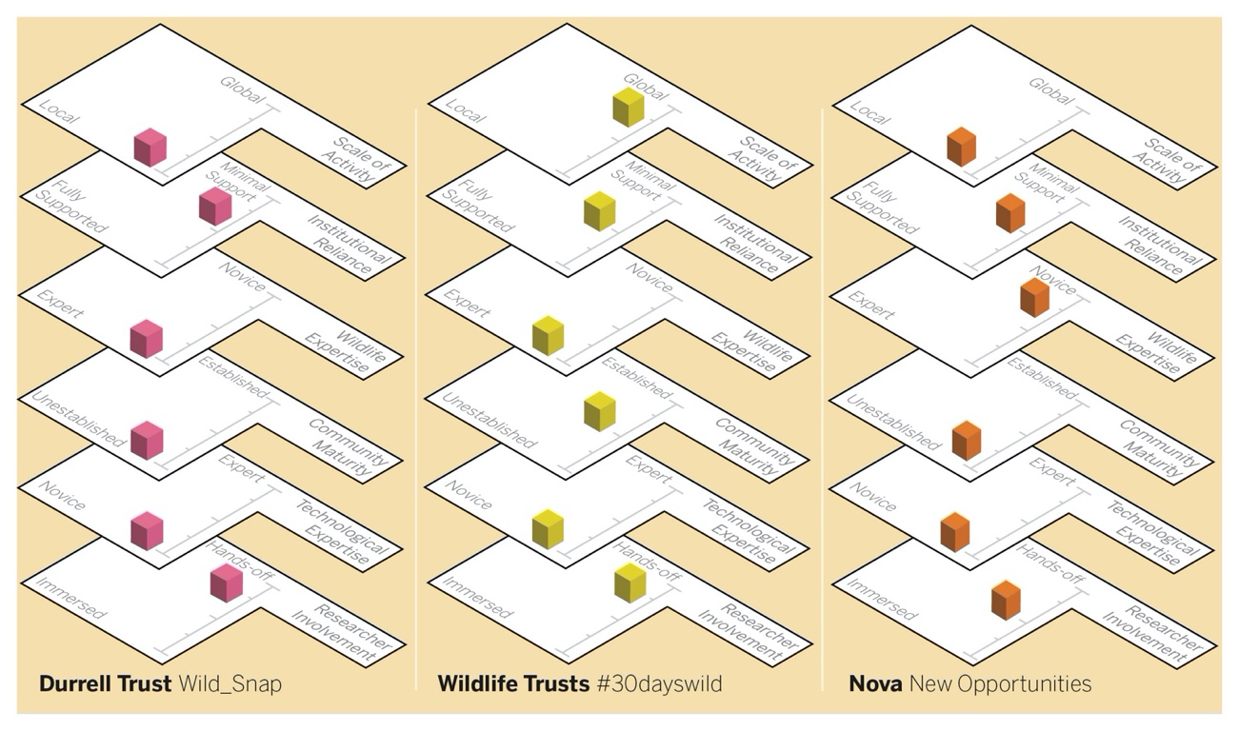
Figure 1: Partners, comparable methodological nuances, as the studies were different in scale and demographic.
Figure 1, shows the nuances of the different organisations and case studies. Organisations had different expertises, scales, and support; however, the cases are thematically comparable. The article crosses design territories to catalyse citizens through social, environmental, commercial, and educational disciplines.
We highlight areas beyond ‘participation’, toward designing active engagement. We are aware the design space has intertwined cultural nuances, complexities, and challenges. We do not see approaches as metaphorical ‘silver bullets’, but critical design-led strategies. An exemplar of (design space) complexities is the documentary Sherpa. It captures the 2014 Everest climbing season’s narrative: “from the Sherpas' perspective, capturing a tragedy, changing Everest forever” (Peedom). In “2014, a 14,000-ton block of ice crashed onto the climbing route, killing 16 Sherpas. The worst tragedy in the history of Everest” (Peedom, 2015). The documentary highlights interconnected complexities of ‘human-nature’ interactions impacting; economies, cultures, environments, governments and importantly citizens.
We identify: the design space, it’s unification, and summaries from design-led perspectives. It contextually frames: Covid-19, Nature (disconnection), Ecological Citizenship, Engaging Design and presents, strategic lessons replicating wider human-nature interactions. The My Naturewatch (NW) project is centrally located within the design space.
Design Space > Covid-19 Context
During 2020, the Covid-19 pandemic transformed our lives over-night. Splitting families, disconnecting people, changing working lives, isolating communities, highlighting disparities and more. The pandemic enhanced our connection with the natural world and nature engagement described as The Natural Health Service (Samuelsson, 2020). The pandemic highlighted that we must “rewild urban spaces” (Monteiro, 2020), develop E-health and highlighted digital inequalities (Khilnani, et al., 2020: 394) among implications.
During 2020 – 2021 nature engagement i.e., bird watching, walking, trail running increased (Spain, 2021). Connections with the natural world cultivates; health, risk, environmental empathy, and human connection (Parker, et al., 2020: 252). The pandemic yielded family inequalities (Hamilton, 2020), reliance on tech, limited access to the environment (EEA, 2020), reduced family’s interactions (Chriscaden, 2020), impacted mental health (Panchal et al., 2020) and had a socio-economic (Bai et al., 2020: 8-17) and social impact (Saladino, et al., 2020: 2550).
At the same time the pandemic also created positive impacts on families (Sibley et al., 2020), children (UN, 2020), family time and nature liberated by lockdown (NHM, 2020). It caused a ‘reclaim’ of wildlife due to government restrictions, i.e., lower emissions, lower human activity and bought “species back to urban settings” (Guardian, 2021). The pandemic’s entirety caused cultures, habits, and freedoms to exponentially transform, with a constant to nurture natural worlds.
In 2020 36% (of people surveyed) told Natural England “the pandemic meant they spent more time outside than before” (Sample, 2021). Nature advocate Jane Goodall stated, the important “lesson from this pandemic is that we need a new relationship with nature and animals” (Watts J, 2021). To summarise, the contemporary design context we are working in is: community based, accessible, distributed, focused on regeneration and reconnecting.
Design Space > Nature Context
Traditional roles demonstrated our reliance on the natural world, that we have now become distanced from. We have moved to cities (Menges, 2020: 201), and prolifically use technologies (Matei, 2017). Nature is fundamental providing healthcare, sustainability, community conservation, knowledge, risk, childhood development, resilience (Lev et al., 2020: 2), behaviour change and more.
Spending time in “nature through lasting and meaningful ways requires intentional activities that relate to everyday life, bring[ing] community members together” (Larson, 2018: 4). Colléony, et al., state “increased quantity of nature experiences did not correlate with environmental knowledge or attitudes”, as the ‘human-nature interactions’ were not embedded within their lives (2019: 96-104).
We must move to better, inclusive ‘custody’ (within communities) rather than seeing ‘nature’ as a resource for exploitation. The pandemic saw increases in public thirst to visit national parks. This ‘thirst’ yielded over popularity as “protected areas require investment to deal with surging nature-based tourism, bringing jobs into Europe’s rural areas” (Mc Clanahan, 2020). Our increasing distance to nature, removes our ability to see forensic or holistic impacts, of our human-nature interactions. For example, ‘Light pollution’ (through artificial lights) impacts birds, nesting up to a month earlier than those distanced from humanity’s glow. Counterintuitively, light pollution “disruption may benefit some birds, helping them adjust to global warming” (Higgins, 2020).
A paradigm for embedded ‘human-nature interactions’ is the Vertical University (VU). VU connects place, nature, and knowledge, fostering a planet centred approach. Professors are “indigenous farmers, possess[ing] intricate, intergenerational knowledge about local fauna and flora, critical for Nepal’s youth to attain. The VU deepen place-based skills in sustainable technology, craft, and medicinal plants. VU conserves and activates local knowledge creating sustainable livelihood opportunities through establishing micro-conservation hubs, throughout locations (The Vertical University, 2021).
Authors summarise the need to embed designed human-nature interactions within our everyday lives. Designed outputs should consider trajectories and impacts over time. Finally design outputs should consider positive human-nature adoption is all critical to the design space.
Design Space > Ecological Citizenship Context
Children interact less in “outdoor free play, have regular contact with the natural world, resulting in their physical boundaries shrinking” (White, 2004: 1-9). RSPB research (2021), states “only 1 in 5 children have a connection to nature”, simply time spent playing outdoors, has halved in one generation (Wildlife Trusts, 2021). This trend is breaking, in 2019 “children walked out of schools in 128 countries” striking for ‘Fridays for Future’ (Carrington, 2019). 2020, saw “one million⁺ international young people” urging governments to prioritise climate change (Harvey, 2021). It is scientifically proven that nature-based activities; “build confidence, promote creativity and imagination” (Skar, et al., 2016: 530), provide stimulation, “create[s] movement, and reduce[s] stress” (Cohen, 2021).
Nature experiences help achieve what Charles et al. call Wild Hope, a way of “living rooted in nature-based experiences, contributing to a healthy present and future for today’s children and [future] generations” (Charles, et al., 2020: 54). Literature demonstrates children “felt empowered by their [nature] knowledge, eager to learn more and take action to minimize harm(s)” (Trott, 2020: 533). Nature and Me written by ‘Nature Connectedness Group’, distils nature connection methods:
- Senses: Actively engaging with nature through the senses, for example listening to birdsong or smelling flowers.
- Beauty: Finding and appreciating beauty in the natural world and exploring it through poetry, music, or art.
- Emotion: Tuning into an emotional bond with nature or reflecting on the positive feelings’ nature can inspire.
- Meaning: Exploring how nature brings meaning to life, for example celebrating the signs and cycles of nature.
- Compassion: Looking after nature as you would look after yourself (Richardson, et al., 2021: 103).
Authors foresee the alignment of Nature and Me’s attributes within the design space. Literature draws attention to the creation of ‘ambassadors’ (El Hitti, et al., 2020: 264-283), creating project communication and public inclusion (Valdes, 2020). Authors see the ambassadorial role as an act of ‘citizenship’. The article advocates 'Ecological Citizenship' (EC), transcending consumerism, undertaking challenges: intervening in cultural habits, enacting sustainable change, and empowering resilience. Authors define “Ecological Citizenship' as; proposals deployed within public communities, positively informing our actions toward sustainable ambitions, beyond our individual needs” (Phillips, R et al., 2020: 2109). EC embodies actions benefiting others, include Bird Friendly Cities (Berg, 2021) or Environmental Holidays (Dunford, 2021).
Authors argue for designing with nature, actively preserving and propagating it, evolving people’s actions. A contextual human-nature impact (designing without nature) is the current increase in artificial grass purchases. In 2018 Artificial Grass (supplier) witnessed a “63% increase in sales, with a 220% sales increase over prior years” (Laville, 2018). 2018 saw “3,000 hectares (12^{sq} miles) of garden vegetation lost (in the UK) over eight years. [These] losses are due to concreting gardens, and artificial grass”, reducing bio-diversity (Laville, 2018). Gardens and green spaces (no matter how small) are “critical to biodiversity” (Barkham, 2018). Garden biodiversity is plummeting, presenting a “hyper-reality, divorced from surrounding natural ecosystems” (Cannon, 1999: 288). A second contextual impact are dog attacks “on sheep flocks have [increased] 67 per cent over seven years”. British police “dealt with over 1,100 dog attacks on sheep in 2018” (Press Association, 2019). These canine impacts demonstrate the complexities within this design space, often occurring through lack of contextual knowledge.
A Measure of Nature Connectedness documents the “size and suddenness of the drop-in levels of nature connectedness from [ages] 10-15” (Richardson, et al., 2020: e0149777). With rising "nature deficit disorder" it is envisaged impacts might exponentially continue (Louv, 2008: 11). Our role in nature has not changed, but we have become more distant from our nature impacts. The design space empowers citizens by, interacting and transitioning, to more distributed human-nature interactions. A medium of this is Citizen Science (CS), “scientific work undertaken by members of the public, often in collaboration with or under the direction of professional scientist and scientific institutions” and “is real science” (Lepczyk, et al., 2020). Many “Citizen scientists participate to make a [difference] they care about whether it’s a new or ongoing environmental issue, asking ‘why does it matter to me” (Cavalier, et al., 2020: 6). Authors summarise this ‘ecological citizenship’ informs our human-nature interactions and can be built into CS models or other processes, supporting municipal and societal objectives.
Design Space > Engaging Design
Authors adapted co-design principles, following best practices in “online co-design principles” (Kennedy et al., 2021: 4147). Combined opportunities to foster digital engagement experiences mixing sustainable values and digital ecological citizenship in a ‘phy-digital’ world. Author’s present “Engaging Design” (ED) borrowing from design traditions and emergent design disciplines; to engage design (verb) as a tool (for change), to design in ways that engage (adjective) (Phillips, & Gant, 2020). ED recognises its capacity as a form of material with value in supporting interactions and critical issues of our time.
The term ‘participatory’ has become an umbrella term for a broad range of practices focusing on the importance of participation, interaction, and social networks. As Ledgard et al., comment “for genuine public engagement, people need either to learn or to be moved, or engage empathetically in some way and feel a connection to the work they are engaging with” (2021: 8). These processes are a crucial part of projects that move away from an exclusive focus on clearly defined and delineated products. The notion of “participation in the arts is inevitably influenced by the increasing ubiquity of digital culture in which ‘participation’ is a central feature” (Rutten, 2018: 7).
Phy-digital experiences blend physical and digital materiality. An Engaging Design (exemplar, within Phy-digital) is Blast Theory’s, Operation Black Antler. Part “role play game, part interactive theatre, Operation Black Antler is an invitation to explore the moral and ethical dilemma of undercover surveillance acceptance in state security” (Blast Theory, 2018). The second exemplar of ED is ‘VR Snorkelling’, a system sold to water parks to experience “swimming through enchanted virtual worlds” (DIVR, 2020). The final ED example is, Forestry England’s “bringing the forest to your home”, through online films, post-able content, and community experience shares (Forestry England, 2021).
In recent Designing with Communities report by the Helen Hamlyn (HH) Centre, (leader of inclusive design principles) states the importance of building communities. The HH centre advise; “clarity of intention, broader brief = longer process, building trust, pacing the project, value what already exists, make engagement accessible, be visual + stimulating and leave responsibly” to develop mutually beneficial engagement activities (Alwani et al., 2020).
Current literature within arts practice highlights the need for; relevant entry points, clear objectives, technical proficiency, solitary, or social involvement and intended partners (Brown, et al., 2011). In Defining the Role of ‘Relational Producer’ Ledgard et al., comment that “while the artist holds the artistic vision, the relational producer supports the artist and holds a solid framework of relationships, enabling the artistic practice and participatory work to develop” (2021: 6). These relationships, design roles and inter-connections are only just being recognised as part of design practice. In 2021 The Design Council published Beyond Net Zero: A Systematic Approach “four key roles for designers to play when tackling systemic issues: system thinker, leader and storyteller, designer and maker, connector and convenor” (The Design Council, 2021). The convergence of citizens agency, accessible technologies and new roles for design practice deems fresh approaches for Engaging Design as a connection between communities and design practice.
A diverse and inter-rational approach of nature, design and health are trials that the London Wetland Centre are implementing under “blue prescribing” scheme, with activities including “birdwatching, pond dipping, nature walks and habitat protection work” (Carrington, 2019). Participants’ “travel costs are to be funded and their progress assessed using standard medical questionnaires” (Carrington, 2019). These interactions align with Engaging Design and the means by which it can be leveraged, supporting other parties. These values are pivotal to the design space and built into the methodology.
Design Space > Summary
The design space unifies active engagement with the natural world, for positive change. This design space can be replicated and scaled. Within design terms it is rare that “communities define their own challenges, make[s] decisions and build[s] its own technological solutions”, so this unique design space requires nurturing (Hernández-Pérez, et al., 2020: 22). However, opening practices to the public empowers “the expansion of who is included in the field of design, It’s a conscious choice” (Lorenzo, 2018). In Opening Up the Participation Laboratory, Krzywoszynska et al state, there is “a risk that engagements become limited to laboratory experiments, highly controlled and foreclosed by participation experts” (2018: 786). The critical element is transitioning to more “embedded practices”, with communities (Treude, 2021: 769).
Authors foresee citizens taking a more active role in their environment, as an act of Citizenship, caring for and gaining great understanding of our environment. Over half the global population live in cities, “consuming 75% of natural resources and produce 50% of global waste. Regenerative design’ calls for a rethink to the way we design, to improve societal resilience, restore planetary health and regenerate ecological systems” (Arup, 2020).​​​​​​​ Design’s role is evolving, transitioning from solely artefacts to service and systems, and more embedded interactions.
We are reliant on the natural world for the air we breathe, the water we drink, our food infrastructures and wider biodiversity. The largest transition is exploring creative ways to drive to community-led responsibilities and agency. In Home to us all, “spending time in nature is good for us—for our children’s development, our health and wellbeing, the vitality of our communities, and for economic sectors” (Charles et al., 2018: 396). Nature engagement has been used in healthcare with significant results, supported by “digital health technologies (e.g., smartphones, and virtual reality) present opportunities for improving healthcare delivery” (Burr, et al., 2020: 69).
The design space coalesces our interaction with the natural world, leveraging the possibility to support communities, in leading their own activities. The research led to common themes and tensions that now have limited ‘best practice’ examples within fields of design research. The question is what is natures payoff from more engagement? The “more we engage, the more we care about our environment, the more chance it has a priority in our personal and national decision making” (Clark, 2018). The My Naturewatch (NW) project sits centrally in this design space. Participating within NW could be an act of ecological citizenship.
Locating The My Naturewatch Project
The NW camera trap (www.mynaturewatch.net) is centralised in the introductions design space. NW was designed specifically using off-the-shelf parts and to be assembled without ‘specialist tools’ on a kitchen table. The cameras are repairable, use pre-approved CE certified components, reusable and utilise components found in schools, homes, or technology enthusiasts place of work. All parts are publicly accessible and purchasable (at the time of writing). The NW project fosters 'active community engagement', a form of CS. The NW camera is a camera trap using computer vision, taking pictures when it sees movement. Participants often made NW cameras for their colleagues, parents and/or children after personal interactions with the project.
Culturally we are disconnected with material value, “repairing” (Schmid, 2019) and underestimate the damage of extracted natural resources used in products, creating loss of “consumption perspective” (Young, et al., 2019: 314). This context requires expertise in reducing misuse, as many UK national parks feared misuse and “frenzy” over pandemic restriction easing and users visiting beauty spots for the first time, subsequently re-visited local “codes” of visitor conduct (BBC, 2021).
NW cameras were used as an ‘agent’ to encourage engagement with the natural world. The NW project uses digital devices to collect visual content about wildlife, promoting ‘active engagements with nature’. NW embodies inclusive design in the digital age, as the activity engages a wide demographic community, and can be used by all. The NW project was designed by the Interaction Research Studio, with engagements led by the Royal College of Art Design Products programme.
The NW project’s nuances align with notions that “craftsman’s work[s] has a definable beginning and end. Furthermore, the craftsman knows the relation of the process of fabrication to the end product” (Tassinari, et al., 2020: 13). i.e., the NW project leverages multiple relationships including enabling and encouraging active participants to edit their surrounding environments, landscapes, camera fabrication, and curating imagery it captures. The NW project emulates three out of five recommendations made by Nature Positive, 1) “Invest in innovative technologies enabling more efficient and effective conservation and sustainable use of natural resources” 2) “Invest in human capital, especially young people, to develop the skills, 3) entrepreneurial mindset required to seize opportunities related to a nature positive economy” (Nature Positive, 2021).
The work builds on authors prior work, approaches, and comprehensions:
- Making: There is an Interplay (for participants) between camera making and constructing or adapting environment(s) for its placement, i.e., technological, and environmental relationships (Phillips, R, et al., 2020: 2109).
- Confidence: Participants built their ‘camera confidence’ as the technology works when people are not there. Participants have shared “am I doing the right thing” requiring validation from other NW users (Phillips, R, et al., 2019).
- Ambassadors: In previous work, the research team leveraged expertise to place the cameras within contexts and alternate communities outside of the researcher’s comprehension (Phillips, & Kau, 2019: 1587-1602).
Method (Prior work)
Previous work shaped methodologies including: fostered relationships (Gaver et al., 2019: 302) with wildlife organisations (Phillips et al., 2019), cinemas, cultural institutions (Phillips, R, 2018), rewilding projects, film festivals, museums, training programmes, cinema outreach (Phillips et al., 2019), designing engagement, User led narratives (Phillips, R, 2013), Gaming (Phillips, Kau, 2019), charities, NGOs and actively engaging audience (Phillips & Gant, 2020). The following research work is primarily ‘ambassador-led’ enabling other agents to: design, execute and foster their own communities satisfying their organisational agendas. The work followed best practice in engagement and created ambassadors.
Method (Common Elements)
Each ambassador was given a repository of existing footage (for promotion) and offered technical troubleshooting. All participants underwent media releases, ensuring transparency. The work followed inclusion and accessibility guidelines, offering free kits where financially required, directing people to balconies and alternative shared green spaces, if garden access was not possible. The work packages, workshops followed institutional, gatekeeper ethical and media consent processes.
The design teams gave briefings to ambassadors setting goals and defining best practice by supporting their creative visions, offered press links and contacts. All participants were recruited through the ambassadors’ networks, briefing sessions, same equipment / tools, welcomed in guest sessions with videographer and connected appropriate expertise to networks. Common objectives were leverage engagement, inform perspectives, encourage engagement with wildlife, and foster inclusion. Each case has different contextual strategies, but maintained common points and objectives: tools, training and online resources. Methodological restrictions included the Covid-19 pandemic, working remotely with continuous adaption to remote locations, evolving researcher commitments and adapting to participants personal challenges i.e., restrictions to technological access.
Methodological Restrictions
This article focuses on: processes, participant motivations for inclusion were not included within the feedback. The organisational gatekeepers controlled their communities, therefore direct researcher contact was restricted. This meant authors could not question or unpick user motivations. Motivations allow “repeatable assets” and bring particular context to participants (Geoghegan et al., 2016). Authors also recognise the potential of ‘gratis’ equipment can change people’s motivations. In Designing for Communities, Alwani et al., raise the questions: How do we build relationships and networks with the community, and still leave responsibly? What’s the impact of the project after we leave? (2020: 5). These challenges were covered by the gatekeeping organisations. The research was restricted (Covid-19), ideally it would have had a longitudinal study, running in parallel.
Method (Organisations)
1) The Wildlife Trusts (#30dayswild)
30 Days Wild is The Wildlife Trusts’ (WT) annual nature challenge, asking the nation to do one ‘wild’ thing a day every day throughout June. The daily “Random Acts of Wildness can be anything you like – litter-picking, birdwatching, puddle-splashing (Wildlife Trusts). In 2020, more than half a million people got involved, from families and couples, to teachers, care homes and workplaces” (Wildlife Trusts). It is badged as the ‘UK’s biggest nature challenge’ crossing counties, generations, and locations. At time of writing, the 2021 audience for #30dayswild was 820,000 participants. 30 Days Wild: Who benefits most? Highlights the growing “need to provide interventions to improve health and wellbeing that are accessible and cost-effective, reducing the burden on health and social services” (Richardson, et al., 2018: 95).
This large-scale engagement protocol brings large and small activities to the forefront of people’s worlds throughout the month of June. The WT has cultivated this engagement over years scaling up to include care homes, schools, offices, and commercial properties. The “campaign success in engaging a large number of participants and delivering outcomes, is notable given governmental and public health interest in policies and interventions to increase human well-being” (Richardson et al., 2016: e0149777).
The NW campaign (Figure 2) empowers a wider calling across the communities, with the intention of yielding longer term impacts from participants initial short ventures. The work learnt from previous lessons in by empowering ambassadors with NW kits and specialist recording equipment. The WT ambassadors were issued equipment, (January 2021) to acclimatise and “embed in their routine” (Barrett et al., 2017: 4). We assisted ambassadors; equipment, check-ins, deployment advice and ‘video editing’, inviting them to create narratives through any means. Ambassadors were recruited, via WT, through an open call amongst their team, widening the demographic. Ambassadors were also equipped with a filming equipment and supported by a professional film editing team. This enabled ambassadors to create social media short films to share within their communities, catalysing engagement. The duration of the research was three months, with one month in full public deployment. Ambassadors’ expertise was core knowledge, subject experience and their ‘public engagement know-how’, providing an appropriate medium to communicate clearly and strategically. Finally, a ‘wildlife camera’ panel discussion, catalysed activities with leading peers, experts and supported by BBC SpringWatch.
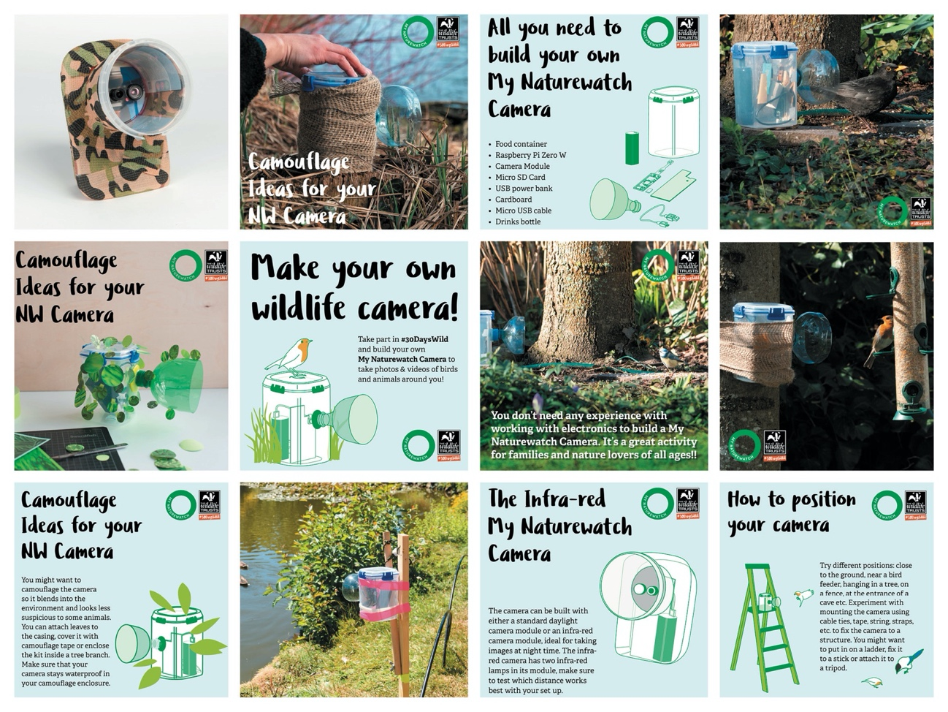
Figure 2: The #30dayswild social media campaign (designed by Naho Matsuda).
2) Durrell Trust (Wild_Snap)
The Durrell Trust (DT) operates in a number of fields; with “staff operating in 50 projects in 18 countries around the world. We focus on islands, where unique species are under immense pressure, and on animal groups suffering the worst declines, such as primates and amphibians” (Durrell, 2020). The Durrell Red List Index of Species Survival (Durrell, 2021) demonstrates that, overall, the Trust have improved the status of many species by over 100%, compared to scenarios of no conservation. DT’s expertise covers, conservation, capacity creation, funding, schools’ operations, and their ‘ark’ in Jersey Zoo. They manage “breeding programmes for release back to the wild, develop the skills and tools to conserve species in the wild, train others in animal husbandry and conservation practice, and communicate important messages to visitors” (Durrell, 2019). The DT have a site in the (world leading) Knepp estate, a 3,500-acre estate West Sussex, devoted to a pioneering rewilding project (Knepp, 2021), where they run the revolutionary “White Stork Project”, re-introducing storks to the UK (White Stork Project, 2020).
DT is a place-based organisation, primarily based in Jersey. Jersey’s location: is an island inhabited by a mix of tourist and local populations, 48 miles of coastline, centrally connected, it is a unique combination of coast and country. Participant motivation was catalysed by a photography competition, with participants given construction and deployment lessons over 3 months. The work leveraged the DT’s existing networks and broadcasts through social media. At time of writing, DT had 43 student engagements, 8 schools and 21 staff / parent engagements. Researchers supported ambassadors’ questions and technical issues, sharing their Instagram channel ‘wildsnap_durrell’, with their networks. The DT’s duration was three months with two months preparation and one month, totally open to local teenage participation. The process was promoted in Jersey’s schools, social media channels and their tourist board all encouraging teenagers to participate and led by DT.

3) Nova New Opportunities
Nova helps people from diverse backgrounds move forward with their skills, confidence and employability such as; those who have missed out on “educational opportunities, women returning to work, long-term unemployed, ethnic minority groups, migrant and refugee communities” (Nova, 2021). Nova (NNO) acts like a metaphorical steppingstone supporting over 1400 disadvantaged residents to move into education, building skills in Maths, English and ICT and open doors through volunteering and participation at a time of tough economic conditions. The organisation offers; education, employment advice, a family programme and help to deliver social change.
Authors intentions were gauging potential engagements in purely urban settings, with diverse groups. The workshops were facilitated through Zoom (online telecommunication platform), under host safeguarding policies. Participant ages ranged from 6 – 60 mainly composing of families that have experienced re-location. At the time of writing NNO had 10 families positively engaging (including 6 to 10 year olds). Researchers provided support, workshops, and resources. Safeguarding was handled by the host organisation, keeping the work fully GDPR compliant. Alongside assembly workshops (hosted by researchers), ambassadors from the Wildlife Trusts hosted a ‘welcome to your window box’, briefing describing; species, seasonality, good practice for feeding and encouraging wildlife to urban areas.
The NW team provided; full kits, power packs, smart devices / tablets (if required) and Field Studies Guides to (garden birds). The works duration was one month over four weekly sessions. The design considerations ensured that everything was provided, we had to cater for participants without acces to garden or public space and all participants should be able to work without any other tools or resources required. We carefully considered (externally supervised) group shares online, sharing best practice and experiences. All organisations (1-3) were provided with: parallel identical equipment, design strategy support, ethical practices from institution(s) and review from My Naturewatch leads.
Method (Researcher-Led Reviews)
Partner organisations undertook review sessions, gathering qualitative feedback / evidence from staff and participants. Participating groups undertook benchmarking pre-engagement activities to ground their engagement with technologies and their nature engagement. The situations are comparable, with different ‘make-up’ nuances (Figure 1). Post NW activities, groups were interviewed with the following questions:
- Please tell us about your experience with the NatureWatch Camera’s, we are particularly interested in how it impacted and or changed how you think about your surroundings.
- What was the defining moment that really helped and or transformed that experience?
- What do you think you achieved during the process?
- What impacts (changes / transformations) do you think it had on your; environment, surroundings, community, neighbours etc?
- Please add your favourite images + or photo’s, describe it and what it means to you. The quality of the imagery is not the focus, but how it makes you feel and what it ‘changed’ is.
Organisational Results
The study focused primarily on impacts the methods had on subsequent participants, including: reviews from senior staff / ambassadors and end users. The ‘review’ process was repeated as either; focus group, email survey and analysed through qualitative thematic analysis, based on repeatable and scalable elements. The analysis relied on ethnographic feedback to meet the objective and “trigger generative scenarios, shedding new light on the whole process of design” (Hirt, et al., 2017).
Results 1) Wildlife Trusts (#30dayswild)
Evidence was gathered from rangers involved in NW camera deployment and a wide questionnaire was gathered from the participating public (820,000). 30dayswild had 1,883 responses to the post event survey (2021). 142 of those answered, ‘yes’ when asked if they used a My NatureWatch camera as part of 30DW. Thematic analysis was conducted on this public data highlighted limited critical analysis of the design and or engagement. Participants engaged well but lacked evidence of opinions based on durations over one month. Locational and demographic material was unable to be shared. Comments from The My Naturewatch project included:
- “Made us more aware of how nature is always alive” User 00.
- “Changed my outlook on my environment” User 012.
- “This was exciting to set up and then watch the shots. We discovered that a ‘local’ rings starlings and monitors their movements. I only knew that because our camera got a good shot of the ring, and we were able to log it with bot.org - then get feedback about that particular bird” User 04.
- “It made the nocturnal world real for my children and not just something talked about” User 01.
- “Made me consider how to better support wildlife at home and encouraged me to take time to look around where I go to spot more wildlife” User 08.
Whilst this provided grounded impacts, it was exceptionally limited to get in-depth analysis of the process. The positives of the process was reaching a large audience supported by a national charity. The negatives were, it was hard to gather feedback (as a researcher) as participants were active, however they often self-evaluated and discounted the value they captured. During interview with leading officers’ impacts of the work were exceptionally provocative:
“People have been saying it's [NW] changed my outlook on the world life and that garden. [One stated] he lived in a flat building and was able to use the camera outside, just outside the building and any last bugs that maybe didn't realize we're visiting. This is the fact that, just because he lives in a flat in a flat, and he doesn't have a garden or even about me. doesn't mean that there's no wildlife visiting. We want people to notice nature, to know that there is nature out of your backdoor. A six-year-old took some captured bird clips into ‘show and tell’ at school. Hopefully there will be knock-on effects, i.e., the kids in the class were like ‘wow that's so cool.’ They might tell their parents, we want a bird feeder we want to cover in our garden now, because this is what” (#30dayswild officer 01).
A critical lesson is empowering ambassadors / individuals to share the narratives and routes to engagement as they are exceptionally important. Naturally people trust their peers, colleagues, and friends before researchers. Building in capabilities are not only good for impact reviews, but also legacies, long-term sustainment, and community building.
“It forced me to think carefully about how I can find different ways to kind of give and engage with some of the wildlife around the flat. I really wanted to get stuck in, so it was amazing when the APP worked, like a Christmas morning feeling you just want to get stuck in and use it. I spent time just doing nothing to do but stare of that window, so it was just surprising [seeing wildlife] I didn't know it was there and it was amazing see” (#30dayswild officer 02).
“Normally you have camera traps, they're quite expensive and technical but to build something from scratch, you had ownership to it as well, this is something quite special. I'm jumping up and down moment yeah there was there was a there was a few of those, one that was captured on camera was badgers coming together, seeing behaviours I have not seen before” (#30dayswild officer 03).
An important element to the work was the notion of surprise and serendipity. Participants did not always know what they would ‘catch’ on camera, leading to pro-active experimentation and exploration. The project also fostered new approaches in participants:
My takeaways were “not to fear technology and it's definitely given me the confidence to believe that I could either create something so as the NW camera, I feel very proud. My parents [borrowed] the camera and they've got hedgehogs which they never knew” (#30dayswild officer 03).
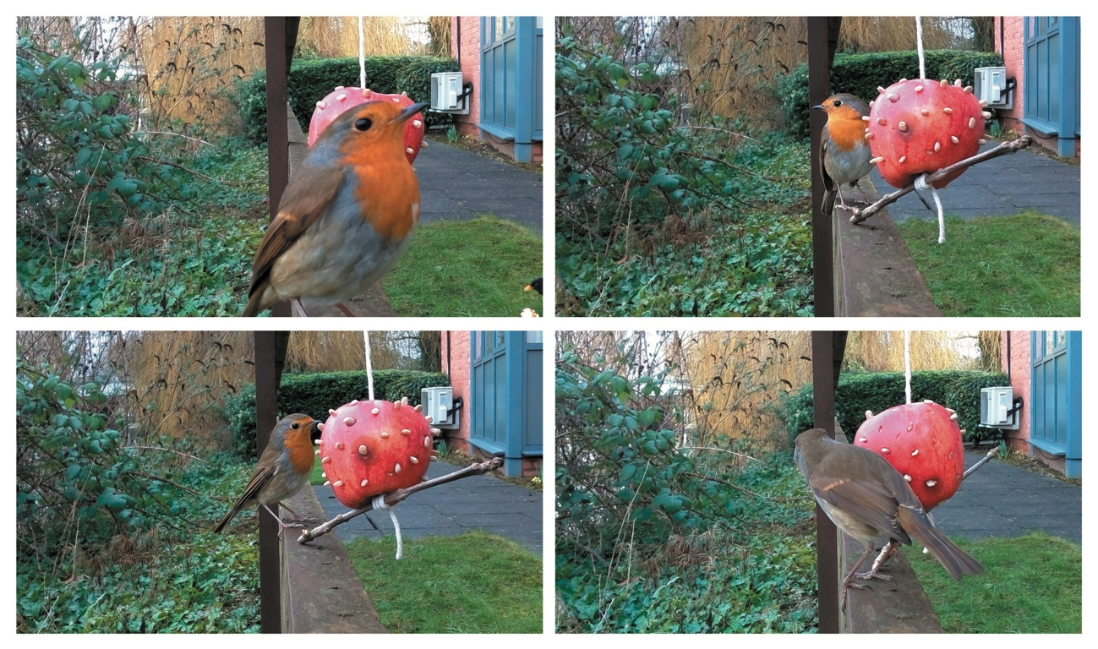
Figure 3: #30dayswild officer demonstrate DIY birdfeeders, images taken by NW Camera(s).
Researchers reflect those impacts were catalysed by the unique perception, that participants had ‘made’ (assembled) the technology. The method was widely supported across the UK, through online and social media platforms. The work produced a series of common themes and repeatable lessons.
Results Summary 1) Wildlife Trusts (#30dayswild)
- United by distance; a unique aspect was participants who had never previously met shared content they had captured openly and supported each other with tips through the NW online forum and via social media channels. On a local level the NW cameras united people with their environments.
- International, scalable & adaptable; the NW project worked across countries, was adaptable to scientific and local low-level engagements. The adaptable nature of the project as a cost-effective resource, enabled it to cross disciplines.
- Follow up; the NW project helped many organisations help participants transition into engaging people into exploring nature. Critically the researchers think they should have designed a transition and or hand-over to more sustained engagements, which is a positive criticism. The follow up (under GDPR conditions, with the Wildlife Trusts), should have focused on ‘designing for exit’ more and engagement transition (over time) is a critical repeatable lesson.
Results 2) Durrell Trust (Wild_Snap)
DT Leveraged their relationship with their zoo and local schools, through their network they hosted a series of engagement events supported by an education officer. Wild_Snap used a social media account to promote their activities and document achievements. DT’s process was an initial workshop with schools’ programmes and then a period of deployment, all autonomous of the researchers. Wild_Snap is an exciting inclusive project aimed at teenagers based in Jersey, CI. By using technology to encourage teens to notice nature we can build their connections to nature and therefore their strength and wellbeing. To target this group most effectively DT launched the project through social media as well as using traditional media options. Following its launch on Facebook, tiktok and Instagram, press releases were used to raise the profile of the project in the local community. Jersey Zoo learning department staff have since been delivering the project in schools and so far, have had 43 student engagements and 21 staff and parent engagements. Each student has taken part in a workshop to build a Wild_Snap camera, on loan from jersey zoo, and to deploy their camera into their school or home environment.
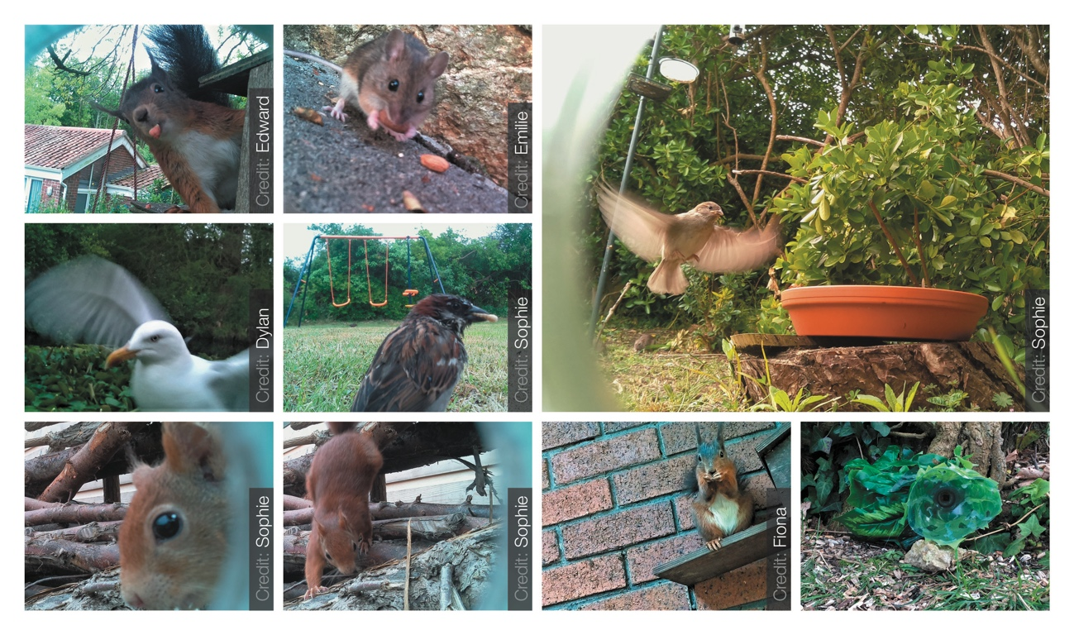
Figure 4: Wild_Snap participant images from NW Camera(s), provided by Durrell Trust.
Participants were left with their cameras for approximately a week and challenged to capture images of nature around them. Reflections on the approach led to independence, but the researchers were distanced from the trial. This type of approach was exceptionally successful but requires a very established partner relationship. The process leaves a very solid grounded legacy and should be considered for this type of work. Feedback was captured in monthly reporting via the DT. The challenges (in the process) were that it was often hard to unpick responses as the educational parties were not trained in exploring qualitative data from participants. Staff reflections had often seen the project as a ‘gateway’ to nature engagement as it was free to interpretation and could catalyse further nature-based interactions.
Results Summary 2) Durrell Trust (Wild_Snap)
- Connections: participants formed new connections with spaces, they were familiar to.
- Trust: needed to be established between the researchers, technology, and participants. There were uncertainties ensuring the technology would work appropriately.
- Defining Success: the importance of opening the scope up in the engagement(s), i.e., short, and long term.
Results 3) Nova New Opportunities
Captured feedback was recorded through a focus group under rigorous safeguarding processes established with the partner. The focus groups, was under parental consent supported by full institutional ethical media, sign off with gatekeepers and stakeholders attending to ensure rigorous ethical practice. The participants were primed with the intention to gather experiences, both positive, negative and reflections. The ‘images’ were as expected, various species within an urban setting (at the time of the workshop) and should not be seen as negative. The participants were very inquisitive, but most of all the research team were surprised at how in such an urban setting the families took to the process with such enthusiasm. The impacts of the work were exceptionally provocative amongst;
“it's funny it's just the whole thing has made us more aware and we're just watching and hearing. I paid more attention to the many different species of wildlife visit in my garden, we have regular visits from squirrel’s blue and Gray tips for being’s stock dubs would pigeons’ woodpeckers’ magpies” (Participant 04).
“During this process we respected the wildlife by sharing my space and feeding them, I’m not afraid of the wildlife and I have become more patient and respectful towards nature and wildlife. I’m more aware of my surroundings, because having the camera setup made me notice the birds singing first thing in the morning. Now my neighbours are more involved and want to help and are helping to look out for new visitors to the garden, bringing me closer to nature and found the value of nature and it was really fun to set up the thing and see what species, you could get” (Participant 06).
The most interesting was the impacts on the families themselves and their extended networks, for example participants commented that;
“Her [the participants] Nan planted lots of cottage garden flowers in a garden this year to try and capture more butterflies, so they can take pictures of them, which is fantastic” (Participant 02).
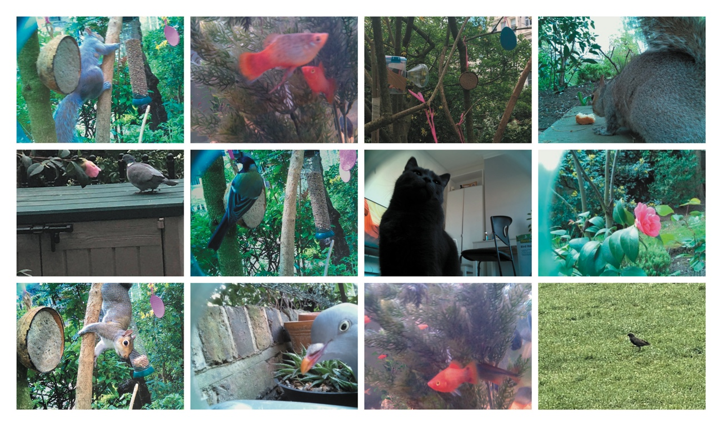
Figure 5: Images taken by Nova workshop participants with NW camera(s), (during lockdown).
The deployments of the NW cameras highlighted many unique characteristics, some of which are tacit, some more grounded, and scalable with different audiences.
Results Summary 3) Nova New Opportunities
- Participant’s role in ‘making’; a unique factor was not just the assembly of the camera, but also the narrative and ‘environment making’ that required careful consideration and curation by participants. Some participants: adapted window boxes, created ponds, grew new (to them) plant life encouraging species they wanted to spot and capture on NW camera.
- The mundane wonderful; participants felt more ‘connected’ and part of the natural world they were in, even taking the NW camera with them on family day trips. Participants commented that the species themselves were things they had seen before, but seeing them through the NW camera trap, enabled them to have fresh eyes and also learn the names of the species.
- Impacts on others; One participants family shared their story with their grandmother, who then grew more flowers to attract more butterflies, because her granddaughter talked about her new fascination with them, fostering a more active inter-generational relationship. The work also had impacts on the guardians (of participants) as they were looking and learning new things about their surrounding world.

Discussion
The article objective identifies strategic lessons to replicate, for wider human-nature interactions. Authors unpicks; repeatable assets, lessons and approaches with ‘distributed audiences’ in restricted times, capturing experiential differences moving towards best practice. Table 1 summarises the studies core repeatable lessons. Findings: cross social and financial divides providing benefit to cultural institutions, designers of experiences and conservation projects, to leverage new ‘phy-digital’ engagements at a distance.
 | Reflections | Benefits | Wider Lessons
1) Wildlife Trusts (#30dayswild) | - Relied heavily on ambassadors.  - Getting participants to share their ‘failures’. | - International outreach.  - Opened dialogue and investigation across age groups. | - The importance of giving participants agency and keeping processes open for alternative uses.  - The importance of designing for exit, from the start of the project.  - The importance of individuals ‘making’ ecologically beneficial spaces within gardens and local parks.
2) Durrell Trust (Wild_Snap) | - Gaining user data through gatekeepers without burdening them. | - Youth programme and legacy, influencing parents.  - Created a camera trap library opening access.  - Participants formed deeper connections with local spaces. | - The importance of defining success and aligning the meaning with participants and organisations.  - Building trust over time, as ‘digital sensing’ is new to people.  - Being financially inclusive with equipment and accessible technologies.  - Supporting ambassadors to influence peers / others.
3) Nova New Opportunities | - Keeping the project pace, without researchers. | - Participant’s role in making and ‘environment making’ appropriately for successful ‘camera trapping’. | - The mundane wonderful, exploring everyday situations, in a new, provocative, and informative way.  - Providing participants with tools to recruit and/or include their peers.  - Creating independence and confidence within participants.
Table 1. Core themes identified by researchers summarising the different research approaches.
There were methodology differences that naturally transformed results. The researches objective was about exploring best practices and not solely about comparability. There is an overarching importance of making and editing ‘ecological spaces’. This ‘craft’ of ‘making the environment’ to optimise the camera’s performance, was extensive. For example, it was a catalyst for people growing new plant species (to them) to encourage pollentation, because they wanted to photograph pollinators. Over time the design space, will become more pro-active as we seek to distill new ‘human-nature interactions’ as communities and distributed approaches are exceptionally powerful. Authors summarise the core design space issues the three studies raised. We frame them within new contexts and diverse literature.
Signposting Design Space Issues
The core themes have been distilled into contemporary areas expanding on research lessons. Authors identify the main barriers to wider adoption of wider human-nature interactions as we must be continually aware of potential impact(s) will that have on the environment if we are fostering ‘re-engagement’ with the natural world.
Ethical practices: stages of review and ensuring potential negative impacts, this is complex as is dependent on context, surroundings, and the deployment. This attribute was raised by organising parties and leads, when they are not in full control of the process, and what ‘control’ is within collaborative design. Safeguarding of users and participants is often discussed and highlighted. However, our physical impact through our actions, physical presence and or movement through spaces is rarely apparent. A contextual example is guiding holiday makers to rent wooden belly boards (mini surf boards) for free as “campaigners say thousands of polystyrene body boards are discarded every year at beaches in the UK, sometimes after one use” (Morris, 2021). This example impacts the local wildlife, surrounding area but predominantly caused by tourists. We are tourists in the natural world, with limited training, knowledge and understanding of our consequences. We recognise that relationships ‘by proxy’ and believe that we must follow design ethical processes of institutional frameworks and encourage others to do the same supporting activities toward continual safeguarding of all parties, researchers, and participants. Finally, there is the challenge of the relationship between “publicly available data”, i.e., Instagram and social media that can be leveraged for other means and connects with issues of collective authorship (Ravn, et al., 2020: 42).
Authorship: is defined as “the person who wrote a particular book, article, play” (Collins, 1999: 15) and recognises “scholarly contributions, develop professional skills, and advance your career” (Haerling, Prion, 2020: 66). This territory was raised by people wanting to use images shared by others on social media, supported within participant interviews. On creative works there are different models of “co-authorship” (Hick, 2014: 148), for example, Zooniverse citizen science platform, famously identifies all parties on scientific publications (Simpson, et al., 2014: 1049). The practice of Creative Commons (alternative co-authorship) operates around attribution and recognition that parties are building on the concepts of others (Lessig, 2004: 25). There are many elements to authorship; intellectual property, tacit & indigenous knowledge (Funk, Guthadjaka, 2020), ownership, privacy, and the concept as financial value (Jungen, 2020: 145-164). Co-operative methods are harder to monitor, but there are transferable skills that can be scaled (without being exploited). In Authorship Protocols Must Change to Credit Citizen Scientists, two critical challenges exist within Citizen Science practice:
“Scientific fraud and appro-privately recogniz[ing] the contributions of everyone who played a major role in the research. The nature of research is changing, with increasing participation by non-professionals. Our rules for authorship need to change to recognize this evolving social dimension of scientific research” (Ward-Fear et al., 2020: 188).
Within this fresh approach we need more indicators of best practice for “Social Authorship” (Stabile, 2020: 342). New practices are also evolving the discussion, for example how “dances can be replicated on social media platforms”, pushing new boundaries for authorship (Stabile, 2020: 342). Authors raise ‘identifying authorship appropriately’, especially when you are engaging communities by-proxy through third parties and capturing data ethically. The results raised wider questions; who is the original author(s), when researchers foster new engagements with diverse contexts and how do we recognise ‘complete’ authorship by proxy as it opens up new divisive opportunities, especially when people re-appropriate it? Finally, how do we design these values into ‘Engagement by Proxy projects’ recognising all contributions?
Behaviour: there are many; dark, unclear, and divisive perspectives around ‘behaviour change’. Authors align with the definition of “public participation in environmental issues through ‘sustainable lifestyles’ as a practical tool for encouraging pro-environmental behaviour” (Barr, et al., 2011: 718). Also, it is understood that it is “essential that behaviour change interventions develop a sounder scientific basis. In practice, the science will inform the technology (i.e., the techniques and methods) required to deliver effective replicable interventions with guidance on their delivery to ensure that effective interventions are actually used” (Michie, et al., 2012: 3).
This territory was raised by participants stating (verbally) that the research changed their perspective on nature and their environment. How should we guide toward new behaviours through interactions? Is it ok to guide parties ‘by proxy’ through other gatekeepers and what are the potential long-term impacts? Ideally the impact and legacy of projects should leave a positive transition to new actions and in time more embedded behaviours. How long does it take to be embedded? How can these wildlife engagements form larger legacies? How do we inform things to become more embedded in our daily lives?
Manzini states we should focus on “project centred democracy, meaning a participatory enabling ecosystem in which everybody can develop their projects and achieve their results”, i.e., designing the conditions for others to excel (Manzini, 2019: 17). There are complexities of; motivation, location, cultures and so much more that should not be dismissed. The other challenge within ‘Behavioural design’ is that it is often just seen as problem solving rather than opening; territories, cultures, or opinions, i.e., making individuals, groups, and communities more planet centred (Kuisma, 2020).
Mundane Wonderful: the notion of re-seeing ‘the mundane’, raised by participants looking at their spaces with a greater degree of detail and seeing things for the first time. The natural world is located “all around us” and often thought about only in remote locations (Leavell et al., 2019: 297). The work engaged people in (conventional settings) Urban and Suburban for example, window boxes, public spaces, municipalities and should not be seen as an exclusive to only those that can access. Authors found that NW participants often just looked in more active observation, enabling people to take time within ‘their’ natural world and learn something new.
Conclusions
Strategic lessons for replicating, wider human-nature interactions:
- Safeguarding; does not just apply to the young or vulnerable, best practice, GDPR and protected data are critical to these types of projects. The challenge is supporting third parties in control and ensuring it is not burdensome. Authors believe that safeguarding is also about: protecting the environment, the data, the individual and third parties, i.e., clear agreements need to be created benefiting all involved.
- Sharing Tacit Knowledge, questioning what tacit knowledge is within a project. It can then be shared within the communities that it has helped create and build. This shares the possibilities for projects to scale as the ‘mundane wonderful’ cannot be dismissed.
- Learning to let go; of premonitions and not holding on ‘too tight’ to the project or stifle them. Letting it grow out of the central theme enables communitys to make it their own. It is good to continually review the agenda well beyond academic research questions. This is the hardest lesson as it changes the balance of care about the project, from researcher to community led. This is required to let activities grow beyond researchers.
- Help foster, seed and share; focus on seeding strategic activities that help grow the passion, motivation and (ethically) share narratives. The process builds on all perspectives and should avoid polarisation. Share lessons, best practice, previous barriers and do not over promise possibilities. This includes aligning the work with the motivations of participants / intended audiences.
- Remove guilt; Some people will disengage due to ‘life’/external factors, don’t make them feel guilty about it. They will naturally support, do what they can or return to the project when possible. Overall, this practice of design has nuanced challenges to deploy, but it enables engagements to scale rapidly through partners and or third-party networks.
Acknowledgements
The work was funded through EPSRC funding Grant EP/P006353/1 and an EPSRC ‘Telling Tales’ engagement grant. Authors thank; Interaction Research Studio, Goldsmiths for collaborating on the My Naturewatch project. Strategic guidance from; Prof Ashley Hall and Prof Paul Anderson. Prior Ecological Citizenship work with Dr Rosie Anderson. Nick Gant, for co-authoring seminal publications framing ‘Engaging Design’. The Wildlife Trusts; Director – Campaigning & Communities Nikki Williams, Abbie Hargraves #30dayswild co-ordinator; WT rangers / officers from around the UK (Gina & Tom). Nova New Opportunities, Matt Barnett. Durrell Trust; Fiona Marchant, Sarah Maguire, Andrew Heaver, Hannah Crespel and Lucy Groves, (The White Stork project). Finally, we thank; families, teenagers and participants, along with designer Naho Matsuda, leading to the successes of the ‘Telling Tales’ part, of the My Naturewatch project.
References
Alwani, R., Charnley, M., Gorzanelli, C., Greene, C., Gribben, G., Jarvis, T., Keren, C., Lockton, D., Outten, A., Raby, E. & Ramster, G. 2020, Designing with Communities, Lessons on Social Design from the Helen Hamlyn Centre for Design, The Helen Hamlyn Centre, London.
Arup 2020, Arup, Explores Regenerative design, Arup, Berlin, Germany.
Bai, H.M., Zaid, A., Catrin, S., Ahmed, K. & Ahmed, A. 2020, "The socio-economic implications of the coronavirus pandemic (COVID-19): A review", Int. J.Surg., vol. 8, no. 4, pp. 8-17.
Barkham, P. 2018, May 31-last update, How to rewild your garden: ditch chemicals and decorate the concrete [Homepage of Guardian], [Online]. Available: https://www.theguardian.com/environment/2018/may/30/how-to-rewild-your-garden-ditch-chemicals-and-decorate-the-concrete [2019, October 2].
Barr, S., Gilg, A. & Shaw, G. 2011, "‘Helping people make better choices’: exploring the behaviour change agenda for environmental sustainability", Applied Geography, vol. 31, no. 2, pp. 712-720.
Barrett, N., Villalba, R., Andrade, E.L., Beltran, A. & Evans, W.D. 2017, "Adelante Ambassadors: Using Digital Media to Facilitate Community Engagement and Risk-Prevention for Latino Youth", Journal of Youth Development, vol. 12, no. 4.
BBC 2021, New Forest visitor 'frenzy' fear as lockdown eases [Homepage of BBC], [Online]. Available: https://www.bbc.co.uk/news/uk-england-hampshire-56199596?fbclid=IwAR0MyQmPASETSSS8hb5gjhKrj6-wNTz_V68ubFw0KAgE-Jwj9-VkcnaJJPA [2021].
Berg, N. 2021, Why cities should be designed for birds Habitats that are good for birds are good for people, to. [Homepage of Fast Company], [Online]. Available: https://www.fastcompany.com/90601980/why-cities-should-be-designed-for-birds [2021.
Blast Theory 2018, October 25-last update, OPERATION BLACK ANTLER [Homepage of Blast Theory], [Online]. Available: https://www.blasttheory.co.uk/projects/operation-black-antler/ [2021, 11 9].
Brown, A.S., Gilbride, S. & Novak, J. 2011, Getting in on the act: How arts groups are creating opportunities for active participation, James Irvine Foundation.
Burr, C. & Morley, J. 2020, "Empowerment or engagement? Digital health technologies for mental healthcare" in The 2019 Yearbook of the Digital Ethics Lab Springer, pp. 67-88.
Cannon, A. 1999, "The significance of private gardens for bird conservation", Bird Conservation International, vol. 9, no. 4, pp. 287-297.
Carrington, D. 2021, Invalid date-last update, Nature on prescription: wetlands project aims to boost mental health London Wetlands Centre to run courses focusing on wildlife beauty as therapy to help alleviate depression and anxiety [Homepage of The Guardian], [Online]. Available: https://www.theguardian.com/society/2021/may/13/nature-on-prescription-wetlands-project-aims-to-boost-mental-health [2021, 05].
Carrington, D. 2019, School climate strikes: 1.4 million people took part, say campaigners Activist Greta Thunberg, 16, says action proved ‘no one is too small to make a difference’ [Homepage of Guardian], [Online]. Available: https://www.theguardian.com/environment/2019/mar/19/school-climate-strikes-more-than-1-million-took-part-say-campaigners-greta-thunberg [2021].
Cavalier, D., Hoffman, C.H.P. & Cooper, C.B. 2020, The Field Guide to Citizen Science: How You Can Contribute to Scientific Research and Make a Difference, 1st edn, Timber Press Incorporated, New York.
Charles, C., Keenleyside, K., Chapple, R., Kilburn, B., Salah van der Leest, Pascale, Allen, D., Richardson, M., Giusti, M., Franklin, L. & Harbrow, M. 2018, Home to us all: how connecting with nature helps us care for ourselves and the Earth. https://derby.openrepository.com/handle/10545/623158, Children & Nature Network, England.
Charles, C. & Louv, R. 2020, "Wild hope: The transformative power of children engaging with nature https://doi.org/10.1007/978-3-319-67286-1”, Research Handbook on Childhoodnature: Assemblages of Childhood and Nature Research, no. 1, pp. 395-415.
Chriscaden, K. 2020, March 12-last update, Impact of COVID-19 on people's livelihoods, their health, and our food systems [Homepage of World Health Organisation], [Online]. Available: https://www.who.int/news/item/13-10-2020-impact-of-covid-19-on-people's-livelihoods-their-health-and-our-food-systems#:~:text=The%20economic%20and%20social%20disruption,the%20end%20of%20the%20year. [2021, 26 04].
Clark, D. 2018, October 12-last update, Engaging with nature [Homepage of Green World], [Online]. Available: https://greenworld.org.uk/article/engaging-nature [2021, 27 04].
Cohen, D. 2021, January 01-last update, Why Kids Need to Spend Time in Nature; They may prefer to stick to their screens, but here's why getting outdoors matters [Homepage of Child Mind Institute], [Online]. Available: https://childmind.org/article/why-kids-need-to-spend-time-in-nature/ [2021, 23 04].
Colléony, A., White, R. & Shwartz, A. 2019, "The influence of spending time outside on experience of nature and environmental attitudes", Landscape and Urban Planning, vol. 187, pp. 96-104.
Collins 1999, English Dictionary, millennium edition, 5th edn, Harper Collins, Glasgow.
DIVR 2020, Virtual Reality for Waterparks; Bring new excitement and revenue to your pool. [Homepage of Ballast Technologies], [Online]. Available: https://www.ballastvr.com/divr [2021].
Dunford, J. 2021, From dolphins to rewilding: 11 environment-friendly holidays for 2021 [Homepage of Guardian], [Online]. Available: https://www.theguardian.com/travel/2021/jan/17/dolphins-to-rewilding-11-environment-aware-holidays-2021 [2021].
Durrell 2021, March 03-last update, THE RED LIST INDEX OF SPECIES SURVIVAL: What is the long-term impact of Durrell’s conservation programmes on its target species’ chances of survival? [Homepage of Durrell Trust], [Online]. Available: https://www.durrell.org/wildlife/global-index/red-list-index/ [2021, 27 04].
Durrell 2020, March 03-last update, Our approach; We pursue our mission by concentrating on four areas of specialisation, all underpinned by robust science. [Homepage of Durrell Trust], [Online]. Available: https://www.durrell.org/wildlife/conservation/our-approach/ [2021, 27 04].
Durrell 2019, April 03-last update, Jersey Zoo; Today, the overarching role of our animal collection in Jersey and overseas – our ‘ark’, as Gerald would have it – is conservation. [Homepage of Durrell], [Online]. Available: https://www.durrell.org/wildlife/conservation/our-approach/wildlife-park/ [2021, 27 04].
EEA 2020, May 11-last update, COVID-19 measures have mixed impacts on the environment [Homepage of European Environment Agency], [Online]. Available: https://www.eea.europa.eu/highlights/impact-of-covid-19-lockdown [2021, 04 26].
El Hitti, S. & Hecht, D. 2020, "Global Pull of Community Engagement: Urban Students Growing Into Youth Ambassadors" in Preparing Students for Community-Engaged Scholarship in Higher Education IGI Global, pp. 264-283.
Forestry England 2021, 2021-last update, Bringing the Forest to you [Homepage of Forestry England], [Online]. Available: https://www.forestryengland.uk/forests-at-home [2021, 04].
Funk, J. & Guthadjaka, K. 2020, "Indigenous Authorship on Open and Digital Platforms: Social Justice Processes and Potential.", Journal of Interactive Media in Education, vol. 2020, no. 1.
Gaver, W., Boucher, A., Vanis, M., Sheen, A., Brown, D., Ovalle, L., Matsuda, N., Abbas-Nazari, A. & Phillips, R. 2019, "My Naturewatch Camera: Disseminating Practice Research with a Cheap and Easy DIY Design", Proceedings of the 2019 CHI Conference on Human Factors in Computing Systems ACM, pp. 302.
Geoghegan, H., Dyke, A., Pateman, R., West, S. & Everett, G. 2016, Understanding motivations for citizen science, Environmental Observation Framework, Natural Environment Research Council, Polaris House, North Star Avenue Swindon, Wiltshire, SN2 1EU.
Guardian 2021, 2021 last update, The urban wild: animals take to the streets amid lockdown – in pictures [Homepage of Guardian], [Online]. Available: https://www.theguardian.com/world/gallery/2020/apr/22/animals-roaming-streets-coronavirus-lockdown-photos [2021, August].
Haerling, K. & Prion, S. 2020, "Negotiating Authorship", Clinical Simulation in Nursing, vol. 46, pp. 66-67.
Hamilton, D. 2020, October 25-last update, Impact of COVID-19 on Children and Families [Homepage of BMJ], [Online]. Available: https://blogs.bmj.com/ebn/2020/10/25/impact-of-covid-19-on-children-and-families/ [2021, 04 26].
Harvey, F. 2021, A million young people urge governments to prioritise climate crisis; World leaders will meet for Climate Adaptation Summit to consider how to adapt to extreme weather [Homepage of Guardian], [Online]. Available: https://www.theguardian.com/environment/2021/jan/22/a-million-young-people-urge-governments-to-prioritise-climate-crisis [2021].
Hernández-Pérez, O., Vilariño, F. & Domènech, M. 2020, "Public Libraries Engaging Communities through Technology and Innovation: Insights from the Library Living Lab", Public Library Quarterly, pp. 1-26.
Hick, D.H. 2014, "Authorship, Co‐Authorship, and multiple authorship", The Journal of Aesthetics and Art Criticism, vol. 72, no. 2, pp. 147-156.
Higgins, D. 2020, Light Pollution Is Causing Birds to Nest Earlier—Which Might Not Be a Bad Thing Earlier nesting may help birds adjust to the effects of climate change [Homepage of Scientific American], [Online]. Available: https://www.scientificamerican.com/article/light-pollution-is-causing-birds-to-nest-earlier-which-might-not-be-a-bad-thing/#:~:text=Birds%20exposed%20to%20artificial%20lights,study%20published%20recently%20in%20Nature.&text=%E2%80%9CFor%20those%20nests%20that%20were,up%20having%20higher%20reproductive%20success.%E2%80%9D [2021].
Hirt, L.L. & Nova, N. 2017, "Design Ethnography: opening the black box-how to draw design decisions from ethnographic observations", A study of the multi-generational relationship with making through mediated designing in collaborative, digital environments.
Jungen, T. 2020, "Collaborative Authorship–Or How to Overcome the “Nightmare of Participation” in Constructions of Media Authorship, 1st edn, De Gruyter, pp. 145-164.
Kennedy, A., Cosgrave, C., Macdonald, J., Gunn, K., Dietrich, T. & Brumby, S. 2021, "Translating Co-Design from Face-to-Face to Online: An Australian Primary Producer Project Conducted during COVID-19", International Journal of Environmental Research and Public Health, vol. 18, no. 8, pp. 4147.
Khilnani, A., Schulz, J. & Robinson, L. 2020, "The COVID-19 pandemic: new concerns and connections between eHealth and digital inequalities", Journal of Information, Communication and Ethics in Society, vol. Vol. 18, no. No. 3, pp. pp. 393-403.
Knepp 2021, March 04-last update, KNEPP WILDLAND rewilding in West Sussex [Homepage of Knepp Estate], [Online]. Available: https://knepp.co.uk/home [2021, 27 04].
Krzywoszynska, A., Matt, W., Buckley, A., Chiles, P., Gregson, N., Holmes, H. & Mawyin, J. 2018, "Opening up the participation laboratory: The cocreation of publics and futures in upstream participation", Science, Technology, & Human Values, vol. 43, no. 5, pp. 785-809.
Kuisma, K. 2020, February 07-last update, Planet centred design, is a methodology for designing products and services that do not harm the planet. Available: https://planetcentricdesign.com/ [2020, February].
Larson, J.M. 2018, "A partnership with nature", Interdisciplinary Journal of Partnership Studies, vol. 5, no. 2, pp. 4.
Laville, S. 2018, February 14-last update, Growth in artificial lawns poses threat to British wildlife, conservationists warn. Growing trend to lay fake lawns instead of real grass causes loss of habitat for wildlife and creates waste that will never biodegrade [Homepage of Guardian], [Online]. Available: https://www.theguardian.com/environment/2016/jul/04/growth-in-artificial-lawns-poses-threat-to-british-wildlife-conservationists-warn [2019, October, 1st].
Leavell, M., Leiferman, J., Gascon, M., Braddick, F., Gonzalez, J. & Litt, J. 2019, "Nature-based social prescribing in urban settings to improve social connectedness and mental well-being: a review", Current environmental health reports, vol. 6, no. 4, pp. 297-308.
Ledgard, A., Hall, S., Layton, S., Storor, M., Petto, N., Wray, J. & Biglino, G. 2021, "Defining the role of ‘relational producer’ in arts-and-health collaborations in hospitals: a reflection on catalysts and partnerships", Leonardo, vol. https://doi.org/10.1162/leon_a_02036, pp. 1-10.
Lepczyk, C., Boyle, O. & Vargo, T. (eds) 2020, Handbook of citizen science in ecology and conservation, 1st edn, University of California Press, Oakland, California.
Lessig, L. 2004, Free culture: How big media uses technology and the law to lock down culture and control creativity, Penguin.
Lev, E., Kahn Jr, P.H., Chen, H. & Esperum, G. 2020, "Relatively Wild Urban Parks Can Promote Human Resilience and Flourishing: A Case Study of Discovery Park, Seattle, Washington", Frontiers in Sustainable Cities, vol. 2, pp. 2.
Lorenzo, D. 2021, 2021-last update, Designers, want to change the world? Read this first... Argodesign’s Mehera O’Brien knows first-hand the challenges of social innovation. Here, she reveals the shortcomings of the fail fast mentality, what to do when clients want to solve the wrong problem, and why technology can’t fix everything. [Homepage of Fast Company], [Online]. Available: https://www.fastcompany.com/90625774/designers-want-to-change-the-world-read-this-first [2021, 05].
Louv, R. 2008, Last child in the woods: Saving our children from nature-deficit disorder, 1st edn, Algonquin books.
Manzini, E. 2019, Politics of the Everyday, 1st edn, Bloomsbury Visual Arts.
Matei, A. 2017, August 09-last update, Technology is changing our relationship with nature as we know it [Homepage of Quartz.], [Online]. Available: https://qz.com/1048433/technology-is-changing-our-relationship-with-nature-as-we-know-it/ [2021, 27 04].
Mc Clanahan, P. 2020, The Newest Challenge for Europe’s Parks: A Surge of New Nature Lovers Lockdown-weary city dwellers across the continent are visiting parks and other protected areas for the first time, overwhelming staff and generating pleas for more support. [Homepage of The New York Times], [Online]. Available: https://www.nytimes.com/2020/12/10/travel/european-parks-pandemic.html [2021].
Menges, E. 2020, "Social Distancing with Nature", Natural Areas Journal, vol. 40, no. 3, pp. 201.
Michie, S. & Johnston, M. 2012, "Theories and techniques of behaviour change: Developing a cumulative science of behaviour change. DOI: 10.1080/17437199.2012.654964", Health Psychology Review, vol. 6:1, no. 1-6.
Monteiro 2020, November 04-last update, Coronavirus should inspire us to rewild cities to better support our children [Homepage of dezeen], [Online]. Available: https://www.dezeen.com/2020/11/24/coronavirus-rewild-cities-cristina-monteiro-opinion/ [2021, 11 04].
Morris, J. 2021, Free wooden bellyboards for hire in push against pollution [Homepage of BBC], [Online]. Available: https://www.bbc.co.uk/news/uk-england-cornwall-57148227 [2021, 05].
Nature Positive 2021, Global Goal for Nature Covid19 Response & Recovery, Nature-Based Solutions for People, Planet and Prosperity, https://www.naturepositive.org/en/resources, Online.
NHM 2020, December 10-last update, Nature: liberated by lockdown? [Homepage of Natural History Museum], [Online]. Available: https://www.nhm.ac.uk/discover/nature-liberated-by-lockdown.html [2021, 26 04].
Nova 2021, March 03-last update, We target the causes of inequality Nova helps people from diverse backgrounds move forward with their skills, confidence and employability such as: Those who have missed out on educational opportunities, Women returning to work, Long-term unemployed, Minority ethnic groups, migrant and refugee communities [Homepage of Nova], [Online]. Available: https://www.novanew.org.uk/about-new/ [2021, 27 04].
Panchal, N., Kamal, R., Orgera, K., Cox, C., Garfield, R., Hamel, L. & Chidambaram, P. 2020, "The implications of COVID-19 for mental health and substance use", Kaiser family foundation.
Parker, J. & Simpson, G.D. 2020, "A theoretical framework for bolstering human-nature connections and urban resilience via green infrastructure", Land, vol. 9, no. 8, pp. 252.
Peedom, J. 2015, Sherpa, Trouble on Everest, 1st edn, Footprint Films, Australia.
Phillips, R. &. Gant, N. 2020, "Engaging Design – Empowering Beyond ‘Participation’ For Active Engagement", Art of Research 2020 “Authorship and Responsibility” https://artofresearch2020.aalto.fi/, full catalogue https://artofresearch2020.aalto.fi/wp-content/uploads/2020/12/AoR_Conference-Catalogue.pdf, ed. M.K. Maarit Mäkelä, Aalto University, pp. 1 - 109.
Phillips, R. 2018, FutureKind: Design by and for the People, 1st edn, Thames & Hudson, London.
Phillips, R. 2013, "Making instructions for others: exploring mental models through a simple exercise", interactions, vol. 20, no. 5, pp. 74-79.
Phillips, R., Abbas-Nazari, A., Tooze, R., Gaver, W., Orville, L., Sheen, A., Brown, D., Matsuda, N. & Vanis, M. 2019, "Design and Deploying Tools to ‘Actively Engaging Nature’ The My Naturewatch project as an agent for engagement", Computer Human Interaction Springer.
Phillips, R., Anderson, R., Abbas-Nazari, A., Gaver, B. & Boucher, A. 2020, "Urban & Suburban Nature Interactions, Impacts And Serendipitous Narratives Of The My Naturewatch Project", Proceedings of the Design Society: DESIGN Conference Cambridge University Press, pp. 2109.
Phillips, R. & Kau, K. 2019, "Gaming for Active Nature Engagement Animal Diplomacy Bureau: designing games to engage and create player agency in urban nature.", The Design Journal, vol. 22, no. sup1, pp. 1587-1602.
Press Association 2019, July 14-last update, Lambs 'professionally slaughtered' in spate of farm attacks. This article is more than 2 months old More than 45 animals in fields around Northamptonshire killed, butchered, and stolen [Homepage of Guardian], [Online]. Available: https://www.theguardian.com/environment/2019/jul/14/lambs-professionally-slaughtered-in-spate-of-farm-attacks [2019], .
Ravn, S., Barnwell, A. & Barbosa Neves, B. 2020, "What Is “publicly available data”? Exploring blurred public–private boundaries and ethical practices through a case study on Instagram", Journal of Empirical Research on Human Research Ethics, vol. 15, no. 1-2, pp. 40-45.
Richardson, M. 2021, New guide shows the pathways to a stronger connection with nature [Homepage of National Trust], [Online]. Available: https://www.derby.ac.uk/news/2021/new-guide-shows-the-pathways-to-a-stronger-connection-with-nature/ [2021].
Richardson, M. 2020, April 20-last update, A NEW RELATIONSHIP WITH NATURE: WHAT IT MEANS AND WHAT WE CAN DO [Homepage of University of Derby], [Online]. Available: https://findingnatureblog.files.wordpress.com/2020/04/naturerelationship.pdf [2020, April 28].
Richardson, M., Cormack, A., Mc Robert, L. & Underhill, R. 2016, "30 days wild: Development and evaluation of a large-scale nature engagement campaign to improve well-being", PloS one, vol. 11, no. 2, pp. e0149777.
Richardson, M., McEwan, K. & Garip, G. 2018, "30 Days Wild: who benefits most?", Journal of Public Mental Health, vol. 17, no. 3, pp. 95-104.
Rutten, K. 2018, "Participation, Art and Digital Culture DOI: 10.1080/02560046.2018.1493055", Participation, art and digital culture, vol. 32:3, no. 1-8.
Saladino, V., Algeri, D. & Auriemma, V. 2020, "The psychological and social impact of Covid-19: new perspectives of well-being", Frontiers in psychology, vol. 11, pp. 2550.
Sample, I. 2021, Covid crisis fuels rise in UK outdoor activity, but home workers benefit most. ONS report find outdoor exercise and park visits surged as people connected with nature in lockdown [Homepage of Guardian], [Online]. Available: https://www.theguardian.com/world/2021/apr/27/covid-crisis-fuels-rise-in-uk-outdoor-activity-but-home-workers-benefit-most [2021].
Samuelsson, B. 2020, "Urban nature as a source of resilience during social distancing amidst the coronavirus pandemic.", OSF preprints, no. 10.31219/osf.io/3wx5a.
Schmid, B. 2019, "Repair's diverse transformative geographies: Lessons from a repair community in Stuttgart.", ephemera: theory & politics in organization, vol. 19, no. 2.
Sibley, C.G., Greaves, L.M., Satherley, N., Wilson, M.S., Overall, N.C., Lee, C.H., Milojev, P., Bulbulia, J., Osborne, D. & Milfont, T.L. 2020, "Effects of the COVID-19 pandemic and nationwide lockdown on trust, attitudes toward government, and well-being.", American Psychologist.
Simpson, R., Page, K.R. & De Roure, D. 2014, "Zooniverse: observing the world's largest citizen science platform", Proceedings of the 23rd international conference on world wide web, pp. 1049.
Skar, M., Gundersen, V. & O'Brien, L. 2016, "How to engage children with nature: why not just let them play?", Children's Geographies, vol. 14, no. 5, pp. 527-540.
Spain, M. 2021, November 04-last update, People and Nature Survey: How are we connecting with nature during the coronavirus pandemic? [Homepage of Gov.UK], [Online]. Available: https://naturalengland.blog.gov.uk/2020/06/12/people-and-nature-survey-how-are-we-connecting-with-nature-during-the-coronavirus-pandemic/ [2020, 04 26].
Stabile, S.M. 2020, "Manuscripts, Manufacts, and Social Authorship", A Companion to American Literature, vol. 1, pp. 340-357.
Tassinari, V. & Staszowski, E. 2020, Designing in Dark Times: An Arendtian Lexicon, 1st edn, Bloomsbury Publishing, London.
The Design Council 2021, Beyond Net Zero; A Systematic Approach https://www.designcouncil.org.uk/sites/default/files/asset/document/Beyond%20Net%20Zero%20-%20A%20Systemic%20Design%20Approach.pdf, The Design Council, London.
The Vertical University 2021, February 10-last update, About The Vertical University [Homepage of The Vertical University], [Online]. Available: https://www.theverticaluniversity.org/ [2021, 02 05].
Treude, M. 2021, "Sustainable Smart City—Opening a Black Box", Sustainability, vol. 13, no. 2, pp. 769.
Trott, C.D. 2020, "Children’s constructive climate change engagement: Empowering awareness, agency, and action", Environmental Education Research, vol. 26, no. 4, pp. 532-554.
UN 2020, September 11-last update, Covid-19 and Families [Homepage of United Nations], [Online]. Available: https://www.un.org/development/desa/family/2020/08/11/covid-19-and-families/ [2021, 26 04].
Valdes, T. 2020, "Sustainability Ambassadors: Spearheading Student Engagement in Climate Change Education https://escholarship.org/uc/item/0t73d8dh".
Ward-Fear, G., Pauly, G.B., Vendetti, J.E. & Shine, R. 2020, "Authorship protocols must change to credit citizen scientists", Trends in ecology & evolution, vol. 35, no. 3, pp. 187-190.
Watts Jonathan 2021, March 01-last update, Jane Goodall: 'Change is happening. There are many ways to start moving in the right way' [Homepage of Guardian], [Online]. Available: https://www.theguardian.com/environment/2021/jan/03/jane-goodall-change-is-happening-there-are-many-ways-to-start-moving-in-the-right-way [2021, 27 04].
White Stork Project 2020, March 05-last update, White storks taking flight reconnecting with a wilder Britain [Homepage of The White Stork Project], [Online]. Available: https://www.whitestorkproject.org/ [2021, 23 04].
White, R. 2004, "Young children's relationship with nature: Its importance to children's development & the earth's future", White Hutchinson Leisure & Learning Group, vol. 16, no. 2, pp. 1-9.
Wildlife Trusts 2021, Take part in 30 Days Wild 2021 1-30 June [Homepage of The Wildlife Trusts], [Online]. Available: https://www.wildlifetrusts.org/30-days-wild-2021-sign-your-pack#:~:text=30%20Days%20Wild%20is%20The,%2Dsplashing%2C%20you%20name%20it! [2021].
Young, M. & Rosner, D.K. 2019, "Repair for the Masses? Gender and Care Work in the Fixers’ Collective" in Repair Work Ethnographies Springer, pp. 313-334.

