Despina Papadopoulos, Untitled, Video Still, 2019

MA School Group with Professor Johnny Golding and Despina Papadopoulos

GENeral:
Day 1 [Monday, Jan. 20: 10:00 - 4:00]: dare to know (sapere aude!)
Day 2 [Tuesday, Jan. 21: 10:00 - 4:00]: second skin (technologies of)
Day 3 [Wednesday, Jan. 22: 10:00 - 3:00]: listening networks (from technosphere surveillance to listening networks) Invited speaker: David Burrows (artist/theorist and part of Plastique Fantastique) will be speaking on his new collaborative project on Fictioning
Day 4 [Thursday, Jan. 23: 09:00 - 20:00]: distributed intelligence (OFFsITE):
The Bloomsbury Home of Art and Ideas
Day 5 [Friday, Jan. 24: 10:00 for 10:30 - 4:00]: mesh morning: Camden Arts Centre: Vivian Suter, afternoon: RADICAL mATTER and your work: connections
Day 1: DYS 125 (Gorvy Lecture Theatre)
Day 2 + 3: STE 034
Day 4: Offsite
Day 5: morning: offsite, afternoon: TBC

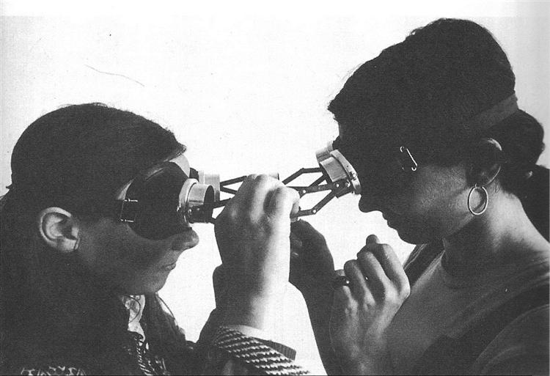
ARTISTs: Jackson 2Bears, March 2019 Lygia Clark, Óculos, 1969

Day 1: dare to know (sapere aude!)
Image by Helen Chadwick Meat Lamp Series 1989 with permission from Zelda Cheatle Gallery
10:00 - 12:30: Introductions: led by Johnny and Despina
Please Bring an Object that has in-formed who you are
12:30 - 1:30: Lunch Break
1:30 - 4:00: Seminar led by Johnny
Consider this Fragment from Nietzsche and then ask yourself: in what way does it create a ‘ground’ for making something ‘true’? [Acorns and Trees and a small point about TELOS]
☞ Nietzsche, Friedrich: Human, All Too Human. As below:
§629: “Conviction is the belief that in some point of knowledge one possesses absolute truth. Such a belief presumes, then, that absolute truth exists; likewise, that the perfect methods for arriving at them have been found; finally, that every man who has convictions makes use of these perfect methods. [...] The countless people who sacrificed themselves for their convictions thought they were doing it for absolute truth. All of them were wrong [...] If only all those people who thought so highly of their conviction, who sacrificed all sorts of things to it and spared neither their honour, body nor life in its service, had devoted only half of their strength to investigation by what right they clung to this or that conviction, how they had arrived at it, then how peaceable the history of mankind would appear! How much more would be known!” (p. 261-62).

Themes:
- What does it mean to ‘dare to know’ (sapere aude!)
- How is this connected to (a) ‘telos’ (b) ‘discourse’ and (c) erotic practice? (ground, surface, movement, ‘reason’)
- How do we get from Habeas Corpus to Habeas Viscus (question of the ‘exit’, ‘logic of sense’)
- Urgency to Think (and feel)

Essential Encounter

[must reads]
- Foucault, Michel. “What is Enlightenment?” in The Foucault Reader, ed. Paul Rabinow, trans. Catherine Porter (New York: Pantheon Books, 1984), 32–50. (RR)*
- Immanuel Kant. “Beantwortung der Frage: Was ist Aufklärung?: An
answer to the Question: What is Enlightenment? (1784).” In Mary J. Gregor
(ed.), Practical Philosophy. Trans. Mary J. Gregor. Cambridge: Cambridge
University Press, pp. 11–23. (RR)
- X-Ray Audio: The Documentary

Extra Readings/Writings/Senses/Octopus [but only if you wish to do so!]

- Anagost, Adrian. “Lygia Clark: Presence, Silence, Intimacy, Duration: Lygia Clark’s Relational Objects,” http://pelicanbomb.com/art-review/2017/presence-silence-intimacy-duration-lygia-clarks-relational-objects” May, 10, 2017, accessed September 3, 2019
- Hantel, Max. "What Is It Like to Be a Human?: Sylvia Wynter on Autopoiesis," philoSOPHIA 8, no. 1 (2018): 61-79. https://muse.jhu.edu/ (accessed September 4, 2019).
- Erik Satie: Pianoless Vexations , Gymnopédies
- Kai Frobb. “Sublation,” accessed September 2, 2019
- Laurie Anderson http://www.ubu.com/sound/anderson.html
- McKittrick,Katherine, ed. “Sylvia Wynter: On Being Human as
Praxis”. Durham: Duke University Press, 2015.
Miles Davis, A Tribute to Jack Johnson
- Musser, Amber Jamilla. “Sensual Excess: Queer Femininity and Brown Jouissance”. New York: NYU Press, 2018.
–––– “Habeas Viscus: Racializing Assemblages, Biopolitics, and Black Feminist Theories of the Human”
- Stengers, Isabelle. Gaia, the Urgency to Think (and Feel), “https://osmilnomesdegaia.files.wordpress.com/2014/11/isabelle-stengers.pdf,” accessed September 2, 2019

*(RR) indicates you can find this text in the reading room

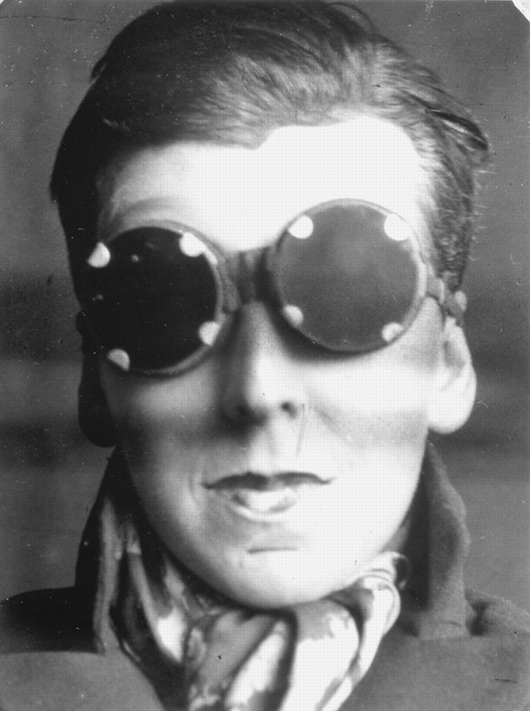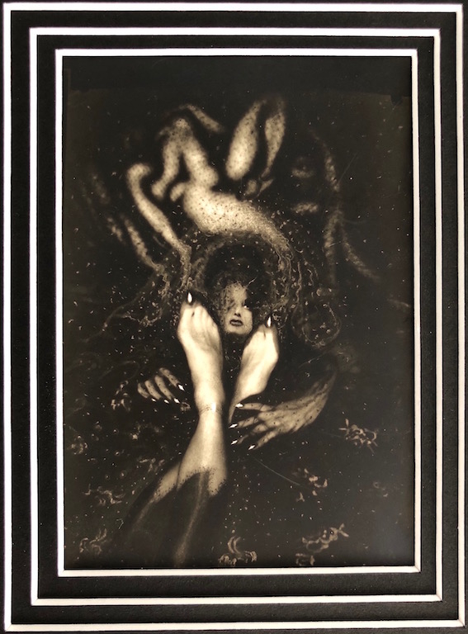
Claude Cahun, Self-Portrait, 1929 Pierre Molinier, Rêve – Les pieds amoureux,1968

Day 2: second skin (technologies of)
Sexual subtleties and secrets: Morning Seminar led by Johnny
Materialities (logics of skin): Afternoon Seminar led by Despina

Consider each photo above and ask yourself the question: how is this a ‘technology of skin’?

In the morning with JG
- Sexual subtleties (and not so subtle) secrets (from Cahun to Molinier to Muñoz to Barad)
- What is called ‘the unconscious’, the ‘consciousness’, ‘ego’, ‘id’, gender, (emphasis on consciousness as a projection and not introspection); condensation and displacement - Dreamwork, metaphor / metonymy
- When is ‘skin’ equal to knowledge, when is it equal to discourse, when is it intelligence, when is it just ‘skin’.
- skin as assemblage - moves from rhizome to tensor

In the afternoon with DP Materialities (logics of skin)
“A Thousand Plateaus: Capitalism and Schizophrenia” by Gilles Deleuze and Félix Guattari, p.150): “A Body without Organs: At any rate, you have one (or several). It's not so much that it preexists or comes ready-made, although in certain respects it is preexistent. At any rate, you make one, you can't desire without making one. And it awaits you; it is an inevitable exercise or experimentation, already accomplished the moment you undertake it, unaccomplished as long as you don't. This is not reassuring, because you can botch it. Or it can be terrifying, and lead you to your death. It is non-desire as well as desire. It is not at all a notion or a concept but a practice, a set of practices. You never reach the Body without Organs, you can't reach it, you are forever attaining it, it is a limit. People ask, So what is this BwO?—But you're already on it, scurrying like a vermin, groping like a blind person, or running like a lunatic: desert traveler and nomad of the steppes. On it we sleep, live our waking lives, fight—fight and are fought—seek our place, experience untold happiness and fabulous defeats; on it we penetrate and are penetrated; on it we love.”

- What can a body do?
- Bodies as Flesh, Bodies in Space, Intra-acting, Spect-acting Bodies
- Algorithmic bodies & Digital Phenotypes
- Taxonomies & Ontologies
- Technologies as (of) second skin

Essential Encounter [must reads]

- Barad, Karen. “TransMaterialities: Trans*/Matter/Realities and Queer Political Imaginings.” GLQ: A Journal of Lesbian and Gay Studies 21, no. 2–3 (June 1, 2015): 387–422.
- Crawford, Kate and Paglen, Trevor. “Excavating AI: The Politics of Training Sets for Machine Learning” (September 19, 2019), (accessed September 19, 2019)
- Lyotard, Jean Françoise. “Libidinal Economy”. Trans. Iain Hamilton Grant. London: The Athlone Press, 1993.( read chapter: “The Great Ephemeral Skin,” pp.1-32) (RR)

Extra Readings/Writings/Senses/Octopus [but only if you wish to do so!]

- Braidotti, Rosi. “The Critical Posthumanities” (video: 1:13:14 mins)
- Braidotti, Rosi. “The Posthuman.” Politi Press, 2013 (RR)
- Deleuze, Giles. “What is the Creative Act” (video: 46:58 mins)
- Foucault, Michel. “The Order of Things: an Archaeology of the Human Sciences.” London; New York: Routledge, 2002. (read Chapter: “Classifying,” pp.136-171) (RR)
- Freud, Sigmund, The Dream Work / Secrets https://www.freud.org.uk/learn/discover-psychoanalysis/the-interpretation-of-dreams/the-dream-work/
- Haraway, Donna. “Tentacular Thinking: Anthropocene, Capitalocene, Chthulucene”, e-flux, Journal #75 - September 2016.
- Hauser, Kitty. “The Fingerprint of the Second Skin; or, How the FBI Illuminated the Prehistory of A Pair of Denim Jeans,” Journal of Material Culture 9, no. (November 1, 2004): 293–313. (RR)
- Haviland, John B, “Guugu Yimithirr and Cardinal Directions,” Ethos 26(1), (March 1998), pp. 25-47
- Hayles, Katherine. “How We Became Posthuman: Virtual Bodies in Cybernetics, Literature, and Informatics”. Chicago, Ill: University of Chicago Press, 1999. (read chapter 9: “Narratives of Artificial Life”)
- Hayles, N.K, and Tony D Sampson. “Unthought Meets The Assemblage Brain,” Capacious, Vol. 1, No. 2 (2018), acessed September 3, 2018
- LeRoy, Xavier Product of Circumstances (youtube, 1:29:55 min)
- LeRoy, Xavier. Self (Unfinished)
- Lyotard, Jean Françoise. “Libidinal Economy”. Trans. Iain Hamilton Grant. London: The Athlone Press, 1993.( read chapter: “The Great Ephemeral Skin,” pp.1-32) (RR)
- Man, Kingson and Damasio, Antonio. “Homeostatically Motivated Intelligence for Feeling Machines,” Towards Conscious AI Systems Symposium, CA, March 25-27, 2019
- Matheson, Rob. “Sensor-packed glove learns signatures of the human grasp,” MIT News Office, May 29, 2019
- Osthoff, Simone. "Lygia Clark and Hélio Oiticica: A Legacy
of Interactivity and Participation for a Telematic Future." Leonardo 30,
no. 4 (1997): 279-289. https://muse.jhu.edu/ (accessed September 4, 2019). (RR)
- Tschumi, Bernard. “The Manhattan Transcripts,” John Wiley & Sons, 1994 (RR)
- Virilio, Paul, and Sylvère Lotringer. 2002. Crepuscular Dawn. Los Angeles: Semiotext(e). (pp.95-109). See also: Steve Mann and Mediated Reality (youtube video: 3:24 min)

Photograph: Anthony Wallace/AFP/Getty Images, David Burrows, Lucky Face Recognition Pig, 201
September 2019 Watercolour, acrylic and varnish on paper

Day 3: Listening Networks (from technosphere surveillance to listening networks)
In the morning with Johnny G , In the afternoon with David Burrows

Themes:
- What is a ‘network’? How does it connect with circulation/distribution/fractals?
- Why is ‘listening’ part of the resistance?
- What is the Panopticon (old and new) - from Bentham to the Technosphere
- What is called populism (and how does this connect with ‘hegemony’, ‘equivalence’ and ‘difference’
- The least possible ‘evil’ (665)

Essential Encounter [must reads]

- Bentham, Jeremy. “The Panopticon Writings”. Ed. Miran Bozovic (London: Verso, 1995). pp. 1-8. (RR)
- Weizman, Eyal. “The least of all possible evils: humanitarian violence from Arendt to Gaza”. London: Verso, 2011. Chapter 1 (RR)

Extra Readings/Writings/Senses/Octopus [but only if you wish to do so!]

- Browne, Simone. “Introduction and other Dark Matters, “Notes on Surveillance Studies: Through the Door of No Return,” in her Dark Matters, On the Surveillance of Blackness, (Duke: 2015), pp. 1-62. (RR)
- Galič, M., Timan, T. & Koops, BJ. Philos. Technol.Bentham, Deleuze and Beyond: An Overview of Surveillance Theories from the Panopticon to Participation, pp 29-39
- Amer, Karim and Noujaim Jelane. Documentary, The Great Hack, 2019 (documentary about Cambridge Analytica)
- Fisher, Mark. 2009. Capitalist realism: is there no alternative? London; New York: Verso, 2011.(RR)
- Laclau, Ernesto, and Chantal Mouffe. “Hegemony and Socialist Strategy: towards a radical democratic politics”. London: Verso, 2001. (RR)
- Lyotard, Jean Françoise. Libidinal Economy. Trans. Iain Hamilton Grant. London: The Athlone Press, 1993, “The Tensor,” pp.43-95 (RR)
- Marx, Gary R. What’s New About the “New Surveillance”? Classifying for Change and Continuity, Surveillance & Society 1(1): 9-29
- Riefenstahl, Leni. Documentary, Triumph of the Will, 1935
- Truffaut, François. Film, Fahrenheit 451, 1966 (based on the Ray Bradbury novel)
- Wenders, Wim. Film, The End of Violence, 1997
- Wiener, Norbert. “The Human Use of Human Beings?”
- Zuboff, Shoshana. The Age of Surveillance Capitalism: The Fight for the Future at the New Frontier of Power. London: Profile Books, 2019. (chapter on “The Reality Business”)

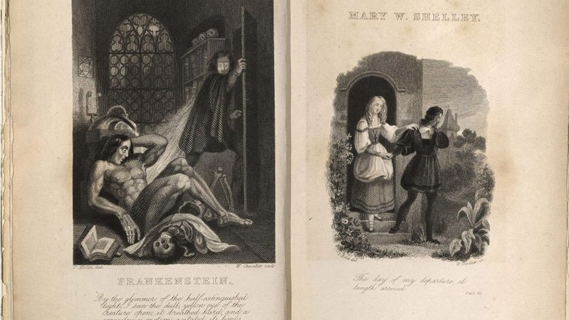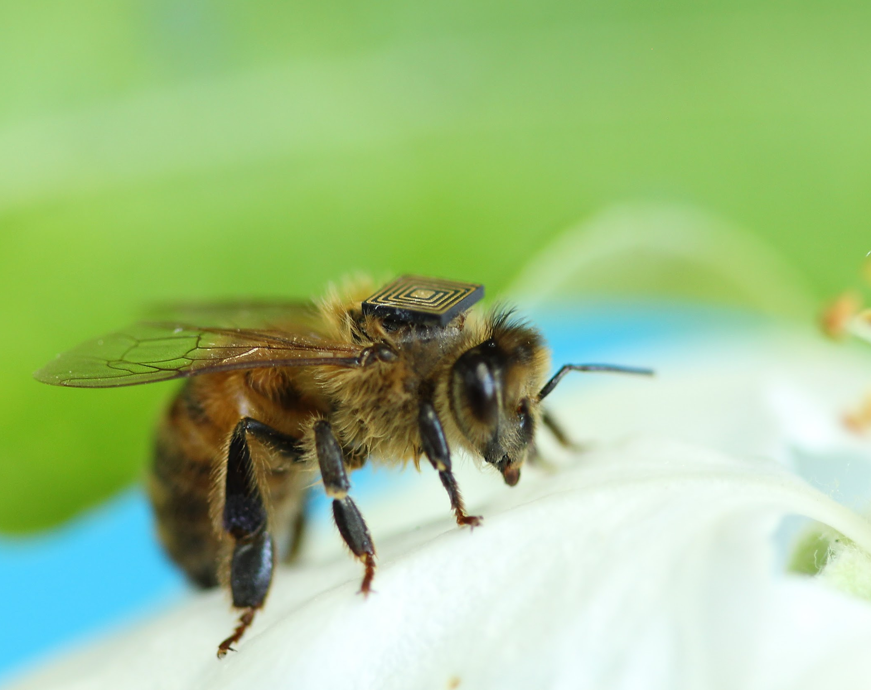 The opening page of Mary Shelley's 'The Modern Prometheus' Bees fitted with tiny sensors as part of ‘swarm sensing”

Day 4: DISTRIBUTED INTELLIGENCE

Meet at front of Dyson at 9.00 where we will go to the 16th century Charleston House located in Kent - here is where in 1916 Vanessa Bell, Duncan Grant and his friend/lover David Garnett, as well as a number of painters, poets, radical thinkers came together to play and to write for over 60 years. The Bloomsbury Home of Art and Ideas! Bring cameras, sacks, warm clothes. We will then take a ride to visit Pooh Bridge. A small stick is required.

Amongst the debris of art, politics, story telling and history, we will ponder the notion of Quantum Intelligence (as both a method, a way of thinking and a paradigm shift. Thomas Kunh’s The Structure of Scientific Revolutions

Essential Encounter
- Godfrey-Smith, Peter. “Other Minds: The Octopus, the Sea, and the Deep Origins of Consciousness”. New York: Farrar, Straus and Giroux, 2016 (RR)
- Haraway, Donna. “Staying With the Trouble: Making Kin in the Chthulucene,” lecture at the San Francisco Art Institute, April 25, 2017. (video, 1:31:00 mins)
- Milne, A.A. The House of Pooh. [the Pooh Bridge]

Extra Readings/Writings/Senses/Octopus [but only if you wish to do so!]
- Bunz, Mercedes and Meikle, Graham. The Internet of Things. (2017). Polity Press, 2017
- Kuhn, Thomas. The Structure of Scientific Revolutions. (RR) Nietzsche, Friedrich. “Nietzsche: The Gay Science: With a Prelude in German Rhymes and an Appendix of Songs”. Edited by Bernard Williams. Translated by Josefine Nauckhoff and Adrian Del Caro. Cambridge Texts in the History of Philosophy. Cambridge: Cambridge University Press, 2001 (RR)

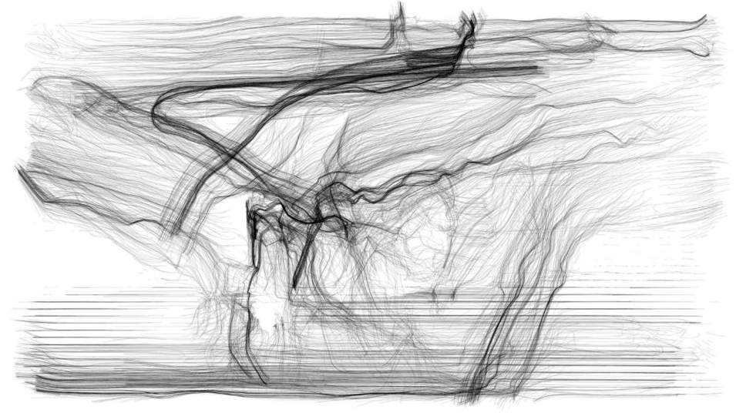
Pussy Riot two prints on paper, julian palacz, 2014

Day 5: mesh (half OFFsITE)
Morning: Camden Arts Centre: Vivian Suter
Afternoon: RADICAL mATTER and your work: connections

Essential Encounter
Zacharopoulou, Despina. Radical Matter Literature Review (RR)
UbuWeb

Extra Readings/Writings/Senses/Octopus [but only if you wish to do so!]
Satz, Aura. Nightvisions (London: 2018) (RR)

Voila! That’s it!! Hope you have a few wild imagining encounters!!

Please remember: RADiCAL mATTER comprises 20% of your total School unit - so make sure you participate 100%

