Designing Design for Safety: How emergent methods indicate new safer future design practices

Hall, Ashley*a; Ferrarello, Laura a; Anderson, Paul a; Cooper, Rachel b; Ross, Chris c.

a Royal College of Art, London, UK

b Lancaster University, Lancaster, UK

c QinetiQ, UK

* ashley.hall@rca.ac.uk

A series of research projects by the authors has supported an understanding of a new type of design practice geared towards ensuring a safer relationship between people and technologies in a number of contexts including rapidly changing dynamic environments. Here we report on the research methods, tools and approaches that were created and adapted for investigating what emerged as a new approach for design in dealing with human behaviours and complex relations between physical and digital technologies. In particular these methods were used to research across both applied and strategic focus areas ranging from saving lives at sea to a future safety foresight review. A particular consideration was to ask whether current design principles and practices were adequate in order to tackle mature and emerging design for safety risks from local to global levels. Our methods emerged across a series of projects in a grand challenge and a foresight review. The first aimed to tackle loss of life at sea while the foresight review investigated the more specific strategic interdisciplinary role of design in tackling major future global risks. We report here on the thinking involved in developing the methods, how these were adapted and changed throughout the process and report on findings at key stages alongside insights from the data captured. The results from this research have been significant in helping to frame what may become a new approach to design practice, one that is capable of enabling change for increasing safety through new methods, practices, ethics and cultures.

Keywords: design methods; design for safety, global risks, methodology, design risks

Introducing design for safety

Safety and reducing risk are considered intrinsic aspects of industrial design yet when we look at the design methods and approaches used for training designers and used in industrial practice it is difficult to identify specific methods of designing for safety. Products and designs are tested to ensure they are safe for use either during or after a design and prototyping process. In this respect the design is tested and refined according to its failure to meet standards, as such design becomes an application of conformance to top down safety procedures and policies. In engineering we are familiar with the concepts of designing for safety and safety factors being applied to structures, however these methods are used in a specific context and do not include the full range of factors that concern design and designing. They tend to be largely concerned with the development of technical products and systems and assume that humans’ interface in predicted ways that can be prescribed in advance. The type of design for safety that concerns us here, in effect the knowledge gap, is design for safety as a holistic activity that is strategic in its aims and anticipatory in both recognising and responding to complex dynamics between shifting human and environmental states in the presence of digital and physical technologies.

The Royal College of Art (RCA) was commissioned by the Lloyds Register Foundation (LRF) to explore safety in the broader context of design, initially through a grand challenge focussing on tangible implementable solutions to saving lives at sea and on rivers, and a follow-on strategic Design for Safety (DFS) foresight review that investigated the role and readiness of design in tackling the top major future global risks. This was to be the first design research projects commissioned by the LRF and that aimed to show how tangible and strategic design led innovation can bring new insights for a safer future. Comparing these projects allowed the research team to develop a perspective that identified evidence at both applied and strategic levels for a new focus on future design methods and practices positioned in a landscape of complex combinations of environmental change, human behaviour and technology revolution. The role of the authors was in developing, delivering and guiding the design research projects with authors Cooper (Lancaster University) and Ross (QinetiQ) providing academic and industrial guidance and oversight as co-chairs for the DFS foresight review.

In effect, a repositioning of the relationship between design and safety is proposed at a fundamental level so that safety itself is designed and practiced in a way that can respond more efficiently to current and future challenges. Our focus in this paper is to describe and provide evidence for how our emerging notion of design for safety as a new practice has itself been developed from design research methods and practices. Many of the methods and combinations of methods resulted from emergent new needs deriving from action, observation, discussions and discoveries rather than prescriptive pre-specification of methods. The pattern recognition of methods that emerged from the research is described here and in many ways is a work in progress. We do not make a claim that we have universally identified a new field for practice as many questions remain unresolved. Furthermore, as is the case in these circumstances overlaps with existing methods inside and outside of design exist.

The background meta-level drivers for change that suggest a reappraisal of the relationship between design and safety fall into three main areas. The first involves research in behavioural science and the emerging bridges being made into design where we now have models for designing for behaviour change including COM-B (Mitchie, 2011) and design practices (Lockton, 2010). These have allowed us an insight into the complexities, motivations and triggers that can be applied through design to human behaviour in a way that can enable safer partnerships when engaged in complex system relationships, particularly in the presence of wicked problems (Rittel, 1973; Buchanan, 1992; Conklin, 2006). The evolution of technology itself and its interdependencies on other systems have resulted in risk emerging in unexpected places and the realisation that unknown risks may emerge unexpectedly in the future is a major concern. For instance, as we develop technologies like AI, the working of which are not fully known to software engineers and computer scientists we see that subtle influences like gender and background can result in unconscious biases emerging in alarming instances (Devlin, 2017). Allied to this driver the nature of conflict has changed over time from physical impacts in geographically distinct locations affecting relatively small numbers of people (Beard, 2018) to large numbers of people frustrated or inconvenienced by digital risks impacting diverse locations. Finally, the global context has shifted as climate change and the Anthropocene (Waters*,* 2016) have affected climate balances and new weather patterns have fundamentally changed the nature, level and timing of the risks that we are exposed to in major events. Designing the flexibility, resilience and new perspectives to visualise, locate and manage risk requires new methods and approaches of designing for safety.

Grand Challenge

In 2016 the Lloyds Register Foundation commissioned the Royal College of Art to develop a Safety Grand Challenge research project (Hall, Ferrarello & Kann, 2017a) to develop innovations capable of saving lives at sea and on rivers. The project focused on two issues; the ship’s pilot ladder that for the last 300 years (Hignett, 2012) has been used by port pilots to transfer from pilot vessels to ships and a second project that explored designs capable of responding to the increased demand for future safety on the river Thames by the year 2030 (Fig.1). In order to explore these new design for safety issues, the project considered action research (Lewin, 1946; Hopkins, 1985; Susman, 1983; Kemmis,1988; Venable, 2006; Kemmis, 2007) and participatory design research (Crabtree, 1998; Kensing, 1998; Sanders, 2002; Spinuzzi, 2005; Ivey, 2006; Juhani, 2009; Sanders, Brandt & Blinder, 2010; Simonson, 2013) as potential research methods.

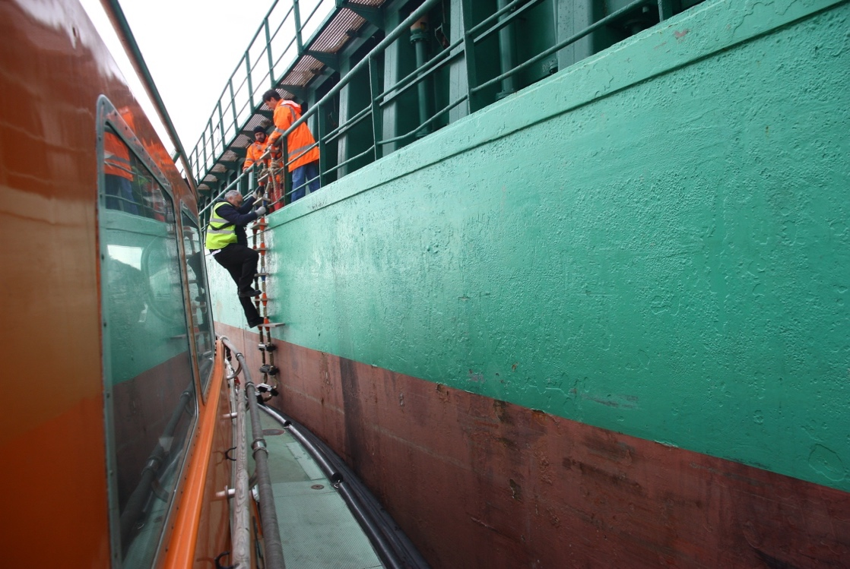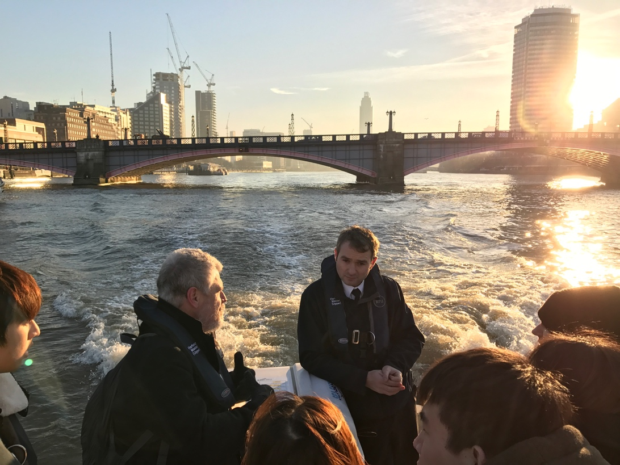

Figure 1. Port of London Authority pilot ladders transfer and Thames 2030 safety field trips

What emerged across the project was the need to blur boundaries and “unsilo” expertise across the collaborative network including designers and researchers. This came about through design acting as a vehicle of engagement, interaction and participation. Design as both strategy and object was mainly perceived by the experts as a mode of changing tangible practices. Nonetheless its intangible strategic value was instrumental and also recognised as potentially supporting cultural change. Under this lens design led a framework of interaction by developing a new methodology to tackle complex design for safety problems and real-life issues.

Although we had identified action research and participatory design research as potential methods, the interaction of these methods only became clear as the project progressed. The pattern of a participatory engaged framework emerged through developing the dialogue amongst experts from the Royal National Lifeboat Institution (RNLI), Lloyd’s Register (LR), the United Kingdom Maritime Pilots’ Association (UKMPA), the International Maritime Pilots’ Association (IMPA), Confidential Hazards Incident Reporting Programme (CHIRP), the Royal Navy and Port of London Authority (PLA), the research team and the 35 postgraduate design and research students working in interdisciplinary groups from across the RCA Schools of Design, Communication, Architecture and Art & Humanities. The outcomes helped introduce new design led innovation connections into the maritime field which supported the development of new concepts for port’s pilots in dealing with safety issues from new perspectives via collaborative methods. One successful method used to identify the need for participatory design was an initial literature review that we thematically analysed to support creative practice rather than academic analysis (Fig. 2). The concept for selecting the topics, sub-topics and themes was driven by the researcher’s industrial design experience and understanding the information, inspirations and knowledge that could support new design innovations.

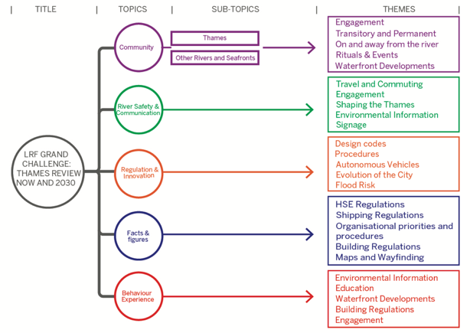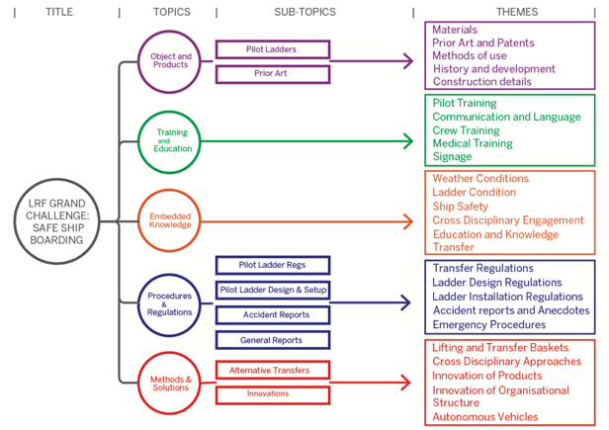

Figure 2. Grand Challenge literature review structure.

The interactions between experts, stakeholders, partners, researchers and students fostered trust and promoted an emerging idea of a new culture of safety through design, whether acting at a strategic or at product level. To achieve this RCA researchers constructed a strategy guided by design research methods that helped gather momentum across the parties involved in the process and gradually gain their trust and participation. Action research emerged through the activities, methodology construction, facilitation, reflection, dialogues and regular design support and critique by the researchers (Fig. 3). This developed knowledge of the topic by observing the pilot’s and Thames river environments as a whole (wellness, stress, eating habits, transfer dynamics, weather, tides, daylight levels, fatigue, equipment, etc.) and visiting key location for field trips including RNLI headquarters and Thames lifeboat station and observing pilot transfers on the Thames via the PLA (Fig.1). Action research helped identify the key research topics to focus on which supported the framework of participatory design. This also helped include the partners, stakeholders and pilots’ experience and develop a strategy that increased their ownership of the project (Ferrarello, Hall, Kann & Hee Lee, 2017). As a result of this, the role of partners, experts and stakeholders moved from the periphery to the very centre of the project. One outcome of action research was the realisation that increasing creative risk could reduce risk to life (Hall, Kann, Ferrarello & Pulley, 2017b), a reflection that in some ways flies in the face of the logic that safety methods should in themselves have little risk attached. Combining action research and participatory research enabled the emergence of our new understanding of design and helped give shape to design for safety, i.e. an applied approach that reframes safety away from product driven solutions and that instead takes account of a much wider set of variable environmental and technological conditions.

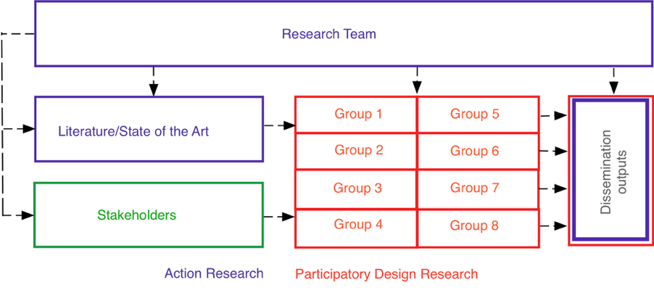

Figure 3. Grand Challenge Research Methods

Alongside action research and participatory design research we also included a number of other interacting design research tools and techniques which in combination allowed us to develop a new perspective on design and safety. The table below (Table 1) captures the findings and impact of each.

Table 1. Grand challenge Methods Analysis

|  |  |  |
| --- | --- | --- |
| Method | Finding | Impact |
| Thematic Literature Review | Extracted 5 themes, sub-themes and topics for each project covering the human to technology risk gap. | Helped design teams quickly source contextual insights and concerns and to use these to support creative methods. |
| Action Research | Capability to iteratively design research and to distil weak from strong design for safety signals by engaging experts. | Helped research team to build, develop and sustain a collaborative relationship between designers, experts and context. |
| Participatory design research | Creative design partnership with experts who became champions of change. | Developed trusted relationships between researchers and experts. |
| Interviews | Navigate existing knowledge to identify the key design topics for tackling risk on water. | Designing and analysing relationship between risks and design potential. |
| Field trips | Experience tangible risk and complex human-machine interactions in changing environments on water | Developed context-aware design solutions that incorporated environmental complexity and changing conditions. |
| Global Pilots Survey | International feedback on the prototypes. | Outline the viability of the prototypes in a global context of different cultures and climactic environments |

The methods culminated in the dissemination of outcomes via seven physical prototypes exhibited at the Lloyds Register Foundation, HMS Wellington IMPA headquarters, Lloyds Register Global Technology Centre in Southampton and the RNLI headquarters in Poole, Dorset. The cross-sector collaborative spirit endures as Dynaweb and Cross Lock System (now Dynalock), two of the award-winning groups have combined their projects after successfully bidding for start-up funding in the InnovationRCA incubator as Helm (Fig. 4). The company combines designers and maritime industry experts as a design for safety platform ensuring that the relationships created by the project develop solutions that tackle real life safety issues in new ways.

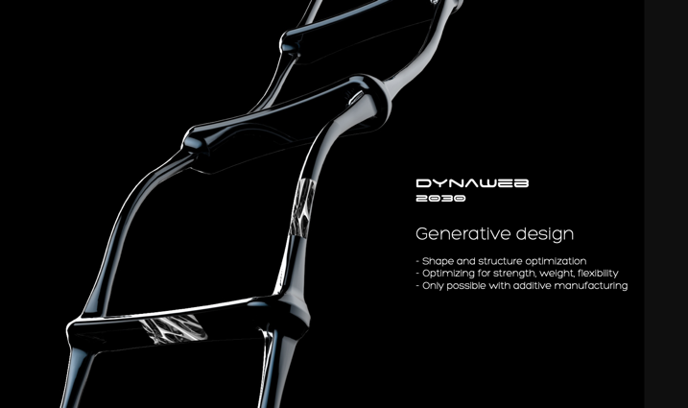 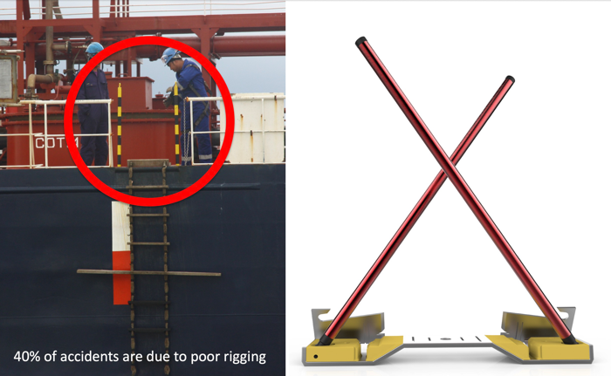

Figure 4. Dynaweb and Cross Lock System combined as the Helm start-up

The Safety Grand Challenge initially began with a practical motivation to develop new safety solutions to save lives at sea and on rivers. However, the approach of allowing methods to emerge and combine has allowed us to reflect and recognise a new potential for how design for safety can be practised. This has been possible through a design for safety research methodology emerging throughout the projects. The combined approach of action research and participatory design and research combined with other tools and techniques listed in Table 1 constructed the design for safety methodology that enabled a new proposed practice for safety.

Foresight Review

Following the successful conclusion of the grand challenge and reflections suggesting new value in how design engages with safety, a Design for Safety Foresight Review (Anderson, Hall, Ferrarello,Cooper & Ross, 2018) was commissioned by the Lloyds Register Foundation in 2017 to investigate the strategic role that design could play in tackling significant future global risks. The foundation has been a major funder in new research and initiatives for tackling risk and safety issues, and as part of this activity has commissioned a series of foresight reviews on a number of subjects ranging from the public understanding of risk through to big data and energy storage (LRF, 2019). The Design for Safety Foresight Review was to be the first to investigate safety from a design perspective. At the centre of this effort was research that explored the opportunities design can address in improving complex future problems between people and technology. In order to achieve this the Foresight Review planned to connect a range of international experts across disciplines and industries to examine the strategic future relationship between design and safety at a global level. This future orientated perspective engaged the understanding of existing and emerging practices together with knowledge and experience of safety from diverse fields. The challenge was to understand how design in the global context of safety could be explored and to consider how this could be investigated across industrial sectors. For this reason, the research looked at the potential learning between emerging and mature industries from a human and technological perspective and selected six representative sectors including: Manufacturing Technologies and Services, National Infrastructure Technologies and Services, Food Technologies and Services, Healthcare Technologies and Services, Transportation Technologies and Services and Consumer Products Technologies and Services.

In order to focus the foresight review the research team developed an initial design for safety statement that served as an initial position aiming at capturing the scope of the review. This was inspired by the findings of the grand challenge that tangibly investigated the interaction of design and safety alongside research and the industrial experiences of the co-chairs (Cooper & Ross) and the research team.

"We believe design for safety enables people and technology to operate safely. Design for safety is the actions taken to ensure that an item, system, system of systems or network is free from adverse impacts on individuals, organisations, communities and the environment, whether these happen as a result of implicit or explicit risks”

This was augmented by a matrix diagram that aimed to capture and visualise the risk relationship between people and technology cross referenced with the potential learning that could be exchanged across emerging and mature industrial sectors (Fig. 5 below).

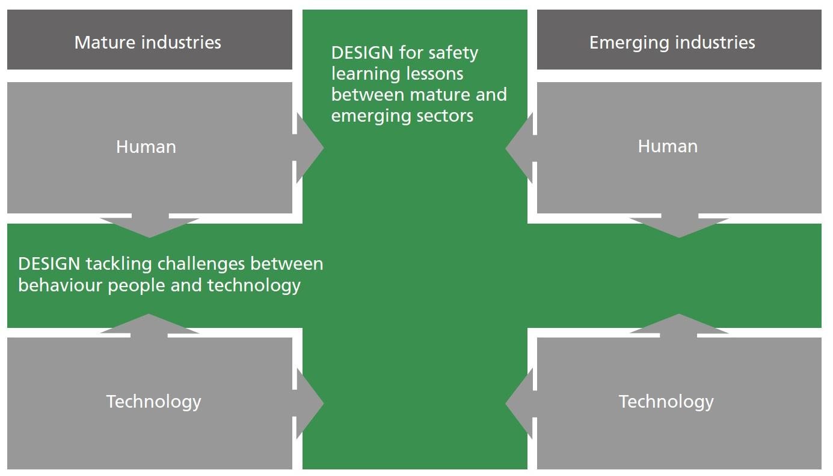

Figure 5. Design for Safety Relationships Matrix

Both the Design for Safety (DSF) statement and matrix were reviewed and developed throughout the foresight review process and functioned as a foundational point of reference to articulate design for safety and its strategic role in relation to industry alongside orientating our network of global experts.

Although we had some success in allowing methods to emerge from practice in the grand challenge the strategic future oriented nature of the foresight review presented a new challenge. One of these was to embrace complexity, whether this was in the form of people, machines, systems or environments. The challenge was to ask if it was possible to test the same set of methods (action research and participatory design research) in a strategic context and build on the design for safety approach that emerged in the Safety Grand Challenge. Following a literature review which pointed towards a major gap in design for safety as a global community of practice (Anderson *et al.*, 2018, p.41) we engaged an international cross section of more than two hundred experts across the six selected sectors through an online questionnaire which allowed us to test insights gained from the literature review in industrial scenarios. The questionnaire helped engage with the experts and identify the knowledge gap that design for safety can tackle to increase safety across sectors. It also identified knowledge gaps and paradoxes in safety procedures across the six sectors globally, as shown in Fig. 6. For instance, Consumer Product experts believe that safety is something they have tackled, while prominent examples of fire risk from washing machines and hair dryers clearly evidence the opposite (Anderson *et al.*, 2018, p.10).

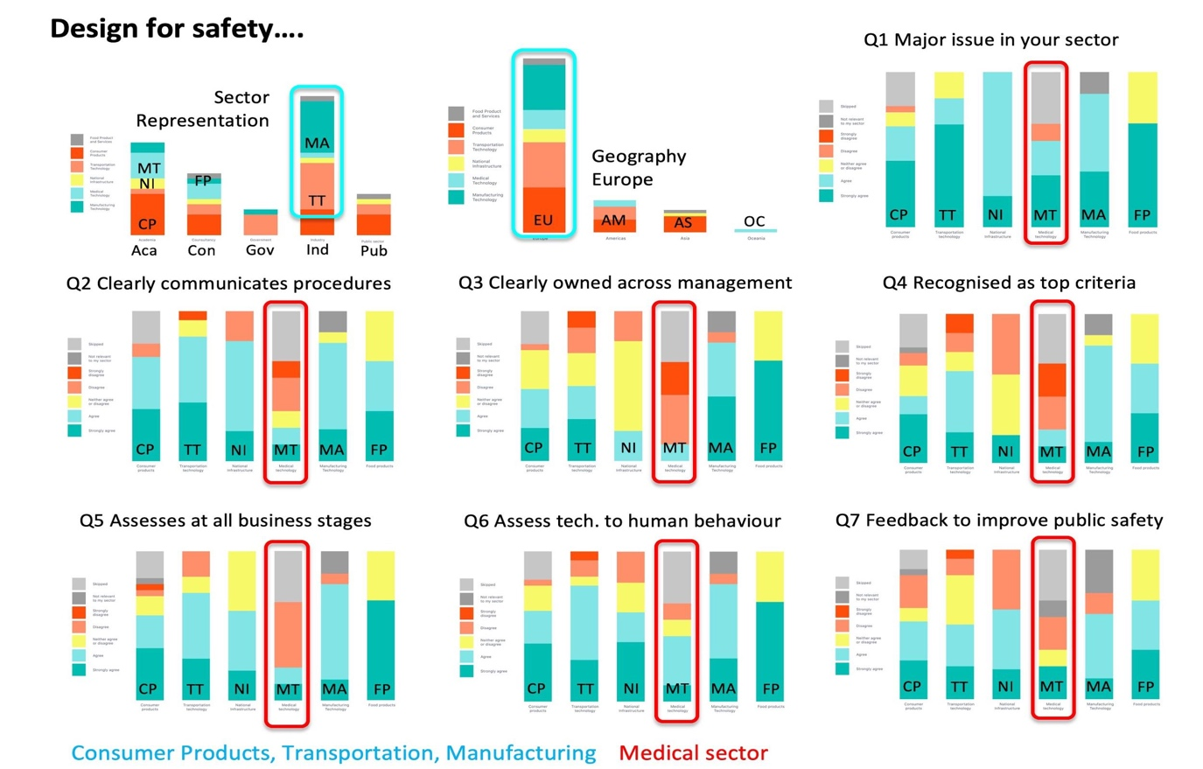

Figure 6. Design for safety questions, data and analysis. CP=Consumer Products, TT=Transport Technologies, NI=National Infrastructure, MT=Medical Technology, MA=Manufacturing Technology, FP=Food Products.

The questionnaire was followed by a symposium where forty selected global experts across the six sectors participated in co-developing (with the foresight researchers) a list of major future design risks and explored their relationship to design.

The symposium was organised around four facilitated activities each of which used a different method to focus future design for safety issues:

* Online questionnaire data review.
* Mapping safety case study examples from each expert to ask where should design operate and what is missing from design.
* Design future scenarios based on future forecasting techniques, which outlined future global risks that cross-sectors experts need to tackle through design.
* Strategic sessions where experts prioritise future design risks.

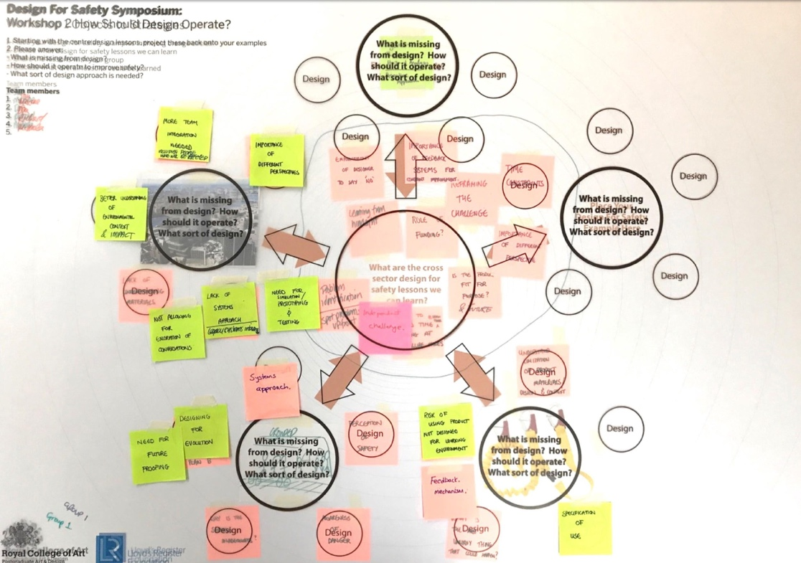

Figure 7. Example of DFS mapping tool exploring issues asking where design should operate.

This facilitated discussions, questioned the prevailing safety culture and promoted the adoption of a new safety culture via exploring what was missing. Under this particular aspect design was not only the action needed to facilitate interactions across participants, design as method, became the communication vehicle that made the changes visible and tangible. An example of this is where experts were asked to bring to the symposium an object representing a design for safety issue in their sector. The mapping tool (Fig. 7) was designed to allow participants to work together comparing and synthesising thinking across disciplines to bring to the surface new and existing relationships between design and safety and to ask fundamental questions around how design operates. These issues were discussed in cross-sector working groups. This exchange of knowledge through tangible objects was an emerging method that enabled a shared language across disciplines via tangible physical examples. Even though safety became tangible through the objects, design for safety as a method took on an intangible form. The objects were perceived as placeholders for further conversations that visibly connected the forecasting of future safety issues.

The review process evidenced the key value that design can play in addressing future global issues and complex risks through the interaction of methods as described in the table below (Table. 2). Through future forecasting techniques, participation and co-design methods evidenced the capability to articulate experts’ thinking across time and space through existing knowledge (Sanders, 2008). In addition, experts across sectors brought their own understanding of design from the individual to a cross disciplinary approach built on a cohesive system of conversations aimed at learning from each other and exchanging knowledge.

Table 2. Foresight Review Methods Analysis

|  |  |  |
| --- | --- | --- |
| Method | Finding | Impact |
| Sector Literature Review | Revealed knowledge gap in global design for safety practices, network, principles and ethics. | Suggested the need for a new approach for design in relation to safety (as captured in the onion diagram below) |
| Action Research | Identified the unknown knows and the DFS paradoxes in the sectors. | Identified the gaps in knowledge across sectors and engaged experts willing to collaborate further in the research. |
| Participatory Design Research | Design for safety future issues, gap in ethics and design practices, confirmed missing global design for safety culture. | Developed and used collaborative tools for issue mapping and forecasting to create a cross-sector future design for safety issues |
| Online Questionnaire | Highlighted difficulty of sector risk self-analysis and comparability across sectors. Healthcare self-analysis of risk highest. | Raised global issues of design for safety across the six selected sectors. |
| DFS Issue Mapping | Outlined the most significant future global issues and relationship to design. | Enabled cross sector and cross disciplinary dialogues on design for safety |
| Future Forecasting Design for Safety Issues | Used design for safety as a probe to tackle future global risks. | Provided future contextual topics to enable discussions across human-technology risk gaps. |

The findings and recommendations from the foresight review were derived from the methods we applied and can be listed under the following points:

* The necessity of developing a DFS observatory that can help monitor knowledge and insights across sectors, in particular within emerging fields and global issues.
* The need to develop training methods that different sectors can implement. This could develop an educational approach where new generations can be trained to develop design methods that tackle future risks.
* Growing a global design for safety network initiated in the review and use this as a basis for knowledge exchange.

The findings from the methods employed across the research project are:

* The balance designed across Action, Participatory and Co-Design methods, along with the other techniques listed in Table 2, helped develop focus, as well as co-define solutions participants could use to focus design for safety issues across disciplines.
* The impact the research had on participants evidences the validity of working with design research methods (which in this case defined design for safety) to tackle complexity aimed at social change at a strategic level.
* Engaging experts across the process shaped the research methodology from existing knowledge mediated through design methods and a combination of tangible and strategic design.

These findings are collected under a common umbrella, which constructs the DFS principles that are deliberately cross sector in their scope. The main overarching principles (Anderson *et al.*, 2018, p.36) are: Design for Safety is environmentally sustainable, Design for Safety actively reduces societal risk, Design for Safety achieves these through the holistic delivery of its outputs. The principles proposed by the review are preliminary and need testing and development through practice, however they act as guideline to navigate the design for safety journey from sector activity via a culture of design for safety ethics and practice to achieve safer design. Figure 8 illustrates the design for safety gap between the relationship of industrial sectors to design for safety culture, towards safer designs.

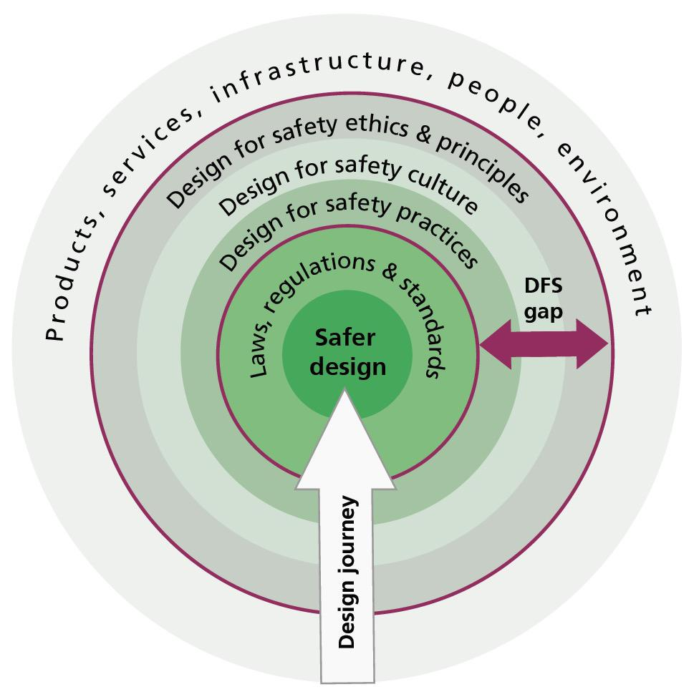

Figure 8. Onion diagram illustrating the design for safety knowledge gap of ethics and principles, cultures and practices between technology and people and safer design.

Findings and Discussion

The design for safety methodology emerged from a combination of recognising the emergence of existing design methods and new tools that were developed in response to research needs. This allowed us to explore the value of design for safety as a new approach for empowering people and providing increased cross disciplinary agency to tackle complex dynamic systems, like safety at sea and risks from consumer products to give just two examples. Design for safety seamlessly engaged experts across sectors in the discussions and created new bridges across boundaries in the form of good practice, successes and failures. This methodology has allowed design research to begin engaging with the complexity of human behaviour for strategically questioning how we deal with the top future global safety issues that we identified from a design perspective.

Methods included future forecasting scenarios to develop safer design interventions that explore the context. Field trips, symposia and workshops were also key methods to facilitate synergy between the parties. Hence both projects succeed in mapping existing knowledge and valuing the exchange for further studies. As a result of the practical and tangible outcomes the grand challenge succeeded in generating design impact in the short term, whereas the foresight review is projective. By working with cross-sectors experts we evidenced the need of new design methods with a specific safety focus that are capable of moving across industries tackling cross-sector safety issues.

The researchers recognised action research and participatory design research as higher-level research methods that emerged during the grand challenge project and also during the foresight review. In the grand challenge these methods were relatively distinct as participatory design applied to prototypes developed in the four ladder projects and three River Thames 2030 design projects. Whereas the iterative process of network generating, facilitation and participant observation by the design research team over an extended period of nine months emerged as action research of a more social and systemic nature. In contrast the foresight review activities were blended and we can see a stronger action research pattern from sourcing and generating the global partner network facilitated through participatory events knitted into the symposia. The lack of tangible artefact generation in the foresight review makes it more difficult to claim a distinction between action and participatory methods and this aligns very much with the findings of Foth and Axup (2006) who identify a significant overlap between both. The interaction and overlaps between action driven and participatory methods facilitated the creation of a new platform for creative participation focussing on an interdisciplinary approach to designing safety and enabling change. The diagram in Figure 9 below captures the DFS methodology flow illustrating the relationships between the tools and methods between both projects showing how insights have informed the knowledge gaps in the findings.

The recognition of design for safety as a potential new culture of practice emerged between the grand challenge and foresight review and was confirmed by a literature review. This evidenced the need for defining new design methods capable of tackling safety through a lens take encodes environmental variability, behavioural differences and unforced errors. Nonetheless there is further research to be done to be able to articulate the limitations across different fields, in particular at the implementation stage. The contrast between the applied nature of the grand challenge compared to the future strategic goals of the foresight review created the space, differences and comparisons that allowed a view to emerge that connected gaps in current practices to the need for a new global community of practice.



*Figure 9. Design for Safety Methodology Flow illustrating how methods have interacted to generate findings that articulate the knowledge and capability gaps.*

Conclusions

Designing design for safety has described how we developed a methodology in action that identified the need for new design methods that are able to tackle safety issues and challenges through a new global community of practice underpinned by ethics, principles, methods and cultures of design for safety. This methodology is the result of a process that understands human behaviour and increased risk leading to errors in the practice of safety procedures when we assume that humans have to interact with technology through fixed sets of instructions, regulation and practices. When humans interact with technology in complex changing environments either as result of unforeseen circumstances, variable behaviours or environmental change then risks can increase to unacceptable levels. As new complex ‘black box’ technologies like AI are introduced into dynamically changing environments we need new practices and methods to foresight risk and mitigate this through new creative design methods.

Both the grand challenge and the foresight review illustrate how design for safety enables the definition of a new culture of safety that supports a holistic observation of people in their working environment. Factors playing a role in safety environments list a range of elements including wellness, weather, behaviour patterns, etc. By bringing the human to the centre, the grand challenge and the foresight review outlined the importance of responsibility that each individual at any level needs to take to respond to risky events. This acknowledges the need of universal design for safety principles that are applicable to different sectors and that can be adopted globally to foster a culture that discusses issues in place of delegation. The design for safety methodology asks new ethical questions from experts across sectors working at the intersection of people and technology.

Reviewing across both projects we uncovered the need for a new design for safety culture, principles and practices. This evidences that methods for DFS practice need to be developed for engaging specifically for the variability of human behaviour in responding to environmental and technological complexity. Future design for safety methods will need to put safety at the centre of practice rather than consign it to prototype testing stages or assigning it to other disciplines. At an applied level we will need to understand how to envision safety impacts, evaluate the balance between creative risk taking and safety gains, and how models of behaviour change can interface with safety. At a global scale design for safety methods will need to collaborate with international agencies and other domains in order to deliver the creative variety required to contribute to global safety issues ranging from climate change and food security to conflict and migration. The future will ask for major contributions from design in solving global safety problems, our research has found that design is wanting in this regard.

References

Anderson, P., Hall, A., Ferrarello, L., Cooper, R., Ross, C., (2018) *Foresight Review on Design for*

*Safety*, Lloyds Register Foundation, London. LRF, Retrieved 15th February 2019,

https://www.lrfoundation.org.uk/en/publications/

Beard, S., (2018) Is There Really Evidence for a Decline of War? In *OE Research*, Retrieved 10th

February 2019 <https://oefresearch.org/think-peace/evidence-decline-war>

Buchanan, R., (1992) Wicked Problems in Design Thinking, *Design Issues*, Vol. 8, No. 2, (Spring), pp.

5-21.

Conklin, J., (2006) "Dialogue mapping." *Building Shared Understanding of Wicked Problems. West*

*Sussex, England: John Wiley & Sons*.

Crabtree, A., (1998), Ethnography in Participatory Design, *Computer Professionals Social*

*Responsibility*, pp. 93-105.

Devlin, H., (2017) Retrieved 10th February 2019

https://www.theguardian.com/technology/2017/apr/13/ai-programs-exhibit-racist-and-sexist-

biases-research-reveals

Ferrarello, L., Hall, A., Kann, M., Hee Lee, C., (2017), Collaborating Design Risk, *IASDR Conference*,

November 2017, Cincinnati, USA.

Foth, M., & Axup, J., (2006). Participatory Design and Action Research: Identical Twins or Synergetic

Pair? In Jacucci, Gianni, Kensing, Finn, Wagner, Ina, & Blomberg, Jeanette (Eds.)

*Participatory Design Conference 2006: Expanding Boundaries in Design*, August 1-5, Trento, Italy.

Hall, A., Ferrarello, L., Kann, M., (2017a) Safety Grand Challenge: *Safe ship boarding and Thames*

*safest river 2030*, Royal College of Art, London, ISBN: 978-0-9561364-3-5

Hall, A., Kann, M., Ferrarello, L., Pulley, R., (2017b), Encouraging Creative Risk to Reduce Risk to

Life, *Engineering and Product Design Education Conference*, Oslo, Norway, September 2017.

Hignett, H. (2012). 21 Centuries of Marine Pilotage: *The History of the United Kingdom Maritime*

*Pilots’ Association,* (Jeremy Mills Publishing, UK).

Hopkins, D., (1985) A Teachers Guide to Classroom Research, Philadelphia: Open University Press.

Ivey, M. et al, (2007) EAD'7, Giving Voice to Equitable Collaboration, *Participatory Design*

*Research*.

Juhani, L. & Venable, J., (2009) Action Research and Design Science Research - Seemingly Similar

but Decisively Dissimilar, 17th European Conference on Information Systems.

Kemmis, S., McTaggert, R., (1988), *The Action Research Planner*, Deakin University Press.

Kemmis, S., McTaggart, R., (2007), *Participatory Action Research*, in Y. Denzin & N. Lincoln

Kensing, F. & Blomberg, J., (1998), Participatory Design: Issues and Concerns, *Computer*

*Supported Cooperative Work* (7), pp. 167-185.

Lewin, K. (1946). Action research and minority problems. *Journal of Social Issues, 2, 4,* pp. 34-46.

Lockton, D., Harrison, D., Stanton, N., (2010), Design For Behaviour Change, *Advances in*

*Psychology Research* 67/69, Nova Science Publishers, Editor: A.M. Columbus.

LRF (2019) Lloyds Register Foundation, Retrieved March 14th 2019.

https://www.lrfoundation.org.uk/en/publications/

Michie, S., M van Stralen, M., West, R., (2011) The behaviour change wheel: A new method for

characterising and designing behaviour change interventions, *Implementation Science.* 2011;

6: 42. Published online 2011 Apr 23. doi: 10.1186/1748-5908-6-42

Rittel, H.W.J. & Webber, M.M. *Policy Sci* (1973) 4: 155. <https://doi.org/10.1007/BF01405730>

Sanders, E. 2002, From User Centred to Participatory Design Approaches, in J. Frascara (ed.),

*Design and the Social Sciences*, Taylor & Francis Books.

Sanders, E.B.N., Stappers, P, J., (2008) Co-creation and the new landscapes of design, *CoDesign*,

4:1, pp. 5-18, DOI: [10.1080/15710880701875068](https://doi.org/10.1080/15710880701875068)

Sanders, E., Brandt, E. & Blinder, T., (2010) A Framework for Organizing the Tools and Techniques

of Participatory Design, Participatory Design Conference.

Simonsen, J. & Robertson, T., (2013), Participatory Design, Routledge.

Spinuzzi, C. (2005) The Methodology of Participatory Design. *Technical Communication*, 52, 163-174.

Susman, G. & Morgan, G. 1983, Action Research: A Socio Technical Systems Perspective, in *Beyond*

*Method: Strategies for Social Research*, pp. 95-113.

Venable, J., (2006), The Role of Theory and theorizing, *Design Science Research*, DESRIST.

Waters, C. *et al (*2016), The Anthropocene is functionally and stratigraphically distinct from the

Holocene, *Science* Vol 351, Issue 6269.

About the Authors:

**Ashley Hall:** Ashley is Professor of Design Innovation at the Royal College of Art where he leads postgraduate research for the design school and the MRes in Healthcare Design. Ashley researches innovation methods, experimental design, design pedagogy, globalisation design and cultural transfer.

**Laura Ferrarello:** Dr Laura Ferrarello is a Senior Tutor and leads the MRes Design Pathway in the design school. Laura’s research investigates the social dynamics between digital and physical space/systems/interfaces, as generated by people’s experience of technology.

**Paul Anderson:** Professor Anderson is Dean of the School of Design at the Royal College of Art. He conducts leading-edge research into fundamental human computer interface issues associated with 3D interfaces, haptics, 3D sound and gesture-based interaction supporting real-time 3D visualisation.

**Rachel Cooper:** Rachel Cooper OBE is Distinguished Professor of Design Management and Policy at Lancaster University. She is Director of Imagination Lancaster, an open and exploratory design-led research centre and also Chair of Lancaster institute for the Contemporary Arts.

**Chris Ross:** Chris Ross is Chief Naval Architect at QinetiQ with extensive experience of complex physical and digital technology platforms.

**Acknowledgement:** We would like to kindly acknowledge funding awarded by the Lloyds Register Foundation for the Saving Lives at Sea Grand Challenge and the Design for Safety Foresight Review.