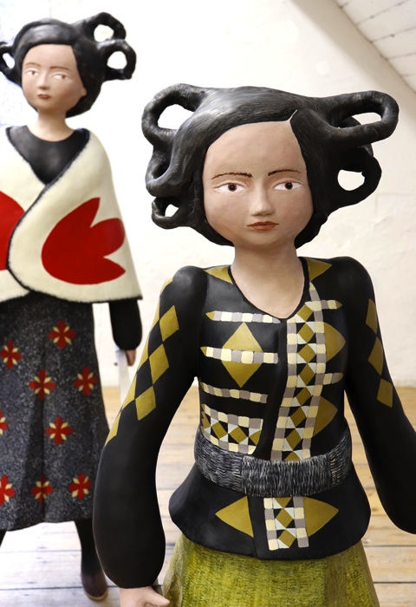
Denise de Cordova

The Materiality of Mild Fear
Deep Wood Women and Women Who
Have Incidents with Animals

Standpoint Gallery

Exhibition: 5 - 26 April 2019
Private view: Thursday 4 April 2019, 6-8:30pm

In her upcoming exhibition at Standpoint Gallery, Denise de Cordova presents a series of imagined beings developed from time spent navigating the deep woods and forests spaces of British Columbia, Canada.

For the past five years, Denise de Cordova has been walking, often alone, in the deep woods and forests spaces of British Columbia, visiting First Nation and Settler communities as part of an ongoing preoccupation with wildness and remoteness. Through her work, de Cordova considers how the idea of the female figurative sculpture can express landscape narratives, intercultural exchange and blended identities that draw upon European and non-European sources which allude to terra mater mythologies.

De Cordova describes falling and tumbling into love with the forest as almost shocking; “a deep phenomenological attachment to place that has become embodied and umbilical; a kind of longing to become part of the deep inside of the forest rather than experiencing a view from afar”. She coverts the sensation that John Berger describes as being “like the inside of a glove by the hand within it”. It’s about closeness, nearness and detail.

Part of the attraction for the artist is fear and the uncanny. How surveillance by non-human eyes and thoughts of being eaten, getting lost, and the supernatural, all feel possible and probable when faced with solitary deep wood imaginings. Feelings that heighten an awareness of mortality and vulnerability; but which also unleash the ‘mild fear’ that is creative and material, and the companion of making.

Conceived as a visual love letter (of sorts) to the deep woods, the exhibition presents the imagined beings that exist in the spaces between the trees: maenads, huntresses, wise women and goddesses, conflate and blur to create hybrid characters that have been ‘collected’ by the artist to be her fictitious walking companions. Ideas of dress, costume, myth and folklore congeal and compress: Fog/ Volcano Woman (Haida First Nation) greets and walks with Demeter (Classical European). Log Lady (Twin Peaks), the faithful one, is always there.

But in all fears, mild or otherwise, there are questions and doubts that flavour imagination and making, and for de Cordova one perpetually returns: Whether, as a European, it is possible to go beyond familiar frames of reference in terms of forest narratives, and how does one acknowledge similarity and difference simultaneously? Answer? Probably do more walking…

Denise de Cordova (born 1957 Birkenhead, UK) trained at the Laird School of Arts and Crafts, Birkenhead (1975–1976) and Brighton Polytechnic (1977–1980). In 1981 she was selected for the Royal College of Art Travel Scholarship to Carrara, Italy, and in 1983 gained an MA in Sculpture from the Royal College of Art. She was the Henry Moore Foundation Fellow in 1984–1985 and became a member of Royal Society of Sculptors in 2015.

Recent residencies include Test Drive Residency, Bowen Island, BC, Canada (2018), Ceramic workshop residency, Bowen Island, BC, Canada (2017), Garage Editions Print Residency, University of Worcester (2015), Ceramics Residency, Standpoint, London (2014). Recent solo exhibitions include: Plaything Two person Exhibition, Blyth Gallery, Imperial College, London 2017, Lies and Camouflage, Art Projects - Eagle Gallery, London Art Fair 2015, Congregation, Jesus College, Cambridge 2013, Salon Particular, Middleton Square Church, Islington, London 2011, Doña Stones and Other Stories, Eagle Gallery, London 2011, Contemporary Sculpture Programme, Clifford Chance, Canary Wharf, London 2010-11. Recent group exhibitions include Particular Conditions, Millimetre 02 Project, Kingsgate Project Space, London and Kyoto, Japan 2016/17, Drawing Show, Royal College of Art, London 2016, Kicking an Elephant Through a Catflap, Royal College of Art, London 2016, Summer Exhibition, Royal Academy of Arts, London

Denise de Cordova is represented by Eagle Gallery, London.

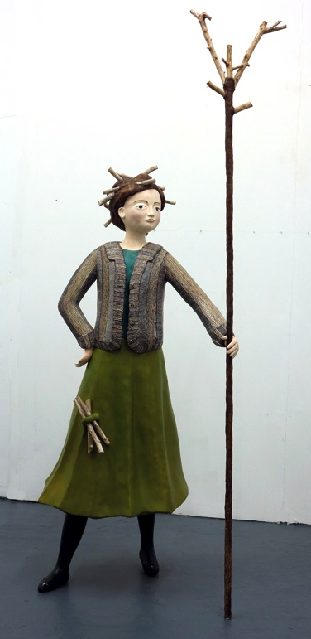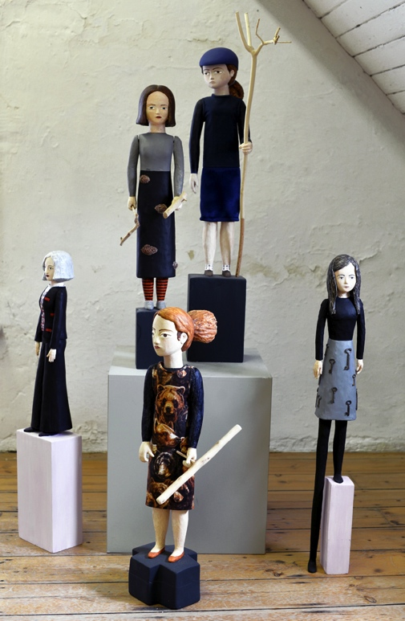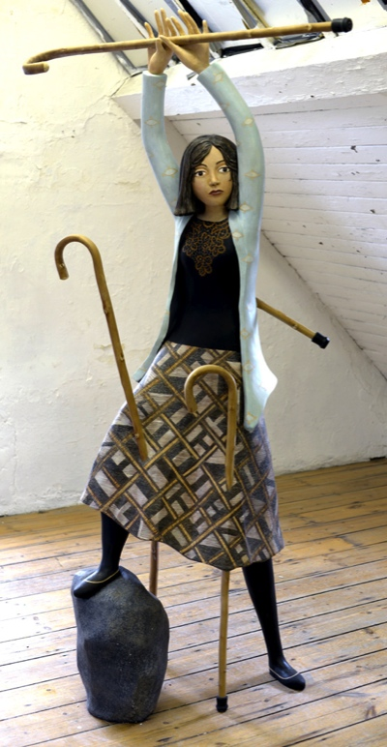

Images l-r: Looking for the Log, large scale mixed media sculpture, Studio view: Women Who Have Incidents with Animals, small scale wood carvings with articulated limbs, Wood Walker, large scale mixed media sculpture.

Main Image: Carrying the Hot Blur 2019 (detail), large scale mixed media sculpture.

- ENDS -

Notes to editor

Standpoint Gallery is a leading artist-run gallery and studios in London. It does not represent artists, but curates shows from submission and invitation, concentrating on emerging/mid-career artists from the UK and internationally.

Standpoint Studios is a registered charity comprising five large studios providing creative workspace for 15+ artists and makers, an Education Studio, and education and outreach workshops or events focused on providing direct, high-quality art-making opportunities.

Standpoint Gallery, 45 Coronet Street, London N1 6HD www.standpointlondon.co.uk
Free Entry. Open Wednesdays – Saturdays, 12-5pm

For more information / high res images contact Emma Kelly: 020 7739 4921/ gallery@standpointlondon.co.uk

