This Is No Longer That Place: A Public Discussion
Thursday 7 March 2019
10.30am–6.30pm
at The Showroom
FULLY BOOKED
Friday 8 March 2019
6.30–8.30pm
at Tate Britain
Book here

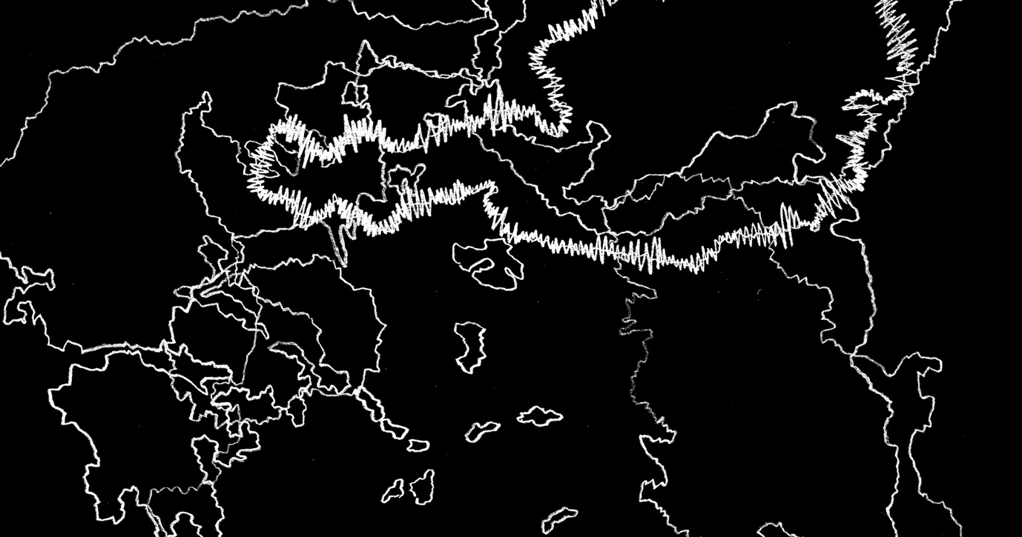
To what extent can art affect change when addressing issues of migration, displacement, and access? Join us for a two-day event that explores the capacity of artists and arts institutions to intervene in the current geopolitical climate.
Speakers include Gurminder K. Bhambra, Professor of Postcolonial and Decolonial Studies in the School of Global Studies, University of Sussex; Yaiza Hernández Velázquez, Lecturer at Central Saint Martins-UAL on the MRes Art: Exhibition Studies as member of the Afterall research centre; artists Kathrin Böhm, Daniela Ortiz and Oliver Ressler; curators Natasha Marie Llorens and Alicia Chillida; Ane Rodríguez Armendariz, Director of Tabakalera - International Centre for Contemporary Culture, San Sebastián; and editors Justinien Tribillon and Dámaso Randulfe, Migrant Journal.
Please note that lunch is included as part of your booking
Full programme:
MORNING
Global citizenship, socio-politics and the arts
10.30–10.40am Introduction, Elvira Dyangani Ose, Director, The Showroom and Michaela Crimmin, Reader in art and conflict, Royal College of Art; co-director, Culture+Conflict
10.40–10.45am Chair's introductions: Yaiza Hernandez Velazquez, Central Saint Martins, with research focused on art institutions understood in a broad sense as sites of political import.
10.45–11.30am Gurminder Bhambra
Professor Postcolonial and Decolonial Studies, School of Global Studies, University of Sussex. Author of Connected Sociologies; and Rethinking Modernity: Postcolonialism and the Sociological Imagination.
11.30am–1pm Oliver Ressler, Daniela Ortiz
Oliver Ressler is an artist who produces installations, projects in public space, and films on issues including democracy, migration, forms of resistance and social alternatives.
Daniela Ortiz is an artist generating visual narratives to critically understand structures of colonial, patriarchal and capitalist power.
Lunch 1–2.15pm
AFTERNOON (1) 2.15–4.15pm
Art, art institutions and frameworks of representation
Chair: Elvira Dyangani Ose
Natasha Marie Llorens
Curator and writer, with current projects including Children of Violence, a cycle of exhibitions, texts and symposia devoted to the representation of violence in contemporary art
Ane Rodríguez Armendariz
Cultural Director, Tabakalera, Spain, programming international residencies, commissions, and bringing special attention to education programmes
Alicia Chillida Ameztoy
Curator working in both public and private space, including Bestea Naiz/El Otro soy yo. Migraciones políticas y poéticas [The Other is me. Political and poetic migrations].
Tea break 4.15–4.30pm
AFTERNOON (2) 4.30–6.30pm
Making sense of culture and identity politics in the context of Brexit
Chair: Michaela Crimmin
Dámaso Randulfe
Artist, architect, and co-editor of Migrant Journal, a 6-issue publication exploring the circulation of humans, matter, goods and ideas, and their impact.
Kathrin Böhm
Artist, focusing on the collective making and culturing of public space, both urban and rural, where shared and collectivised everyday practises are foregrounded.

On Friday 8 March 2019 This Is No Longer That Place: A Public Discussioncontinues at Tate Britain Clore Auditorium, Millbank, London SW1P 4RG, 6.30–8.30pm
The debate features contributions from Professor Gurminder Bhambra, Oliver Ressler, and Justinien Tribillon, co-editor of Migrant Journal. Chaired by Elvira Dyangani Ose.
Booking for this event is essential, via the Tate Britain website

This is No Longer That Place is part of the European Cooperation project 4Cs: From Conflict to Conviviality through Creativity and Culture co-funded by Creative Europe, with UK activities co-funded by the Royal College of Art.
4Cs seeks to understand how training and education in art and culture can constitute powerful resources to address the issue of conflict as well as to envision creative ways in which to deal with conflictual phenomena.
This is a partnership of the Universidade Católica Portuguesa; Tensta Konsthall; SAVVY Contemporary; Fundació Antoni Tàpies; Museet for Samtidskunst; Ecole Nationale Supérieure des Arts Décoratifs; Royal College of Art; and Nida Art Colony of Vilnius Academy of Art.
Image: Oliver Ressler, Emergency Turned Upside-Down, film still, 2016

