Conference Proceedings – Short Paper
Design Practice for Blue Green Infrastructure in the Context of Urban Resilience
Qian Sun^{1,}*, John Makepeace ¹ , Nicolas Rebolledo¹ and Nick de Leon ¹
¹ Royal College of Art, Kensington Gore, London, SW7 2EU, UK
E-Mails: qian.sun@rca.ac.uk; +44 (0)20 7590 4290

Abstract: This paper presents four projects where design practice is applied to address the challenges of engaging communities in the maintenance of Blue-Green Infrastructure (BGI). The design projects were initiated by the Royal College of Art in partnership with Enfield council, UK. The aim was to develop service propositions that encourage shared ownership of Broomfield Park between local communities and the council. These projects demonstrate the relevance of design practice in developing urban resilience through BGI. When considering BGI as a ‘wicked problem’, design practice demonstrations its potential in fundamentally transforming the traditional way in which public services are designed and implemented.
Keywords: Service Design; Design Thinking; Blue Green Infrastructure (BGI); Wicked Problems; Urban Resilience; Public Services

1. Introduction
BEGIN (Blue Green Infrastructures through Social Innovation) is a 4-year project funded through the European Regional Development Fund (ERDF) by the Interreg Europe programme. The BEGIN project brings together 10 cities across the North Sea Region (Antwerp, Ghent, Aberdeen, London Enfield, Bradford, Kent, Dordrecht, Hamburg, Gothenburg, Bergen) with 6 leading research institutes (CIRIA, UNESCO-IHE, University of Sheffield, TUHH, Royal College of Art and Erasmus University). The overall objective of BEGIN is to demonstrate how cities can improve climate resilience with Blue Green Infrastructure (BGI) involving stakeholders in a value-based decision-making process to overcome its current implementation barriers . It proposes Design and Social Innovation as its core approach to BGI, in comparison to traditional planning processes that often merely inform or consult stakeholders. BEGIN considers this approach helps mobilize the problem-solving capacity of a wide range of stakeholders to facilitate climate change adaptation, and capture multiple societal values.

The Service Design team of the Royal College of Art (RCA) provides design expertise in the space of social innovation in this project. The team has rich experience in collaborating with public organisations, social entities, and businesses, through studio projects. Their practice entails an integrated approach to the design of human experiences and the socio-cultural, economic and technological systems in which the services are experienced.

However, for design practice, BGI is a new context; and for most cities, working with designers to address BGI issues is also seen as a new attempt. Therefore, at the start of BGIN, a project was initiated by the RCA in partnership with Enfield council, UK. It aims to look deeply into urban planning processes, contexts and cases with the question: How can design practices help communities build resilience against flooding by creating services that can help city planners engage communities in the development and maintenance of Blue Green Infrastructures (BGI), through reconnecting people with nature and helping them take ownership of their public spaces?

This paper reports the process, methods and outcomes of four design projects under the brief. In this study, the researchers were involved in the project through developing the design brief, monitoring the progress through regular tutorials, reviewing documents and reports, representing design outcomes to the stakeholders, and reflecting on their own experience. As such, this case study is developed combing three sets of information:
• Design practice: 12 weeks design projects involving 10 designers (4 teams) and 2 design managers at the RCA. In the design process, various research tasks were performed including interviews, observations, workshops and prototypes. The process was monitored and observed by the researchers.
• Design outcomes: 4 solutions/service propositions were proposed (one by each design team). Each solution addresses its individual problem redefined by the designers and proposes innovative ideas for consideration. Two reviews were taken place for key stakeholders to input into the process and feedbacks and discussions were recorded.
• Reflection: each design team delivered a report based on their critical reflection of practice. A follow-up workshop was conducted including both the researchers and the designers.
2. Project Background
Enfield is a London borough council, one of 32 in the United Kingdom capital of London. This project focuses a new wetland in the grounds of Broomfield Park to manage and clean water, increase biodiversity and bring more value to the community, as part of a collection of ongoing natural flood prevention works going on in Enfield. Problems relating to Broomfield Park ? (list a few here as examples)

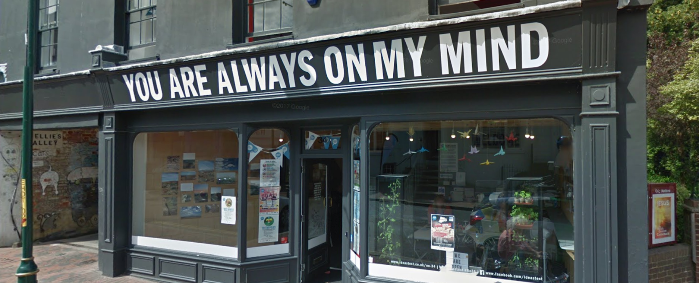
Figure 1. The Local Charity
(b) Add source here

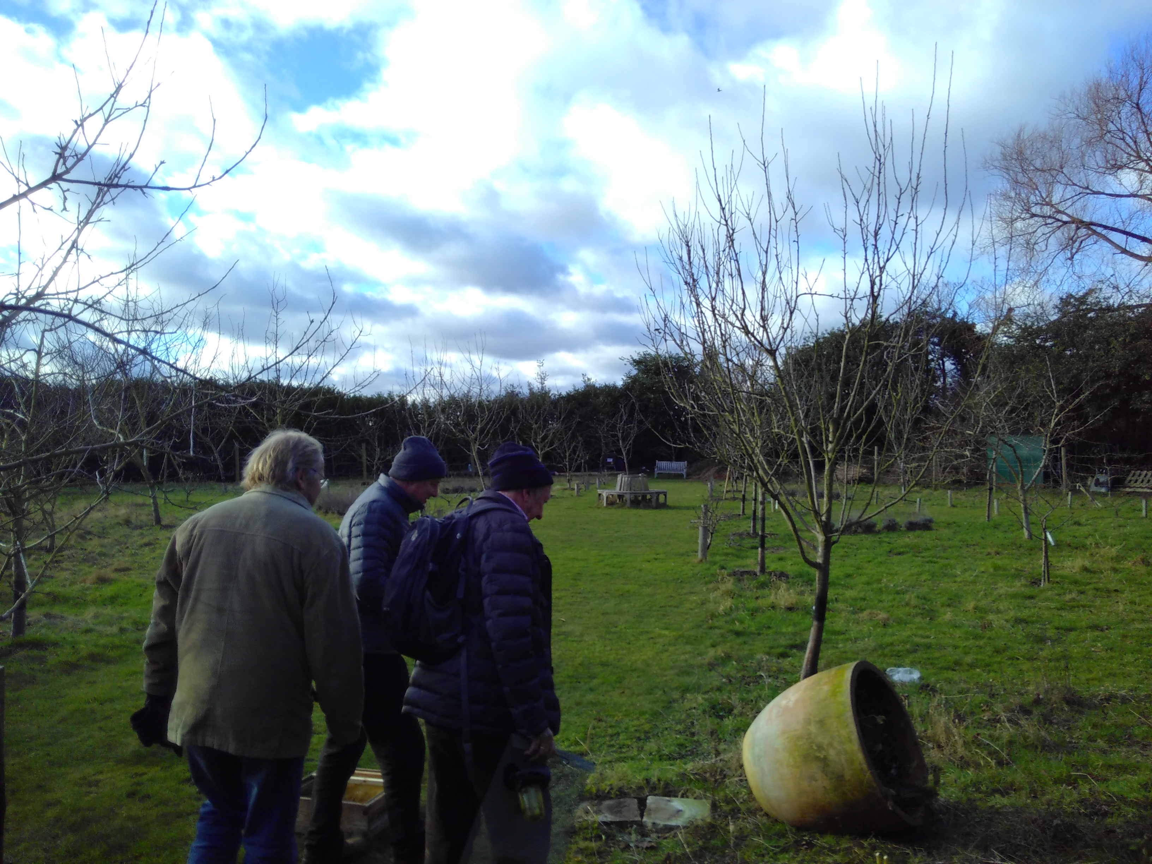

Figure 2. The current situation in the Park.
(b) Add source here
2. The Design Brief
Prior the design projects, a number of site-visits were taken place, as well as interviews with the BGI planning team, ‘friends of Broomfield Park’, local community groups and relevant charities. A design brief was develop as a document of communication between the designers and the council. The goal was defined as ‘ to help cities tackle flooding challenges by enabling communities to become active shareholders in the co-production of BGI’.

Four teams of MA students on the service Design MA at the RCA responded to the brief. The students in most teams were typically multidisciplinary with backgrounds including engineering, communication design, business and policy.
3. The Design Process
The design teams followed Design Council’s double diamond process, including four stages activities: discover, define, develop, and deliver, as shown in the following figure. The process is iterative combing both divergent and convergent thinking. It starts with a discover stage aiming to identify user needs through behaviour-led design research leading to an initial idea or inspiration. This leads to the next stage of activities aligning and interpreting the users needs into the wider objectives of the organisations and society. Designers then iterate and prototype these design-led solutions to test their relevance. The design is finalised and launched involving final testing approval and evaluation. This process becomes synonymous to a human-cantered approach to wicked problems.
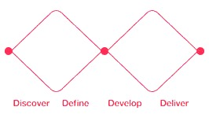

Figure 3. Double Diamond
Source: https://www.designcouncil.org.uk/news-opinion/design-process-what-double-diamond

4. Design Solutions
Each team proposed a design solution to the problems redefined by themselves. The four design solutions are:
- Park Frog: Uses a digital pet caring game to encourage younger generations of people to contribute to and take ownership of public parks in order to avoid the worsening cycle of youth disengagement with parks, nature and citizenship. (to insert relevant pics)

- Open Park: Uses design tools to create new types of partnerships between authorities and the public. Fostering stronger engagement with the public and creating a collaborative design process to support shared ownership. Turning a closed and rigid process into an open, inclusive and resilient one. (to insert relevant pics)

- Compass: Uses an online platform and multiple types of engagement materials to help the public understand the way taxes are spent in a transparent and honest way. Helping the public to understand each scheme in the area and the decision making process behind it. In this case helping the public understand the role of climate change in flooding, what the risks are, why BGI (Blue-Green Infrastructure) is necessary and how they can contribute. (to insert relevant pics)

- The Little Gardening Club: Uses the enthusiasm of children and the format of a school gardening club this service connects children and parents to nature through gardening, enriching their education and creating opportunities for local authorities to set tasks that help maintain public space. (to insert relevant pics)

6. The Value of Design in BGI
The design projects demonstrate that the value of design practice in BGI is multiple and is potentially relevant to other public sector issues beyond BGI.

First, as design practice is problem oriented in nature, the designers invent and envision new and possible futures in which problems are solved or mitigated through the redesign of practice. Park Frog is a good example. The team found that the presence of young people in the park was perceived negative and associated with occasional anti-social behaviours and violence. They redefined the problem that subverted council current practice, seeking solutions that can forge new engagement between young people and the park without the council as a visible facilitator. The problem was thus turned it into a design opportunity where mobile and digital gaming interventions were introduced to encourage young people to go out into public spaces and enjoy those spaces. The concept was perceived highly positive by the council. (to insert relevant pics)

Secondly, its interactive process ensures all relevant and affected actors are involved in the process which further increase the relevance of innovative solutions to be relevant to their different experiences, resources, competences and expertise. At each stage of the projects, all the teams have engaged with a large number of stakeholders, including park users, urban planners, Enfield park coordinator, local authorities, ‘Friends of Broomfield Park’ group, local schools, and local businesses. The Little Gardening Club is a good example. Within a short span of time, the team had intense involvement with schools, the council and other local stakeholders like commercial garden centres, delivered 6 site visits, 4 workshops (7-8 people each), and 7 in-depth interviews. As such, this project explored the potential for a new model of relationship between these people that could help sustainably build a club that would help children connect to nature. When the design project ended, the club had sufficient buy-in from all parties involved. (to insert relevant pics)

Thirdly, the approach tends to explore systemic problems. Many of the BGI implementation barriers, like in many other public sector services, are difficult to overcome because they are systemic and embedded within organisational cultures, practices and processes. Design practice proved its relevance in addressing systemic problems. In Open Park project, the designers started with recognizing the systemic nature of parks, and to build the foundation of resilience, a holistic understanding of systems and a basis in the community were essential in order to be: reflective, resourceful, inclusive and integrative. As the result, they proposed a new type of partnership model that could enable any public engagement, co-ownership related activities and facilitate a more resilient community around the park. As such, their proposal turned a closed and rigid process into an open, inclusive and resilient one. (to insert relevant pics)

Fourthly, the design tools become heuristic devices that stimulate the development of iterative process and make the possible futures concrete and tangible. In this aspect, all four projects have used prototyping and visual aids in their co-creation workshops etc. Compass was highly relevant in this context. They developed a mix of physical campaigns and an online platform to mediate communications between councils and the public. They prototyped the idea as a live website which allowed them to engage the users in the iterative process of design. (to insert relevant pics)
6. Relevance to Urban Resilience
The involvement of citizens, communities and businesses in city strategy is considered crucial to the success of any resilience initiatives and services. In recognising that simply consulting citizens is insufficient and ineffective in achieving sustainability, there is a need for a more integrated and inclusive approach to designing and managing urban resilience. The design projects demonstrate the integrity of design practice in this context. More importantly, these design projects suggest that our understanding of resilience expands to include the resilience gained through the intended innovation processes for implementing BGI:
- Resilient spaces - Improved capacity of the infrastructure of public environments to withstand climate changes;
- Resilience through better decision making - The improved decision making capacity of municipalities resulting from better community involvement;
- Resilience through more resources - The increased capacity and resource derived from enlarged and better engaged communities;
- Resilience through more active/dynamic communities - Improved capacity to enlist and organise social capital drawn from newly empowered communities with improved social cohesion.
Acknowledgments
We would like to thank …
Especially those directly involved in the project:
Councils:
Kent County Council: Bronwyn Buntine, Louise Smith
Enfield Council: Graham Campbell
Designers:
Open Park: Natalia Carrasco, Bianca Benvenuto, Daniela Soto Espinoza, Karen Rozenbaum
Park Frog: Nicole Zheng, Wen Han Yap
Compass: Breana Russel, Francesca Schiboni Grimaldi, Rhea Belani
Community Gardening Club: Judith Buhman

© 2018 by the authors; licensee MDPI and IFoU, This article is an open access article distributed under the terms and conditions of the Creative Commons Attribution license.

https://northsearegion.eu/begin/
http://webarchive.nationalarchives.gov.uk/20080821071133/http://www.designcouncil.org.uk/en/About-Design/managingdesign/The-Study-of-the-Design-Process/

