Design for Healthcare, ed. Cooper & Tsekleves
Design for Social Responsibility series

Workplace health and wellbeing: can greater design participation provide a cure?

Author:
Professor Jeremy Myerson, Royal College of Art
Gail Ramster, Royal College of Art

Synopsis
This chapter looks at current initiatives to improve health and wellbeing in the office workplace, against the background of a loss of productivity and a rise in incidences of stress, depression and burnout. It explores giving employees a greater sense of control over their work environment through participation in the design of their workspace, and describes a UK research study which makes a link between participatory design activities and improved levels of mental wellbeing. A conceptual model is presented which suggests that better health and wellbeing can be achieved in the office workplace by aligning organisational purpose more closely with both the functional and psychological needs of the individual. Co-design is advocated as a way to improve employee belonging and wellbeing despite the relative unfamiliarity of the concept in the workplace.
Key words: participation, co-design, workplace, health, wellbeing, stress

Introduction
Business leaders and public health experts look at the workplace from very different perspectives. But on the subject of workplace health, they increasingly speak with one voice on the need to find new ways to make the work environment less damaging and more beneficial to the health and wellbeing of employees. The combination of a loss of workplace productivity, which has caused alarm in business circles, and growing concerns among healthcare professionals over the negative effects of a sedentary, long hours working culture has pushed design for health in the workplace right up the agenda for change.
“We want people to leave the workplace healthier than when they arrive,” according to Duncan Young, Head of Health and Wellbeing at Lend Lease, one of the world’s largest office property developers (WORKTECH London 2015). Better diet at work, more exercise, more natural light, improved air quality and frequent breaks are among Young’s recommendations to improve workplace health. Dame Carole Black, expert advisor to the UK Government on work and health, takes a wider view: “The workplace, traditionally seen as a source of health problems, in fact represents a huge opportunity to improve the health and wellbeing of the nation” (The Guardian March 2016). Black’s focus is on a creating a total workplace culture that can deliver better physical and mental health, with wider benefits feeding back to families and communities.
The reason why opportunities to improve health at work need to be seized is best understood by looking at the current impact of poor health on productivity. Absence from work costs the UK economy more than £14 billion a year according to the Confederation of British Industry (CBI 2011). In 2014, around 27.3 million working days were lost in the UK, according to the Health and Safety Executive; 23.3 million of them were due to work-related ill health, and just over 4 million were due to workplace injuries (HSE 2016). Work-related ill health covers musculoskeletal disorders, which account for most days lost, as well as stress, anxiety and depression, which is generally on the rise. Calculate the knock-on effects in the wider community and the cost becomes even higher.
Not surprisingly, the issue of health and wellbeing is now widely debated within the global industry of professionals who plan, build and manage workplaces, and there is growing consensus that design has a key role to play in a field that becomes more complex the longer you look at it. A Well Building Standard, established by the International Well Building Institute (Delos 2015), helpfully organises the key elements under seven headings - Air, Water, Nourishment, Light, Fitness, Comfort and Mind – in a bid to cover all the angles.

Looking broadly at current practice, the core environmental comfort issues of air quality, light and lighting, acoustics, thermal control, water quality and access to nature very much affect physical and mental health. These depend very much on design decisions. Other factors include layouts and settings that encourage movement and exercise through activity-based working, and the provision of ergonomic innovations such as sit-stand desks, stand-up meeting rooms and posture correction devices.

Mindful of the growing threat of obesity, which is becoming the lifestyle epidemic of the 21st century in the way that smoking was in the 20th century, nutrition protocols in the workplace are under scrutiny with a move towards preparing healthier food, growing your own fruit and veg, and cutting down on calorific vending machines. Commuting is under scrutiny too with growing emphasis on walking and cycling to work (active transport) as a complement to the formal provision of gyms, exercise spaces and fitness equipment in the workplace.

Indeed there is a whirlwind of activity around the subject, with many new health and wellbeing technologies coming online – from wearables that count steps and calories to intelligent buildings that use the Internet of Things to monitor health by recalibrating air quality and light levels according to levels of occupancy. But what emerges from a broad look at the field is that, despite the growing physical influence of design and technology, the toughest nut to crack in the workplace relates to mental health. Managing stress, depression and burnout is the red light flashing on the management dashboard. Health in the workplace context is partly all in the mind.
At a time when workplace injuries are falling and the workplace is physically safer than a generation ago, incidences of psychological distress have been rising proportionally. One in six people in work are experiencing depression, anxiety or another mental health condition to a diagnosable level at any one time, excluding drug and alcohol dependency (Singleton et al. 2000). The estimated cost to the UK economy of mental health problems is £1,035 per employee (Sainsbury Centre for Mental Health, 2007).
Not all mental health problems affecting work are necessarily caused by the workplace. A 2011 survey by the Chartered Institute of Personnel Development found that 65% of people reporting poor mental health said that this was due to a combination of work and non-work factors, 20% said their poor mental health is just down to non-work issues, while 15% said their poor mental health is the result of work alone. Nevertheless, mental health problems in the workplace bring those knotty issues of identity, belonging, empowerment and work-life balance to the fore – and these tend to be tougher to fix through design interventions than challenges related to environment or settings.
In this chapter, I want to focus on the importance of mental health and wellbeing in the workplace, explore the concept of ‘ a sense of control’ in supporting psychological comfort, and describe and reflect upon a UK research study which I co-directed, looking at the impact of participatory design on team wellbeing.
A sense of control
There are many reasons why people around the world become disenchanted, disassociated or distressed at work – growing stress levels have been recorded from Mexico to China (Regus 2009). Dame Carol Black (2016) lays some of the blame at the door of managers: “Poor quality leadership is linked with stress, depression and burnout.” Others point the figure at unreliable IT systems, inadequate training or poorly designed work environments that offer little personal choice and over which employees can exercise no control. Conversely, workplace interventions that improve wellness appear to have financial benefits due to their impact on reduced absence and staff turnover, and they also positively influence employee satisfaction, productivity levels and organisational profile (PwC, 2008). But what exactly constitutes a sense of mental wellbeing in the workplace and how can it be maintained?
One way to understand wellbeing is as the equilibrium between a person’s own psychological, physical and social resources on one hand and external circumstances and challenges on the other (Dodge et al., 2012). This approach presents personal wellbeing as subjective and dynamic. The UK Office of National Statistics measure of national wellbeing encompasses happiness, satisfaction, freedom from anxiety and feeling worthwhile (ONS: Oguz et al., 2013). Research by New Economics Foundation (Jeffrey et al., 2014) suggests that factors affecting wellbeing in the workplace include: personal resources (‘who you are’) – your health, activity, level of relaxation and work-life balance; and organisational systems (‘where you work’) – environmental factors, social value of work, technology and infrastructure, social interactions and relationships, and sense of control.
Indeed a ‘sense of control’ emerges from the literature as an established driver of wellbeing and happiness at work. It is a factor relevant to successful functioning at work, reducing the negative aspects that can erode wellbeing on an on-going basis (Marks, 2014; Gensler Workplace Survey 2014). Of course, a sense of control has wide meaning: it can apply to choices regarding work-life balance, surrounding environment, commuting and travel; it also refers to control in terms of access to tools, resources, spaces, control over territory and privacy, and control over relationships and interactions with others in the office community.
However a sense of control has particular meaning in relation to the level of participation that people have in the design and planning of their own workplace. The levels of control and empowerment associated with participation in office design have been connected to higher levels of wellbeing in a number of research studies. Vischer (2005) suggests that participation in the design process and feeling ‘empowered’ in environmental decision-making affects the sense of belonging or ownership felt by employees over their workspace. This contributes to what Vischer (2008) terms as “psychological comfort”.
Knight and Haslam (2010) found through workplace-based experiments that environments enriched by workers with plants and artwork had a greater effect on their psychological comfort, autonomy and job satisfaction compared to environments enriched by others. Enrichment by workers also led to improved productivity and reduced errors. When their input was overridden and the workspace reverted to pre-empowerment conditions, the effect on autonomy and psychological comfort fell, reflecting the disempowerment of the worker.

As part of its advice on mental wellbeing at work, Nice Guidelines recommend taking action to promote “a culture of participation, equality and fairness that is based on open communication and inclusion” (Nice, 2009). However participatory design or ‘co-design’ activities, which give participants a greater sense of control over their environment, are less in evidence in the workplace than in community development, public services and urban environments where they are far more common.

Participatory design

Participatory design or co-design is a growing field. It sees designers working collaboratively with end users as equal partners to create, design and/or produce ideas, spaces, products, technologies or services. By adopting a co-design methodology, people benefit from involvement in the process as well as the end result (Sanders and Stappers, 2008; Ramirez 2009). According to Bradwell & Marr (2008), “Co-design broadly refers to the effort to combine the views, input and skills of people with many different perspectives to address a specific problem.”
Co-design methods promote participation, open discussion and collective decision-making, helping people to arrive at decisions even if they do not meet their personal preferences; as a result, solutions are more sustainable due to a sense of collective ownership. Co-design methods have been widely piloted in community development to improve neighbourhood cohesion (Ramirez, 2008; Boyle et al 2010) and in healthcare where experienced-based co-design (EBCD) has reoriented medical services and systems around patient needs (MacDonald and Teal, 2011). It is not hard to see their value to the creation of office environments, but detailed evidence of practice in the workplace is relatively thin on the ground.
StudioTilt (2014) produced a series of case studies of co-design in workplaces through which it identified a series of methods (role-playing, mock-ups, mapping, workshops and so on) as well as a series of advantages in getting dissenting voices out in the open and creating more sustainable results. New Zealand Bank ANZ (Lynch & Roulston, WORKTECH London 2015) developed and discussed a new ‘Playbox’ methodology to enable staff to co-design their own flexible furniture, leading to the design of settings with such names as Scrum, Showcase and Exchange. Clearly, the scope to extend co-design practice within the workplace is considerable. However a key question is whether greater participation by employees in the design of the workplace environment will increase a sense of control and contribute to higher levels of wellbeing. This is the main question that a one-year study entitled Workplace & Wellbeing (2015), jointly led by the Helen Hamlyn Centre for Design at the Royal College and the architectural practice Gensler, set out to explore.

Workplace & Wellbeing research study

The RCA-Gensler study was conducted in two stages over a period of one year. In the first phase of research, the research team conducted a Scoping Study in four different organisations in London and the south east of England that have undergone different levels of workplace change over the past three years (relocation to new purpose-built premises, relocation to new premises without refurbishment, introduction of new furniture in existing premises and no workplace change). This phase was conducted through cross-organisation interviews, stakeholder mapping (with managers, building services, department representatives and so on) and observations of teams within the workplace. Thirty interviews were conducted and analysed across the four organisations (22 with employees, eight with other stakeholders).
In the second phase of research, a Participatory Design Project was devised with three teams on one office floor in one organisation in order to test the impact of different levels of design participation (high, low and no participation) on employee wellbeing. Teams worked to create, design and test interventions in their workspace. The intention of this approach was to give employees more sense of control over the environment in two ways: first, by inviting them to participate in the design process using co-design methods; and second, by providing interventions designed for and by them, creating a sense of co-ownership of space. A validated measurement of mental wellbeing, the Short Warwick-Edinburgh Mental Wellbeing Scale, was used to measure the effects on teams of employees.
Based on the findings of the two phases of the study, the research team built a workplace wellbeing conceptual model that illustrates a necessary balance between the functional and psychological needs of the individual that organisations need to provide in the workplace. The model presents two axes of need, from functional need to psychological need, and from the organisation to the individual.
Research findings
Findings from the Scoping Study presented ‘a snapshot of change’ characterised by an ever-shifting workplace landscape and a relentless squeeze on space. This constant change was seen by employees as often in the interests of the organisation, while worsening their physical and psychological wellbeing. Huge variations in levels of mobility, choice and flexibility for individuals emerged, with many people feeling excluded from decision-making processes in relation to the work environment.
The Scoping Study revealed that employee wellbeing and satisfaction was supported by such workplace factors as: a sense of connection with the outside world through natural light, birdsong and plants as well as closeness to leisure amenities and transport links; a positive and purposeful environment which is welcoming and easy to navigate; a variety of spaces to suit different tasks; and control and personal autonomy over space. People felt better about work when invited to participate in the planning and design of the work environment, and unfairly excluded from decision-making processes when not given a voice.
Generally, mental wellbeing was seen to suffer when there were poor connections with the outside world, badly managed communication between teams, difficulties in wayfinding and inadequate provision of a variety of flexible spaces, thus exposing staff to constant noise and distraction. Decision-making that failed to account for the impact on the individual and a general lack of consultation over workplace design was also seen as unhelpful.

Insights into employee views on participatory design provided a bridge to the second phase of the project: the Participatory Design Project. The research team worked with three teams of employees all situated on the same floor. Each team contained between six and nine people who work together and share similar work patterns. Team 1 was offered the highest level of participation by being invited to co-design ideas and interventions and becoming involved in their implementation. Team 2 was offered a lower level of participation through engagement activities to identify those aspects of the workplace that were important to them and where opportunities for improvement lie. However Team 2 was not involved in how ideas and interventions were developed or chosen for implementation. Team 3 was excluded from design participation, but received interventions designed by and for the other teams on the floor.
Team 1 (high participation) and Team 2 (low participation) both focused in their initial engagement workshops on the corporate feel and identity of the space, its dullness and low levels of natural light with poor connections to the outside. Team 1 then went on to co-design a ‘Life and Light’ intervention with the research team. This comprised the introduction of plants in the space installed in hanging skyplanters, a range of salad crops, herbs and chillies to eat that the team would cultivate. Blinds were fully retracted to increase light. This intervention was delivered to Team 2 (low participation) and Team 3 (no participation). Team 1 and Team 2 also combined to organise a ‘Tidy Friday’ De-Clutter Day to clean up their space. Team 3 did not initiate this activity but participated in it.
Figure 1: Life and Light design intervention in workplace, with hanging skyplanters
The Participatory Design Project made use of the Short Warwick-Edinburgh Mental Wellbeing Scale (Warwick Medical School, 2015), a validated tool developed to evaluate the impact of a project on the mental wellbeing of a group of people. It is based on seven positively worded statements about mental wellbeing (such as ‘I’ve been feeling useful’ and ‘I’ve been thinking clearly’) that can be scored from 1 (none of the time) to 5 (all of the time). This tool was presented to participants as an online survey that they could complete themselves. The survey was distributed before the design participation project began and again after implementation of the design intervention to chart changes in team wellbeing that might be attributed to the project.
The survey was based on a sample of 18 people in total, drawn from the three teams. Results suggested a detectable link between design participation in the workplace and mental wellbeing. The two teams that participated in design recorded bigger increases on the wellbeing scale than the team that was not given the opportunity to participate. However there was no real difference between the wellbeing scores for Team 1 (high participation) and Team 2 (low participation), indicating that that the level or ‘dose’ of design participation is less important that the overall invitation to engage in some way. Providing a more intense or prolonged participatory design experience does not automatically boost wellbeing further.
More in-depth feedback from all teams (through a qualitative survey) provided greater context, showing that many people appreciated being invited to participate in an open design process and expressed satisfaction with the staff-designed workspace intervention irrespective of whether or not they had participated in the process.
Workplace-Wellbeing Model
A conceptual model to chart and assess wellbeing needs in the workplace was developed by the research team over the duration of the study, based on the thematic analysis from phase 1 (Occupancy Study in four organisations) and the live findings recorded in phase 2 (Participatory Design Project). The model illustrates a necessary balance between the functional and psychological needs of the individual that organisations need to provide in the workplace. This approach mirrors to some extent the purpose of the organisation itself, which can also be seen as a combination of functional and psychological needs.
The model therefore presents two axes of need, from functional need to psychological need, and from the organisation and the individual. Individual needs are those that appear to benefit the individual more than the organisation; organisational needs are those that benefit the organisation more. At the heart of the model is what has been termed ‘the psychological contract’ - in return for hard work, commitment and loyalty, the individual worker expects the organisation to be responsible for their workplace wellbeing.
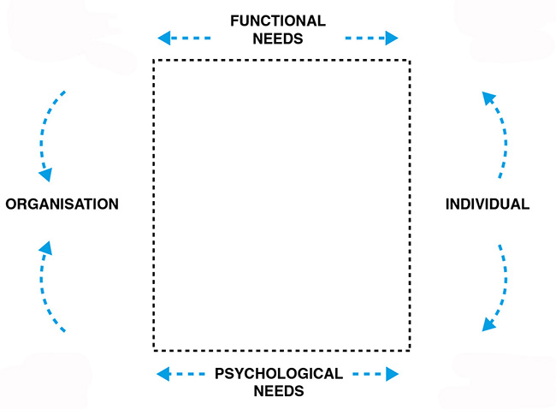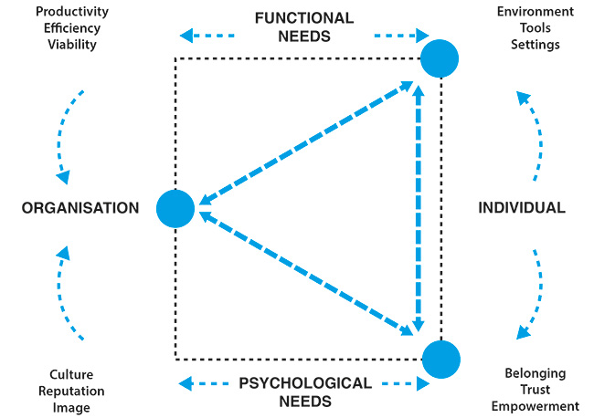
Figure 2: Workplace & Wellbeing model showing full alignment (right) between organisational purpose and individual needs
Organisations have a number of functional requirements in order to be productive, efficient and viable. They must capitalise on assets and property, utilising space in an efficient way (for example, by introducing new working practices). They must raise performance and increase commercial competitiveness (for example, though collaboration). Keeping the workforce safe and healthy to work, through provision of ergonomic work settings, is also part of this picture. Organisations also have ‘softer’ psychological needs based around creating and maintaining a positive culture, reputation and brand. These needs are related to motivating the workforce and attracting and retaining talent (for example through training, social amenities and other incentives), as well as exerting influence in the wider world of customers, partners and suppliers.
Individuals have a number of functional requirements to carry out their work. These broadly relate to environment (light, heat, air quality, spatial layout, ambience, décor and so on), tools (technology, furniture, protocols and systems) and settings (spaces for different work and social activities). Individuals have a range of psychological needs in the workplace that are related to belonging, trust and empowerment. They want to feel valued, cared for and acknowledged. They want to feel that their contribution is worthwhile. Factors relating to levels of flexibility, autonomy and choice in the workplace come into play here, also issues of identity and territory and the process of participating in workplace design.
The model proposes that for wellbeing in the workplace to be optimised, organisational purpose has to be geared towards meeting both the functional and psychological needs of the individual on an equal basis. There are four versions of the model: a Full Alignment model in which the organisational purpose is fully aligned with both the individual’s functional and psychological needs; two Partial Alignment versions in which the organisational purpose is aligned with either the functional or psychological needs of the individual, but not both; and a Non-Alignment Model in which organisational purpose is aligned to neither the functional nor psychological needs of the individual.
It is proposed that the ideal state of wellbeing in the workplace is when the organisation’s needs and individual needs are aligned, both functionally and psychologically. This state of equilibrium is rare and hard to achieve, although the research team identified examples in the field. In this scenario, the organisation benefits directly from its investment in the workplace and in people’s wellbeing because the psychological contract ensures that people will work harder, have more commitment, be more innovative, and so on.
More often, the alignment is incomplete or partial in one way or another. Sometimes the psychological contract with employees is strong – staff members feel trusted, empowered and understood. They have a strong sense of belonging based on a commitment and attraction to the organisation’s mission and values. Their psychological needs are met. However their functional needs are unmet. The environmental conditions might not be appropriate given what the organisation is trying to do, or the tools and systems are inadequate, or there is insufficient choice or variety of settings. A vibrant sense of identity with the organisation’s mission is therefore undermined by a workplace that is not fit for purpose. This scenario can occur when an organisation has adopted a new workplace culture but not adapted its workspace functionally to reflect new ways of working
Sometimes the opposite occurs. Functional needs are met in terms of providing the right physical work environment, tools and settings to match the organisation’s purpose. However the psychological contract with employees is weak – staff members do not feel trusted, empowered or understood and they have no real sense of belonging, indicating that their underlying psychological needs have not been considered. This scenario can occur after an organisation has invested in the design of a new workplace without having taken their workforce through a change management process or without allowing staff to participate in the decision-making for the design of a new space.
In the worst cases, there is a complete non-alignment, resulting in a demotivated workforce adrift in a disorganised workplace. All elements of the model are out of synch with each other. Functional needs of the individual are not met. The organisation is not providing the right environment, tools or settings to get the work done effectively. Psychological needs of the individual are not met either. Employees do not feel they belong. They feel disempowered, mistrusted and misunderstood. This scenario can occur when an organisation is physically stretched – the office is full beyond capacity but there is no budget for improvements and no planned investment. At the same time, there is a failure to compensate for physical workplace shortcomings by meeting psychological needs.
Conclusions
Although a small study as part of an on-going programme of research, the RCA-Gensler Workplace & Wellbeing study provides evidence that participation in the design of the workplace can have some beneficial effect on wellbeing at work. Those teams that were engaged in the Participatory Design Project at any level (whether high or low participation) registered a higher increase in their mental wellbeing than the team not invited to participate. The study offers insights into how participatory design activities might be planned and delivered in a busy workplace; it also provides a model to help organisations look at the balance of their provision to meet employee needs and thus address the mental health problems of stress, depression, anxiety, disassociation and burnout that are becoming increasing prevalent.

Why mental health should be getting worse as offices become more sophisticated and comfortable in terms in design can be attributed to the particular characteristics of knowledge working in the digital age - the always-on, 24/7 nature of the commitment required and the move away from individually assigned desks to more flexible modes of working that can create anxiety as well as offer choice. It is ironic that progressive remote working technologies and activity-based working formats can impact so negatively on an individual’s sense of control at work when they were intended to do exactly the opposite.

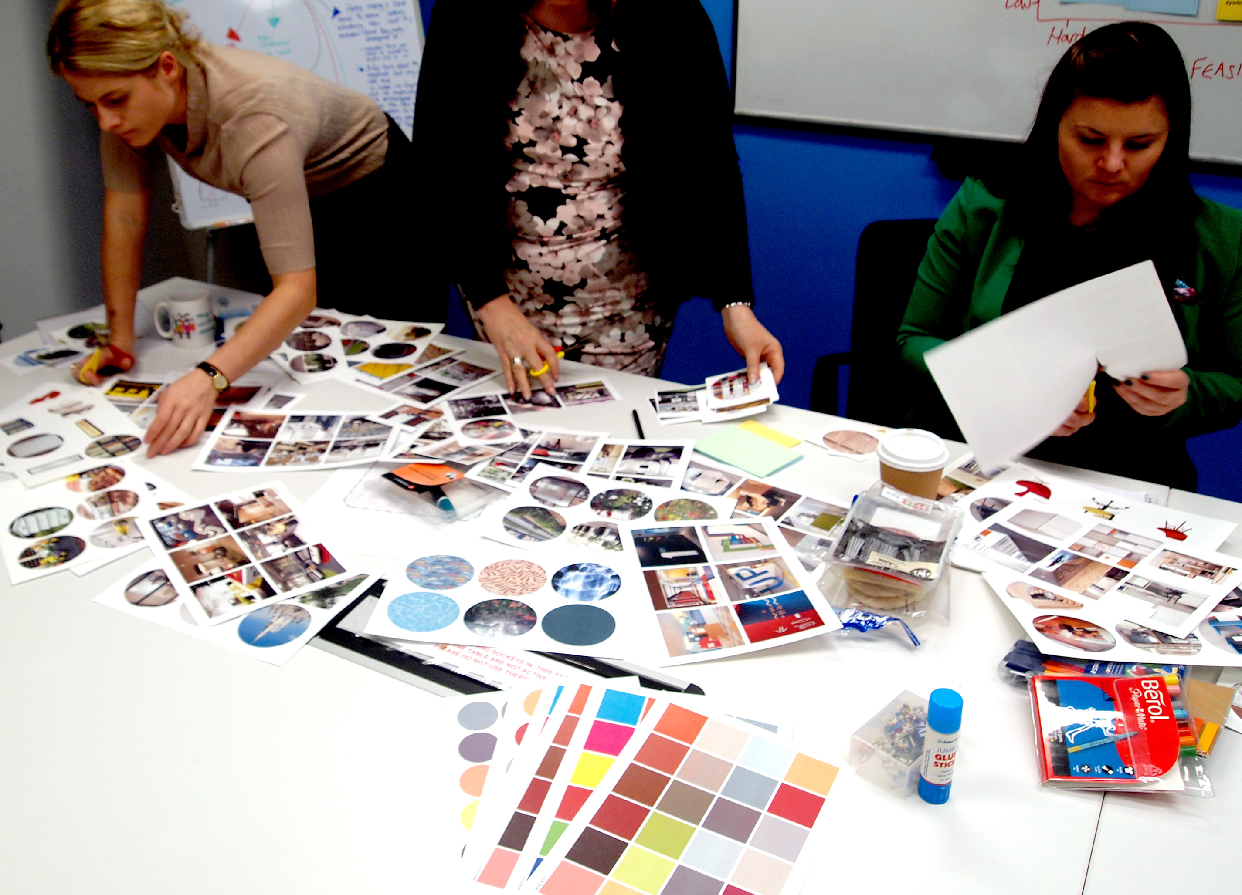

Figure 3: Co-design activities during Workplace & Wellbeing research study

What is clear is that employees appreciate being given the opportunity to exercise some control over the change process that is now a constant part of working life through participation in workplace design. But the invitation to participate is more important than the level of participation on offer. Both business leaders and public health experts will continue to advocate design changes that influence health and wellbeing in the workplace. These will span the technical considerations of air and water quality, light and lighting, as well as spatial issues such as circulation, movement and provision of varied settings, and cultural factors such as management style, supervision and nutrition. The 21st century workplace must do everything it can to address the health deficit that is a legacy from the efficiency-at-all-costs mantra of the past 100 years of office design. In the mix, however, we should start paying more attention to how design participation in the workplace can help to improve mental wellbeing. Despite the relative unfamiliarity of the concept in the workplace, the potential of co-design is there to be adopted.

Acknowledgements
The authors would like to thank Andrew Thomson and Alma Erlich from the RCA who worked with the authors on the RCA-Gensler Workplace & Wellbeing study described in this chapter. The Gensler team was led by Philip Tidd, Ankita Dwivedi and Namrata Krishna. The study was supported by an industrial consortium comprising Bupa, Kinnarps, Milliken, RBS and Shell.

References
Black, C. ‘How everyone benefits from company health and wellbeing campaigns’, The Guardian supplement on workplace health, March 2016
Bradwell, P., Marr, S: Making the most of collaboration: An international survey of public service co-design. DEMOS and PriceWaterhouseCoopers Public Sector Research Centre 2008. London. Report.
CBI 2013, Fit for purpose: Absence and Workplace Health Survey 2013 [pdf] Available at: http://www.cbi.org.uk/media/2150120/cbi-pfizer_absence___workplace_health_2013.pdf [accessed 31-3-2016]
DELOS Living LLC, Wellbeing Standard, International Institute of Wellbeing, February 2015
Dodge, R., Daly, A., Huyton, J., & Sanders, L. (2012) The Challenge of Defining Wellbeing. International Journal of Wellbeing, 2(3), 222-235. Available at: http://www.ernationaljournalofwellbeing.org/index.php/ijow/article/viewFile/89/238?origin=publication_detail [Accessed 4 March 2015]
Gensler. (2013) 2013 U.S. Workplace Survey – Key Findings. Gensler [pdf]. Available at: http://www.gensler.com/uploads/document/337/file/2013_US_Workplace_Survey_07_15_2013.pdf [Accessed 4 March 2015]
HSE 2015, Health and Safety Statistics Annual Report for Great Britain 2014/15 [pdf] Available at: http://www.hse.gov.uk/statistics/overall/hssh1415.pdf [accessed 31-3-2016]
Jeffrey, K., Mahony, S., Michaelson, J. & Abdallah, S. (2014) Well-being at work: A review of the literature. New Economics Foundation [pdf] Available at: http://b.3cdn.net/nefoundation/71c1bb59a2ce151df7_8am6bqr2q.pdf [Accessed 4 March 2015]
Knight, C., & Haslam, S., 2010. The relative merits of lean, enriched, and empowered offices: An experimental examination of the impact of workspace management strategies on well-being and productivity. Journal of Experimental Psychology: Applied, Vol 16(2), Jun 2010, 158-172.
Lynch, K. and Roulston, T. ‘The Playbox: ANZ Bank’, conference presentation at WORKTECH London, 17 November 2015
Macdonald, A. and Teal, G. (2011) Inspiring service innovation through co-design in public sector healthcare. From Include conference 2011

Marks, N. (2014) Guardian readers reveal what makes them happy at work. The Guardian [online] Available at: http://www.theguardian.com/sustainable-business/happy-work-what-makes-you
Myerson, J. and Tidd, P. (2016) Workplace & Wellbeing: what aspects of workplace design are most important to people’s wellbeing? Royal College of Art-Gensler research report
Nice (2009) Mental wellbeing at work, Manchester: National Institute for Health and Care Excellence
Oguz, S., Merad, S. & Snape, D. (2013a) Measuring National Well-being - What matters most to Personal Well-being? Office for National Statistics [pdf] Available at: http://www.ons.gov.uk/ons/dcp171766_312125.pdf [Accessed 4 March 2015]
PWC (2008) Building the case for wellness [pdf] Available at: https://www.gov.uk/government/uploads/system/uploads/attachment_data/file/209547/hwwb-dwp-wellness-report-public.pdf [accessed 11 March 16]
Ramirez, R. (2008). A 'meditation' on meaningful participation. The Journal of Community Informatics North America, 4, Apr. 2009. Available at: http://ci-journal.net/index.php/ciej/article/view/390. [accessed: 17 March 2016]
Regus, 2009. Stress Out? A study of trends in workplace stress across the globe [pdf] Available at http://www.regus.co.uk/images/Stress%20full%20report_FINAL_Designed_tcm294-21560.pdf [Accessed 30 March 2016]
Sainsbury Centre for Mental Health (2007) Mental health at work: developing the business case. Policy paper 8, London: Sainsbury Centre for Mental Health

Sanders, E B-N., Stappers, P J. (2008). Co-creation and the new landscapes of design. Co-Design: International Journal of CoCreation in Design and the Arts, 4(1); 5-18. Available at: http://www.tandfonline.com/doi/pdf/10.1080/15710880701875068
Singleton, N., Bumpstead, R., O’Brien, M., Lee, A & Meltzer, H. (2000) Psychiatric Morbidity among Adults Living in Private Households, 2000: Summary Report. London: Office for National Statistics

StudioTilt (2014), Codesigning space, Artiface, London
Vischer, J.C. (2005) Space Meets Status: Designing Workplace Performance. Oxford: Taylor and Francis/Routledge
Vischer, J. ‘Towards an environmental psychology of workspace: How people are affected by environments for work’, Architectural Science Review, Vol 51.2, 2008, 97-108
Warwick Medical School 2015, Warwick Edinburgh Mentalhttp://www2.warwick.ac.uk/fac/med/research/platform/wemwbs/ [Accessed 30 March 2016]
Young, D. ‘Walking Urbanism and the Workplace’, conference presentation at WORKTECH London, 17 November 2015

