Circular Makerspaces: the founder’s view

Sharon Prendeville^{a,b} , Grit Hartung^{b}, Clare Brass^{b}, Erica Purvis^{c} and Ashley Hall^{b}

ªInsititute of Design Innovation, Loughborough University London, London, UK; ^{b}SustainRCA, Royal College of Art, London, UK; ^{c}Technical Nature, Reading, UK

ABSTRACT
Makerspaces – open access design and fabrication workshops – provide new contexts for design practice through ‘distributed production’. The global community of makerspaces has evolved quickly and in turn, substantial hype is attributed to its potential for radical sustainable innovation. In this article, we explore this potential in the context of the new ‘circular economy’ agenda. We focus the research on the critical role of makerspace managers/founders who are recognised as gatekeepers to circular practices. The research method is action-led including expert interviews (academics and founders/managers) as well as two generative context-mapping workshops, run at selected makerspaces in collaboration with their founders/ managers. We unearth everyday ‘how-to’ guidance to interweave circular practices within makerspaces from the outset by: fostering an enabling culture; building local connections; nurturing individual/ community capacities; and stimulating practical know-how. However, while the research reveals immense opportunities to cultivate circular literacy from within makerspaces, the prospects to ask more profound questions about our economy, through makerspace practices, are found to be compromised by day-to-day concerns. The insights from this research can act as a starting point for future work in this emerging research area.

KEYWORDS

Makerspaces; circular economy; distributed production; design; makers; sustainability

1. Introduction

Increasingly commonplace design and fabrication laboratories, colloquially known as makerspaces,¹ are places where people can access a range of equipment and machines for personal making (Smith et al. 2016). Variously known as Fab Labs, Hackerspaces, Tech Shops and Community Garages, these are (networks of) workshops that provide (open) access to technologies (such as additive and subtractive prototyping equipment, lathes, cutting machines) that allow people to make things, from beginning idea to final

production (Fleischmann, Hielscher, and Merritt 2016). Makerspaces can be funded through a range of different business models including being voluntarily run, government or institution supported, or commercial ventures. They exhibit a range of activities, governance structures, scope of ambitions, regularity of use and attendance, and exist in diverse local contexts (Hielscher, Smith, and Fressoli 2015). The maker community is acknowledged in the UK Government’s additive manufacturing strategy,² reflecting their perceived role in a future distributed manufacturing system.

Similarly, the circular economy (CE) concept envisions a reformed industrial system promoting resource efficiency by adding value through closed loop resource approaches (EMF 2013a, 2013b, 2015). This involves slowing resource loops (Stahel 1984), through the design of long-life goods and product life extension (through maintenance, repair, refurbishing, remanufacture, upcycling) (Bakker, den Hollander, et al. 2014) and closing resource loops (recycling) (Stahel 1984), resulting in a circular flow of resources (Stahel 1984; Braungart, McDonough, and Bollinger 2007; EMF, 2013a, 2013b). Some of these activities can already be observed within makerspaces giving rise to speculation on the potential role of makerspaces in a future distributed manufacturing system founded on CE principles.

However, so far little research has been undertaken that evidences these claims. On the contrary, negative effects such as continued over-consumption as well as high environmental rebound effects can be linked to both the CE (Murray, Skene, and Haynes 2015; Edbring, Lehner, and Mont 2016; Hobson and Lynch 2016; Hobson 2016) and makerspace (Ritzer and Jurgenson 2015) movements, respectively. Furthermore, resource efficiency approaches have been deeply criticised for their inadequacy in ‘reducing unsustainability’ (Dewberry and Monteiro de Barros 2009) when instead our goals and the system of values and motivations that drive our actions (Dewberry and Monteiro de Barros, 2009) need to be radically challenged. This sheds light on the types of interventions needed if the makerspace movement is to become sustainable. In addition, the literature on sustainability within makerspaces acknowledges the need for more leadership and guidance to come from within it (Fleischmann, Hielscher, and Merritt 2016; Kohtala and Hyysalo 2015).

In the light of this, in this research we explore the role of makerspace managers/founders, who are identified as both operational and strategic gatekeepers for developing circular makerspaces and anticipate that their views are key to future work in this area. The research asks: What is the role of makerspace managers/founders in developing circular makerspaces?
Firstly, the article reviews the literature for conceptual synergies between the CE, distributed production and makerspaces. Next, the research method is described, including expert interviews and two con-text-mapping workshops. This is followed by the results and then we present our analysis, discussion and final conclusion.

2. Literature

This section analyses the current literature on the CE, maker-spaces and distributed production and concludes with a conceptual comparison of the CE and the makerspace movement. This comparison is the basis to develop circular themes to inform the workshop activities described in Section 3.2.

2.1. Circular economy: frameworks, principles and actors

The CE concept is described by innovation in the management of flows of resources (resources, energy, materials) and therefore CE frameworks tend towards a techno-centric focus, evidenced by measures of physical resource flows (Haas et al. 2015). This perspective on the CE has informed the development of a number of CE frameworks. The EMF (2013a) ‘Butterfly Diagram’ conceptualises a dichotomy of synergistic resource cycles: a ‘biocycle’ and a ‘technocycle’. Equally, Braungart et al. (2007) conceive a cradle-to-cradle framework, also drawing on a biocycle and technocycle concept, focusing on closing resource loops. Many authors stress that both product design and business model innovation are needed (Bakker, den Hollander et al. 2014; Bocken, Bakker, and De Pauw 2016; Moreno et al. 2016; Prendeville et al. 2017) to realise a future CE. For instance, Bakker, den Hollander et al. (2014) emphasises product life extension through repair, remanufacturing, refurbishment, reuse and recycling, achievable through a combination of technical design strategies and systems innovation. Other scholars emphasise macro-level systemic interventions in spatial contexts (Lieder and Rashid 2016; Su et al. 2013; Prendeville, Cherim, and Bocken 2017). Lieder and Rashid (2016) compose a framework combining complementary business and policy activities: top-down (national efforts at societal, legislative, and policy levels) and bottom-up (company collaborations, supply chain efforts, product design, information and communication technology), omitting that bottom-up activities can and should include citizen engagement and action. Su et al. (2013) and Ghisellini et al. (2015) each use a micro (single object e.g. ecodesign, cleaner production, single company or consumer actions), meso (symbiosis association e.g. stakeholder networks, waste management systems) and macro (city, provincial, state strategies e.g. eco-cities, circular cities, urban mining) framework to conceptualise a CE. Such frameworks reflect the business/policy narrative of the CE as well as its emphasis on resource efficiency as a route to sustainability. In this article, we use the terms ‘circular/circularity’ to convey the core principles of the CE, to close resource loops and to reflect the focus of the article on circular practices rather than the wider economic/infrastructural issues at hand.

2.2. Makerspaces

The maker movement upholds the individual as a maker (Toombs, Bardzell, and Bardzell 2014; Nascimento and Pólvora 2016) locating itself with values of localism, openness, sharing and col-laboration (Gershenfeld 2005; Thackara 2011; Nascimento and Pólvora 2016; Kohtala and Hyysalo, 2015). Nascimento & Pólvora (2016) see the potential for citizen empowerment through making activities as a means to provoke the status quo. Appreciation for resources and culture manifests through practices for ‘meaning and expression’ as well as ‘innovation and skills’ development (From Now On 2016). However, Smith and Light (2015) describe how despite these strong social drivers, users of makerspaces are overly fixated on technology and recent research concedes that non-experts struggle to use many technologies housed in makerspaces (Lupton 2016). In addition, the diversity of maker-spaces means that commercially-oriented spaces exist who seek to do business in traditional ways that depart from this characterisation. For instance, the London-based Central Research Laboratory³ is a UK-based hardware start-up established to incubate entrepreneurs bringing new products to the marketplace.

Smith et al. (2016) describe the makerspace movement as a people-centred grassroots innovation movement. Grassroots innovation has long been seen as a strategy to address climate change (Verheul and Vergragt 1995) and involves communities working on solutions for sustainable innovation, through practices that respond to local contexts, interests and values (Seyfang and Smith 2007). For example, repair networks, often hosted in makerspaces (e.g. Restart Project/Repair Cafes) (Riisgaard, Mosgaard, and Zacho 2016; RSA 2015) involve community members helping one another fix things, illustrating how localities can self-determine local resource management, indicating a form of citizen-led and local CE. In addition, makerspaces often host technologies that can facilitate rapid part manufacture, to support repair or remanufacturing, indicating a technological capacity to support CE activities. What this shows is that many activities described as product life-extension strategies can occur within makerspaces. This is further illustrated through the examples from literature and practice described in Table 1. It is worth noting that such activities can occur without a maker-space’s physical structure, even though there may be beneficial aspects of doing so within a makerspace (access to tools, skills, communities) (Salvia and Prendeville 2017).

2.2.1. New manufacturing paradigm

Dickel, Ferdinand and Petschow (2016) describe how manufacturing and value creation are in the midst of a great transition, enabled by low-cost desktop digital technologies (such as those housed in makerspaces) and the ability to share information easily and quickly over the Internet (Kostakis et al. 2015). Through new means to support product development costs (through platforms such as Indiegogo⁴ and Kickstarter⁵) and foster global communities around products, makerspaces are considered to play a prominent role in this transition. Distributed production is characterised by local production; cloud manufacturing services; flexible production environments capable of creating personalised/customisable products; sustainable and resource efficient technologies; and flexibility/agility in production suited to short ramp-up times (Srai et al. 2016; EPSRC 2013; Moreno and Charnley 2016). Srai et al. (2016) state that because decentralisation is embodied in the concept of distributed production, distributed production in-and-of-itself is the very
manifestation of the CE. This is because it has the capacity to implement short/ flexible production/consumption loops as well as reduce transportation (Birtchnell and Urry 2013) making it an important potential enabler of a future CE.
Table 1. Circular practices observed in Makerspaces.
CE strategy | Makerspace activities | Examples of CE activities
Reuse | Establishing relationships within the local environment for product, | Library of things: http://www.libraryofthings.co.uk/
 | materials, tools reuse, generated through its value chain as well as
 | through one-off donations (Smith and Light 2015)
Repair | Hosting community-led repair meetings, building repair skills and providing access to tools (Dewberry et al. 2016; Charter and Keiller 2014; Charter and Keiller 2016; Salvia 2015; Terzioğlu, Brass, and Lockton 2016; Smith and Light 2015) | Restart parties: https://therestartproject.org/ Repair cafes: https://repaircafe.org/  Product teardowns
Remanufacturing | Additive technologies can facilitate repair and remanufacturing of | Advanced manufacturing to produce spare parts in low-volume
 | parts/goods through on-demand production (Despeisse et al. 2017)
Upcycling | Collecting and serving the local community as a hub of products and materials that can be upcycled to form new ones (Sung, Cooper, and Kettley 2015) | Making improvements to furniture, lampshades, old bicycle tyres
Recycling | Exploring local techniques of recycling materials used in makerspaces e..g. PLA shredders and re-grinders (Hunt and Charter 2016 | Precious plastic – open source shredder shreds plastic for re-processing: https://preciousplastic.com/en/
Sharing | Product life extension through intensification of use (Cohen and | Library of things: http://www.libraryofthings.co.uk/
 | Muñoz 2016)
In addition, Kohtala’s (2015) integrated literature review identifies ways that sustainability may be benefitted by distributed production including through: product longevity (e.g. product life extension through emotional attachment, intensification of use through product-service systems); local production (reduced transportation reduces environmental impacts); co-design (users involved in the early stage of the innovation process for responsible decision-making about what is produced); and technology affordances (the abilities technologies personify towards sustain-able practices). For more detailed reviews of the terminology related to distributed production see Srai et al. (2016) and Kohtala (2015). This indicates distributed production intervenes dually in consumption and production, offering ways to reimagine the entire system (over and above a resource efficiency approach). Knowing that ‘both sides of the sustainability equation’ must be addressed in unison (Dewberry and Monteiro de Barros, 2009) therefore makes the potential for the makerspace movement compelling. For these reasons, we approach the research question through the lens of distributed production.

2.3. Synergies for circular makerspaces: ideologies, visions, attributes and actors

The literature described so far allows synergies and difference to be identified between the CE and the maker movement. Importantly, both movements are led by ideologies based on new forms of governance and economics. Yet, the CE is oriented towards technological solutions, whereas the maker movement is seen as a counter-narrative to centralised and top-down socio-technical systems (Smith et al. 2016). Even if not all makerspaces can be characterised as such, we can agree that maker-spaces create culture, are creative and social, focusing on opening up access to technologies. This ideology sits in stark contrast to the largely policy-driven and business-led approach that characterises the CE. Critics of the CE state that it is undermined by this bias towards technological solutions, as well as overlooked complex socio-cultural issues such as consumer behaviour (Hobson and Lynch 2016). Therefore, hints of a more radical CE are perceived at the nexus of the CE and makerspace movements, blending the resource benefits the CE brings to society with the social value embraced by the makerspace movement. Practical synergies can also be identified. For instance, the CE promotes a hierarchy of product life extension and these ‘inner-loops’ (reuse and repair) can be realised in makerspace and enabled by close proximity between the consumer/producer, but which are perceived to be under-addressed in the CE literature so far (Ghisellini, Cialani, and Ulgiati 2015; Riisgaard, Mosgaard, and Zacho 2016). Table 2 compares the CE and makerspace movement according to their ideologies, visions, defining attributes and key actors.

2.4. Research and practice gap

Makerspaces are endowed with a capacity to address climate change and sustainability, by fostering social inclusivity and creativity in sustainable innovations (Hielscher and Smith 2014). However, it has been found that day-to-day survival mean environmental issues are not given much concern within maker-spaces (Hielscher, Smith, and Fressoli 2015; Hielscher and Smith 2014; Kohtala and Hyysalo, 2015). While sustainability may be championed sustainability is not given (Smith et al. 2016) nor are sustainable design practices unequivocal within a given mak-erspace context (Fleischmann, Hielscher, and Merritt 2016). In addition, Fleischmann, Hielscher, and Merritt (2016) describe how support as well as co-creation between citizens and experts is needed (Fleischmann, Hielscher, and Merritt 2016) otherwise unsustainable practices will inevitably be ‘reproduced unwittingly’ (Smith and Light 2015). Perhaps because designing with circular practices is challenging there is a lack of exemplars to draw inspiration from. So far, very little research has been under-taken that explores the relationship between makerspaces and circular practices. Studies that have been undertaken on sustain-ability in makerspaces convey how it must be proactively driven from within the makerspace environment itself (Fleischmann, Hielscher, and Merritt 2016).

Characteristics |  | Makerspace movement | Circular Economy
Belief/ideology |  | • Grassroots innovation movement (Smith et al. 2016)  • Self/local production alternative to mass production and consumption (Kohtala 2016) | • Business/economy-led and policy-driven approach to growth and economic renewal (EMF, 2013a, 2013b, 2015)  •Vision for a reformed economy that questions the basis of capitalism (Gregson et al. 2015)
Vision |  | • Vision of a new industrial revolution through democratization of tools/ technologies, enabling localised grassroots innovation (Smith et al.2016; Kohtala 2016) enabled through the information era | • Vision of a new economy to preserve resources/waste through closed loop methods to generate profitable business activities (EMF, 2013a, 2013b, 2015)
Attributes |  | • Individuals can use accessible and cheap production tools/technologies for making  • Information and knowledge is shared with offline/online communities through digital platforms to rapidly diffuse innovation and foster collaboration (Dickel, Ferdinand, and Petschow 2016)  • Value creation through new business models and distributed production systems (Dickel, Ferdinand, and Petschow 2016; Ferreira 2008  • Local production (Kohtala 2015)  • Community development (Smith & Light, 2015)  • Toxicity, waste (Kohtala, 2015)  • Collaboration/Partnerships for internalising expertise (Fleischmann, Hielscher, and Merritt 2016) | • Mapping and management of resource flows  • Value creation through product lifecycle design (Bakker, den Hollander,­ van Hinte and Zijlstra 2014), circular business models ( Bakker, den Hollander, van Hinte and Zijlstra 2014; Bocken, Bakker, and De Pauw 2016; Moreno et al. 2016; Prendeville et al. 2017)  • Product lifecycle extension strategies such as reuse, repair, remanufacturing, refurbishment, upcycling, anaerobic digestion and recycling (EMF, 2013a, 2013b, 2015), upgradability and emotional attachment ( Bakker, Wang, Huisman and den Hollander 2014)  • Short production loops (e.g. localised through repair/reuse) (EMF, 2013a, 2013b, 2015)  • Waste becomes resources (EMF, 2013a, 2013b, 2015)  • Reverse logistics and closed loop supply-chains (EMF, 2013a, 2013b, 2015) require new forms of collaboration and stakeholder interaction
Key actors |  | • Individuals | • Businesses
 |  | • Creative founders | • Policy-makers
 |  | • Communities (online and offline)
Emphasis is placed on the critical role of managers/founders in supporting sustainability through guidance (Kohtala and Hyysalo, 2015) and leadership (Fleischmann, Hielscher, and Merritt 2016), which are needed to embed certain practices within these contexts. This is not unique to makerspaces – sustainable innovation requires intervening in what is designed, but also in the ‘why’: the values, beliefs, visions and objectives of organisations (Dewberry and Monteiro de Barros, 2009). Drawing on this viewpoint, in this research we focus on the importance of the manager/founder vision and how this vision is enacted through its day-to-day practices.

Table 2. Comparison between the Maker movement and the CE.

Note: Italicised text indicates criteria used for data gathering during workshop 2.

3. Methodology

3.1. Research approach

The aim of this research is to explore the role of makerspaces managers/founders in developing circular makerspaces. The research focuses particularly on uncovering each manager’s vision and how this vision is operationalised. The manager/ founder vision is explored through expert interviews and conversations in situ during the workshops. The day-to-day practices are also discussed through the interviews and elicited by using circular themes as probes during the workshops conducted.

The research methodology is action-led, qualitative and exploratory. An action research approach was chosen as it is flexible and well suited to working within organisations and socio-technological concerns (Robson and McCartan 2015) and the emergent nature of action research (Koshy, Koshy, and Waterman 2010) is seen as well suited to the makerspace context. Bryman and Bell (2015) describe action research approaches as iterative, based on applied problems that require practical results and focus on changing thinking through collaboration. The research process was iterative insofar as the researchers carried out a series of activities in collaboration with a number of makerspace managers/founders, which were then reflected upon. In addition, through informal conversations, further insights were gleaned through on- site visits to makerspaces during the study (Appendix A). The research approach is illustrated in Figure 1.

3.2. Research activities

The research activities included six expert interviews; two work-shops; and eight site visits. Firstly, the research team conducted interviews with thought-leaders in the field. The interviewees have expertise in establishing and running makerspaces for both educational and commercial purposes, many of whom have pioneered sustainability within the makerspace movement. These interviews allowed the research team to establish core aspects of embedding circular practices within makerspaces. The expert interviewees are described in Table 3 and the interview guide used to conduct the semi-structured interviews can be seen in Appendix B.
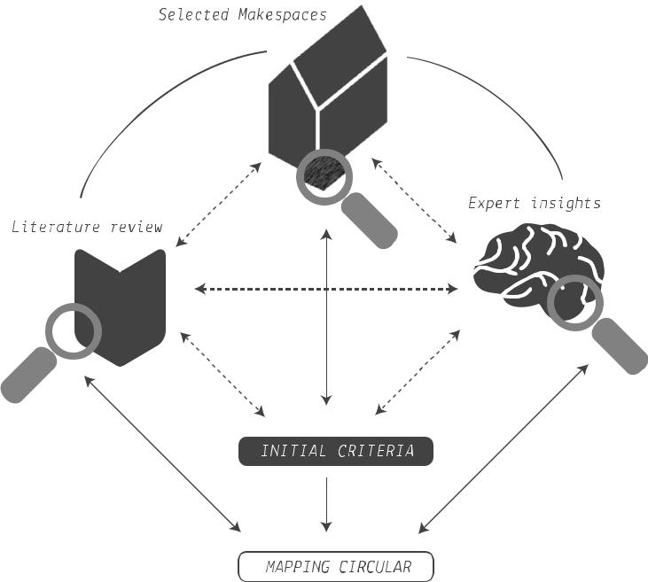

Figure 1. Overview of research methodology.

3.2.1. Workshop selection

Table 3. Overview of expert interviews.
Interviewee Role | Expertise | Date | Interview Purpose
Academic | Distributed production, sustainability in Makerspaces | 14 August 2015 | • identify exemplary and/or unique makerspaces to conduct workshops with
Makerspace founder | Incubating commercial start-ups in Makerspaces | 5 August 2015 | • explore concept of distributed production
Makerspace founder/academic | Implementation, incubating start-ups, distributed  production, sustainable urbanism | 31 July 2015 | • identify examples of distributed production
Makerspace founder/academic | Distributed production, sustainability in Makerspaces, repair practices | 1 September 2015 | • explore role of and opportunities for makerspaces in distributed production
Makerspace founder/academic | Distributed production, manufacturing, technology | 22 July 2015 | • explore role of and opportunities for makerspaces in circular economy
Makerspace founder/academic | Distributed production, sustainability in Makerspaces | 1 September 2015 | • identify their understanding of and experience  with CE  • identify criteria for context-mapping workshop  to map activities commensurate with the  development of circular makerspaces
The workshop selection was both purposive and opportunistic: on the one hand, we sought recommendations for pioneering makerspaces (from the experts interviewed) and this was supplemented with a pragmatic approach. The intention was to seek a range of views. The research scope is outlined in Figure 2, which situates the research within the makerspace landscape. Figure 2 combines a classification by (Troxler 2011) with a classification by Nesta (2015). The solid coloured area indicates the remit of selected makerspaces.

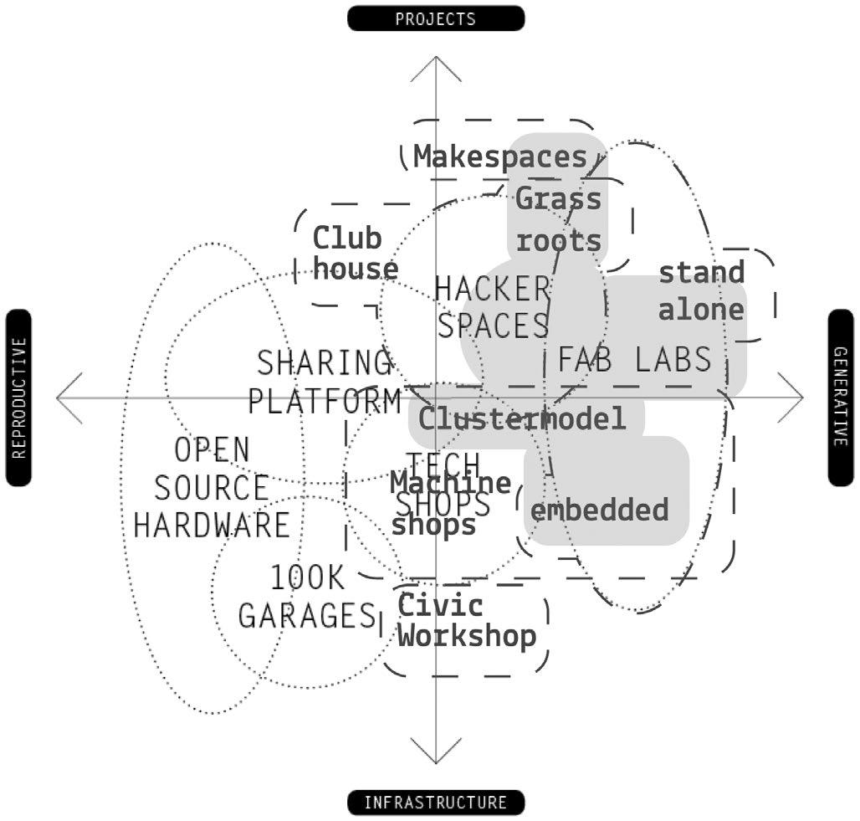

Figure 2. Map defining the scope of the research activities adapted from Troxler (2011) and Nesta (2015).

Troxler’s framework describes distinct types of makerspaces – fab labs, hackerspaces, techshops and community workshops – as more reproductive or more generative in their nature, and as more infrastructure-oriented or more-project oriented in their approach. Nesta emphasises ‘subjective interpretation’, nonetheless noting emergent patterns of common types of makerspaces and indicating a trend towards ‘hybrid’ models’. Hybrid models include ‘cluter-models’ and are perceived as a successful approach because they select and combine a range of beneficial attributes: access to co-working space; business services and technical equipment; income through consultancy or design services; and event hosting. In addition, the researchers sought examples exhibiting the following range of characteristics: grassroots to commercially-oriented; early stage set-up to more developed initiatives; potential for circular practice; and potential for distributed production.

The following makerspaces (cluster-models) were chosen for the workshops:
Fab Lab London: This Fab Lab was identified as an early stage makerspace with unique attributes due to its partnerships and co-location (at the time of writing) with a CE-focused government-funded agency, The Great Recovery⁶.
Buda::lab Kortrijk: This Fab Lab was identified through expert interviews as having a strong commercial focus and strategic links with its local context and therein high future potential for distributed production.
The two workshops were hosted at makerspaces chosen from an initial list of 19 potential makerspaces. Both were conducted on-site in collaboration with the makerspace managers and founders.

3.2.2. Description of workshop activities

The workshops use a generative context-mapping approach (Visser et al. 2005). Context-mapping is a participatory/user approach that involves lead participants from the outset to build understanding of contexts (ibid.). The context-mapping method was chosen to allow the researchers to directly understand the space from the viewpoint of each manager/founder. In the first case, this involved observation, participating in a design challenge and a walk-around the Fab Lab London in conversation with the Fab Lab manager.

For the second workshop, a series of tags, each with a circular theme, were used to map stories in the space. The themes used were identified through a combination of the literature, insights from workshop one, and insights from the expert interviews. These can be seen in Table 4. The research team developed the tagging approach to draw out and open up a dialogue with the founders/managers. This method is useful as it engages participants with the space directly and was viewed as an insightful technique to uncover and share key CE themes about day-to-day practices, in dialogue with the makerspace founders/man-agers. Hyysalo et al. (2014) employ a similar context-mapping approach using a tagging activity undertaken with makers who were instructed to add notes, with solutions statements to known issues, onto machines and surfaces as part of a participatory research study.

Table 4. Description of tags used during the Buda::LAB workshop.
Tags |  | Rationale | Tag explanation
Tools/technology |  | Expert interviews | The equipment used within the space and its relevance,
 |  | Literature (Kohtala, 2015) | relationship and impact to circularity
Value creation |  | Literature (Bocken et al. 2016; Bakker, den | Creating value that includes financial survival as well as social,
 |  | Hollander, et al. 2014; Dickel et al. 2016; | environmental and cultural
 |  | Ferreira, 2008)
Product lifecycle extension |  | Literature (Bakker, Wang, et al. 2014) | Consideration of raw material extraction, production, use,  transport and product life extension (reuse, repair,  remanufacture, upcycle, adaptability, upgradability, emotional  attachment, co-design/ prosumption)
Local contexts/local production |  | Expert interviews | Partnerships with local entities, such as through industrial
 |  | Literature (Kohtala, 2015) | symbiosis approaches
Community connections [local/global] |  | Expert interviews  Literature (Smith & Light, 2015) | Engagement with global communities for local benefit
Toxicity |  | Literature (Kohtala, 2015) | Environmental hazard of toxic materials, off-gassing of machines, waste toxicity
Waste/resources |  | Workshop 1  Literature (Bakker, Wang, et al. 2014; EMF 2013a,  2013b; Kohtala, 2015) | Sourcing materials from waste, sustainable use of resources and low environmental impact materials
Collaboration/partnerships |  | Expert interviews  Literature (Fleischmann et al. 2016) | Building partnerships to support activities, such as with experts, to assimilate knowledge
Supply chains |  | Literature (EMF, 2013a, 2013b) | Decisions about on know-how of sourcing of materials/parts
Actors/stakeholders |  | Expert interviews | Product value chain stakeholders
 |  | Literature (EMF 2013a, 2013b; Smith & Light, 2015)
Good practice guidance |  | Expert interviews  Workshop 1 | Guidance (e.g. signage, short descriptive overviews, visual cues,  processes)
Skills & knowledge |  | Expert interviews | Capacity building to bridge knowledge-action gap/access to
 |  |  | know-how
Workshop 1: Fab Lab London. This workshop was run in parallel to a design challenge that was co-developed in collaboration with The Great Recovery and the Open Source Circular Economy⁷ days (OSCEdays) global community. The central topic of the challenge was the CE, focusing on issues such as: product life cycles, information flows required to improve waste management, how wearable technology can facilitate circularity and the environmental impacts of open hardware manufactured within a makerspace.

• Approach: participatory context-mapping workshop integrating observation and shadowing.
• Purpose: the purpose was to develop initial insights into how circular practices are supported and from this develop initial guidelines and criteria for workshop two.
• Participants: Seven participants: researchers (3); manager/ founder (2); CAD software sustainability lead (1); soft-ware developer (1).

• Activities: the activities involved three key steps:
◦ Walk-around: the walk-around in conversation with the Fab Lab manager included an introduction to the work-shop focusing on processes and tools and examples of how they introduces circular principles and how these have been informed by its partnership with The Great Recovery, such as through understanding of proper machine set-up (e.g. correct positioning for optimal machine and material use).
◦ Observation: the ethnographic observation activities involved note-taking during and after the workshop and visually documenting important aspects/circular themes through photographs.
◦ Design challenge: the researchers participated in the design challenge⁸ focusing on the topic of embedding circular practices within makerspaces through the global OSCE days community. The process involved gathering best practices by connecting with experts, synthesising key issues from the initial research and conceptualizing potential solutions that could be further developed. The outcomes were discussed with all of the participants at the end of the session.

Workshop 2: Buda::lab Kortrijk. The researchers documented stories and anecdotes about circular themes to establish a view of the overall makerspace context. Figure 3 shows an example of a tag illustrating the themes of product life cycle, waste, good practice guidance and toxicity.

• Approach: participatory context-mapping approach using pre-selected tags each with a unique CE theme.
• Purpose: the purpose of the workshop was to: explore the makerspace activities from a circular viewpoint, as well as uncover ‘show & tell’ exemplars (similar to those identified during workshop one) through a tagging activity.
• Participants: 6 participants: researchers (2); managers (1); user/student (1); founders (2).
• Participant selection: prior to the workshop, the researchers shared an explanation of the activities and purpose (Appendix C) with the workshop manager and requested that he invite relevant parties to the workshop on our behalf.
• Activities: the main activities included establishing a dialogue with the makerspace manager and using ethnographic observation during the visit (documented through photographs and notes taken during the work-shop and detailed post workshop). The tagging activity involved laying the tags in front of the participants and asking them to choose tags to discuss. Participants were asked to choose tags that relate to an object or location within the makerspace in the context of (positive or negative) circular practices.

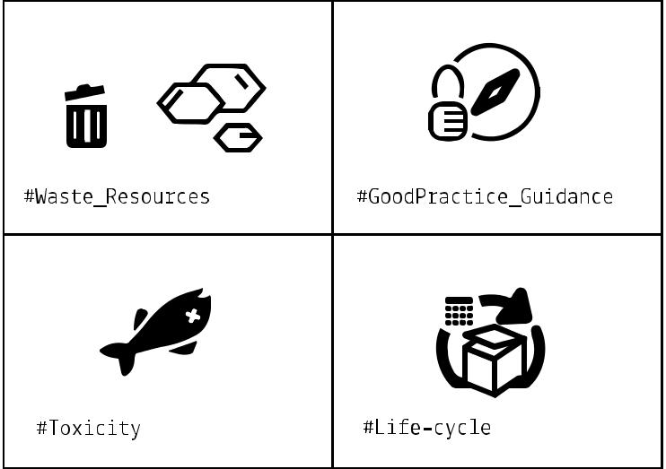

Figure 3. Example of tags with circular themes (Workshop 2).

4. Results

This section discusses the results of both workshops with respect to the vision and the key CE themes identified.

4.1. Workshop 1 – Fab Lab London

4.1.1. Vision

Fab Lab London was set up in 2013. Its focus is on digital manufacturing and rapid prototyping and it adheres to the Fab Charter⁹, which sets out its manifesto. It has an explicit commitment to using closed-loop methods and fostering ‘sustain-ability thinking’. Its overarching aim is to take an educational role tailored to knowledge facilitation, training and skill sharing, through events and engagement activities. It typically caters to corporate audiences through workshops and is centrally based in the City of London. In addition, it works ‘in-partnership’ with The Great Recovery¹⁰, to build knowledge on sustainable design by focusing on learning-by-doing. For instance, The Great Recovery’s signature activity, the educational ‘product tear down’ workshop, builds understanding and asks questions about what is behind manufacturing. The managers themselves are interested in CE issues and they are keen to transfer this to the lab users. The managers convey how their advocacy for sustainability through circular is realised in their educational activities. This is evident in its programme of events, trainings and open days built around circular design¹¹.

4.1.2. CE themes

The examples shown in Figure 4 communicate the key circular themes and insights from workshop one.

(1) Waste/resources: off-cuts of all types of materials are collected and stored visibly for reuse for prototyping models.

(2) Product life cycles: during the design challenge, participants developed concepts that relate to building knowledge of product life cycles:

(a) One group designed cosmetic packaging suited to easy disassembly, 3D modelling and printing their new design of an inner plastic cartridge and outer housing that could be easily separated. With the aid of the lab technician, this was quickly realised on the 3D printer and was seen as a strong example of circular product design, conveying the limitations of current design practices that fuse different materials together, thereby inhibiting clean recycling.

(b) Another group worked on doing a fast life cycle assessment (LCA) to assess the embodied energy of the Open Energy Monitor¹², with support from participants with expertise in LCA, illustrating how scientific knowledge relevant to circular is brought into the lab through collaborations.

(3) Technology/tools: examples of ‘fast print’ highlight the size and surface finish according to chosen print set-ting and the print time required to convey the pro-cess duration and material requirements to ensure users choose the optimum settings for their needs. In addition, it houses a machine to test filaments for recycling.

(4) Signage/visual cues: these are commonplace ‘show and tell’ tools that are perceived to guide the lab users towards better practices and support managers running the space. Simple examples range from labelling valuable scrap materials, to guidelines for efficient machine use, to signposting to local resources and collected off-cut material. These are useful to guide better behaviour because, according to the lab man-ager, it is too easy to go straight to high fidelity proto-typing. For instance, using the laser cutter to cut basic cardboard shapes for models, when a cutting mat and scalpel can be fine. This is something that needs to be conveyed to lab users daily and represents wider issues about use of technologies and materials.

(5) Value: the manager reflected on the cost of standard materials (such as hard plastics, acrylic, fibreboards, Plywood). Using the lab’s materials list (excerpt Appendix D) as a talking point, he described the prohibitive cost of exotic (and perhaps more sustainable options such as Polylactic acid (PLA)) that come at a premium and moreover are not requested by lab users. He proposed that knowing better the links between the material, the process and tool most appropriate to the product (and its system), to guide design choices via the material list would be beneficial, as well as vice versa the tool and processes.
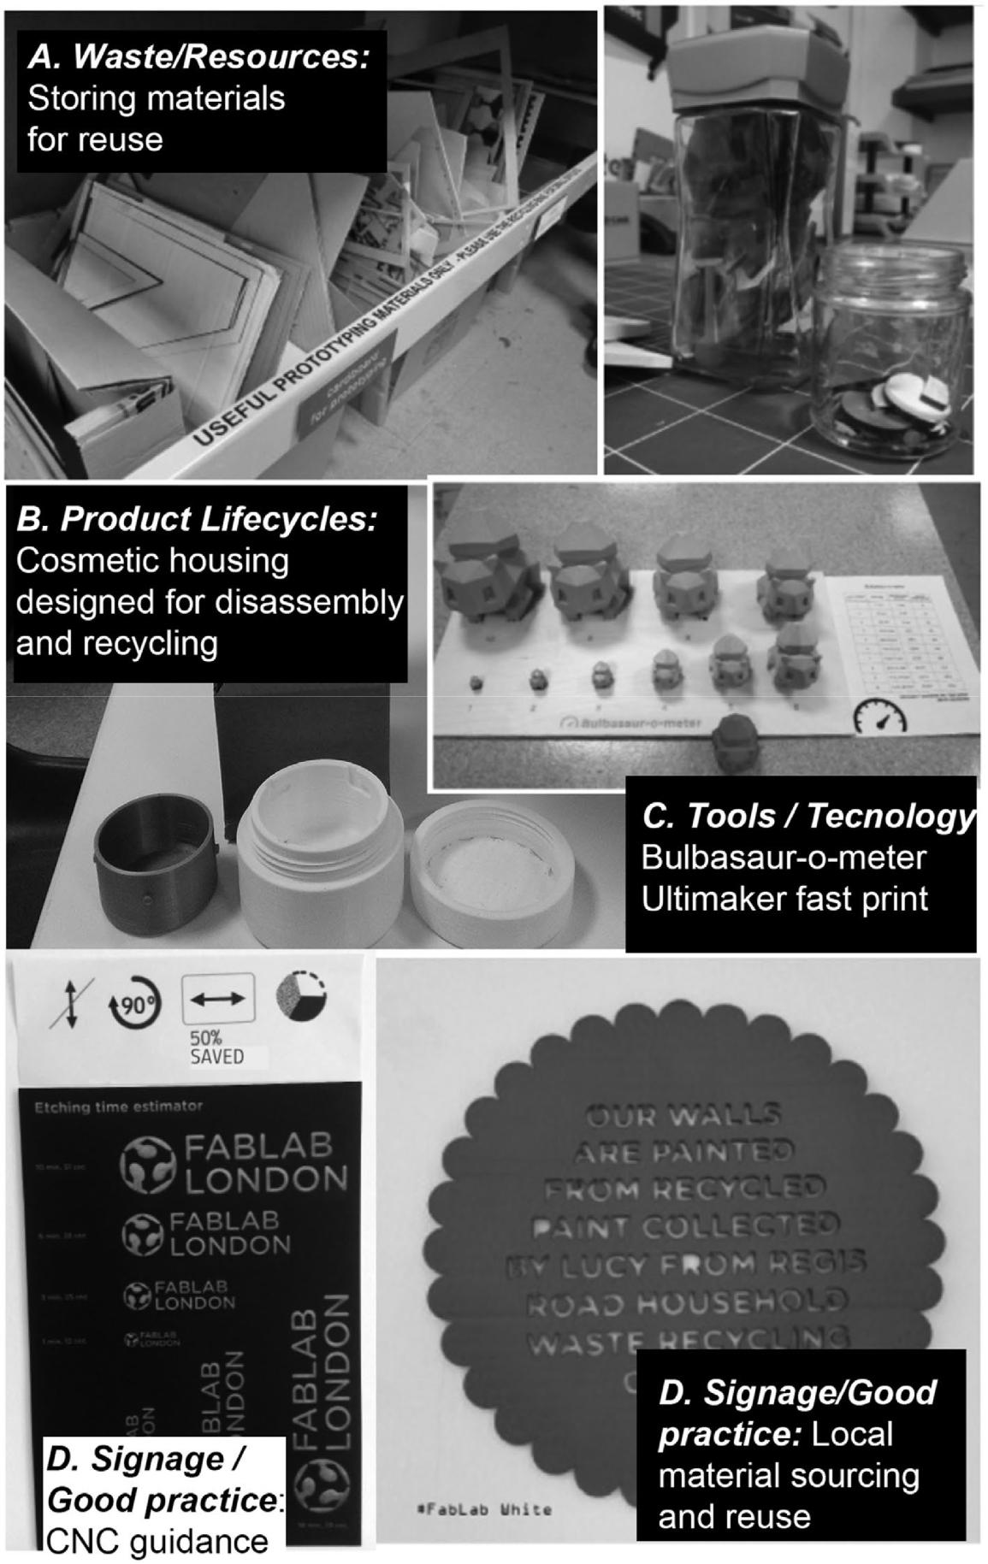

Figure 4. Documentation of Insights at Fab Lab London (Workshop 1).

4.2. Workshop 2 – Buda::lab

4.2.1. Vision and strategy

Buda::lab is a Fab Lab in the Belgian town of Kortrijk established in 2011 under a European interregional funding programme, in collaboration with the municipality, local design council and a polytechnic. The lab is part of the Budafabriek, a recently renovated textile factory, located within BUDA-island, situated between two river banks in Kortrijk. Its vision it is to stimulate networking between arts, entrepreneurship, education and creative citizens – it is a public space as well as a cultural centre. Both the chairman and the coordinator of the Buda::lab want to encourage people of the region to use the lab as a working place for co-creation, as well as to encourage the creative collaborative process of companies.

4.2.2. Circular themes

Figure 5 illustrates some of the outcomes of the tagging activity and theme discussion around: local collaborations; tools and technologies; typical prototypes produced in the lab; initiatives such as the open source beehive project13 and the global Fab Lab network.

(1) Technology/tools: Buda::lab is a public workshop where an extensive collection of machines is available to process materials. It houses conventional techniques such as sawing, drilling and tools for wood, machines through additional funding and donations (including a lathe and textile plotter).
(2) Product lifecycles: the lab manager describes how they often don’t ‘see the end result’ of their commercial work, reflecting their supply chain position (research and development). The open source bee-hive project led to a discussion about fixtures and joining and highlighted that more knowledge needs to be shared about good design practices (such as glue free joints).
(3) Value: the lab generates financial income through commercial activities including prototyping and making high fidelity architectural models, examples included a prototype mechanical gear made of a commonplace engineering plastic, a bespoke trike and a diorama.
(4) Sharing: the lab users have established and organise their own ‘electronics library’.
(5) Toxicity: typical day-to-day activities at the lab generate lots of waste some of which is problematic to dispose of (such as spray paint cans).

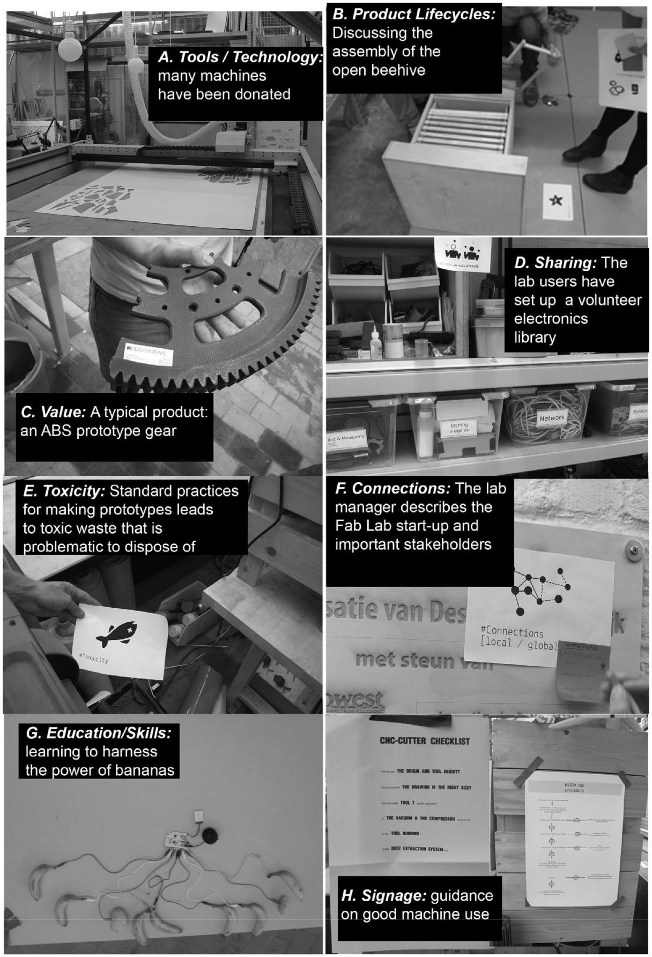

Figure 5. Documentation of Insights at BUDA::lab Kortrijk (Workshop 2).

(6) Local production/local contexts: initially, the man-ager had a vision to promote local production net-works, connecting producers and lab users and this was expressed in their previous attempts to set up a local supplier database. For example, they conveyed an interest to engage with a local textile federation upskilling people, by making it possible for everyone as Kortrijk was once a textile-producing region. The manager expressed his desire to enlist local providers where possible (e.g. for aluminum extrusions) and according to them, these relationships unfold over time.
(7) Education/skills: during the workshop, Buda::lab was hosting a six-week educational course with introductions to tools and technologies. The manager described how makerspaces are already reskilling and upskilling people, by making it possible for everyone to carry out their projects themselves, offering startups machines and equipment, as well as material exhibitions, and establishing a materials database. In addition, he indicated that induction courses, such as machine tool master classes as part of the PROUD work online, help to instill good practices in lab users from the outset.
(8) Guidance/signage: the Buda::lab also uses signage and process steps commonly throughout the space, to guide its users to encourage good behaviours for Health and Safety but also efficiency and good design practices.

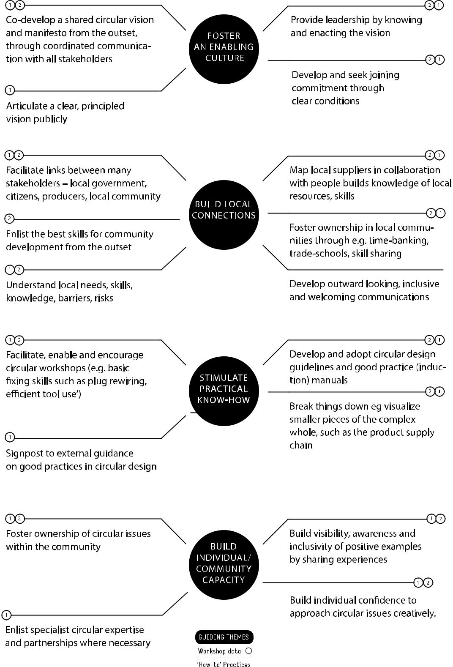

Figure 6. Circular Makerspaces: guiding themes and ‘How-to’ practice

5. Analysis and discussion

5.1. Enacting circularity in Makerspaces

Through clustering and thematic analysis, this section analyses and discusses the research findings. Figure 6 describes the practices identified through the research, clustered according to four themes: foster an enabling culture; build local connections; stimulate practical know-how; nurture individual/ community capacities. The whole cluster analysis can be seen in Appendix E. For each theme, a set of ‘how -to’ guidelines are described, supported by interviewee quotes and workshop data.

5.1.1. Foster an enabling culture

Interviewees variously reflected on the necessity to facilitate a ‘… stakeholder circle’ to ensure dedication from those individuals who can bring relevant skills. There is a need to set a ‘clear and principled vision’ that emphasises ‘responsible products’ from the outset. It is clear that establishing this vision sets the course for a given makerspaces and this is enacted through its admission processes (e.g. ‘initiation’, ‘joining conditions’, induction) and day-to-day practices. For instance, Fab Lab London has a strategic commitment to ‘sustainability thinking’ supported by its staff, tools and activities, despite the absence of explicit sustainability criteria in the Fab Charter. These practices help form the culture. One interviewee conveyed the cultural differences between contexts, ‘Hackerspaces reuse things, Fab Labs don’t place so much priority on reuse’ and another that ‘Fab Labs are waste machines …’. Similarly, one interviewee describes how ‘repair days … create a culture … and foster appreciation of design and craftsmanship’, that itself has ripple effects. However, the hurdles of commercial viability, lack of time and expert know-how and relevant tools and methods were raised repeatedly.

5.1.2. Build local connections

The participants reflected on the great diversity between different makerspaces and the importance of being sensitive to distinct cultures, local contexts and values. The participants conveyed a need to integrate and work closely with their local communities stating that the local context needs to be considered in the business plan from the very outset, ‘do some local context research to understand … needs to co-develop a lab and a business plan – you need to be sensitive to the project fulfilling local needs …’. However, many described how this is a challenge for them, due to a lack of time to invest in building relationships and a lack of knowledge of potential local skills and suppliers. During workshop two, the manager described their intention to build a repository of local suppliers, but the activity got side-lined due to more pressing daily concerns. Yet, it is perceived that over time, by being inclusive and working on genuine local issues makerspaces can build up ‘industrial ecology’ and create networks of local skills, resources and suppliers. It is also seen as a means to overcome ‘credibility’. Prejudices that see it as ‘elitist’ or the ‘preserve of geeks’ were raised and this can limit engagement with a diverse range of people within the local community.

5.1.3. Stimulate practical know-how

Reusing materials such as cardboard on a laser-cutter is not necessarily practical because the card burns. Similarly, specially produced technical materials are still used in the vast majority of additive/subtractive machines rather than recycled ones. Therefore, makerspace users are shown to need support to adopt good practices and develop appropriate skills (e.g. workshop one where LCA expertise is brought in through an external expert). These familiar (technical) issues mean that the need for ‘understanding of what it takes to have a sustainable artifact’ prevails. There is emphasis on the need to visualise problems, ‘it’s important to take things apart’, see practical solutions and break issues down to make them manageable, ‘the sub-dimensions of circular practices’. The interviewees described how this can be achieved by making issues ‘visible’ to users through workshops, sharing examples and good practices or for instance through practical tools that aid visualising supply chains. Nevertheless, the research identified that tools and methods are needed to facilitate sharing this know-how amongst the global makerspace communities.

5.1.4. Nurture individual/community capacity

One interviewee described the need for individuals to ‘experience circular practices’ through activities such as tear-downs. This builds engagement with circular issues and eventually, through ongoing experimentation and experience, lab users build confidence to challenge the current norms of design practice. This focus on ‘… building aptitude rather than expertise’ provides ‘access to confidence’ and a ‘cultural collaborative landscape’, reminiscent of a ‘community of practice’ approach to learning design. For instance, one interviewee described a time when one makerspace challenged another to identify a local waste stream, once it did, the challenger shared its information about this waste stream and how to create value from it.

5.2. Positioning makerspaces in a future CE

In this research, the potential for circular makerspaces was explored through the lens of distributed production. The research found that makerspaces are perceived as having a variety of potential roles in a future CE: as educational nodes, spaces for creativity and solution development by ‘hothousing’ circular design into the mainstream, for prototyping and (to a lesser degree) as places for manufacturing. This is because, ‘makerspaces are not seen to be geared toward manufacturing’ at present. In contrast, makerspaces are described as ‘knowledge centres’ well suited to ‘experimentation with different approaches to see what works’ for developing circular ideas. This is important from a circularity viewpoint because it reflects whether or not these spaces can legitimately offer an alternative production system founded on circularity principles.

In this research, we see how managers/founders play an instrumental role in supporting circular practices. However, the research unearths many contradictions in the current narrative about circularity in makerspaces. For instance, the technology/ business focus of the CE, juxtaposed with the social drivers of makerspaces (often a by-product of their funding) seem at odds. This raises questions about the willingness of businesses to collaborate with makerspaces and moreover the likelihood of makerspaces developing manufacturing competences. In addition, we already see makerspaces that depart from purely social motivations. In the absence of funding streams to establish makerspaces founded on circularity principles, this is a concern. This means that for these two agendas to meaningfully coalesce structured facilitation is required, that could nevertheless lead to an ultimately richer and more sustainable (social, economic, environmental) manifestation of the CE. Many makerspaces are not financially self-sustainable and for this reason makerspace managers and founders themselves see a role for government intervention for issues related to sustainability and emphasise the important external factors that restrict their capacity to ‘act’ including consumer behaviour, market forces, policy and government legislation. This is illustrative of how circular makerspaces face many similar challenges (cultural, behavioral, organizational, technical, infrastructural) to sustainable innovation implemented in ‘mainstream’ design and manufacturing realms.

6. Conclusion

This article aimed to explore the concept of circular makerspaces, focusing on the role of managers/founders, who were identified as gatekeepers to circular practices. Through dialogue with representatives of the makerspace movement, themselves advocates for sustainability within it, we have uncovered initial principles supported by practical ‘how to’ guidance that are perceived to support these key actors to: foster an enabling culture; build local connections; stimulate practical know-how; nurture individual/ community capacity. It was found that to develop a makerspace with circularity at its core, its managers/founders need to pro-mote a vision for circular makerspaces from the outset, leveraging practical tools to embed circular practices in the day-to-day.

It was found that makerspaces can play a critical role in a future CE. However, none of the makerspaces visited were wholly conceptually orientated around a circular vision, even though they may espouse sustainability values. The pressing day-to-day concerns of remaining in operation mean that more profound activities that ask questions about our economy through makerspace platforms are often compromised. Yet, we see that they remain abundantly promising places for exploration and inspiration for systems change for a more sustainable future. However, the lack of circular practices conveyed through this and other studies needs to be addressed. The opportunity to develop circular literacy within makerspaces is immense, yet so far untapped and the insights from this research can act as a starting point for future work.

7. Limitations and further work

This study used a combination of a purposive and opportunistic sampling approach and therefore the results have some limitations. Makerspaces are subject to rapid change and are not heterogeneous; therefore, the results may not be representative, but rather offer insights to a particular set of makerspaces at a given point in time. More research needs to be undertaken in this area and the following are recognised here:

• Elaborate on the processes, people and projects synonymous with makerspaces – to explore the decisions being made and the necessary guidance needed.
• Elaborate on the outputs being produced, the processes within the makerspace and within its local and global ecosystem.
• Elaborate on the tools and methods that can sup-port founders/managers (induction manuals, signage packs, online resource, processes for mapping local resources).
• Elaborate on the training needs of people running makerspaces (guidance, know-how, leadership skills) to over-come challenges they face.
• Clarification on what is meant by distributed production and how it can emerge from different types of maker-spaces needs to be better understood.
• Mechanisms and incentives to drive local distributed production need further exploration in terms of legislation, education and technology.

Notes

1. In this article, we use the term ‘makerspace’ though we recognise that ‘makespace’ is also used and that the activities that characterise hackspaces, build-space, innovation spaces, Fab labs, Tech shops, etc. often overlap and can be difficult to define.
2. http://www.ifm.eng.cam.ac.uk/resources/technology/additive-manufacturing-strategy/
3. http://www.centralresearchlaboratory.com/
4. https://www.indiegogo.com.
5. https://www.kickstarter.com.
6. http://www.greatrecovery.org.uk.
7. It was hosted during a global hackathon on the topic of Open Source Circular Economy Days (OSCEdays: https://oscedays.org/) in collaboration with the global online OSCEdays community. The nature of the OSCEdays hackathon was such that the event was promoted throughout makerspace networks online and participants were given the option to choose a challenge (out of a possible five).
8. http://community.oscedays.org/t/headline-challenge-circular-maker-spaces/451.
9. http://fab.cba.mit.edu/about/charter/.
10. http://www.greatrecovery.org.uk.
11. http://www.greatrecovery.org.uk/fab-fridays-introduction-to-the-great-recovery-and-fab-lab-london/.
12. https://openenergymonitor.org/emon/
13. http://opensourcebeehives.net/.

Disclosure statement

No potential conflict of interest was reported by the authors.

Funding

This research was in-part supported by an EPSRC-funded re-distributed manufacturing network grant awarded to the Royal College of Art in 2015 [grant number EP/M017591/1].

Notes on contributors

Sharon Prendeville is a lecturer at the Institute of Design Innovation at Loughborough University's London campus. She researches new con-texts for design, such as distributed production or circular cities and their potential to enable sustainable futures. This encompasses how sustainability manifests in urban contexts through grass-roots initiatives and policy-making. She is a visiting lecturer at the Royal College of Art and a guest affiliate at the Technical University of Delft in The Netherlands.

Grit Hartung is a creative communicator and a design researcher. She is a visiting lecturer (since 2011) at universities including Brunel University, Royal College of Art, Ravensbourne College, London South Bank University on modules: Advanced Graphic Communication, Design for Sustainable Society and Design Interactions. Her design research focuses on areas including design thinking, experimental design, transdisciplinary co-creation, sustainable practice and innovation.

Clare Brass is a designer and a trainer with a product design background and expertise in turning societal and environmental issues into entrepreneurial solutions. She was the head of sustainability at the Design Council before joining the Royal College of Art in 2008 as senior tutor in IDE. In 2011, she set up SustainRCA, a cross-departmental sustainability centre, using the creative power of design to help businesses address sustainability challenges. She recently established Department 22, offering circular economy consultancy and training in pursuit of a better twenty-second century.

Erica Purvis works at TechnicalNature, mixing technical engineering experience with design thinking and creative engagement. Currently, she works as a design and impact lead at the Central Research Laboratory, a hardware accelerator and co-working space in London. Previous and ongoing roles include sustainability engineer at Philips, programme manager in NGOs Waste Watch and Keep Britain Tidy, start-up coach for Climate KIC The Journey and supporting the development of the OSCEdays and People’s Design Lab.

Ashley Hall is a professor of design innovation at the Royal College of Art’s Innovation Design Engineering programme, where he is the head of research and runs an MRes in Healthcare and Design and MRes Design pathway. He researches in a number of design and innovation fields including design thinking, experimental design, future of making, cultural transfer, translocated making and design risk.

References
Bakker, Conny, Marcel den Hollander, E. van Hinte, and Y. Zijlstra. 2014. Products That Last: Product Design for Circular Business Models. Delft: TU Delft Library/Marcel den Hollander IDRC.

Bakker, Conny, Feng Wang, Jaco Huisman, and Marcel den Hollander. 2014. “Products that Go Round: Exploring Product Life Extension Through Design.” Journal of Cleaner Production 69 (April): 10–16. doi:10.1016/j.jclepro.2014.01.028.

Birtchnell, Thomas, and John Urry. 2013. “Fabricating Futures and the Movement of Objects.” Mobilities 8 (3). 388–405. doi:10.1080/174501 01.2012.745697.

Bocken, Nancy M. P., Conny Bakker, and Ingrid De Pauw. 2016. “Product Design and Business Model Strategies for a Circular Economy.” Journal of Industrial and Production Engineering 33 (5): 308–320.

Braungart, Michael, William McDonough, and Andrew Bollinger. 2007. “Cradle-to-Cradle Design: Creating Healthy Emissions – A Strategy for Eco-effective Product and System Design.” Journal of Cleaner Production 15 (13–14): 1337–1348. doi:10.1016/j.jclepro.2006.08.003.

Bryman, Alan, and Emma Bell. 2015. Business Research Methods. Oxford: Oxford University Press.

Charter, Martin, and Scott Keiller. 2014. Grassroots Innovation and the Circular Economy: A Global Survey of Repair Cafés and Hackerspaces. Farnham: Centre for Sustainable Design.

Charter, Martin, and Scott Keiller. 2016. “The Second Global Survey of Repair Cafés: A Summary of Findings.” Report by Centre for Sustainable Design, Surrey May 2016. http://www.research.ucreative.ac.uk/3140/1/The%20Second%20Global%20Survey%20of%20Repair%20Cafes%20 -%20A%20Summary%20of%20Findings.pdf.

Cohen, Boyd, and Pablo Muñoz. 2016. “Sharing Cities and Sustainable Consumption and Production: Towards an Integrated Framework.” Journal of Cleaner Production 134 Part (October): 87–97. doi:10.1016/j. jclepro.2015.07.133.

Despeisse, M., M. Baumers, P. Brown, F. Charnley, S. J. Ford, A. Garmulewicz, S. Knowles, T. H. W. Minshall, L. Mortara, and F. P. Reed-Tsochas. 2017. “Unlocking Value for a Circular Economy through 3D Printing: A Research Agenda.” Technological Forecasting and Social Change 115: 75–84.

Dewberry, Emma, and M. Monteiro de Barros. 2009. “Exploring the Need for More Radical Sustainable Innovation: What Does It Look like and Why?” International Journal of Sustainable Engineering 2 (1): 28–39. doi:10.1080/19397030802643518.

Dewberry, Emma, Lourdes Saca, Mariale Moreno, Leila Sheldrick, and Matt Sinclair. 2016. “A Landscape of Repair.” In Sustainable Innovation 2016 Surrey, November 7–8. 76–85.

Dickel, Sascha, Jan-Peter Ferdinand, and Ulrich Petschow. 2016. “The Multiple Applications of 3D Printing: Between Maker Movements and the Future of Manufacturing.” In The Decentralized and Networked Future of Value Creation, edited by Jan-Peter Ferdinand, Ulrich Petschow, Sascha Dickel, 9–26. Springer. doi:10.1007/978-3-319-31686-4

Edbring, Emma, Matthias Lehner, and Oksana Mont. 2016. “Exploring Consumer Attitudes to Alternative Models of Consumption: Motivations and Barriers.” Journal of Cleaner Production 123: 5–15. doi:10.1016/j.jclepro.2015.10.107.

Ellen MacArthur Foundation. 2013a. “Towards a Circular Economy: Business Rationale for an Accelerated Transition.” http://www. ellenmacarthurfoundation.org/publications.

Ellen MacArthur Foundation. 2013b. “Towards the Circular Economy: Opportunities for the Consumer Goods Sector.”

Ellen MacArthur Foundation. 2015. “Growth within: A Circular Economy Vision for a Competitive Europe.”

EPSRC. 2013. “Redistributed Manufacturing Workshop Report.” Ferreira, Edy. 2008. “Open Hardware Business Models.” Open Source Business Resource, April 2008.

Fleischmann, Katja, Sabine Hielscher, and Timothy Merritt. 2016. “Making Things in Fab Labs: A Case Study on Sustainability and Co-creation.” Digital Creativity 27 (2): 113–131. doi:10.1080/14626268.20 15.1135809.

From Now On. 2016. “The Cultural Role of Makerspaces.” https://issuu.com/deehalligan/docs/fno_report.

Gershenfeld, Neil. 2005. Fab: Personal Fabrication, Fab Labs and the Factory in Your Computer. New York: Basic Books Inc.

Ghisellini, Patrizia, Catia Cialani, and Sergio Ulgiati. 2015. “A Review on Circular Economy: The Expected Transition to a Balanced Interplay of Environmental and Economic Systems.” Journal of Cleaner Production 114: 11–32. doi:10.1016/j.jclepro.2015.09.007.

Gregson, Nicky, Mike Crang, Sara Fuller, and Helen Holmes. 2015. “Interrogating the Circular Economy: The Moral Economy of Resource Recovery in the EU.” Economy and Society 44 (2): 218–243. doi:10.1080 /03085147.2015.1013353.

Haas, Willi, Fridolin Krausmann, Dominik Wiedenhofer, and Markus Heinz. 2015. “How Circular Is the Global Economy? An Assessment of Material Flows, Waste Production, and Recycling in the European Union and the World in 2005.” 19 (5): 765–777. doi:10.1111/ jiec.12244.

Hielscher, Sabine, Adrian Smith, and Mariano Fressoli. 2015. WP4 Case Study Report: FabLabs, Report for the TRANSIT FP7 Project.. Brighton, UK: SPRU, University of Sussex. Accessed May 16, 2015.

Hielscher, Sabine, and Adrian G. Smith. 2014. “Community-based Digital Fabrication Workshops: A Review of the Research Literature.”

Hobson, Kersty. 2016. “Closing the Loop or Squaring the Circle? Locating Generative Spaces for the Circular Economy” 40 (1): 88–104. doi:10.1177/0309132514566342.

Hobson, Kersty, and Nicholas Lynch. 2016. “Diversifying and De-growing the Circular Economy: Radical Social Transformation in a Resource-Scarce World.” Futures 82: 15–25. doi:10.1016/j. futures.2016.05.012.

Holman, Will. 2015. “The Open Source Object.” Medium. https:// medium.com/@objectguerilla/the-open-source-object-8ceac1c8ef55#. n7diyshis.

Hunt, Rhiannon, and Martin Charter. 2016. “3D Printing Applications for Creating Products Made from Reclaimed Fishing Nets.” In Sustainable Innovation, 150–164. Farnham, UKThe Centre for Sustainable Design.

Hyysalo, Sampsa, Cindy Kohtala, Pia Helminen, Samuli Mäkinen, Virve Miettinen, and Lotta Muurinen. 2014. “Collaborative Futuring with and by Makers.” CoDesign 10 (3–4): 209–228. doi:10.1080/15710882.2014. 983937.

Kohtala, Cindy. 2015. “Addressing Sustainability in Research on Distributed Production: An Integrated Literature Review.” Journal of Cleaner Production 106: 654–668. doi:10.1016/j.jclepro.2014.09. 039.

Kohtala. (2016) 2017. “Making ‘Making’ Critical: How Sustainability is Constituted in Fab Lab Ideology Making.” The Design Journal 6925 (January): 1–20. doi:10.1080/14606925.2016.1261504.

Kohtala, Cindy, and Sampsa Hyysalo. 2015. “Anticipated Environmental Sustainability of Personal Fabrication.” Journal of Cleaner Production 99: 333–344. doi:10.1016/j.jclepro.2015.02.093.

Koshy, Elizabeth, Valsa Koshy, and Heather Waterman. 2010. Action Research in Healthcare. London: Sage.

Kostakis, Vasilis, VasilisNiaros, George, Dafermos, and Michel Bauwens. 2015. “Design Global, Manufacture Local: Exploring the Contours of an Emerging Productive Model.” Futures 73: 126–135. doi:10.1016/j. futures.2015.09.001.

Lieder, Michael, and Amir Rashid. 2016. “Towards Circular Economy Implementation: A Comprehensive Review in Context of Manufacturing Industry.” Journal of Cleaner Production 115: 36–51. doi:10.1016/j. jclepro.2015.12.042.

Lupton, Deborah. 2016. “3D Printing Technologies: Social Perspectives.” Social Perspectives: 1–6. https://ssrn.com/abstract=2865290.

Moreno, Mariale, and Fiona Charnley. 2016. “Can Re-distributed Manufacturing and Digital Intelligence Enable a Regenerative Economy? An Integrative Literature Review.” In Sustainable Design and Manufacturing 2016, edited by Rossi Setchi, Robert J. Howlett, Ying Liu, and Peter Theobald, 563–575. Cham: Springer International Publishing. doi:10.1007/978-3-319-32098-4_48.

Moreno, Mariale, Carolina De los Rios, and ZoeRowe, and Fiona Charnley. 2016. “A Conceptual Framework for Circular Design.” Sustainability (Switzerland) 8 (9): 937. doi:10.3390/su8090937.

Murray, Alan, Keith Skene, and Kathryn Haynes. 2015. “The Circular Economy: An Interdisciplinary Exploration of the Concept and Application in a Global Context.” Journal of Business Ethics 140: 369– 380. doi:10.1007/s10551-015-2693-2.

Nascimento, Susana, and Alexandre Pólvora. 2016. “Maker Cultures and the Prospects for Technological Action.” Science and Engineering Ethics: 1–20: doi:10.1007/s11948-016-9796-8.

Nesta. 2015. “Open Dataset of UK Makerspaces: A User’s Guide.” http://www.nesta.org.uk/publications/open-dataset-uk-makerspaces-users-guide.

Prendeville, Sharon, Emma Cherim, and Nancy Bocken. 2017. “Circular Cities: Mapping Six Cities in Transition.” Environmental Innovation and Societal Transitions. doi:10.1016/j.eist.2017.03.002. http://www. sciencedirect.com/science/article/pii/S2210422416300788.

Prendeville, Sharon M., Frank O’ Connor, Nancy M. P. Bocken, and Conny Bakker. 2017. “Uncovering Ecodesign Dilemmas: A Path to Business Model Innovation.” Journal of Cleaner Production 143: 1327–1339. doi:10.1016/j.jclepro.2016.11.095.

Riisgaard, Henrik, Mette Mosgaard, and Kristina Overgaard Zacho. 2016. “Local Circles in a Circular Economy-the Case of Smartphone Repair in Denmark.” European Journal of Sustainable Development 5 (1): 109–124. European Center of Sustainable Development: 109.

Ritzer, George, and Nathan Jurgenson. 2015. “Production, Consumption, Prosumption.” Journal of Consumer Culture 10 (1): 13–36. doi:10.1177/1469540509354673.

Robson, Colin, and Kieran McCartan. 2015. Real World Research. Fourth: Wiley.

Royal Society for the Encouragement of the Arts, Manufactures and Commerce. 2015. “Ours to Master: How Makerspaces Can Help Us Master Technology for a More Human End.”

Salvia, Giuseppe. 2015. “Design in the New Do-It-Yourself Age: Trialing Workshops for Repairing.” In Virtuous Circle: Summer Cumulus Conference, Politecnico di Milano, Milan, Italy, June 3–7.

Salvia, Giuseppe, and Sharon Prendeville. 2017. Design for a Circular Future through Distributed Repair. In Design Management Academy: Research Perspectives for Creative Intersections, Hong Kong, June 7–9, 2017.

Seyfang, Gill, and Adrian Smith. 2007. “Grassroots Innovations for Sustainable Development: Towards a New Research and Policy Agenda.” Environmental Politics 16 (4): 584–603.

Smith, Adrian, Mariano Fressoli, Abrol Dinesh, Arond Elisa, and Adrian Ely. 2016. Grassroots Innovation Movements. London, New York: Earthscan from Routledge.

Smith, Adrian, and Ann Light. 2015. “How to Cultivate Sustainable Developments in Makerspaces.” Report of workshop, October 2015 Brighton. http://steps-centre.org/wp-content/uploads/MC-report_final.pdf.

Srai, Jagjit Singh, Mukesh Kumar, Gary Graham, Wendy Phillips, James Tooze, Simon Ford, Paul Beecher, Baldev Raj, Mike Gregory, and Manoj Kumar Tiwari. 2016. “Distributed Manufacturing: Scope, Challenges and Opportunities.” International Journal of Production Research 54 (23): 6917–6935.

Stahel, W. R. 1984. “The Product-life Factor.” An Inquiry Into the Nature of Sustainable Societies: The Role of the Private Sector 3: 72–96. http:// www.product-life.org/en/major-publications/the-product-life-factor%5Cnhttp://infohouse.p2ric.org/ref/33/32217.pdf.

Su, Biwei, Almas Heshmati, Yong Geng, and Xiaoman Yu. 2013. “A Review of the Circular Economy in China: Moving from Rhetoric to Implementation.” Journal of Cleaner Production 42 (March): 215–227. doi:10.1016/j.jclepro.2012.11.020.

Sung, K., T. Cooper, and S. Kettley. 2015. “An Exploratory Study on the Links between Individual Upcycling, Product Attachment and Product Longevity.” In Product Lifetimes and the Environment. Nottingham, June 17–19.

Terzioğlu, Nazlı Gökçe, Brass Clare, and Dan Lockton. 2016. “3D Printing for Repair: A Paradigm Shift in Fixing Our Relationships with Things.” In Sustainable Innovation 2016. Surrey, November 17–18.

Thackara, John. 2011. “Into the Open.” In Open Design Now: Why Design Cannot Remain Exclusive, edited by Bas van Abel, Roel Klaassen, Lucas Evers, Lucas, and Peter Troxler, 42–45. Amsterdam: BIS Publishers.

Toombs, Austin, Shaowen Bardzell, and Jeffrey Bardzell. 2014. “Becoming Makers: Hackerspace Member Habits, Values, and Identities.” Journal of Peer Production 5: 1–8.

Troxler, Peter. 2011. “Libraries of the Peer Production Era.” In Open Design Now: Why Design Cannot Remain Exclusive, edited by Bas van Abel, Roel Klaassen, Lucas Evers, Lucas, and Peter Troxler, 86–97. Amsterdam: BIS Publishers.

Verheul, Hugo, and Philip J. Vergragt. 1995. “Social Experiments in the Development of Environmental Technology: A Bottom-up Perspective.” Technology Analysis & Strategic Management 7 (3): 315–326.

Visser, Froukje Sleeswijk, Pieter Jan Stappers, Remko Van der Lugt, and Elizabeth B N Sanders. 2005. “Contextmapping: Experiences from Practice.” CoDesign: International Journal of CoCreation in Design and the Arts 1 (2): 119–149.

Appendix A. Site visits undertaken

Space | Date | Purpose | Format | Actors | Selection criteria
Fab Lab London, UK | 14–16 June | Scoping and testing (see Section | OSCEdays 2015 | Organisers: OSCEdays team | Commercial/Educational
 | 2015 | 2.3.1) | 2-day Workshop | Challenge Setters: (1 of 5)  Participants (3 of 26)  Researchers (1/3)
Lewes Phoenix Indus trial Estate, UK | 24 July 2015 | Initial mapping and observations | Invited  Guided Tour  Site visit | Organiser:  Research Team  Guide (1)  Makers, Inventors (6)  Researchers (2) | Grassroots
Kortrijk Buda LAB, BE | 21 August  2015 | Testing and further observations | Site visit and workshop (see section 2.3.2) | Organisers: Research team  Researchers (2) | Commercial/Educational
Fab Lab Amersfoort,  NL | 22 August  2015 | Participation in workshops and  observation | Site-visit, Fab Fuse event | Organisers: Fab Lab Amersfoort  Participants: [20–25]  Researchers (2) | Grassroots/Educational  Sustainability-focused
Machines Rooms, UK | 10 March 2015 | Participation and observation | Launch Level 1 FMs Workshop | Organisers: Research team  Researcher (1) | Commercial/Educational
Machines Rooms, UK | 26–27 October 2015 | Participation in workshops and  observation | Sustainable Makerspaces –  Workshop  Event | Organisers: SPRU, STEP  Speakers:12  Participants: 25/30  Researcher (2/1) | Commercial/Educational
Makerversity, UK | 24–25 July 15 | Participation and observation | Good For Nothing Hack with  Restart, Civic shop & New  Citizenship Project | Organiser: Good For Nothing  Participants: Approx 30  Researcher (1) | Commercially-focused hardware start-up incubation focus
Central Research | 4 August 2015 | Ongoing - involvement in the |  | Researcher (1) | Commercially-focused
Laboratory, UK | onwards | setting-up and running of space |  |  | hardware start-up incubation focus

Appendix B. Expert interview guide
I: Please introduce yourself
- Name, your role, current activities (related to distributed manufacturing and/ or circular economy)
- If unclear from introduction, seek clarification the interviewee is familiar with terms: circular design and circular economy. Explain for the remain-der of the interview the term ‘circularity’ will be used.

Questions
(1) Are you familiar with the concept of distributed production/or redistributed manufacturing? [ ] yes … [ ] no …
If so, what do you understand DM to mean? If not, we explain outline (see appendix), you imagine DM. Can you cite (A)/think of (B)/imagine (C) any examples?
(2) What do you think the importance of DM is in terms of circularity?
(3) From your perspective, do you think makerspaces have a role in a DM future?
(4) What do you think DM mean in terms of circularity? What does this mean for the future of manufacturing?
(5) What do you think this idea of circularity* means in the context of makerspaces?
(6) What examples of circularity have you seen (in makerspaces), if any? Can you direct us to any potential case studies?
(7) What do makerspaces/the people of the makerspace need to develop/improve circular their practice (rationale for development of activities/tools)?
(8) What is the role of technology in makerspaces?
(9) What do these technologies mean in terms of circularity?
(10) What is the role of tools and technology in makerspaces?
(11) What do these tools and technologies mean in terms of circularity/contribute to circularity?
(12) What is the role of people in makerspaces?
(13) What do these people mean in terms of circularity? What are the key: barriers; enablers; opportunities
(14) What other characteristics would you say encourage a circular economy in makerspace, for
example, customers/ethos/ expertise/resources?
(15) If at all, how does the culture of makerspaces relate to sustain-ability/practice & regulations?

Appendix C. Pre-workshop Information for Participants at Workshop 2

Workshop 2
Purpose: To conduct a series of design research activities to build on (and test) existing insights gleaned from the earlier stages of the research on how circular practices can be integrated in day-to-day makerspace activities.
Participants: Makerspaces founders, manager and users

Stage 1: focus: approach
Estimated time: ongoing during visit

Stage 1 Methods:
• Observations
• Conversations: managers and founders focusing on description of: vision, strategy, cultural context, manifesto

Stage 2. focus: criteria
Estimated time: 30–45 min

Stage 2 Methods:
‘Show & Tell’ – we will observe, collect and record examples of ‘circular themes’ in the space in collaboration with you the maker-space managers/founders.
• Conversations: managers and founders
• People-led analogue tagging activity using a set of criteria we provide (e.g. material; toxicity; impacts; waste; locality; technology)

Appendix D. Fab lab London materials list (excerpt)

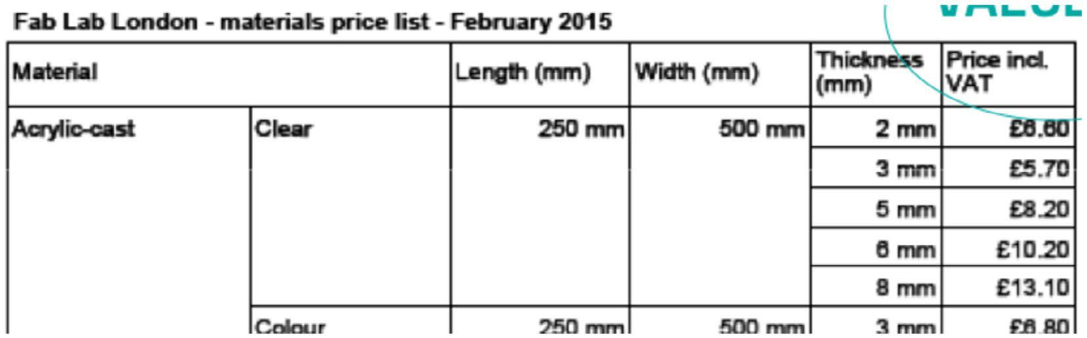

Appendix E. Cluster analysis

Guiding theme | ‘How-to’ practices | Excerpts from interviews | Workshop data
Foster an enabling culture | Co-develop a shared circular vision  and manifesto from the outset,  through coordinated communication  with all stakeholders | ‘Stakeholder Circle’  ‘… structured initiation from the outset reduces rick…’  ‘joining conditions are a social contract’  repair days … create a culture … and fosters  appreciation of design and craftsmanship’ | 1. Partnership approach integrating sustainability experts/skills from outset  2. Intentions to link and build connections for strategic local alliances
 | Publicly articulate a clear and  principled vision for responsible  products | ‘Responsible products is [sic] part of the manifesto’  ‘Our role … is to set out a principled vision to create a culture’ | 1. Explicit commitment to sustainability/circular implemented through its day-to-day e.g. tools/ technology e.g. filament recycler, part of its commitment to develop ‘sustainable thinking’
 | Develop and seek joining commitment | ‘Joining conditions are a social contract’ | 1. Fab Charter
 | through clear conditions |  | 2. Fab Charter
 | Provide leadership by knowing and | ‘Lead the vision, be steadfast’ | 1. Embed practices in the day-to-day e.g. circular
 | enacting the vision |  | design workshops
 |  | ‘Up to people running the space not to be driven’ | 2. ‘Be open because you believe it … because you  want to be not because the Fab Lab tells you’
Guiding
theme | ‘How-to’ practices | Excerpts from interviews | Workshop data
Build local  connections | Facilitate links between many stake  holders (local government, citizens,  producers, local community) | ‘industrial ecology is slowly built up through registering skills and local materials …’  ‘do a social network analysis’ | 1: Key strategic stakeholders identified from the outset  2. Efforts to build local supplier database, strategic  local partnerships, promoting local suppliers
 | Map local suppliers in collaboration  with users builds knowledge of local  resources and skills | ‘User mapping’  ‘industrial ecology is slowly built up through registering skills and local materials …’ | 1. Local suppliers of materials for reuse identified  and promoted  2. Efforts to build local supplier database, strategic  local partnerships, promoting local suppliers
 | Understand local needs, skills, knowledge, barriers, risks | ‘Don’t just buy a machine, which is what most  people do, we do some local context research to  understand some needs to co-develop a lab and  a business plan – you need to be sensitive to the  project fulfilling local needs.’ | 1. Local suppliers of waste/materials for reuse identified and promoted internally  2. Efforts to build local supplier database, strategic  local partnerships, promoting local suppliers
 | Foster ownership in local communities | ‘enlist skills’ | 1. Product tear-downs/repair outreach activities/
 | through e.g. time-banking, trade- |  | circular design challenges
 | schools, skill sharing, repair days | ‘Business plan should include local supply from the  outset | 2. Electronics ‘library’ developed and maintained by users
 | Develop outward looking, inclusive and welcoming communications | ‘seen as elitist … the preserve of geeks … closed to the masses’ | No data
 |  | ‘clear communications with different groups that
 |  | should be involved’
 |  | ‘Build credibility’
 | Enlist skills for community development from the outset | Hire team members with ‘community building skills…’  ‘enlist skills’ | 2. Initial efforts to build local supplier network side lined due to lack of local strategic relationships
Stimulate practical know-how | Facilitate, enable and encourage circular workshops (e.g. basic fixing skills such as plug rewiring, efficient tool us’) | ‘Sustainability workshops’  ‘repair days … create a culture … and fosters appreciation of design and craftsmanship’ | 1. Product tear-downs/repair outreach activities/ circular design challenges  2. Educational activities on energy use
 | Develop/adopt circular design guidelines and good practice induction manuals | ‘it’s important to take things apart’ …’ | 1. Circular design guidance and visual cues are commonplace  2. Online masterclass tutorials for initial inductions/  upskilling
 | Signpost to external guidance on good  practices in circular/sustainable design | No data | 1. Circular design guidance and visual cues are commonplace, expertise brought in when needed  e.g. circular design workshops, LCA
 | Break things down e.g. visualize smaller pieces of the puzzle, such as the product supply chain | ‘Knowledge of where materials come from, how products work, why’  ‘it’s important to take things apart’ …’ | 1. Visualising supply-chains through easy to use online tools, product tear-downs, LCAs of specific products  2. Educational activities on energy use
Build individual/community capacity | Foster ownership of circular issues within the community  Build visibility, awareness and inclusivity by sharing experiences and good practice examples | ‘Not enough to talk about things, have to engage’  ‘Share stories … create a cultural collaborative landscape’  ‘You should be open because you believe in it’  ‘share by necessity’ | 1. Product tear downs, reusable materials sourced locally  2. Electronics sharing ‘library’  1. Online documentation of circular design challenge during OSCEdays allows global community to learn
 |  | ‘One of the foundations of circular thinking is sharing knowledge’
 | Enlist specialist circular expertise where necessary | ‘Build aptitude rather than expertise’ | 1. LCA expertise supports environmental assessment, Great Recovery supplements knowledge
 | Build individual confidence to approach circular issues through learning process | Provide ‘access to confidence’  ‘Build aptitude rather than expertise’ | 1. Experience-based workshops e.g. tear-downs  2. Experience-based workshops e.g. educational visualising energy

