Do you really think that it’s funny?
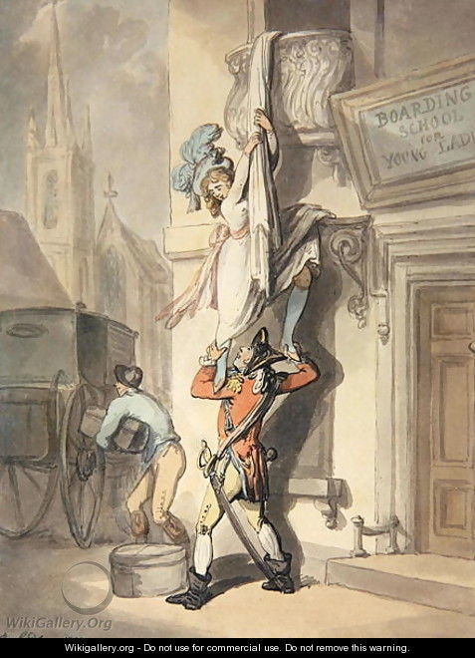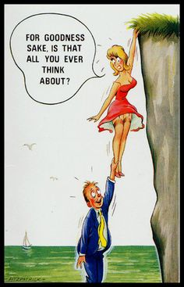
Thomas Rowlandson, A York Address to the Whale. Caught lately off Gravesend. Royal Collection Trust/© Her Majesty Queen Elizabeth II 2015
Bamforth. Comic Risqué. Anon Publisher. 1968
It belongs neither altogether to art nor altogether to life. On the one hand, characters in real life would never make us laugh were we not capable of watching their vagaries in the same way as we look down at a play from our seat in a box; they are only comic in our eyes because they perform a kind of comedy before us. But, on the other hand, the pleasure caused by laughter, even on the stage, is not an unadulterated enjoyment; it is not a pleasure that is exclusively aesthetic or altogether disinterested. It always implies a secret or unconscious intent, if not of each one of us, at all events of society as a whole. In laughter we always find an unavow intention to humiliate, and consequently to correct our neighbour, if not in his will, at least in his deed. This is the reason a comedy is far more like real life than a drama is.
Laughter: An Essay on the Meaning of Comic
by Henri Bergson (1990)

Through a visual presentation Professor David Rayson will explore Rowlandson’s legacy – and no-pun-intended connections to British contemporary satire with connections to historically seminal figures such as Hogarth, Gillary, Cruikshank, Beardsley, and contemporary references such as Gerald Scarfe, Ralph Steadman, Steve Bell, and the TV series Spitting Image. Rayson will also draw upon populist references such as the ‘saucy seaside postcards’ genre, TV soap operas, as well as indulging in the wonderfully guilty pleasure of wading through the Pinewood Studios phenonimun that was the Carry-on Films.

Professor David Rayson
January 2016

.

