Document Type
Conference Paper

Publication Details
Universal Design in Education Conference, Dublin, Ireland, 12-13 November, 2015

Recommended Citation
Myerson, J., West, J. (2015). Make It Better: how universal design principles can have an impact on healthcare services to improve the patient experience. Universal Design in Education, Dublin, Ireland, 12-13 November 2015.
Title:
Make It Better: how universal design principles can have an impact on healthcare services to improve the patient experience

Authors
Prof Jeremy Myerson & Jonathan West
The Helen Hamlyn Centre for Design, Royal College of Art

Abstract
The delivery of frontline healthcare services has traditionally been framed by clinical considerations and viewed predominantly from the perspective of the medical professions involved in care of patients. But what if a broader approach was adopted in which the patient experience was placed at the centre of the process and services were framed by design thinking as well as clinical considerations? This paper explores an alternative patient-centred approach to healthcare – both in the hospital and in the community – that draws on universal design principles. The paper examines the Seven Principles of Universal Design (as defined by Ron Mace, North Carolina State University, 1997) and evaluates which of those principles are relevant to the complex demands of healthcare today, using case studies from The Helen Hamlyn Centre for Design, RCA. The paper concludes by reflecting on the implications of a more inclusive approach for both clinical and design practice.

Keywords: universal, inclusive, designer, healthcare, innovation, patient-centred

Introduction
The role of design and designers within healthcare to improve patient experience and patient safety has been growing in recent years (Chamberlain et al, 2014). Clinical leadership of healthcare processes and practices remains a given, but the entire healthcare system is now more open to new ideas and new ways of doing things than ever before.
As a complex system requiring innovation to improve efficiency and health outcomes while reducing medical error and managing escalating costs, healthcare has started to look outside professional medical borders for answers and this has opened the door for design. As Asch et al explain in the New England Journal of Medicine (2014): ‘ Healthcare is not a single problem but thousands of problems…the challenge of healthcare innovation lies in combining contextual understanding with fresh perspectives.’
The design touchpoints within any healthcare service or environment provide ample scope to contribute ‘fresh perspectives’. Universal design, which places the person at the centre of the process and studies their needs closely (Preiser, W. F., & Ostroff, E.,2001), has the potential to align more generally with a patient-centred approach to health. But, despite this, the application of more inclusive and people-centred approaches to design within healthcare has been slow to gather momentum.
Designers have traditionally worked at the back end of the healthcare innovation process on the shaping and delivery of ideas pre-specified by clinicians, rather than operating at the front end of the innovation process where the value generation of universal design – focusing on such things as empathy, ethnography, evidence-gathering, experiment and evaluation – might have most impact.
The Helen Hamlyn Centre for Design (HHCD) at the Royal College of Art has been asking a simple question since its Healthcare Research Lab was set up in 2003: how can universal design techniques and methods support the safer, more humane and more innovative delivery of healthcare services? The lab’s founder Roger Coleman co-authored a report, Design for Patient Safety (Buckle et al, 2003), which set out an agenda for a more people-centred and better-managed approach to design in healthcare. More broadly, the RCA can trace its heritage in healthcare back to the 1960s with Bruce Archer’s work on a number of innovations for secondary care, including the ‘King’s Fund’ bed, which became the standard across the NHS (Lawrence, 2001). The Design for Patient Safety report reignited this approach, and since then the HHCD has developed a flow of innovation projects based on thinking inclusively about patients within a complex system. Ranging from surgical instruments to information and service design across primary and secondary care, this body of award winning work continues to grow and have real world impact in a variety of ways.
Principles of Universal Design
Like many other research centres in the design field, the centre’s healthcare team looked to Ron Mace’s Seven Principles of Universal Design (Mace et al, 1998) as a key point of reference. But, through our work, we gradually discovered that some universal principles were more applicable to the healthcare arena than others.
For example, principles related to Equitable Use and Flexibility in Use – allowing people to use products and services whatever their age or ability – have less resonance in healthcare environment where many products and processes are designed for application by professionals only within strictest of protocols (the use of surgical instruments by surgeons, for example). The same is true of Low Physical Effort: healthcare processes might seek to minimize fatigue for such staff as nurses and porters in the best cases, but generally, within hospitals, effort and support is placed where it is really needed.
That, however, leaves four universal design principles that have direct relevance to healthcare contexts. The rest of this paper explores their impact with healthcare, on the basis of our own collaborations.
Simple and intuitive use

This principle concerns the reduction of unnecessary complexity, the meeting of user expectations, the accommodation of a wide range of literacy and language skills, and the construction of a consistent hierarchy of information.

One example of the HHCD’s work that used this principle was the redesign of the neck brace.

Around 440,000 people in the UK each year require head and neck immobilisation by ambulance services following trauma. This usually involves fitting a disposable semi-rigid cervical collar, known as a neck brace; these do not provide adequate safety and comfort for the patient.

Conceived by a collaborative team of designers, engineers and clinicians, the new design was based on intensive research involving ambulance ride-outs, following the patient journey, and collaborative workshops with doctors, nurses, paramedics and physiotherapists.

The starting point for the brief was an improved immobilisation of the head and neck, but following the thorough research, it became clear that the design must also cater for varying user circumstances. The new neck brace had to be able to be readily fitted to the patient regardless of whether they are seated or lying down. Often trauma patients are in poorly accessible areas, so the neck brace had to be easy to fit in tight spaces (e.g. road traffic accidents). The new design also had to allow for continued immobilisation during X-rays; current neck braces are removed at this point.

The new design works by bracing between the head and shoulders, instead of simply gripping around the neck. The paramedic places the front piece to the patient's forehead and chest, and straps in place a rear piece to complete the stabilisation of the head. By keeping in mind the driving principle of simple and intuitive use, and involving all the end users during conception and development, the design has been popular in initial trials.

Perceptible information

This principle is that the design should communicate the necessary information effectively to the user; this should involve the use of different modes (pictorial, verbal, tactile) for essential information, should ensure maximum legibility and contrast with surroundings, and provide effective prompting and feedback during and after task completion.

Good information design in healthcare can save lives by preventing errors. It also has the potential to more broadly affect behaviour (and thus has a crucial role in preventative healthcare).

A good illustration of this principle is the ‘Violence in A&E: improving the patient experience by design’ project undertaken by the HHCD, Pearson Lloyd and the Design Council in collaboration with a number of NHS hospitals.

The cost of violence in the NHS exceeds £69m annually, affecting staff and patients through reduced patient satisfaction, loss of productivity, increased staff absence and additional security measures.

Through immersive research in the Accident and Emergency (A&E) environment, a deeper understanding of this behaviour emerged. Arriving at the emergency department is stressful for patients and relatives who are already anxious or in pain. There is little to help them to understand the A&E process - there are often long periods of waiting in uncomfortable spaces with little communication.

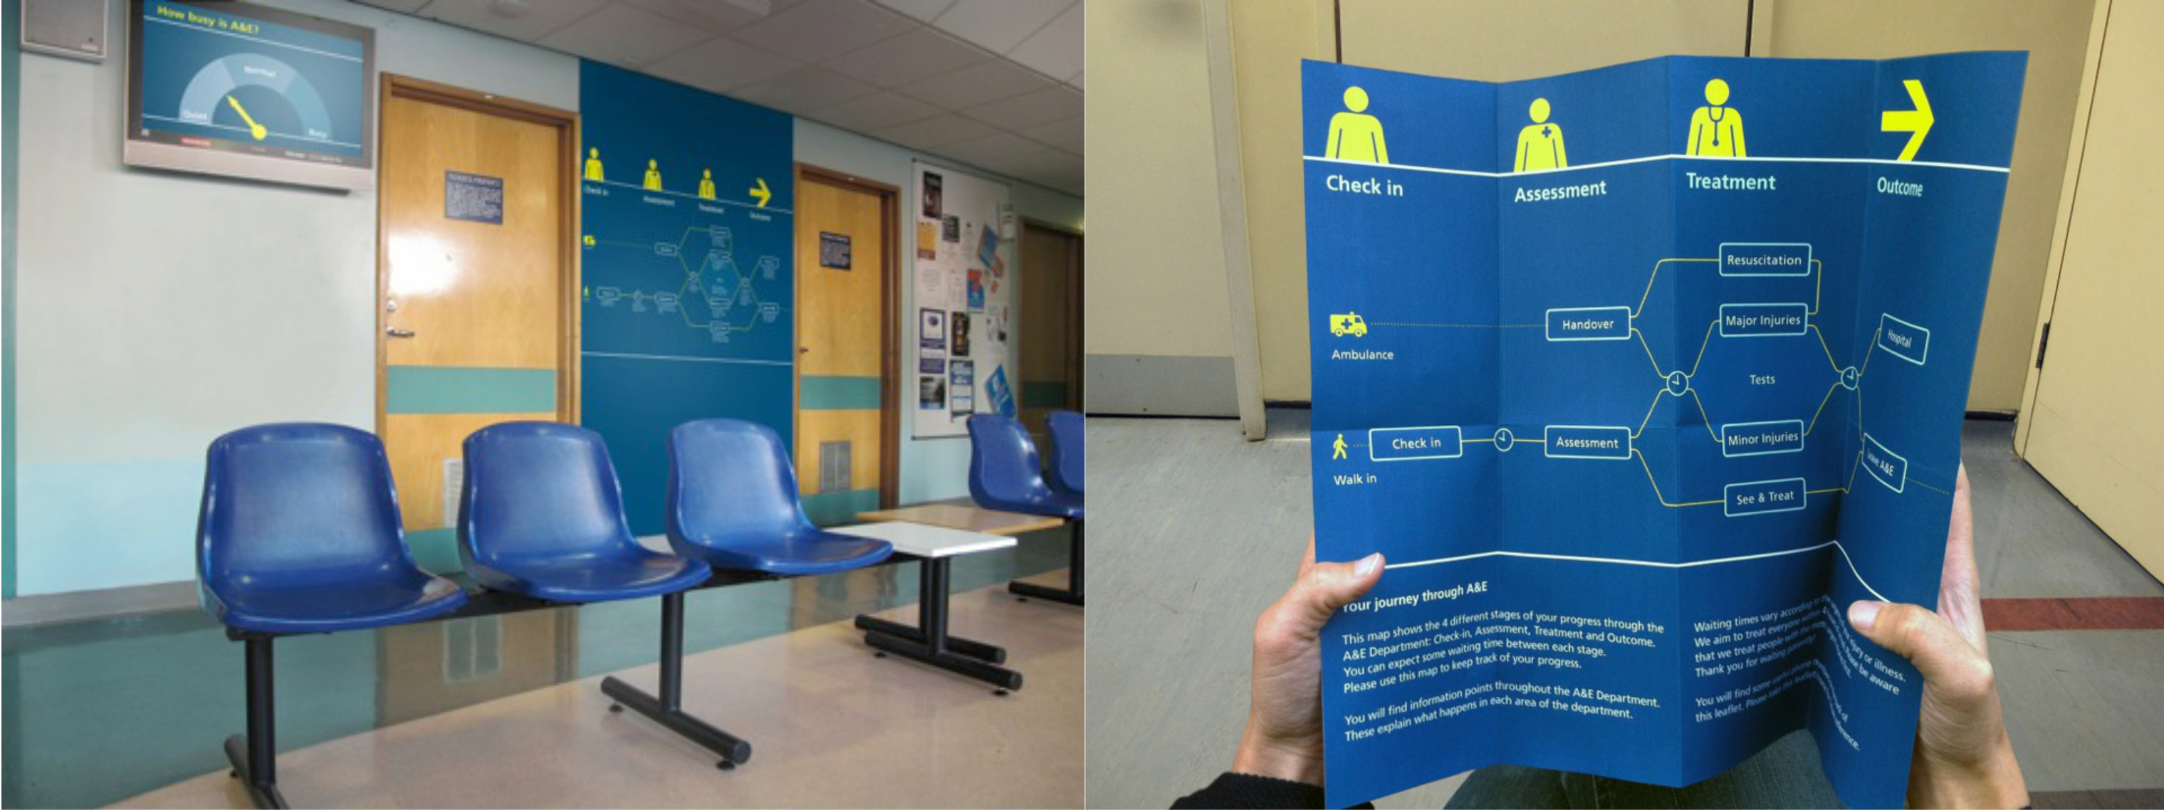
Figure 1 – clearer communication in A&E

The design outcomes are based around the idea that the patient and staff experience can be improved through better communication across the A&E journey. They include: Guidance: a modular information and communication system designed to empower patients with key information about their visit (figure 1); People: a reporting tool and reflective practice system that helps staff deal better with potentially aggressive patients; and a web-based Toolkit: aimed at NHS commissioners and decision makers.

Sticking to this principle made a difference: an evaluation showed that 75 per cent of patients said the improved signage reduced their frustration during waiting times, and threatening body language and aggressive behaviour fell by 50 per cent following implementation.

Tolerance for error

This principle focuses on hazards and the adverse consequences of accidental or unintended actions. Elements of a design should be arranged to minimise hazards and errors, should provide warnings and fail safe features and discourage unconscious action in tasks that require vigilance.

Error reduction and patient safety has an extensive body of literature itself, of which design forms a part (Vincent, 2010).

The HHCD undertook a three year study (called Designing Out Medical Error - DOME) in partnership with Imperial College, London, to determine where design could reduce medical error on elective surgical wards (West et al 2014).

Key to the success of the project was the close working relationship between the designers and clinicians, as well as the extensive access, allowing the designs to be firmly rooted in thorough clinical research.

Using analytical tools derived from other hazardous industries (e.g. Failure Mode and Effects Analyses), the breadth of research was narrowed to form five validated briefs: design to improve infection control, hand hygiene, medication administration, handover and the measurement of vital signs.

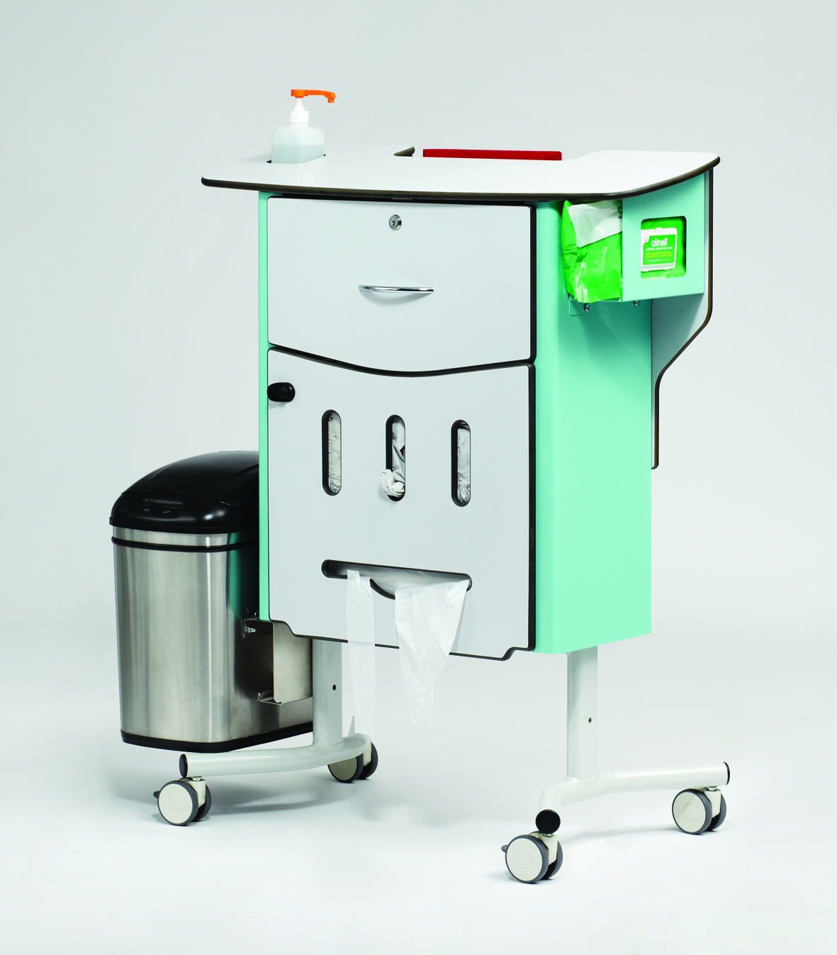
Figure 2 - CareCentre

Among the five design outputs was the ‘CareCentre’ (figure 2), a new item of ward furniture placed at the end of the bed that contains all the necessary equipment for common bedside care tasks. The underlying principle was to rationalise workflow (previously identified as disorganised due to the location of equipment being scattered across the ward and out in the corridor), and work with the staff where possible. This design principle minimised hazards and the adverse consequences of accidental or unintended actions; direct staff movement between beds without cleaning their hands was reduced, a key contributor to healthcare associated infections.

Creating a focal point meant that staff footfall was reduced, and the compliance with hand hygiene, infection control and waste disposal protocols was improved (Anderson et al 2012). The design was taken forward to manufacture and is in use in UK hospitals.

Size and space for approach and use

Regarding physical design, this principle is that it should be easy to use regardless of user's body size, posture, or mobility; should provide a clear line of sight (and comfortable reach) to important elements; accommodate variations in hand and grip size; and provide adequate space for the use of assistive devices or personal assistance.

A flagship project at the HHCD is the redesign of the emergency ambulance; a project which embodies this principle.

There are many problems with the design of existing ambulances. The interior is difficult to keep clean given the frequency of use and the resultant lack of opportunity to clean the vehicle. Ambulance crews also suffer from poorly thought-out ergonomics, badly laid out equipment and difficult-to-access storage spaces, all of which can affect performance in critical, life-threatening situations.

In a project spanning over a decade in collaboration with numerous clinical, industrial and ambulance service stakeholders, a new ambulance interior was researched and designed to improve workflow, safety, usability and comfort.

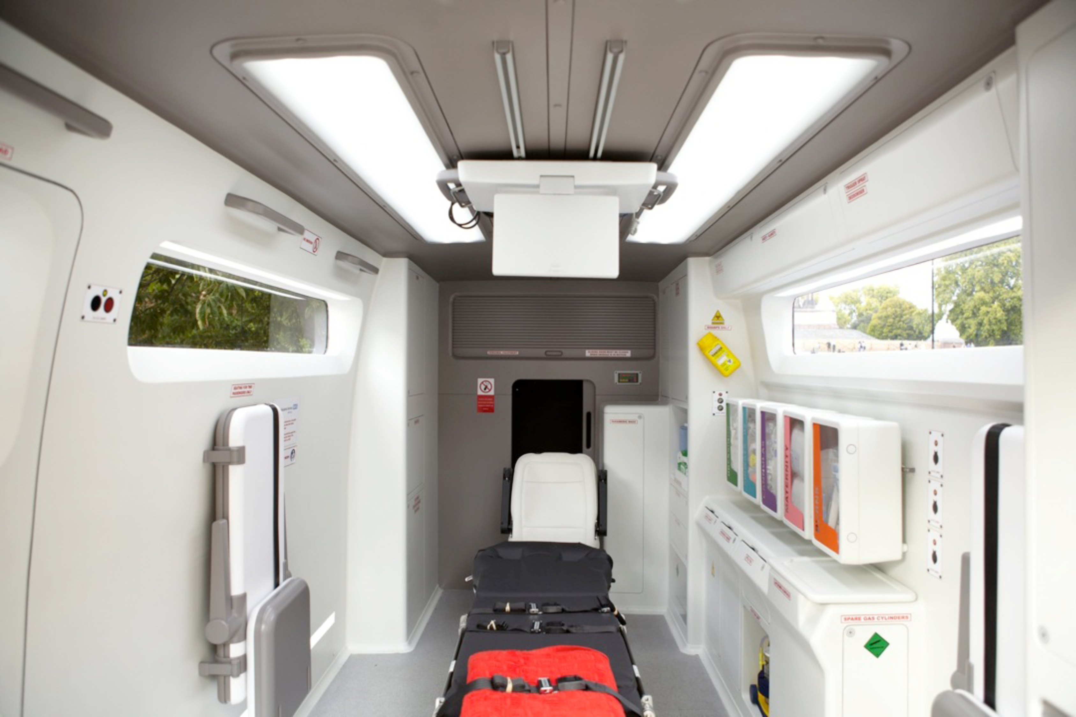
Figure 3 – redesigned ambulance interior

Based on in-depth co-research and co-design (including extended periods of shadowing the paramedic teams, and having a paramedic as a dedicated member of the design team), the prototype has a number of radical features, different from current ambulances (figure 3).

Most noticeably, the stretcher is placed in the centre of the interior, allowing access all around the patient. Equipment and disposables for treating the patient are arranged into treatment packs, clearly organised and visible, and within easy reach. Patient information is displayed on an overhead touch screen that also integrates with hospital records to facilitate handover. All corners and narrow gaps have been smoothed to allow for easy cleaning, and there are prominent and useable hand hygiene points close to hand.

This interior forms part of an analysis of the whole emergency response service, thus extending the principles of good design beyond the physical manifestation through to communication, process and task design, an analysis of the fleet, and a wholesale service redesign. The number of admissions to hospital Emergency Departments can be halved by treating and discharging patients in the community, having determined that it is safe and in the patient's interest to do so. This improves patient outcomes, makes the system more efficient and reduces costs.

Conclusions

These examples illustrate the importance of the principles of universal design, with the four detailed principles being particularly relevant to healthcare. One might argue for the inclusion of the remaining three, but a broader point underpins each example.

Whilst each principle itself is essential to a good design, the exact manifestation of the principle within the design depends on the quality of the insight on which the feature is based. Having everything within easy reach is important, but the location of the patient in the centre of the ambulance interior is the result of extensive observation and insight. Minimising hazards in use is crucial for design in healthcare, but it was immersion in the ward environment that led to the development of the CareCentre, which forms a focal point to minimise error.

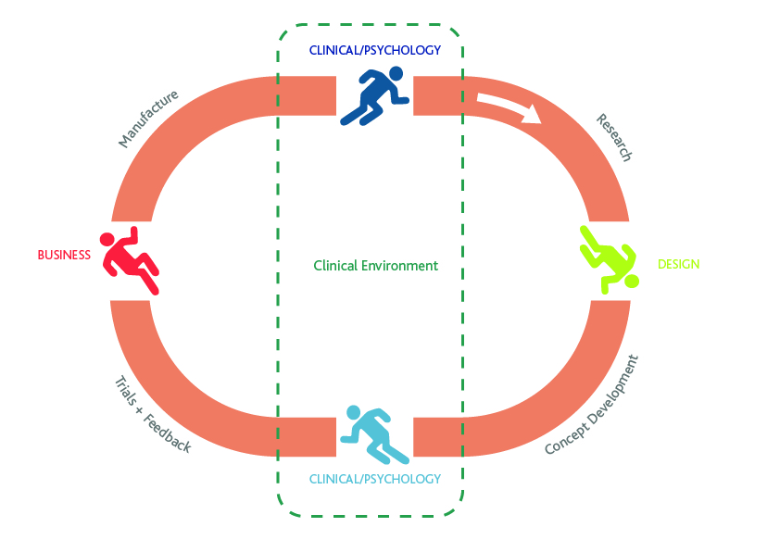
Figure 4 – relay race methodology

This quality of insight is wholly dependent on the quality of the collaboration between the design and clinical disciplines. Traditionally, this collaboration has been somewhat sequential, to the detriment of the design outputs. This type of collaboration might be depicted as a relay race (figure 4). The clinical team might identify a need, and pass the baton on to a design team who have not fully experienced the problem for themselves. The design is developed, and the baton passed back to a team for evaluation, and perhaps on to a business or manufacturing team. Each time the baton is passed on, there is a chance that information is lost. By the time the design is implemented in the clinical environment, it is not what was originally intended.

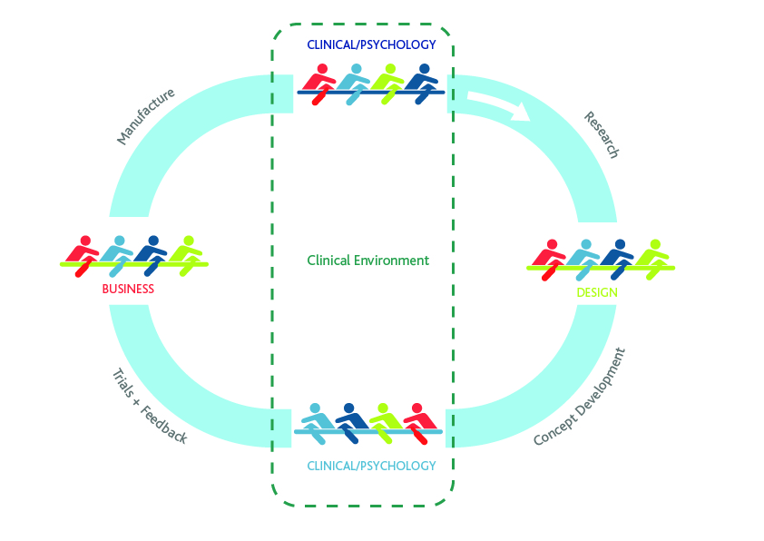
Figure 5 – rowing boat methodology

Instead, we have adopted a different approach in these examples, more akin to a rowing team (figure 5). All the experts in each discipline are in the same boat. Clinicians might lead on the initial clinical research, but all other members of the team (design, business etc) are also present. Similarly for the design process, the designers take the rest of the team through co-creation processes, and so on. At each stage, instead of information being lost, there is an opportunity to learn.

As the body of work grows, there is now a growing evidence base to validate this approach.

References
Anderson, O., Briggs, M., West, J., Vincent, C., Hanna, G.B., 2012. The CareCentre™: a cluster-randomised crossover clinical trial. Br J Surg 2012; 99 (Suppl. 6): 52
Asch, D, Terwiesch, C. Mahoney, K, Rosin, R (2014) Insourcing Health Care Innovation New England Journal of Medicine 2014; 370:1775-1777

Buckle, P., Clarkson, P. J., Coleman, R., Lane, R., Stubbs, D., Ward, J., Jarrett, J. and Bound, J. (2003). Design for Patient Safety. London: Department of Health.

Chamberlain, P., Wolstenholme, D., Dexter, M., Seals, Eds. (2015). The State of the Art of Design in Health: An expert-led review of the extent of the art of design theory and practice in health and social care. Sheffield, Sheffield Hallam University

Lawrence, G. (2001), Hospital beds by design: a socio-historical account of the 'King's Fund Bed',1960-1975, PhD Thesis, London University

Preiser, W. F., & Ostroff, E. (2001). Universal design handbook. McGraw Hill Professional.

Story, M., Mueller, J., Mace, R. (1998) The Universal Design File: Designing for People of All Ages and Abilities. NC State University, The Center for Universal Design.

Vincent, C. (2010) Patient Safety (second edition) BMJ Books/Wiley-Blackwell, UK
West, J., Davey, G., Anderson, A., Brodie, A., Norris, B. and Myerson, J. (2014) Designing out medical error - an interdisciplinary approach to the design of healthcare equipment The Design Journal 17 (3)

