SlowMo: Inclusive design to improve therapy for paranoid and suspicious thoughts

Jonathan West¹, Anna Wojdecka¹, Ed Matthews¹, Rama Gheerawo¹, Amy Hardy², Philippa Garety^{,2}

1 The Helen Hamlyn Centre for Design | Royal College of Art | 4 Hester Road, London SW11 4AN
2 Institute of Psychiatry, Psychology & Neuroscience | King’s College London | Denmark Hill | London SE5 8AF

ABSTRACT

Background: Around one in five people may experience paranoid thoughts. An intervention of structured therapy developed by psychologists has been effective in improving such thought processes (Garety et al, 2014, Ross et al, 2009; Waller et al, 2011, 2015). However, engagement and persistence with the intervention remained difficult. This study explores how inclusive design methodologies transformed the intervention, and raises methodological questions as the practice moves further into the field of mental health.

Method: An interdisciplinary team of psychologists and designers worked closely with service users in the research and development of an improved intervention, conducting in-depth interviews, observations of therapy, collaborative synthesis of findings, iterative prototyping and extensive user testing.

Results: The revised intervention is a digital therapy platform (‘SlowMo’). This supports therapy sessions with interactive web-based media; this tailored content synchronises with a smartphone to allow the service user to benefit from the therapy outside of sessions. Pilot results are promising; extensive trials are scheduled for early 2017.

Conclusions: Inclusive design methods need careful application in this area; occasionally design decisions must balance user benefit against user opinion. The correct application of inclusive design methodologies can lead to improved engagement with, and benefit from, such therapy.

Keywords

Mental health; universal design; inclusive design; paranoia; schizophrenia

INTRODUCTION

Around one in five people may experience paranoid thoughts (Bebbington et al, 2013); this is estimated to cost the UK economy £11.8 billion per year (Schizophrenia Commission, 2012).
Talking therapy has been effective in improving thought processes for these people (Garety & Freeman, 2013). However, less than 10% of eligible people have access to talking therapies for psychosis (Schizophrenia Commission, 2012).

The role of design and design thinking is becoming increasingly established in healthcare. Many applied design and academic research projects have played major roles in innovation in healthcare, ranging from commercial design consultancy outputs to design for policy interventions (e.g. Policy Lab; Bason, 2014).

Over the past decade there has been a rapid growth in start-ups exploring innovation in healthcare. The resulting digital interventions span a huge number of areas in healthcare, including mental health. The case for many of these is unproven (Charani et al, 2014), and often the research and development methodology unreported. This project is, to the authors’ knowledge, the first project to apply inclusive design thinking and methodologies to the problem of improving therapy for paranoia.

The Psychosis Research Partnership has been developing the understanding and treatment of paranoid thoughts since the 1990s. More recently, the partnership developed the ‘Thinking Well’ tool to aid therapy for people with paranoid and suspicious thoughts (Waller et al, 2015). A trial of an early version of this showed that working memory, holding information in mind, and motivation all had an impact on the effectiveness of the therapy (Garety et al, 2014).

This serves as context for this case study: therapeutic advances are shown to be beneficial, and improving the user experience of therapy is likely to improve impact; much innovation has taken place, yet none with a formal inclusive design methodology and dissemination.
The purpose of the study is to explore how inclusive design methodologies can improve therapy and extend its reach to a larger patient population.

METHOD

Inclusive design is, at its heart, inherently collaborative. As the design and research were both to take place in close partnership with clinical and frontline expertise, the team itself had to reflect this. One designer researcher, supervised within a broader team of designers, worked closely with a practising clinical psychologist. Both sides of the team had access to other professionals in their respective discipline, both to draw in additional expertise, and to allow the designer access to front line psychologists and patients.

The research began with an aim to understand the context of the complex system of mental health services. The patients’ journey and experience of the service has a number of touchpoints with therapists, and the therapists themselves work both individually with service users, but also communicate within a broader team of both clinical and community workers. This was sketched out very early in the project by the clinical psychologist (detail shown in figure 1, serving to illustrate complexity).

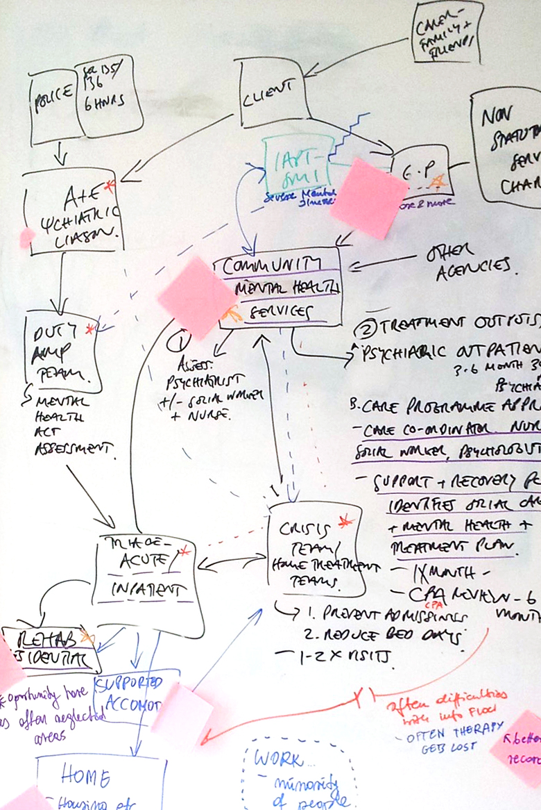

Figure 1. Selected detail of broader map of mental health services in South London (sketched by psychologist in initial workshop)

The designer was immersed in the different flows that the patient follows through the service, visiting different environments (including waiting rooms), and attending clinical team meetings.

This served as a broad context for more detailed research with patients and front line psychologists. The ‘Thinking Well’ intervention had already been tested on a select group of patients, and these were subjects in the designer’s interviews. These subjects were selected to represent the requisite range of severity, gender, and ethnographic spread. As paranoia has a range of severity, it was important to specify that certain patients were not targeted in the research; in this instance, the extremes of user perspective would not be helpful in the eventual design work. The key attributes or characteristics that were found to influence the effectiveness of the therapy in the ‘Thinking Well’ study were cognitive difficulties, motivation and paranoia severity. The subjects were selected to provide a range of these attributes.

The designer also had access to the therapy sessions. This was key in understanding elements of the therapy that are difficult to capture in a protocol; a rapport with the patient, tone of voice and so on. Video recording was not permitted, so the designer took notes or sketches, and was able to listen to audio recordings of therapy sessions. One challenge was that it was unusual for a designer to be present. This was occasionally confusing for the patient, as they understandably wanted to communicate with the designer, and would confuse the roles of observer and therapist, thus making it harder to maintain a strict observer position.

A further challenge was that of maintaining the right level of empathy. Traditional thought within inclusive design states that designers should strive to have as much empathy as possible, the better to design accordingly. However, with psychosis, the thinking model is not functioning well, and so limits must be placed on empathy to avoid encouraging any psychosis. Clinical guidance from the psychologist was invaluable in this, as well as helping to maintain distance in a field that has upsetting subject matter.

The insights gained from observing the sessions, interviewing the subjects and clinical staff, and experiencing the environments of the patient journey led to a series of collaborative workshops to synthesise broad areas for design intervention. Working with further psychologists and designers new to the project, the insights were distilled and abstracted to form fundamental design principles in the intervention (who the intervention is for, rough function etc.).

This detailed picture allowed the team to identify an area of focus (figure 2), which was as important to define who would (and who would not) be served by the intervention. For example, early ideas about peer support, or interventions purely for carers were not developed further. Instead, the agreement among the team (and broader supervisory board) was to focus on the talking therapy itself, but extending the benefit beyond the face-to-face session using a digital platform.

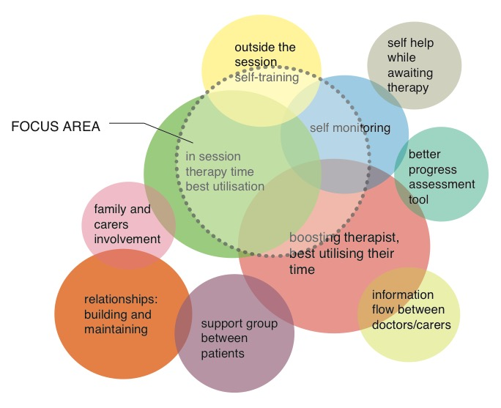

Figure 2. Area of focus identified during synthesis workshops.

With the focus area agreed, the team turned to the generation of ideas. Again, using collaborative workshops, creative techniques were used within brainstorming sessions (figure 3). 60 concepts were generated, with three themes emerging.

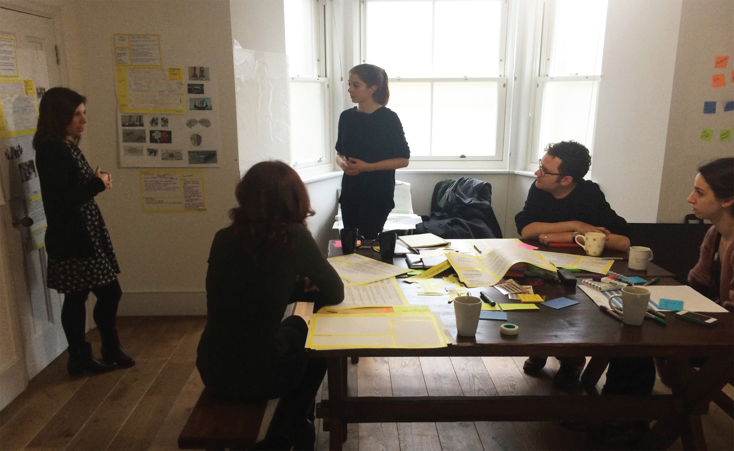

Figure 3. Collaborative brainstorming session with designers and psychologists

The three themes emerging from these sessions were:

- Bubbles – thoughts could be visualised as bubbles, which could in turn be manipulated and transformed to reflect the changing in thinking;
- Journey – the therapy could be presented as a journey, which would be helpful for the patient to locate where they are in the course of their therapy;
- Interactions – thoughts and thinking styles may be represented by abstract stylised shapes, and their interactions could illustrate changes in thinking.

These themes gave rise to more detailed designs, and each was prototyped and tested with patients and therapists (figure 4).

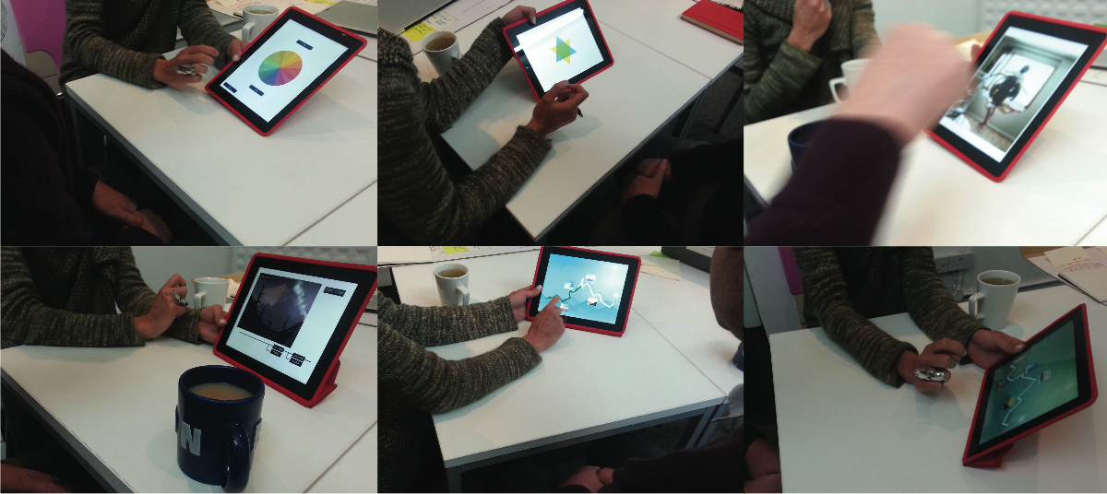

Figure 4. Testing the three design themes as early prototypes with users

This extensive and iterative user testing led to the refinement of the design. This method identified that the ‘interactions’ theme received the least positive user feedback. In a project where engagement is key to the effectiveness of the therapy, the team were quick to drop any confusing design features. Certain elements of this theme that were positively received were carried through to the final prototype. More detailed prototyping was done in close collaboration with a developer.

This final prototype will be extensively tested in a larger scale trial scheduled for 2017.

RESULTS

The design emerging from this iterative refinement, called ‘SlowMo’, is a digital platform comprising a screen-based tool to aid in-session therapy, and a smartphone app to extend the benefits beyond the session into the patients’ lives.
The previous ‘Thinking Well’ intervention had descriptions of the content, as well as videos to normalise certain instances of paranoid thoughts. The previous study (Garety et al, 2014) showed that working memory, holding information in mind, and motivation all had an impact on the effectiveness of the therapy. This pointed to the hypothesis that an improved design of the content would make it more immediate and memorable for the patient, and thus improve the above factors and increase the effectiveness of the therapy. One example of this is in consideration of scenarios that might lead to upsetting thoughts. In the previous ‘Thinking Well’ intervention, these were explained in text-heavy slides (figure 5).
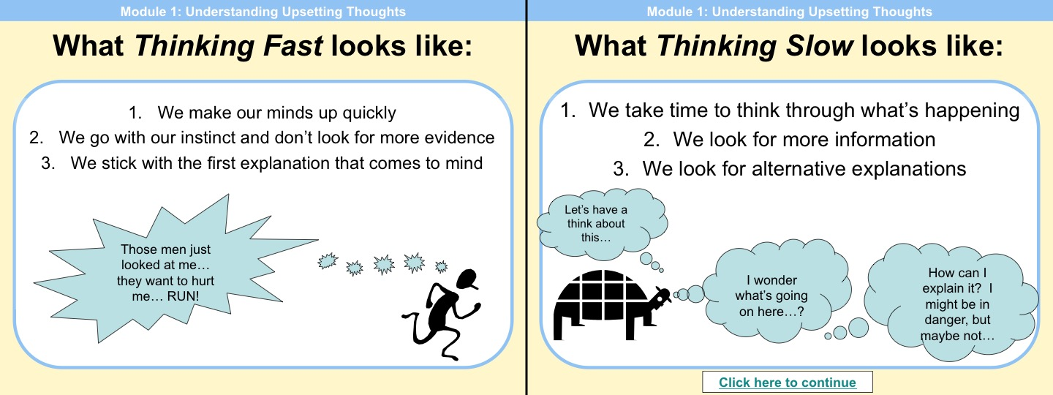
Figure 5. Slides from previous ‘Thinking Well’ intervention
The redesigned content showed animated scenarios (stills shown in figure 6 – in this example, a ‘fast’ thinking would lead to the conclusion that people are chasing the subject. However, as more of the scenario is revealed, ‘slower’ thinking shows that they are in fact running for the bus). Similar visual improvements have been designed to improve understanding and formulation of thinking styles, learning about the impact of psychological processes on thoughts, and, crucially, coping outside the therapy sessions.

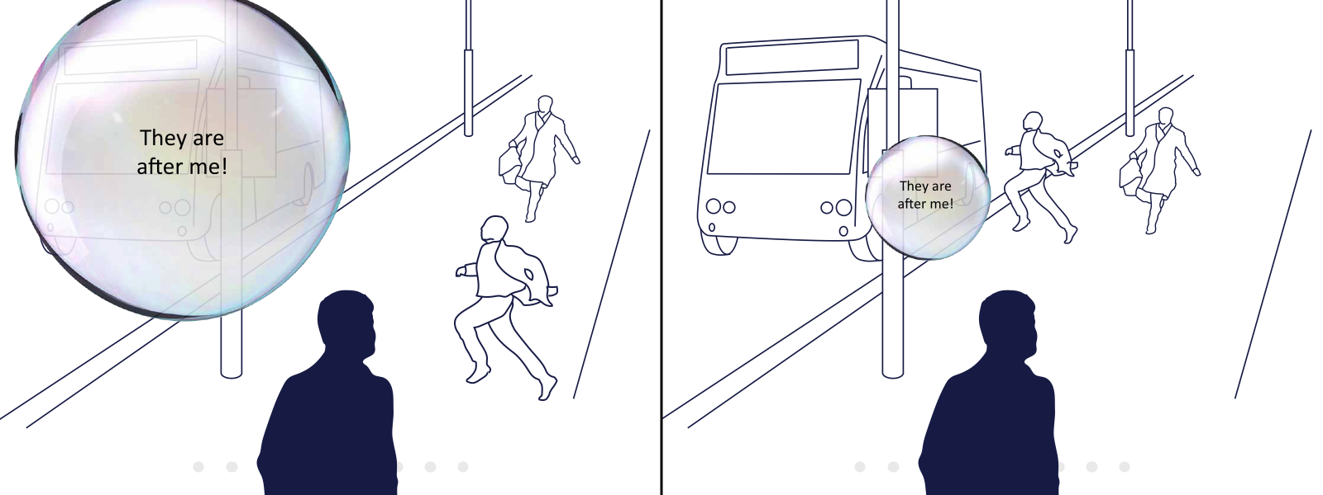
Figure 6. Stills from ‘SlowMo’ session animation
In this manner, the redesign improves the delivery of key in-session lessons: recognition of ‘fast’ thinking, taking a moment to slow down, seeking alternative, less upsetting explanations, recognising that other factors can influence thoughts, and so on. The ‘journey’ theme was used in the introduction to each session to show the patient their position and progress through the sessions.

The smartphone app to be used by the patient outside the sessions is completely new, and had no equivalent precedent. This takes the lessons taught in the sessions, and builds in functionality as the therapy progresses. For example, early sessions explain the need for the patient to notice their thoughts, and later to slow them down and seek for alternative explanations. Thus the app at first encourages the user to log their thoughts, and later functionality is ‘unlocked’ as the patient progresses through therapy which encourages the user to slow down their thoughts (and even later to seek tips to modify the thought or seek alternative explanations).

The ‘bubbles’ theme is a useful vehicle to represent these functions. The user logs an upsetting thought by creating a bubble, the size of which reflects how distressing it may be (figure 7).

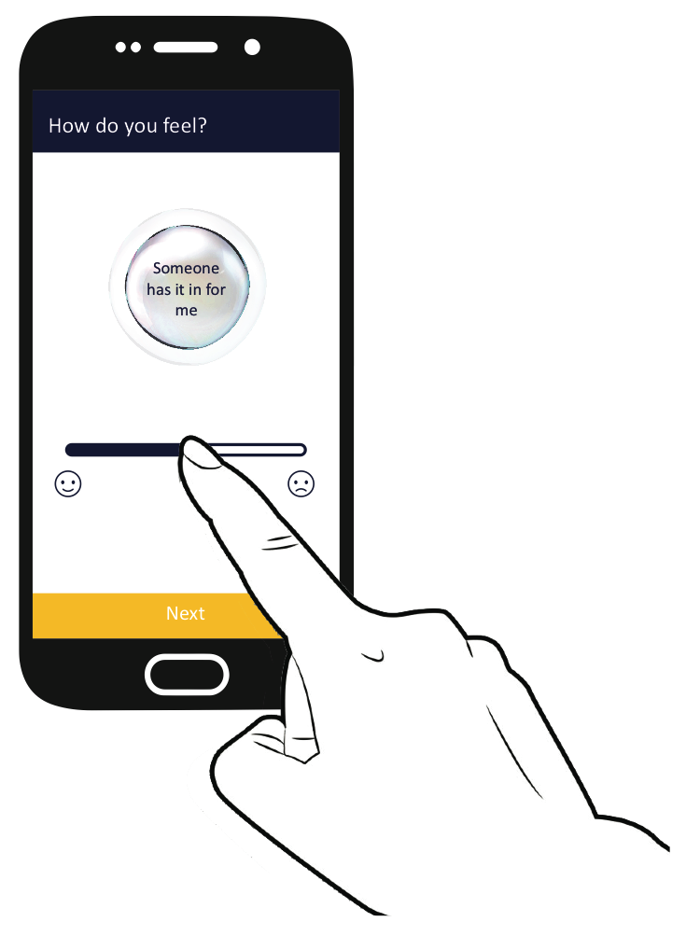

Figure 7. Creation of bubbles to represent upsetting thoughts

In later sessions, these bubbles can be coloured (to reflect which tip they found helpful), reduced in size (if the tip has decreased the distress attached to the thought), and annotated with written or dictated notes (figure 8).

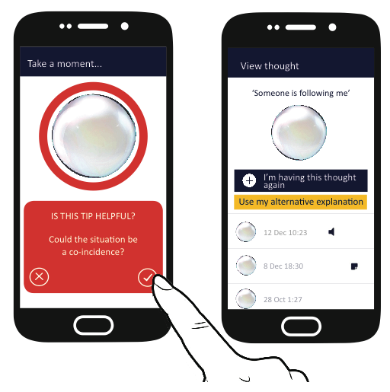

Figure 8. Manipulation of bubbles to reflect modified thinking styles

These user-entered data are later accessible to the therapist, who in turn can guide future sessions and enables further tailoring of the therapy.

DISCUSSION

The initial overview of the service, and its place within the broader mental health system led gave a contextual understanding of the subject matter, invaluable during the interviews and observations of therapy. Any set of methodologies used within an inclusive design project must be tailored to the specific subject at hand, and the context setting exercise helped to selec the most appropriate methods of research (in this case, interviews and observations; later, co-creation workshops and feedback sessions).
The sensitive nature of the research meant that the inclusive design methods used needed careful application in this area. Further, in designing the intervention, there were interesting balances to be struck that contribute to the general debate about placing the user at the heart of the design process: occasionally design decisions must balance user benefit against user opinion.
One example of this is a small piece of digital user interface design. Accepted practice would be to allow the user more control over where they are, or want to be, in a string of options. Providing a ‘back’ button is fairly standard practice for this. In certain elements of the app, the decision was taken to omit a ‘back’ button, with intent to force the user through elements of the therapy lessons. This effectively makes the early opting out of certain lessons more difficult; although this is an easier and freer option for the patient, missing out on lesson content is ultimately unhelpful if the therapy is to be effective. Another way of looking at this balance is to consider who the user is. Certainly the patient is a user, but in instances such as this, the therapist’s opinion, also treated as a valid user, was prioritised instead. This inclusion of therapists as users was initially surprising for the psychologists, but led to beneficial features in the ‘SlowMo’ tool as a whole – the main example being the logging of thoughts and sessions which clearly benefits the patients, but also reduces the administrative burden on therapists.

The resulting design will be more extensively trialled to gather evidence on a larger scale to determine if the intervention is effective in reducing paranoia severity, and whether it does so by reducing ‘fast’ thinking. Adherence and usability will also be measured, with a view to discovering if it improves engagement at scale when implemented. This larger scale trial is important in validating the inclusive design approach, and will result in ‘SlowMo’ being one of the few mental health digital interventions with a substantial evidence base.

CONCLUSION

Early user feedback shows that the inclusive design approach can lead to improved engagement with, and benefit from, cognitive behavioural therapy for patients with paranoid and suspicious thoughts. In order for this approach to be effective, close collaboration with clinical psychologists and sensitive application of methodologies is vital. In fields where multiple user types are identified (and are at odds), close guidance must be sought from the collaborating team, and a consensus sought when taking design decisions. Such decisions must be verified through extensive field testing. This is important not only to gather an evidence base to validate the design of ‘SlowMo’, but is crucial for the success of any mental health digital platform.

ACKNOWLEDGEMENTS

The author acknowledges the extensive help and support from the design team at the Helen Hamlyn Centre for Design, the clinical psychologists at King’s College, London, and the staff, patients, friends and families who gave so generously of their time and expertise.

REFERENCES

Bason, C. 2014. “Design for Policy”. London & New York: Routledge ISBN 9781472413529

Bebbington PE, McBride O, Steel C et al. 2013. “The structure of paranoia in the general population”. The British Journal of Psychiatry, 202(6), 419¬427.

Charani E., Castro-Sánchez E., Moore L., Holmes A. 2014. “Do smartphone applications in healthcare require a governance and legal framework? It depends on the application!” BMC Medicine 12:29

Garety PA & Freeman D. 2013. “The past and future of delusions research: from the inexplicable to the treatable”. British Journal of Psychiatry, 327¬333.

Garety P, Waller H, Emsley R, Jolley S, Kuipers E, Bebbington P, Dunn G, Fowler D, Hardy A & Freeman D. 2014. “Cognitive mechanisms of change in delusions: An experimental investigation targeting reasoning to effect change in paranoia”. Schizophrenia Bulletin, 41(2), 400-410.

Schizophrenia Commission. 2012. “The Abandoned Illness: A Report by the Schizophrenia Commission”. Rethink Mental Illness.

Waller H, Emsley R, Freeman D, Bebbington P, Dunn G, Fowler D, Hardy A, Kuipers E & Garety P. 2015. “Thinking Well: A randomised controlled feasibility study of a new CBT therapy targeting reasoning biases in people with distressing persecutory delusional beliefs”. Journal of Behaviour Therapy and Experimental Psychiatry, 48, 82¬89.

