HANS.STOFER

B-Room
I am on this side of the fence
Bundles of Energies

LIST of WORK :

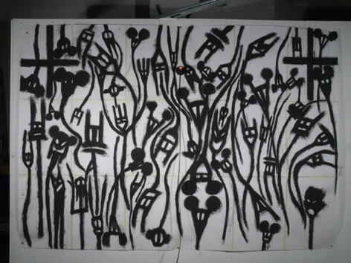 Young demons I can hear your legendary laughs,
MAP
2011
2400 X 1600mm
Charcoal on paper

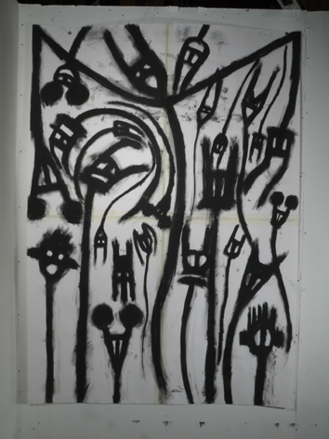 From these days that are nights,
MAP
2011
1200 X 1600mm
Charcoal on paper

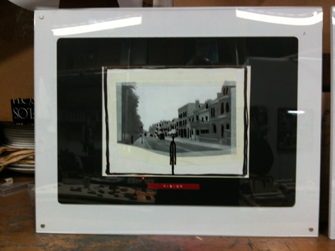 Vision,
Residue
2011
600 X 400mm
mixed matter

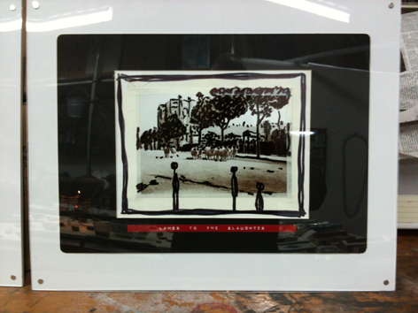 Lambs to the slaughter.
Residue
2011
600 X 400mm
mixed matter

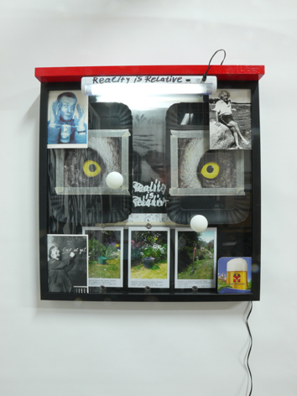 Reality Is Relative,
Bundle of Energy
2011
500 X 520mm
mixed matter

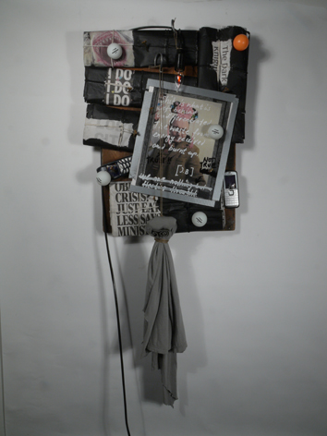 Truth
Bundle of Energy
2011
400 X 600mm
mixed matter

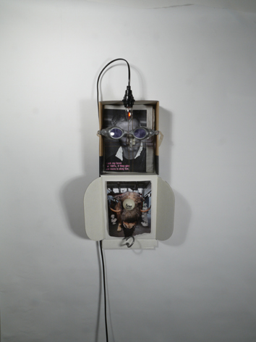 100% and more,
Bundle of Energy
2011
200 X 400mm
mixed matter

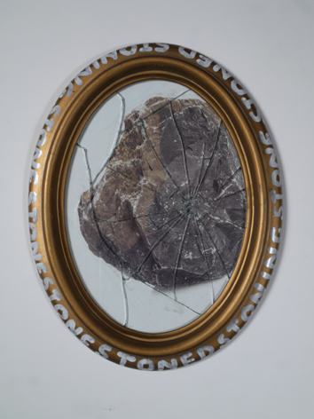 Stoned,
Issue
2011
160 X 120mm
mixed media

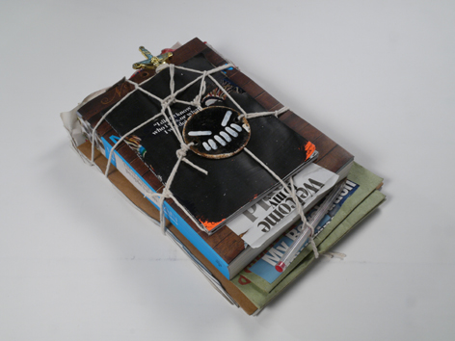 Welcome to my world,
Bundle of Energy
2011
140 X 240mm
mixed media

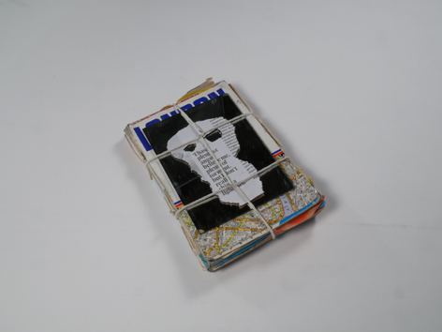 Believe me,
Bundle of Energy
2011
120 X 160mm
mixed media
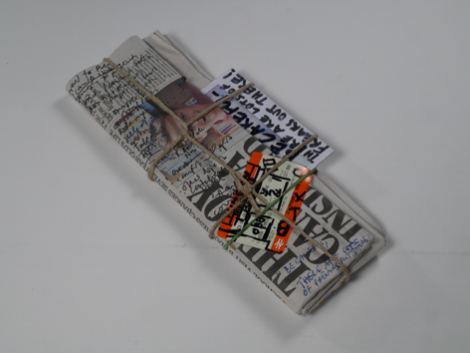 Be careful,
Bundle of energy
2011
110 X 300mm
mixed media
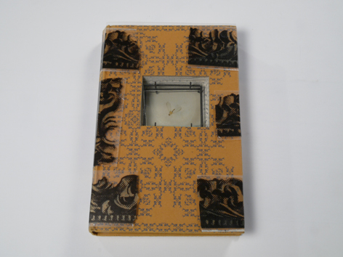 The space is the shell,
Book 10 + brooch
2011

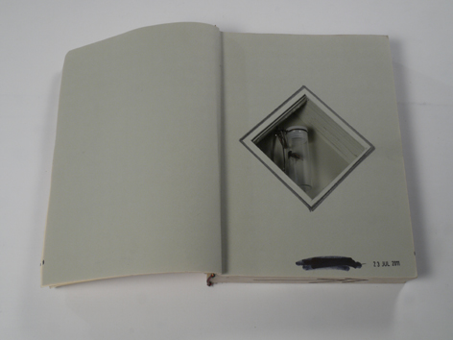 The space is the shell,
Book 9 + brooch
2011

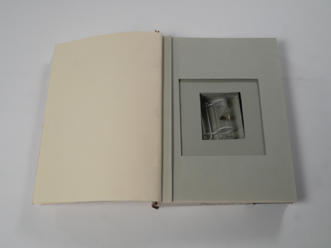 The space is the shell,
Book 8 + brooch
2011

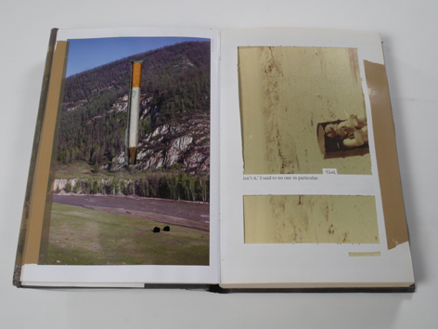 The space is the shell,
Book 7 + cigarette-pen
2011
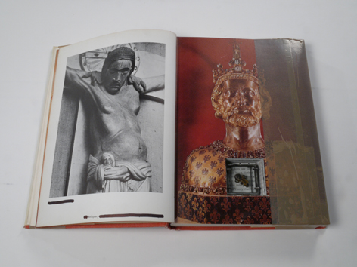 The space is the shell,
Book 6 + brooch
2011

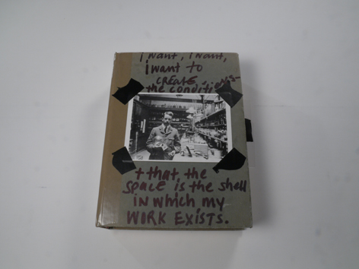 The space is the shell,
Book 5 + brooch
2011

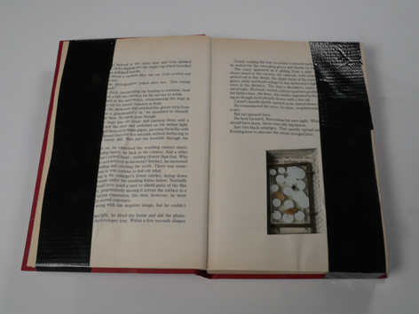 The space is the shell,
Book 4 + brooch
2011

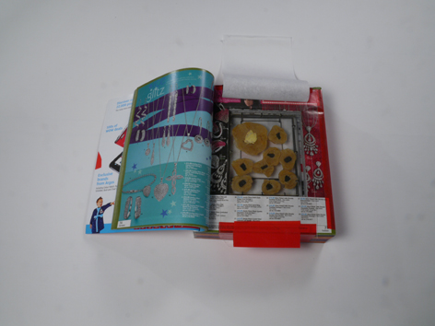 The space is the shell,
Book 3 + brooch
2011

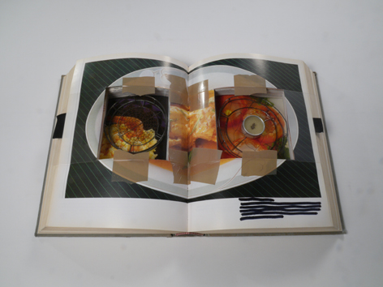 The space is the shell,
Book 2 + brooches
2011

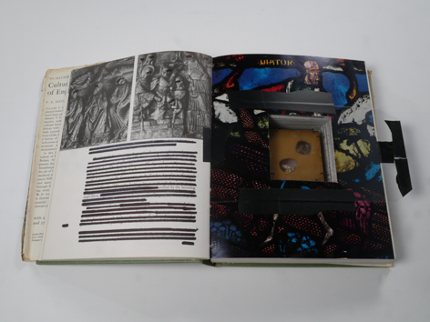 The space is the shell,
Book 1 + brooch
2011

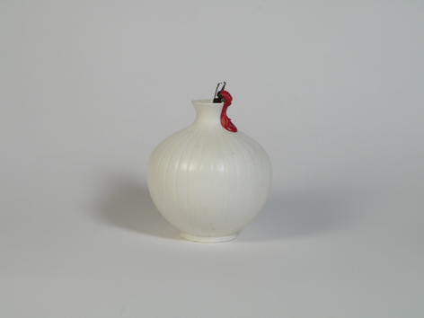 Wasp Neck
Phobia
2011
H 130mm
Mixed matter

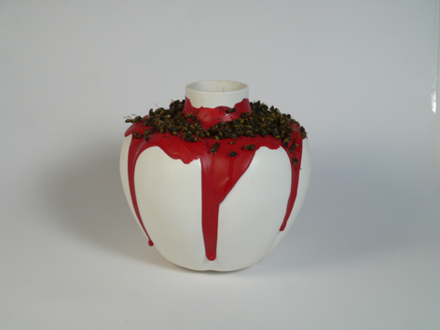 Wasp Waist
Phobia
2011
H 240mm
Mixed matter
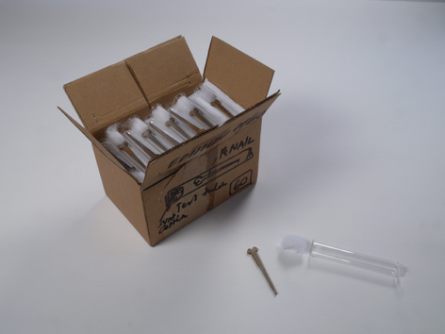 The peace of your body,
HaMiMoTo Nail
Roche Edition
2011
Mixed media

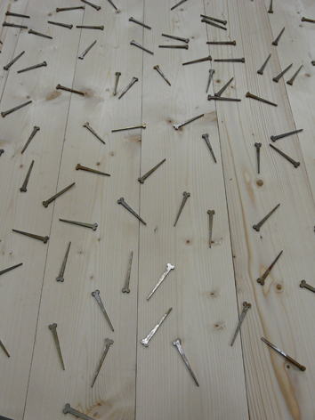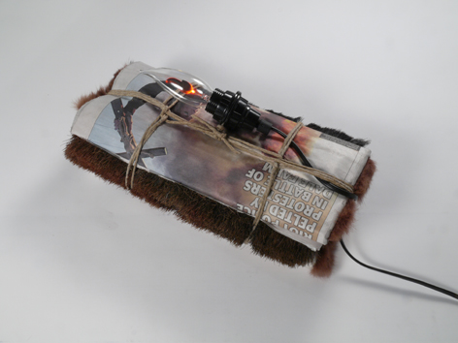

The blood with which I sign this contract,
Bed boards
2011
1710 X 1900mm
mixed media

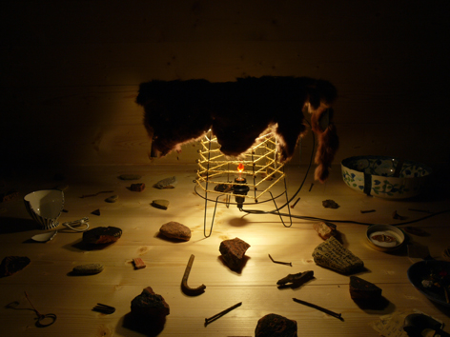
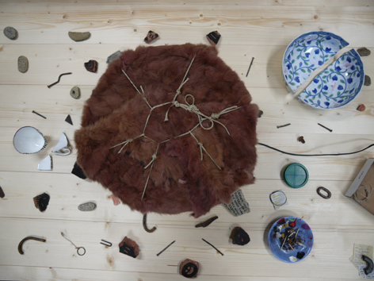 Life in exile,
Curriculum Vitae
Ongoing
Light and Text on matter

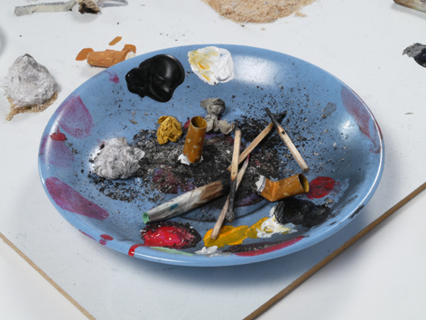 Contemplation,
Ashtray
2011
ø 130mm
mixed media

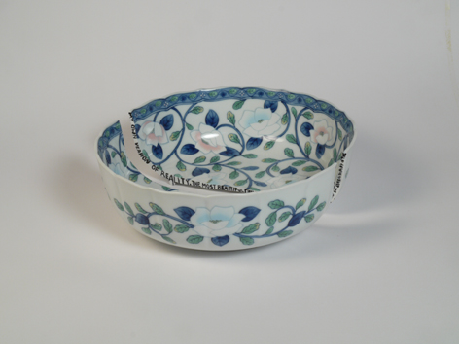 My own version of reality,
2011
mixed media

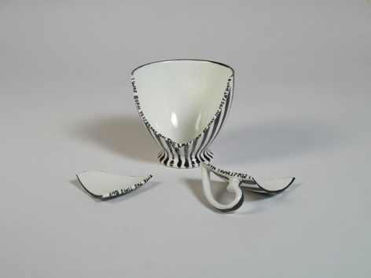 I was born yesterday,
2011
mixed media

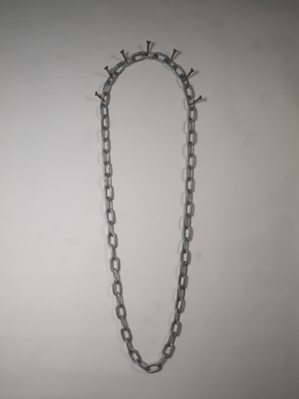 Chain,
2011
mixed media

Caught in flight,
2011
mixed media

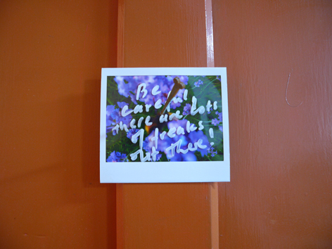 Be careful there are lots of freaks out there,
2011
mixed media

30 Books HansStofer’s designwilderness

Set of Roche drawings ( used for invitation ) to be collected –NOT FOR SALE

